Process Creation
During the course of execution, a process may create several new processes. As
mentioned earlier, the creating process is called a parent process, and the new
processes are called the children of that process. Each of these new processes
may in turn create other processes, forming a tree of processes.
Most operating systems (including UNIX , Linux, and Windows) identify
processes according to a unique process identifie (or pid), which is typically
an integer number. The pid provides a unique value for each process in the
system, and it can be used as an index to access various attributes of a process
within the kernel.

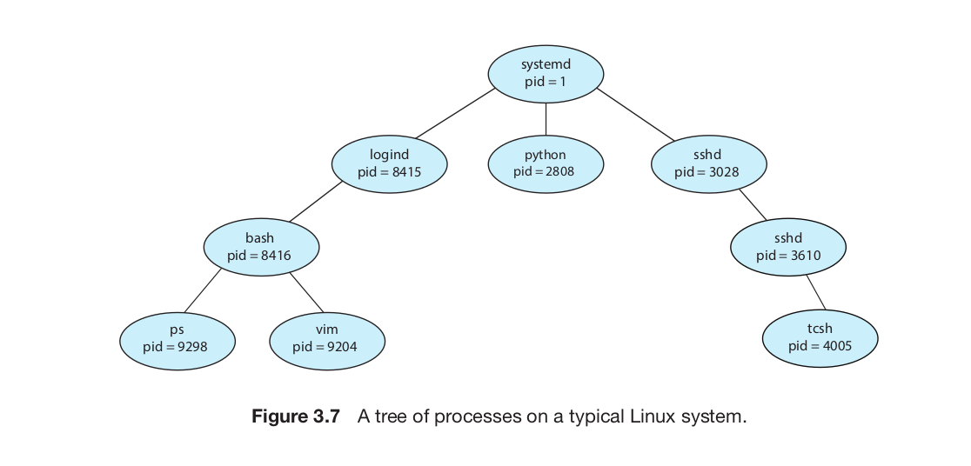

On UNIX and Linux systems, we can obtain a listing of processes by using
the ps command. For example, the command
ps -el

In general, when a process creates a child process, that child process will
need certain resources ( CPU time, memory, files, I/O devices) to accomplish
its task. A child process may be able to obtain its resources directly from
the operating system, or it may be constrained to a subset of the resources
of the parent process. The parent may have to partition its resources among
its children, or it may be able to share some resources (such as memory or
files) among several of its children. Restricting a child process to a subset of
the parent’s resources prevents any process from overloading the system by
creating too many child processes.
In addition to supplying various physical and logical resources, the parent
process may pass along initialization data (input) to the child process. For
example, consider a process whose function is to display the contents of a file —
say, hw1.c —on the screen of a terminal. When the process is created, it will get,
as an input from its parent process, the name of the file hw1.c . Using that file
name, it will open the file and write the contents out. It may also get the name
of the output device. Alternatively, some operating systems pass resources to
child processes. On such a system, the new process may get two open files,
hw1.c and the terminal device, and may simply transfer the datum between
the two.
When a process creates a new process, two possibilities for execution exist:
1. The parent continues to execute concurrently with its children.
2. The parent waits until some or all of its children have terminated.
There are also two address-space possibilities for the new process:
1. The child process is a duplicate of the parent process (it has the same
program and data as the parent).
2. The child process has a new program loaded into it.

To illustrate these differences, let’s first consider the UNIX operating system. In
UNIX , as we’ve seen, each process is identified by its process identifier, which
is a unique integer. A new process is created by the fork() system call. The
new process consists of a copy of the address space of the original process.
This mechanism allows the parent process to communicate easily with its child
process. Both processes (the parent and the child) continue execution at the
instruction after the fork() , with one difference: the return code for the fork()
is zero for the new (child) process, whereas the (nonzero) process identifier of
the child is returned to the parent.
After a fork() system call, one of the two processes typically uses the
exec() system call to replace the process’s memory space with a new pro-
gram. The exec() system call loads a binary file into memory (destroying the
memory image of the program containing the exec() system call) and starts
its execution. In this manner, the two processes are able to communicate and
then go their separate ways. The parent can then create more children; or, if it
has nothing else to do while the child runs, it can issue a wait() system call
to move itself off the ready queue until the termination of the child. Because
the call to exec() overlays the process’s address space with a new program,
exec() does not return control unless an error occurs.
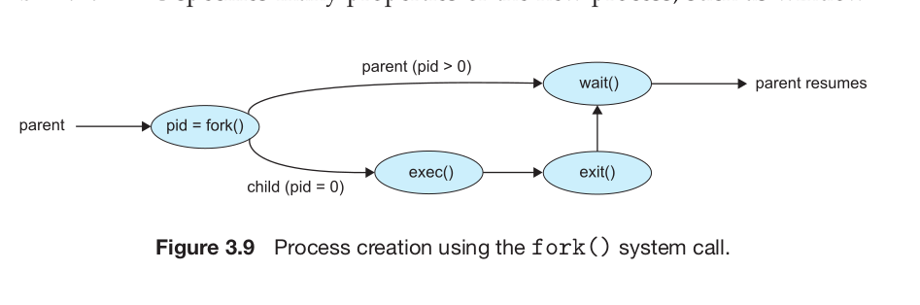

pid t pid;
int status;
pid = wait(&status);
wait argument for get return value of child process
but pid=wait() return the pid of child process.

