

PHINMA COC STUDENTS VIOLATION COMMUNITY SERVICE
MONITORING SYSTEM
In Partial Fulfillment of the
Requirements for the Subject
Computer Programming 2 and
Introduction to Computing

Prepared by:
Bulac P. Reynnel
Bidoy Jebon Ace
Montano, Derick M.
Dalogdog, Ian Joven B.
Abecia, John Toven P.
Maambong, Recsle Joe M.

April 2026

Introduction
A Student Violation Monitoring System is a web-based or software application developed to streamline the way educational institutions monitor, record, and manage student violations. It aims to replace traditional paper-based or spreadsheet tracking with a centralized digital platform where teachers and staff can log incidents promptly, track sanction histories, and generate official reports. Ahmad Fachrur Rozy(2022). By providing a structured and consistent approach to discipline, the system helps schools enforce policies fairly, identify behavioral patterns among students, and support early interventions that promote a safer and more orderly learning environment. Many schools now use browser-accessible or hybrid systems so teachers and staff can log violations from any device, even with unstable internet. Fenequito, Jm Jason J. (2018). In the current era, the role of information technology is very important and is applied to the field of education both academically and non-academicly. In the academic field, from elementary school to university education, information technology has now been used to support educational progress. Information technology develops with various kinds of information delivery systems in the form of a website or Android. Sandra Dewi Saraswati (2022).

The purpose of this study is to monitor students’ action that can also help to improve the traditional methods of recording violations that are often time-consuming, prone to record error, and difficult to manage. In order to address these challenges, the Student Violation Monitoring System is developed, it intends to provide a digital solution that allows authorized personnel, to efficiently organize records, view violations, edit violations, archive violations, and monitor violations for students. It also allows school personnel to easily input data and generate more accurate records, plus by applying this system it will be easier to record the students’ violations Information Access. By digitalizing the monitoring process, the system not only reduces its paperwork's but also improves information access and its reliability. In addition, the system also supports the school for maintaining a safe, disciplined and organize learning environment for everybody.

Statement of the Problem
Right now, the process of recording students’ violation in PHINMA COC is being done manually using paper-based records or simple encoding methods. Firstly, manual recording can expand the risk of lost or damage records, making it hard to retrieve deleted information when needed. Second, the way it process is time consuming, especially when finding for specific students record or even generating reports. Third, there is a lack of real time monitoring, which what makes it more difficult for guidance personnel to track repeating offenses or identify patterns in student behavior.

Specifically, this study seeks to address the following problems:
- How can the system reduce the risk of lost or damaged student violation records compared to manual paper-based methods?

- How can the system improve the speed and efficiency of recording, searching, and retrieving student violation records?

- How can the system generate accurate and timely reports for guidance personnel?

- How can the system provide real-time monitoring of student violations?

Objectives of the Study
General Objective
General objective of this study is to developed a Student Violation Monitoring System, that is efficient, accurate, and a reliable system for student with violation records which would automate the management and tracking of student violations information in PHINMA COC.
Specific Objectives
- To develop a database that allows to secure and maintain the student records.
- To develop a feature that can generate accurate and timely reports.
- To ensure that all student records are properly organized and securely stored.
- To improve the ability to record, search, and retrieve students’ information easily and fast
- design a system that can minimize the risk of losing or damage student information record.
Scope and Limitation Scope:
This study focuses on the design and development of a computerized system management on student violation records. The system is planned to replace the existing manual process by providing a digital platform for recording, storing, retrieving, monitoring students’ violations. It also allows authorized user, such as the guidance personnel, to input students’ information, record violations, and generate reports effectively. The system will also involve real time monitoring and tracking of repeat offenses, as well as arranging records in a secure database. The study protects the usefulness, usability, efficiency of the system within the school.

Limitation:
This study is only limited to the deployment of the system within the PHINMA COC and intended to use by authorized personnel by the school. It does not include with other institutional systems such as enrollment or grading system. The system only anticipates on accurate latest data or information by its user, although error in encoding may still affect the result. Additionally, the study does not cover the long-term system maintenance, advanced data analysis, or mobile application development. Security features are also limited to basic user authentication and do not include high advance cybersecurity measurements.

System Requirements

Hardware Requirements
- Processor: Intel Core i3 / i5 or 10th Gen and above
- Memory (RAM): Minimum of 4 GB or above
- Storage: At least 236GB or above of free disk space
- Monitor: 21-inch or above
- Input: Keyboard and mouse
- Output: Monitor and Display Screen

Software Requirements
- OS: Windows 11
- Language: HTML and CSS Runtime
- Database (MySQL, Firebase, etc.)
- Environment: Web Browser
- Web Browser: Google Chrome

Flowchart (INSERT IMAGE)

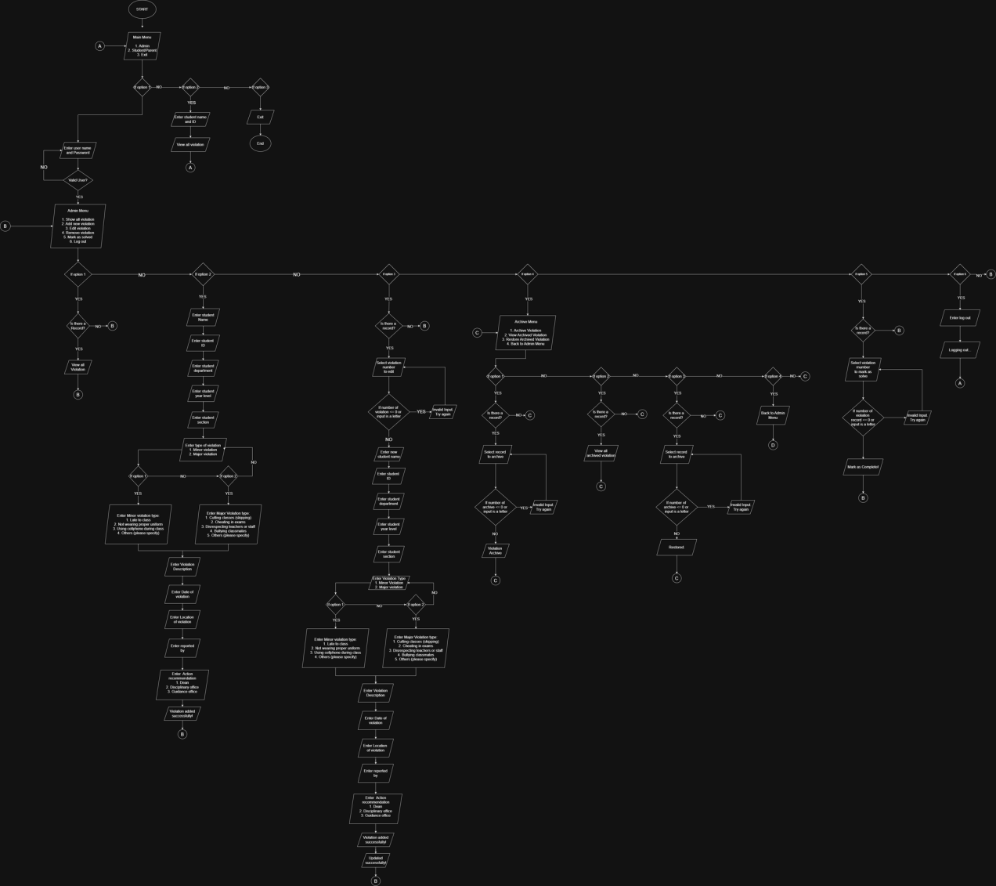

Reference:

Fenequito, Jm Jason J. Fenequito, Jm Jason J.Gagante, Kent G.Leona, Anne Shirley B.Unsan, Chandre’ Maverick G. (2018) Student violation management system with mobile application for Central Philippine University. Bahandian Computer Studies https://repository.cpu.edu.ph/handle/20.500.12852/2238

Ahmad Fachrur Rozy, Rangsang Purnama (2022) ViMoIS: The Student Violation
Point Monitoring Information System. Edumatic: Jurnal Pendidikan Informatika e-
ISSN 2549-7472 https://www.academia.edu/download/107748556/5813-242034PB.pdf

Jully Triansyah, Maya Apriyanti1, Rusma Insan Nurachim, Sandra Dewi Saraswati3
Web-Based Student Violation Monitoring Information System Design at SMK
Gandasari. (2022) https://ejurnal.stmik-budidarma.ac.id/index.php/ijics/index

