FloodCrew: Project Proposal
A smart helper that tells a council where to send its crews and gritters, and warns the public, during floods, snow and black ice.
John Ajiboye · MSc AI with Data Analytics, Teesside University · Intelligent Decision Support Systems · November 2026
1. The problem
When a river floods or roads freeze, a council has only a few crews and gritters. Staff must decide quickly where to send them, often using guesswork or waiting for an official warning, which can be too late. A care home, school or hospital road can be left unprotected. Drivers and people walking also often find a flooded or icy road only when they reach it.
2. Aim
To build a smart system that helps a council protect the most vulnerable places before bad weather hits, send its crews and gritters to the right places, and keep the public informed.
3. Objectives
- Predict river levels 6 hours ahead and which roads will freeze overnight.
- Give every place and road a risk score (how likely × how bad).
- Suggest the best job for each crew and gritter automatically.
- Let the officer approve the big decisions and try "what if" scenarios.
- Send the public alerts for their street and a safer route.
- Test the system fairly against what councils do today.
4. The proposed solution
How FloodCrew works:
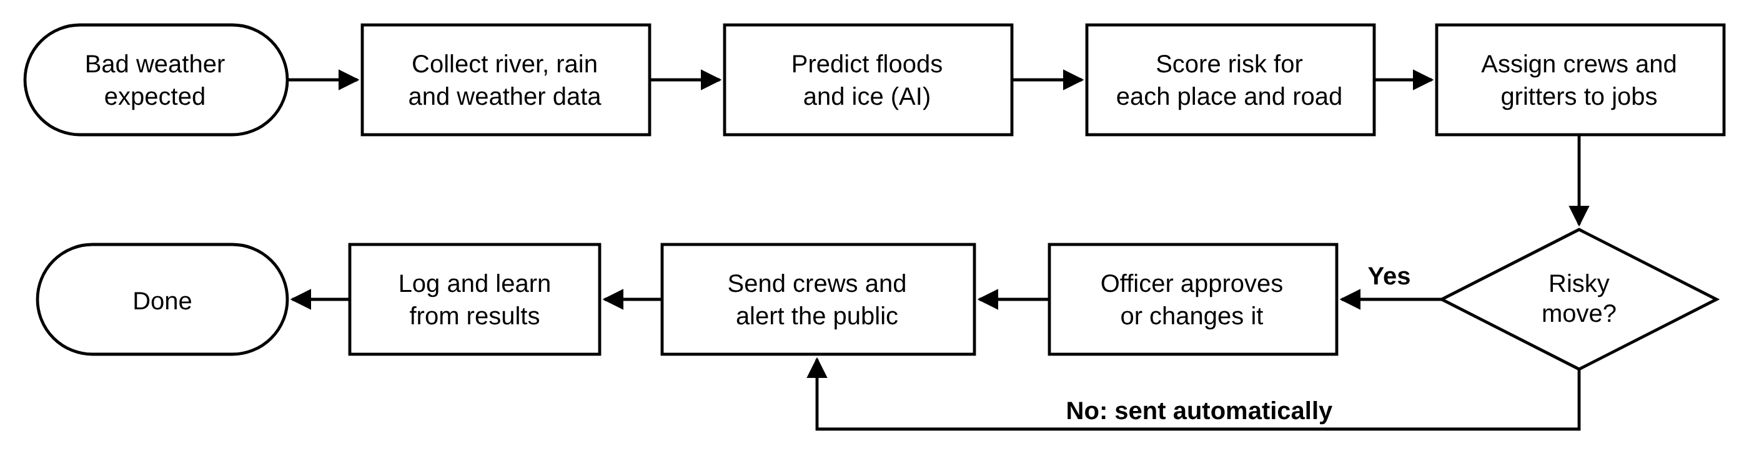
It follows Simon's decision model (intelligence, design, choice, review) and has three parts:
Officer dashboard  Map, ready-made plan, approvals and what-if |  | Crew phone page  Each job and the reason for it, plus status updates |  | Public alerts page  Alerts by postcode, flooded and icy roads on a map, safer route

5. Who will use it
User | What they get
Emergency officer | A ready-made plan, with only the important moves to approve
Crew lead | Jobs on a phone, with the reason for each
Public (drivers, walkers, residents) | Alerts for their street and a safer way to travel

6. Why it is an intelligent decision support system
IDSS part | In FloodCrew
Data | Environment Agency river levels and rainfall; weather forecasts for ice
Models (AI) | Machine learning predicts river levels and road temperature
Knowledge base | Rules: risk = likelihood × impact; extra weight for care homes, schools, hospital routes
Optimiser | Hungarian algorithm gives each crew the best job, counting travel time
User interface | Dashboard, crew page and public alerts page
Human in control | Officer approves risky moves; every action is logged and can be undone

7. Tools and data
- Data: Environment Agency open data (free) and Open-Meteo weather forecasts. Simulated River Tees data is used first while real data is collected.
- Build: Python (scikit-learn, SciPy, FastAPI) and a web app.
8. How it will be tested
The models are trained on older data and tested on newer data they have never seen. FloodCrew is compared with today's practice: sending crews when the official warning comes, and gritting at fixed times. Early results on simulated data:
Test | FloodCrew | Today's method
River level prediction error | About 3 cm | About 9 cm
Protected sites reached before flooding (5 crews) | 12 of 13 | 7 of 13
Road temperature prediction error | 0.85 °C | 2.90 °C
Icy roads gritted in time (1 gritter) | 79% | 50%
Gritting runs used (2 gritters) | 412 | 436

9. Expected benefits
- Vulnerable places protected earlier.
- Better use of a small number of crews and gritters.
- Fewer people driving or walking into danger.
- Clear, explainable decisions with a full record.
10. Risks and limits
- Results so far use simulated data; real data is the next step.
- Flood levels and gritting routes are estimates until the council's real ones are used.
- Public alerts need officer approval to avoid false alarms. The system supports official warnings and does not replace them.

