Continuous Assessment 1 Specifications

Multimedia and Mobile Application Development

## Introduction

My app is for students atttending class during the week or at night classes to assess attendence for both the lecture and the student. When the student enters the class, they will access the app to inform the lecture and college of attendence and will send a notification to the lecture informing them of students currently present. As a lot of colleges already have forms of taking attendence, this will benefit students who have lost/broken their cards or forgotten them. It will also grab your location to make sure your presently in the class until it is finished as in my current college, you scan in when you enter class but don’t have to scan out so they have no form of knowing if you stayed for entire class.

# Evaluation Process

1. Market survey

Technology Used –

* Android Studios is a java-Based technology. It is the offical IDE of Android app delopment and can offer better quality tools when building an Android app. Some of these features are an emulator to figure out what code is working while you are developing the app. The emulator has the capabilities for many types of devices meaning the capabilities of the app your building has the same capabilities. Has the capabilities to rub the app without building a new APK every time you create changes to the app.
* To begin, every student would need to insert there timetable to the app which will be done using SQL and further down the line the process of this will be imporved but it will be uploaded and then saved so the app accesses it easily by grabbing it and displaying your day and times of classes and lecture you have on a grid. So when I’m creating the SQL the first operations I will create is the creating and updating of the database. This will be developed using a subclass which will provide the necessary operations to Create and Update within the database.
* An android location API will be used to ensure the location of the student in the college. It will also allow the lecture to verify the student is in class. A GPS module can be used while also using wifi and a cell tower for triangulation in order to grab the users coordinates. All this can be done through android studios, it has all the capabilities.

**3 similar apps –**

* 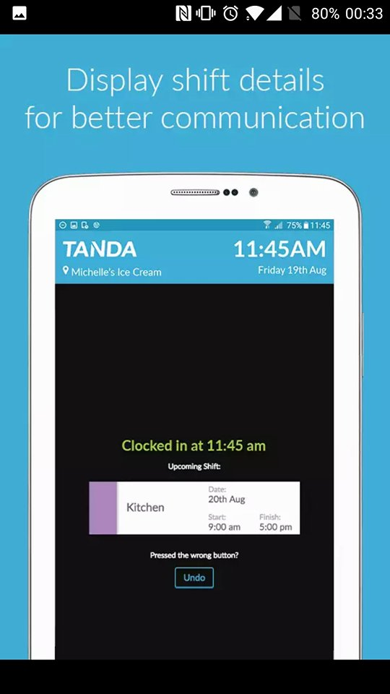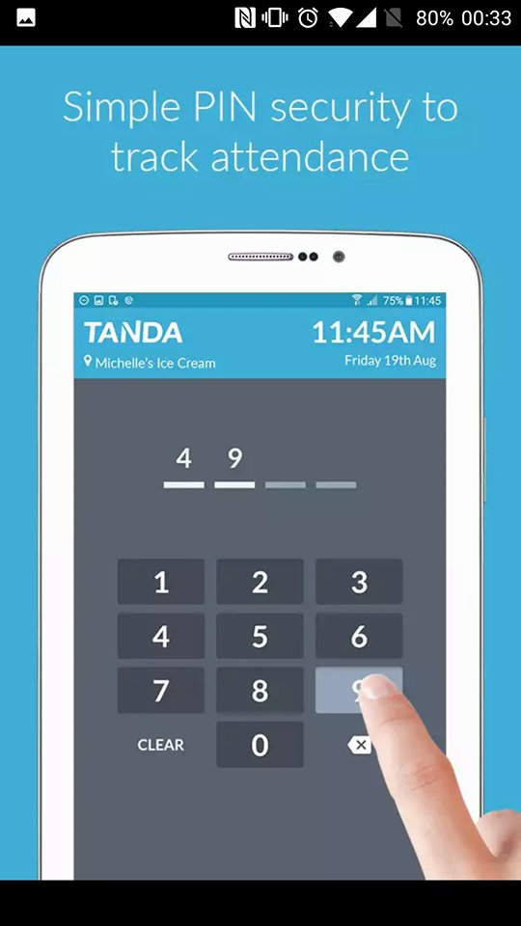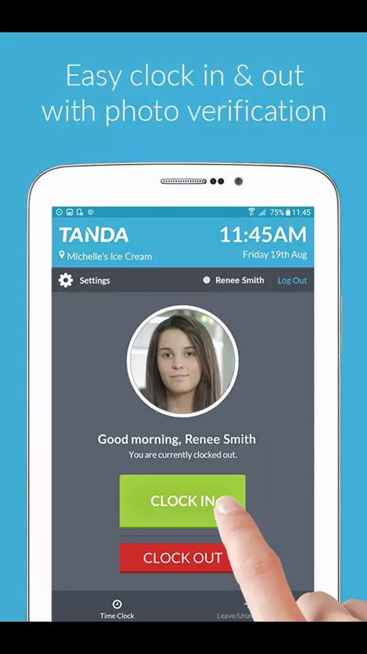Employee Time Clock works around your job, so when you show up, you clock on the app what time you arrived. It will record the hours youve done and has a pin and security protocols such as photo verification to make sure your at work and has the option of weekly emails to employees about rosters or other information.
* 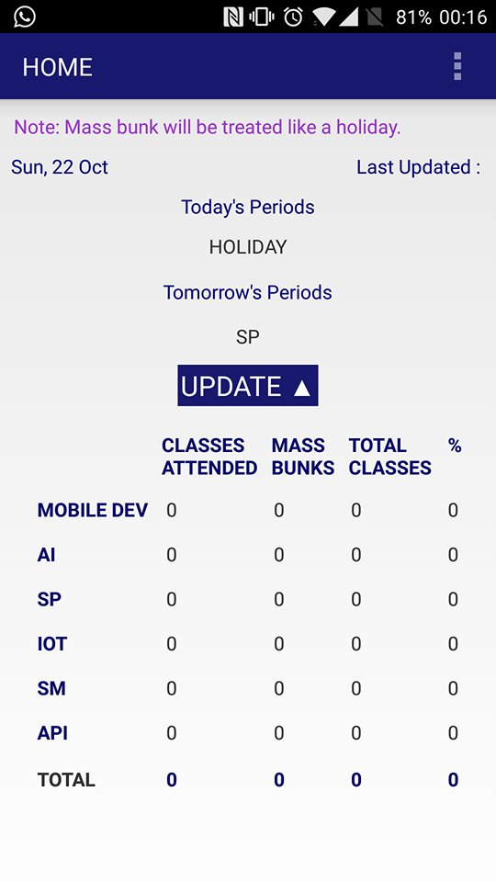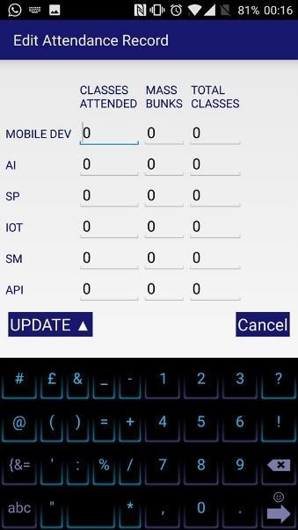Attendence Tracker allows you to insert your modules and how many times a week your in, then will show a grid allowing you to see your timetable. It allows gives other information such as classes attended and how many and mass bunks and then the % you’ve attended. Allows you to update any classes youve done if you only started using app two or three weeks into semester.
* Attendence Tracker is used for events but it allows you to create the event and then add people to it. It allows you to name and date the event in order to allow participments to know when it is. Then it allows the creator to mark the attendence of each participment.

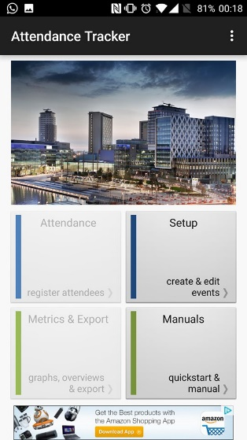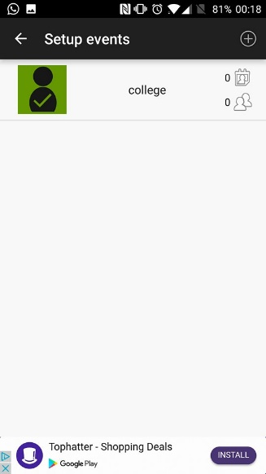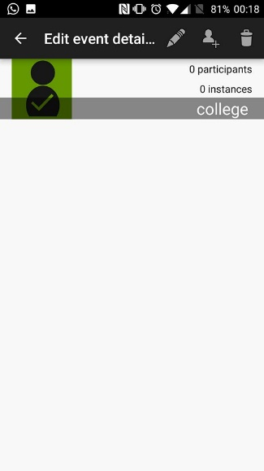

Future trends –

Ways to improve my app, would be integrating IPS(Indoor Positioning System) instead of GPS as IPS would work on better terms with the app. It can determine the floor and room you are located in rather than a general location using Bluetooth beacons around the building. The reason for this is there’d be no need for any verification that they’re actually present in the room and the app would be able to use IPS to locate their position in the building rather than have a rough idea. This would result in more accurate results for both the lecture and the student throughout the year.

Any innovative / research element that differentiate your app with others

The difference between my app and the others I have researched is, in case of the event, the creator can change all the details and such but the participment has no involvement over the situation. In my app, both the lecture and student will have access in some form with different plat forms for each. I feel this will be more beneficial as it will have a better result to using it, rather than the other attendence app that is only for the student and for him to keep track of himeslf during the week. This app will track your entire year allowing you to recall which classes you have missed and also notifying your lecture if youll miss a class so you know what material you can ask for.

# Bibiography

(Anon., n.d.)

(Anon., n.d.)

(Anon., n.d.)

(Anon., n.d.)