**CSI 403 – Project #5 – Network Topology Detector**

Goal:

* Study a representation of a computer network to determine which type of network topology exists – bus, ring, or star.

Problem:

* Provide a RESTful service which accepts as a POST of JSON a representation of a network of computers. Assume each connection between computers is bidirectional.
* Output a JSON message indicating if the topology is a bus (1), a ring (2), or a star (3). If the topology is none of these, then output the type as “irregular”.

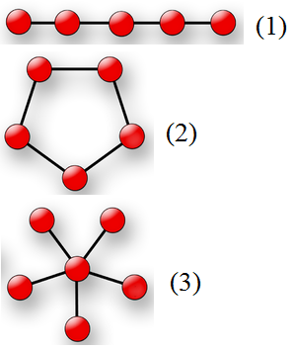

* Example input:

{ “inList” : [

{ “connected” : [ “A”, “B” ] },

{ “connected” : [ “B”, “C” ] },

{ “connected” : [ “C”, “D” ] },

{ “connected” : [ “D”, “E” ] }

] }

Example output:

{ “type” : “bus” }

* Erroneous input (e.g. malformed JSON) should be handled gracefully.

Deliverables:

Submit to the Blackboard by the due date:

* An HTTP URL to a RESTful service which must remain up and running 24/7 until grading is complete. Graders will invoke your service with a tool such as curl or Postman at a time of their choosing.
* A ZIP file containing your source code, written in any language you choose.