中原大學工業與系統工程學系

碩士學位論文

運用專利搜尋與文字探勘來探討產品設計之演化趨勢模式

蔡明政

中華民國110

年

1

月

中 原 大 學

工 業 與 系 統 工 程 學 系碩士學位論文

運用專利搜尋與文字探勘來探討產品設計之

演化趨勢模式

Applying Patent Search and Text Mining to Explore the Evolutionary Trend Modeling for

Product Design

指導教授：劉天倫研 究 生：蔡明政

中華民國 110 年 1 月

# 摘要

在使用 TRIZ 理論進行產品設計時往往需要選擇適合工具解決問題，過去大多是以人為的判斷為主，而產品開發流程以提升產品設計理想性(Ideality)為目標，來達到跳躍式的創新。藉由 TRIZ 中演化趨勢的演化漸進線可以有效的提升理想性，然而選擇適合的演化漸進線來分析產品的內容是相當關鍵的。因此本論文運用文字探勘及語義相似度計算來分析專利文件中可能有關的演化趨勢，進而協助產品開發者選擇適合解決設計中問題的演化漸進線。本研究首先建立了 37 演化趨勢 SAO(Subject-Action-Object)語法結構關鍵字詞集，並參考了與產品設計需求相關的研究來選定本論文之實驗題目- 步矩橢圓機以及建立出 SAO(Subject-Action-Object)語法結構之產品設計需求，再從專利資料庫擷取步矩橢圓機之專利文本，利用文字探勘對專利文本進行依存分析(Dependency

Parsing)來擷取出 SAO 語法結構，通過 Word2Vec 訓練的詞向量進行語義相似度計算來分類該專利文件符合的演化趨勢以及設計需求，最後將結合演化趨勢分類結果和設計需求分類結果來探討步矩橢圓機的產品設計在演化趨勢應用上的推薦。

關鍵字: TRIZ、演化趨勢、文字探勘、依存分析、語義相似度

# ABSRTACT

When applying the TRIZ theory for product development processes, it is often necessary to choose suitable tools to solve problems. In the past, most of them were based on human judgment, and the product development process aimed to improve the ideality of product design to achieve leapfrog innovation. The ideality can be effectively improved by the trend lines of the evolution trends in TRIZ, but it is quite critical to choose a suitable evolutionary lines to analyze the content of the product. Therefore, this paper uses text mining to analyze the evolutionary trends that may be relevant in patent documents, and then assists product developers to choose an evolutionary lines suitable for solving design problems. This research first constructed the 37 evolutionary trends SAO (Subject-Action-Object) grammatical structure keywords set, and referred to the papers related to product design requirements to select the experimental topic of this research - elliptical machine and established SAO grammatical structure of product design requirements, and then extract the patents texts of the elliptical machine from the patent database, and use text mining to perform dependency parsing on the patent text to extract SAO grammatical structure. The semantic similarity calculation of the word vector trained by Word2Vec is used to classify the evolutionary trends and design requirements of the patent documents. Finally, the product design of the elliptical machine will be discussed in combination with the evolutionary trends classification results and the design requirements classification results recommendations on evolutionary trends applications.

Keywords: TRIZ, Evolutionary Trends, Text Mining, Dependency Parsing, Semantic Similarity

# 致謝

首先要感謝指導老師劉天倫副教授的指導，讓我在學業上譜下精彩的一頁：提供機會讓我申請到科技部補助並一人獨自遠赴英國利物浦大學參與研討會發表論文、前往金門大學參加研討會與發表科技部計畫論文以及多留的碩士半年參加 IEEE 國際研討會發表論文等等，都豐富了我的學術和人生歷練，而藉由參與這些研討會指導老師提供了我在論文上的建議和方向，在本論文的修訂及內文中提出諸多建議與指教讓我能順利完成口試。

就讀研究所的這段期間，感謝研究室學弟凌翔、崇恩、鋐槐、江謙在我寫論文這段期間的互相幫助：在助教事務繁雜的時候為了讓我有空寫論文協助我頂替助教的工作、在論文遇到瓶頸時提供一些建議和幫忙等等。感謝研究室學長凱仁在與我共同就讀研究所時與我一起到日本東京參加 ICIEA 國際研討會，讓我第一次瞭解到國際研討會的格局和生態，奠定我後來願意獨自參與的兩次國際研討會的勇氣，若沒有這個契機就可能無法讓我發表與本論文相關的二篇國際研討會論文，感謝以前的大學同學之易在我撰寫論文時幫我取得位於他校僅供校內閱覽紙本全文的重要參考文獻和互相交流論文撰寫方式，貢獻甚多；還有大學部學弟柏倫在我幫老師處理科技部計畫和參加 IEEE 國際研討會多留的半年裡提供我諸多協助。

最後要感謝家人對我的支持，叔叔、阿嬤和母親不僅是我在學時的經濟支柱也提供了我學習的動力，尤其是阿嬤身體健康每況愈下且走路都有困難，但是仍為了出席我的畢業典禮拄著拐杖走了好長一段路來會場合照，激勵了我讓我在碩二下的這段時間每天都睡研究室、六點起床寫論文、下午處理助教的事務，最後成功趕在七月通過口試。

蔡明政 謹誌於中原大學 工業與系統工程學系中華民國一一零年一月

# 目錄

摘要 I

ABSRTACT II

致謝 III

目錄 IV

圖目錄 VI

表目錄 VIII

第一章 緒論 1

第一節 研究動機 1

第二節 研究目的 2

第三節 研究流程 3

第二章 文獻探討 5

第一節 創新發明問題解決理論 5

第二節 演化趨勢 6

第三節 文字探勘 7

* + 1. 基於演化趨勢關鍵字詞集的特徵提取 10
    2. 基於 TFIDF 的特徵提取 11
    3. 基於 SAO 結構規則的特徵提取 12

第四節 語義相似度計算 13

2.4.1 基於 Word2Vec 的語義相似度計算 13

第五節 依存句法分析 15

第三章 研究方法 17

第一節 演化趨勢 SAO 結構詞庫建立 19

第二節 產品設計需求建立 21

第三節 專利文件蒐集 26

第四節 專利文本的特徵擷取 29

* + 1. 自然語言處理套件spaCy 29
    2. 依存關係分析 30
    3. SAO 依存關係結構的特徵提取 33

第五節 WORD2VEC 詞向量訓練 33

第六節 語義相似度計算 35

第七節 演化趨勢分類方法 37

第八節 設計需求分類方法 41

第九節 演化趨勢模式分析 44

第四章 實驗結果 45

第一節 演化趨勢分類效果驗證 45

* + 1. 驗證用專利資料集彙整 45
    2. 分類效果驗證 48

第二節 實驗用專利文件資料集 50

第三節 專利之設計需求分類 55

4.3.1 專利文本與設計需求之語義相似度計算結果 56

第四節 英文專利之演化趨勢分類 57

4.4.1 演化趨勢分類結果 57

第五節 產品設計需求與專利之演化趨勢模式分析 61

* + 1. 基於所有設計需求之演化趨勢模式分析 61
    2. 基於調整步距需求之演化趨勢模式分析 64
    3. 演化趨勢模式分析結果探討 70

第五章 結論與建議 72

第一節 結論 72

第二節 研究限制 73

* + 1. 自然語言處理 73
    2. 詞向量模型 73
    3. 演化趨勢推薦 73
    4. 演化趨勢驗證 73
    5. 設計需求分類 74

第三節 未來研究及建議 74

參考文獻 75

附錄 A: 演化趨勢及演化原因彙整 79

附錄 B: 演化趨勢SAO 結構關鍵字詞集 102

# 圖目錄

圖 1-1、研究架構圖 4

圖 2-1、TRIZ 問題解決流程(Mann, 2007) 5

圖 2-2、詞幹提取規則範例(Porter, 2006) 9

圖 2-3、基於不同詞幹提取規則的提取結果(Tomfohr, Lu & Kepler, 2005) 9

圖 2-4、CBOW 模型架構圖(Mikolov et al., 2013) 14

圖 2-5、Skip-gram 模型架構圖(Mikolov et al., 2013) 14

圖 2-6、依存關係分析範例(Jurafsky & Martin, 2019) 16

圖 3-1、研究方法流程架構圖 18

圖 3-2、演化趨勢SAO 結構詞庫彙整方式 1 之圖解 19

圖 3-3、演化趨勢SAO 結構詞庫彙整範例 20

圖 3-4、演化趨勢SAO 結構詞庫彙整為csv 檔(前 1~10 筆) 20

圖 3-5、演化趨勢SAO 結構詞庫讀取結果 21

圖 3-6、設計需求彙整為csv 檔之範例(前 10 筆) 25

圖 3-7、設計需求SAO 結構詞組讀取結果 25

圖 3-8、WEBPAT 網站及搜索條件設定 27

圖 3-9、WEBPAT 網站抓取之專利文本範圍 27

圖 3-10、WEBPAT 網站抓取之專利名稱及公告號 28

圖 3-11、WEBPAT 網站抓取之部分專利內文敘述 28

圖 3-12、專利公告號US10549153 進行詞形還原及POS Tagging 後之結果 31

圖 3-13、專利公告號US10549153 依存分析後之各詞組依存關係 31

圖 3-14、專利公告號US10549153 進行 SAO 結構依存分析後之結果 33

圖 3-15、專利公告號US10549153 之文本內容 34

圖 3-16、專利公告號US10549153 進行詞向量可視化之結果 34

圖 3-17、專利文本與演化趨勢SAO 結構詞組語義相似度計算示意圖 35

圖 3-18、專利文本與設計需求語義相似度計算示意圖 36

圖 3-19、專利之演化趨勢相似度計算結果(1) 37

圖 3-20、專利之演化趨勢相似度計算結果說明(1) 38

圖 3-21、專利之演化趨勢相似度計算結果說明(2) 39

圖 3-22、專利之演化趨勢相似度計算結果(2) 39

圖 3-23、產品設計與專利之演化趨勢模式分析流程 40

圖 3-24、專利公告號US10549153 語義相似度計算≥ 1.6之部分結果 40

圖 3-25、專利公告號US10549153 之演化趨勢出現次數結果 41

圖 3-26、專利產品設計分類之部分相似度計算結果 42

圖 3-27、專利產品設計分類之相似度計算結果說明 42

圖 3-28、產品設計與專利之演化趨勢模式分析流程 43

圖 3-29、設計需求分類相似度計算< 1.6之執行結果範例 43

圖 3-30、設計需求分類相似度計算≥ 1.6之執行結果範例 44

圖 3-31、產品設計與專利之演化趨勢模式分析流程 44

圖 4-1、驗證用專利文本彙整(前 20 筆) 45

圖 4-2、專利文本彙整範例(前 1~30 筆) 50

圖 4-3、專利文本之設計需求分類結果範例 55

圖 4-4、專利文本之演化趨勢分類結果(左)及出現次數(右) 57

圖 4-5、基於所有設計需求之演化趨勢出現次數(計數) 61

圖 4-6、基於所有設計需求之演化趨勢出現次數(計次) 62

圖 4-7、基於所有設計需求之演化趨勢出現次數大至小排序(計次) 62

圖 4-8、基於排名最高設計需求之演化趨勢出現次數統計(計數) 68

圖 4-9、基於排名最高設計需求之演化趨勢出現次數統計(計次) 68

圖 4-10、基於排名最高設計需求之演化趨勢出現次數大至小排序(計次) 69



# 表目錄

表 2-1、演化趨勢之八大型態(Zlotin & Zusman, 2006) 6

表 2-2、空間分割之演化階段與演化利益(Mann, 2007) 7

表 2-3、演化趨勢Smart Material 之關鍵字詞集(蔡元豪，2012) 10

表 2-4、依存關係與定義(其中的 8 種) 16

表 3-1、產品設計需求列表(王志超，2013) 22

表 3-2、SAO 結構的產品設計需求列表 23

表 3-3、WEBPAT 網站特色 26

表 3-4、spaCy 自然語言處理基本功能表 30

表 3-5、Clear NLP 句法依存分析之標籤及敘述(Choi, 2015) 32

表 4-1、驗證用 40 筆專利資料清單 46

表 4-2、驗證用專利分類結果 48

表 4-3、實驗用專利資料清單 51

表 4-4、設計需求分類結果 56

表 4-5、符合設計需求的專利進行演化趨勢分類結果 58

表 4-6、基於所有設計需求之演化趨勢模式推薦 63

表 4-7、演化趨勢分類結果出現次數大到小整理 64

表 4-8、基於排名最高設計需求之演化趨勢模式推薦 69

表 4-9、演化趨勢模式推薦彙整(前十名) 71

# 第一章 緒論

在這科技進步飛快的時代，要讓產品有市場競爭力的話，符合顧客需求的創新產品設計勢在必行，但是要如何持續的創新來維持市場競爭力就是一大難題。單純修改參數的設計、更換材料、改變外觀的設計很難在市場競爭中站得住腳以及符合多樣的顧客需求，所以產品必須要做到持續地創新、符合顧客需求才能在市場上保有優勢，因此如何在產品設計的過程中提高理想性儼然成為現代設計者不可避免的課題。隨著產品設計的顧客需求越來越多，衍生出的產品設計需求也會越來越繁雜，甚至會跨足到其他專業領域，因此要如何在各設計需求中找到滿足顧客需求的最佳解以及各專業部門的妥協也是產品設計的一大課題。

## 第一節 研究動機

TRIZ 工具看似是簡單的問題分析與解決的過程，但是常常會被一般人錯誤地分析與使用，在應用過程中有時容易迷失方向，例如使用工程參數來做產品改善時，如果是單一問題或矛盾解決還可以處理，但是若要考慮到產品整體性的考量，會因為產品問題分析的複雜性增加，導致所涵蓋的工程參數也變多，進而讓取捨式改善陷入瓶頸，因此透過工程參數這種取捨式的改善對於產品的創新性沒有明顯地提升，而 TRIZ 工具中的演化趨勢是利用預測產品演變的過程所歸納出的演化漸進線來提供產品創新設計或改善的參考，透過演化趨勢可以有效的改善產品以及提升創新性，但是演化趨勢的分析並不是簡單的工作。在傳統的演化趨勢改善案例中大多都是經過人為判斷來進行分析，過去利用演化趨勢進行產品設計的研究有：

1. 以風力發電LED 為例，廖士德(2010)將綠色產品設計之研究個案相關專利整合後，經由作者的主觀判斷對綠色產品設計做演化趨勢、工程參數、40 發明原則和矛盾矩陣的分析，其中演化趨勢的部份在分析後以雷達圖呈現，來找尋未來可發展、具潛力的演化方向。
2. 以電子晶片式防潮櫃為例，周依穎(2014)結合了 TRIZ 發明原則以及演化趨勢來解決防潮櫃的目標缺點，其中演化趨勢的辨識方式是利用作者自行整理所建立的發明原則與演化趨勢對照表，並透過自行判斷電子晶片式防潮櫃所屬的發明原則來進行演化趨勢分析，也是屬於人工判斷的範疇。

由於演化趨勢分析是需要仰賴有經驗的專家輔助才能協助分析出屬於專業技術層面的演化趨勢，因此若能建構出一個能夠透過產品設計需求與其他同性質產品專利的探勘來自動化分類並推薦演化趨勢之方法流程，可以幫助設計團隊進行產品設計的分析與改善。

## 第二節 研究目的

為了提高產品競爭力往往會進行市場調查並蒐集顧客需求來做為產品開發的理想目標，但是要如何將顧客/設計需求轉換成 TRIZ 的演化趨勢來提供產品開發團隊使用是一大課題。黃鈺婷(2010)以問題特性陣列(PCA)做為模式化問題的手段，以”Hands-On Systematic Innovation”(Mann,2007)書中的案例做為訓練資料，輸入功能與屬性來辨識能夠解決問題的演化趨勢，但是由於實驗資料受限於 50 筆讓實驗成效還有待改善的空間， 為了解決實驗資料不足的問題，找尋了能夠利用大量專利來進行演化趨勢辨識的文獻， 其中蔡元豪(2012)使用文字探勘方法，利用演化趨勢關鍵字詞集與TFIDF 的權重特徵值計算來進行演化趨勢的分類，以 912 筆中華民國及 91 筆美國的氣動打釘機專利為例， 發現演化趨勢之簡約設計已達演化極限，而打破邊界(空間)、打破空間(介面)、減少能源轉換、非線性及單-雙-多(同質性)這些演化趨勢皆尚未發展。

選用文字探勘進行分析的好處主要有兩點：

1. 利用文字探勘進行演化趨勢分析時可以避免人為分析所造成的影響，因為人為分析會被個人主觀想法與觀念左右，進而影響到分析結果的正確性與客觀性。
2. 利用專利資料庫中蘊含了大量專利技術的優勢，將大量專利下載好後整理為專利資料集，利用整合而成的專利資料集進行文字探勘可以解決黃鈺婷(2010)研究中提到的實驗資料不足的情況。

參考上述相關研究的實驗步驟，發現文字探勘可以從專利中提取出有用的資訊，結合文字探勘方法與本論文之研究動機，決定建立一個利用輸入產品設計需求，經由文字探勘等技術來找出符合產品設計需求的專利並辨識專利文本中的演化趨勢，提供設計時改善的參考，讓改善後的產品能透過演化趨勢來達到創新性以及理想性的提升，進而滿足顧客需求以維持市場競爭力。

## 第三節 研究流程

本研究的架構與流程如圖 1-1 所示，為了建立出一透過產品設計需求找出具潛力之演化趨勢推薦方法，此研究將分為六個部分：

1. 第一章為本論文之研究動機與研究目的。
2. 第二章為本論文之文獻探討，透過探討 TRIZ 理論、TRIZ 演化趨勢、文字探勘方法、語義相似度計算與依存關係分析等相關文獻來進行實驗架構之建立。
3. 第三章為研究方法，說明本研究建立演化趨勢模式分析的流程與架構，包括資料蒐集、SAO 結構之關鍵字詞集建立、SAO 結構之特徵擷取與語義相似度計算等步驟。
4. 第四章為實驗結果，先是透過透過資料蒐集、特徵擷取、語義相似度計算進行演化趨勢分類方法驗證，再利用上述方法與設計需求進行演化趨勢的推薦。
5. 第五章為結論與未來研究建議，對本研究進行總結，並說明研究限制以及提供未來可進行之發展方向與建議，以利後續研究參考。



實驗結果

研究方法

文獻探討

研究動機與目的

結論與建議

圖 1-1、研究架構圖

# 第二章 文獻探討

## 第一節 創新發明問題解決理論

TRIZ 是俄文首字之縮寫，英文譯為 Theory of Inventive Problem Solving（TIPS），中文為創新發明問題解決理論或「萃思」，由已故的蘇聯科學家 Genrish Altshuller 與他的團隊在 1946 年所提出之方法(Altshuller, 2000)，是藉由分析研究超過數十萬筆的專利並進行了有條理的分類，將其中的創新原理和解決問題方式有系統的分類與歸納所得的創新設計方法，其應用領域涵蓋了：工程、管理、教育、醫療、財務、客戶服務，品質管理、未來技術以及商業機會辨識等。

TRIZ 有五個基本概念，即 Functionality(功能)、Resource(資源)、Contradiction(矛盾)、Space-Time-Interface(時間-空間-介面)和 Ideality(理想性)，基於這些概念，衍生了各種方法和工具，所發展而成的一套方法，其內容主要有：問題規劃(Problem Formulation)、功能分析(Functional Analysis)、矛盾矩陣表(Contradiction Matrix)、四十項創新法則(40 Inventive Principles)、演化趨勢(Trends)、物質-場理論(Su-Field)、最終理想化結果(Ideal Final Result, IFR)、科學效應(Effects)、TRIZ 演算法則(Algorithm for Inventive-Problem

Solving)等。利用上述 TRIZ 工具來解決問題是一種從問題定義到問題解決的流程， 如圖 2-1，將特定問題經由TRIZ 轉換成一般問題，再從一般問題產生出一般解，最後由一般解產生出特定解的架構方式。



特定問題

**TRIZ**

一般解

**TRIZ**

一般問題

特定解

圖 2-1、TRIZ 問題解決流程(Mann, 2007)

## 第二節 演化趨勢

演化趨勢(Trends of Evolution)是指一個系統從最基礎的起點慢慢的轉變到最後理想化結果的過程。TRIZ 創始者 Altshuller 發現不同技術系統的演化過程並非漫無章法，而是有程序的演進法則，其技術系統演化可分為八種型態(Zlotin & Zusman, 2006)如表 2-1。

Mann(2007)將這八種演化型態進一步解讀成 37 項演化趨勢如附錄 A，舉例說明如表 2-2 所示，「空間分割(Space Segmentation)」之演化趨勢包含 5 個由 2.1 至 2.5 的演化階段，每一個演化轉變均存在有好處(benefits)，例如由單一固體轉變至中空結構，將可以達到重量減少、材料減少等效果。若以實例來說明，籃球橡膠鞋底之設計，由實心結構演變成多重中空的氣墊結構來達到重量減少等效果。

表 2-1、演化趨勢之八大型態(Zlotin & Zusman, 2006)

|  |  |
| --- | --- |
| 演化形態 | 演化形態說明 |
| 技術系統以階段性的形態  來發展 | 產品通常會歷經四個階段從產品的誕生、成長、成熟到死  亡的生命週期 |
| 朝向逐漸理想化的境界發  展 | 朝向「以最少的有害功能，達到最高有用效益」來發展 |
| 系統之元件(子系統)非一  致性發展 | 每個子系統都有不同的演化形態。因發展不一致所導致的  衝突 |
| 朝向逐漸動態化及可操控能力發展 | 增加系統的動態性，使得系統以更大彈性與更多樣性的方  式來執行。首先是相配的元件，之後卻是不相配的元件來  取得優勢 |
| 以簡單的方式增加效能性 | 先是不斷地複雜化來增加系統的效能性，然後透過整合的  簡單化來減少複雜性 |
| 以匹配和非匹配元件演化 | 當技術系統發展時，系統會以匹配或不協調匹配的方式來  改善效能或消除不需要的效果，如大系統到極小系統的轉變過程 |
| 朝向微觀層次及增加能場  的使用發展 | 技術系統發展由巨大的系統轉換為微小系統。在轉換過程  中，不斷改善動態與操作性能以達到更好的效能或控制 |
| 朝向減少人為參與發展 | 系統去執行重複的功能，讓人類從事更多智慧工作。簡言  之，即高度自動化 |

表 2-2、空間分割之演化階段與演化利益(Mann, 2007)

|  |  |  |
| --- | --- | --- |
| 2.Space Segmentation 空間分割 | | |
| 演化階段 | 演化階段(英文) | 演化階段(中文) |
| 2.1 | Monolithic Solid | 單一固體 |
| 演化原因 | reduced weight reduced use of material  space to insert other material hole to hang an object from increase moment of inertia  pass something through the object  improve heat transfer | |
| 2.2 | Hollow Solid | 中空結構 |
| 演化原因 | improve heat transfer improve strengh properties  pass multiple things through object  increase surface area | |
| 2.3 | Structure with Multiple Hollow | 多孔結構 |
| 演化原因 | improve surface area  improve strengtrh/weight ratio improve heat transfer | |
| 2.4 | Capillary/Porous Structure | 毛細孔結構 |
| 演化原因 | improve heat transfer add new function  allow variation | |
| 2.5 | Porous Structure with Active Elements | 多孔結構及主動有效元素 |

## 第三節 文字探勘

文字探勘(Text Mining)是指從非結構化(WORD 及 EXCEL 等)或半結構化(XML 及

JSON 等)的文本資源中提取出重要及有用的資訊，不同於傳統的資料探勘(Data Mining)

是針對結構化的資料進行萃取。

文字探勘應用的領域相當廣泛，包括且不限於：資訊檢索(Information Retrieval)、機器學習(Machine Learning, ML)、文本資訊提取(Information Extraction from text, IE)、文本

摘要(Text Summarization)、文本分類(Text Classification)、情感分析(Sentiment Analysis)、自然語言處理(Natural Language Processing, NLP)等。

Allahyari et al.(2017)歸納出了文字探勘的各種領域方面的概念與應用，其中在文本資訊提取(Information Extraction from text)方面，歸納出了幾種主要的文字預處理以及特徵提取方法：

一、文本預處理方法：

文本預處理是文字探勘中最重要的步驟之一，文本預處理的好壞會影響到文字探勘後續任務的結果，特別是文本分類領域。

* 1. 斷詞(Tokenization)：

斷詞的目的在於將文本或句子分割成多個以一個單詞或短語為單位的”tokens”，並去除掉文本或句子中的某些字或標點符號，以利後續文本處理的任務，範例如下：

斷詞前：“The entire contents of Taiwan Patent Application.”

斷詞後：“The” “entire” “contents” “of” “Taiwan” “Patent” “Application” “.”

* 1. 篩選(Filtering)：

對文本進行過濾以刪除某些停用詞（Stop-words），停用詞是指經常出現在文本中但是沒有太多有用訊息的字詞如介詞和連接詞等（例如：“the”、“is”、

“at”），或是很少出現在文本中的單詞，因為可能沒有重要的意義。在文本量很大的任務中，去除停用詞可以減少文本儲存空間以及提高任務處理效率。

* 1. 詞形還原(Lemmatization)：

詞形還原是基於字典中存在的有效詞來處理單詞時態與形態的方法，將單詞還原成詞的原形，提取單詞的主幹部分，以統一所有出現的詞的表示方式， 例如：

還原前：“ ate” 還原後：“eat” 還原前：“eating” 還原後：“eat” 還原前：“apples” 還原後：“apple”

需要注意的是，通常詞形還原需要先解析出詞性才能正確的還原，因此詞性標註(part-of-speech, POS)是詞形還原前需要的前置作業，詞性標註的準確率會直接影響詞形還原的結果。

* 1. 詞幹提取(Stemming)：

藉由去除單詞的詞綴以及複數形態來提取詞根(root)，以達到詞的簡化效果， 實現詞幹提取通常由建立詞幹提取規則庫來提取詞幹，因此有可能會提取出不存在於字典裡面的詞幹，詞幹提取規則舉例如圖 2-2 與圖 2-3。

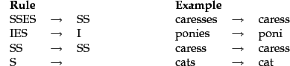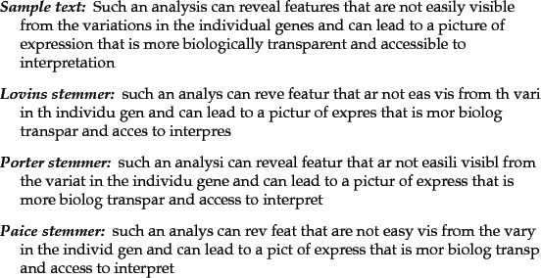

圖 2-2、詞幹提取規則範例(Porter, 2006)

圖 2-3、基於不同詞幹提取規則的提取結果(Tomfohr, Lu & Kepler, 2005)

二、特徵提取方法：

從文本中提取特徵的方法大致可分為三大類，依照不同的特徵提取方法會有不同的文字預處理方法，例如某些基於規則的方法會以盡量不破壞句子的語法結構關係為前題來提取特徵，所以不會去除停用詞，而基於字典的方法會盡量不使用詞幹提取或詞形還原來影響字典比對的結果，除非字典是用詞根或詞的原形來建立的。

1. 基於字典的方法(Dictionary-based approach)：

字典比對法使用了詳盡的字典來定位文本中提及的關鍵字詞，確認文本中的單詞或短語與字典中的內容匹配以找出特徵。

1. 基於規則的方法(Rule-based approach)：

基於規則的方法首先定義了辨識出關鍵字詞的出現模式規則，例如特定語法結構或某帶有某些詞性的字詞，再透過這些規則提取出特徵

1. 統計方法(Statistical approaches)：

統計方法可分為機器學習方法(Machine Learning Methods)以及基於字詞頻率(Term Frequency)的統計方法，機器學習需透過大量文本資料以及經過多次的訓練來進行預測，而詞頻方法則是從各字詞的出現頻率進一步做後續處理分析。

### 基於演化趨勢關鍵字詞集的特徵提取

為了識別專利文件中的演化趨勢，蔡元豪(2012)首先透過「中央研究院中英雙語知識本體詞網英文查詢」與「Yahoo！奇摩字典」網站擴增與整理了和 37 演化趨勢有相關

的關鍵字詞並歸納出了英文關鍵字詞典來協助針對 37 條演化漸進線的特徵進行提取， 並搭配 TFIDF 的權重值以及作者自定義的權重值 1、3、9 來相乘進行得分計算，以得分前二的結果判定為專利文件中具有的演化潛力，部分演化趨勢英文關鍵字詞集如表 2-3：

表 2-3、演化趨勢 Smart Material 之關鍵字詞集(蔡元豪，2012)

|  |  |  |  |  |  |
| --- | --- | --- | --- | --- | --- |
| 參數 | 關鍵字 | 權重 | 參數 | 關鍵字 | 權重 |
| 1-1 | passive material | 9 | 1-3 | two-way adaptive | 9 |
| 1-1 | passive component | 9 | 1-3 | adaptive materials | 3 |
| 1-1 | inactive material | 3 | 1-3 | adaptive components | 3 |
| 1-1 | inactive component | 3 | 1-3 | two adaptive | 3 |
| 1-1 | passively | 1 | 1-3 | double adaptive | 3 |
| 1-1 | passiveness | 1 | 1-3 | dual adaptive | 3 |
| 1-1 | passivity | 1 | 1-3 | two-way material | 3 |
| 1-1 | inactivity | 1 | 1-3 | two-way component | 3 |
| 1-2 | one-way adaptive | 9 | 1-3 | two functional | 1 |
| 1-2 | adaptive material | 9 | 1-3 | bifunctional | 1 |

|  |  |  |  |  |  |
| --- | --- | --- | --- | --- | --- |
| 1-2 | adaptive component | 9 | 1-3 | two elastic | 1 |
| 1-2 | one adaptive | 3 | 1-3 | double elastic | 1 |
| 1-2 | single adaptive | 3 | 1-3 | two flexible | 1 |
| 1-2 | mono adaptive | 3 | 1-3 | double flexible | 1 |
| 1-2 | functional material | 3 | 1-4 | fully adaptive | 9 |
| 1-2 | functional component | 3 | 1-4 | complete adaptive | 9 |
| 1-2 | elastic material | 1 | 1-4 | whole adaptive | 9 |
| 1-2 | elastic component | 1 | 1-4 | all adaptive | 9 |
| 1-2 | flexible material | 1 | 1-4 | multifunctional material | 3 |
| 1-2 | flexible component | 1 | 1-4 | multifunctional component | 3 |
| 1-2 | one-way material | 1 | 1-4 | variety of functional | 1 |
| 1-2 | one-way component | 1 | 1-4 | diverse functional | 1 |
| 1-2 | adaptive | 1 | 1-4 | multi-functional | 1 |
| 1-2 | adaption | 1 |  | | |

### 基於 TFIDF 的特徵提取



在 2.3.1 節有提到，蔡元豪(2012)透過字典比對法的權重值和 TFIDF 的權重值的相乘並找出具有最大值的演化趨勢得分來找出與專利文件可能最相關的演化趨勢。TFIDF(Salton, 1983)值是由 TF(Term Frequency)與 IDF(Inverse Document Frequency)的相乘來得出如方程式(2.1)，其中 TF 又稱為詞彙頻率，即該字詞在文本中出現的次數，代表了該字詞在此文本的重要程度，詞彙頻率越高時重要程度也越高，在方程式(2.1)中以

𝑡𝑓(𝑑, 𝑡)表示；IDF 稱為反轉文件頻率，在方程式(1)中以log (𝑁 )表示，N 代表了文本資料

𝑛𝑡

集的文本數量，而 𝑛𝑡 代表了某一詞彙t 在文本資料集中有多少文本有包含了這個詞彙， 若該詞 t 在文本資料集中只有在很少的文本中有出現，IDF 值會越大，代表這個詞在有出現的文本中具有特徵代表性。

𝑡𝑓(𝑑, 𝑡) × log (

𝑁

𝑛𝑡

) (2.1)

為了能使用向量空間模型來進行分類，需要將 TFIDF 值轉換成 TFIDF 的權重值 TFIDF weighting(Ricardo & Berthier, 1999)，才能產生出個別文本的權重值向量，TFIDF 權重值

計算如方程式(2.2)，𝑤(𝑑, 𝑡) 是代表在文本 d 中字詞 t 的 TFIDF 權重值，其中的分子

𝑡𝑓(𝑑, 𝑡) × log (𝑁 )是該字詞 t 於文本 d 的 TFIDF 值，而∑𝑚

2

𝑡𝑓(𝑑, 𝑡)2 × [log ( 𝑁 )] 是文

𝑛𝑡

𝑗=1

𝑛𝑡𝑗

件 d 中所有的 TFIDF 值之平方和，透過 TFIDF 權重值向量的計算，就可以很容易地篩選並挑選出個別文本中 TFIDF 權重值高的演化關鍵字詞進行特徵提取。

𝑡𝑓

(𝑑, 𝑡)

𝑁

× log (𝑛𝑡)

𝑤(𝑑, 𝑡) =

2

(2.2)

√ 𝑚

∑

𝑗=1

𝑡𝑓(𝑑, 𝑡)2 × [log ( 𝑁 )]

𝑛𝑡

𝑗

### 基於 SAO 結構規則的特徵提取

過去已有利用特定的形容詞來辨識演化趨勢的研究(Verhaegen et al., 2009)，但是仍需人工輔助判斷加上當時的詞性標註準確率不高導致形容詞標註錯誤，為了改善演化趨勢的分類方法，Yoon & Kim(2011)提出了 SAO 結構的演化趨勢自動辨識方法。

SAO(Subject-Action-Object)結構是由主語(名詞短語)、動作(動詞短語)和賓語(名詞短語)組成，SAO 結構通常用以表示技術功能，此種簡單的結構明確表示了專利文本中出現的功能、效果、解決方案、技術概念和組件之間等等的關係(Cascini, Fantechi & Spinicci, 2004)。其中，AO 代表功能、S 表示了實現 AO 功能的工具、方法或系統，例如 Ki & Kim(2017)的研究中提到：“Nanosensor detects micro-signal” (奈米傳感器檢測微信號)，S 結構包含了Nanosensor (奈米傳感器)，A 結構包含了detects(檢測)，O 結構包含了 micro-signal(微訊號)，其中 AO 結構“detects micro-signal”(檢測微訊號)代表了問題， 而 S 結構的奈米傳感器則是解決檢測微訊號的方法或工具。

此外 S 和 O 也可以表示為成分、A 表示兩成分之間的作用或關係，例如：“Nanosensor includes carbon reactor”(奈米傳感器包含碳反應器)，S 結構和 O 結構分別包含了

Nanosensor(奈米傳感器)和 carbon reactor(碳反應器)，並由 A 結構 includes(包括)表示兩成分或組件之間的關係。

為了從文本中提取出 SAO 結構，需要透過詞性標註後才能進行分析，因此需要進行自然語言處理，過去提取 SAO 結構進行演化趨勢分類的相關研究有專利演化趨

勢識別系統「 TrendPerceptor 」(Yoon & Kim, 2012) 以及有價值的專利技術識別(Park, Ree and Kim, 2013)，使用了 Stanford Parser (de Marneffe & Manning, 2008)從專利文本中標註依存關係來提取文本中的 SAO 結構，並利用 WordNet (Miller, 1995)來進行語義相似度的計算以進行演化趨勢識別。

## 第四節 語義相似度計算

語義相似度是自然語言處理的一部份，目的計算兩個概念內在含意之間的相似程度，在資訊檢索、資訊推薦、過濾、資料探勘、機器翻譯等領域有廣泛的應用，過去語義相似度研究主要有：

* + - 1. 利用概念距離的方法：

陳博俊(2014)利用語義詞典如 WordNet 或其他知識庫中的同義詞組成的樹狀層次結構來計算兩個概念之間的距離相似度(Conceptual Distance)，兩個概念之間的距離越小代表概念間的相似度越高。

* + - 1. 利用統計的方法：

粘怡祥(2008)利用統計的方法，例如根據兩概念上下文出現的頻率來計算概念間的語義相似度。

* + - 1. 利用餘弦相似度的方法：

黃振綸(2017)利用了機器學習的方法來進行計算語義相似度的研究，證明基於 Word2vec 的方法優於 LSA(Latent Semantic Analysis)、PLSA(Probabilistic Latent Semantic Analysis)與 LDA(Latent Dirichlet Allocation)，而宁建飞、刘降珍

(2016)透過 word2vec 詞向量的詞語相似度來計算語句相似度，並且證明準確率優於過去基於知識庫詞典計算語義相似度的方法。

### 基於 Word2Vec 的語義相似度計算

為了將文本中的文字轉換成機器能夠理解的語言，自然語言處理中通常會將文字轉換成向量形式，例如[0,0,0,0,1]和[0,0,1,0,0]等等，每一個向量皆代表著一個單詞且向量的維度取決於字典的大小。

Word2Vec(Mikolov et al., 2013)是一種用於訓練詞向量的淺層神經網路模型，主要用來產生詞向量(Word Vector)，透過訓練可以將文本或語句的內容轉化為高維度的向量空間之向量值，並且文本或語句中的每個字詞都會有各自的空間向量。Word2Vec 具備了兩種淺層的神經網路模型，分別是 CBOW(Continuous Bag-of-Words Model)以及 Skip- Gram(Continuous Skip-gram Model)，CBOW 是根據上下文來預測當前的詞，而 Skip-gram 則是根據當前的詞來預測上下文如圖 2-4 與圖 2-5。

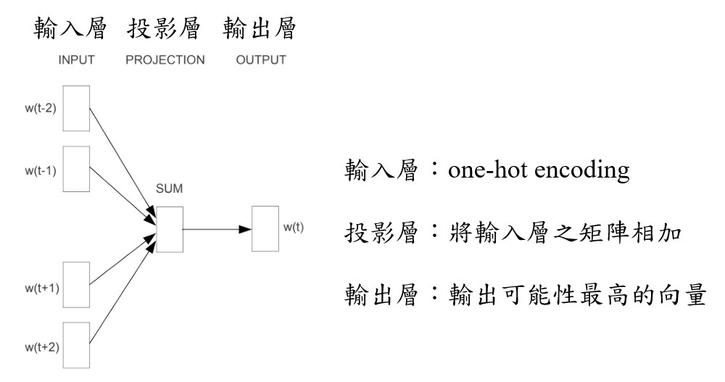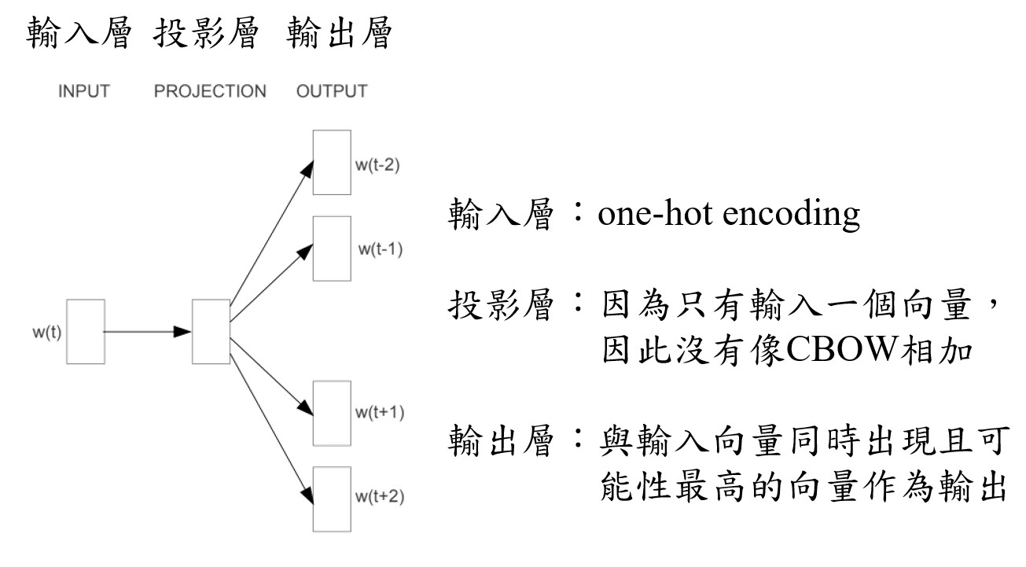

圖 2-4、CBOW 模型架構圖(Mikolov et al., 2013)

圖 2-5、Skip-gram 模型架構圖(Mikolov et al., 2013)

由於Word2Vec 屬於向量空間模型，語義越相近的詞會在向量空間中有越小的夾角， 因此語義相似度可從餘弦相似度計算出來，李晓、解辉、李立杰等人(2017)提到向量空間模型的語義相似度算法為方程式(2.3)。

Sim(𝑒 , 𝑓 ) = cos 𝜃 = 𝑒𝑖 ∙𝑓��

(2.3)

𝑖 𝑗

‖𝑒𝑖 ‖∙‖𝑓𝑗 ‖

其中𝑒𝑖是指文本 e 中的第 i 個詞，𝑓𝑗則是指文本 f 中的第 j 個詞，𝑒𝑖與𝑓𝑗兩個詞的相似度可以透過計算兩者餘弦夾角來取得，當角度越趨近於 0 時，餘弦值也會越接近 1。

## 第五節 依存句法分析

依存句法分析是指僅根據句子中的單詞和單詞之間一組單向的二元語法關係來描 述句子的句法結構，依存句法的優點在於能夠處理詞法形態豐富且語序相對自由的語言， 即使主詞、動詞或受詞的順序不同也可以正確地找到這些詞之間的關係。

句子中的詞都會被帶有標籤的箭頭從head 指向 dependent，他們彼此代表著直接與間接的依存關係，而沒被任何箭頭指向的則為 root node，屬於依存關係結構的頭部。李彥璇(2019)提到依存關係通常會將句子分為兩類：子句關係(Clausal Relations)以及修飾關係(Modifier Relations)：子句關係與謂語有關，代表著句子中的語意角色且通常是動詞，修飾關係則是分類出修飾詞是以何種方式修飾該詞所連接的 heads。以圖 2-6 與表 2-4 為例，子句關係由 root 的“prefer”出發找出nsubj 對應的主詞關係“I”，而受詞 dobj 對應到“flight”；修飾關係由“flight”出發找到的“morning”與“Denver”都是 nmod，屬於名詞修飾關係。

表 2-4、依存關係與定義(其中的 8 種)

|  |  |
| --- | --- |
| **Clausal Relations** | **Description** |
| nsubj | Nominal subject |
| dobj | Direct object |
| iobj | Indirect object |
| ccomp | Clausal complement |
| **Nominal Relations** | **Description** |
| nmod | Nominal modifier |
| amod | Adjectival modifier |
| nummod | Numeric modifier |
| case | Prepositions, postpositions and other case markers |

資料來源：https://universaldependencies.org/docsv1/u/dep/index.html

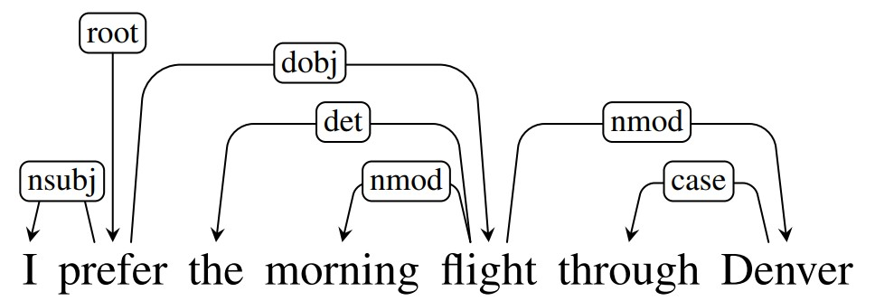

圖 2-6、依存關係分析範例(Jurafsky & Martin, 2019)

# 第三章 研究方法

根據第二章提到的 TRIZ 相關研究，為了能達到分析專利文件中的演化趨勢以及透過產品設計需求來探討演化趨勢模式，本章節將透過圖 3-1 的流程圖依序建立出演化趨勢模式分析方法，本章之第一節透過參考演化趨勢文獻建立出 37 演化趨勢SAO 結構詞庫。第二節將從已經整理出設計需求的文獻中選定欲進行演化趨勢模式分析的主題及參考該文獻之產品設計需求。第三節將訪問 WEBPAT 網站下載與主題產品相關的專利進行彙整。第四節透過 spaCy 進行專利文本的 SAO 語法結構之特徵擷取。第五節須要把第二節蒐集到的專利資料透過 Word2Vec 進行訓練以及生成詞向量。第六節須利用第五節生成之詞向量進行語義相似度計算並進行第七節以及第八節之演化趨勢以及設計需求分類，最後在第九節將前面第七節和第八節所得到的演化趨勢及設計需求分類結果進行分析與配對完成演化趨勢模式分析。



1. 依存關係分析
2. SAO結構特徵擷取

結果探

討

1. 演化趨勢與專利文本之SAO

結構詞組的語義相似度計算

1. 設計需求與專利文本之SAO

結構詞組的語義相似度計算

分類引

擎

專利文本特徵截取

WEBPAT專利

資料庫

資料前處

理

有列出詳細產品設計需求的

相關文獻

37演化趨勢英文關鍵字詞集

Word2Vec詞向量

訓練

專利文件蒐集與彙

整

產品設計需求演化

趨勢模式分析

專利文本之設計需

求分類

專利文本之演化趨

勢分類

語義相似度計算

產品設計需求建立

演化趨勢SAO結構

詞庫建立

圖 3-1、研究方法流程架構圖

## 第一節 演化趨勢 SAO 結構詞庫建立

本小節透過參考與引用蔡元豪(2012)建立的演化趨勢關鍵字詞集，以及利用依存關係提取 SAO 結構(Choi et al., 2012)，須將原詞集修改成能與依存關係詞組進行語義相似度計算用的 SAO 結構關鍵字詞集，因此整理了用於判斷演化階段的演化階段簡易對照表，演化趨勢SAO 結構關鍵字詞集彙整方式如下：

* + - 1. 將演化趨勢關鍵字詞集內超過兩個單詞、少於兩個單詞及其中某些單詞內包含連接詞如“one-way”這些條件組成的詞組都從詞集中刪除，原因可參考圖 3-2， 例如從圖 2-6 中的依存關係“nmod”可提取出“morning”和“flight”是由兩個單詞所組成，而圖 3-2 中第一組演化趨勢詞組中的“passive”需和“morning”進行語義相似度計算，“material”則是和“flight”進行語義相似度計算，最後進行加總以獲得詞組相似度，因此演化趨勢關鍵字詞集必須以兩個詞所組成的詞組來建立。
      2. 因為不使用權重計算方式來選取演化趨勢，故將權重欄位刪除。
      3. 整理原先詞典中一些有遺漏或錯誤的部分並修正或補充。
      4. 修改參數為數字標籤，例如 1-1 修改成 1，整數變數形式方便在後續計算及判斷演化趨勢出現次數時使用。

彙整方式 2 和 4 的範例如圖 3-3，將演化趨勢英文關鍵字詞集逐筆彙整好後命名為演化趨勢 SAO 結構關鍵字詞集，可至附錄B 查閱。

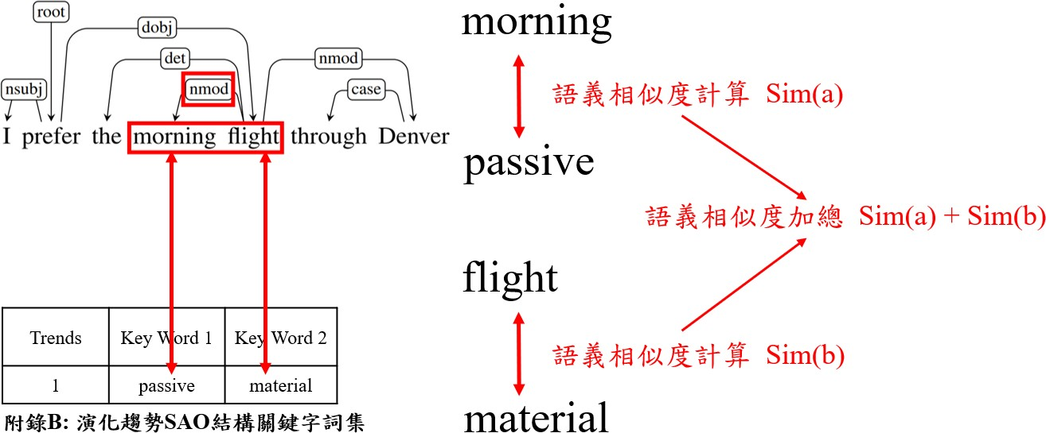

圖 3-2、演化趨勢 SAO 結構詞庫彙整方式 1 之圖解

圖 3-3、演化趨勢SAO 結構詞庫彙整範例

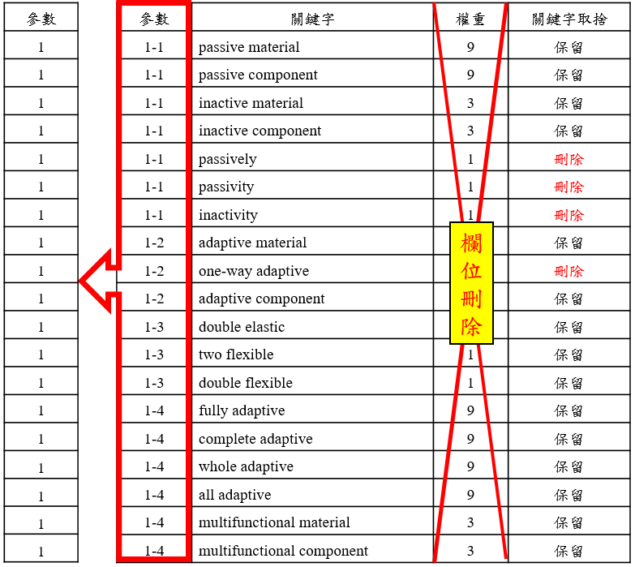

為了實驗需求需要將字詞集整理成 csv 檔案方便讀取，整理好之檔案如圖 3-4，並讀入至 pandas 中(圖 3-5)，確認有正確讀取以用於後續實驗。

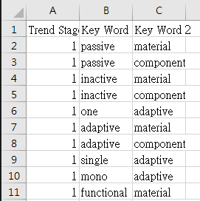

圖 3-4、演化趨勢 SAO 結構詞庫彙整為csv 檔(前 1~10 筆)

圖 3-5、演化趨勢SAO 結構詞庫讀取結果

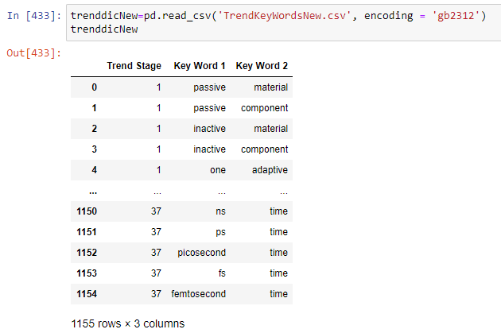

## 第二節 產品設計需求建立

產品設計需求是一種藉由問卷或訪談所統整出來的需求，讓受訪者表達出自己對於產品或服務的期望及需求，透過這些蒐集來的設計需求讓設計出滿足需求的新產品能夠符合消費者的期待以及提高市場競爭力。

本研究之產品設計需求希望透過已經經過調查的文獻來取得，其中被選定的產品必須有大量英文專利可以下載並且有詳細的設計需求可以用來建立 SAO 結構之設計需求詞集，經過多筆設計需求相關文獻探討，王志超(2013)的研究主題最適合本實驗使用， 因此透過參考與引用該文獻中第四章品質機能展開的實驗過程得到步矩橢圓機(Elliptical machine)的產品設計需求整理於表 3-1。

表 3-1、產品設計需求列表(王志超，2013)

|  |  |
| --- | --- |
| 系統 | 設計需求 |
| 儀表介面 | 使用方式簡單 |
| 按鍵尺寸要大 |
| 心肺功能的訓練模式要多一點 |
| 顯示面板上的字體要大要亮 |
| 操作時最好有引導功能 |
| 不同高度的使用者都可以看到清楚的資訊顯示 |
| 機台結構 | 上下機台要容易 |
| 輔助扶手不要有壓迫感 |
| 踏板要舒服不打滑 |
| 機台體積不要太大，搬運及擺設較容易 |
| 給消費者組裝的組件根步驟不要太多 |
| 步距要可以自由調整 |
| 維修方式要簡單 |
| 運轉的聲音要小一點 |
| 電源架構 | 不要插電 |
| 提供手機使用的充電功能 |
| 提供蓄電功能 |
| 其他 | 可以選擇的顏色搭配多一點 |
| 造型要流線一點的設計 |
| 價格要低 |

由於專利是採用英文專利來進行實驗，因此需要將產品設計需求翻譯成英文，並且依照

SAO 結構來重新修訂如表 3-2：

表 3-2、SAO 結構的產品設計需求列表

|  |  |  |  |
| --- | --- | --- | --- |
| 中文設計需求 | 自訂義  label | SAO 結構的英文設  計需求 1 | SAO 結構的英文設  計需求 2 |
| 使用方式簡單 | 1 | simple | use |
| 1 | convenient | use |
| 1 | easy | use |
| 1 | simple | operate |
| 1 | convenient | operate |
| 1 | easy | operate |
| 按鍵尺寸要大 | 2 | big | button |
| 2 | large | button |
| 心肺功能的訓練模式要多一點 | 3 | more | modes |
| 3 | multi | modes |
| 3 | many | modes |
| 顯示面板上的字體要大要亮 | 4 | large | font |
| 4 | big | font |
| 4 | large | word |
| 4 | big | word |
| 4 | bright | font |
| 4 | light | font |
| 4 | bright | word |
| 4 | light | word |
| 操作時最好有引導功能 | 5 | guide | function |
| 5 | lead | function |
| 不同高度的使用者都可以看  到清楚的資訊顯示 | 6 | clear | display |
| 6 | angle | display |
| 上下機台要容易 | 7 | simple | up |
| 7 | convenient | up |
| 7 | easy | up |
| 7 | simple | down |
| 7 | convenient | down |
| 7 | easy | down |
| 輔助扶手不要有壓迫感 | 8 | no | oppression |
| 踏板要舒服不打滑 | 9 | comfortable | pedal |
| 9 | not | slip |
| 機台體積不要太大，搬運及擺設較容易 | 10 | simple | handle |
| 10 | convenient | handle |
| 10 | easy | handle |
| 10 | small | volume |

|  |  |  |  |
| --- | --- | --- | --- |
|  | 10 | little | volume |
| 10 | tiny | volume |
| 10 | small | size |
| 10 | little | size |
| 10 | tiny | size |
| 給消費者組裝的組件跟步驟不要太多 | 11 | simple | assembly |
| 11 | convenient | assembly |
| 11 | easy | assembly |
| 步距要可以自由調整 | 12 | adjust | pace |
| 12 | adjust | step |
| 維修方式要簡單 | 13 | simple | maintain |
| 13 | convenient | maintain |
| 13 | easy | maintain |
| 13 | simple | repair |
| 13 | convenient | repair |
| 13 | easy | repair |
| 13 | simple | fix |
| 13 | convenient | fix |
| 13 | easy | fix |
| 運轉的聲音要小一點 | 14 | not | noisy |
| 14 | be | quiet |
| 不要插電 | 15 | no | power |
| 15 | no | plug |
| 提供手機使用的充電功能 | 16 | phone | charge |
| 16 | phone | charger |
| 16 | cellphone | charge |
| 16 | cellphone | charger |
| 提供蓄電功能 | 17 | store | electricity |
| 17 | power | storage |
| 可以選擇的顏色搭配多一點 | 18 | choice | color |
| 18 | select | color |
| 造型要流線一點的設計 | 19 | aerodynamic | design |
| 19 | streamline | design |
| 19 | aerodynamic | shape |
| 19 | streamline | shape |
| 價格要低 | 20 | low | cost |
| 20 | low | price |



在修訂好英文的 SAO 結構設計需求之後需要建立成.csv 檔案，並標籤上顧客需求的數字標籤後範例如圖 3-6。

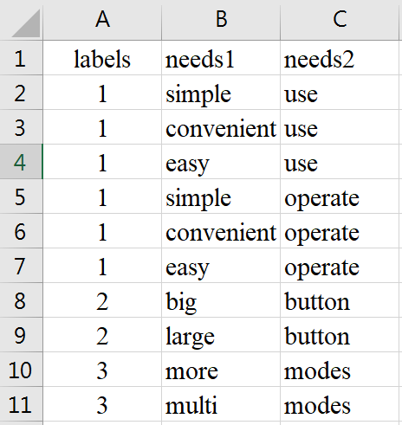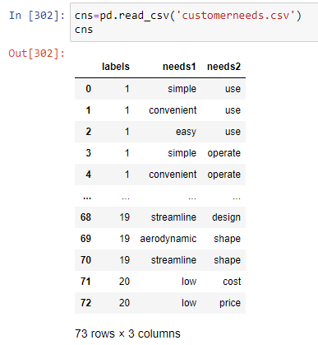

圖 3-6、設計需求彙整為csv 檔之範例(前 10 筆)

彙整好 csv 檔之後，透過pandas 匯入後印出，如圖 3-7，確認資料有正常匯入及無誤， 以防影響後續的相似度計算。

圖 3-7、設計需求SAO 結構詞組讀取結果

## 第三節 專利文件蒐集

專利文獻蒐集必須從專利資料庫下載，經過多種專利資料庫使用後評估，認為

WEBPAT 全球專利資訊網(https://webpat.tw/webpat/)較適合作為本實驗之專利文本來源。

WEBPAT 全球專利資訊網具備一站檢索多國專利的便利性，收錄了包含台灣(TIPO)、美國(USPTO)、歐盟(EPO)、中國(SIPO)、日本(JPO)、韓國(KIPRIS)、DOCDB(100 餘國)的

專利書目及全文影像，共超過 1.8 億筆資料，其專利檢索特色如表 3-3：

表 3-3、WEBPAT 網站特色

|  |  |
| --- | --- |
| 特色 | 功能 |
| 專利檢索方式 | 布林檢索 |
| 號碼檢索 |
| AI 檢索 |
| 同義詞庫檢索 |
| 分類號檢索 |
| 保留檢索紀錄 |
| 檢索結果UI | 多種排序方式 |
| 圖文/圖示/列表顯示模式 |
| 再搜索功能 |
| 保留匯出紀錄 |
| 專利檢視之內容 | 詳細專利全文 |
| 法律資訊 |
| 引證資料 |
| 專利家族 |

資料來源：https://[www.innovue.ltd/Pages/products-webpat.html](http://www.innovue.ltd/Pages/products-webpat.html)

從 WEBPAT 網站下載關於“Elliptical”的英文專利文本，進階搜索條件關鍵詞如圖 3-8，並彙整成 EXCEL 的.csv 格式，分別依照圖 3-9 紅框處之專利名稱、專利公告號、專利內容進行抓取，以便後續實驗使用，部分清晰圖可查看圖 3-10 與圖 3-11。

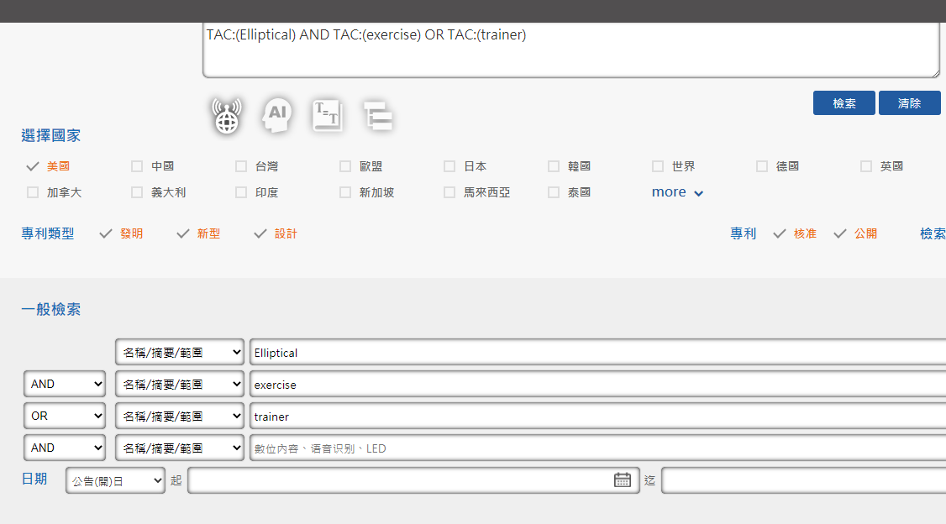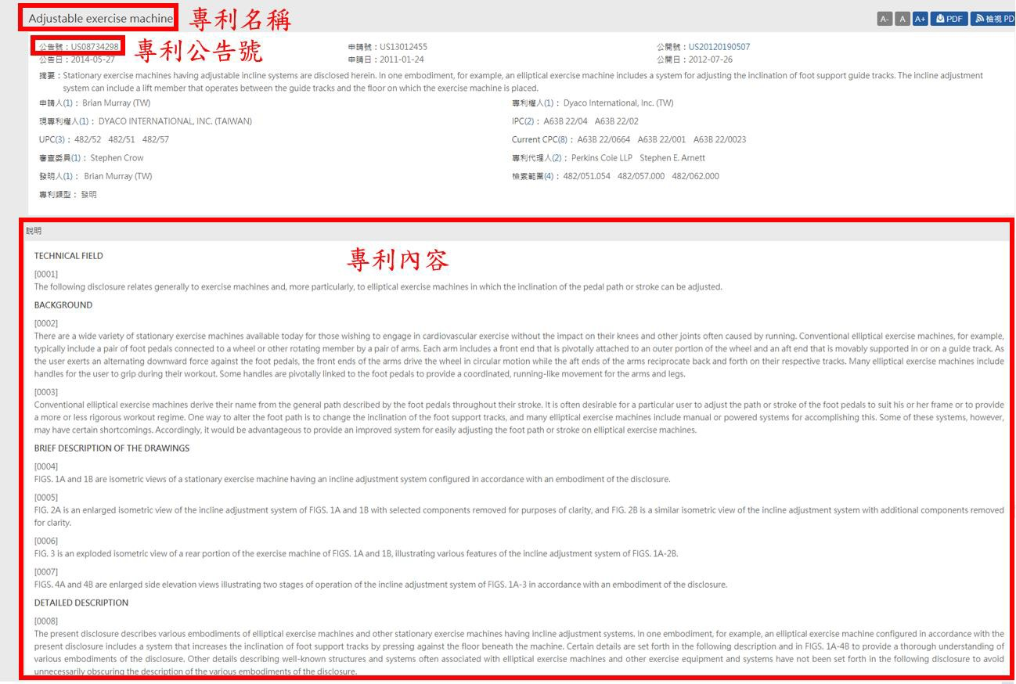

圖 3-8、WEBPAT 網站及搜索條件設定

圖 3-9、WEBPAT 網站抓取之專利文本範圍

圖 3-10、WEBPAT 網站抓取之專利名稱及公告號

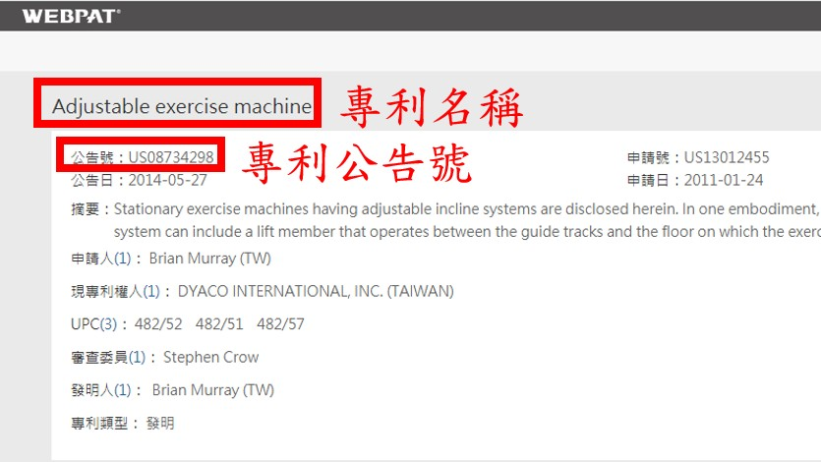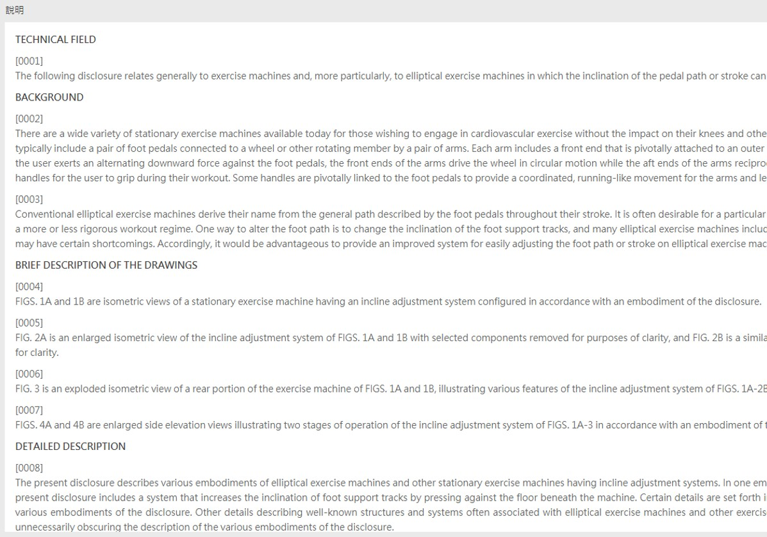

圖 3-11、WEBPAT 網站抓取之部分專利內文敘述

## 第四節 專利文本的特徵擷取

在此結將會利用自然語言處理來進行專利文件的斷詞、詞性標註、詞形還原、依存句法分析以及SAO 結構特徵擷取，此過程將會使用python 以及自然語言處理套件spaCy 及 pandas 套件來完成。

1. 電腦主機硬體及系統配置：

作業系統：Windows 10 工作站專業版 64-bit

處理器：Intel(R) Xeon(R) E-2244G CPU @ 3.80GHz (8 CPUs), ~3.8GHz

記憶體：16384MB

顯示卡：NVIDIA GeForce RTX 2070

顯示卡記憶體：8031 MB

1. 實驗環境：

Python 版本：3.7.6

使用套件：spaCy、pandas、numpy、pyplot、sklearn 程式編輯器：Jupyter Notebook

### 自然語言處理套件 spaCy

spaCy (https://spacy.io/)是一個由 Explosion AI 團隊開發的工業級自然語言處理開源程式庫，支持Python 以及 Cython 語言，重要的功能包括：斷詞(Tokenization)、詞性標註(Part-of-speech Tagging)、詞形還原(Lemmatization)、依存分析(Dependency Parsing)、文本分類(Text Classification)、命名實體識別(Named Entity Recognition)、相似度計算

(Similatity)以及深度學習整合等如表 3-4，在可以處理的語言方面支援了多種語言包含了：英語、中文、日語、德語、希臘語、西班牙語、葡萄牙語、法語、義大利語、荷蘭語、立陶宛語、挪威語等超過 50 種語言。

表 3-4、spaCy 自然語言處理基本功能表

|  |  |
| --- | --- |
| Function | Description |
| Tokenization | Segmenting text into words, punctuations marks etc. |
| Part-of-speech(POS) Tagging | Assigning word types to tokens, like verb or noun. |
| Dependency Parsing | Assigning syntactic dependency labels, describing the relations between individual tokens, like subject or object. |
| Lemmatization | Assigning the base forms of words. For example, the lemma of “was” is “be”, and the lemma of “rats” is “rat”. |
| Sentence Boundary Detection (SBD) | Finding and segmenting individual sentences. |
| Named Entity Recognition (NER) | Labelling named “real-world” objects, like persons, companies or locations. |
| Entity Linking (EL) | Disambiguating textual entities to unique identifiers in a Knowledge Base. |
| Similatity | Comparing words, text spans and documents and how similar they are to each other. |
| Text Classification | Assigning categories or labels to a whole document, or parts of a document. |
| Rule-based Matching | Finding sequences of tokens based on their texts and linguistic annotations, similar to regular expressions. |
| Training | Updating and improving a statistical model’s predictions. |
| Serialization | Saving objects to files or byte strings. |

資料來源：https://spacy.io/usage/spacy-101

### 依存關係分析

要進行依存關係分析之前必須先標註詞性，由於在處理的時候是 spaCy 已經先幫我們處理好整篇文章需要的斷詞、斷句以及詞性標註的步驟了，因此我們不用另外處理上述步驟，可以分別透過印出“token.pos_”和“token.lemma_”來查看 spaCy 的詞性標註以及詞形還原的處理結果如圖 3-12。

圖 3-12、專利公告號 US10549153 進行詞形還原及POS Tagging 後之結果

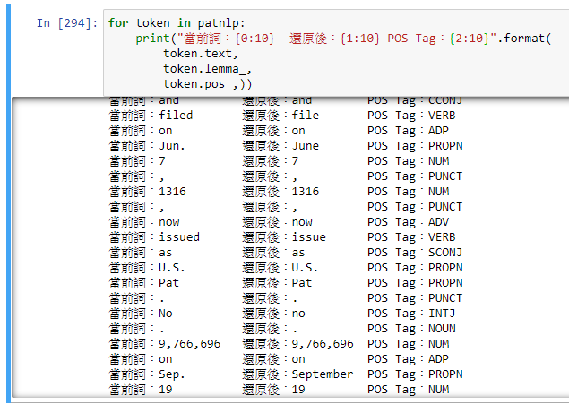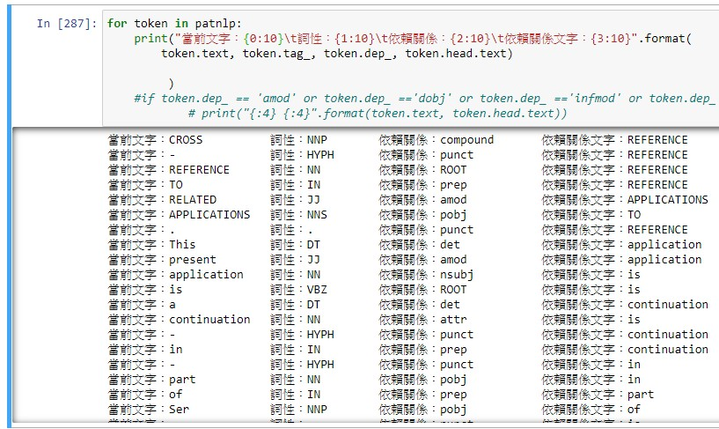

目前 spaCy 所使用的依存關係分析是採用 Clear NLP 所發表的分析模型，在 spaCy

中可以透過“token.dep_”來查看這兩個詞之間的依存關係如圖 3-13。

圖 3-13、專利公告號 US10549153 依存分析後之各詞組依存關係

透過依存分析可以得到各詞組之間的依存關係，Clear NLP(Choi, 2015)模型中的所有依存關係以及詳細的敘述皆整理於表 3-5。

表 3-5、Clear NLP 句法依存分析之標籤及敘述(Choi, 2015)

|  |  |  |  |
| --- | --- | --- | --- |
| Labels | Description | Labels | Description |
| acl | clausal modifier of noun  (adjectival clause) | mark | marker |
| acomp | adjectival complement | meta | marker |
| advcl | adverbial clause modifier | neg | negation modifier |
| advmod | adverbial modifier | nn | noun compound modifier |
| agent | agent | nounmod | modifier of nominal |
| amod | adjectival modifier | npmod | noun phrase as adverbial modifier |
| appos | appositional modifier | nsubj | nominal subject |
| attr | attribute | nsubjpass | nominal subject (passive) |
| aux | auxiliary | nummod | numeric modifier |
| auxpass | auxiliary (passive) | oprd | object predicate |
| case | case marking | obj | object |
| cc | coordinating conjunction | obl | oblique nominal |
| ccomp | clausal complement | parataxis | parataxis |
| compound | compound | pcomp | complement of preposition |
| conj | conjunct | pobj | object of preposition |
| cop | copula | poss | possession modifier |
| csubj | clausal subject | preconj | pre-correlative conjunction |
| csubjpass | clausal subject (passive) | prep | prepositional modifier |
| dative | dative | prt | particle |
| dep | unclassified dependent | punct | punctuation |
| det | determiner | quantmod | modifier of quantifier |
| dobj | direct object | relcl | relative clause modifier |
| expl | expletive | root | root |
| intj | interjection | xcomp | open clausal complement |

### SAO 依存關係結構的特徵提取

在 SAO 依存關係結構的特徵提取將會依照依存分析標籤“amod”、“dobj”對專利文本進行依存分析，專利公告號US10549153 經過依存分析後的分析結果如圖 3-14，當前文字指的是當前被判斷的詞，依賴關係文字是指向當前文字的 head，兩詞間有屬於 amod 或 dobj 的依存關係，由當前文字和依賴關係文字這兩個詞組成的詞組後續將用於語義相似度計算。

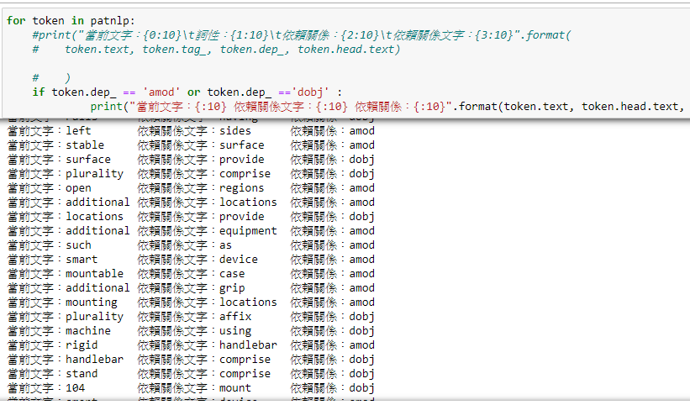

圖 3-14、專利公告號US10549153 進行 SAO 結構依存分析後之結果

## 第五節 Word2Vec 詞向量訓練

本實驗是在向量空間模型中來進行語義相似度的計算，結合第二章提到的文獻，決定使用 Word2vec 針對專利進行詞向量訓練，Word2Vec 可以透過詞向量的可視化來輸出詞向量在二維平面上的圖片，以專利公告號US10549153 為例，先透過 spaCy 進行處理後(圖 3-15)再進行詞向量生成，生成的詞向量透過 TSNE 進行降維後可視化的結果如圖 3-16，若字詞與字詞的座標距離越近代表有越高的相似度，例如 measures、measure、

measuring、measured 在二維座標中有非常近的距離，代表可能有越高的語義相似度。

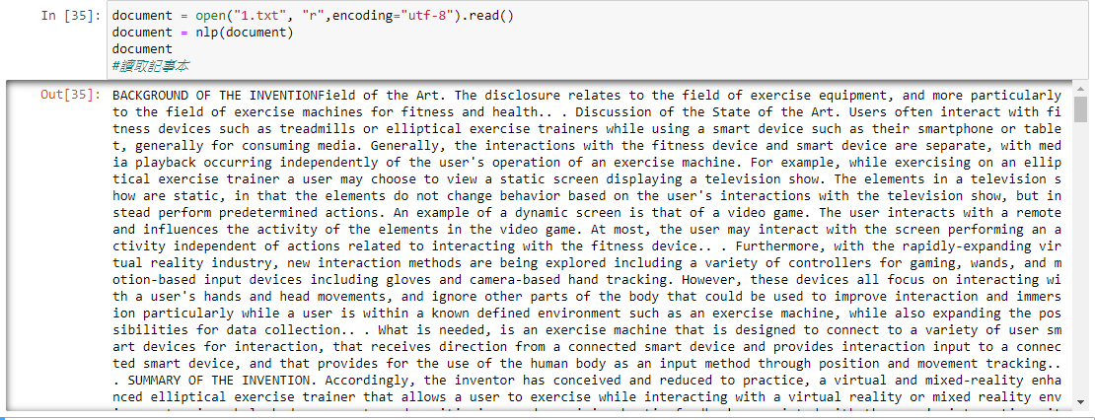

圖 3-15、專利公告號US10549153 之文本內容

必須注意圖 3-16 可視化結果是只以專利公告號US10549153 這篇專利內容之詞向量為例子，並非整個資料集之詞向量，因為將資料集訓練後之可視化結果印出的話會難以閱覽，畢竟幾百筆專利所涵蓋的單詞太多了。

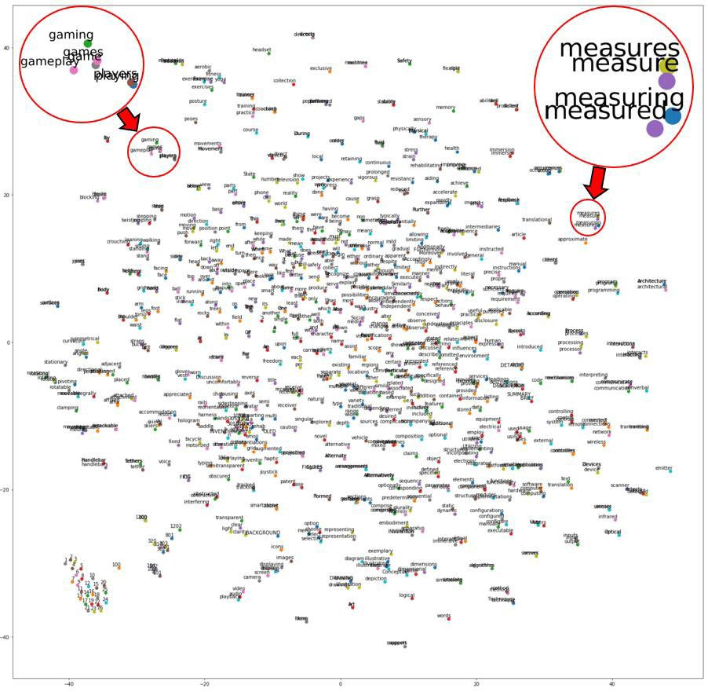

圖 3-16、專利公告號US10549153 進行詞向量可視化之結果

## 第六節 語義相似度計算

由於本實驗是在向量空間模型中來進行語義相似度的計算，結合第二章提到的文獻， 使用 Word2vec 來進行語義相似度的計算，專利文本與演化趨勢 SAO 結構關鍵字之餘弦計算方程式如方程式(3.1)，因為相似度計算是通過測量兩個向量的夾角的餘弦值來度量 它們之間的相似性，因此相似度的值域為[−1 , 1]。

𝑆𝑖𝑚(𝑃𝑎𝑡 , 𝐷𝑖𝑐 ) = 𝑐𝑜𝑠 𝜃 = 𝑃𝑎𝑡𝑖 ∙ 𝐷𝑖𝑐𝑗

(3.1)

𝑖 𝑗

‖𝑃𝑎𝑡 ‖ ∙ ‖𝐷𝑖𝑐 ‖

𝑖 𝑗

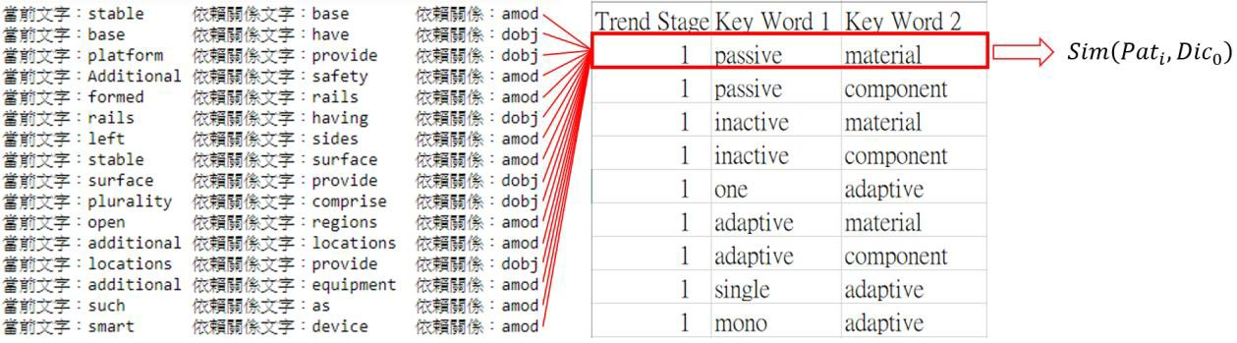

由於每對詞組是由兩個單詞所組成，因此語義相似度的計算是由演化趨勢 SAO 結

構詞組的第一個詞與當前文字計算的相似度加上演化趨勢 SAO 結構詞組的第二個詞與依賴關係文字計算的相似度並加總，範例如圖 3-17。

圖 3-17、專利文本與演化趨勢SAO 結構詞組語義相似度計算示意圖

在本實驗中的𝑃𝑎𝑡𝑖為從專利資料中提取出的SAO 語法結構的第i 組單詞、𝐷𝑖𝑐𝑗為演化趨勢 SAO 結構詞庫中的第 j 組詞組，其中每組𝑃𝑎𝑡𝑖與𝐷𝑖𝑐𝑗單詞中都是兩個單詞組成， 因此本實驗的專利文本與演化趨勢關鍵字之間的語義相似度計算方程式可以歸納如方程式(3.2)，且因為方程式(3.2)是兩組詞向量的相似度總和，因此𝑆𝑖𝑚(𝑃𝑎𝑡𝑖 , 𝐷𝑖𝑐𝑗)的相似度值域為[−2 , 2]。

𝑆𝑖𝑚 (𝑃𝑎𝑡 , 𝐷𝑖𝑐 ) = ( 𝑃𝑎𝑡ℎ𝑒𝑎𝑑(𝑖) ∙ 𝐷𝑖𝑐1(𝑗)

𝑃𝑎𝑡𝑑𝑒𝑝(𝑖 ) ∙ 𝐷𝑖𝑐2(𝑗)

+

) (3.2)

𝑖 𝑗

‖𝑃𝑎𝑡ℎ𝑒𝑎𝑑(𝑖)

‖ ∙ ‖𝐷𝑖𝑐𝑗1‖

‖𝑃𝑎𝑡𝑑𝑒𝑝(𝑖)

‖ ∙ ‖𝐷𝑖𝑐𝑗2‖

依照方程式(3.1)的相似度計算方法，計算專利文本與 SAO 結構設計需求詞組相似度的方程式可以歸納如方程式(3.3)，同樣地因為餘弦函數的特性，相似度的值域為[−1 , 1]。

𝑆𝑖𝑚(𝑃𝑎𝑡 , 𝐷𝑅 ) = 𝑐𝑜𝑠 𝜃 = 𝑃𝑎𝑡𝑖 ∙ 𝐷𝑅𝑗

(3.3)

𝑖 𝑗

‖𝑃𝑎𝑡 ‖ ∙ ‖𝐷𝑅 ‖

𝑖 𝑗

與演化趨勢的語義相似度計算相同，每對詞組是由兩個單詞所組成，因此語義相似度的計算是由設計需求 SAO 結構詞組的第一個詞與當前文字計算的相似度加上設計需

圖 3-18、專利文本與設計需求語義相似度計算示意圖

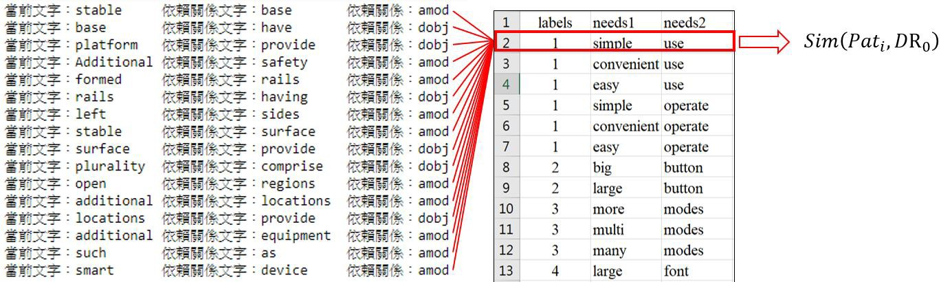

求 SAO 結構詞組的第二個詞與依賴關係文字計算的相似度並加總，範例如圖 3-18。

參照方程式(3.1)與方程式(3.2)的關係，可以將方程式(3.3)展開成方程式(3.4)，其中𝑃𝑎𝑡𝑖為從專利文本中提取出的 SAO 語法結構的第 i 組單詞、𝐷𝑅𝑗為設計需求 SAO 結構列表中的第 j 組設計需求，因為𝑆𝑖𝑚(𝑃𝑎𝑡𝑖, 𝐷𝑅𝑗)也是兩組相似度的加總，所以值域為[−2 , 2]。

𝑃𝑎𝑡ℎ𝑒𝑎𝑑(𝑖) ∙ 𝐷𝑅1(𝑗)

𝑆𝑖𝑚(𝑃𝑎𝑡 , 𝐷𝑅 ) = (

𝑃𝑎𝑡𝑑𝑒𝑝(𝑖) ∙ 𝐷𝑅2(𝑗)

+

) (3.4)

𝑖 𝑗

‖𝑃𝑎𝑡ℎ𝑒𝑎𝑑(𝑖)

‖ ∙ ‖𝐷𝑅1(𝑗) ‖

‖𝑃𝑎𝑡𝑑𝑒𝑝(𝑖)

‖ ∙ ‖𝐷𝑅2(𝑗) ‖

## 第七節 演化趨勢分類方法

經由語義相似度的計算，可以得到範圍界於[−2 , 2]的相似度值，接下來就是要利用相似度的值來判斷當前詞組是否與當前計算的演化趨勢有相關，首先參考 Yoon(2011) 所設定的門檻值 0.9，利用相似度≥ 0.9的所有結果來分析，相似度區間界於[0.9 , 1.6)的特徵詞與演化詞經人工判斷及字典查詢後，發現在語義上並不相似，以專利公告號

US10549153 為例，部分相似度區[1.3 , 2.0]間之語義相似度計算結果如圖 3-19。

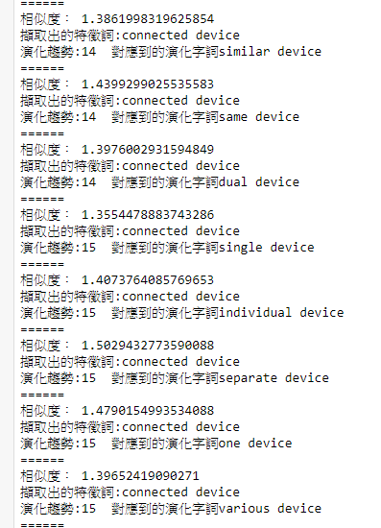

圖 3-19、專利之演化趨勢相似度計算結果(1)

以圖 3-19 的執行結果為例，第一組執行結果中的“擷取出的特徵詞:connect device” 是從專利文本中經過依存分析後提取出的其中一組 SAO 節構詞組，而“演化趨勢:14 對應到的演化字詞:similar device”是指附錄B：演化趨勢SAO 結構關鍵字詞集中屬於Trends

14(第 14 條演化趨勢)的其中一組詞組“similar device”，經過 connect 與 similar 、device 與 device 這兩組詞的語義相似度計算並做加總，得到趨近於 1.3862 的語義相似度，詳細圖解如圖 3-20。

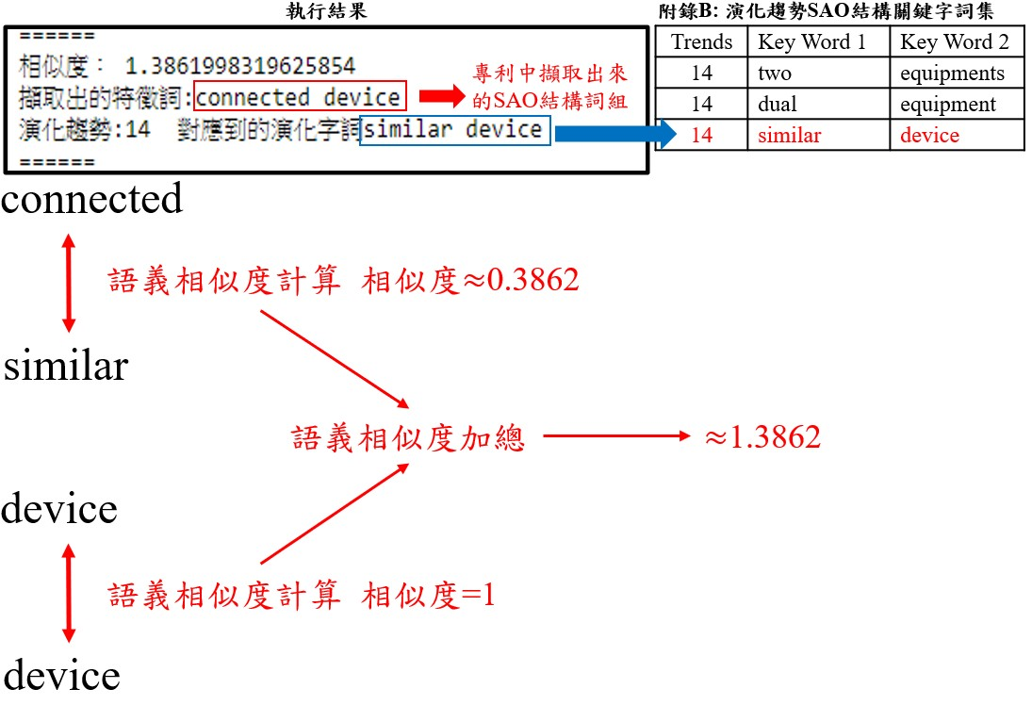

圖 3-20、專利之演化趨勢相似度計算結果說明(1)

如圖3-21，從專利中擷取出來的其中一組詞組connected device 依序對演化趨勢SAO

結構關鍵字詞集之詞組進行語義相似度計算，在執行結果中有被印出的關鍵詞有 similar

device、same device 和 dual device，它們的相似度都符合[1.3 , 2.0]區間，反之沒被印出的則代表 connected device 與其他詞組(two equipments、dual equipment、homogenous device、two devices)的語義相似度都不在[1.3 , 2.0]區間內。

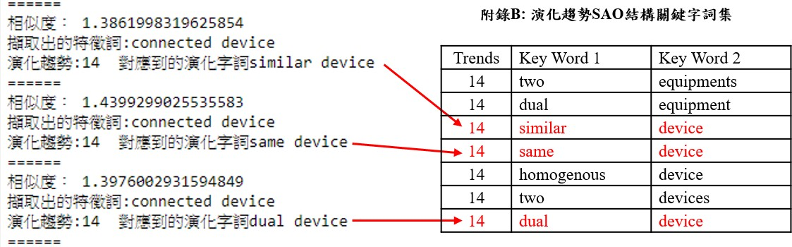

圖 3-21、專利之演化趨勢相似度計算結果說明(2)

總結開頭提到的語義相似度分析結果，相似度界於[1.6 , 2.0]的執行結果(圖 3-22)經判斷較適合本實驗使用，因此本研究設定的語義相似度分類條件為：當相似度≥ 1.6時就判定該詞組與該演化趨勢有相關，< 1.6則判斷為無關，只要判斷有關就會儲存該演化趨勢的標籤值與當前的詞組並計算判斷與該演化趨勢有相關的總次數，判斷無關則進行下一組詞的計算，流程圖如圖 3-23。

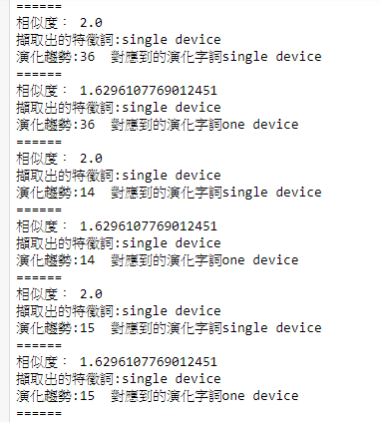

圖 3-22、專利之演化趨勢相似度計算結果(2)

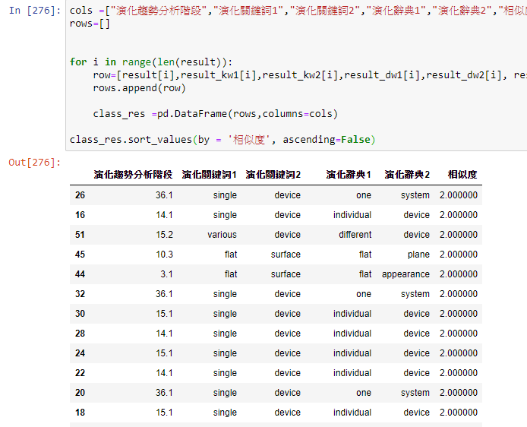

英文專利文本

文本預處理

37演化趨勢英文關鍵字詞集

演化趨勢SAO結構詞組與專利文本SAO結構詞組語義相似度計算

判斷語義相似度

1.6

演化趨勢分類

圖 3-23、產品設計與專利之演化趨勢模式分析流程

透過對專利公告號 US10549153 進行語義相似度的計算以查看分類結果如圖 3-24， 其中演化關鍵詞是從專利文本透過依存分析提取出的關鍵詞特徵，而圖中的演化詞典 1 與演化詞典 2 是演化趨勢SAO 結構詞庫中同一對詞組的前後詞。

圖 3-24、專利公告號US10549153 語義相似度計算≥ 1.6之部分結果

在計算完語義相似度之後，需要統計該演化出現的總次數，在這裡透過 padnas 印出的範例如圖 3-25。

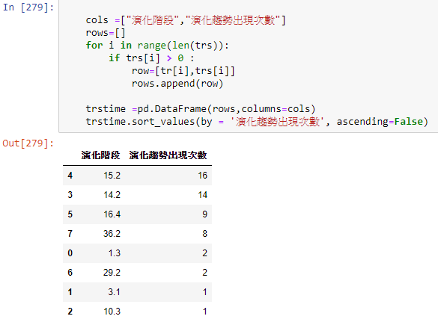

圖 3-25、專利公告號US10549153 之演化趨勢出現次數結果

## 第八節 設計需求分類方法

同第七節的演化趨勢分類方法，首先分析專利文本的 SAO 結構詞組及設計需求

SAO 結構詞組所有語義相似度≥ 0.9的執行結果，0.9 是參考 Yoon(2011)所設定的門檻值，先設定 0.9 進行分類後再自行判斷要修改成多少的門檻值。透過圖 3-26 的執行結果探討語義相似度區間[1.3 , 1.6]的執行結果，經過人工判斷已經偏離設計需求的語義，設計需求分類說明如圖 3-27，從專利中提取出的其中一組 SAO 結構詞組 right handle 和

SAO 結構設計需求詞組 easy handle 之語義相似度計算方式為 right 與 easy、handle 與

handle 個別經過語義相似度計算後再進行加總，得到了趨近於 1.5384 的語義相似度。結合前面的討論結果，本研究設定的設計需求分類相似度門檻為：當門檻值≥ 1.6就

判定該專利文本中的詞組與該設計需求有相關，< 1.6則判斷為無關，只要判斷有關就會儲存該設計需求的標籤值與當前的詞組，判斷無關則進行下一組詞的語義相似度計算， 設計需求分類流程如圖 3-28。

圖 3-26、專利產品設計分類之部分相似度計算結果

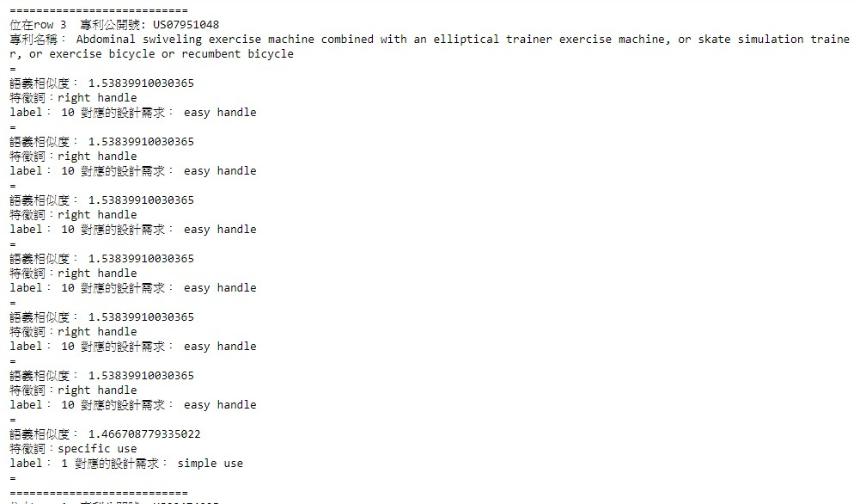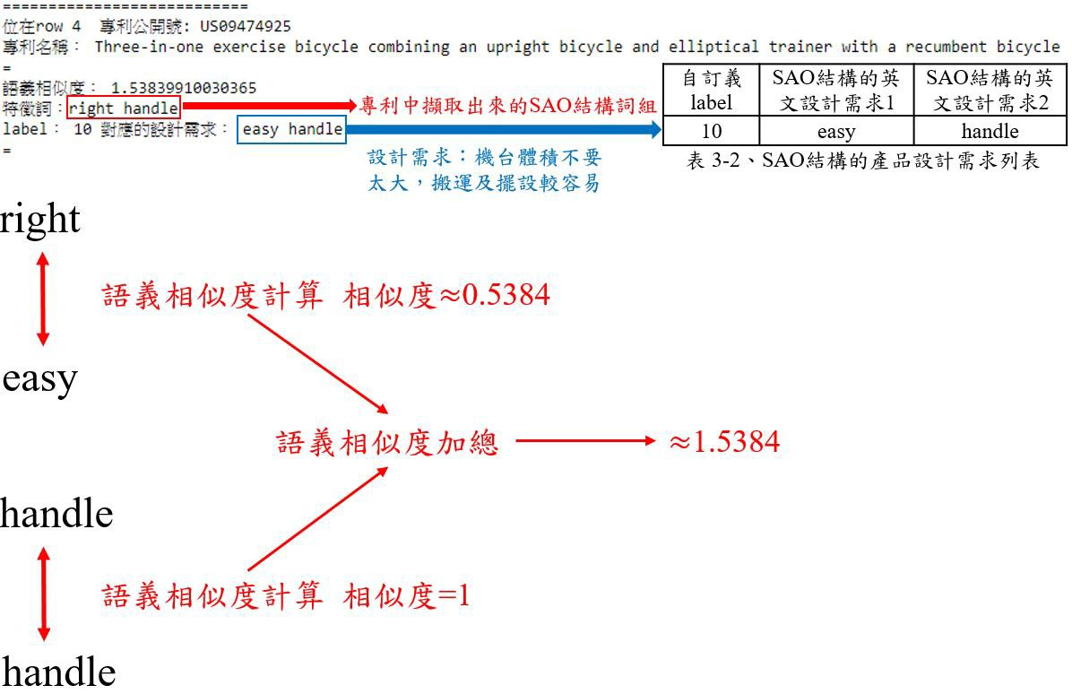

圖 3-27、專利產品設計分類之相似度計算結果說明



英文專利文本

文本預處理

SAO結構設計需求詞集

設計需求SAO結構詞組與專利文本SAO結構詞組語義相似度計算

判斷語義相似度

1.6

設計需求分類

圖 3-28、產品設計與專利之演化趨勢模式分析流程

專利公告號 US09707439、US09636540 與 US07993247 透過相似度計算後結果如圖 3-29，因為沒有任何匹配到的設計需求(相似度 < 1.6)，因此不會印出任何內容；專利公告號 US20160184626 語義相似度計算結果的結果如圖 3-30 所示，只要相似度≥ 1.6判斷有關就會印出該專利文本當前特徵詞組及所對應到的設計需求詞組。

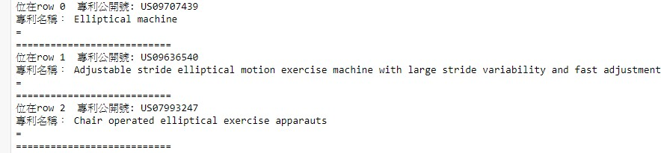

圖 3-29、設計需求分類相似度計算< 1.6之執行結果範例

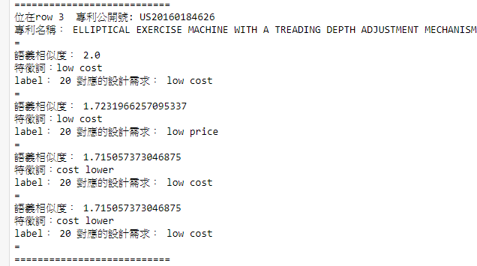

圖 3-30、設計需求分類相似度計算≥ 1.6之執行結果範例

## 第九節 演化趨勢模式分析

透過第七節語義相似度的計算專利中的SAO 結構詞組與設計需求SAO 結構詞組得到的語義相似度來判斷，若有語義相似度≥ 1.6的專利，將該篇專利進一步進行第六節之演化趨勢分類，透過專利中的 SAO 結構詞組與 SAO 結構的演化關鍵詞組的語義相似度計算，語義相似度≥ 1.6的演化趨勢SAO 詞組所對應的標籤即為此設計需求的演化趨勢模式，演化趨勢模式分析流程如圖 3-31。

英文專利文本演化趨勢分類結果



英文專利文本設計需求分類結果



設計需求分類結果與演化趨勢分類結果互相比對

產品設計與專利之演化趨勢模式分析

圖 3-31、產品設計與專利之演化趨勢模式分析流程

# 第四章 實驗結果

本章節首先會對蔡元豪(2012)曾經分類過演化趨勢的專利利用本實驗建立的分類器進行演化趨勢分類做驗證，因為演化趨勢分類目的在盡量不進行人為主觀判斷的前題來進行實驗，因此在第一節使用了過去文獻的分類結果來做比較，第二節將說明實驗的資料來源以及彙整方式並列出專利公告號清單，第三節把蒐集到的英文專利透過 SAO 結構進行設計需求的分類與彙整，第四節會探討英文專利的 SAO 結構進行演化趨勢分類， 第五節會統整第三節與第四節的結果進行設計需求與演化趨勢的模式分析。

## 第一節 演化趨勢分類效果驗證

在驗證資料收集的部份，訪問 WEBPAT 網站並透過專利編號下載該專利，總共下載 40 篇該文獻所分類的英文專利以及 160 篇氣動打釘機專利共 200 筆並彙整為.csv 檔。

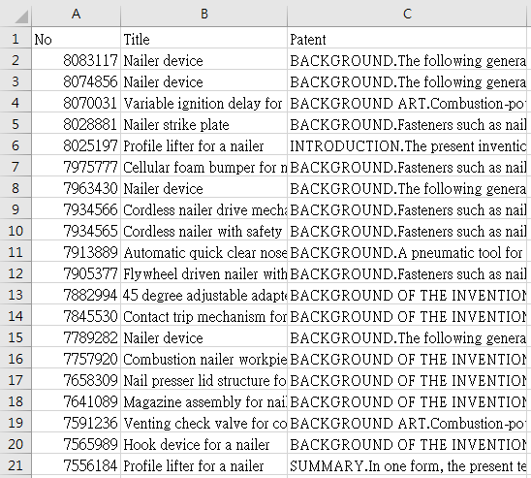

### 驗證用專利資料集彙整

在文本資料抓取的部份針對該文獻提供的氣動打釘機專利文件編號進行查詢，並擷取專利名稱及該文獻的分類結果，彙整好的 csv 檔如圖 4-1，完整的專利編號、專利名稱及文獻分類的演化趨勢於表 4-1，表中的演化趨勢分類結果請參照附錄 A 的演化階段。

圖 4-1、驗證用專利文本彙整(前 20 筆)

表 4-1、驗證用 40 筆專利資料清單

|  |  |  |
| --- | --- | --- |
| No | Title | 演化趨勢分類結果 |
| 8083117 | Nailer device | 7.2 , 33.2 |
| 8074856 | Nailer device | 28.2 , 29.3 |
| 8070031 | Variable ignition delay for combustion nailer | 25.1 , 33.2 |
| 8028881 | Nailer strike plate | 6.1 |
| 8025197 | Profile lifter for a nailer | 27.2 , 29.3 |
| 7975777 | Cellular foam bumper for nailer | 1.2 , 2.4 |
| 7963430 | Nailer device | 13.2 , 33.2 |
| 7934566 | Cordless nailer drive mechanism sensor | 28.2 , 32.2 |
| 7934565 | Cordless nailer with safety sensor | 22.2 , 28.2 |
| 7913889 | Automatic quick clear nose for nailer | 13.4 , 15.2 |
| 7905377 | Flywheel driven nailer with safety mechanism | 13.2 , 22.2 |
| 7882994 | 45 degree adjustable adapter for flooring nailer | 13.3 , 22.2 |
| 7845530 | Contact trip mechanism for nailer | 16.3 , 29.3 |
| 7789282 | Nailer device | 30.3 , 33.2 |
| 7757920 | Combustion nailer workpiece contact element  with enhanced gripping | 13.2 , 33.1 |
| 7658309 | Nail presser lid structure for a nailer | 18.2 , 22.1 |
| 7641089 | Magazine assembly for nailer | 4.1 , 27.4 |
| 7591236 | Venting check valve for combustion nailer | 4.6 , 33.2 |
| 7565989 | Hook device for a nailer | 2.3 , 14.2 |
| 7556184 | Profile lifter for a nailer | 27.2 , 29.3 |
| 7513407 | Counterforce-counteracting device for a nailer | 16.3 , 28.1 |
| 7503400 | Two shot power nailer | 28.2 |
| 7438207 | Dust-removing structure of a nailer | 18.2 , 24.1 |

|  |  |  |
| --- | --- | --- |
| 7431187 | Nailer | 3.3 , 13.3 |
| 7431103 | Trigger assembly for nailer | 16.3 , 29.3 |
| 7389901 | Nailer with a safety device | 13.3 , 22.3 |
| 7344058 | Low-overhead secure information processing for mobile gaming and other lightweight device  applications | 32.3 , 33.1 |
| 7344057 | Nailer with adjustable guide member | 13.3 , 22.2 |
| 7331685 | Nailer with an illumination device | 3.2 , 15.2 |
| 7328826 | Power nailer with driver blade blocking  mechanism magazine | 10.2 , 33.2 |
| 7316342 | Nailing depth control structure for a palm nailer | 27.2 , 32.3 |
| 7299963 | Temperature sensor for combustion nailer | 19.1 , 28.2 |
| 7293486 | Structure of a screw nailer | 1.2 , 18.2 |
| 7290659 | Pad package structure for nailer | 2.2 , 3.2 |
| 7287681 | Palm nailer | 22.3 , 32.3 |
| 7287680 | Nailer with ratchet-provided plunger mechanism | 2.2 , 33.1 |
| 7275505 | Thermal regulation control for combustion nailer | 19.1 , 28.2 |
| 7273160 | Nailer magazine | 13.1 , 22.2 |
| 7255256 | Finish nailer with contoured contact trip foot | 3.2 , 33.2 |
| 7232052 | Inner head housing of a nailer | 1.2 , 4.6 |



### 分類效果驗證

由於本研究是針對演化趨勢來進行分析，並非針對詳細的演化階段，因此在實驗中會以演化趨勢來驗證，並利用第三章的分類流程進行本次驗證。下載的專利數量為 200

筆用於詞向量訓練，然後將驗證資料集共 40 筆用於演化趨勢分類，經由本實驗的分類

結果比對(表 4-2)，被分類的專利數量共為 40 筆，其中表 4-2 內的紅色字體代表該篇專利經演化趨勢分類後分類正確的答案，故完全命中的專利數量為31 筆，準確率為77.5%； 由於該文獻的準確率判斷方式是只要有任何一個演化趨勢分類命中即代表分類正確，因此若以該文獻的標準的話準確率為 97.5%。

表 4-2、驗證用專利分類結果

|  |  |  |
| --- | --- | --- |
| No | 文獻結果 | 本實驗之分類結果 |
| 8083117 | 7.2 , 33.2 | 1, 3, 7, 10, 11, 13, 14, 15, 29, 33, 36, 37 |
| 8074856 | 28.2 , 29.3 | 1, 3, 10, 11, 13, 14, 15, 29, 33, 36, 37 |
| 8070031 | 25.1 , 33.2 | 1, 12, 13, 14, 15, 16, 17, 19, 22, 27, 29, 30, 33, 34, 35, 36, 37 |
| 8028881 | 6.1 | 1, 6, 10, 13, 14, 15, 16, 17, 19, 27, 28, 29, 30, 36, 37 |
| 8025197 | 27.2 , 29.3 | 2, 3, 10, 11, 15, 17, 27, 29, 31 |
| 7975777 | 1.2 , 2.4 | 1, 2, 3, 6, 10, 14, 15, 16, 17, 19, 27, 28, 29, 30, 36, 37 |
| 7963430 | 13.2 , 33.2 | 1, 3, 7, 10, 11, 13, 14, 15, 17, 19, 29, 30, 31, 33, 35, 36, 37 |
| 7934566 | 28.2 , 32.2 | 1, 3, 5, 9, 10, 11, 13, 14, 15, 16, 17, 19, 22, 26, 27, 28, 29, 30, 31,  32, 34, 35, 36, 37 |
| 7934565 | 22.2 , 28.2 | 1, 3, 5, 9, 10, 11, 13, 14, 15, 16, 17, 19, 22, 26, 27, 28, 29, 30, 31,  32, 34, 35, 36, 37 |
| 7913889 | 13.4 , 15.2 | 3, 10, 11, 13, 14, 15, 17, 29, 35, 36 |
| 7905377 | 13.2 , 22.2 | 1, 3, 5, 9, 10, 11, 13, 14, 15, 16, 17, 19, 22, 26, 27, 28, 29, 30, 31,  32, 34, 35, 36, 37 |
| 7882994 | 13.3 , 22.2 | 1, 2, 3, 7, 9, 10, 11, 13, 14, 15, 16, 17, 22, 26, 27, 29, 31, 35, 36 |
| 7845530 | 16.3 , 29.3 | 1, 2, 3, 4, 7, 10, 11, 12, 13, 14, 15, 16, 17, 22, 25, 27, 29, 36 |

|  |  |  |
| --- | --- | --- |
| 7789282 | 30.3 , 33.2 | 6, 10, 13, 14, 15, 17, 23, 29, 30, 33, 34, 35, 36 |
| 7757920 | 13.2 , 33.1 | 1, 2, 3, 4.8, 6, 10, 13, 14, 15, 16, 17, 23, 25, 29, 30, 31, 33, 36 |
| 7658309 | 18.2 , 22.1 | 1, 2, 3, 4, 6, 7, 10, 11, 12, 13, 14, 16, 17, 18, 23, 28 |
| 7641089 | 4.1 , 27.4 | 2, 3, 4, 10, 11, 13, 14, 15, 16, 17, 19, 24, 25, 27, 29, 30, 33, 35,  36, 37 |
| 7591236 | 4.6 , 33.2 | 1, 2, 3, 4, 6, 7, 10, 13, 14, 15, 16, 17, 27, 28, 29, 30, 35, 36 |
| 7565989 | 2.3 , 14.2 | 2, 3, 10, 14, 15, 17, 28, 29, 36 |
| 7556184 | 27.2 , 29.3 | 2, 3, 10, 11, 15, 17, 28, 29, 31 |
| 7513407 | 16.3 , 28.1 | 1, 3, 6, 7, 10, 13, 14, 15, 16, 17, 18, 28, 29, 30, 36 |
| 7503400 | 28.2 | 1, 6, 10, 13, 14, 15, 16, 17, 19, 27, 28, 29, 31, 33, 35, 36, 37 |
| 7438207 | 18.2 , 24.1 | 2, 3, 6, 10, 11, 12, 13, 16, 17, 19, 23, 27, 28, 29, 30, 31, 32, 33 |
| 7431187 | 3.3 , 13.3 | 1, 3, 4, 10, 13, 14, 15, 16, 17, 19, 23, 29, 31, 36 |
| 7431103 | 16.3 , 29.3 | 1, 2, 3, 4, 7, 10, 11, 12, 13, 14, 15, 16, 17, 22, 25, 27, 29, 36 |
| 7389901 | 13.3 , 22.3 | 3, 4, 5, 6, 7, 9, 10, 12, 13, 14, 15, 16, 17, 19, 22, 25, 26, 27, 28,  29, 30, 35, 36 |
| 7344058 | 32.3 , 33.1 | 1, 2, 3, 7, 10, 11, 12, 13, 14, 15, 16, 17, 18, 19, 27, 29, 33, 36, 37 |
| 7344057 | 13.3 , 22.2 | 1, 2, 3, 4, 5, 10, 11, 13, 14, 15, 16, 19, 22, 28, 29, 33, 35, 36 |
| 7331685 | 3.2 , 15.2 | 1, 3, 4, 11, 13, 14, 15, 16, 17, 18, 22, 29, 36 |
| 7328826 | 10.2 , 33.2 | 1, 3, 4, 7, 10, 13, 14, 15, 16, 17, 24, 27, 29, 30, 33, 35, 36 |
| 7316342 | 27.2 , 32.3 | 1, 2, 3, 5, 6, 9, 10, 11, 13, 14, 15, 16, 17, 19, 22, 23, 26, 27, 28,  29, 30, 31, 32, 33, 34 |
| 7299963 | 19.1 , 28.2 | 1, 2, 4, 7, 10, 13, 14, 15, 16, 17, 19, 22, 26, 27, 28, 29, 30, 35, 36,  37 |
| 7293486 | 1.2 , 18.2 | 1, 2, 6, 10, 11, 13, 14, 15, 16, 17, 18, 19, 23, 25, 27, 29, 30, 33,  34, 36, 37 |
| 7290659 | 2.2 , 3.2 | 2, 3, 6, 10, 11, 13, 17, 27, 34 |



|  |  |  |
| --- | --- | --- |
| 7287681 | 22.3 , 32.3 | 1, 2, 3, 7, 12, 13, 14, 15, 16, 17, 18, 29, 32, 36, 37 |
| 7287680 | 2.2 , 33.1 | 1, 2, 3, 7, 9, 10, 11, 12, 15, 16, 17, 18, 19, 26, 29, 33, 37 |
| 7275505 | 19.1 , 28.2 | 1, 4, 6, 10, 13, 14, 15, 16, 17, 19, 22, 23, 26, 27, 28, 29, 30, 32,  33, 35, 36, 37 |
| 7273160 | 13.1 , 22.2 | 1, 2, 4, 13, 14, 15, 17, 25, 28, 29, 36 |
| 7255256 | 3.2 , 33.2 | 1, 3, 10, 11, 13, 14, 15, 16, 17, 28, 29, 32, 33, 35, 36 |
| 7232052 | 1.2 , 4.6 | 1, 2, 3, 4, 6, 10, 11, 13, 14, 15, 16, 17, 23, 24, 26, 30, 34, 35, 36 |

## 第二節 實驗用專利文件資料集

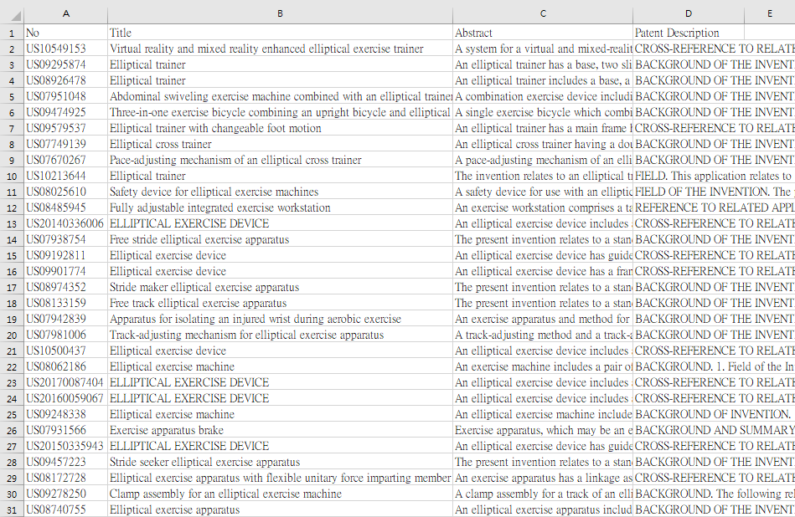

在專利文本資料收集的部份，透過訪問 WEBPAT 網站並設定搜尋條件

TAC:(Elliptical) AND TAC:(exercise) OR TAC:(trainer)得到的搜尋結果之後，針對搜尋結果提取了專利名稱、專利公告號、專利摘要及專利說明，總共下載 200 篇並彙整為.csv 檔，作為訓練詞向量使用，檔案如圖 4-2，而其中的 100 做為分類使用，所有下載用於分類的 100 筆專利資料整理了專利公告號以及專利名稱於表 4-3。

圖 4-2、專利文本彙整範例(前 1~30 筆)

表 4-3、實驗用專利資料清單

|  |  |
| --- | --- |
| **專利公告號** | **專利名稱** |
| US10549153 | Virtual reality and mixed reality enhanced elliptical exercise trainer |
| US09295874 | Elliptical trainer |
| US08926478 | Elliptical trainer |
| US07951048 | Abdominal swiveling exercise machine combined with an elliptical  trainer exercise machine, or skate simulation trainer, or exercise bicycle or recumbent bicycle |
| US09474925 | Three-in-one exercise bicycle combining an upright bicycle and elliptical  trainer with a recumbent bicycle |
| US09579537 | Elliptical trainer with changeable foot motion |
| US07749139 | Elliptical cross trainer |
| US07670267 | Pace-adjusting mechanism of an elliptical cross trainer |
| US10213644 | Elliptical trainer |
| US08025610 | Safety device for elliptical exercise machines |
| US08485945 | Fully adjustable integrated exercise workstation |
| US20140336006 | ELLIPTICAL EXERCISE DEVICE |
| US07938754 | Free stride elliptical exercise apparatus |
| US09192811 | Elliptical exercise device |
| US09901774 | Elliptical exercise device |
| US08974352 | Stride maker elliptical exercise apparatus |
| US08133159 | Free track elliptical exercise apparatus |
| US07942839 | Apparatus for isolating an injured wrist during aerobic exercise |
| US07981006 | Track-adjusting mechanism for elliptical exercise apparatus |
| US10500437 | Elliptical exercise device |
| US08062186 | Elliptical exercise machine |

|  |  |
| --- | --- |
| US20170087404 | ELLIPTICAL EXERCISE DEVICE |
| US20160059067 | ELLIPTICAL EXERCISE DEVICE |
| US09248338 | Elliptical exercise machine |
| US07931566 | Exercise apparatus brake |
| US20150335943 | ELLIPTICAL EXERCISE DEVICE |
| US09457223 | Stride seeker elliptical exercise apparatus |
| US08172728 | Elliptical exercise apparatus with flexible unitary force imparting  member |
| US09278250 | Clamp assembly for an elliptical exercise machine |
| US08740755 | Elliptical exercise apparatus |
| US08808148 | Elliptical exercise machine with declining adjustable ramp |
| US09586086 | Elliptical exercise machine with an adjustable connection |
| US07691035 | Adjustable elliptical exercise machine |
| US20140135996 | DIGITAL EXERCISE EQUIPMENT CLUSTER SYSTEM |
| US07674205 | Elliptical exercise machine with adjustable foot motion |
| US10363455 | Exercise machine and cross trainer |
| US08968159 | Folding elliptical exercise machine |
| US20190224525 | EXERCISE MACHINE AND CROSS TRAINER |
| US10478664 | Exercise apparatus with divergent/convergent motion along the  symmetric semi elliptical rout |
| US20170080282 | ELLIPTICAL EXERCISER |
| US10369404 | Pedal assembly for exercise machine |
| US07651446 | Elliptical core cycle exercise apparatus |
| US07682288 | Elliptical exercise methods and apparatus |
| US09604099 | Positional lock for foot pedals of an elliptical exercise machine |
| US20120004077 | Lateral elliptical exercise machine |



|  |  |
| --- | --- |
| US08210993 | Elliptical exercise apparatus |
| US10022586 | Elliptical exercise machine with a front resisting unit |
| US20190282852 | Elliptical Exercise Machine |
| US09457222 | Arch track for elliptical exercise machine |
| US09302145 | Elliptical exercise machine with adjustable stride length |
| US09757613 | Elliptical exercise device with cam drive |
| US09511255 | Elliptical exercise device with moving control tracks |
| US07648445 | Elliptical exercise apparatus |
| US07682293 | Lateral elliptical exercise apparatus |
| US20160151665 | ELLIPTICAL EXERCISE DEVICE WITH CAM DRIVE |
| US08668627 | Free terrain elliptical exercise apparatus |
| US07918766 | Elliptical mechanism |
| US20180221705 | ELLIPTICAL EXERCISE DEVICE FOR SIMULTANEOUS  TRAINING OF SHOULDER GIRDLE, PELVIC GIRDLE AND TRUNK MUSCLES IN A HUMAN |
| US08029416 | Free course elliptical exercise apparatus |
| US10518126 | Elliptical exercise methods and apparatus |
| US08814757 | Free pace elliptical exercise apparatus |
| US09636540 | Adjustable stride elliptical motion exercise machine with large stride  variability and fast adjustment |
| US07993247 | Chair operated elliptical exercise apparauts |
| US20160184626 | ELLIPTICAL EXERCISE MACHINE WITH A TREADING DEPTH  ADJUSTMENT MECHANISM |
| US09017223 | Selective stride elliptical exercise apparatus |
| US07686743 | Elliptical rock climber exercise apparatus |
| US08272995 | Elliptical exercise methods and apparatus |



|  |  |
| --- | --- |
| US07670268 | Exercise methods and apparatus with elliptical foot motion |
| US10232211 | Exercise apparatus |
| US20140206507 | ADJUSTABLE EXERCISE MACHINE |
| US09707439 | Elliptical machine |
| US08734298 | Adjustable exercise machine |
| US10232211 | Exercise apparatus |
| US09827461 | Elliptical exercise device |
| US07841968 | Free path elliptical exercise apparatus |
| US09403585 | Elliptical human-powered watercraft |
| US07972250 | Exercise training tool |
| US08852059 | Elliptical exercise methods and apparatus |
| US10315068 | Exercise methods and apparatus |
| US10105567 | Arc center drive elliptical exercise device |
| US08323155 | Exercise machine |
| US10201727 | Exercise machine |
| US09907995 | Suspension elliptical exercise device |
| US10549144 | Hand-foot composite motion exercise machine |
| US10201727 | Exercise machine |
| US09764187 | Exercise methods and apparatus |
| US09272182 | Exercise machine |
| US10105567 | Arc center drive elliptical exercise device |
| US07942787 | Exercise machine |
| US08147384 | Exercise methods and apparatus |
| US08308617 | Elliptical treadmill with torsional swinging |
| US09095741 | Exercise methods and apparatus |
| US07811206 | Elliptical exercise device |



|  |  |
| --- | --- |
| US07662069 | Ellipical exercise apparatus with flexible unitary force imparting  member |
| US08449437 | Exercise methods and apparatus |
| US07691034 | Total body elliptical exercise device with independent upper and lower  body motion |
| US09974998 | Exercise device with elliptical stepping motion |
| US07780580 | Arm exercise apparatus for run simulation |
| US07731634 | Elliptical exercise equipment with stowable arms |
| US07811207 | Exercise methods and apparatus |

## 第三節 專利之設計需求分類

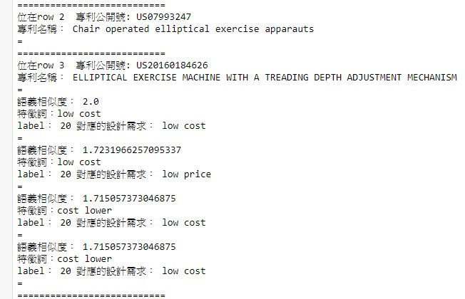

本節將透過第二節彙整好的專利文本以及先前第三章第四節已經整理好的產品設計需求 SAO 結構詞組來進行語義相似度的計算，只要相似度≥ 1.6就會印出來該詞組以及設計需求 label 及其對應的關鍵字詞組，若無則不印出如圖 4-3。

圖 4-3、專利文本之設計需求分類結果範例

### 4.3.1 專利文本與設計需求之語義相似度計算結果

經過語義相似度的計算之後，相似度≥ 1.6的分類結果及詞組彙整為表 4-4，透過此表可以知道並非每一筆專利都會匹配到設計需求的，本實驗將對有匹配到設計需求的專利進行後續的演化趨勢分類。

表 4-4、設計需求分類結果

|  |  |  |  |
| --- | --- | --- | --- |
| 專利公告號 | 專利文件特徵詞 | 設計需求標籤 | 設計需求標籤內容 |
| US10549153 | transparent displays | 6 | clear display |
| US09295874 | different modes | 3 | many modes |
| stride adjust | 12 | adjust pace |
| US09474925 | easy assembly | 11 | simple assembly |
| US07670267 | pace adjust | 12 | adjust pace |
| US10213644 | easy maintenance | 13 | easy maintain |
| different modes | 3 | many modes |
| US08485945 | speed adjust | 12 | adjust pace |
| US09248338 | stride adjust | 12 | adjust pace |
| guiding element | 5 | guide function |
| US09278250 | low cost | 20 | low cost |
| US09586086 | easier maintenance | 13 | easy maintain |
| US07682288 | speed adjust | 12 | adjust pace |
| US10022586 | convenient operation | 1 | convenient operate |
| US09302145 | stride adjust | 12 | adjust pace |
| US07682293 | several modes | 3 | many modes |
| US10518126 | path adjust | 12 | adjust step |
| US09636540 | stride adjusting | 12 | adjust step |
| US20160184626 | low cost | 20 | low cost |
| US07670268 | speed adjust | 12 | adjust step |
| US20140206507 | path adjust | 12 | adjust step |

|  |  |  |  |
| --- | --- | --- | --- |
| US08734298 | path adjust | 12 | adjust step |
| US10549144 | path adjust | 12 | adjust step |
| US08147384 | path adjust | 12 | adjust step |
| US08449437 | path adjusting | 12 | adjust step |
| US09974998 | element guiding | 5 | guide function |
| US07811207 | path adjust | 12 | adjust step |
| US07686743 | several modes | 3 | many modes |

## 第四節 英文專利之演化趨勢分類

本節將透過第二節有符合設計需求的專利進行演化趨勢分類，透過專利文本與演化

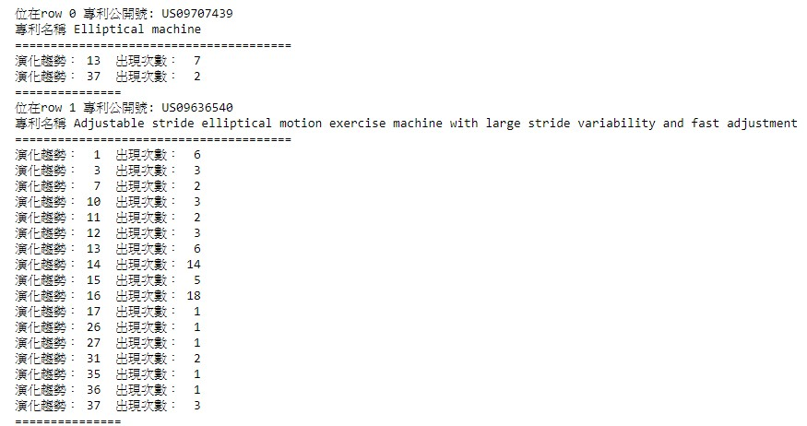

趨勢 SAO 結構詞組的語義相似度計算，只要相似度≥ 1.6就會計算並彙整出包含的演化趨勢及匹配到的次數如圖 4-4。

圖 4-4、專利文本之演化趨勢分類結果(左)及出現次數(右)

### 4.4.1 演化趨勢分類結果

首先將所有專利資料進行語義相似度計算並分類演化趨勢之後，再從所有分類結果找出在第三節有匹配到的專利及其演化趨勢並彙整成表表 4-5，其中分類結果中左邊的

整數結果為演化趨勢標籤，右邊的整數數字則是該演化趨勢標籤在此專利文本中經語義相似度計算後判斷相似度≥ 1.6為 TRUE 的次數。



表 4-5、符合設計需求的專利進行演化趨勢分類結果

|  |  |  |  |  |
| --- | --- | --- | --- | --- |
| 專利公告號 | 演化趨勢標籤 | 演化趨勢標籤  出現次數 | 演化趨勢標籤 | 演化趨勢標籤  出現次數 |
| US10549153 | 1 | 3 | 16 | 17 |
| 3 | 1 | 17 | 14 |
| 10 | 2 | 19 | 4 |
| 11 | 1 | 28 | 9 |
| 13 | 1 | 29 | 5 |
| 14 | 59 | 35 | 3 |
| 15 | 57 | 36 | 18 |
| US09295874 | 1 | 2 | 15 | 2 |
| 6 | 1 | 25 | 2 |
| 14 | 2 |  |  |
| US09474925 | 4 | 2 | 29 | 1 |
| 14 | 3 | 31 | 3 |
| 15 | 2 | 36 | 1 |
| 19 | 1 |  |  |
| US07670267 | 3 | 1 | 29 | 4 |
| 4 | 1 | 31 | 2 |
| 10 | 1 |  |  |
| US10213644 | 13 | 1 | 29 | 5 |
| 14 | 8 | 31 | 2 |
| 15 | 13 | 35 | 2 |
| 16 | 1 | 36 | 2 |
| 17 | 6 | 37 | 1 |
| US08485945 | 1 | 4 | 23 | 1 |
| 2 | 1 | 27 | 3 |
| 10 | 1 | 29 | 3 |
| 12 | 3 | 32 | 8 |
| 13 | 1 | 35 | 2 |
| 14 | 3 | 36 | 2 |
| 15 | 6 | 17 | 1 |
| 16 | 3 |  |  |
| US09248338 | 1 | 1 | 14 | 1 |

|  |  |  |  |  |
| --- | --- | --- | --- | --- |
|  | 2 | 1 | 15 | 1 |
| 7 | 14 | 25 | 1 |
| US09278250 | 1 | 15 | 17 | 2 |
| 2 | 2 | 19 | 1 |
| 6 | 1 | 28 | 1 |
| 7 | 8 | 33 | 1 |
| 14 | 10 | 35 | 3 |
| 15 | 12 | 36 | 3 |
| 16 | 1 |  |  |
| US09586086 | 1 | 6 | 15 | 9 |
| 3 | 3 | 16 | 12 |
| 7 | 5 | 17 | 3 |
| 10 | 2 | 28 | 1 |
| 13 | 2 | 31 | 14 |
| 14 | 12 | 35 | 3 |
| 36 | 3 |  |  |
| US07682288 | 1 | 3 | 16 | 8 |
| 10 | 5 | 27 | 1 |
| 14 | 3 | 37 | 1 |
| 15 | 2 |  |  |
| US10022586 | 13 | 7 | 15 | 3 |
| 14 | 1 | 16 | 1 |
| US09302145 | 15 | 1 |  |  |
| US07682293 | 14 | 4 | 36 | 3 |
| 15 | 4 |  |  |
| US10518126 | 1 | 3 | 15 | 5 |
| US09636540 | 1 | 6 | 16 | 18 |
| 3 | 3 | 17 | 1 |
| 7 | 2 | 26 | 1 |
| 10 | 3 | 27 | 1 |
| 11 | 2 | 31 | 2 |
| 12 | 3 | 35 | 1 |
| 13 | 6 | 36 | 1 |
| 14 | 14 | 37 | 3 |
| 15 | 5 |  |  |
| US20160184626 | 2 | 3 | 13 | 6 |
| 4 | 1 | 37 | 1 |
| 10 | 4 |  |  |



|  |  |  |  |  |
| --- | --- | --- | --- | --- |
| US07670268 | 1 | 1 | 17 | 11 |
| 14 | 5 | 36 | 1 |
| 15 | 8 | 37 | 1 |
| 16 | 4 |  |  |
| US20140206507 | 1 | 4 | 15 | 38 |
| 2 | 1 | 16 | 11 |
| 11 | 1 | 17 | 11 |
| 13 | 19 | 29 | 7 |
| 14 | 33 | 35 | 15 |
| 36 | 18 |  |  |
| US08734298 | 1 | 4 | 16 | 11 |
| 2 | 1 | 17 | 11 |
| 11 | 1 | 29 | 7 |
| 13 | 19 | 35 | 15 |
| 14 | 33 | 36 | 18 |
| 15 | 38 |  |  |
| US10549144 | 4 | 1 | 15 | 3 |
| 13 | 2 | 17 | 1 |
| 14 | 5 |  |  |
| US08147384 | 13 | 2 | 16 | 1 |
| 14 | 4 | 31 | 1 |
| 15 | 4 | 36 | 1 |
| US08449437 | 1 | 10 | 23 | 1 |
| 14 | 15 | 31 | 3 |
| 15 | 9 | 36 | 1 |
| 16 | 18 |  |  |
| US09974998 | 1 | 8 | 16 | 16 |
| 10 | 10 | 18 | 1 |
| 13 | 1 | 19 | 1 |
| 14 | 6 | 31 | 1 |
| 15 | 3 | 37 | 1 |
| US07811207 | 13 | 2 | 16 | 1 |
| 14 | 4 | 31 | 1 |
| 15 | 4 | 36 | 1 |
| US07686743 | 14 | 4 | 36 | 3 |
| 15 | 4 |  |  |



## 第五節 產品設計需求與專利之演化趨勢模式分析

本節將透過彙整第三節及第四節專利文本符合的設計需求以及演化趨勢標籤來進行演化趨勢模式分析，並探討分析後的結果，其中共分為兩種分析方式，第一種是透過所有符合設計需求的專利來進行演化趨勢模式分析，第二種是利用配對到最多設計需求的需求來代表該產品的改善方向並進行演化趨勢分析與推薦。

### 基於所有設計需求之演化趨勢模式分析

透過表 4-5 所有符合設計需求的專利進行 Excel 的樞紐分析，得到的結果如圖 4-5 與圖 4-6，其中表格的第二列-第二欄至三十八欄中的 1~37 分別代表了第一條至第三十七條的演化趨勢，而樞紐分析表中的數字則是對應該演化趨勢標籤出現次數。圖 4-5 計

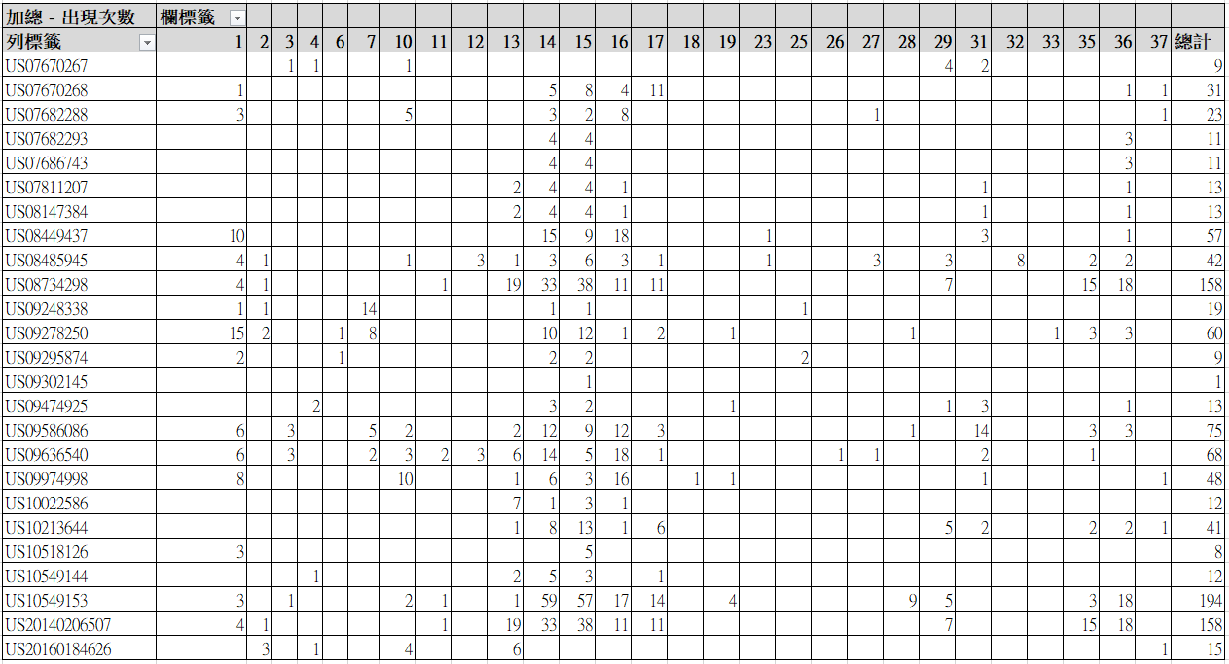

數的值是代表該篇專利文本經相似度被判斷符合該演化趨勢的詞組數，圖 4-6 的計次是

將圖 4-5 的次數進行正規化，只要原本計數的值為非 0 就會為 1，用以計算各項演化趨勢出現的總次數，會進行這個步驟是因為專利文本的字數較多、字詞量大導致演化趨勢出現次數越多，為了不讓專利的字數影響到演化趨勢分析，故只要有被判斷到都歸類為1，沒有則為 0。

圖 4-5、基於所有設計需求之演化趨勢出現次數(計數)

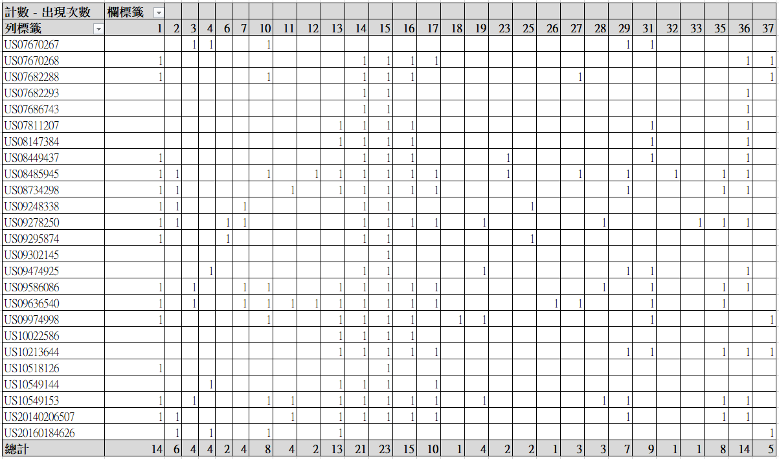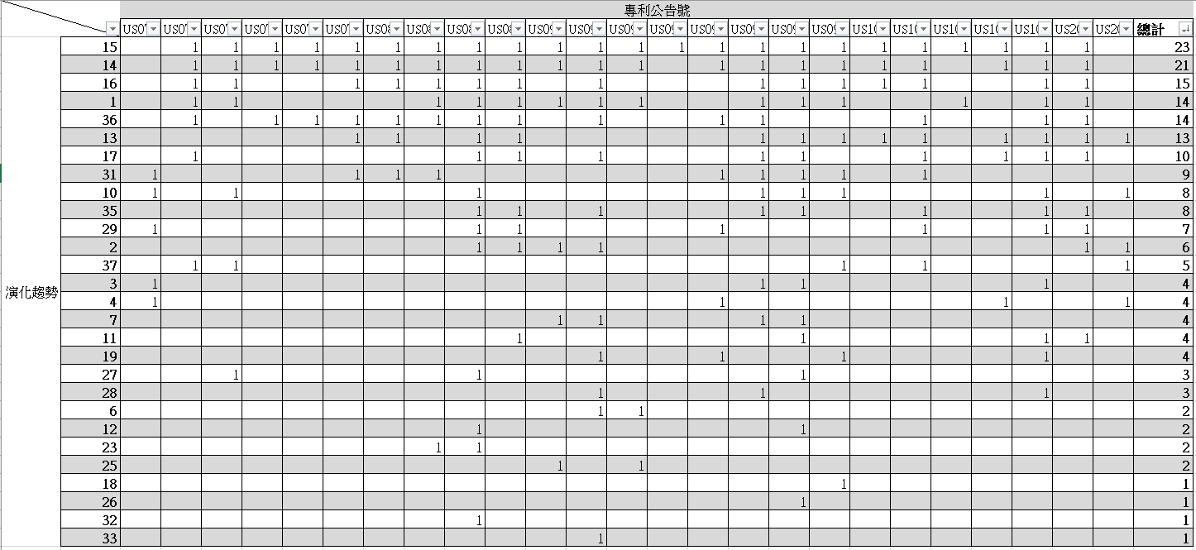

圖 4-6、基於所有設計需求之演化趨勢出現次數(計次)

透過圖 4-6 的結果經過轉置並針對演化趨勢計次之出現次數進行大至小的排序之後如圖 4-7，進一步將演化趨勢及總計數擷取出來並彙整成表 4-6，即為步距機整體演化趨勢的模式推薦。

圖 4-7、基於所有設計需求之演化趨勢出現次數大至小排序(計次)

表 4-6、基於所有設計需求之演化趨勢模式推薦

|  |  |  |
| --- | --- | --- |
| 演化趨勢標籤 | 演化趨勢名稱 | 出現次數(計次) |
| 15 | Mono-Bi-Poly (Various) Surface  單-雙-多(變異性)介面 | 23 |
| 14 | Mono-Bi-Poly (Similar) Surface  單-雙-多(同質性)介面 | 21 |
| 16 | Mono-Bi-Poly (Increasing Difference)  單-雙-多(增加差異) | 15 |
| 1 | Smart Material  智慧材料 | 14 |
| 36 | Mono-Bi-Poly (Various) Time  單-雙-多(變異性)時間 | 14 |
| 13 | Dynamization  動態性 | 13 |
| 17 | Nesting-Up  向上整合 | 10 |
| 31 | Reducing Energy Conversions  減少能源轉換 | 9 |
| 10 | Geometric Evolution (Linear)  幾何進化(線性) | 8 |
| 35 | Mono-Bi-Poly (Similar)Time  單-雙-多(同質性)時間 | 8 |
| 29 | Human Involvement  人為參與 | 7 |
| 2 | Space Segmentation  空間分割 | 6 |
| 37 | Evolution Marco to Nano Scale  從巨觀到微觀(奈米化) | 5 |
| 3 | Surface Segmentation  表面分割 | 4 |
| 4 | Object Segmentation  物體分割 | 4 |
| 7 | Decreasing Density  減少密度 | 4 |
| 11 | Geometric Evolution (Volumetric)  幾何進化(立體) | 4 |
| 19 | Senses Interaction  感官作用 | 4 |

|  |  |  |
| --- | --- | --- |
| 27 | Trimming  簡約設計 | 3 |
| 28 | Controllability  控制度 | 3 |
| 6 | Web and Fibers  網狀纖維 | 2 |
| 12 | Nesting-Down  向下縮合 | 2 |
| 23 | Market Evolution  市場演化 | 2 |
| 25 | Degrees of Freedom  自由度 | 2 |
| 18 | Reduced Damping  減少阻尼 | 1 |
| 26 | Boundary Breakdown-Space(Surface)  打破邊界(介面) | 1 |
| 32 | Action Co-ordination  動作協調 | 1 |
| 33 | Rhythm Co-ordination  節奏協調 | 1 |

### 基於調整步距需求之演化趨勢模式分析

將分類後匹配到最多的設計需求來做為演化趨勢模式分析的方法，經過計算調整步距這個設計需求是匹配到次數最多的，因此本小節將針對符合調整步距的專利進行演化趨勢標籤及出現次數整理後，依照出現次數高至低進行排列，結果如表 4-7。

表 4-7、演化趨勢分類結果出現次數大到小整理

|  |  |  |  |
| --- | --- | --- | --- |
| 設計需求 | 專利公告號 | 演化趨勢標籤 | 出現次數 |
| 調整步距 | US09295874 | 1 | 2 |
| 14 | 2 |
| 15 | 2 |
| 25 | 2 |
| 6 | 1 |
| US07670267 | 29 | 4 |
| 31 | 2 |
| 3 | 1 |

|  |  |  |  |
| --- | --- | --- | --- |
| 調整步距 |  | 4 | 1 |
| 10 | 1 |
| US08485945 | 32 | 8 |
| 15 | 6 |
| 1 | 4 |
| 12 | 3 |
| 14 | 3 |
| 16 | 3 |
| 27 | 3 |
| 29 | 3 |
| 35 | 2 |
| 36 | 2 |
| 2 | 1 |
| 10 | 1 |
| 13 | 1 |
| 17 | 1 |
| 23 | 1 |
| US09248338 | 7 | 14 |
| 1 | 1 |
| 2 | 1 |
| 14 | 1 |
| 15 | 1 |
| 25 | 1 |
| US07682288 | 16 | 8 |
| 10 | 5 |
| 1 | 3 |
| 14 | 3 |
| 15 | 2 |
| 27 | 1 |
| 37 | 1 |
| US09302145 | 15 | 1 |
| US10518126 | 15 | 5 |
| 1 | 3 |
| US09636540 | 16 | 18 |
| 14 | 14 |
| 1 | 6 |
| 13 | 6 |
| 15 | 5 |



|  |  |  |  |
| --- | --- | --- | --- |
| 調整步距 |  | 3 | 3 |
| 10 | 3 |
| 12 | 3 |
| 37 | 3 |
| 7 | 2 |
| 11 | 2 |
| 31 | 2 |
| 17 | 1 |
| 26 | 1 |
| 27 | 1 |
| 35 | 1 |
| 36 | 1 |
| US07670268 | 17 | 11 |
| 15 | 8 |
| 14 | 5 |
| 16 | 4 |
| 1 | 1 |
| 36 | 1 |
| 37 | 1 |
| US20140206507 | 15 | 38 |
| 14 | 33 |
| 13 | 19 |
| 36 | 18 |
| 35 | 15 |
| 16 | 11 |
| 17 | 11 |
| 29 | 7 |
| 1 | 4 |
| 2 | 1 |
| 11 | 1 |
| US08734298 | 15 | 38 |
| 14 | 33 |
| 13 | 19 |
| 36 | 18 |
| 35 | 15 |
| 16 | 11 |
| 17 | 11 |
| 29 | 7 |
| 1 | 4 |



|  |  |  |  |
| --- | --- | --- | --- |
| 調整步距 |  | 2 | 1 |
| 11 | 1 |
| US10549144 | 14 | 5 |
| 15 | 3 |
| 13 | 2 |
| 4 | 1 |
| 17 | 1 |
| US08147384 | 14 | 4 |
| 15 | 4 |
| 13 | 2 |
| 16 | 1 |
| 31 | 1 |
| 36 | 1 |
| US08449437 | 16 | 18 |
| 14 | 15 |
| 1 | 10 |
| 15 | 9 |
| 31 | 3 |
| 23 | 1 |
| 36 | 1 |
| US07811207 | 14 | 4 |
| 15 | 4 |
| 13 | 2 |
| 16 | 1 |
| 31 | 1 |
| 36 | 1 |

將表匯入 Excel 整理成樞紐分析表後，得到的演化趨勢模式如圖 4-8，為了不讓文本字詞量多寡影響到分類結果，將有分類到演化趨勢即為 1，若無則為 0 的方式做資料正規化(圖 4-9)，其中表格的第二列-第二欄至三十八欄中的 1~37 分別代表了第一條至第三十七條的演化趨勢，而樞紐分析表中的數字則是對應該演化趨勢標籤出現次數，可以透過分析是否有共同的演化來判定調整步距這個設計需求與哪些演化趨勢有關聯。

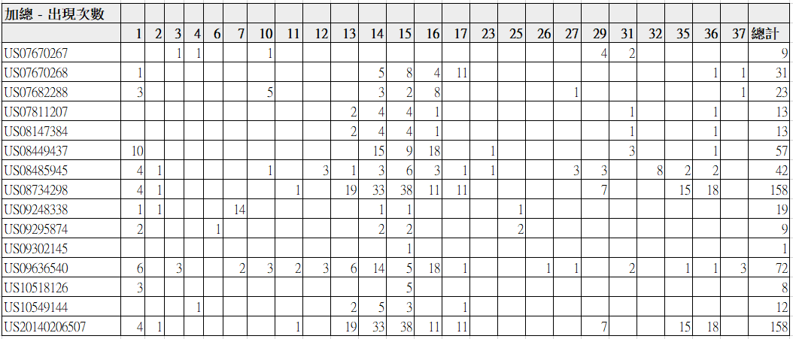

圖 4-8、基於排名最高設計需求之演化趨勢出現次數統計(計數)

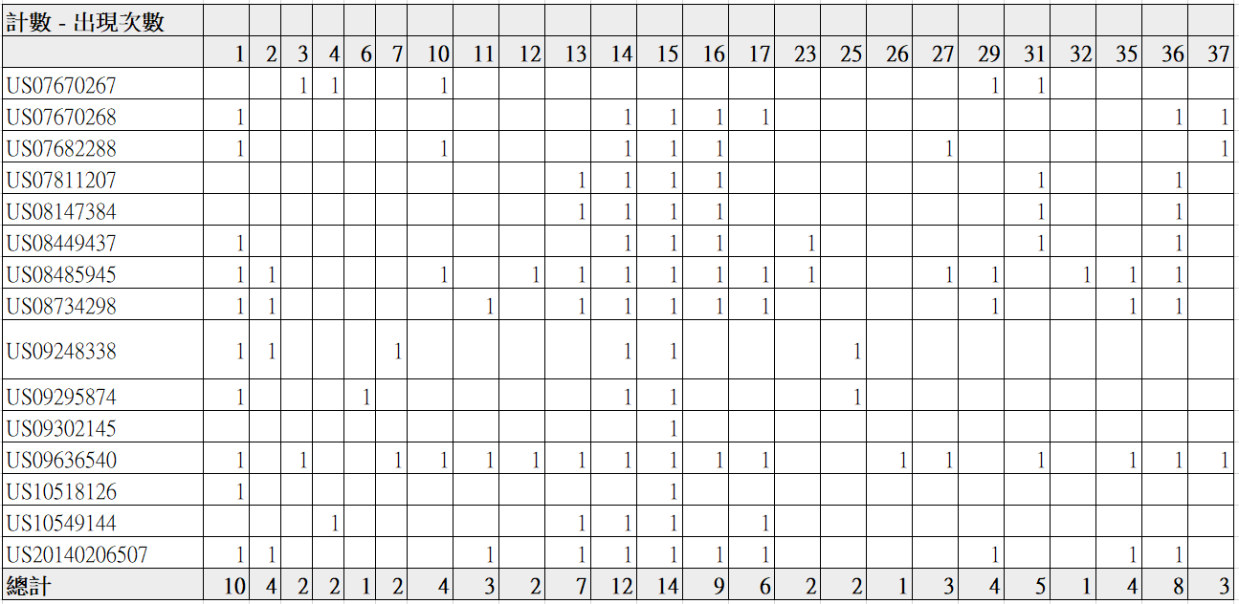

圖 4-9、基於排名最高設計需求之演化趨勢出現次數統計(計次)

透過圖 4-9 的結果經過轉置並針對演化趨勢計次之出現次數進行大至小的排序之後圖 4-10，進一步將演化趨勢及總計數擷取出來並製成表 4-8，即為以調整步距這個設計需求來進行步距機的演化趨勢的模式推薦。

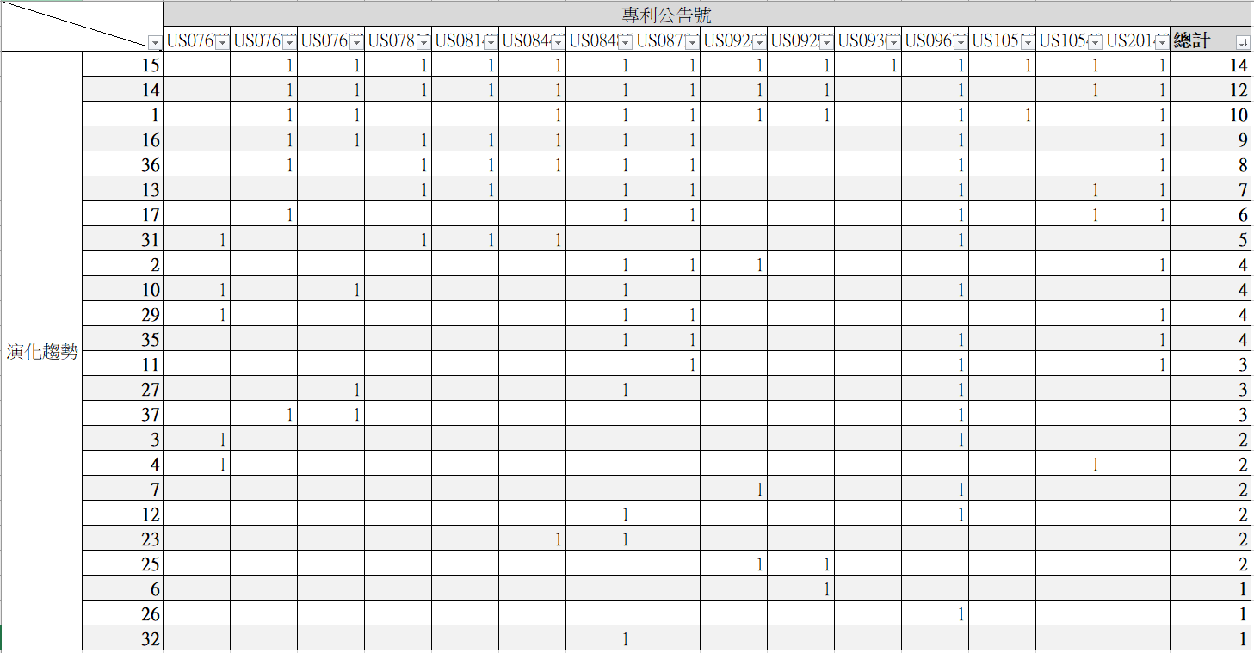

圖 4-10、基於排名最高設計需求之演化趨勢出現次數大至小排序(計次)

表 4-8、基於排名最高設計需求之演化趨勢模式推薦

|  |  |  |
| --- | --- | --- |
| 演化趨勢標籤 | 演化趨勢名稱 | 出現次數(計次) |
| 15 | Mono-Bi-Poly (Various) Surface  單-雙-多(變異性)介面 | 14 |
| 14 | Mono-Bi-Poly (Similar)介面  單-雙-多(同質性)介面 | 12 |
| 1 | Smart Material  智慧材料 | 10 |
| 16 | Mono-Bi-Poly (Increasing Difference)  單-雙-多(增加差異) | 9 |
| 36 | Mono-Bi-Poly (Various) Time  單-雙-多(變異性)時間 | 8 |
| 13 | Dynamization  動態性 | 7 |
| 17 | Nesting-Up  向上整合 | 6 |
| 31 | Reducing Energy Conversions  減少能源轉換 | 5 |
| 2 | Space Segmentation  空間分割 | 4 |
| 10 | Geometric Evolution (Linear)  幾何進化(線性) | 4 |

|  |  |  |
| --- | --- | --- |
| 29 | Human Involvement  人為參與 | 4 |
| 35 | Mono-Bi-Poly (Similar)Time  單-雙-多(同質性)時間 | 4 |
| 11 | Geometric Evolution (Volumetric)  幾何進化(立體) | 3 |
| 27 | Trimming  簡約設計 | 3 |
| 37 | Evolution Marco to Nano Scale  從巨觀到微觀(奈米化) | 3 |
| 3 | Surface Segmentation  表面分割 | 2 |
| 4 | Object Segmentation  物體分割 | 2 |
| 7 | Decreasing Density  減少密度 | 2 |
| 12 | Nesting-Down  向下縮合 | 2 |
| 23 | Market Evolution  市場演化 | 2 |
| 25 | Degrees of Freedom  自由度 | 2 |
| 6 | Web and Fibers  網狀纖維 | 1 |
| 26 | Boundary Breakdown-Space(Surface)  打破邊界(介面) | 1 |
| 32 | Action Co-ordination  動作協調 | 1 |

### 演化趨勢模式分析結果探討

將 4.5.1 與 4.5.2 所得到的演化趨勢推薦結果出現次數前十的演化趨勢統整成表 4-9，可以發現兩種方法所得到前十高的推薦結果除了「基於調整步距設計需求」次數排第九的空間分割(Space Segmentation)和「基於所有設計需求」次數排第十的單-雙- 多(同質性)時間(Mono-Bi-Poly (Similar) Time)之外，幾乎都涵蓋了一樣的演化趨勢，因此本研究認為兩種推薦方法都可以作為改善步距橢圓機的演化趨勢推薦方法。

表 4-9、演化趨勢模式推薦彙整(前十名)

|  |  |  |  |  |  |
| --- | --- | --- | --- | --- | --- |
| 基於調整步距設計需求 | | | 基於所有設計需求 | | |
| 演化  趨勢標籤 | 演化趨勢名稱 | 出現次數 | 演化  趨勢標籤 | 演化趨勢名稱 | 出現次數 |
| 15 | Mono-Bi-Poly (Various)  Surface  單-雙-多(變異性)介面 | 14 | 15 | Mono-Bi-Poly (Various)  Surface  單-雙-多(變異性)介面 | 23 |
| 14 | Mono-Bi-Poly (Similar)  Surface  單-雙-多(同質性)介面 | 12 | 14 | Mono-Bi-Poly (Similar)  Surface  單-雙-多(同質性)介面 | 21 |
| 1 | Smart Material  智慧材料 | 10 | 16 | Mono-Bi-Poly (Increasing Difference)  單-雙-多(增加差異) | 15 |
| 16 | Mono-Bi-Poly (Increasing Difference)  單-雙-多(增加差異) | 9 | 1 | Smart Material  智慧材料 | 14 |
| 36 | Mono-Bi-Poly (Various)  Time  單-雙-多(變異性)時間 | 8 | 36 | Mono-Bi-Poly (Various)  Time  單-雙-多(變異性)時間 | 14 |
| 13 | Dynamization  動態性 | 7 | 13 | Dynamization  動態性 | 13 |
| 17 | Nesting-Up  向上整合 | 6 | 17 | Nesting-Up  向上整合 | 10 |
| 31 | Reducing Energy Conversions  減少能源轉換 | 5 | 31 | Reducing Energy Conversions  減少能源轉換 | 9 |
| 2 | Space Segmentation  空間分割 | 4 | 10 | Geometric Evolution (Linear)  幾何進化(線性) | 8 |
| 10 | Geometric Evolution (Linear)  幾何進化(線性) | 4 | 35 | Mono-Bi-Poly (Similar)Time  單-雙-多(同質性)時間 | 8 |

# 第五章 結論與建議

在這不斷追求創新、物質、感官與功能性的時代，產品開發已經不像以往能夠經由 簡單的調整參數或取捨式設計來解決越來越複雜的設計需求，而本研究利用設計需求來 挖掘出可能有參考價值的專利，並透過分析專利來推薦演化趨勢來提供產品改進的方向， 藉此達到跳躍性的創新與滿足產品設計需求。

## 第一節 結論

本研究是參考相關文獻，歸納出可以達到一樣目的且解決部分問題的方法：例如語義相似度計算方法，本研究使用了 Word2vec 詞向量完成語義相似度的計算，比起WordNet (Miller, 1995)，可以解決基於詞距離深度的語義相似度計算造成某些演化趨勢無法被推薦的問題；在演化趨勢推薦方面，本研究透過 SAO 依存關係結構提取專利中的功能屬性來進行分類，可以解決在蔡元豪(2012)中，使用 TF-IDF 及詞典權重計算得分來推薦演化趨勢的問題，相較於使用 TF-IDF 配合字典比對的方法是利用權重的計算提取得分前兩高的演化趨勢進行推薦，無法涵蓋一篇專利中所有蘊含的演化趨勢，此外字典比對的方法必須要 100%吻合該詞組才會得到相對應的權重，再加上被專利的撰寫以及用詞的方式影響，導致字詞多的詞組通常很難被匹配到，偏偏權重高的詞組也由不少的字詞組成，本研究在評估這些問題後，決定利用語義相似度的算法來辨識與推薦演化趨勢。

本研究共有三項貢獻：

* + - 1. 本研究建立出一利用產品設計需求來進行演化趨勢推薦的方法：透過 spaCy 進行依存分析來達到專利文本的 SAO 結構擷取，並利用 Word2vec 語義相似度計算對專利文本進行設計需求分類，再針對有分類到設計需求的專利進行語義相似度計算達成演化趨勢分類，最後將所有得到的演化趨勢與關鍵詞出現次數進行整理並排序出改善產品設計的演化趨勢推薦名單。
      2. 根據步距橢圓機設計的需求與相關專利經過依存分析、特徵擷取、語義相似度計算來推薦出用於改善步距橢圓機設計以滿足設計需求的演化趨勢。
      3. 建構出基於 SAO 語法結構的 37 演化趨勢關鍵詞詞集(附錄 B)，可以透過該詞集用於演化趨勢的分析以及其他相關研究。

## 第二節 研究限制

### 自然語言處理

依存分析的結果是否正確會直接關係到 SAO 結構特徵詞擷取的正確性，而本研究是利用 spaCy 所提供之自然語言處理套件進行依存分析，加上處理的專利文本數量多很難逐一查核，因此無法判定在利用 spaCy 進行依存分析時有無分析錯誤的可能性存在， 若有分析錯誤的可能性將會影響到本實驗在專利文本SAO 結構特徵擷取的結果。

### 詞向量模型

因為專利資料數量的不足，所以導致有某些演化趨勢專利詞庫及設計需求詞庫的詞匯是沒有 Word2vec 詞向量的，若能增加更多訓練的專利文本，在增加的文本中若有原先向量空間中沒有的詞匯，可以解決某些詞組沒有向量的問題。

### 演化趨勢推薦

本研究是利用依存分析對 SAO 語法結構來進行特徵擷取，而每篇專利文件的寫法會因為不同申請人的撰寫而有不同的呈現方式，因此每篇專利文件的撰寫方式不同會影響到本實驗的 SAO 結構特徵擷取進而影響演化趨勢推薦結果。

### 演化趨勢驗證

基於演化趨勢的特性，本研究無法透過個人來給予專利人工標籤的方式來驗證，因為演化趨勢分類是會被主觀認知所影響的，意即同一份資料給不同人做演化趨勢的分析會有不同的答案，加上本人並非演化趨勢之專家，因此本研究只能使用目前可取得之演化趨勢分類相關文獻來做驗證，但是也無法保證該文獻作者自行標記的答案是否可信， 所以第四章第一節的演化趨勢驗證僅供參考。

### 設計需求分類

由於產品設計需求的來源是從相關文獻的顧客需求來取得，顧客需求沒有辦法詳細的敘述某些專業領域的術語，從而無法了解其含意(未將顧客聲音轉換為設計參數)導致設計需求 SAO 結構詞集建構的方向可能有誤，例如無法從“減少壓迫感”這個產品設計需求來建構出更詳細的詞彙，只能從片面意思上來建立相關詞集，導致很難找出能解決此設計需求的專利。

## 第三節 未來研究及建議

結合整個研究的實驗、結論以及研究限制後，歸納出以下幾點未來建議來協助後續的相關研究以及參考方向：

* + - 1. 礙於演化趨勢分類在機器學習領域屬於多標籤分類的範疇，加上演化趨勢分類沒有標準的答案又多達 37 個標籤，因此很難利用非監督學習達到準確的分群， 若未來能利用具有極大參數的模型例如 GPT-3 的模型概念或架構，可以達到利用非監督學習達到專利文本進行演化趨勢辨識。
      2. 建議未來能利用其他方法來解決SAO 結構的限制，來更有效的辨識出真正相關的演化趨勢及設計需求，因為 SAO 結構的關鍵字詞集限制只能用兩個詞來代表設計需求和演化趨勢，讓實驗結果可能漏判設計需求特徵或推薦出不適合的演化趨勢。
      3. 本研究建構出的37 演化趨勢SAO 結構關鍵詞詞集尚有許多可以被改進的地方， 因為目前該詞集僅使用同義字字典擴充法進行建構，但是在專利文本提取出的

SAO 結構中，可能含有演化潛力的專業領域術語無法經由語義相似度的計算來辨識出與目前演化趨勢SAO 結構關鍵詞之間的關係，因此未來若可以加入領域的專業術語詞彙可以增加相關專業知識的特徵擷取效果。

# 參考文獻

一、中文參考文獻

1. 王志超，「應用 QFD 與 TRIZ 在新產品設計之研究 ‐以自由步距橢圓機為例」，逢甲大學工業工程與系統管理學系碩士在職專班碩士論文，2013。
2. 宁建飞、刘降珍，「融合Word2vec 与 TextRank 的关键词抽取研究」，现代图书情报技术，2016，P20 – 27，2016。
3. 李晓、解辉、李立杰，「基于 Word2vec 的句子语义相似度计算研究」，计算机科学，

44(9):256 – 260，2017。

1. 李彥璇，「基於類神經網路之繁體中文依存句法分析器」，國立交通大學電信工程研究所碩士班碩士論文，2019。
2. 陈沈焰、吴军华，「基于本体的概念语义相似度计算及其应用」，微電子學與計算機

25 卷 12 期，P96 – 99，2008。

1. 周依穎，「整合 TRIZ 發明原則與演化趨勢於產品研發之問題解決-以電子晶片式防潮櫃為例」，國立臺北科技大學工業工程與管理系碩士班碩士論文，2014。
2. 陳宛琳，「結合本體論與語意相似程度對文件萃取關鍵字」，中原大學資訊工程學系碩士學位論文，2014。
3. 陳博俊，「基於結構與語義關係評估XML Schema 相似度」，國立中興大學資訊科學與工程學系碩士學位論文，2014。
4. 粘怡祥，「應用社會性推薦於學術社群」，國立交通大學資訊管理研究所碩士論文，2008。
5. 黃振綸，「整合多種字詞相似度的方法」，國立臺灣大學電機資訊學院資訊工程學研究所碩士論文，2017。
6. 黃鈺婷，「以功能屬性關係辨識相關技術演化趨勢」，國立清華大學工業工程與工程管理學系碩士論文，2010。
7. 廖士德，「整合 TRIZ 演化趨勢與綠色產品設計之研究－以風力發電LED 燈為例」， 明新科技大學企業管理研究所碩士論文，2010。
8. 蔡元豪，「萃智(TRIZ)演化趨勢專利分類系統建置—氣動打釘機之實證研究」，國立臺北科技大學工業工程與管理學系碩士論文，2012。
9. 新穎數位文創股份有限公司。WEBPAT 全球專利資訊網介紹。2020 年 5 月 20 日， 取自：https://[www.innovue.ltd/Pages/products-webpat.html](http://www.innovue.ltd/Pages/products-webpat.html)

二、英文參考文獻

1. Altshuller, G. S. “40 Principles: TRIZ keys to technical innovation.” Lev Shulyak & Steven Rodman, Trans. Worcester, MA: Technical Innovation Center, 1998.
2. Altshuller, G. S. “The Innovation algorithm: TRIZ, Systematic Innovation and Technical Creativity.” Technical Innovation Center, Inc. 2000.
3. Allahyari, M. Pouriyeh, S. Assefi, M. Safaei, S. Trippe, E. D. Gutierrez, J. B. and Kochut,

K. “A brief survey of text mining: Classification clustering and extraction techniques. ” arXiv preprint arXiv:1707.02919, 2017.

1. Cascini, G. Fantechi, A. and Spinicci, E. “Natural language processing of patents and technical documentation.” Proc. Int. Workshop Document Anal. Syst., pp. 89-92, 2004.
2. Choi, S. Park, H. Kang, D. Lee, J. Y. and Kim, K. “An SAO-based text mining approach to building a technology tree for technology planning.” Expert Systems with Applications 39(13): 11443-11455, 2012.
3. Choi J. D. “ClearNLP Dependency Labels.” Retrieved from https://github.com/clir/clearnlp-

guidelines/blob/master/md/specifications/dependency_labels.md, 2015.

1. de Marneffe, M. C. and Manning, C. “Stanford typed dependencies manual.” Technical report, 2008.
2. Faloutsos, C. and Oard, D. W. “A survey of information retrieval and filtering methods.” Technical Report, 1998.
3. Jurafsky, D. and Martin, J. H. “Speech and Language Processing.” Draft of October 2, 2019, Dependency Parsing (Chap. 15), Retrieved from

https://web.stanford.edu/~jurafsky/slp3/15.pdf

1. Ki, W. and Kim, K. “Generating Information Relation Matrix Using Semantic Patent Mining for Technology Planning: A Case of Nano-Sensor.” IEEE Access 5: 26783-26797, 2017.
2. Liddy, E. D. “Natural language processing.” Syracuse University, 2001.
3. Miller, G. A. “Wordnet: A lexical database for english.” Commun. ACM, 38(11):39–41, Nov, 1995.
4. Mann, D. “Hands-On Systematic Innovation for Technical System.” 2nd Edition, IFR Press, 2007.
5. Mann, D. Zlotin, B. and Zusman, A. “Matrix 2003: Updating the TRIZ Contradiction Matrix.” CREAX, Press, Detroit, USA, 2003.
6. Mikolov, T. Chen, K. Corrado, G. & Dean, J. “Efficient Estimation of Word Representations in Vector Space.” In ICLR Workshop Papers, 2013.
7. Porter, M. F. “An algorithm for suffix stripping.” Program 40(3): 211-218, 2006.
8. Park, H. Ree, J. J. and Kim, K. “Identification of promising patents for technology transfers using TRIZ evolution trends.” Expert Systems with Applications 40(2): 736-743, 2013.
9. Ricardo, B. Y. and Berthier, R. N. “Modern information retrieval.” US: Addison-Wesley, 1999.
10. Salton, G. “Introduction to Modern Information Retrieval.” US: McGraw-Hill, 1983.
11. Tomfohr, J. Lu, J. and Kepler, T. B. “Pathway level analysis of gene expression using singular value decomposition.” BMC Bioinformatics 6, 225, 2005.
12. Ulrich, K. T. and Eppinger, S. D. “Product design and development.” 3rd Edition, New York:McGraw Hill, 2004.
13. Verhaegen, P. A. D’hondt, J. Vertommen, J. Dewulf, S. and Duflou, J. R. “Relating properties and functions from patents to TRIZ trends.” CIRP Journal of Manufacturing Science and Technology 1(3): 126-130, 2009.
14. Yoon, J. and K. Kim. “An automated method for identifying TRIZ evolution trends from patents.” Expert Systems with Applications 38(12): 15540-15548, 2011.
15. Yoon, J. and K. Kim. “TrendPerceptor: A property–function based technology intelligence system for identifying technology trends from patents.” Expert Systems with Applications 39(3): 2927-2938, 2012.
16. Zlotin, B. and Zusman, A. “Patterns of Evolution: Recent Findings on Structure and Origin.” The TRIZ Journal, Sep, 2006.
17. Universal Dependencies v1 (n. d. ). Retrieved May 21, 2020, from https://universaldependencies.org/docsv1/u/dep/index.html
18. spaCy Features (n. d. ). Retrieved May 21, 2020, from https://spacy.io/usage/spacy-101#features

# 附錄 A: 演化趨勢及演化原因彙整

|  |  |  |
| --- | --- | --- |
| 1.Smart Material 智慧材料 | | |
| 演化階段 | 演化階段(英文) | 演化階段(中文) |
| 1.1 | Passive Material | 被動材料 |
| 演化原因 | solve a physical contradiction by creating two different states create a 2-way switch  reduced control system complexity  opportunities for self-organising/self-serving systems make simple measurements | |
| 1.2 | One-Way Adaptive Material | 單向適應材料 |
| 演化原因 | increased operational flexibility  three-way switching | |
| 1.3 | Two-Way Adaptive Material | 雙向適應材料 |
| 演化原因 | system adaptable to multiple user requirements mass customisation  offers continuous variability  sophisticated measurement indicator | |
| 1.4 | Fully Adaptive Material | 全向適應材料 |
| 2.Space Segmentation 空間分割 | | |
| 演化階段 | 演化階段(英文) | 演化階段(中文) |
| 2.1 | Monolithic Solid | 單一固體 |
| 演化原因 | reduced weight reduced use of material  space to insert other material hole to hang an object from increase moment of inertia  pass something through the object  improve heat transfer | |
| 2.2 | Hollow Solid | 中空結構 |
| 演化原因 | improve heat transfer improve strengh properties  pass multiple things through object  increase surface area | |
| 2.3 | Structure with Multiple Hollow | 多孔結構 |
| 演化原因 | improve surface area  improve strengtrh/weight ratio improve heat transfer | |
| 2.4 | Capillary/Porous Structure | 毛細孔結構 |

|  |  |  |
| --- | --- | --- |
| 演化原因 | improve heat transfer add new function  allow variation | |
| 2.5 | Porous Structure with Active Elements | 多孔結構及主動有效元素 |
| 3.Surface Segmentation 表面分割 | | |
| 演化階段 | 演化階段(英文) | 演化階段(中文) |
| 3.1 | Smooth Surface Action | 光滑表面 |
| 演化原因 | easier to grip  reduce aerodynamic drag improve traction improve drainage  improve heat transfer properties increase surface area  improve aesthetic appearance increase noise  create deliberate weak-point  improve location when joining to another object | |
| 3.2 | Surface with 2D Rib Protrusions | 肋狀突出表面 |
| 演化原因 | reduce drag improve traction improve grip  improve aerodynamic controllability self cleaning  improve heat transfer increase surface area  incorporate identification marks | |
| 3.3 | 3D Roughened Surface | 立體粗糙面 |
| 演化原因 | improve control under different conditions reduce drag  incorporate change indicators  add a new useful function | |
| 3.4 | Roughened Surface + Active Elements | 粗糙表面+主動元素 |
| 4.Object Segmentation 物體分割 | | |
| 演化階段 | 演化階段(英文) | 演化階段(中文) |
| 4.1 | Monolithic Solid | 單一固體 |
| 演化原因 | easier to transport easier to arrange/pack increase surface area  increase perimeter | |



|  |  |  |
| --- | --- | --- |
|  | separate different functions  isolate stresses/loads | |
| 4.2 | Segmented Solid | 分割固體 |
| 演化原因 | easier to transport easier to arrange/pack increase surface area increase perimeter  separate different functions  isolate stresses/loads | |
| 4.3 | Particulate Solid | 粒狀固體 |
| 演化原因 | improve transportability reduce viscosity  increased system flexibility improved compressive load handling self levelling capability  easier to control flow rate  easier to mix with other substances | |
| 4.4 | Fluid | 液體 |
| 演化原因 | increase surface area separate different functions isolate stresses/loads increase mixing capability increase dispersion rate  increase useful effect per mass of substance | |
| 4.5 | Segmented Fluid (foam / aerosol) | 泡沫/氣霧 |
| 演化原因 | increase surface area reduced density  increase mixing capability increase dispersion rate  increase effect per mass of substance improve transportability  reduce viscosity  increase system flexibility easier to control flow rate | |
| 4.6 | Gas | 氣體 |
| 演化原因 | add new function easier to mix reduce density  increase energy flux | |
| 4.7 | Plasma | 電漿 |



|  |  |  |
| --- | --- | --- |
| 演化原因 | improve transmission of loads/energy reduce losses  increase flexibility  increase controllability reduce use of substance | |
| 4.8 | Field | 能場 |
| 演化原因 | reduce use of substance | |
| 4.9 | Vacuum | 真空 |
| 5.Evolution Marco to Nano Scale (空間) 從巨觀到微觀(空間) | | |
| 演化階段 | 演化階段(英文) | 演化階段(中文) |
| 5.1 | Marco | 巨觀 |
| 演化原因 | increase understanding of system structure more effective use of resources  improve strength/weight ratio reduced overall size of system  improve system performance efficiency  reduce losses | |
| 5.2 | Milli | 毫米 |
| 演化原因 | increase understanding of system structure more effective use of resources  improve strength/weight ratio reduced overall size of system  improve system performance efficiency  reduce losses | |
| 5.3 | Micro | 微米 |
| 演化原因 | increase understanding of system structure more effective use of resources  improve strength/weight ratio reduced overall size of system  improve system performance efficiency  reduce losses | |
| 5.4 | Nano | 奈米 |
| 演化原因 | increase understanding of system structure more effective use of resources  improve strength/weight ratio reduced overall size of system  improve system performance efficiency  reduce losses | |
| 5.5 | Pico | 皮米 |



|  |  |  |
| --- | --- | --- |
| 演化原因 | increase understanding of system structure more effective use of resources  improve strength/weight ratio reduced overall size of system  improve system performance efficiency  reduce losses | |
| 5.6 | Femto | 費米 |
| 6.Web and Fibers 網狀纖維 | | |
| 演化階段 | 演化階段(英文) | 演化階段(中文) |
| 6.1 | Homogenous Sheet Structure | 均質平面架構 |
| 演化原因 | reduced use of materials improved strength/weight ratio increased flexibility  increased deformation capability | |
| 6.2 | 2D Regular Mesh Structure | 二維網狀架構 |
| 演化原因 | alignment with dominant load paths leads to imprpves strength/weight  increased durability | |
| 6.3 | 3D Fiber, Alignment according to Load  Condictions | 立體纖維，可以負荷條件  調整 |
| 演化原因 | add new function  allow variation in properties | |
| 6.4 | Addition of Action Elements | 添加作用元素 |
| 7.Decreasing Density 減少密度 | | |
| 演化階段 | 演化階段(英文) | 演化階段(中文) |
| 7.1 | Metal | 金屬 |
| 演化原因 | increased strength/weight ratio  reduced consumption of material resource increased component flexibility | |
| 7.2 | Plastic | 塑膠 |
| 演化原因 | increased strength/weight ratio  reduced consumption of material resource increased component flexibility | |
| 7.3 | Gas | 氣體 |
| 8.Increasing Asymmetry 增加非對稱性 | | |
| 演化階段 | 演化階段(英文) | 演化階段(中文) |
| 8.1 | Fully Symmetrical System | 對稱系統 |
| 演化原因 | improved ergonomics improved aesthetic appearance  poke yoke componet assembly | |



|  |  |  |
| --- | --- | --- |
|  | ease of operation  more compact installation varied motion control orientation visibility | |
| 8.2 | Asymmetric in 1D | 線性非對稱 |
| 演化原因 | improved ergonomics  improved aesthetic appearance ease of operation | |
| 8.3 | Matched Asymmetric in 2D | 符合平面非對稱 |
| 演化原因 | improved ergonomics improved aesthetic appearance  ease of operation | |
| 8.4 | Matched Asymmetric in 3D | 符合立體非對稱 |
| 9.Boundary Breakdown-Space (Space) 打破邊界(空間) | | |
| 演化階段 | 演化階段(英文) | 演化階段(中文) |
| 9.1 | Many Boundaries | 多重界線 |
| 演化原因 | improve reliability  improve strength properties improve toughness improve communications | |
| 9.2 | Few Boundaries | 少數界線 |
| 演化原因 | improve reliability  improve strength properties  improve toughness improve communications | |
| 9.3 | No Boundaries | 無界限 |
| 10.Geometric Evolution (Linear) 幾何進化(線性) | | |
| 演化階段 | 演化階段(英文) | 演化階段(中文) |
| 10.1 | Point | 點 |
| 演化原因 | improve load distribution improve flow distribution improve integrity of a join increase hydraulic diameter increase surface area change aspect ratio  create ability to identify/change component orientation  improve ability to see object | |
| 10.2 | 1D Line | 一維線性 |
| 演化原因 | improve load distribution | |



|  |  |  |
| --- | --- | --- |
|  | improve flow distribution improve strength properties improve moment of inertia  improve location for two joining parts increase surface area  add new function | |
| 10.3 | 2D Plane | 二維平面 |
| 演化原因 | improve compatibility with real world effects improve structural strength  improve aesthetics improve ergonomics improve surface area  add new function | |
| 10.4 | 3D Surface | 三維表面 |
| 11.Geometric Evolution (Volumetric) 幾何進化(立體) | | |
| 演化階段 | 演化階段(英文) | 演化階段(中文) |
| 11.1 | Planer Structure | 平面結構 |
| 演化原因 | improve load distribution improve flow distribution increase surface area change aspect ratio  create ability to identify/change component orientation  add new useful function | |
| 11.2 | 2D Structure | 二維結構 |
| 演化原因 | improve load distribution improve flow distribution improve strength properties improve moment of inertia  improve location for two joining parts increase surface area  add new function | |
| 11.3 | Axi-Symmetric Structure | 軸對稱結構 |
| 演化原因 | improve compatibility with real world effects improve structural strength  improve aesthetics improve ergonomics improve surface area  add new function | |
| 11.4 | Fully 3D Structure | 三維結構 |



|  |  |  |
| --- | --- | --- |
| 12.Nesting-Down 向下縮合 | | |
| 演化階段 | 演化階段(英文) | 演化階段(中文) |
| 12.1 | Non-Hierarchical Structure | 非階層化 |
| 演化原因 | increased strength/weight ratio increased surface area increased material strength increased component flexibility increased fatigue resistance  benign/graceful failure structures increased efficiency  improved co-ordination  solve a physical contradiction | |
| 12.2 | Two-Level Hierarchical | 二階結構 |
| 演化原因 | increased strength/weight ratio increased surface area increased material strength increased component flexibility increased fatigue resistance  benign/graceful failure structures increased efficiency  improved co-ordination  solve a physical contradiction | |
| 12.3 | Three-Level Hierarchical | 三階結構 |
| 演化原因 | increased strength/weight ratio increased surface area increased material strength increased component flexibility increased fatigue resistance  benign/graceful failure structures increased efficiency  improved co-ordination  solve a physical contradiction | |
| 12.4 | Recursive Structure | 遞迴結構 |
| 13.Dynamization 動態性 | | |
| 演化階段 | 演化階段(英文) | 演化階段(中文) |
| 13.1 | Immobile System | 不動系統 |
| 演化原因 | fold to make more compact maneuverability  increase positional flexibility | |



|  |  |  |
| --- | --- | --- |
|  | mechanical 2-way switching solving physical contradiction variable deflector  compound properties  damage protection | |
| 13.2 | Jointed System | 連結系統 |
| 演化原因 | more compact folding positional flexibility multi-way switching  compound prpoerties | |
| 13.3 | Multiple Jointed System | 多重連結系統 |
| 演化原因 | positional flexibly smooth deflection compact installation continuous variability  impact load damage resistance | |
| 13.4 | Fully Flexible System | 完全彈性系統 |
| 演化原因 | positional flexibilty improve power/weight ratio improve strength/weight increase reliability  increase convenience | |
| 13.5 | Fluid or Pneumatic System | 液體/氣態系統 |
| 演化原因 | increase reliability  increase operation flexibility increase efficiency  increase control precision increase power density  increase ability to change system characteristics | |
| 13.6 | Field-Based System | 以場域為基礎系統 |
| 14.Mono-Bi-Poly (Similar) Surface 單-雙-多(同質性) 介面 | | |
| 演化階段 | 演化階段(英文) | 演化階段(中文) |
| 14.1 | Mono-System | 單系統 |
| 演化原因 | improve amount of useful function deliverable improved function distribution  improve user convenience synergy effects  reduced cost per system component | |
| 14.2 | Bi-System | 雙系統 |



|  |  |  |
| --- | --- | --- |
| 演化原因 | improve amount of useful function deliverable improved function distribution  improve user convenience synergy effects  reduced cost per system component | |
| 14.3 | Tri-System | 三系統 |
| 演化原因 | improve amount of useful function deliverable improved function distribution  improve user convenience synergy effects  reduced cost per system component | |
| 14.4 | Poly-System | 多系統 |
| 15.Mono-Bi-Poly (Various) Surface 單-雙-多(變異性)介面 | | |
| 演化階段 | 演化階段(英文) | 演化階段(中文) |
| 15.1 | Mono-System | 單系統 |
| 演化原因 | increased operability increased user convenience reduced packaging  synergy effects  reduced number of systems reduced net system size | |
| 15.2 | Bi-System | 雙系統 |
| 演化原因 | increased operability increased user convenience reduced packaging  synergy effects  reduced number of systems reduced net system size | |
| 15.3 | Tri-System | 三系統 |
| 演化原因 | increased operability increased user convenience reduced packaging  synergy effects  reduced number of systems reduced net system size | |
| 15.4 | Poly-System | 多系統 |
| 16.Mono-Bi-Poly (Increasing Difference) 單-雙-多(增加差異) | | |
| 演化階段 | 演化階段(英文) | 演化階段(中文) |
| 16.1 | Similar Components | 相似元件 |



|  |  |  |
| --- | --- | --- |
| 演化原因 | increased system functionality increased operability  increased ability to adapt to different use circumstances increasing user convenience  synergy effects | |
| 16.2 | Components with Biased Characteristics | 變異元件 |
| 演化原因 | add ability to achieve the opposite function increased adaptability  increase operational flexibility reduced packaging  synergy effects  increase user convenience | |
| 16.3 | Components Plus Negative Components | 含反面元件 |
| 演化原因 | increased system functionality increased operability increasing user convenience reduced packaging  synergy effects  reduced number of systems reduced net system size | |
| 16.4 | Different Components | 不同的元件 |
| 17.Nesting-Up 向上整合 | | |
| 演化階段 | 演化階段(英文) | 演化階段(中文) |
| 17.1 | Independent Structure | 獨立結構 |
| 演化原因 | improved system co-ordination reduced system complexity improved co-ordination  solve a physical contradiction | |
| 17.2 | Structure Connected Into Higher Level System | 結構向高階層系統連結 |
| 演化原因 | improved system co-ordination reduced system complexity improved co-ordination  solve a physical contradiction | |
| 17.3 | Completely Integrated Into Higher Level System | 完全與較高階層系統整合 |
| 18.Reduced Damping 減少阻尼 | | |
| 演化階段 | 演化階段(英文) | 演化階段(中文) |
| 18.1 | Over-Damping | 過阻尼 |
| 演化原因 | reduced energy loss in system  improved dynamic performance | |



|  |  |  |
| --- | --- | --- |
|  | improved response time | |
| 18.2 | Under Damped (Oscillatory) | 阻尼作用(擺盪) |
| 演化原因 | reduced energy loss in system  improved dynamic performance improved response time | |
| 18.3 | Un-Damped (Plus Active Control) | 無阻尼(加主動控制) |
| 19.Senses Interaction 感官作用 | | |
| 演化階段 | 演化階段(英文) | 演化階段(中文) |
| 19.1 | 1 Sense | 1 個感官 |
| 演化原因 | improved interaction increased human involvement sensual immersion  improved realism of simulation | |
| 19.2 | 2 Senses | 2 個感官 |
| 演化原因 | improved interaction increased human involvement sensual immersion  improved realism of simulation | |
| 19.3 | 3 Senses | 3 個感官 |
| 演化原因 | improved interaction increased human involvement sensual immersion  improved realism of simulation | |
| 19.4 | 4 Senses | 4 個感官 |
| 演化原因 | improved interaction increased human involvement sensual immersion  improved realism of simulation | |
| 19.5 | 5 Senses | 5 個感官 |
| 20.Increasing Use of Color 增加顏色 | | |
| 演化階段 | 演化階段(英文) | 演化階段(中文) |
| 20.1 | No Use of Color (Monochrome) | 無色或單色 |
| 演化原因 | ability to make simple yes/no measurement warning indicator  improved aesthetic appearance  improved radiation heat management | |
| 20.2 | Binary Use of Color | 雙色 |
| 演化原因 | increased flexibility of measurement | |



|  |  |  |
| --- | --- | --- |
|  | improved aesthetic appearance | |
| 20.3 | Use of Visible Spectrum | 使用可見光譜色 |
| 演化原因 | eliminate interference with human interfaces  add new function through employmant of effects present increased range of measurement possibilities | |
| 20.4 | Full Spectrum Use of Color | 全彩 |
| 21.Increasing Transparency 增加透明 | | |
| 演化階段 | 演化階段(英文) | 演化階段(中文) |
| 21.1 | Opaque Construction | 不透明 |
| 演化原因 | increased natural illumination save energy  increased visibility for safety ease of inspection  aesthetic appeal | |
| 21.2 | Partially Transparent | 部分透明 |
| 演化原因 | ease of inspection save energy  energy management  aesthetic appeal impression of reduced size | |
| 21.3 | Transparent | 全部透明 |
| 演化原因 | add new function/integration of other functions  allow variation in properties | |
| 21.4 | Active Transparent Elements | 主動透明元件 |
| 22.Customer Purchase Focus 顧客採購關注的焦點 | | |
| 演化階段 | 演化階段(英文) | 演化階段(中文) |
| 22.1 | Performance | 表現 |
| 演化原因 | customers desire for more of the parameter has been fulfulled competitive advantage  overcomes common problem of technology capability overtaking customer  requirement | |
| 22.2 | Reliability | 可靠 |
| 演化原因 | customers desire for more of the parameter has been fulfulled competitive advantage  overcomes common problem of technology capability overtaking customer  requirement | |
| 22.3 | Convenience | 方便 |
| 演化原因 | customers desire for more of the parameter has been fulfulled  competitive advantage | |



|  |  |  |
| --- | --- | --- |
|  | overcomes common problem of technology capability overtaking customer  requirement | |
| 22.4 | Price | 價格 |
| 23.Market Evolution 市場演化 | | |
| 演化階段 | 演化階段(英文) | 演化階段(中文) |
| 23.1 | Commodity | 商品 |
| 演化原因 | customer expectations increase with time if you stand still, you are actually going backwards  in order to remain competitive, you should be looking to the right along the  trend | |
| 23.2 | Product | 產品 |
| 演化原因 | customer expectations increase with time if you stand still, you are actually going backwards  in order to remain competitive, you should be looking to the right along the  trend | |
| 23.3 | Service | 服務 |
| 演化原因 | customer expectations increase with time if you stand still, you are actually going backwards  in order to remain competitive, you should be looking to the right along the  trend | |
| 23.4 | Experience | 體驗 |
| 演化原因 | customer expectations increase with time if you stand still, you are actually going backwards  in order to remain competitive, you should be looking to the right along the  trend | |
| 23.5 | Transformation | 轉換 |
| 24.Design Optimization 設計最佳化 | | |
| 演化階段 | 演化階段(英文) | 演化階段(中文) |
| 24.1 | Design optimized for single operating point | 單點設計最佳化 |
| 演化原因 | improved performance at all operating conductions reduced energy loss  increased user operational flexibility broader operating range  increased operating safety margin  solving a physical contradiction | |
| 24.2 | Design optimized for two operating point | 雙點設計最佳化 |
| 演化原因 | improved performance at all operating conductions reduced energy loss  increased user operational flexibility | |



|  |  |  |
| --- | --- | --- |
|  | broader operating range increased operating safety margin  solving a physical contradiction | |
| 24.3 | Design optimized at deveral discrete operating  point | 不連續操作多點設計最佳  化 |
| 演化原因 | improved performance at all operating conductions reduced energy loss  increased user operational flexibility broader operating range  increased operating safety margin  solving a physical contradiction | |
| 24.4 | Design re-optimized continuously | 設計持續最佳化 |
| 25.Degrees of Freedom 自由度 | | |
| 演化階段 | 演化階段(英文) | 演化階段(中文) |
| 25.1 | 1 Degree of Freedom | 1 個自由度 |
| 演化原因 | increase operability  increase positional flexibility  improved co-ordination with human actions improved dynamic response | |
| 25.2 | 2 Degree of Freedom | 2 個自由度 |
| 演化原因 | increase operability  increase positional flexibility  improved co-ordination with human actions improved dynamic response | |
| 25.3 | 3 Degree of Freedom | 3 個自由度 |
| 演化原因 | increase operability  increase positional flexibility  improved co-ordination with human actions improved dynamic response | |
| 25.4 | 4 Degree of Freedom | 4 個自由度 |
| 演化原因 | increase operability  increase positional flexibility  improved co-ordination with human actions improved dynamic response | |
| 25.5 | 5 Degree of Freedom | 5 個自由度 |
| 演化原因 | increase operability  increase positional flexibility  improved co-ordination with human actions improved dynamic response | |



|  |  |  |
| --- | --- | --- |
| 25.6 | 6 Degree of Freedom | 6 個自由度 |
| 26.Boundary Breakdown-Space (Surface) 打破邊界(介面) | | |
| 演化階段 | 演化階段(英文) | 演化階段(中文) |
| 26.1 | Many Boundaries | 多重界線 |
| 演化原因 | improve reliability  improve strength properties improve toughness improve communications | |
| 26.2 | Few Boundaries | 少數界線 |
| 演化原因 | improve reliability  improve strength properties improve toughness improve communications | |
| 26.3 | No Boundaries | 無界線 |
| 27.Trimming 簡約設計 | | |
| 演化階段 | 演化階段(英文) | 演化階段(中文) |
| 27.1 | Complex System Action | 複雜系統 |
| 演化原因 | reduced complexity reduced manufacture cost improved reliability  improved maintainability | |
| 27.2 | Elimination of non-key components | 消除非關鍵元件 |
| 演化原因 | reduced complexity reduced manufacture cost improved reliability  improved maintainability | |
| 27.3 | Elimination of non-key sub-system | 消除非關建次要系統 |
| 演化原因 | reduced complexity reduced manufacture cost improved reliability  improved maintainability | |
| 27.4 | Trimmed System | 簡約後系統 |
| 28.Controllability 控制度 | | |
| 演化階段 | 演化階段(英文) | 演化階段(中文) |
| 28.1 | Direct Control Action | 直接控制 |
| 演化原因 | improved user safety  reduced user effort | |
| 28.2 | Action Through Intermediary | 中介作動 |
| 演化原因 | system self-correction | |



|  |  |  |
| --- | --- | --- |
|  | reduced likelihood of error/catastrophic failure  ability to control function delivery to specified requirements improved user proofing  reduced likelihood of failure due to system non-linearities | |
| 28.3 | Addition of Feedback | 回饋 |
| 演化原因 | adaptive systems self-learning systems  self-repairing systems  reduced likelihood of failure due to system non-linearities | |
| 28.4 | Intelligent Feedback | 智慧回饋 |
| 29.Human Involvement 人為參與 | | |
| 演化階段 | 演化階段(英文) | 演化階段(中文) |
| 29.1 | Human | 人力 |
| 演化原因 | reduced human drudgery  reduced likelihood of human error effects increased accuracy  ability to deliver extremes of a function outside the human range reduction of fatigue effects  reduced cost | |
| 29.2 | Human + Tool | 人力+工具 |
| 演化原因 | reduced human drudgery  reduced likelihood of human error effects increased accuracy  ability to deliver extremes of a function outside the human range reduction of fatigue effects  reduced cost | |
| 29.3 | Human + Powered Tool | 人力+動力工具 |
| 演化原因 | reduced human drudgery  reduced likelihood of human error effects increased accuracy  ability to deliver extremes of a function outside the human range reduction of fatigue effects  reduced cost | |
| 29.4 | Human + Semi-Automated Tool | 人力+半自動工具 |
| 演化原因 | reduced human drudgery  reduced likelihood of human error effects increased accuracy  ability to deliver extremes of a function outside the human range  reduction of fatigue effects | |



|  |  |  |
| --- | --- | --- |
|  | reduced cost | |
| 29.5 | Human + Automated Tool | 人力+自動工具 |
| 演化原因 | reduced human drudgery  reduced likelihood of human error effects increased accuracy  ability to deliver extremes of a function outside the human range reduction of fatigue effects  reduced cost | |
| 29.6 | Automated Tool | 自動化工具 |
| 30.Design Methodology 設計方法 | | |
| 演化階段 | 演化階段(英文) | 演化階段(中文) |
| 30.1 | Cut & Try | 試誤法 |
| 演化原因 | improved use of design resources reduced waste in development time/cost reduced waste of materials  reduced product development time | |
| 30.2 | Steady-stste design | 穩定狀態設計 |
| 演化原因 | improve product reliability | |
| 30.3 | Transient effects included | 考慮暫時效果 |
| 演化原因 | improve product reliability | |
| 30.4 | Slow-degradation effects included | 考慮磨耗效果 |
| 演化原因 | improve product reliability | |
| 30.5 | Cross couping effects | 考慮耦合效果 |
| 演化原因 | improve realiability  enable easy shift to functional sales model | |
| 30.6 | Design for Murphy | 防呆設計 |
| 31.Reducing Energy Conversions 減少能源轉換 | | |
| 演化階段 | 演化階段(英文) | 演化階段(中文) |
| 31.1 | Three energy conversions | 三次能源轉換 |
| 演化原因 | improved system efficiency reduce waste products  reduced overall system complexity reduced weight  reduced harmful side effects increase reliability  reduce cost | |
| 31.2 | Two energy conversions | 二次能源轉換 |
| 演化原因 | improved system efficiency  reduce waste products | |



|  |  |  |
| --- | --- | --- |
|  | reduced overall system complexity reduced weight  reduced harmful side effects increase reliability  reduce cost | |
| 31.3 | One energy conversions | 一次能源轉換 |
| 演化原因 | improved system efficiency reduce waste products  reduced overall system complexity reduced weight  reduced harmful side effects increase reliability  reduce cost | |
| 31.4 | Zero energy conversions | 零次能源轉換 |
| 32.Action Co-ordination 動作協調 | | |
| 演化階段 | 演化階段(英文) | 演化階段(中文) |
| 32.1 | Non Co-ordinated Action | 不協調動作 |
| 演化原因 | redeuce time wastage increase system efficiency  improve response to external changes improve safety  reduce likelihood of system damage reudce system wear  increase user convenience | |
| 32.2 | Partially Co-ordinated Action | 部分協調動作 |
| 演化原因 | redeuce time wastage increase system efficiency  improve response to external changes improve safety  reduce likelihood of system damage reudce system wear  increase user convenience | |
| 32.3 | Fully Co-ordinated Action | 完全協調動作 |
| 演化原因 | insert a new useful function improve overall efficiency increase user convenience  improve safety | |
| 32.4 | Different Action During Intervals | 間隔時不同動作 |
| 33.Rhythm Co-ordination 節奏協調 | | |



|  |  |  |
| --- | --- | --- |
| 演化階段 | 演化階段(英文) | 演化階段(中文) |
| 33.1 | Continuous Action | 持續動作 |
| 演化原因 | reduction in energy usage overcome a physical contradiction increase efficiency of useful effect  introduce time measurement capability  reduce waste | |
| 33.2 | Periodic Action | 週期動作 |
| 演化原因 | take advantage of force lever offered by resonance increase magnitude of useful effect  increase efficiency of useful effect reduce energy usage  reduce waste  reduce system complexity reduce cost | |
| 33.3 | Use of resonance | 共振 |
| 演化原因 | increase efficiency reduce system complexity reduce energy usage  reduce cost | |
| 33.4 | Travelling Wave | 行波 |
| 34.Non Linearities 非線性 | | |
| 演化階段 | 演化階段(英文) | 演化階段(中文) |
| 34.1 | Linear consideration of system | 線性系統 |
| 演化原因 | reduced complexity reduced manufacture cost improved reliability improved maintainability improved user safety  reduced likelihood of catastrophic failure  improving functionality | |
| 34.2 | Partial accounting of non-linearities | 部分非線性 |
| 演化原因 | reduced complexity reduced manufacture cost improved reliability improved maintainability improved user safety  reduced likelihood of catastrophic failure  improving functionality | |



|  |  |  |
| --- | --- | --- |
| 34.3 | Full accommodation of non-linearities | 完全非線性系統 |
| 35.Mono-Bi-Poly (Similar) Time 單-雙-多(同質性)時間 | | |
| 演化階段 | 演化階段(英文) | 演化階段(中文) |
| 35.1 | Mono-System | 單系統 |
| 演化原因 | improve amount of useful function deliverable improved function distribution  improve user convenience synergy effects  reduced cost per system component | |
| 35.2 | Bi-System | 雙系統 |
| 演化原因 | improve amount of useful function deliverable improved function distribution  improve user convenience synergy effects  reduced cost per system component | |
| 35.3 | Tri-System | 三系統 |
| 演化原因 | improve amount of useful function deliverable improved function distribution  improve user convenience synergy effects  reduced cost per system component | |
| 35.4 | Poly-System | 多系統 |
| 36.Mono-Bi-Poly (Various) Time 單-雙-多(變異性)時間 | | |
| 演化階段 | 演化階段(英文) | 演化階段(中文) |
| 36.1 | Mono-System | 單系統 |
| 演化原因 | increased operability increased user convenience reduced packaging  synergy effects  reduced number of systems reduced net system size | |
| 36.2 | Bi-System | 雙系統 |
| 演化原因 | increased operability increased user convenience reduced packaging  synergy effects  reduced number of systems reduced net system size | |
| 36.3 | Tri-System | 三系統 |



|  |  |  |
| --- | --- | --- |
| 演化原因 | increased operability increased user convenience reduced packaging  synergy effects  reduced number of systems reduced net system size | |
| 36.4 | Poly-System | 多系統 |
| 37.Evolution Marco to Nano Scale (Time) 從巨觀到微觀(時間) | | |
| 演化階段 | 演化階段(英文) | 演化階段(中文) |
| 37.1 | Marco | 巨觀 |
| 演化原因 | increase understanding of system structure more effective use of resources  improve strength/weight ratio reduced overall size of system  improve system performance efficiency  reduce losses | |
| 37.2 | Milli | 毫秒 |
| 演化原因 | increase understanding of system structure more effective use of resources  improve strength/weight ratio reduced overall size of system  improve system performance efficiency  reduce losses | |
| 37.3 | Micro | 微秒 |
| 演化原因 | increase understanding of system structure more effective use of resources  improve strength/weight ratio reduced overall size of system  improve system performance efficiency  reduce losses | |
| 37.4 | Nano | 奈秒 |
| 演化原因 | increase understanding of system structure more effective use of resources  improve strength/weight ratio reduced overall size of system  improve system performance efficiency  reduce losses | |
| 37.5 | Pico | 皮秒 |
| 演化原因 | increase understanding of system structure | |



|  |  |  |
| --- | --- | --- |
|  | more effective use of resources improve strength/weight ratio reduced overall size of system  improve system performance efficiency  reduce losses | |
| 37.6 | Femto | 費秒 |



# 附錄 B: 演化趨勢 SAO 結構關鍵字詞集

|  |  |  |  |  |  |
| --- | --- | --- | --- | --- | --- |
| Trends | Key Word 1 | Key Word 2 | Trends | Key Word 1 | Key Word 2 |
| 1 | passive | material | 1 | multifunctional | component |
| 1 | passive | component | 1 | variety | functional |
| 1 | inactive | material | 1 | diverse | functional |
| 1 | inactive | component | 1 | multi | function |
| 1 | one | adaptive | 2 | monolithic | solid |
| 1 | adaptive | material | 2 | single | solid |
| 1 | adaptive | component | 2 | whole | solid |
| 1 | single | adaptive | 2 | entire | solid |
| 1 | mono | adaptive | 2 | unitary | structure |
| 1 | functional | material | 2 | a | solid |
| 1 | functional | component | 2 | one | solid |
| 1 | elastic | material | 2 | hollow | structure |
| 1 | elastic | component | 2 | fistular | structure |
| 1 | flexible | material | 2 | cannular | structure |
| 1 | flexible | component | 2 | tubular | structure |
| 1 | one | material | 2 | fistulous | structure |
| 1 | one | component | 2 | cavity | structure |
| 1 | adaptive | materials | 2 | cavum | structure |
| 1 | adaptive | components | 2 | multiple | hollow |
| 1 | two | adaptive | 2 | multiple | hole |
| 1 | double | adaptive | 2 | multiple | eyelet |
| 1 | dual | adaptive | 2 | multiple | aperture |
| 1 | two | material | 2 | multiple | orifice |
| 1 | two | component | 2 | capillary | structure |
| 1 | two | functional | 2 | porous | structure |
| 1 | two | elastic | 2 | active | capillary |
| 1 | double | elastic | 2 | active | porous |
| 1 | two | flexible | 3 | smooth | surface |
| 1 | double | flexible | 3 | smooth | appearance |
| 1 | fully | adaptive | 3 | smooth | shell |
| 1 | complete | adaptive | 3 | smooth | plane |
| 1 | whole | adaptive | 3 | flat | surface |
| 1 | all | adaptive | 3 | flat | appearance |
| 1 | multifunction  al | material | 3 | flat | shell |

|  |  |  |  |  |  |
| --- | --- | --- | --- | --- | --- |
| Trends | Key Word 1 | Key Word 2 | Trends | Key Word 1 | Key Word 2 |
| 3 | flat | plane | 3 | wrinkled | plane |
| 3 | glossy | surface | 3 | coarse | surface |
| 3 | glossy | appearance | 3 | coarse | appearance |
| 3 | glossy | shell | 3 | coarse | shell |
| 3 | glossy | plane | 3 | coarse | plane |
| 3 | sleek | surface | 3 | wrinkled | shell |
| 3 | sleek | appearance | 3 | bumpy | surface |
| 3 | sleek | shell | 3 | bumpy | appearance |
| 3 | sleek | plane | 3 | bumpy | shell |
| 3 | rib | protrusion | 3 | bumpy | plane |
| 3 | rib | surface | 3 | active | surface |
| 3 | rib | appearance | 3 | active | appearance |
| 3 | rib | shell | 3 | active | shell |
| 3 | rib | plane | 3 | active | plane |
| 3 | costa | surface | 4 | monolithic | solid |
| 3 | costa | appearance | 4 | single | solid |
| 3 | costa | shell | 4 | whole | solid |
| 3 | costa | plane | 4 | one | solid |
| 3 | protruding | surface | 4 | segmented | solid |
| 3 | protruding | appearance | 4 | divided | solid |
| 3 | protruding | shell | 4 | split | solid |
| 3 | protruding | plane | 4 | separate | solid |
| 3 | roughened | surface | 4 | segmented | entity |
| 3 | roughened | appearance | 4 | divided | entity |
| 3 | roughened | shell | 4 | split | entity |
| 3 | roughened | plane | 4 | separate | entity |
| 3 | rough | surface | 4 | segmented | object |
| 3 | rough | appearance | 4 | divided | object |
| 3 | rough | shell | 4 | split | object |
| 3 | rough | plane | 4 | separate | object |
| 3 | rugged | surface | 4 | particulate | solid |
| 3 | rugged | appearance | 4 | granular | solid |
| 3 | rugged | shell | 4 | grainy | solid |
| 3 | rugged | plane | 4 | fluid | emission |
| 3 | wrinkled | surface | 4 | liquid | partition |
| 3 | wrinkled | appearance | 4 | air | bladder |



|  |  |  |  |  |  |
| --- | --- | --- | --- | --- | --- |
| Trends | Key Word 1 | Key Word 2 | Trends | Key Word 1 | Key Word 2 |
| 4 | air | pocket | 5 | millimeter | scale |
| 4 | bubble | emission | 5 | milli | scale |
| 4 | bubble | partition | 5 | mm | scale |
| 4 | foam | emission | 5 | mg | weight |
| 4 | foam | partition | 5 | micrometer | scale |
| 4 | lather | emission | 5 | micro | scale |
| 4 | lather | partition | 5 | μm | scale |
| 4 | spume | emission | 5 | μg | weight |
| 4 | spume | partition | 5 | nanometer | scale |
| 4 | aerosol | emission | 5 | nano | scale |
| 4 | aerosol | partition | 5 | nm | scale |
| 4 | fog | emission | 5 | ng | weight |
| 4 | fog | partition | 5 | picometer | scale |
| 4 | mist | emission | 5 | pico | scale |
| 4 | mist | partition | 5 | pm | scale |
| 4 | vapor | emission | 5 | pg | weight |
| 4 | vapor | partition | 5 | femtometer | scale |
| 4 | gas | emission | 5 | femto | scale |
| 4 | gas | partition | 5 | fm | scale |
| 4 | air | emission | 5 | fg | weight |
| 4 | air | partition | 6 | homogenous | sheet |
| 4 | plasma | emission | 6 | homogenous | pad |
| 4 | plasma | partition | 6 | homogenous | cushion |
| 4 | energy | field | 6 | homogenous | plane |
| 4 | gravitational | field | 6 | mesh | structure |
| 4 | electric | field | 6 | web | structure |
| 4 | electromagne  tic | field | 6 | net | structure |
| 4 | vacumn | field | 6 | fiber | structure |
| 5 | marco | scale | 6 | fibril | structure |
| 5 | huge | scale | 6 | Fibrous | structure |
| 5 | mass | scale | 6 | additional | effect |
| 5 | enormous | scale | 6 | acting | element |
| 5 | tremendous | scale | 7 | metal | material |
| 5 | immense | scale | 7 | metallic | material |
| 5 | large | scale | 7 | metal | component |
| 5 | vast | scale | 7 | metallic | component |



|  |  |  |  |  |  |
| --- | --- | --- | --- | --- | --- |
| Trends | Key Word 1 | Key Word 2 | Trends | Key Word 1 | Key Word 2 |
| 7 | metal | element | 8 | three- dimensional | asymmetrical |
| 7 | metallic | element | 8 | 3d | asymmetry |
| 7 | plastic | material | 8 | three- dimensional | asymmetry |
| 7 | plastic | material | 8 | fully | asymmetric |
| 7 | plastic | element | 8 | completely | asymmetric |
| 7 | gaseous | element | 8 | all | asymmetric |
| 7 | gas | element | 8 | fully | asymmetrical |
| 7 | gaseity | element | 8 | completely | asymmetrical |
| 7 | fume | element | 8 | all | asymmetrical |
| 8 | symmetrical | system | 8 | fully | asymmetry |
| 8 | fully | symmetrical | 8 | 3d | asymmetrical |
| 8 | completely | symmetrical | 8 | completely | asymmetry |
| 8 | all | symmetrical | 8 | all | asymmetry |
| 8 | fully | symmetry | 9 | many | boundaries |
| 8 | completely | symmetry | 9 | multiple | boundaries |
| 8 | all | symmetry | 9 | multi | border |
| 8 | fully | symmetries | 9 | many | border |
| 8 | completely | symmetries | 9 | many | bounds |
| 8 | all | symmetries | 9 | multi | bounds |
| 8 | linear | asymmetric | 9 | few | boundaries |
| 8 | not | symmetrical | 9 | few | border |
| 8 | linear | symmetrical | 9 | few | bounds |
| 8 | not | asymmetric | 9 | few | limits |
| 8 | linear | asymmetry | 9 | less | boundaries |
| 8 | not | asymmetry | 9 | less | border |
| 8 | planar | asymmetric | 9 | less | bounds |
| 8 | some | asymmetric | 9 | less | limits |
| 8 | planar | asymmetrical | 9 | little | boundaries |
| 8 | some | asymmetrical | 9 | little | border |
| 8 | planar | asymmetry | 9 | little | bounds |
| 8 | some | asymmetry | 9 | little | limits |
| 8 | 3d | asymmetric | 9 | no | boundaries |
| 8 | three- dimensional | asymmetric | 9 | no | border |



|  |  |  |  |  |  |
| --- | --- | --- | --- | --- | --- |
| Trends | Key Word 1 | Key Word 2 | Trends | Key Word 1 | Key Word 2 |
| 9 | no | bounds | 11 | flat | structure |
| 9 | no | boundary | 11 | planar | construct |
| 9 | no | borders | 11 | plane | construct |
| 9 | never | boundaries | 11 | flat | construct |
| 9 | never | border | 11 | slab | construct |
| 9 | never | bounds | 11 | 2d | structure |
| 9 | never | boundary | 11 | 2d | construct |
| 9 | never | borders | 11 | two- dimensional | structure |
| 9 | no | limits | 11 | two- dimensional | construct |
| 10 | fixed | point | 11 | two | dimensions |
| 10 | the | dot | 11 | axi-symmetric | construct |
| 10 | central | point | 11 | axisymmetric | structure |
| 10 | center | point | 11 | axi-symmetric | structure |
| 10 | geometric | linear | 11 | axisymmetric | construct |
| 10 | 1d | linear | 11 | axi | symmetric |
| 10 | 1d | linearity | 11 | axis | symmetric |
| 10 | the | line | 11 | axle | symmetric |
| 10 | 2d | plane | 11 | three- dimensional | structure |
| 10 | flat | surface | 11 | three- dimensional | construct |
| 10 | flat | plane | 11 | 3d | structure |
| 10 | flat | appearance | 11 | 3d | construct |
| 10 | 3d | surface | 11 | 3 | dimensions |
| 10 | solid | surface | 11 | three | dimensions |
| 10 | entity | surface | 12 | non | hierarchical |
| 10 | 3d | appearance | 12 | no | hierarchical |
| 10 | solid | appearance | 12 | without | hierarchical |
| 10 | entity | appearance | 12 | non | layer |
| 10 | 3d | shape | 12 | no | layer |
| 10 | solid | shape | 12 | without | layer |
| 10 | entity | shape | 12 | non | level |
| 11 | planar | structure | 12 | no | level |
| 11 | plane | structure | 12 | without | level |



|  |  |  |  |  |  |
| --- | --- | --- | --- | --- | --- |
| Trends | Key Word 1 | Key Word 2 | Trends | Key Word 1 | Key Word 2 |
| 12 | two | level | 13 | stationary | structure |
| 12 | two | stage | 13 | immovable | structure |
| 12 | two | layer | 13 | immobile | construct |
| 12 | two | layers | 13 | fixed | construct |
| 12 | two | levels | 13 | stationary | construct |
| 12 | two | stages | 13 | jointed | system |
| 12 | 2 | layers | 13 | link | system |
| 12 | 2 | levels | 13 | connection | system |
| 12 | 2 | stages | 13 | junction | system |
| 12 | three | level | 13 | conjunction | system |
| 12 | three | stage | 13 | bonding | system |
| 12 | three | layer | 13 | concatenated | system |
| 12 | three | layers | 13 | jointed | equipment |
| 12 | three | levels | 13 | link | equipment |
| 12 | three | stages | 13 | connection | equipment |
| 12 | 3 | layers | 13 | junction | equipment |
| 12 | 3 | levels | 13 | conjunction | equipment |
| 12 | 3 | stages | 13 | bonding | equipment |
| 12 | recursive | structure | 13 | concatenated | equipment |
| 12 | loop | structure | 13 | jointed | structure |
| 12 | cirulation | structure | 13 | link | structure |
| 12 | repeat | structure | 13 | connection | structure |
| 12 | recursive | construct | 13 | junction | structure |
| 12 | loop | construct | 13 | conjunction | structure |
| 12 | cirulation | construct | 13 | bonding | structure |
| 12 | repeat | construct | 13 | concatenated | structure |
| 13 | immobile | system | 13 | jointed | construct |
| 13 | fixed | system | 13 | link | construct |
| 13 | stationary | system | 13 | connection | construct |
| 13 | immovable | system | 13 | junction | construct |
| 13 | immobile | equipment | 13 | conjunction | construct |
| 13 | fixed | equipment | 13 | bonding | construct |
| 13 | stationary | equipment | 13 | concatenated | construct |
| 13 | immovable | equipment | 13 | flexible | system |
| 13 | immobile | structure | 13 | elastic | system |
| 13 | fixed | structure | 13 | adaptive | system |



|  |  |  |  |  |  |
| --- | --- | --- | --- | --- | --- |
| Trends | Key Word 1 | Key Word 2 | Trends | Key Word 1 | Key Word 2 |
| 13 | adjustable | system | 13 | pneumatic | equipment |
| 13 | flexible | structure | 13 | gaseous | equipment |
| 13 | elastic | structure | 13 | air | equipment |
| 13 | adaptive | structure | 13 | airflow | equipment |
| 13 | adjustable | structure | 13 | gas | equipment |
| 13 | flexible | construct | 13 | field | system |
| 13 | elastic | construct | 13 | energy | field |
| 13 | adaptive | construct | 13 | gravitational | field |
| 13 | adjustable | construct | 13 | magnetic | field |
| 13 | flexible | equipment | 13 | nuclear | field |
| 13 | elastic | equipment | 13 | nuclear | system |
| 13 | adaptive | equipment | 13 | nuclear | energy |
| 13 | adjustable | equipment | 14 | mono | system |
| 13 | automatically | adjust | 14 | single | system |
| 13 | automatic | correct | 14 | individual | system |
| 13 | initiative | adjust | 14 | separate | system |
| 13 | initiative | amend | 14 | one | system |
| 13 | liquid | system | 14 | mono | equipment |
| 13 | fluid | system | 14 | single | equipment |
| 13 | hydraulic | system | 14 | individual | equipment |
| 13 | liquid | equipment | 14 | separate | equipment |
| 13 | fluid | equipment | 14 | one | equipment |
| 13 | hydraulic | equipment | 14 | mono | device |
| 13 | liquid | device | 14 | single | device |
| 13 | fluid | device | 14 | individual | device |
| 13 | hydraulic | device | 14 | separate | device |
| 13 | pneumatic | system | 14 | one | device |
| 13 | gaseous | system | 14 | one | component |
| 13 | air | system | 14 | similar | system |
| 13 | airflow | system | 14 | same | system |
| 13 | gas | system | 14 | homogenous | system |
| 13 | pneumatic | device | 14 | two | systems |
| 13 | gaseous | device | 14 | dual | system |
| 13 | air | device | 14 | similar | equipment |
| 13 | airflow | device | 14 | same | equipment |
| 13 | gas | device | 14 | homogenous | equipment |



|  |  |  |  |  |  |
| --- | --- | --- | --- | --- | --- |
| Trends | Key Word 1 | Key Word 2 | Trends | Key Word 1 | Key Word 2 |
| 14 | two | equipments | 15 | one | component |
| 14 | dual | equipment | 15 | various | system |
| 14 | similar | device | 15 | different | system |
| 14 | same | device | 15 | heterogeneous | system |
| 14 | homogenous | device | 15 | various | equipment |
| 14 | two | devices | 15 | different | equipment |
| 14 | dual | device | 15 | heterogeneous | equipment |
| 14 | similar | components | 15 | various | device |
| 14 | same | components | 15 | different | device |
| 14 | three | systems | 15 | heterogeneous | device |
| 14 | three | equipments | 15 | two | systems |
| 14 | three | devices | 15 | dual | system |
| 14 | poly | system | 15 | two | equipments |
| 14 | poly | equipment | 15 | dual | equipment |
| 14 | poly | device | 15 | two | devices |
| 14 | multi | system | 15 | dual | device |
| 14 | multi | equipment | 15 | three | systems |
| 14 | multi | device | 15 | three | equipments |
| 14 | multiple | systems | 15 | three | devices |
| 14 | multiple | equipments | 15 | poly | system |
| 14 | multiple | devices | 15 | poly | equipment |
| 15 | mono | system | 15 | poly | device |
| 15 | single | system | 15 | multi | system |
| 15 | individual | system | 15 | multi | equipment |
| 15 | separate | system | 15 | multi | device |
| 15 | one | system | 15 | multiple | systems |
| 15 | mono | equipment | 15 | multiple | equipments |
| 15 | single | equipment | 15 | multiple | devices |
| 15 | individual | equipment | 16 | similar | component |
| 15 | separate | equipment | 16 | similar | parts |
| 15 | one | equipment | 16 | similar | function |
| 15 | mono | device | 16 | similar | composition |
| 15 | single | device | 16 | same | component |
| 15 | individual | device | 16 | same | parts |
| 15 | separate | device | 16 | same | function |
| 15 | one | device | 16 | same | composition |



|  |  |  |  |  |  |
| --- | --- | --- | --- | --- | --- |
| Trends | Key Word 1 | Key Word 2 | Trends | Key Word 1 | Key Word 2 |
| 16 | biased | characteristic | 17 | separate | device |
| 16 | variation | component | 17 | separate | equipment |
| 16 | variation | parts | 17 | alone | structure |
| 16 | variation | function | 17 | alone | construct |
| 16 | variant | component | 17 | alone | system |
| 16 | variant | parts | 17 | alone | device |
| 16 | variant | function | 17 | alone | equipment |
| 16 | variability | component | 17 | connected | highlevel |
| 16 | variability | parts | 17 | linked | highlevel |
| 16 | variability | function | 17 | junction | highlevel |
| 16 | change | characteristic | 17 | connected | high-level |
| 16 | property | variation | 17 | linked | high-level |
| 16 | negative | component | 17 | junction | high-level |
| 16 | negative | parts | 17 | highlevel | connection |
| 16 | reverse | component | 17 | high-level | connection |
| 16 | reverse | parts | 17 | link | highlevel |
| 16 | correction | component | 17 | link | high-level |
| 16 | correction | parts | 17 | upward | link |
| 16 | amend | component | 17 | upward | connection |
| 16 | amend | parts | 17 | upward | joint |
| 16 | different | component | 17 | upward | convergence |
| 16 | different | parts | 17 | upward | interactive |
| 16 | unlike | component | 17 | above | connection |
| 16 | unlike | parts | 17 | link | above |
| 16 | dissimilar | component | 17 | integrate | highlevel |
| 16 | dissimilar | parts | 17 | integrate | high-level |
| 16 | diverse | component | 17 | consolidated | highlevel |
| 16 | diverse | parts | 17 | consolidated | high-level |
| 17 | independent | structure | 17 | combined | highlevel |
| 17 | independent | construct | 17 | combined | high-level |
| 17 | independent | system | 17 | associated | highlevel |
| 17 | independent | device | 17 | associated | high-level |
| 17 | independent | equipment | 17 | merger | senior |
| 17 | separate | structure | 17 | combined | senior |
| 17 | separate | construct | 17 | upward | integration |
| 17 | separate | system | 17 | upward | merger |



|  |  |  |  |  |  |
| --- | --- | --- | --- | --- | --- |
| Trends | Key Word 1 | Key Word 2 | Trends | Key Word 1 | Key Word 2 |
| 17 | highlevel | integration | 19 | 2 | feeling |
| 17 | high-level | conbination | 19 | two | feeling |
| 17 | integration | above | 19 | double | feeling |
| 18 | over | damping | 19 | dual | feeling |
| 18 | over | damped | 19 | 3 | senses |
| 18 | large | damping | 19 | three | senses |
| 18 | anti | vibration | 19 | triple | senses |
| 18 | reducing | vibration | 19 | 3 | sensory |
| 18 | decreasing | vibration | 19 | three | sensory |
| 18 | shock | absorbing | 19 | triple | sensory |
| 18 | under | damped | 19 | 3 | feeling |
| 18 | low | damping | 19 | three | feeling |
| 18 | no | damping | 19 | triple | feeling |
| 18 | no | vibration | 19 | 4 | senses |
| 18 | regular | swing | 19 | four | senses |
| 18 | regular | oscillation | 19 | 4 | sensory |
| 19 | 1 | sense | 19 | four | sensory |
| 19 | one | sense | 19 | 4 | feeling |
| 19 | a | sense | 19 | four | feeling |
| 19 | single | sense | 19 | 5 | senses |
| 19 | 1 | sensory | 19 | five | senses |
| 19 | one | sensory | 19 | 5 | sensory |
| 19 | a | sensory | 19 | five | sensory |
| 19 | single | sensory | 19 | 5 | feeling |
| 19 | 1 | feeling | 19 | five | feeling |
| 19 | one | feeling | 20 | no | color |
| 19 | a | feeling | 20 | single | color |
| 19 | single | feeling | 20 | unitary | color |
| 19 | 2 | senses | 20 | a | color |
| 19 | two | senses | 20 | 1 | color |
| 19 | double | senses | 20 | one | color |
| 19 | dual | senses | 20 | a | hue |
| 19 | 2 | sensory | 20 | 1 | hue |
| 19 | two | sensory | 20 | one | hue |
| 19 | double | sensory | 20 | binary | color |
| 19 | dual | sensory | 20 | two | colors |



|  |  |  |  |  |  |
| --- | --- | --- | --- | --- | --- |
| Trends | Key Word 1 | Key Word 2 | Trends | Key Word 1 | Key Word 2 |
| 20 | double | colors | 22 | product | safety |
| 20 | dual | color | 22 | product | convenience |
| 20 | 2 | colors | 22 | product | easement |
| 20 | binary | hue | 22 | product | convenient |
| 20 | two | hues | 22 | product | handy |
| 20 | double | hues | 22 | commodity | reliability |
| 20 | dual | hue | 22 | commodity | credibility |
| 20 | 2 | hue | 22 | commodity | safety |
| 20 | visible | spectrum | 22 | commodity | convenience |
| 20 | multi | color | 22 | commodity | easement |
| 20 | variety | colors | 22 | commodity | convenient |
| 20 | multiple | colors | 22 | commodity | handy |
| 20 | full | color | 22 | product | price |
| 20 | million | colors | 22 | commodity | price |
| 21 | no | transparent | 23 | raw | material |
| 21 | non | transparent | 23 | daily | supplies |
| 21 | partially | transparent | 23 | daily | necessities |
| 21 | some | transparent | 23 | product | necessities |
| 21 | slightly | transparent | 23 | product | supplies |
| 21 | completely | transparent | 23 | product | supply |
| 21 | all | transparent | 23 | commodity | supply |
| 21 | fully | transparent | 23 | general | product |
| 21 | whole | transparent | 23 | common | commodity |
| 21 | active | transparent | 23 | common | product |
| 21 | initiative | transparent | 23 | general | commodity |
| 21 | smart | transparent | 23 | service | industry |
| 21 | self | transparent | 23 | purchase | service |
| 21 | automatic | transparent | 23 | paid | service |
| 22 | commodity | performance | 23 | experience | course |
| 22 | product | performance | 23 | experience | activities |
| 22 | product | efficacy | 23 | consumer | experience |
| 22 | service | performance | 23 | market | transformation |
| 22 | product | reliability | 23 | services | transformation |
| 22 | product | credibility | 23 | service | transformation |
| 22 | reliable | service | 23 | marketing | conversion |
| 22 | service | credible | 23 | changes | value |



|  |  |  |  |  |  |
| --- | --- | --- | --- | --- | --- |
| Trends | Key Word 1 | Key Word 2 | Trends | Key Word 1 | Key Word 2 |
| 24 | design | optimization | 25 | 5 | variables |
| 24 | design | optimized | 25 | five | freedom |
| 24 | single | optimized | 25 | five | variables |
| 24 | single | optimization | 25 | 6 | freedom |
| 24 | two | optimization | 25 | 6 | variables |
| 24 | two | optimized | 25 | six | freedom |
| 24 | dual | optimization | 25 | six | variables |
| 24 | discontinuity | optimization | 26 | many | boundaries |
| 24 | variety | optimization | 26 | multiple | boundaries |
| 24 | multi-point | optimization | 26 | multi | border |
| 24 | decentralized | optimization | 26 | many | border |
| 24 | optimized | continuously | 26 | many | bounds |
| 24 | continuous | optimization | 26 | few | boundaries |
| 24 | continue | optimization | 26 | less | boundaries |
| 24 | constantly | optimization | 26 | little | boundaries |
| 24 | continuation | optimization | 26 | few | bounds |
| 25 | 1 | freedom | 26 | less | bounds |
| 25 | single | freedom | 26 | little | bounds |
| 25 | one | freedom | 26 | few | limits |
| 25 | degree | freedom | 26 | less | limits |
| 25 | 1 | variable | 26 | little | limits |
| 25 | one | variable | 26 | no | boundaries |
| 25 | 2 | freedom | 26 | no | borders |
| 25 | two | freedom | 26 | no | bounds |
| 25 | double | freedom | 26 | no | boundary |
| 25 | 2 | variables | 26 | no | limit |
| 25 | two | variables | 26 | never | boundaries |
| 25 | 3 | freedom | 26 | never | borders |
| 25 | three | freedom | 26 | never | bounds |
| 25 | three | variables | 26 | never | boundary |
| 25 | 3 | variables | 27 | complex | system |
| 25 | 4 | freedom | 27 | elimation | key |
| 25 | four | freedom | 27 | elimation | principal |
| 25 | four | variables | 27 | elimation | critial |
| 25 | 4 | variables | 27 | elimation | essential |
| 25 | 5 | freedom | 27 | elimation | unimportant |



|  |  |  |  |  |  |
| --- | --- | --- | --- | --- | --- |
| Trends | Key Word 1 | Key Word 2 | Trends | Key Word 1 | Key Word 2 |
| 27 | elimation | unnecessary | 27 | terseness | system |
| 27 | eliminate | key | 27 | concise | system |
| 27 | eliminate | principal | 28 | direct | control |
| 27 | eliminate | critial | 28 | direct | manipulation |
| 27 | eliminate | essential | 28 | immediately | control |
| 27 | eliminate | unimportant | 28 | immediately | manipulation |
| 27 | eliminate | unnecessary | 28 | immediate | control |
| 27 | remove | key | 28 | immediate | manipulation |
| 27 | remove | principal | 28 | easy | control |
| 27 | remove | critial | 28 | easy | manipulation |
| 27 | remove | essential | 28 | easy | manipulate |
| 27 | remove | unimportant | 28 | ease | control |
| 27 | remove | unnecessary | 28 | ease | manipulation |
| 27 | cleared | key | 28 | ease | manipulate |
| 27 | cleared | principal | 28 | through | intermediary |
| 27 | cleared | critial | 28 | through | intermediaries |
| 27 | cleared | essential | 28 | intermediary | control |
| 27 | cleared | unimportant | 28 | intermediaries | control |
| 27 | cleared | unnecessary | 28 | intermediaries | operating |
| 27 | elimation | component | 28 | intermediaries | operate |
| 27 | eliminate | component | 28 | through | medium |
| 27 | remove | component | 28 | through | media |
| 27 | cleared | component | 28 | via | conduction |
| 27 | elimation | components | 28 | by | conduction |
| 27 | eliminate | components | 28 | by | medium |
| 27 | remove | components | 28 | by | media |
| 27 | cleared | components | 28 | by | intermediary |
| 27 | elimation | material | 28 | addition | feedback |
| 27 | eliminate | material | 28 | addition | response |
| 27 | remove | material | 28 | addition | respond |
| 27 | cleared | material | 28 | addition | reply |
| 27 | trimmed | system | 28 | addition | reaction |
| 27 | simplify | system | 28 | addition | return |
| 27 | predigested | system | 28 | add | feedback |
| 27 | laconic | system | 28 | add | response |
| 27 | streamlined | system | 28 | add | respond |



|  |  |  |  |  |  |
| --- | --- | --- | --- | --- | --- |
| Trends | Key Word 1 | Key Word 2 | Trends | Key Word 1 | Key Word 2 |
| 28 | add | reply | 29 | electrial | tool |
| 28 | add | reaction | 29 | electrial | tools |
| 28 | add | return | 29 | electrial | device |
| 28 | active | feedback | 29 | electrial | apparatus |
| 28 | intelligent | feedback | 29 | electrial | equipment |
| 28 | automatic | feedback | 29 | electric | tool |
| 28 | active | response | 29 | electric | tools |
| 28 | intelligent | response | 29 | electric | device |
| 28 | automatic | response | 29 | electric | apparatus |
| 28 | active | respond | 29 | electric | equipment |
| 28 | intelligent | respond | 29 | Semiautomatic | tool |
| 28 | automatic | respond | 29 | Semiautomatic | tools |
| 28 | proactively | response | 29 | Semiautomatic | device |
| 28 | proactively | respond | 29 | Semiautomatic | apparatus |
| 28 | proactively | feedback | 29 | Semiautomatic | equipment |
| 29 | human | factors | 29 | Semiautomatic | machine |
| 29 | Artificially | caused | 29 | automated | tool |
| 29 | human | caused | 29 | automated | tools |
| 29 | Artificially | factors | 29 | automated | device |
| 29 | hand | tools | 29 | automated | apparatus |
| 29 | hand | tool | 29 | automated | equipment |
| 29 | use | tool | 29 | automated | machine |
| 29 | use | tools | 29 | fully | automatic |
| 29 | use | instrument | 30 | cutting | test |
| 29 | hand | instrument | 30 | cutting | trial |
| 29 | hand | device | 30 | stready | design |
| 29 | hand | apparatus | 30 | stability | design |
| 29 | manual | instrument | 30 | transient | effect |
| 29 | manual | device | 30 | transient | impact |
| 29 | manual | apparatus | 30 | transient | role |
| 29 | manual | tools | 30 | degradation | effect |
| 29 | manual | tool | 30 | depletion | effect |
| 29 | power | tools | 30 | aging | effect |
| 29 | power | apparatus | 30 | wear | effect |
| 29 | power | plant | 30 | cross | coupling |
| 29 | power | device | 30 | coupling | effect |



|  |  |  |  |  |  |
| --- | --- | --- | --- | --- | --- |
| Trends | Key Word 1 | Key Word 2 | Trends | Key Word 1 | Key Word 2 |
| 30 | combined | effect | 32 | partially | coordinate |
| 30 | interactive | effect | 32 | part | coordination |
| 30 | coupling | impact | 32 | few | coordination |
| 30 | combined | impact | 32 | some | cooperation |
| 30 | interactive | impact | 32 | few | cooperation |
| 30 | design | murphy | 32 | partially | harmonious |
| 30 | foolproof | design | 32 | part | harmonious |
| 30 | mistake | proofing | 32 | few | harmonious |
| 30 | foolproof | mechanism | 32 | some | harmonious |
| 30 | error | prevention | 32 | some | harmony |
| 31 | three | conversion | 32 | partially | concord |
| 31 | three | transformation | 32 | part | concord |
| 31 | three | changes | 32 | few | concord |
| 31 | two | conversion | 32 | some | concord |
| 31 | two | transformation | 32 | fully | coordinated |
| 31 | two | changes | 32 | full | coordination |
| 31 | one | conversion | 32 | all | coordinated |
| 31 | one | transformation | 32 | all | coordination |
| 31 | one | change | 32 | fully | harmonious |
| 31 | energy | conversion | 32 | full | harmonious |
| 31 | energy | shift | 32 | all | harmonious |
| 31 | energy | transformation | 32 | fully | concord |
| 31 | energy | change | 32 | full | concord |
| 31 | zero | conversion | 32 | all | concord |
| 31 | zero | transformation | 32 | interval | different |
| 31 | zero | change | 32 | interval | changing |
| 31 | no | conversion | 32 | interval | change |
| 31 | no | transformation | 32 | interval | differ |
| 31 | no | change | 33 | non | stop |
| 31 | without | conversion | 33 | without | stop |
| 31 | without | transformation | 33 | without | interruption |
| 31 | without | change | 33 | without | ceasing |
| 32 | non | coordinated | 33 | fixed | intervals |
| 32 | non | coordinate | 33 | fixed | periodic |
| 32 | not | concord | 33 | fixed | cycle |
| 32 | partially | coordinated | 33 | fixed | periodicity |



|  |  |  |  |  |  |
| --- | --- | --- | --- | --- | --- |
| Trends | Key Word 1 | Key Word 2 | Trends | Key Word 1 | Key Word 2 |
| 33 | same | cycle | 35 | multi | system |
| 33 | same | periodicity | 35 | multiple | systems |
| 33 | same | intervals | 36 | mono | system |
| 33 | sympathetic | response | 36 | single | system |
| 33 | same | frequency | 36 | individual | system |
| 33 | traveling | wave | 36 | separate | system |
| 33 | progressive | wave | 36 | single | equipment |
| 34 | linear | system | 36 | single | device |
| 34 | linear | structure | 36 | one | system |
| 34 | linear | architecture | 36 | one | equipment |
| 34 | 1d | system | 36 | one | device |
| 34 | 1d | structure | 36 | two | system |
| 34 | 1d | architecture | 36 | two | systems |
| 34 | dimensional | system | 36 | dual | system |
| 34 | dimensional | structure | 36 | two | equipments |
| 34 | dimensional | architecture | 36 | two | devices |
| 34 | partial | nonlinear | 36 | dual | equipment |
| 34 | partial | non-linear | 36 | dual | device |
| 34 | some | nonlinear | 36 | three | systems |
| 34 | some | non-linear | 36 | tri | system |
| 34 | fully | nonlinear | 36 | three | equipments |
| 34 | fully | non-linear | 36 | three | devices |
| 34 | all | nonlinear | 36 | poly | system |
| 34 | all | non-linear | 36 | multi | system |
| 35 | mono | system | 36 | multiple | systems |
| 35 | single | system | 36 | multiple | equipments |
| 35 | individual | system | 36 | multiple | devices |
| 35 | separate | system | 36 | multi | equipment |
| 35 | one | system | 36 | multi | device |
| 35 | bi | system | 37 | long | time |
| 35 | two | system | 37 | long | term |
| 35 | two | systems | 37 | marco | time |
| 35 | dual | system | 37 | millisecond | time |
| 35 | three | systems | 37 | ms | time |
| 35 | tri | system | 37 | mircosecond | time |
| 35 | poly | system | 37 | mirco | time |



|  |  |  |  |  |  |
| --- | --- | --- | --- | --- | --- |
| Trends | Key Word 1 | Key Word 2 | Trends | Key Word 1 | Key Word 2 |
| 37 | nanosecond | time | 37 | picosecond | time |
| 37 | ns | time | 37 | fs | time |
| 37 | ps | time | 37 | femtosecond | time |

