CS401 MPP Midterm - *Solutions*

Corazza

Name:__________________________ StudentId:___________________________

|  |  |  |  |  |  |
| --- | --- | --- | --- | --- | --- |
| **Part I**  **(16)** | **Part II.1**  **(10)** | **Part II.2**  **(8)** | **Part II.3**  **(12)** | **Part II.4**  **(8)** | **Part III SCI**  **(3)** |
|  |  |  |  |  |  |

**Part I: Short Answer** (2 points each)

_F_ 1. (T/F) To implement the class diagram below in code, a list of type A objects must be

placed inside the class B.

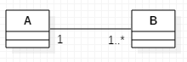

**_**F**_**2. (T/F) If the class diagram below has been implemented in code, the

following must be true at runtime: When an instance of class A is created, it keeps a reference to class B.

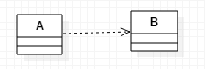

_T_3. (T/F) A Sequence Diagram shows the flow of communication between the running

objects of the system, driven by the use cases of the system.

_C_4. What happens when the main method in the following code is executed?

|  |  |
| --- | --- |
|  |  |

1. There is a compiler error.
2. There is a runtime error.
3. "From Base" is printed to the console.
4. "From Extension" is printed to the console.

_A_5. In the following code, which of the following is correct regarding the relationship   
 between Employer and Gardener? Circle one letter.

1. There is a dependency from Employer to Gardener
2. There is a one-way association from Employer to Gardener
3. There is a two-way association between Employer and Gardener
4. Not possible to determine from the code shown

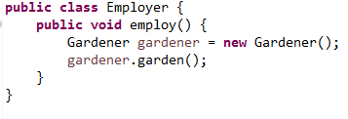

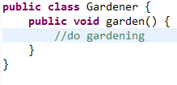

B, C, D 6. Consider the following class diagram:



Which of the following statements is (are) correct? Circle all that are correct.

* 1. Each instance of the class B contains a list of instances of A.
  2. Each instance of the class A contains a list of instances of B.
  3. A is a property of B.
  4. If an instance of A has been created, at least one instance of B has also been created.

_C_7. Which of the following UML diagrams correctly models the relationship between  
 Director and Program? The code for Director and Program is shown below.

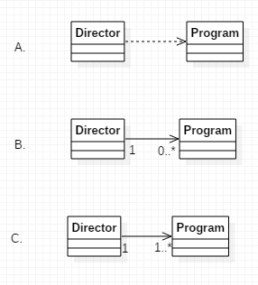

1. Consider the following Customer class. It contains instance variables of type Account, LocalDate, and List<Double>. (The Account class is also shown.)

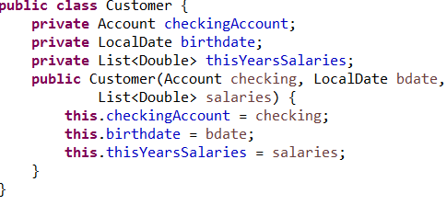



If this Customer class is modeled in a class diagram:

1. Which instance variables should be modeled as *attributes*?  
    birthdate, thisYearsSalaries
2. Which instance variables should be modeled as *associations?* checkingAccount

Explain your answer.

checkingAccount has an internal structure with its own attributes and behavior so it needs to be modeled with an association

The internal structures of date and listOfSalaries are not being modeled – we do not need to represent them with associations

**Part II: Skill Questions**

1. [10 pts] A rectangle can be specified by specifying two sides joined at an endpoint (in other words, length and width), but it can also be specified by specifying one side and a diagonal.

A. (5 points) The following code attempts to implement a Rectangle class and provide   
 support for   
 the two ways of constructing a Rectangle. The code does not compile. Why is there a  
 compiler error? (Write your answer below.)

Your Explanation:  
  
Java syntax does not allow two constructors with the same signature

Grading:

Student's answer must be essentially the same as the above answer.

1. (5 points) In the space provided below, rewrite the code for Rectangle (from Part A) so that it supports the two ways of constructing a rectangle. Use a technique described in the course.

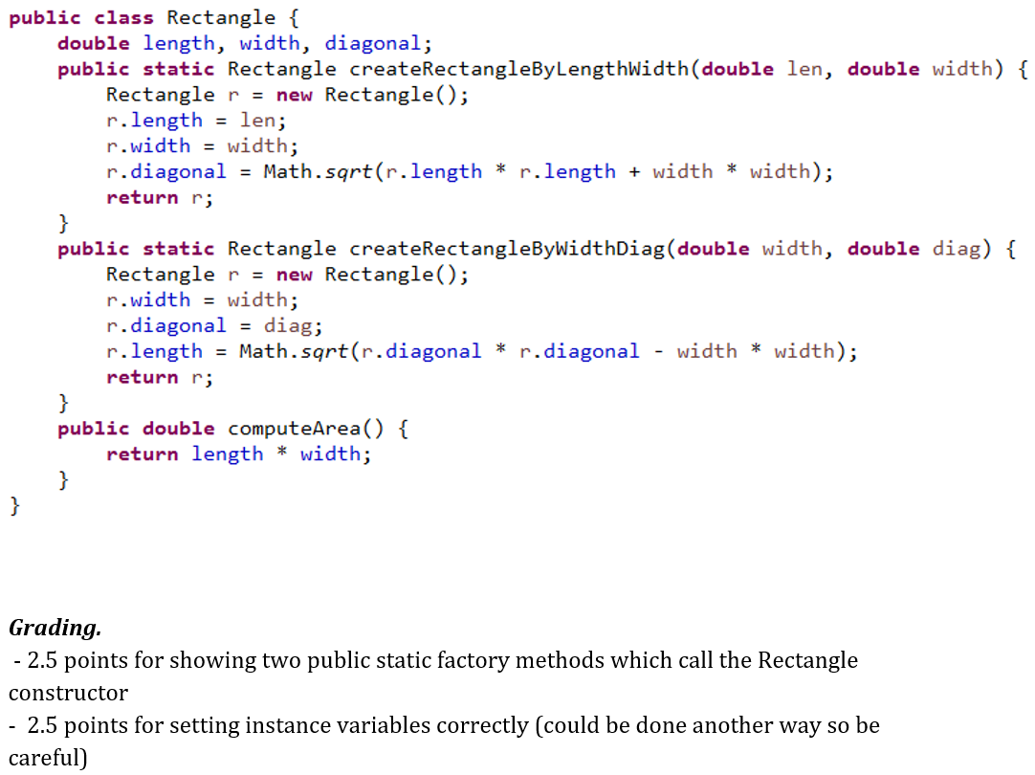

1. [8 pts] The diagram below shows that (for a particular application) there is a one-one bidirectional association between a UI class and a Controller class.

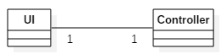

In the space provided below, write Java code that implements this diagram. Assume that UI and Controller are the only classes in a particular package. Your code must meet the following requirements:

* 1. The UI class owns the relationship, so it should not be possible to create an instance of Controller independently of an already existing UI class
  2. The code must show relevant instance variables, constructor implementations, and methods, sufficient to implement this model. (Show only those instance variables that are implied by the diagram. Getters for instance variables should be provided.) Note: Using this diagram, the only instance variables will be those that are implied by the bidirectional 1-1 relationship.
  3. All classes, properties, methods, and constructors must be given appropriate visibility qualifiers (private, protected, public, or package level).

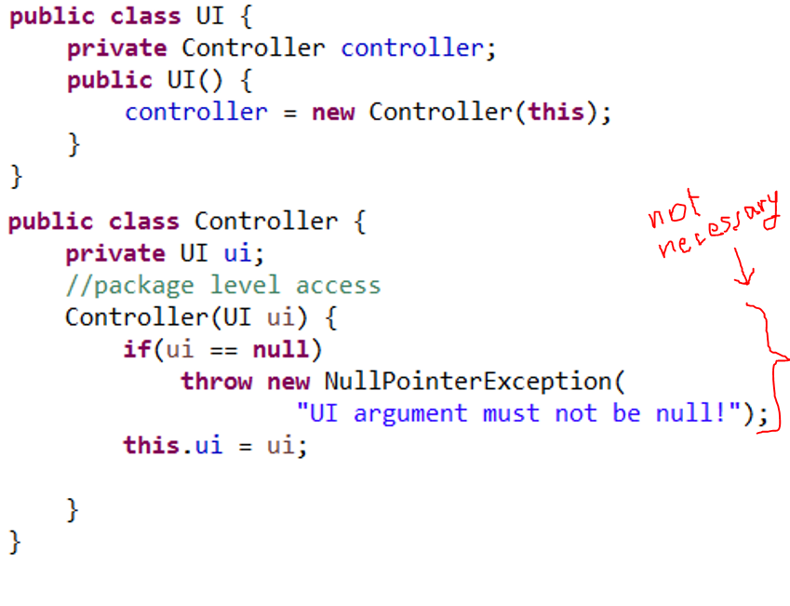  
Grading:   
 2 pts for having instance variables of each class in the other class

1 pt for calling Controller constructor inside UI constructor

1.5 pts for passing "this" in "new Controller" call inside UI().

1.5 pts for setting ui variable from within Controller constructor

1 pt for package level access of Controller constructor

3. [12 pts] In the problem description below, a properties management system is described. As a first step in analysis for providing a solution to this problem, a very simple class diagram is given below. For this problem, develop the class diagram further using inheritance and include associations (with multiplicities) and some operations for you classes. Your new diagram should use the new class Property for the purpose of inheritance.  
  
The code provided gives implementations of all the classes in the diagram shown below. Your objective is to update those implementations so that they correspond to the new version of the class diagram. Note that the Admin and Driver classes that have been provided for you have implementations that produce correct outputs, but the method computeTotalRent in Admin performs its computation by checking the types of different rental properties. You need to refactor the implementation of computeTotalRent so that the inheritance you have introduced in your new diagram is used and computation is performed using polymorphism. To do this you will need to implement and make use of the (unimplemented) class Property.  
  
Note: This problem is asking for 4 things:   
 (i) An improved class diagram that shows associations, multiplicities, inheritance (and uses

the Property class)

(ii) Refactored code in Admin and Driver; in particular, a rewritten version of

computeTotalRent(). (Note: You do not need to implement the functionality of listing all

properties in a certain city that is mentioned in the Problem Description below.)

(iii) Implementation of the Property class   
 (iv) Updates of the other classes provided so that they correspond to your new class diagram  
The Admin and Driver classes must be completely rewritten and an implementation of Property needs to be done (use the space provided for each of these). For the other classes, just make small modifications of the classes provided rather than rewriting the code for these.   
  
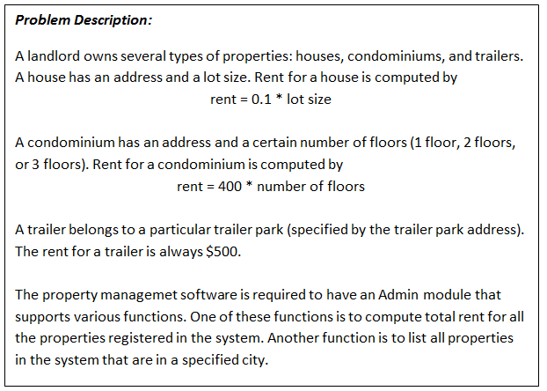

//Simple class diagram for this problem – you must create a new class diagram (next page)

// showing associations, multiplicities, a few operations, and a new inheritance relationship



//Your new class diagram should be drawn on this page  
  
  
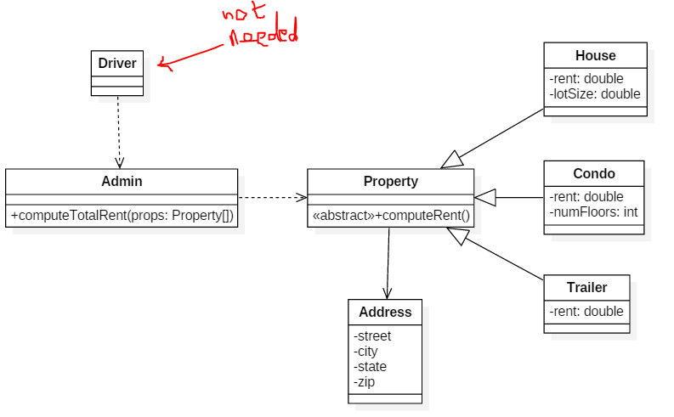

Grading: 6 points

Admin -> Property is a dependency   
 Three inheritance relationships  
 Property -> address association

//Your code for Problem 3 should begin here

//Implement Admin and Driver from scratch and give a new implementation of Property

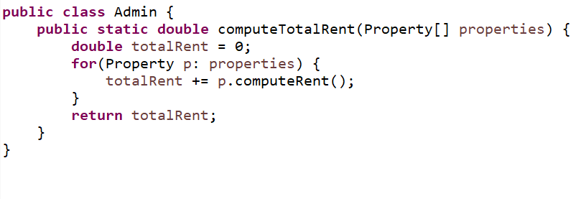

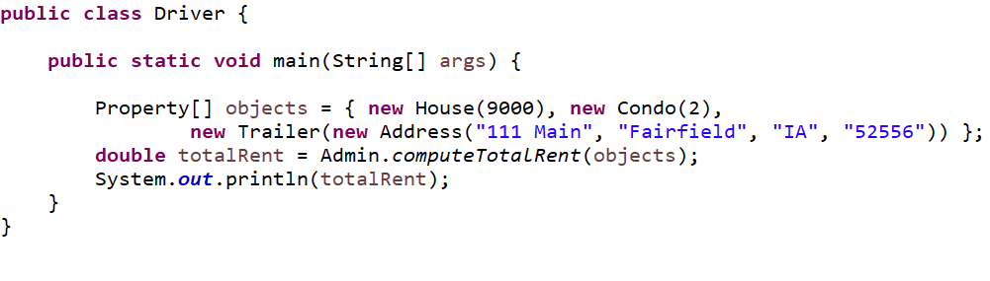

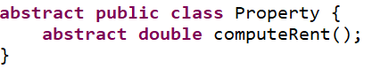

//Non-OO versions of Driver and Admin are shown here – your code

//above should refactor these

|  |  |
| --- | --- |
|  |  |

//Implementations of other classes are shown below. These

//must be updated as necessary so that they match your new class diagram

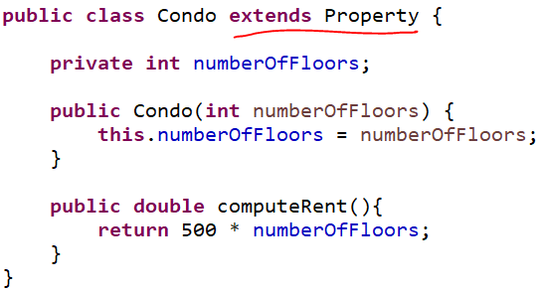

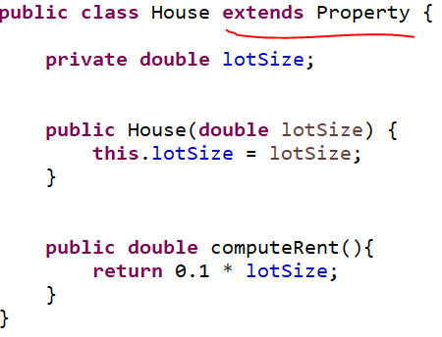

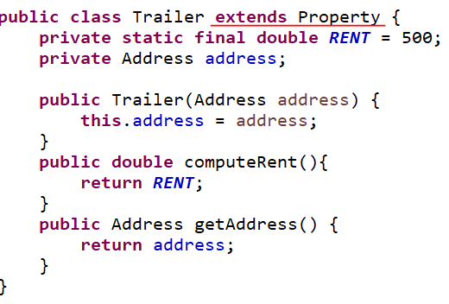

Grading: 6 points

1.5 coding Admin   
 1.5 coding Driver   
 1.5 coding Property  
 1.5 filling in "extends" in the three other classes

1. [8 points] Create a sequence diagram to model the dynamics of the problem given in Problem 3. Provide a diagram only for the main flow. In this case, the main flow will be the flow in which three properties – one house, one condominium, and one trailer – are passed to the computeTotalRent method in Admin (as shown in the Driver class implementation). Remember: sequence diagrams are concerned with run-time objects only.

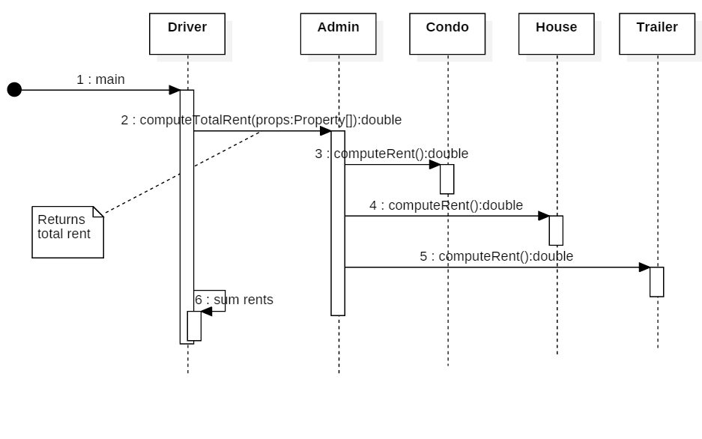

Grading:

1. All five objects should be shown

2. Array param for computeTotalRent should be shown

3. computeTotalRent should call computeRent for each Property

4. Sum of rents should be computed

5. Numbering and activation bars should be shown

**Part III: SCI.** [3 pts] In an ancient text, one reads the following:

*Know that by which all this is known.*

1. What does this expression mean? What is it saying? Is it some kind of SCI point?
2. Does this expression illuminate any aspect of the software engineering discipline discussed in class? Explain.