John Paz

Senior Technical Writer

Developer Documentation
Work Samples

Introduction
This portfolio highlights selected API, developer documentation, and technical automation projects. Each example summarizes the audience, problem, my contribution, and resulting deliverables.

Table of Contents
#1 “API proxy module”
#2 “Response object hydration”
#3 “Airbnb Python Documentation Automation”

#1 “API proxy module”

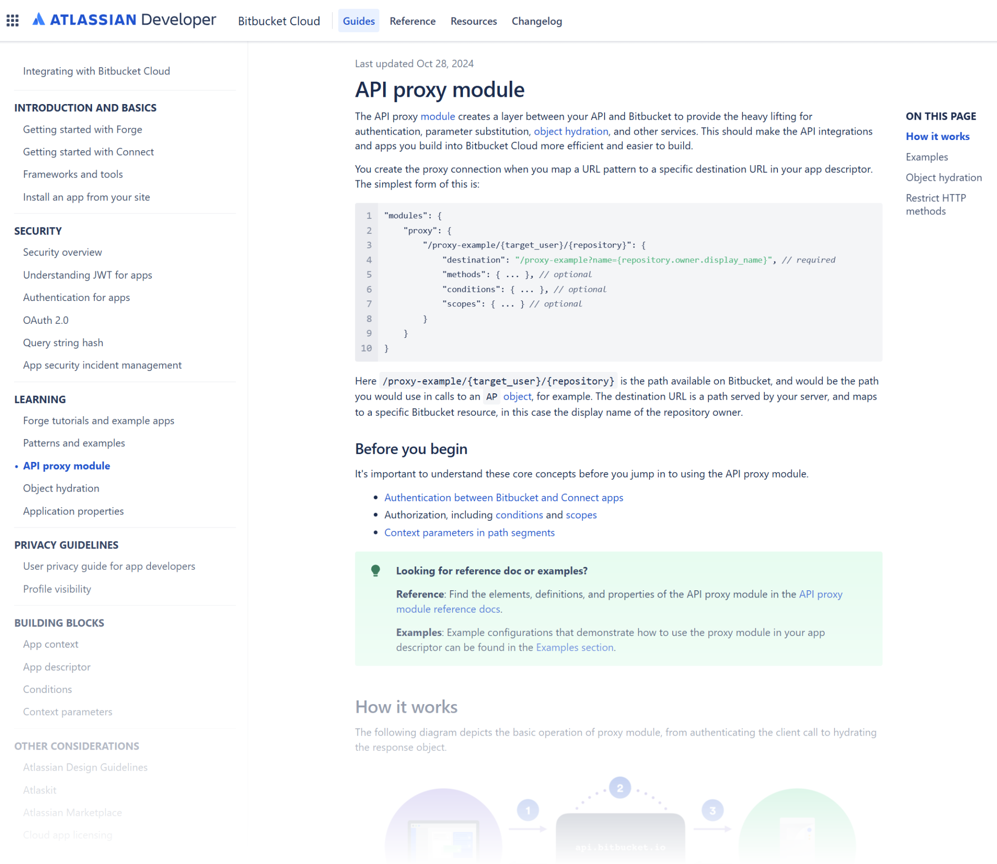
Overview
Content Type: API reference with code samples and diagrams
Purpose: Introduce new module, provide examples for use
Audience: Bitbucket Platform/Marketplace Vendor Development Teams
Role: Primary Actor
Team: Software Architect, PM
AI: None

Deliverables
- File/Link: API proxy module | Bitbucket Cloud Developer Documentation
- Publishing Details: None

Key Features/Background
Object hydration was originally documented as part of the API Proxy Module. As the content grew, I identified that the concept required its own page to remain usable and discoverable. I restructured the information architecture and partnered with an engineer to develop examples that demonstrated the core behavior without overwhelming developers.

#2 “Response object hydration”

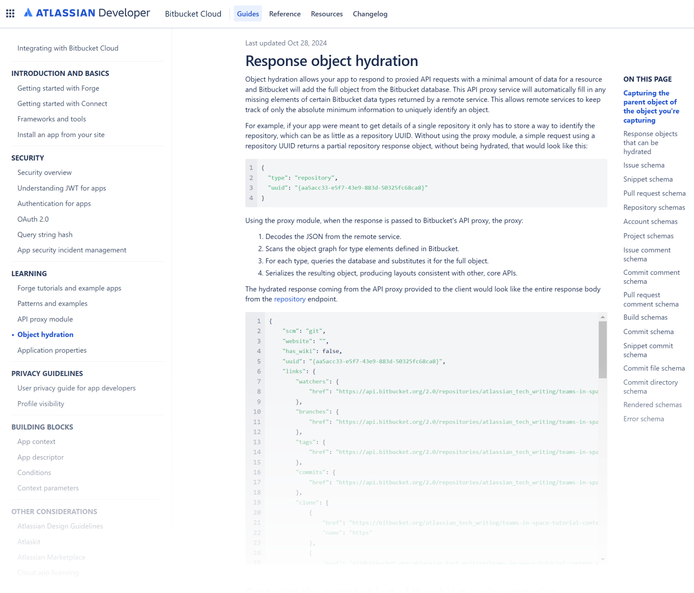
Overview
Content Type: API reference
Purpose: Document new module and endpoints, include examples for use
Audience: Bitbucket Platform/Marketplace Vendor Development Teams
Role: Primary Actor
Team: Software Engineer
AI: None

Deliverables
- File/Link: Response object hydration | Bitbucket Cloud Developer Documentation
- Publishing Details: None

Key Features/Background
I originally documented object hydration as part of the API Proxy Module, but the page became too long and the concept was difficult to understand in context.

Although the original assignment focused on the proxy module, the work revealed several related concepts that needed separate treatment. I broke object hydration into its own page, reworked the information architecture, and clarified the relationship between hydration and the broader API workflow.

I then partnered closely with an engineer to develop examples that demonstrated the essential behavior without overwhelming developers. The result was a focused, self-contained guide that made a complex concept easier to understand and apply.

#3 “Confluence Automation Toolkit”

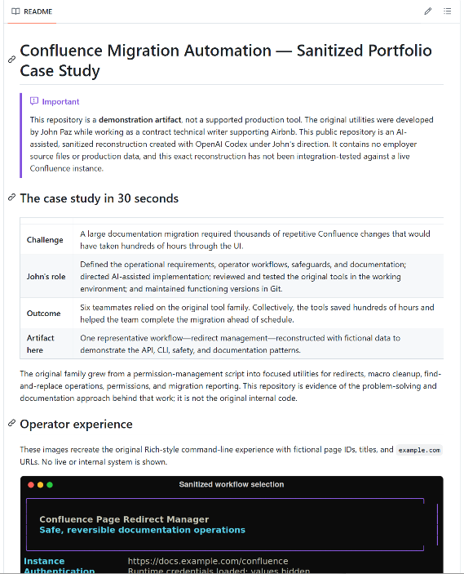
Overview
Content type: Documentation-operations case study
Purpose: Automate large-scale Confluence migration and maintenance work
Audience: Technical writers and content operations teams
Role: Requirements, workflow design, AI-assisted development direction, testing, documentation, and Git maintenance
AI: AI-assisted development with product requirements, testing, and version control

Deliverables
- Link*: View the sanitized technical case study
- Artifacts: Four Python CLI tools, operator documentation, batch-input templates, and audit-style output
- Environment: Large-scale Confluence content migration and maintenance
*The linked GitHub repository is a sanitized, AI-assisted reconstruction of one representative workflow—not the original internal source code. Codex performed much of the public reconstruction under my direction. It contains no proprietary data or credentials and has not been tested against a live Confluence instance. It is presented as a technical case study, not a supported product or an Airbnb-sponsored project.

Key Features/Background
While working as a contract technical writer supporting Airbnb, I designed a family of Python CLI tools to automate thousands of repetitive Confluence changes that would otherwise have required hundreds of hours of manual work.

Drawing on my knowledge of Confluence and the migration requirements, I defined the tools’ functionality, operator workflows, and safety controls. I directed AI-assisted implementation, reviewed and tested changes in the working environment, maintained functioning versions in Git, and documented the tools so other technical writers could use them confidently.

The toolkit supported permissions, redirects, macro cleanup, find-and-replace operations, and reporting. Confirmation steps, debug modes, progress reporting, version comments, and per-page results made large content changes safer, visible, and reproducible.

