John Paz, Senior Content Designer
  - Technical documentation writing samples

About this document
This document contains some examples of my work writing for a developer audience. For each example I include:
- considerations made for developing the content,
- an explanation of my contribution, and
- a description of the contribution made by others (where applicable).

During my tenure at Atlassian I wrote primarily for the developer audience. Developers have completely different expectations for content than the typical tech doc audience; they have less tolerance for content not directly addressing their issue, or that oversimplifies complex topics.

Technical content written for a developer audience
These first samples demonstrate my ability to explain some basic Git concepts (pull requests) in a way that's not patronizing and pitches the value-prop of using pull requests to make code better.

1a. Using pull requests in Bitbucket Server
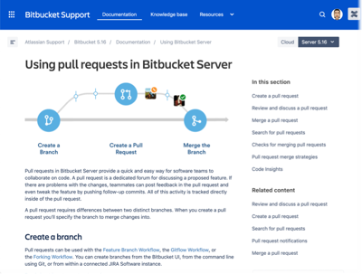
My contribution: This page initially was a step-by-step procedure that described how to create, edit, and merge a pull request. It also initially included some great conceptual content that was getting buried, and that users were skimming over (evident by their submitted feedback).

The page was trying to do too much and had become an unorganized list of features. I made it more of a landing page for finding more detailed content and figured an interesting-looking graphic might be more inviting for novice users to read through the content entirely.

I addition to rewriting all the content, I mocked up the graphic and commissioned a staff designer to create it, extracted the important content to their own pages, and encouraged
marketing to link more heavily to this page as a jumping off point for campaigns aimed at converting new users.

1b. Review and discuss a pull request
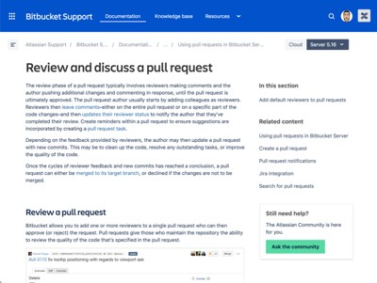
My contribution: This page was born of the adjustments to the "Using pull requests..." page mentioned above. Again, the content is aimed at people not familiar with Git. This was an interesting piece to write, in that much of the content I inherited, but I just happened to actually be part of the target audience for this content!

Even though I worked in Bitbucket everyday, there were times I didn't always understand what was expected of me. An example of this is a request to review a pull request. Unless you know what Git is, asking someone to "review a PR," does little to help you understand exactly how you're meant to do this. With that in mind, I optimized this page to "CTRL+F" quick finding, and sprinkled in some "why" in the introductory content to help users know what each procedure is for (instead of just telling them "how"). This sample demonstrates a mix of conceptual content with concrete steps.

1c. Pull request merge strategies (task/reference)
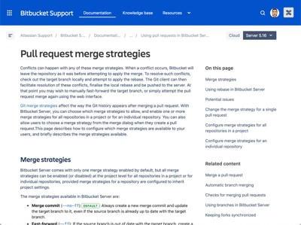
My contribution: This bit of content was some of the trickiest I'd ever written in my career up until that point, and not necessarily because of the complexity. This doc describes PR merge strategies in Git, which out of the box are already a bit more complex than they probably should be.

But this content always felt odd to me, especially considering a lot of the content from the options actually made it into the UI! Right away I knew I needed to be involved in this as early as possible. My contributions were a bit controversial initially. I took issue with much of the language we were using to describe the merge strategies. I felt things could be explained more clearly using less jargon.

2. Structured API reference documentation
My second stint with Atlassian I started on Bitbucket Cloud's developer documentation. It was my first-time writing developer documentation; with Bitbucket Server, I was writing content for developers, but wasn't asked to contribute much to the developer documentation. The former describes how developers use Bitbucket, the latter describes how to build integrations to use with Bitbucket.

My first contribution was to describe an entirely new way to use Bitbucket's API using a new module called the API proxy module. With it came a new group of resources to optimize what data app developers had to parse and store for their Bitbucket apps to adhere to the new GDPR privacy standards. This content explains these changes and provide examples to developers to help get their apps using the new standards.

2a. API proxy module
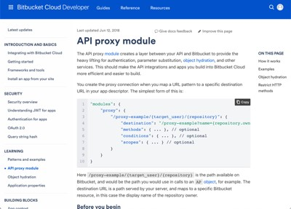
My contribution: Lots of investigation and interviewing SMEs to understand the use case for the API proxy, then to uncover how it's intended to be used by the public. Initially, this functionality was developed for an internal use case, but was built in a way where it could be used by external developers building plugins on our platform.

Like many features initially designed to be internal-only, the specifications and all the options weren't well-documented. There was disagreement about what the "happy path" looked like.

The initial assignment was "doc this," and it was my first undertaking on my new team, Bitbucket Cloud. But right away it was clear this one piece of doc wasn't going to be enough, as this new functionality didn't just add a single module, it added several other complimentary, but entirely separate, features that had to be explained. And, like most pieces of good developer content, it needed to include lots of examples that were very difficult for me to write on my own.

I paired with a developer for several days over a few sprints to create examples designed to demonstrate all the most important functionality, but in a way that builds up to increasingly more complex scenarios to avoid information overload.

2b. Response object hydration
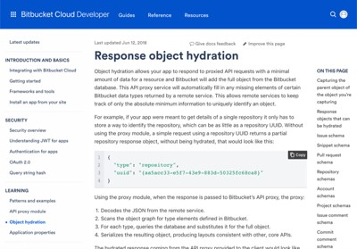
My contribution: Initially I wrote the API proxy module doc (mentioned above) with an entire section devoted to object hydration on the same page. This made the doc epic in length and tiny in user value provided.

The scope of the initial assignment didn't include writing several complementary sets of content in addition to the API proxy module doc, but it was clear that the task required more time and attention than was first expected. But once I broke out the object inflation section, the entire concept made more sense to me, and the document's final form took place.

The developer and I sat in a room over a few meetings to describe the perfect set of examples that will demonstrate all the vital functionality without confusing people. The result was a tight, but comprehensive, piece of content that I feel goes a long way towards helping devs get the most from their integration with Bitbucket.

