Workflow Basics Exercises

Hadley Wickham and Garrett Grolemund and Kim Roth; Edited by Johnathan Clementi

1/25/2020

These are somewhat modified exercises from the Workflow Basics Chapter of R For Data Science by Wickham and Grolemund.

The website where the book appears is (and will always be) **free to use**, and is licensed under the [Creative Commons Attribution-NonCommercial-NoDerivs 3.0](http://creativecommons.org/licenses/by-nc-nd/3.0/us/) License.

library(tidyverse)

## -- Attaching packages ----------------------------------------------------------------------------------------------------------------------------------------------- tidyverse 1.3.0 --

## v ggplot2 3.2.1 v purrr 0.3.3  
## v tibble 2.1.3 v dplyr 0.8.3  
## v tidyr 1.0.0 v stringr 1.4.0  
## v readr 1.3.1 v forcats 0.4.0

## -- Conflicts -------------------------------------------------------------------------------------------------------------------------------------------------- tidyverse_conflicts() --  
## x dplyr::filter() masks stats::filter()  
## x dplyr::lag() masks stats::lag()

1. Why does this code not work? Write code that works.

* my_variable <- 10  
  my_variabl
* ## Error in eval(expr, envir, enclos): object 'my_variabl' not found

This code will not run because the ‘my_variabl’ is not ‘my_variable’

my_variable <- 10  
 my_variable

## [1] 10

Look carefully! (This may seem like an exercise in pointlessness, but training your brain to notice even the tiniest difference will pay off when programming.)

1. Tweak each of the following R commands so that they run correctly:

library(tidyverse)  
  
 ggplot(datta = mpg) +   
 geom_point(mapping = aes(x = displ, y = hwy))  
   
 fiter(mpg, cyl = 8)  
 filter(Diamonds, carat > 3)

What I fixed: 1. ‘data’ = (not ‘datta’) 2. ‘filter’ (not ‘fiter’) 3. ‘==’ comparison operator (not ‘=’ assignment operator) 4. ‘diamonds’ (not ‘Diamonds’)

library(tidyverse)  
  
 ggplot(data = mpg) +   
 geom_point(mapping = aes(x = displ, y = hwy))

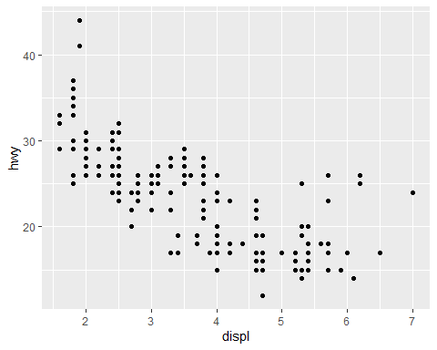

filter(mpg, cyl == 8)

## # A tibble: 70 x 11  
## manufacturer model displ year cyl trans drv cty hwy fl class  
## <chr> <chr> <dbl> <int> <int> <chr> <chr> <int> <int> <chr> <chr>  
## 1 audi a6 quatt~ 4.2 2008 8 auto(~ 4 16 23 p mids~  
## 2 chevrolet c1500 su~ 5.3 2008 8 auto(~ r 14 20 r suv   
## 3 chevrolet c1500 su~ 5.3 2008 8 auto(~ r 11 15 e suv   
## 4 chevrolet c1500 su~ 5.3 2008 8 auto(~ r 14 20 r suv   
## 5 chevrolet c1500 su~ 5.7 1999 8 auto(~ r 13 17 r suv   
## 6 chevrolet c1500 su~ 6 2008 8 auto(~ r 12 17 r suv   
## 7 chevrolet corvette 5.7 1999 8 manua~ r 16 26 p 2sea~  
## 8 chevrolet corvette 5.7 1999 8 auto(~ r 15 23 p 2sea~  
## 9 chevrolet corvette 6.2 2008 8 manua~ r 16 26 p 2sea~  
## 10 chevrolet corvette 6.2 2008 8 auto(~ r 15 25 p 2sea~  
## # ... with 60 more rows

filter(diamonds, carat > 3)

## # A tibble: 32 x 10  
## carat cut color clarity depth table price x y z  
## <dbl> <ord> <ord> <ord> <dbl> <dbl> <int> <dbl> <dbl> <dbl>  
## 1 3.01 Premium I I1 62.7 58 8040 9.1 8.97 5.67  
## 2 3.11 Fair J I1 65.9 57 9823 9.15 9.02 5.98  
## 3 3.01 Premium F I1 62.2 56 9925 9.24 9.13 5.73  
## 4 3.05 Premium E I1 60.9 58 10453 9.26 9.25 5.66  
## 5 3.02 Fair I I1 65.2 56 10577 9.11 9.02 5.91  
## 6 3.01 Fair H I1 56.1 62 10761 9.54 9.38 5.31  
## 7 3.65 Fair H I1 67.1 53 11668 9.53 9.48 6.38  
## 8 3.24 Premium H I1 62.1 58 12300 9.44 9.4 5.85  
## 9 3.22 Ideal I I1 62.6 55 12545 9.49 9.42 5.92  
## 10 3.5 Ideal H I1 62.8 57 12587 9.65 9.59 6.03  
## # ... with 22 more rows

1. Press Alt + Shift + K(pc) or Option+Shift_+K(mac). What does it do?

Shows keyboard shortcuts! That’s awesome! I will use that SO much