LCD Weight Display wit Pressure Sensor Input

Activity 1:

Description
For the first activity you will be learning how to display the R/C Discharge Time in the BASIC Stamp DEBUG Window. The force response of this sensor is approximately 1.6 lbs. using the Flexiforce Sample Drive Circuit. However, the best way to determine the correlation is by placing known weights on the end of the sensor and recording your RCTime values from the sample BASIC Stamp programs.

Parts required
This experiment requires the following parts:

(1) BS2
(1) FlexiForce Sensor
(1) 1 Jumper Wire
(1) 0.01 uF capacitor
(1) 0.1 uF capacitor
(1) 220 Ohm Resistor

Build It
Build the circuit shown in Figure 1-1.
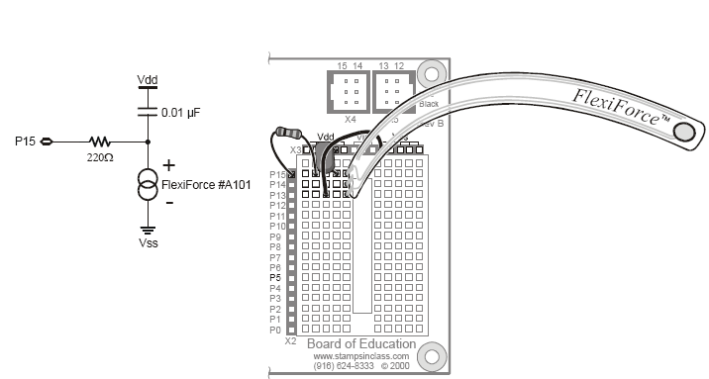
Figure 1-1

This example demonstrates the Flexiforce sensor in a BASIC Stamp resistor/capacitor time-discharge measurement circuit. For higher accuracy, replace the 0.01 uF capacitor with the 0.1 uF capacitor.

Program It
Once you have the BS2 properly set up you are ready to begin entering the code. The following code will display your output to the debug window of BASIC Stamp.

' {$STAMP BS2}
' {$PBASIC 2.5}

' -----[ Declarations ]----------------------------------------------------

rawForce VAR Word ' Stores raw output
sensorPin CON 15 ' Flexiforce sensor circuit

' -----[ Main Routine ]----------------------------------------------------

Measure:
HIGH sensorPin ' Discharge the capacitor
PAUSE 2
RCTIME sensorPin,1,rawForce ' Measure RC charge time
DEBUG HOME, "Flexiforce raw output = ", DEC rawForce,CR
GOTO Measure

The Output
The debug window should constantly keep updating itself as long as the pressure is changing. If the pressure on the FlexiForce does not change the output will stay the same. The Flexiforce single element sensor acts as a resistor in an electrical circuit. When the sensor is unloaded, its resistance is very high. Resistance decreases when force is applied to the sensor.

