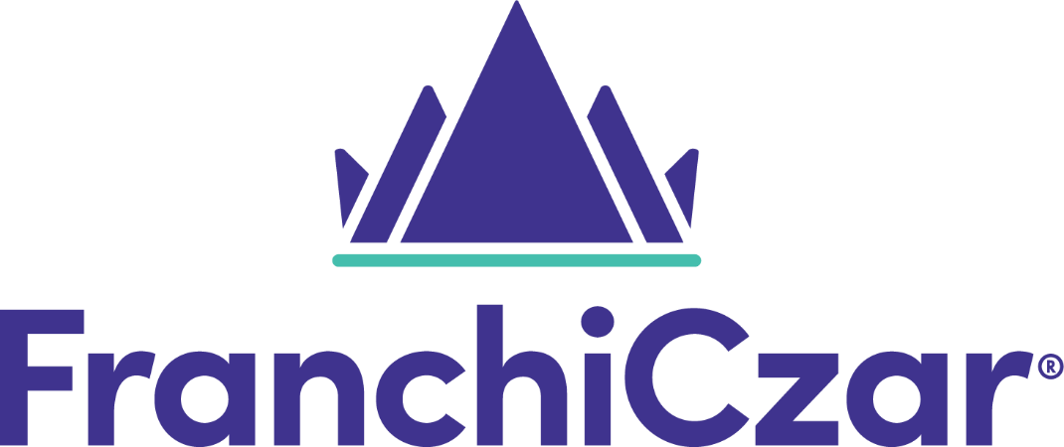

Document Management Procedure

Updated July 20, 2021
DCN DocMgmtPro-SOP-001
Version 1.0

Table of Contents
Purpose 3
Document Control 3
Definition 3
Scope 4
Responsibilities 4
Managing Director 4
Document Controller 4
Employees 5
Document Types 5
Controlled Documents 5
Non-Controlled Documents 5
Procedure 5
Document Creation 5
Document Format 6
Policies 6
Procedures 6
Consultation & Communication 7
Document Approval 7
Document Review 7
Obsolete Documents 7
Document Control Register 8
Version History Table 9

Purpose
The purpose of the FranchiCzar Document Management Procedure is to ensure that documents and records are appropriately created, captured, accessed, managed, and stored in a manner that reflects business, corporate, and regulatory compliance requirements.

Document Control
Measures shall be established to control the issuance of documents, such as instructions/user guides, procedures, policies, diagrams/drawings, and platform documentation, including changes thereto, which prescribe all activities affecting quality. These measures shall assure that documents, including changes, are reviewed for appropriateness, and approved for release by authorized personnel and are distributed to and used at the location where the prescribed activity is performed. Changes to documents shall be reviewed and approved by the same organizations that performed the original review and approval unless the applicant designates another responsible organization.

Definition
Term | Description
Author | The actual author of the document.
Controlled Document | Any document for which distribution and status are required to be kept current to ensure authorized users have the most current version.
Document Control | The process established in this procedure to define controls needed for the management of Work Health and Safety documentation.
Document Control Number | The number assigned to a document when it is entered into the document register as a controlled document. This number will always be the next sequential number in the register. This number is to be recorded on the controlled document in the (e.g. top left corner of the header).
Document Control Register | A list which identifies all FranchiCzar documents and includes current revision status.
DMS | Document Management System
FCOS | FranchiCzar Operating System
IP | Intellectual Property
Organization
PII | Personally Identifiable Information
SOP | Standard Operating Procedure
Uncontrolled Document | A copy of a controlled document. Uncontrolled documents may not be the latest version.

Scope
This standard operating procedure (SOP) applies to all documentation that is housed on the FranchiCzar OS (FCOS) and SharePoint platforms as well as all FranchiCzar future and potential documentation.

The document’s author/owner is responsible for adhearing to the process through which documentation is reviewed and approved according to the herein described procedure. Documentation authors/owners are also responsible for the submission of substantially revised documentation via the platform’s workflow; the (re)submission of any current documentation that is revised due to a change of the therein described procedure.

All documentation authors are responsible for ensuring compliance with this SOP.

Responsibilities

Managing Director
The Executive Vice President is responsible for:
- Ensuring the effective implementation of the document and records management system;
- Ensuring that appropriate resources are provided for the management of documents and records;
- Ensuring information, training and instruction is provided on the document and records management system; and
- The review and final approval of all FranchiCzar documentation.

Document Controller
The Document Controller is responsible for:
- Managing the document management process;
- Checking the quality of documents;
- Ensuring documents are developed using correct styles and format;
- Maintaining the document register;
- Maintaining all FranchiCzar records;
- Ensuring that only approved current versions of documents are available for use; and
- Archiving of all obsolete documents and records.

Employees
All employees are responsible for:
- Obtaining documents from the approved location;
- Not making copies (uncontrolled documents) of documents; and
- Participating in reviews of documents as required.

Document Types
Examples of documents are listed in the following sections, Documents in Document Management System (DMS) (FCOS and/or SharePoint). Each department defines what documents are Controlled Documents and are handled as such via the DMS.

Controlled Documents
- Have an expiration date (revision date)
- Are revisable in accordance with approved processes
- Are (commonly) distributed on a timetable
- Have a controlled (limited) access for revision and distribution
- Contains Personally Identifiable Information (PII) or Intellectual Property (IP)

Non-Controlled Documents
- Copies or drafts of Controlled Documents

Procedure

Document Creation
Any FranchiCzar employee or contractor may identify and request the need for a new document. The employees’ direct supervisor shall be consulted on the need for any documentation. Direct supervisor shall then verify if there is a document already existing within the Document Management System meeting the requirements of the request. Where no suitable document exists, the direct supervisor shall arrange for the document controller to develop the new document.
The requirement for new or additional documents may be based on, but not limited to:
- Legislative requirements;
- Suggestions from workers;
- Suggestions/requests from FCOS users;
- Scheduled system updates/changes;
- System failures/bugs reported;
- Internal or external audit findings;
- Outcomes of workplace inspections and monitoring;
- Industry or organizational best practice; or
- Changes in business activities and or structure.

The development of all documents shall include consultation and communication with employees who perform the work to ensure key risks are identified.

Document Format

Policies
The following standard format shall be used for all Policies:
- Purpose and Scope; and
- Responsibilities.


All FranchiCzar Policies shall be signed by the Executive Vice President and dated.

Procedures
The following standard format shall be used for all Work Health and Safety Procedures:
- Title;
- Purpose;
- Definitions;
- Scope;
- References;
- Responsibilities;
- Procedure content;
- Performance measures (where applicable);
- Appendices (where applicable); and
- Version History/Review Table

Document Properties
All FranchiCzar documentation shall display the following document properties:
- Document control number;
- Version number;
- Issue date (Version History Table);
- Review date (Title Page/Version History Table);
- Document Owner; and
- Document approver.

Consultation & Communication
Consultation on new or revised documents is required prior to approval.

Evidence of consultation shall be documented through meeting minutes, memorandums or emails and records maintained. Feedback shall be reviewed and incorporated into draft documents, where relevant, and a final draft prepared by the Document Controller for approval.

Document Approval
New or revised final draft documents shall be approved by the direct supervisor.

Once approved, the final controlled document shall be released by the Document Controller via the FCOS platform and/or SharePoint and communicating requirements to relevant personnel to allow implementation.

Document Review
All documentation that forms part of FranchiCzar and/or FCOS document management system shall be formally reviewed at least once every year in order to ensure it is still up to date. Reviews may be scheduled or unscheduled.

The review shall ensure that the following is considered:
- The continuing suitability and relevance of the documentation;
- The accuracy and clarity of the documentation;
- Compliance with current legislative requirements;
- The effectiveness of the document in achieving desired outcomes;
- Identified areas requiring improvement;
- The creating of any new documents and removal of obsolete documents; and
- The status / currency of any attachments / references included in the documents.

Obsolete Documents
Obsolete controlled documents are those which are no longer required, replaced, or superseded as determined by the needs of the Document Management System. Obsolete documents may be identified as part of the review process and shall be removed from the website and appropriately archived to prevent unintended use. Archived documents must be retained and accessible for system evaluation and legal purposes.

All documentation identified as obsolete shall be removed from points of issue by the Document Controller, archived electronically (if applicable) or in hard copy and retained for system evaluation purposes and legal requirements (where relevant).

Document Control Register
A Document Control Register shall be maintained by the Document Controller for all FranchiCzar documentation created or modified.

The Document Control Register shall include the following information:
- Document number;
- Document type;
- Document title;
- Issue date;
- Revision number;
- Description;
- Review date; and
- Owner.

Version History Table

Date | Version | Description | Owner | Approver
07/20/2021 | 1.0 | Document created | John Beatty

