1. Executive overview:

Many bars and restaurants use an inefficient method of keeping track of the liquor they have sold. In the interest of saving time, the standard is to “eyeball” the level of the liquid in the bottle in relation to it's label and basically guess the percentage of remaining liquid. While this certainly is a method of tracking inventory that is popular among many establishments, it makes it difficult to track things like waste or spillage.

2. General overview of solution

My solution would simply be to weigh the bottles before and after each shift, compare the remaining weight to that day's sales, and calculate any waste. This is not only a more efficient way to keep track of product, but it narrows down any potential theft or negligent pouring by employees.

3. Overview of Frames

Menu

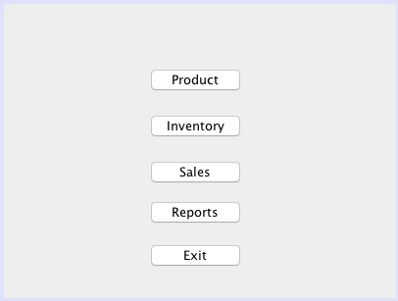

Upon running the application, the menu screen will pop up allowing the user to select which frame they would like to use.

Product Frame

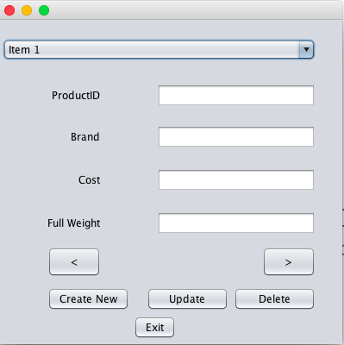

The product frame allows the bar management team to add, delete and update products that are stored in inventory. The User selects product from the drop down list and enters cost and full weight. The “Create New” option clears the text fields and allows the user to add a new product by selecting the “Update” button. Alternatively, if a bar were to no longer carry a certain brand, the user can mark a particular brand inactive from the database by clicking “Delete.” This frame would only be accessible by the owner of the establishment.

Inventory Frame

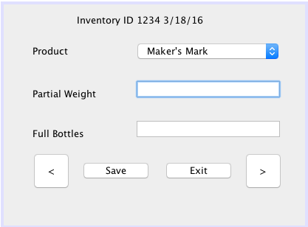

The user can select a previous inventory or create a new one. When a new inventory is selected, the application will create a new Inventory ID that will tie all of the records for this “point in time” inventory together. User will select product from the combo box based on the bottle they are about to weigh. Once the bottle is weighed, the user will enter that weight as Partial Weight, and catalog the amount of Full Bottles in storage. A save will create a unique Inventory ID that can be accessed in the Inventory Report Frame.

Sales will be imported from the Point of Sale System

Inventory Report.

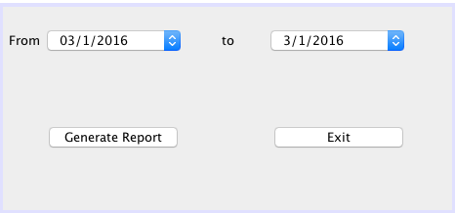

In the Inventory Report frame, the user will be able to specify two dates to compare inventories and generate a spreadsheet that will show the partial weights and full bottles of each respective inventory. The generated spreadsheet will also show the units wasted and the dollar value of the wasted units.

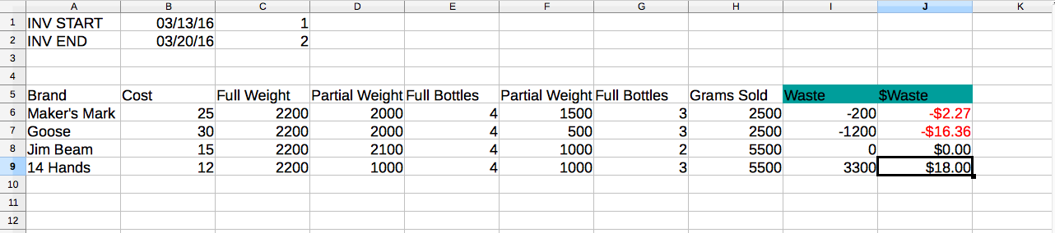

ERD

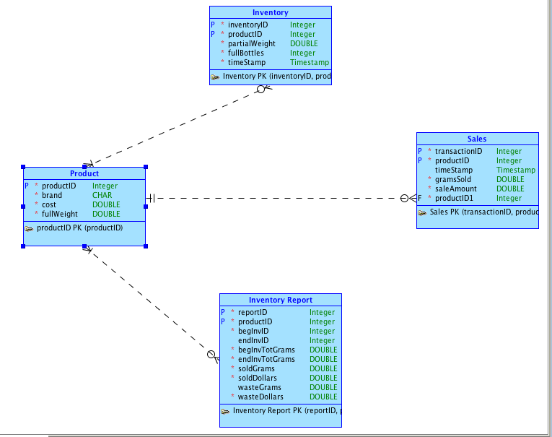

The Product table is the parent table with productID represented as the foreign key to all three child tables in an N:M non-identifying relationship. The product table has attributes of brand, cost, and full weight.

The Inventory table contains a unique inventoryID as it's primary key that ties together the productID, partial weight of an individual bottle, the amount of full bottles in storage, and a timestamp.

The Sales table contains a transactionID as it's primary key along with productID, grams sold, the dollar amount of a sale, and a timestamp. Most of this information will come from an establishment's point of sale system.

The Inventory Report table lists a beginning inventory ID and an end inventory ID to compare two individual inventories as well as a beginning total grams and ending total grams. The table also shows the total grams sold, the dollar amounts sold, the waste in grams, and the dollar amount of the waste.

4. Security

This application will have two roles: admin, and manager. An admin can add users, define roles, and will have access to the Product Frame, allowing them to update and delete product. Managers will be able to access the Inventory Frame.