1. Executive overview:

Many bars and restaurants use an inefficient method of keeping track of the liquor they have sold. In the interest of saving time, the standard is to “eyeball” the level of the liquid in the bottle in relation to it's label and basically guess the percentage of remaining liquid. While this certainly is a method of tracking inventory that is popular among many establishments, it makes it difficult to track things like waste or spillage. The product is sold by weight, it should be inventoried by weight.

2. General overview of solution
My solution would simply be to weigh the bottles before and after each shift, compare the remaining weight to that day's sales, and calculate any waste. This is not only a more efficient way to keep track of product, but it narrows down any potential theft or negligent pouring by employees.

3. Technical descriptions

Product Frame

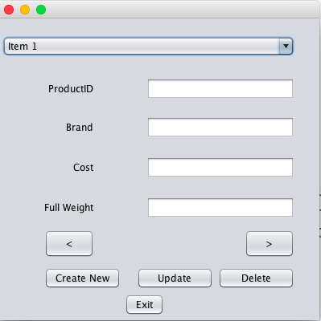

The product frame allows the bar management team to add, delete and update products that are stored in inventory.
The User selects product from the drop down list and enters cost and full weight. The “Create New” option clears the text fields and allows the user to add a new product by selecting the “Update” button. Alternatively, if a bar were to no longer carry a certain brand, the user can mark a particular brand inactive from the database by clicking “Delete.” This frame would only be accessible by the owner of the establishment.

Inventory Frame

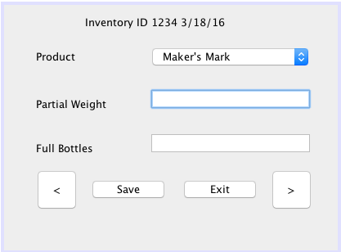
User will select product from the combo box based on the bottle they are about to weigh. Once the bottle is weighed, the user will enter that weight as
Partial Weight, and catalog the amount of Full Bottles in storage. A save will create a unique Inventory ID that can be accessed in the Inventory Report frame.

Sales will be imported from the Point of Sale System.

Inventory Report
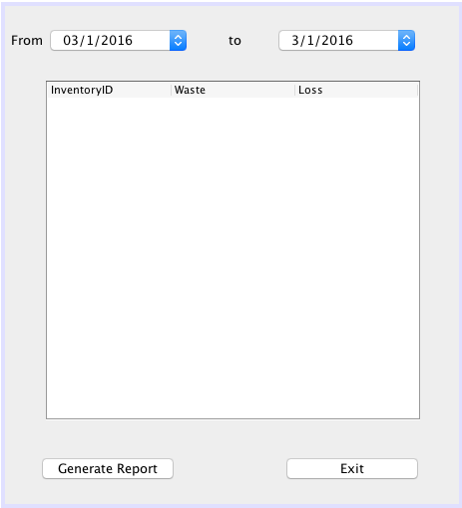

From this frame, the user will be able to view their
total waste and dollar loss between any two
dates specified by the combo boxes.

4. Technical Description

ERD

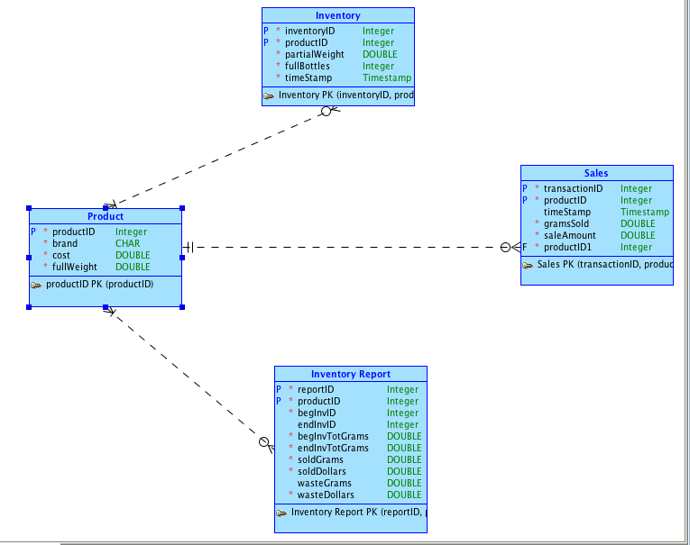

3. Security
This application will have two roles: admin, and manager.
Admin - can add users, define roles, and will have access to the Product Frame, allowing them to update and delete product.
Manager - access the Inventory Frame and run reports.

Ideally the best way to prevent waste and theft in this industry is to hire dependable employees

