
SOC(Security Operation Center)
A Security Operation Center(SOC) is a centralized function within an organization employing people, processes, and technology to continuously monitor and improve an organization’s security posture while preventing, detecting, analyzing, and responding to cybersecurity incidents. There are different types of SOC but we’ll be building an Internal SOC
How SOC Works
- Threat Monitoring
- Investigating Alerts
- Responding Incidents
Technologies Required
- SIEM(Wazuh)
- Endpoint Detection and Response – EDR
- Ticketing System – Services Now/ Jira
- Threat Intelligence Platform- TP
- SOAR
- Cisco Switch(for LAN setup)
- Fortinet Fortigate Firewall

Process.
- Threat Monitoring
- Incidendent Response
- Risk Management
- Threat Interlligence
- Vulnerability Management

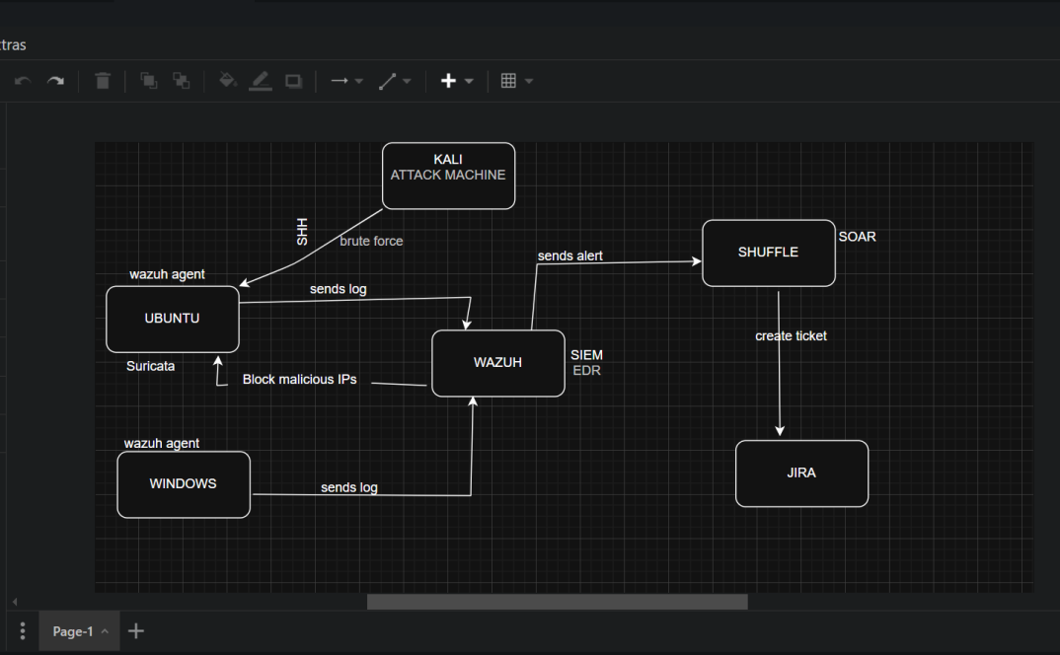

internet
FIREWALL
Kali Attack Machine
A
UBUNTU
IDS & IPS
SWITCHCH
WINDOWS

SIEM EDR
WINDOWS RUNNING WAZUH
Sends alert Ticket
SHUFFLE
JIRA
SOAR

