## **Web test task**

Please test Contact Us form that is shown below.

## **There is no file in attachments block.**

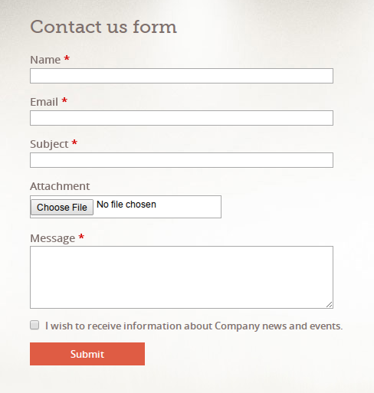

## **The form includes the following requirements:**

1. Name/Email/Subject/Message - input fields. All fields are mandatory;
2. "Name" field: Maximum length of the this field is up to 80 characters. Only English characters are allowed. Special characters are not allowed;
3. "Email" field: Email part before @ (login) corresponds to this conditions:

3.1 Maximum length of this part of email is up to 64 characters;

3.2 Only English characters in upper/lower case;

3.3 Digits (from 0 to 9);

3.4 Special characters are allowed to use in the middle of the this part (not the

first and not the last character) and shouldn't repeat twice in a row.

4. Email part after @ (domain) corresponds to this conditions:

4.1 English lowercase letters;

4.2 Digits (from 0 to 9);

4.3 "Dash" symbol;

4.4 "Dot" symbol;

5. "Subject" field corresponds to this conditions:

5.1 User can enter English characters,

5.2 Digits (from 0 to 9);

5.3 Special characters;

5.4 The maximum length of string is up to 255.

6. Attachment block contains "Choose file" button.

6.1 User can upload pdf/doc/txt/jpg/png/gif files by clicking on "Choose file" button.

6.2 The maximum file size is 2MB.

7. "Choose file" button: By clicking on this button modal window has been

opened.

8. "Message" field:

8.1 Digits (from 0 to 9);

8.2 English characters;

8.3 Special characters;

8.4 The length of string is up to 1000 characters.

9 'I wish to receive information about Company news and events.' checkbox.

9.1 If checkbox is checked, the regular notification with latest updates are

provided to the user's email address.

9.2 Information about checkbox state (checked / default) is stored in the column in

the database 'subscribe' in the table 'Feedbacks';

10. "Submit" button:

10.1 If user clicks on this button, validation of filled in data is started.

10.2 If the data are not valid, user can see three type of error messages.

11. Error messages:

11.1 "This field is required and can not be empty" - mandatory field is not filled in;

11.2 "Incorrect data. Please fix it before submitting the form" - field has invalid data;;

11.3 "This file is not supported" - if the attached file is not supported.

12. Mail to user and site administrator will be sent after user clicks on "Submit" button.

Text for email is depend on checkbox state.

12.1 User gets "Thanks for the feedback. Administrator will contact you soon."

message, if checkbox was not checked.

12.2 User gets "Thanks for the feedback. Administrator will contact you soon.

You've subscribed for updates of our company." message, if checkbox was

checked.

13 These contact forms are stored separately in the database table, as well as in the

admin panel under 'Feedbacks';