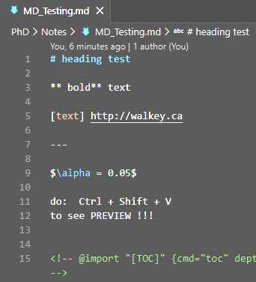
heading test
MARK DOWN Doc from VS Code to .docx (or pdf)
** bold** text
[text] http://walkey.ca

$$α=0.05$$
do: Ctrl + Shift + V to see PREVIEW !!!
IN Terminal: pandoc Notes/MD_Testing.md -o Notes/MD_Testing.docx
pandoc Notes/MD_Testing.md -o Notes/MD_Testing.pdf
alt text Ctrl + Shift + P
Tasks: Run Task
Preview with:
Ctrl + Shift + V
HTML-style comments:
These are ignored in previews, Word, and PDF.
✔ Works everywhere
✔ Pandoc-safe
✔ Invisible in exports
✔ Best for notes-to-self

If it starts with <!—and ends with -- >
it’s a real Markdown comment.

👉 Uses both Pandoc and LaTeX (MiKTeX)

