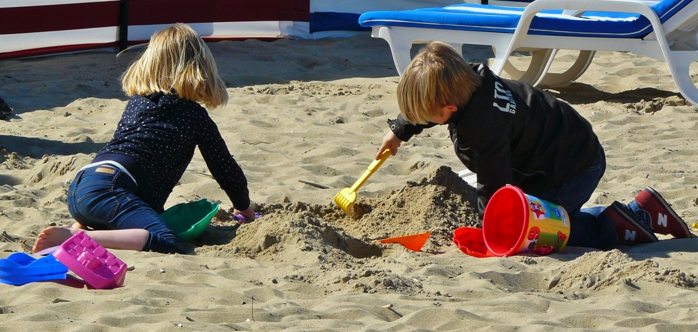

AUGUST NURSERY NEWSLETTER 2019

**Parents/Carers:**

Can’t believe we are halfway through the summer holidays already. Hope you have all been enjoying the nice weather and have been able to get a trip to the beach.

**New staff: -**

We would like to congratulate Rosin on her new post, Rosin has been working in the nursery over the past few weeks and will be taking on the role of working in the 3-5 room in the mornings and then moving across to the after schools room for the evening, we hope that you will enjoy your new role.

We would also like to introduce Amelia; Amelia will start in the 2-3 room and will work Tuesday – Friday, we would like to welcome her into the Magic Roundabout team, and we hope she enjoys her new role.

**Summer Club: -**

We are now half-way through our summer scheme. Each week we will display a list of activities which the children will partake in. This will be displayed in both the front entrance and on the door of afterschool’s room, If there are costs to any activity this will be displayed. If the children are going on a picnic, then we ask for parents to supply a sandwich for their child. We will supply the additional snacks to make the lunch up. ask Stacey to show you this. We also ask as the weather is so changeable that parents ensure that they send in coats for their children if there is a trip, Thank you for your co-operation.

**Head lice**

This is just a reminder to parents to regularly check your children’s hair for head lice. Thanks

**Birthdays**

Birthday boys and girls of August

|  |  |  |  |  |
| --- | --- | --- | --- | --- |
| **BABY 1** | **BABY 2** | **2-3’s** | **3-5’s** | **A.School’s** |
| Pippa | Lily | Reuben | Sophie | Malachi |
| Robyn | Niamh Mc A | Chloe | Henry | Dainin |
|  | Niamh Q | Ryan | Oscar | Maddie |
|  | Neve | Sean |  |  |
|  | Sophie |  |  |  |

We hope you all have a lovely time celebrating your birthday with family and friends.

**New school year**

Hard to believe we have come to this stage of the year already. Can we please ask that as your children receive their settling in schedules for pre-school or P1 that you give the nursery a copy. This is particularly important if we need to collect your child through this period as we need to ensure we have pick up times organised. Thanks to all for your co-operation.

**New faces in nursery**

We welcome some new faces into nursery. We hope you all settle in quickly and make lots of new friends.

|  |  |  |
| --- | --- | --- |
| **Baby 1** | **Baby 2** | **2-3’s** |
| Pippa | Isla | Caoileann |
| Aoibhinn |  | Chloe |
| Erinn |  |  |
| Cassie |  |  |

We are currently working on inputting a new nursery system. This will replace nursery pal and will include a lot of new features for both the nursery and the parents. We will keep you all up to date regarding this transition. Can we ask in advance for your patience and co-operation as I’m sure there will be some teething problems. We will work with the two systems initially until we are a little more confident and then Connect Childcare will go live. We are hoping this will benefit the nursery as a whole and increase our parent partnership with you all.