

SEPTEMBER 2019 NURSERY NEWSLETTER

I’m sure like myself you can’t believe it’s back to school time. The past week has been emotional as well as busy as we waved our little ones of to pre-school and school. Some of the children who went off to nursery have been here from we first opened and have come all the way from baby room. It’s hard to believe that within two years children can progress so far. We wish them all good luck and we hope everyone settles back into school quickly.

**Parents/Carers:**

**Starting nursery/school**: Can we ask parents/carers to please keep in touch with us regarding your child’s settling in schedule in nursery etc. The schedule changes each week until they are in their full hours and this differs in each individual school/nursery, so if you require your child to be dropped and/or picked up then we ask you to please let us know. Thanks in advance.

**Headlice:** Can we ask that you continue to check your child’s hair for headlice as they start the new school year. Prevention is better than cure. If your child does get headlice can we also ask that you let either Caroline or your child’s room leader know so we can watch out for further outbreaks.

**Fundraising:** if you can cast your mind back to December last year and remember our Santa who visited the nursery. This Santa came from Belfast from an organisation call Tiny Life.

***Tiny Life is a charity committed to providing a range of support services that meet the growing needs of families of premature and ill babies in Northern Ireland. Tiny Life continues to support vital research to ensure that every pregnancy has the best chance of a healthy outcome and a healthy baby.***

**We promised “Santa” (Tiny Life) that we would hold a fundraising event this year. This has been discussed within the nursery and the idea of participating in a local 5K would be an idea which everyone could become involved with. The proposed event is the 5K Spooktakular which takes place through the town centre and this year it will be held on Friday the 25th October at 8pm. We would like to ask Parents/Carers to please let us know if you would be interested in taking part. Staff within the nursery will also take part. We will get fundraising forms from Tiny Life and using these hopefully raise some valuable funds for the charity. Children must be accompanied by an adult and can not be registered as a participant due to insurance limitations If we get a good response, then we will go ahead and organise the group from Magic Roundabout. You can run, walk, push buggy etc. Registration to the event costs around £12 (this was last years price so estimating from this) and we will collect this and pay as a group and then we ask that you get sponsorship from your family and friends collecting as much as you can. We will keep you updated on this when we see what interest there is in the event. Thanks in advance.**

**Birthdays:**

|  |  |  |  |  |
| --- | --- | --- | --- | --- |
| **Baby 1** | **Baby 2** | **2-3’s** | **3-5’s** | **A.School’s** |
| **Sean 27th** | **Dara 1st** | **Dylan 13th** | **Rory 14th** | **Yuriy 10th** |
|  | **Teagan 6th** | **Lilly McG 15th** | **Bella 15th** | **Luke 17th** |
|  |  | **Brooke 20th** | **Isla 28th** |  |
|  |  | **Lily-Rose 23rd** |  |  |
|  |  |  |  |  |

**We hope you all have a great birthday and enjoy celebrating with family and friends.**

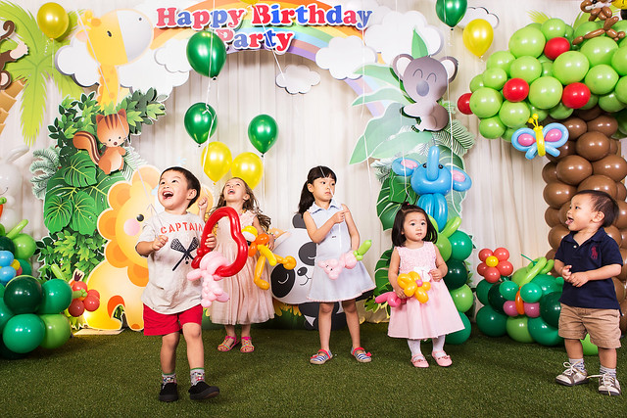

**New starts:**

**We would like to welcome some new little faces into nursery. We hope you all settle in quickly and enjoy your time as you make lots of new friends.**

|  |  |  |
| --- | --- | --- |
| **Baby 1** | **Baby 2** | **3-5’s** |
| **Niamh** | **Elle** | **Elizabetha** |
|  |  |  |

**New nursery system:**

We are currently working on inputting a new nursery system. This will replace nursery pal and will include a lot of new features for both the nursery and the parents. We will keep you all up to date regarding this transition. Can we ask in advance for your patience and co-operation as I’m sure there will be some teething problems. We will work with the two systems initially until we are a little more confident and then Connect Childcare will go live. We are hoping this will benefit the nursery as a whole and increase our parent partnership with you all.

**Coats:**

**As the weather is changing can we remind parents/carers to please send a coat in each day with your child. Please ensure your child’s coat as well as fleeces, jackets, jumpers etc are all named as we always seem to end up with a lot of lost property which is hard to find owners for. This would be greatly appreciated.**

**Nappies/wipes/spare clothes:**

**Can we ask that when staff ask for the above that they can be brought in promptly. We appreciate that i can be hard to remember this on a busy morning trying to get out to work but if you can appreciate that sometimes we are borrowing from others and this is unfair. Spare clothes particularly if your child is toilet training needs to be brought in each day. We are constantly running out of nursery spares. Can I also remind parents of children who are potty training to please ensure your child is wearing items of clothing which are easily pulled up and down. If you have pants and socks which your child has grown out of then these would be very much appreciated as spares, as we never seem to have enough. Thanks in advance.**

**If you bring any of the above ~~in in the morning particularly~~ into breakfast club room, can we ask that you write your child’s name on the bag as sometimes at the end of breakfast club we find items which have been left in the dining room unnamed and we don’t know who they belong to. Thank you in advance.**

**Wedding Congratulations:**

**I’m sure everyone is aware our Gemma got married last week. The children in 3-5 where all excited. Her big day was Saturday the 31st August and she looked fabulous. It was a great day!! Gemma is back with us for a little while before she goes off on honeymoon. We wish her a long and happy married life. Congratulations from us all Gemma!!!**

Congratulations from all your little toots!!!

 