***DOST-X Scheduling and Relevant Communication System***

**USER MANUAL**

1. 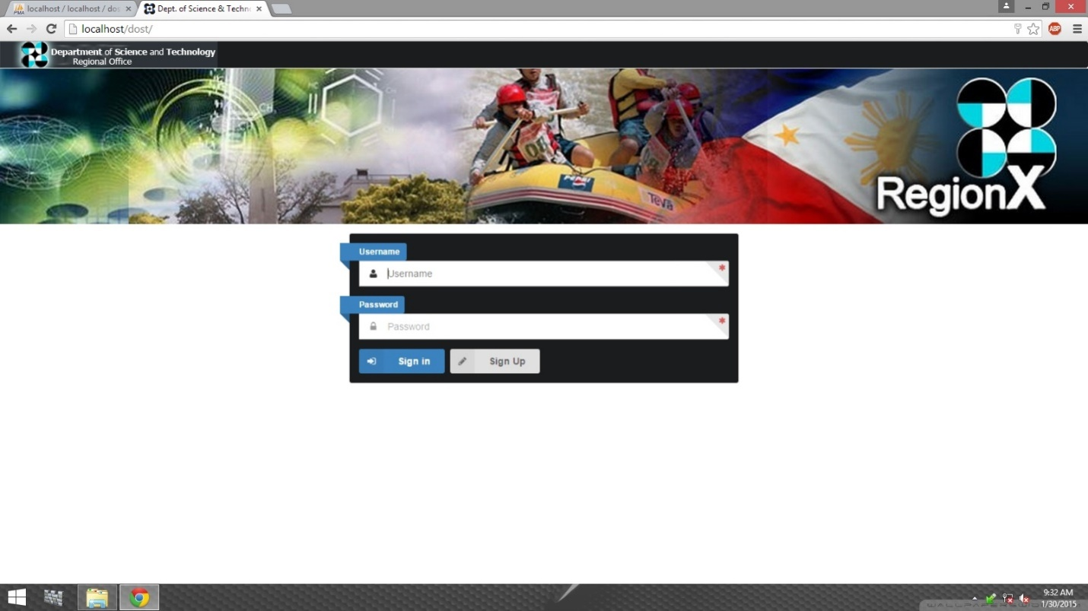

* In this page you can see the Login page of the System where you can login your users account and click Sign in. if you didn’t have sign an account yet click the Sign up button.

1. 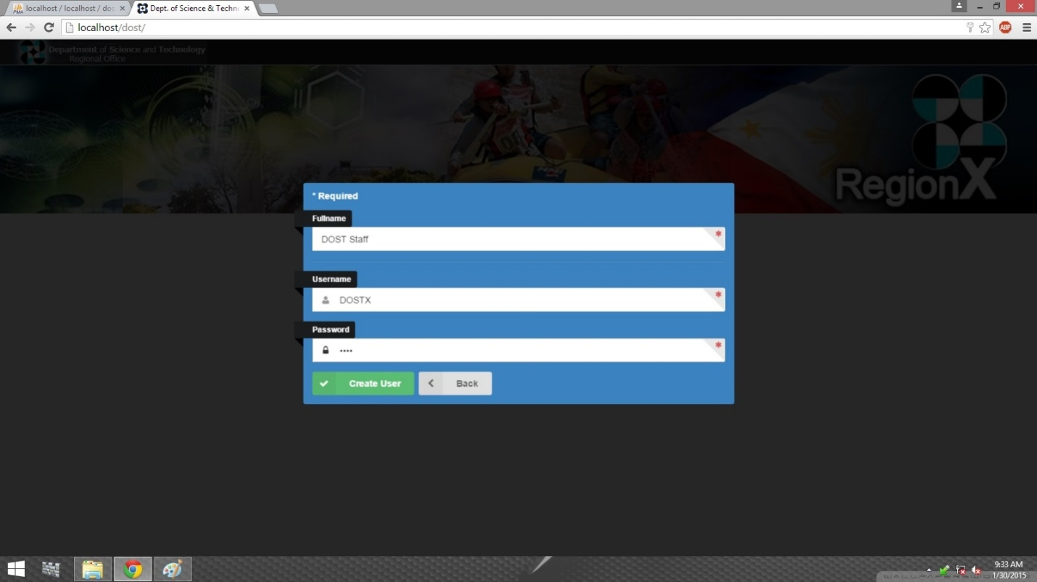

* After you have clicked the Sign Up button. This page will pop-up and will ask for your Full name, User name and password for the system. After you have filled the necessary fields click the Create User button. And then you can know login to the system.

1. 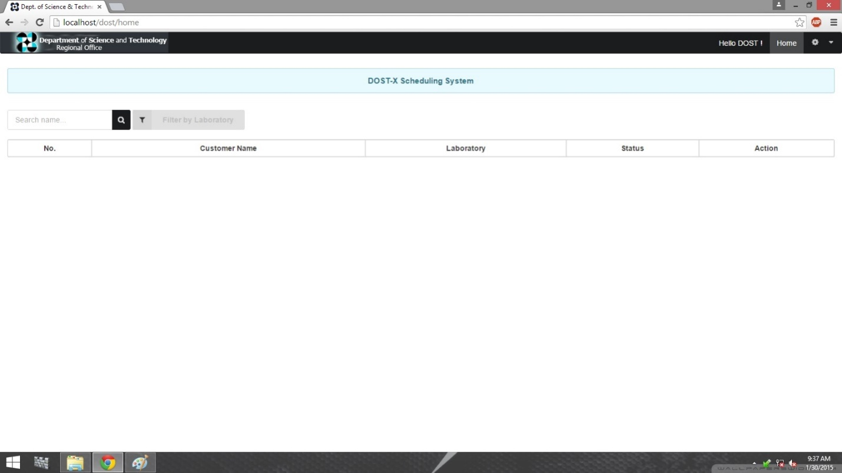

* Now you have login into the system and you can see its main page for the scheduling transactions. Then we will click the gear button for the functions.

1. 

* There we can see the different functionalities of our system: **Add Customer, Add Schedule, Add/Change Sample type, Add Reminder and Logout.**

1. 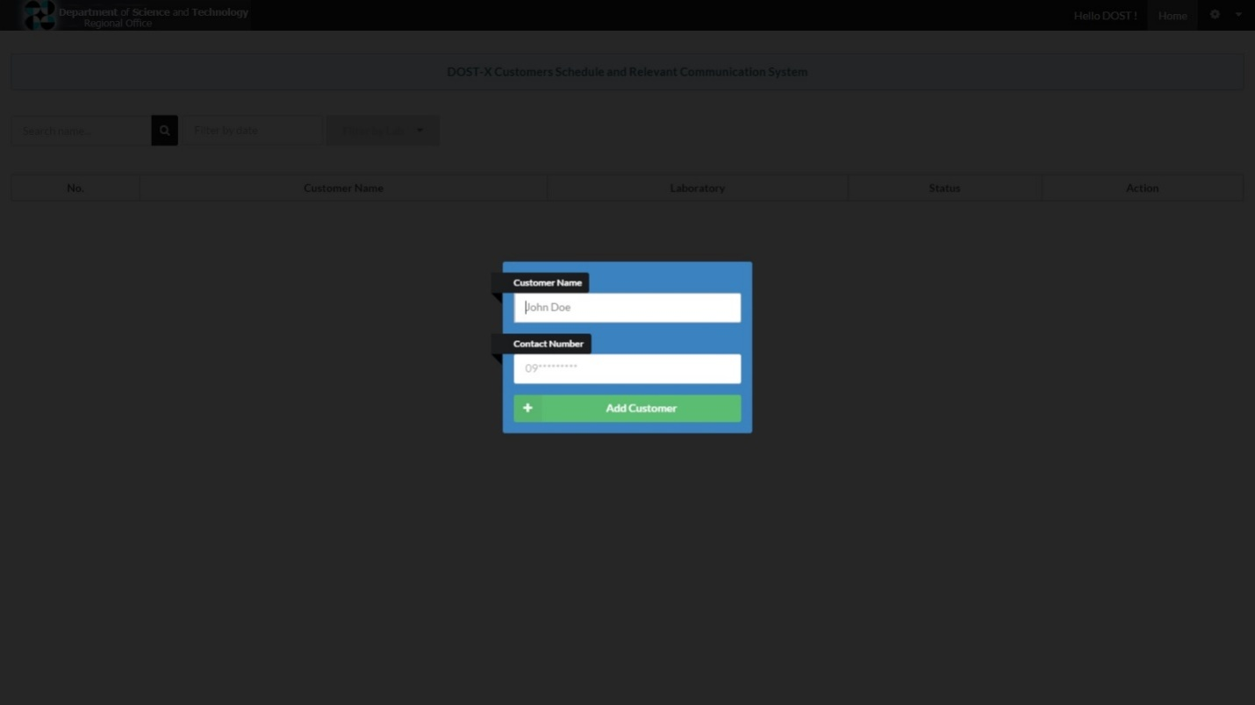

* **Add Customer Function**, in this function it will pop up a form that will let you add a customer name and its contact number before you will go to Adding his schedule.

1. 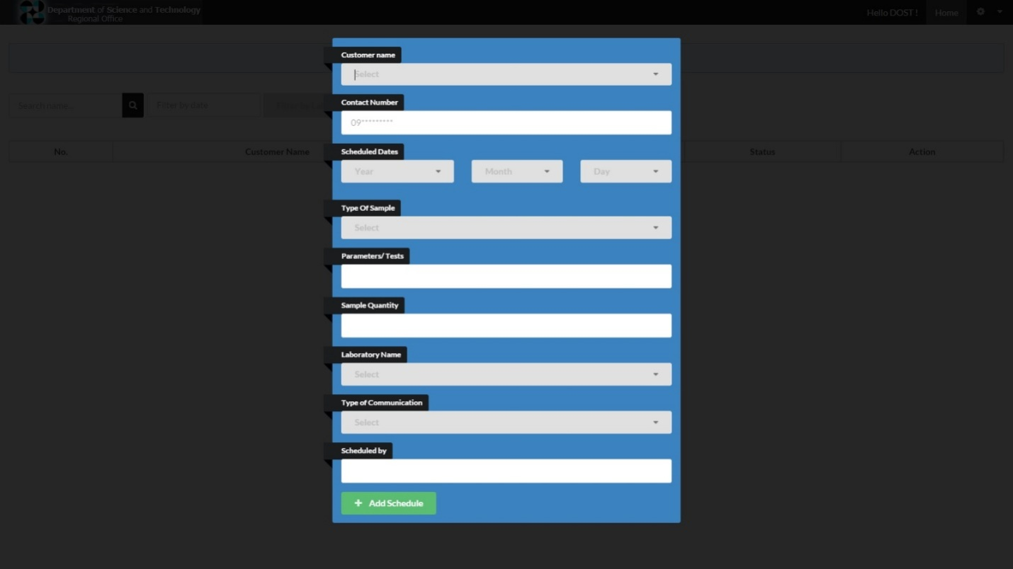

* **Add Schedule Function**, in this core function there will be a form that will pop up and will ask you to fill up its field and will make a reservation/schedule for the specific testing.

1. 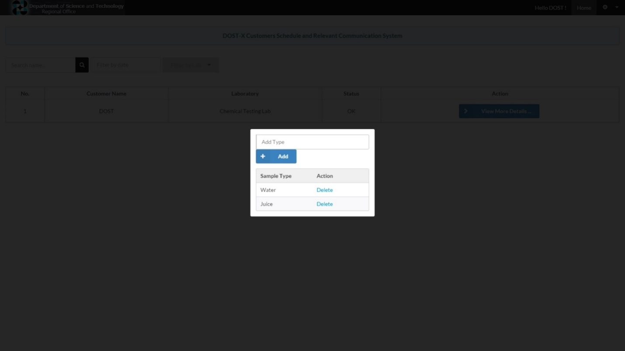

* **Add/Change Sample Type**, in this function it will let you add a specific sample type base on the customers sample you can change or delete sample type.

1. 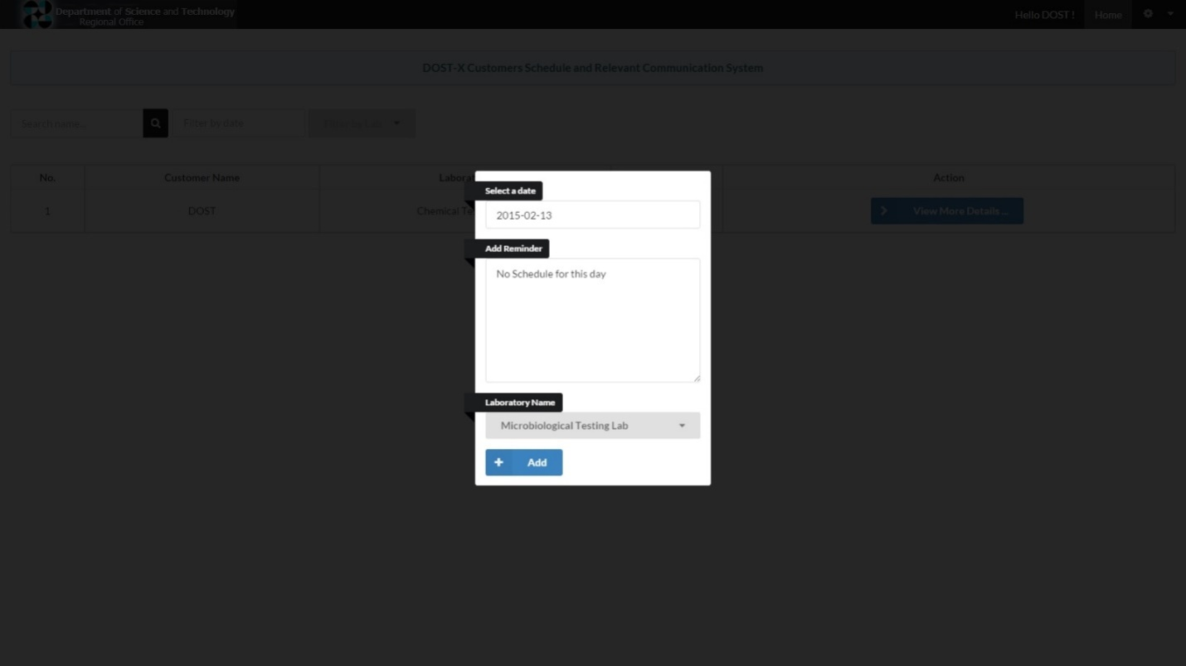

* **Add Reminder Function**, in this function it will let you add a reminder about a specific date any announcements and cancellation of testing and analyzing of samples to aware users on that date.

1. 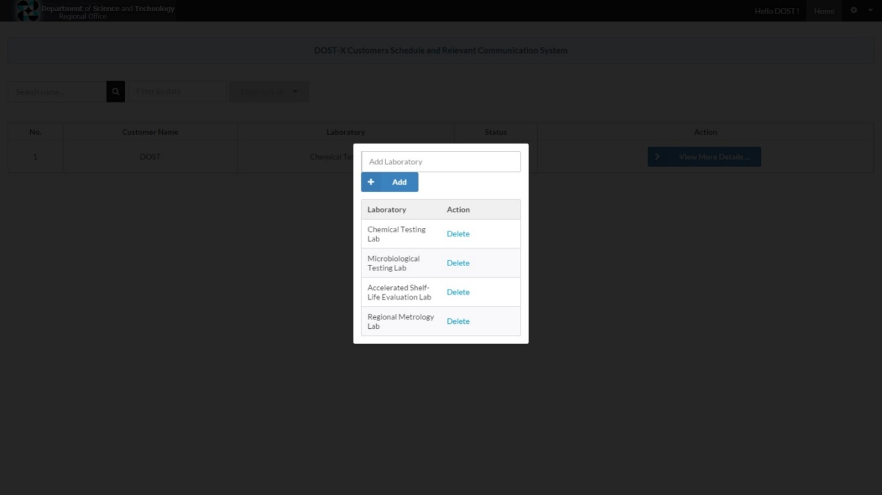

* **Add Laboratory Function**, in this form it will let you add and delete a specific laboratory for testing, calibrating and analyzing of samples and equipment.

1. 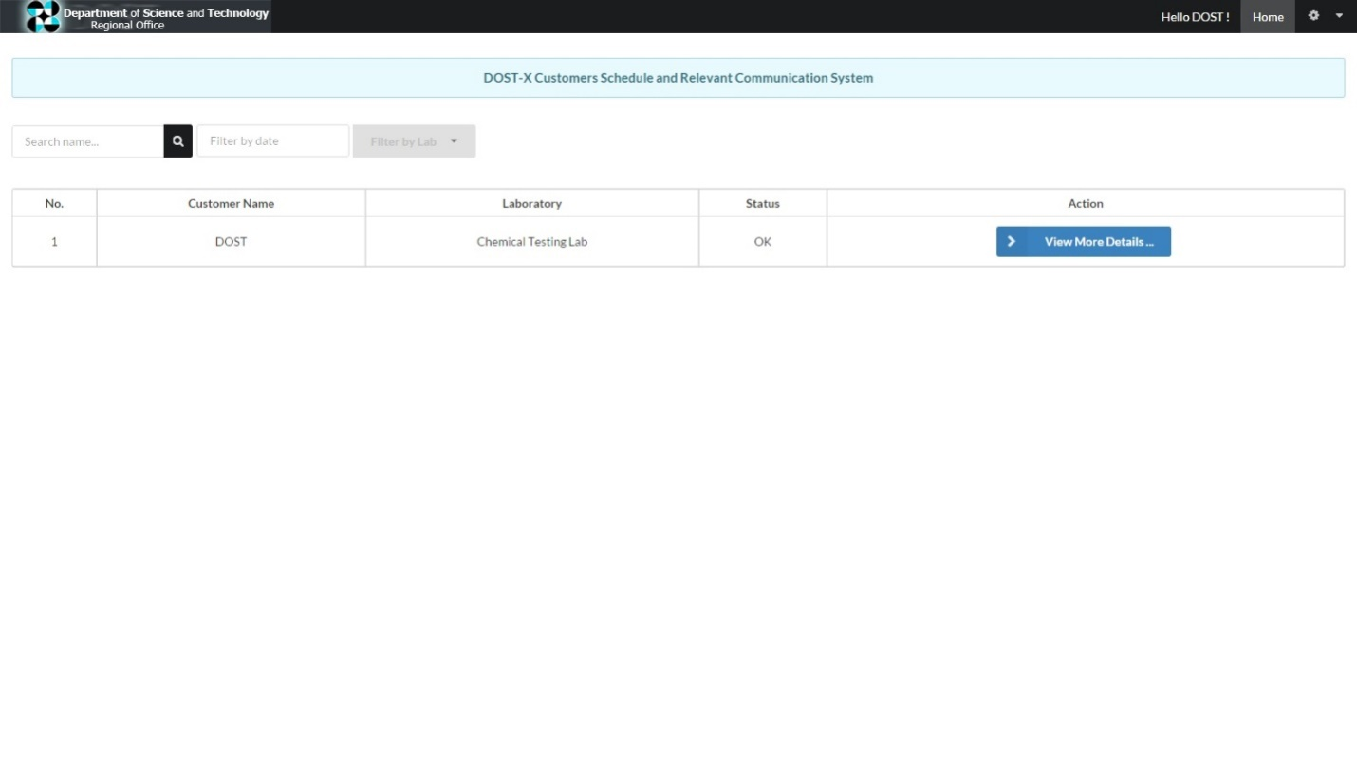

* In this area you will see the scheduled customers with its corresponding laboratory and status. We can also see its full details when we click the view more details button.

1. 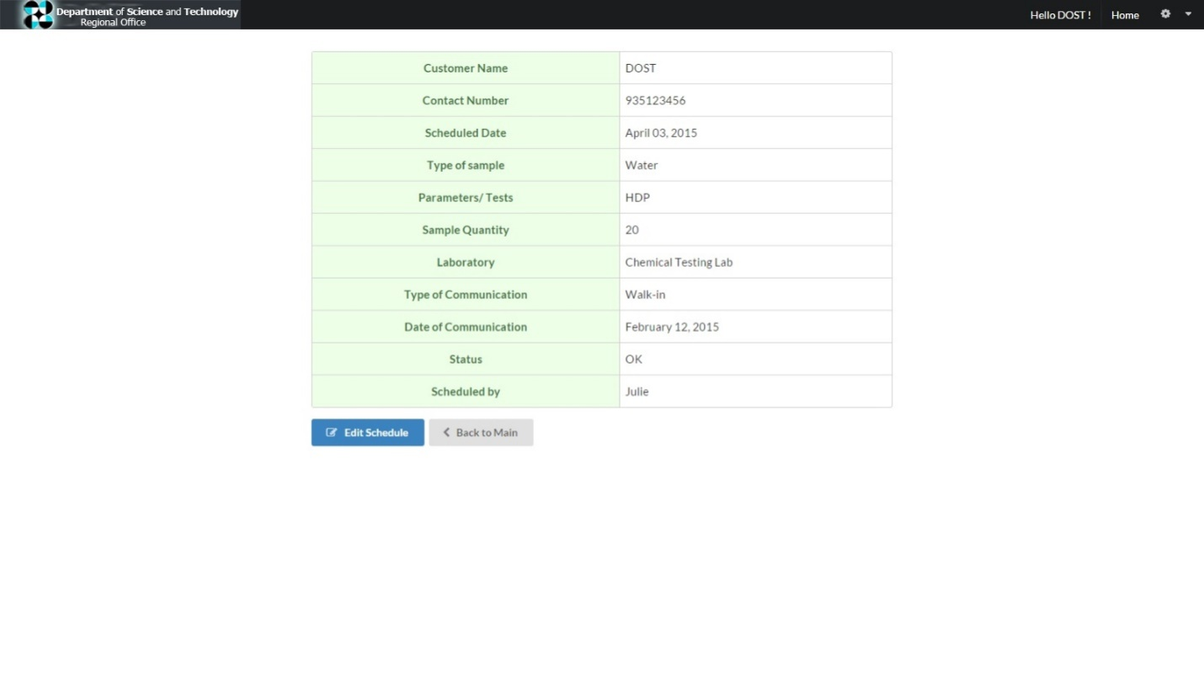

* After you have click the view more details button this will display on your screen the full information of the scheduled customer. And we can also edit its information just in case for changes. Just click the edit schedule.

1. 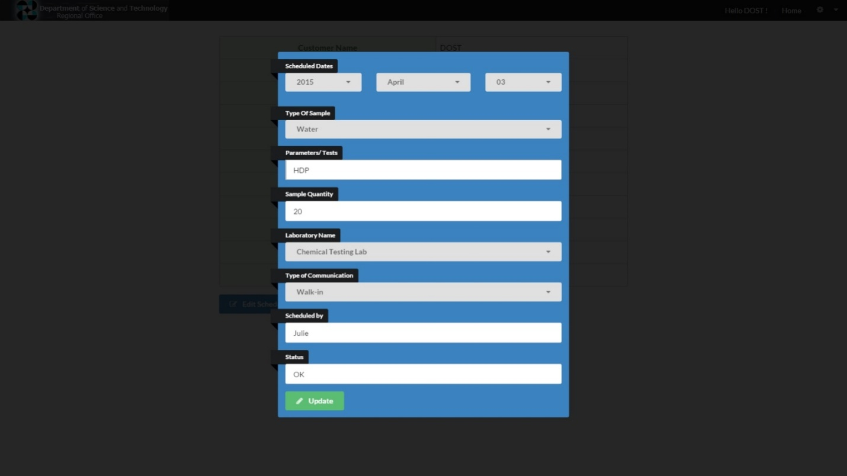

* After you clicked the edit schedule, this will pop up and now we can edit and modify the information that is schedule and change them in case of any further changes.

1. 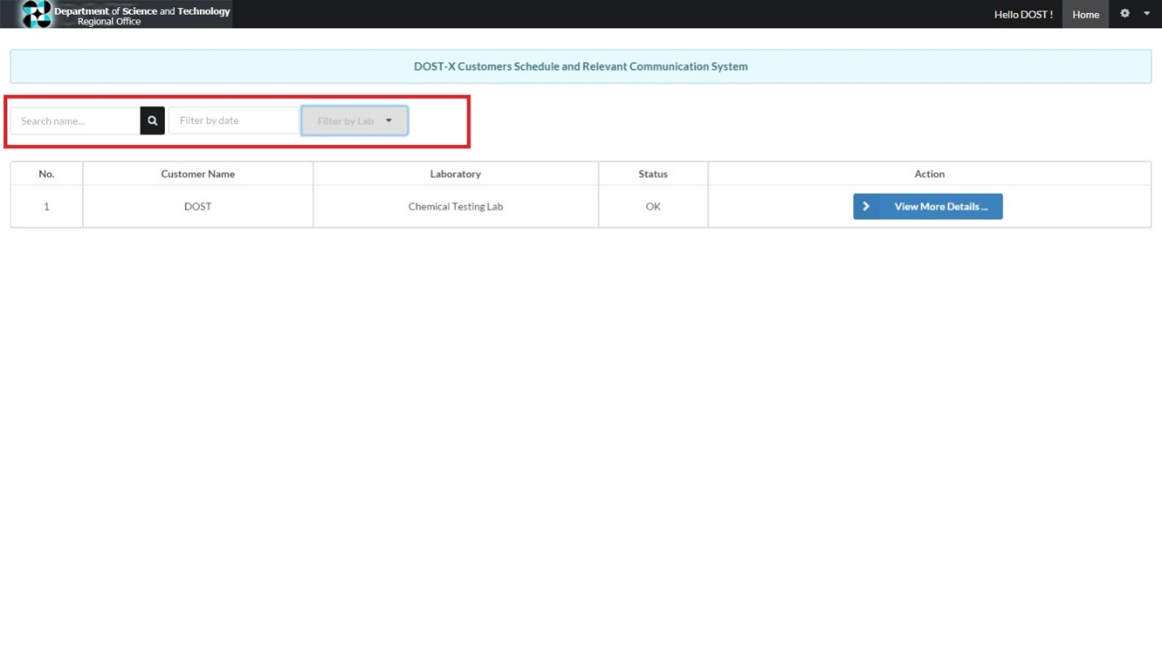

* In this part for the easy sorting and finding of data and scheduled customers we have made tools for you to use and be fast in finding data you want, we have place a search box, filtering by date and filtering by lab. For it to become user-friendly and it will not cause time finding data if the database is populated.