Project: TestDBDesktopApp1

Author: John Caley

Last Updated: 5/9/2018

Overview:

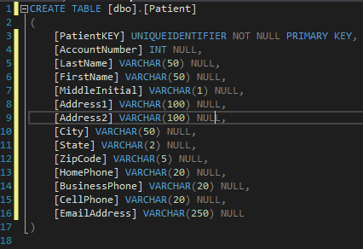 The Purpose of this Assignment is to create a database in SQL server which stores one table of patient’s records and a GUI which can allow for easy creation and insertion of rows into the table. The GUI displays the patient information in a data grid; specifically, name, city, state, zip, and home phone number. Three buttons are available on the top left of the window which allows the user to create a new row, edit an existing one or update the grid should any changes occur.

Program in Operation:

Creating a New Row:

When clicking the new button, the user is prompted to fill in all the attributes for the patient data with the exception of the PatientKEY which is a Uniqueidentifier and the AccountNumber which gets incremented with every new row. The user then has the option of either saving the changes and returning to the data grid or returning to the data grid without saving. The process can be seen in the images provided below.

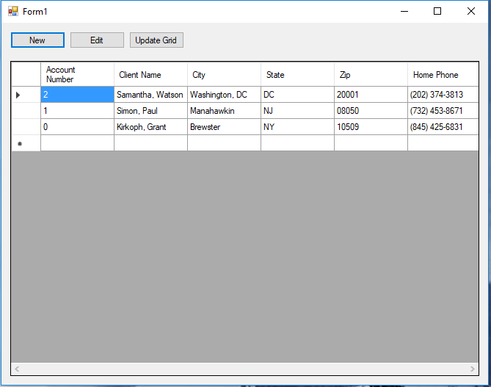

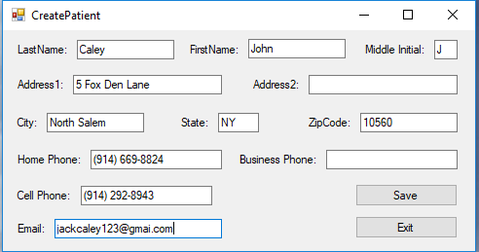

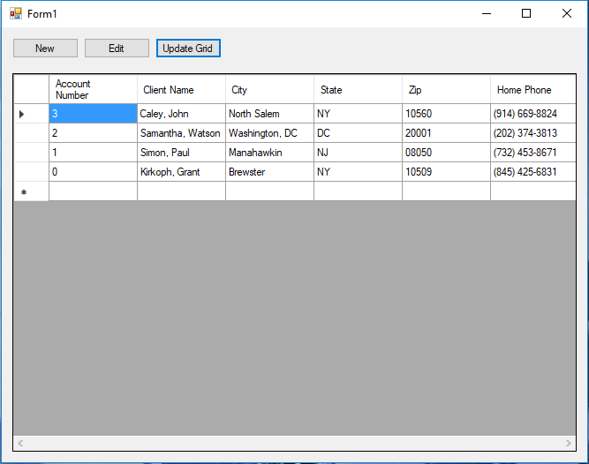

Updating a Row:

When Clicking the edit button, the user is prompted to input the AccountNumber of the patient whos records need to be updated. Clicking the get data button will fill in all the textboxes with the appropriate data which the user may then edit. Finally, much like the createPatient form, the user has the option to save and return to the data grid or return to the data grid without saving changes. The process can be seen in the images provided below.



