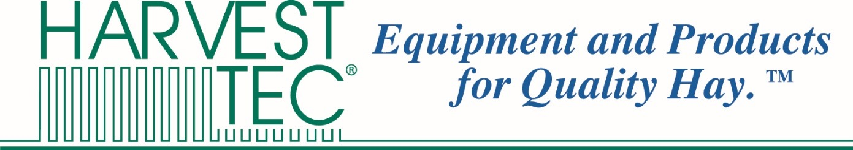

July 25, 2016

To Whom It May Concern,  
This letter is written in regards to the nature of John Calvin Roberts’ history of employment with Harvest Tec Inc. Harvest Tec is a manufacturer of specialized technology solutions for the harvesting & management of quality alfalfa hay, based out of Wisconsin, U.S.A. Our products are sold throughout North America, Europe, and in recent years we’ve expanded into the APAC region.

John first started working with us on Monday August 1st, 2011. We took him on during a probationary period doing full-time marketing, and after a few months of proving himself as a valuable asset to our team, we gave him a full-time salaried position. John helped with a variety of business operations, focusing mainly on marketing and market research. During this time he helped us research the market in China, and laid the groundwork for our expansion into China.

On August 16th, 2013, John officially left his post as a Junior Manager at Harvest Tec to pursue his Master’s degree in Shanghai. John continued to work remotely on a contract basis while he was in China, occasionally assisting in translation & logistics for our China expansion. John gained rich experience in marketing, market research, and project management during his time at Harvest Tec.

Sincerely yours,

Jeffrey S. Roberts, President

HARVEST TEC, INC.