Laboratory 3

Assembly Loop Programming and Debugging

Part 0:

|  |  |  |  |  |  |  |  |  |  |
| --- | --- | --- | --- | --- | --- | --- | --- | --- | --- |
| **Iteration** | **Code Line** | **PC** | **X** | **A** | **B** | **N** | **Z** | **V** | **C** |
| 0 | 4: **BEQ** **endLoop** | $4106 | $3000 | 0 | 5 | 0 | 0 | 0 | 0 |
| 1 | 4: **BEQ** **endLoop** | $4106 | $3001 | 3A | 04 | 0 | 0 | 0 | 0 |
| 2 | 4: **BEQ** **endLoop** | $4106 | $3002 | 98 | 03 | 0 | 0 | 0 | 0 |
| 3 | 4: **BEQ** **endLoop** | $4106 | $3003 | 96 | 02 | 0 | 0 | 0 | 1 |
| 4 | 4: **BEQ** **endLoop** | $4106 | $3004 | 21 | 01 | 0 | 0 | 0 | 1 |
| 5 | 4: **BEQ** **endLoop** | $4106 | $3005 | 77 | 00 | 0 | 1 | 0 | 0 |
|  | **10:BRA** endmain | $4111 | $3005 | 77 | 00 | 0 | 0 | 0 | 0 |

Figure 7 - Breakpoint Trace (Part I)

**Part I:**

**Q1**: Where is the sum value saved in the memory location? What is the sum of the given array in hex and in decimal?

The sum is stored at location $1009. In hex, the result is: 7C. In decimal, the result is 124.

**Part II:**

**Q2**: Where is the sum value saved in the memory location? What is the ***sum of the first N natural numbers*** in hex and in decimal?

The sum is stored at location $1001. For N=10, in hex, the result is: 37. For N=10, in decimal, the result is 55.

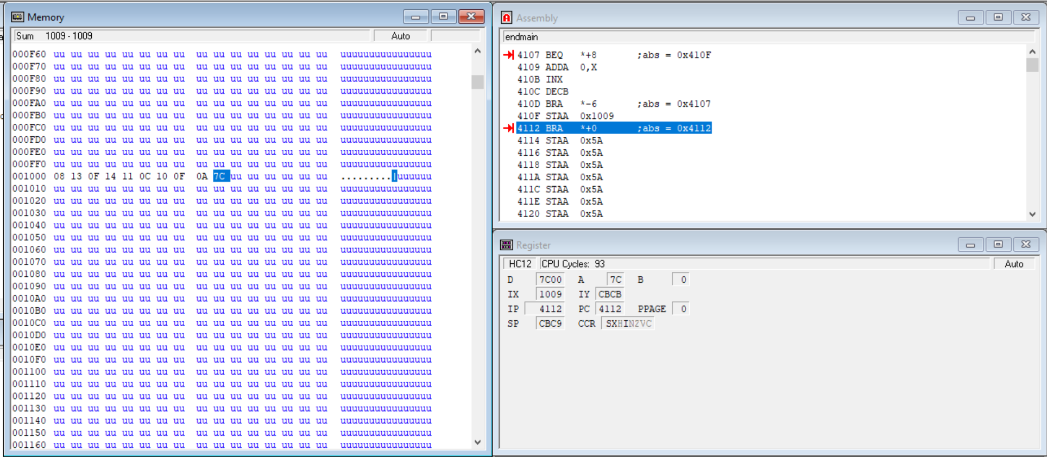

Screenshot for Project3_Part1

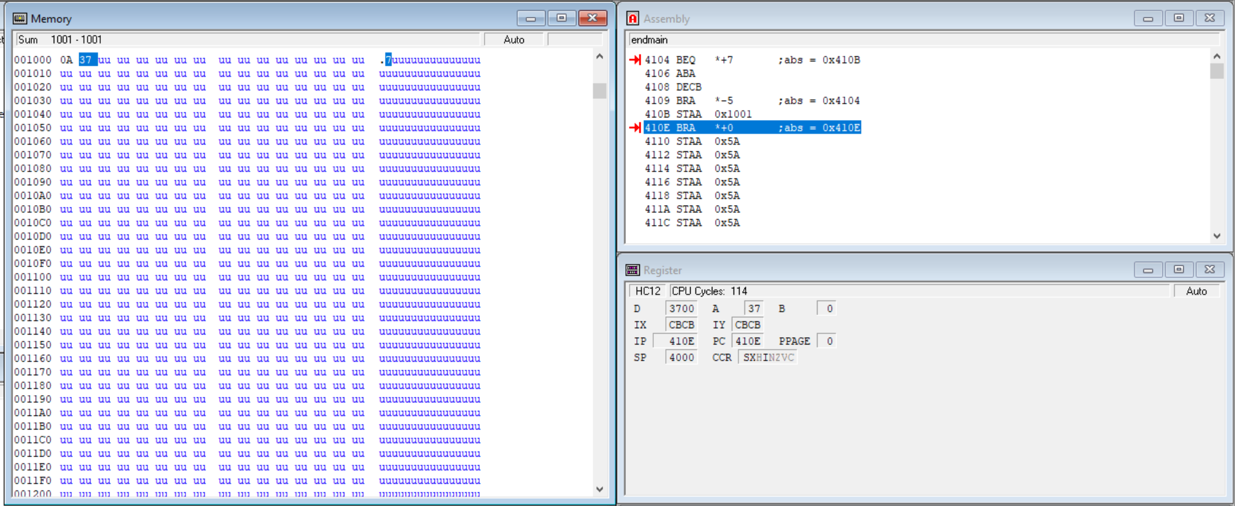

Screenshot for Project3_Part2