**Task1:** Check the memory locations $0001 (PORT B) and $0258(PORT P). For each inner loop iteration in Step3, write down the values in the memory locations (at $0001 and $0258) and generate the memory screenshots. The sample screenshots of the memory map are provided below.

Table 1. Memory map

|  |  |  |
| --- | --- | --- |
| **Iteration** | **Memory $0001 (PORT B)** | **Memory $0258 (PORT P)** |
| **1** |  |  |
| **2** |  |  |
| **3** |  |  |
| **4** |  |  |

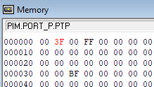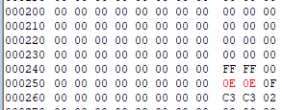

**Fig. 4. Screenshots of the Memory map: display ‘0’ on LED #0.**

**Task2: Test the program with the new data set in Array1 and N as below.**

**Array1: DC.B** $FA, $02, $34, $FD, $52, $11

**N EQU 6**

Add two breakpoints at the beginning of the inner loop, ‘**LEDLoop’**, and the outer loop, **‘FOREVER’**.Then, rerun the program and check the memory locations $0001 (PORT B) and $0258(PORT P). For each inner loop iteration, write down the values in the memory locations (at $0001 and $0258) and generate the screenshots of the memory.

Table 2. Memory map

|  |  |  |
| --- | --- | --- |
| **Iteration** | **Memory $0001 (PORT B)** | **Memory $0258 (PORT P)** |
| **1** |  |  |
| **2** |  |  |
| **3** |  |  |
| **4** |  |  |