**A PROPOSED OFFERING OF WEB BASED**

**PET MEDICAL RECORDS SYSTEM**

**FOR PETLINK VETERINARY CLINIC, 10TH AVENUE, CALOOCAN CITY**

A Thesis Project Presented to the

Faculty of Datamex College of Saint Adeline, Inc.

In Partial Fulfillment of the Requirements for the

Degree of Bachelor of Science in Information Technology

By:

Mamay, John Carlo P.

Remoto, Rachel

Solidum, Jasmin E.

August 2025

**PROJECT PROPOSAL**

**INTRODUCTION**

A Pet Medical Records System is a web-based application designed to manage and organize pet health information in veterinary clinics. It serves as a modern replacement for paper-based records, which are often prone to damage, loss, and difficulty to manage. The system allows staff to create pet profiles, record medical history such as check-ups, treatments, and vaccinations, and generate reports when needed. With this, veterinary clinics can ensure that records are accurate, secure, and easily accessible through a web browser within the clinic.

**Overview**

This project is developed using modern web technologies such as HTML, CSS, JavaScript, Node.js, Python, APIs, SQLite. Unlike traditional desktop-based systems, it is designed to run on a local server setup. This setup allows authorized users to access records through any computer connected to the same local network, without requiring an internet connection.

The system provides a platform where staff can record and manage both pet information and medical histories in an organized manner. Each pet’s details, including its name, breed, sex, age, and owner information, are stored in the database and directly linked to its medical records, such as check-ups, treatments, and vaccinations.

In addition, the system includes role-based access, allowing users to manage staff accounts and oversee the overall database, while Staff users focus on daily record-keeping tasks. The system also offers features for generating and printing medical records, serving as an organized reference for both clinic staff and pet owners.

**Background**

Veterinary clinics provide essential healthcare services to pets, including vaccinations, treatments, and regular check-ups. However, many clinics, such as Petlink Veterinary Clinic, still rely on manual recording methods like paper forms and logbooks for storing pet information and medical histories. While this has long been the standard practice, it presents serious challenges in efficiency, accuracy, and accessibility. The growing number of pets and clients makes it increasingly difficult for staff to manage records effectively, which can directly affect the quality of service and even the safety of pets.

The current practice of using paper-based records is highly inefficient and vulnerable to errors. Pet medical records stored on paper can be easily misplaced, lost, or damaged, which creates difficulties in retrieving crucial information when needed. Staff may struggle to locate specific records quickly, especially in emergency situations where immediate access to accurate data is vital. Incomplete records, unclear handwriting, and human error further compound the problem, potentially leading to misdiagnosis or delayed treatments.

For pet owners, relying on physical records also poses challenges. They may find it hard to monitor their pet’s medical history, such as vaccinations, treatments, and health updates. The responsibility of maintaining printed documents can be overwhelming, especially for owners with multiple pets that require different types of care. As a result, both staff and clients face unnecessary stress, reduced efficiency, and lower satisfaction due to outdated and disorganized record-keeping methods.

To address these issues, the Pet Medical Records System will serve as a digital solution that transitions pet records from physical documents to a secure platform. The system will be web-based and supported by SQLite, allowing staff to store, update, and retrieve pet medical information with greater accuracy and convenience. By digitizing records, the system eliminates the risks associated with paper-based methods, ensuring that pet histories remain intact, well-organized, and accessible at any time

**Objectives and Goals of the Project**

* To help the clinic keep pet records safe, accurate, and easy to update.
* To provide staff with convenient, fast, and accessible tools for daily tasks.
* To minimize the chances of lost, incomplete, or missing records by using an online database.
* To improve the overall service quality provided to pet owners through organized record management.
* To make follow-ups and check-ups more efficient through secure web-based access to records.
* To support the clinic in adopting modern technology for long-term efficiency, scalability, and growth.

**CLIENT INFORMATION**

Client information is the personal or business details collected about someone who receives services. It can include things like their name, contact details, and relevent background information. This helps organization understand their client’s needs and provide better support.

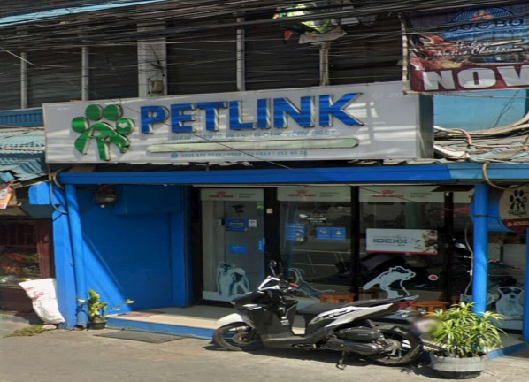

*Figure 1. Logo of Petlink Veterinary Hospital*

Client Name: Petlink 10th Avenue Caloocan City

Contact Person: Veterinarian Staff

Email: petlink.vetclinic@gmail.com

Phone: 0905-471-1129

Service offered: The clinic offers medical care for pets such as vaccinations, consultations, deworming, grooming, and treatment of illnesses. Petlink operates under the veterinary services industry, which focuses on animal healthcare and welfare.

**PROJECT SCOPE**

The main output of this project is a Computer-Based Pet Medical Records System designed for Petlink Veterinary Clinic. The system will allow staff to:

* Record pet information such as name, age, breed, and owner details
* Log medical records including check-ups, treatments, and vaccination history
* Edit and update patient records as needed
* View pet history for follow-up consultations
* Securely store all data for future reference

Inclusions

* Pet profile management.
* Recording of medical treatments and vaccination history.
* Data editing, updating, and deletion.
* Online database using SQLite.
* User roles for Vet Staff.
* Report generation and printing of medical records.

Exclusions

* No scheduling or appointment management.
* No automated text/email reminders.
* No medical supplies, inventory, billing, or payment tracking.
* No mobile application (desktop/laptop use only).

Assumptions

* The clinic has computers or devices (desktop or laptop) with internet access.
* Clinic staff will be trained to use the system.
* A stable internet connection is available for online access to records

Constraints

* The system will run locally through SQLite and will not require an internet connection.
* The system will primarily run on computers with Windows, macOS, or Linux that support SQLite.
* Access to the system will be limited to the computer where SQLite is installed (or within a local network if configured).
* Development will be limited to the tools available: HTML, CSS, JavaScript, and SQLite.

**PROJECT APPROACH**

To achieve the goals of this project, an organized and flexible approach will be used in developing the Pet Medical Records System. The project will follow the Agile development method, where the work is divided into short phases or sprints, and each phase includes requirements, design, development, testing, and review. This allows the team to make improvements based on feedback before moving to the next set of tasks.

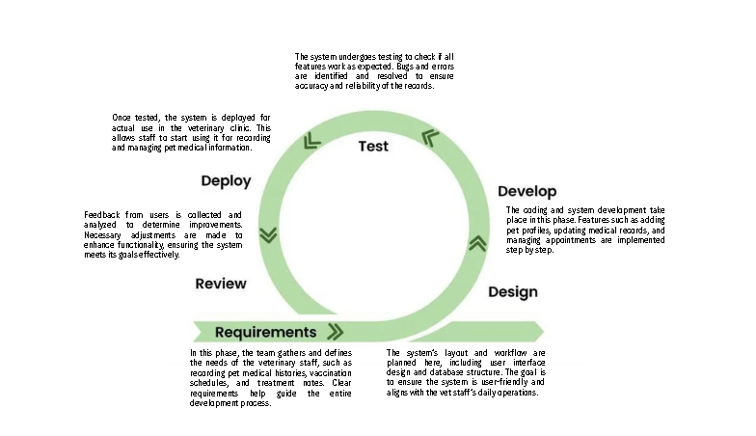This approach also improves efficiency and reduces risks by focusing on step-by-step progress instead of waiting for the full system to be finished. With regular reviews and testing, the project stays on track with its goals, and adjustments can be applied quickly when needed.

*Figure 2. Agile Model Used in Developing the Pet Medical Records System*

**PROJECT TEAM**

The development of the Pet Medical Records System was made possible through the combined efforts and collaboration of the following team members: `

|  |  |  |
| --- | --- | --- |
| **NAME** | **ROLE** | **SKILL** |
| F  Rachel Remoto | Project Leader | • Handled data gathering and documentation tasks in their 2nd-year thesis  • Participated in system design and creative planning during Gamefest |
| Jasmin E. Solidum | Data Gatherer | • Experienced in system analysis and identifying possible bugs  • Contributed as a system designer in their Gamefest participation |
| John Carlo P. Mamay | Programmer | • Applied system analysis skills from their 2nd-year thesis project  • Took part in system interface design during Gamefest |

*Table 1 lists the members of the group with their roles and skills.*

**PROJECT TIMELINE**

The project timeline outlines the major phases of the Pet Medical Records System development, including planning, requirement gathering, development, and testing. It shows the duration of each task, the expected deliverables, dependencies, and the identified critical path needed to complete the project within 12 to 14 weeks.

|  |  |  |  |  |
| --- | --- | --- | --- | --- |
| Date | Task | Milestone/Deliverable | Dependecies | Critical Path |
| July 7, 2025 | Project Planning & Title Approval | Approved project title and plan | None | ✓ |
| July 11-17 | Requirement Gathering | Documented user and system requirements | Planning | ✓ |
| July 30 to Aug 2, 2025 | Development | Initial system prototype | Requirements | ✓ |
| Aug 3 to Aug 19 | Testing and Debugging | Tested and debugged system modules | Development | ✓ |
| Aug 20 to Oct 9, 2025 | Traning/Support | User training and support materials | Testing | ✓ |

*Table 2. Timeline of Major Project Tasks and Deliverables*

**PROJECT RESOURCES**

The project requires specific resources to ensure the successful development and implementation of the system. These include hardware and software requirements for the system to run effectively, as well as human resources who will contribute their skills and expertise throughout the project.

**A. Hardware Requirements**

|  |  |
| --- | --- |
| Item | Purpose |
| 1 Desktop (Intel Core i5 10th Gen or higher) | To run SQlite and access the web-based system through a browser |
| Local Network (optional) | To allow multiple computers within the clinic to use the system offline |
| Printer | For printing medical records or summaries |

*Table 3. System Requirements and Resources*

**B. Software Requirements**

|  |  |
| --- | --- |
| Software | Purpose |
| SQLite | Local server environment for system development and database management |
| HTML, CSS, JavaScirpt | Web technologies used for developing the system’s front-end and back-end |
| Web Browser (Google Chrome or Microsoft Edge) | To access and run the web-based system |
| Microsoft Office (Word) | Documentation |

*Table 4. System Requirements and Resources*

**C. Human Resources**

|  |  |
| --- | --- |
| Role | Task |
| Client Representative | Giving Requirements and Feedback |
| Project Adviser | Supervision and Feedback |

*Table 5.* *System Requirements and Resources*

**Budget Allocation and Justification**

|  |  |  |
| --- | --- | --- |
| Item | Cost | Justification |
| Desktop Computer (with monitor, keyboard, mouse) | ₱25,000 | Main hardware needed to install and run the system. |
| USB Drive / External Storage | ₱1,000 | Backup for files, installer, and database to ensure data safety. |
| Printer | ₱4,000 | For printing medical records, reports, or summaries. |
| Miscellaneous (Transport, Printing of Documentation, Binding) | ₱1,000 | Covers expenses for reports, drafts, and other minor needs. |

*Table 6. The outlines the project’s budget and the justification for each expense.*

Estimated Total Budget: ₱31,000

**RISK MANAGEMENT**

Risk management identifies possible issues in the project and provides ways to reduce their impact, helping ensure the Pet Medical Records System is completed successfully.

|  |  |  |  |  |
| --- | --- | --- | --- | --- |
| Risk Type | Risk Description | Likelihood | Impact | Mitigation Strategy |
| Time constraints | The project may not follow the planned schedule due to other school tasks or personal reasons | Medium | Medium | Follow a weekly schedule; divide tasks among team members and avoid last-minute work. |
| Hardware or system failure | The computer used by the client may not be compatible or may crash | Low | High | Hardware or System Failure |

*Table 7. Identified Risks and Mitigation Strategies for the Pet Medical Records System*

**COMMUNICATION PLAN**

Communication will be managed through regular updates between the project team and the client (Petlink Veterinary Clinic). All team members will stay connected through both online and in-person communication to ensure that everyone is updated on the project progress, deadlines, and any issues that may come up. Clear and consistent communication is important to avoid misunderstandings and delays.

**Communication Schedules and References**

|  |  |  |  |
| --- | --- | --- | --- |
| Type of Meeting | Frequency | Format/Platform | Purpose |
| Client Meetings | Twice a month or as needed | In person at the clinic or via messenger | Gather requirements, show updates, and get feedback |
| Final System Review | Once (before deployment) | In person (clinic) | Present the final system and ensure client satisfaction |
| Adviser Consultation | As scheduled | In person | Review project progress and seek guidance |
| Team Meetings | Thrice a week | In person or group chat (messenger) | Discuss progress, divide tasks and solve issues |

*Table 8. This outlines the meetings, frequency, format, and purpose to support effective communication within the team.*

**PROJECT GOVERNANCE**

The project will be managed by a student development team with guidance from a project adviser. All major decisions such as system features, deadlines, and revisions will be based on team discussions, client feedback, and adviser approval. Regular meetings will be conducted to track progress, address issues, and make informed decisions.

1. Roles and Responsibilities of Project Stakeholders

Project Manager – Remoto, Rachel

- Assign tasks

- Schedule meetings

- Act as main contact with client/adviser

Project Team (Developers and Data Gatherers) – Mamay, Solidum

- Gather requirements

- Design and develop the system

- Conduct testing and deployment

- Prepare documentation

Client (Vet Staff)

- Provide system requirements

- Give feedback on progress

- Test and approve the final system