Segmentation tool: ilastik
Webpage for this tool: https://www.ilastik.org/

Workflow needed to use: Pixel Classification
How to do in this workflow: https://www.ilastik.org/documentation/pixelclassification/pixelclassification

Main steps:
- Import images (2D or 3D data).
Import Image Zircon 016

- Label the regions that you want to segment and background region.
CZr, MZr, RZr, BG
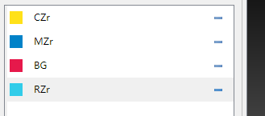
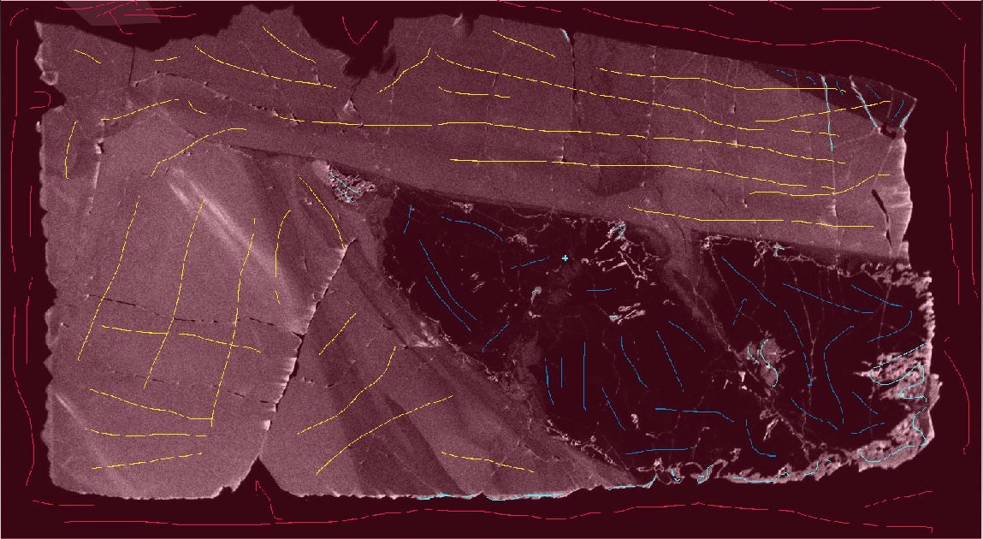
- Generally, more labels will lead to better segmentation results.
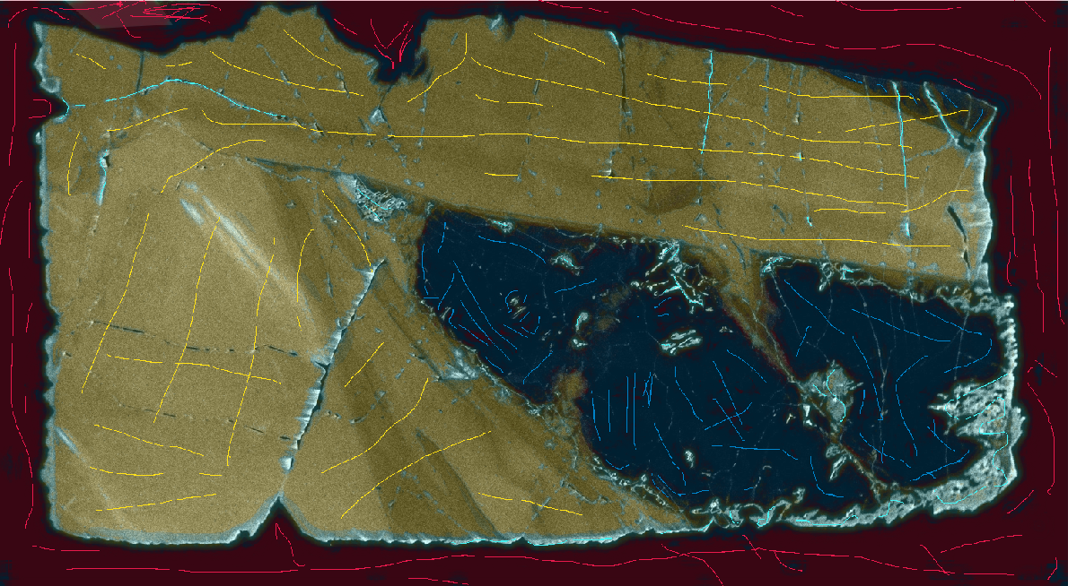
- Export the simple segmentation results when you think the predicted results are acceptable.
