Stable isotope dilution approach to measuring mineral replacement rates at high P-T conditions: Replacement of metamict zircon by hydrothermal zircon

John C. Ayers, Pan Hu, and Blake Wallrich, Vanderbilt University
Chen Zhu, Indiana University Bloomington
Keewook Yi, Korea Basic Science Institute

Abstract
Mineral replacement rates at elevated pressures and temperatures have not been previously measured. By doping experiments with a rare stable isotope and measuring the isotope compositions of the resulting solids and fluids, we can accurately measure isotope exchange caused by mineral replacement. This method was tested in experiments at 0.1-0.2 GPa and 600-800°C on partially metamict ZrSiO4 with radiation damage measured by alpha doses in 10¹⁸ α/g of AFG = 0.46 and Norway 0.6. The higher Gibbs free energy and aqueous solubility of metamict zircon enhance its dissolution in hydrothermal fluids, providing Zr to the fluid and causing precipitation of hydrothermal zircon. Initial fluids contained isotopically doped ²⁹SiO₂ ± NaF and were significantly depleted in ¹⁸O relative to metamict zircon. Isotopic compositions of quenched solutes showed that Norway fragments were completely replaced with one day at 600 °C in both H2O and 1m NaF. Cathodoluminescence images and Raman spectroscopy of the AFG run products showed formation of hydrothermal rims in fluids containing NaF, but not in those without NaF. Hydrothermal zircon had lower concentrations of U, Th, and Pb than metamict zircon, and exhibited porosity characteristic of natural hydrothermal zircon.
Raman spectroscopy showed replacement of AFG with crystalline hydrothermal rims and partially recrystallized zircon cores. SIMS U-Pb dating showed partial resetting and younger ages due to loss of Pb > U, with hydrothermal rims being slightly younger than recrystallized cores. SIMS Si-O isotope analysis revealed that hydrothermal rims had large shifts in Si and O isotope composition while recrystallized cores did not. The extent of replacement calculated from Si isotope dilution was 6% after 3 days and 19% after 19 days in 1 molal NaF at 800 °C, which agreed well with estimates based on the shift in oxygen isotope composition of the fluid and image analysis of zones in run product cubes. Bulk replacement rates in moles kg H2O-1 s-1 ranged from 1.7E-07 to 5.4E-07 for AFG at 800 °C to a minimum of 1.7E-02 for Norway at 600 °C, indicating that replacement rates depend strongly on the degree of radiation damage. Isotopic profiles were consistent with formation of hydrothermal rims through homogeneous replacement by coupled dissolution-reprecipitation. Replacement of metamict ZrSiO4 is a viable mechanism for formation of hydrothermal zircon, but because lead loss is not complete, U-Pb ages may not correspond to the hydrothermal event. Spiking experiments with rare stable isotopes shows promise for measuring element exchange between phases in high P-T experiments.

Plain language summary
Radiation-damaged zircon can recrystallize when heated or be replaced by crystalline hydrothermal zircon when in contact with fluid. Isotope dilution was used to measure the rate of replacement in hydrothermal experiments at upper crustal conditions. Replacement rates increased with degree of radiation damage and when NaF was present in the fluid, and loss of Pb > U caused U-Pb ages to decrease but not to zero.

Introduction
The mineral zircon (ZrSiO4) has provided more geochronological ages than any other mineral, because it is ubiquitous in rocks, and it provides precise ages using the U-Pb decay system (Gehrels, 2014). Zircon commonly crystallizes from magma, and because intracrystalline diffusion is slow and the closure temperature for the zircon U-Pb system is high (Cherniak et al., 2003), measured zircon U-Pb ages usually represent magmatic crystallization ages. Zircon ages can also represent new growth through heterogeneous reaction during metamorphism (Yakymchuk et al., 2017). In contrast, when zircon recrystallizes, it completely resets by losing radiogenic lead, so the measured U-Pb age represents a recrystallization age rather than a growth age (Pidgeon, 1992). Recrystallization can be caused by Ostwald ripening (Ayers et al., 2003) or by fluid infiltration (Hoskin, 2005). In the case of fluid infiltration, the driving force for zircon recrystallization is compositional re-equilibration due to changes in bulk composition (Hoskin, 2005; Rubatto et al., 2008) or structural resetting of radiation-damaged (metamict) zircon. Zircon recrystallizes in infiltrating fluids, rather than simply dissolving, because its aqueous solubility is very low (Ayers et al., 2012; Wilke et al., 2012; Bernini et al., 2013). The resulting shift in composition of recrystallized zircon reduces the fidelity of zircon proxies such as the Ti-in-zircon thermometer (*cite), but may it produce a unique trace element signature that could be used to identify zircon grains that experienced fluid-induced recrystallization.
Crystalline zircon may recrystallize when it is exposed to changes in P-T conditions or bulk composition. For example, zircon that crystallizes from a silicic crustal melt under upper crustal conditions might have a very different trace element and isotopic composition from zircon that is subducted to great depths and exposed to mantle fluids. Changing P-T conditions can cause exsolution of phases like thorite (Peters et al., 2013), and the associated volume change of reaction may form cracks that allow fluid penetration. When its environment changes and it is exposed to fluid, zircon becomes susceptible to recrystallization, and in this example, the measured U-Pb age would represent the age of fluid-induced recrystallization (Tomaschek et al., 2003; Rubatto et al., 2008). Recrystallized zircon has much lower concentrations of incompatible elements such as light rare Earth elements (REE) and lead (Peters et al., 2013).
Metamorphic rims are commonly observed on magmatic zircon cores (Corfu et al., 2003) and are often interpreted as resulting from coupled dissolution – reprecipitation in the presence of a fluid (Vonlanthen et al., 2012). For example, an eclogite facies meta-granite contained magmatic zircon that yielded a protolith age and zircon microcrystals with much lower Th and light-to middle REE concentrations and younger ages interpreted as having formed through recrystallization through coupled dissolution – precipitation of crystalline zircon in an alkaline metamorphic fluid (Rubatto et al., 2008).
In contrast to recrystallization, the replacement of noncrystalline metamict zircon by crystalline zircon involves a phase/structural change (T Geisler et al., 2001; Geisler et al., 2003). Old zircon grains with high U contents can become metamict through radiation damage (Ewing et al., 2003). Compared to crystalline zircon, metamict zircon has a lower density, elastic modulus, and hardness, as well as an aqueous dissolution rate one to two orders of magnitude higher (Ewing et al., 2003).
Metamict zircon can be replaced by crystalline zircon by thermal annealing or by hydrothermal replacement. Recent work shows that thermal annealing causes recrystallization of metamict domains, microcrack propagation, and nanopore formation; the latter two can provide access to the interior of zircon grains for fluids (Morales et al., 2022). The rate of thermal annealing is strongly temperature-dependent; over several billion years recrystallization can occur at temperatures as low as 100°C (Ewing et al., 2003). The rate of hydrothermal replacement is likely much higher, especially at lower temperatures. Experiments at 450 °C showed that the thickness of hydrothermal replacement rims increased with degree of radiation damage (T Geisler et al., 2001) . Ayers and Zhu ((2025)) used photomicrographs in Geisler et al. (Geisler et al., 2003) to estimate rate constants for fluid-assisted replacement of metamict ZrSiO₄ by crystalline zircon. *Do we have enough data to compare rates of thermal annealing and hydrothermal replacement?
Metamict zircon is highly susceptible to lead loss (Pidgeon O’Neil, J.R., Silver, L.T., 1966). Burial and heating causes replacement of metamict zircon by crystalline zircon, which retains radiogenic lead. During the replacement process zircon grains in a rock expel varying amounts of lead, so that their U-Pb isotope ratios define a discordia with concordia intercepts corresponding to a protolith age and the age of a replacement or recrystallization event (Ayers et al., 2002; Morales et al., 2022). The aqueous solubility of metamict zircon is much higher than for crystalline zircon, so replacement of metamict by crystalline zircon likely occurs through dissolution – precipitation in a fluid (Geisler et al., 2003; Ayers and Zhu, 2025). The resulting hydrothermal zircon can therefore provide the timing of fluid infiltration events (Hoskin, 2005; Ayers and Peters, 2018). Experimental investigation of the replacement of metamict zircon has led to conflicting results, in part due to the use of analytical methods with different spatial resolutions (Thorsten Geisler et al., 2001).
The rate of zircon recrystallization or replacement depends on the rate-limiting step, zircon dissolution or precipitation. Despite the importance of understanding the kinetics of zircon recrystallization and replacement, there are no published studies on precipitation kinetics, and only one on aqueous dissolution kinetics (Tole, 1985). Multi-point batch experiments were conducted on crystalline and amorphous zircon. Powders were placed in a 1-L reactor, and solutions were sampled over fixed time intervals for 2 months at 25, 60, and 80 °C at pH 5. Inductively coupled plasma – optical emission spectrometry (ICP-OES) was used to measure Si and Zr concentrations, but Zr was not detected (<0.05 ppm). The reported rate for amorphous zircon dissolution (6.2E-14 mol m⁻² s⁻¹ at 25 °C, pH=5) was similar to the dissolution rate of quartz and decreased over time, but no detectable dissolution was found for crystalline zircon (Tole, 1985).
During coupled dissolution-precipitation a reaction front advances into an unstable phase such as metamict zircon. The interior of the grain retains its isotopic composition, while the precipitate will inherit the fluids isotopic composition with a small difference caused by isotopic fractionation that decreases as temperature increases. Two competing models describe what happens to precipitated phases during coupled dissolution-precipitation. In a homogeneous model (batch equilibrium) the precipitated phases will continuously reequilibrate with the fluid as the isotopic composition of the fluid evolves. In a heterogeneous model there is no back-reaction of precipitated minerals with fluid, so the replacement phase will have variable isotopic composition.
Evidence of zircon recrystallization in hydrothermal experiments has been mixed. Our piston cylinder experiments at 1.5 GPa and 800-1000 °C on zircon grains ~20 µm in diameter showed clear evidence of complete recrystallization of zircon grains (Ayers and Peters, 2018). However, our cold seal pressure vessel experiments at 0.2 GPa and 450-750 °C found no evidence for bulk recrystallization of 250-500 µm diameter grains, although the presence of thin reaction rims could not be ruled out (Ayers et al., 2012). Likewise, a four-month experiment at 0.05 GPa and 850 °C on 80-300 µm wide natural zircon crystals found no evidence of recrystallization (Bindeman et al., 2018). Finally, our earlier piston cylinder experiments on ~1mm cubes at 1.0-2.0 GPa and 1000-1100 °C showed no evidence of bulk recrystallization (Ayers and Watson, 1991). The different responses of zircon could be due to different P-T conditions, to a size effect, or to recrystallization in the temperature gradient in the piston cylinder experiments. The size effect would result from smaller grains being more likely to recrystallize during an experimental timeframe than large grains, possibly due to having higher surface areas and therefore higher surface free energies.
In this study we combine SIMS analysis with stable isotope tracers to study the rates and mechanisms of zircon recrystallization and replacement. To date nearly all recrystallization experiments using stable isotope tracers have analyzed only the solution (Gorski and Fantle, 2017). Nanoscale isotope analysis of the solids has been combined with solution isotope analysis in only a handful of experimental studies (Taylor et al., 2019), and none on silicates to our knowledge.
Zircon is an ideal mineral to study the processes of recrystallization and replacement because its aqueous solubility is very low, meaning the interface position and shape will remain relatively unchanged during the experiment. Additionally, an improved understanding of the process will lead to refined interpretations of zircon U-Pb ages. We therefore chose to experimentally investigate the processes of fluid-induced recrystallization of crystalline zircon and replacement of metamict zircon by using isotopically enriched fluids. Isotope doping is a highly sensitive method for measuring the extent of reaction because very large shifts in isotopic composition will occur in both solid and fluid phases. Isotope mass balance equations allow estimation of the mass of ZrSiO₄ reacted per unit time. This isotope tracer method allows estimation of the recrystallization rate from the change in isotope ratios in aqueous solutions and solids. In this study we measure rates of recrystallization and replacement for different temperatures and fluid compositions. We used fluid with known δ¹⁸O and doped it with rare stable isotope ²⁹Si and zircon grains with varying degrees of radiation damage. By running cold seal pressure vessel experiments at 0.2 GPa and 600-800 °C and measuring the isotope compositions of run product solids and fluids, we were able to estimate replacement rates using isotopic mass balance.

Methods
We used two methods to estimate percent replacement of metamict zircon by crystalline zircon. Backscattered electron (BEI) or cathodoluminescence (CL) greyscale images collected on the SEM with high contrast between metamict and crystalline zones can be thresholded in ImageJ to produce a binary image. The number of pixels in the metamict zone can be counted and divided by the total number of pixels to obtain Area%. However, this approach is somewhat arbitrary, as the % replacement depends on the threshold level. A bigger problem is that the 2D section is unlikely to be representative of the bulk sample, so the area % obtained will not equal the volume %. This problem is overcome through use of the isotope dilution methods, which measures the shift in isotopic composition of the fluid as a function of the total volume of metamict zircon replaced.

Analytical Methods
Before the experiments, BEI and CL images of zircon cubes were collected on a Tescan Vega 3 LM environmental scanning electron microscope with 10kV accelerating voltage. An Oxford x-Max energy dispersive spectrometer was used to collect chemical analysis of the starting materials and run products. A dwell time of 15 seconds was used for point analyses and linescans. The beam was optimized internally using Aztec version 4.1 on pure copper tape, and USGS RGM-1 glass was run daily as a standard.
After the experiments zircon cubes were mounted in 1” epoxy round mounts. Prior to analysis, each sample was polished and then sputter coated (EMS Quorum/Q 150T ES plus, Quorum, UK) with 10 nm graphite powder. Morphological characteristics and imaging of the prepared sample mounts were obtained by using a focused ion beam scanning electron microscope (FEI Helios NanoLab G3 CX, FEI Company, USA) equipped with a concentric backscatter detector in the core facilities of the Vanderbilt Institute of Nanoscale Sciences and Engineering (VINSE).
The analyses of the major elements were performed using an X-max 50^2 SDD energy-dispersive x-ray spectrometer (EDS) manufactured by Oxford Instrument, UK. Point analysis was performed on the interested spots of the sample to determine the concentrations of Na, Mg, Al, Si, P, K, Ca, Ti, Cr, Mn, Fe, Zr and Ni. The oxygen concentration was determined by stoichiometric calculation assuming all the elements were oxides. To determine the signal of trace elements like Th (Lα: 12.97 eV), and U (Lα: 13.61 eV), it is necessary to overshoot the critical ionization energy by a margin, usually 1.5–3 times the desired X-ray energy. Secondary and back-scatter electron imaging were carried out at 15 keV and 0.34 nA with a working distance of 6.0 mm, while the EDS analysis was carried out at 15~20 keV and 0.34 nA at 6.0 mm working distance. The beam was optimized internally using Clif-Lorimer standardless method in Aztec (3.1).
Micro-Raman measurements were conducted with a Thermo Scientific DXR Confocal Raman microscope in the core facilities of the Vanderbilt Institute of Nanoscale Sciences and Engineering (VINSE). A microscope is equipped with a 532 nm (10 mW) and 780 nm (24 mW) depolarized lasers with a power regulated in 0.1 mW. It has a set of 10X, 50X and 100X objectives and a 25/50 µm spectrograph apertures. The locations of the scanning spots have been captured with a digital camera. The lateral spot size could be controlled by objectives and can be as small as 0.6 µm for 100x objective. The tool calibration is done by on-board neon and polystyrene standards. All measurements were made using a 50 um aperture slit at full power (10mW) and an adaptive grating range of 1100-300.
For each peak, the FWHM was obtained by fitting a Lorentzian (plus linear baseline) to a local window and then correcting the fitted (measured) FWHM for the instrument's apparatus function following Irmer (1985). The alpha-dose was then estimated from the corrected FWHM of the ν3(SiO4) band (~1000 cm-1) using Eq. (6) of Nasdala et al. (2001). Average radiation doses AFG α-dose 0.46 α/g * 10¹⁸, Norway α-dose 0.6 α/g * 10¹⁸, MTZ 0.32 α/g * 10¹⁸. For AFG we found that bright zones in BEI have higher alpha doses and radiation damage than the dark zones.
Oxygen isotope analysis of ²⁹SiO₂ and ³⁰SiO₂ purchased from Isoflex was performed using Laser Fluorination by Ilya Bindeman at University of Oregon. Measured values normalized to SMOW were δ¹⁸O = -19.25‰ for ²⁹SiO₂ and +20.77‰ for ³⁰SiO₂.
Zircon samples were analyzed for Si and O isotopes using a Cameca ims 7f at Caltech. Spot size was 20-25 μm diameter. Oxygen isotope analyses were performed first using a cesium source, and then Si isotope analyses were collected using a duoplasmotron source. Measured isotopic ratios were corrected for instrumental mass fractionation by applying a correction factor calculated from the analyses of Mudtank zircon reference material with known ¹⁸O/¹⁶O ratio and ²⁹Si/²⁸Si ratio. The measured values of δ¹⁸O for the zircon standard Mudtank is 5.03 ± 0.20 ‰ (referenced to SMOW) and δ²⁹Si for Mudtank is -0.19 ± 0.11 ‰ (referenced to NBS28). Measurements of isotopic ratio were background-corrected. The average value of the correction factor determined by multiple measurements of standard Mud Tank zircon during the same analytical session was used as the primary standard to correct the background-corrected measured isotopic ratios of the samples. Use oxygen isotope as an example, (¹⁸O/¹⁶O)_{t,s} = (¹⁸O/¹⁶O)_{m,s} * CF, where CF = (¹⁸O/¹⁶O)_{t,std}/(¹⁸O/¹⁶O)_{m,std} and t = true, m = measured, s = sample, and std = standard. Periodic measurement of isotopic ratios of Mudtank of homogenous zircon domains over the course of an analytical session showed no significant drift over time. The corrected ¹⁸O/¹⁶O and ²⁹Si/²⁸Si ratios of samples were then expressed in delta notation.
The δ¹⁸O isotope values of run product solutions were determined using a Picarro L2130-i isotope and gas concentration analyzer at Vanderbilt University. Each sample was analyzed twice, with four measured injections (following four preparatory injections) for each run. The average values of the two sample runs are reported in delta notation relative to Vienna Standard Mean Ocean Water (VSMOW). The data sets were corrected for machine drift during the run and normalized to the USGS 50/USGS 49 scale by assigning values of 4.95‰ and -50.55‰ (δ18O) to USGS 50 and USGS 49 through the USGS LIMS for Lasers data reduction scheme (Coplen, 1998). The external analytical reproducibility for the laser spectrometer, defined as the standard deviation of control standard (USGS 44 and in-house standard ENT-2) during all runs, yielding an average precision (1σ) of ~0.02‰ for δ¹⁸O between replicate sample runs.

Starting Materials
Chunks of Mud Tank zircon (MTZ) were obtained from eBay. Metamict zircon from Afghanistan (AFG) was provided by GIA. Metamict zircon from the Kåbuland 06 Feldspar Quarry in Norway (https://www.mindat.org/loc-299592.html) collected by Tom Udø and provided by Ron Werner at the Evje og Hornnes geomuseum Fennefoss in Norway. Cubes of 1-2 mm diameter of MTZ and AFG were produced using a DISCO saw (DAD3220 dicing saw, Disco, Japan). SEM imaging using BEI and CL showed MTZ to be homogeneous and without internal zoning. AFG showed internal zoning, especially in CL, and cracks and mineral inclusions were common. Results from confocal Raman microscope measurements show that Mud Tank is crystalline and AFG and Norway are metamict (Figure 1). Raman spectra showed that BEI-dark, CL-bright zones had less radiation damage than BEI-bright, CL-dark zones. Grains from Norway had higher α doses and therefore more radiation damage than AFG grains, which caused the large pieces to crumble and prevented successful cutting of cubes. We therefore used fragments of Norway grains several hundred microns in diameter.

Experiments
Zircon solubility measurements were made at 0.2 GPa and 450, 600, and 700 °C. Cubes were cleaned, optically inspected for impurities, dried and weighed. Two cubes were placed in a 3mm o.d. Pt inner capsule ~1.2 cm in length. We used The Geochemists Workbench React program and the 0.2 GPa thermodynamic database of Ayers and Zhu (2025) to calculate the amount of SiO₂ needed to saturate the solution in the outer capsule in quartz and added that amount of powdered ²⁹SiO₂. The weighed inner capsule was placed in a weighed 5 mm o.d. ~3 cm long Pt capsule tri-crimped and welded on one end. A microsyringe was used to add 120 μL of USGS49 Antarctic Ice core water (δ²H = -394.7‰, δ¹⁸O -50.55‰) ± 1m NaF to the outer capsule, which was flat-crimped and welded shut using a Lampert PUK-06 microwelder. The capsule was weighed, placed in a 110 °C oven overnight, and weighed again to test the weld integrity (Figure 2).
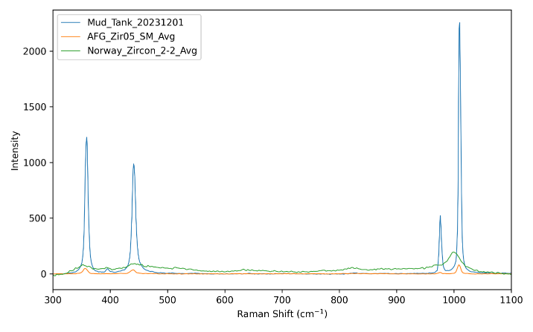
Figure 1: Raman spectra collected for starting materials.
Capsules were run in cold seal pressure vessel systems. Samples were quenched by raising the furnace and using a fan to blow air on the pressure vessel (<5 min to reach ambient temperature). The capsule was retrieved, weighed, and then punctured. A plastic microsyringe was used to extract solution, which was immediately injected into a vial. The vial was topped off with East Nashville Tap water with δ²H = -40.6‰, δ¹⁸O -6.59‰ to eliminate headspace and bring the isotopic composition within the calibrated range and then weighed.
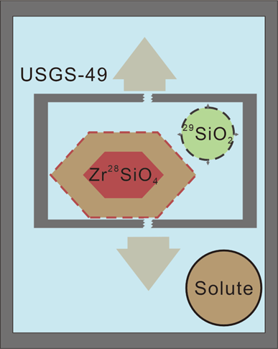
The inner capsule was removed, dried, and weighed before opening and collecting the zircon cubes. The cubes were cleaned, dried, and weighed. One cube was placed face-down on double-stick tape and covered with epoxy. The 1” o.d. cured epoxy mount was ground into to expose a cross-section, then polished to 1 μm and carbon-coated. Quenched solutes were collected from the outer capsule, dried, weighed, and then mounted in epoxy and polished for SIMS analysis.
Figure 2: Schematic diagram of double capsule method. Amorphous 29SiO2 powder in the inner capsule dissolves in USGS-49 fluid in the outer capsule, then natural metamict zircon is progressively replaced by crystalline zircon through coupled dissolution-reprecipitation. Dissolved solutes precipitate in the outer capsule during the quenching process.

Estimation of percent replacement
Replacement can be quantified because metamict zircon mz is replaced with crystalline zircon z with a very different isotopic composition. In the experiment the ³⁰SiO₂ added to the outer capsule dissolves rapidly to make a solution slightly undersaturated in quartz. The metamict zircon will start dissolving, adding Zr and Si to the solution. If any quartz precipitates, it will have roughly the same isotope composition as the solution. As metamict zircon continues to dissolve, the solution becomes oversaturated in crystalline zircon, and the concentrations of Zr and Si in the solution will be maintained at a steady state during coupled dissolution-precipitation. The Si isotope composition of the solution δ³⁰Si_{soln} will decrease continuously. At the end of the experiment, the Si isotope composition of the solution and quenched solutes will be the same, and are determined by the amounts and isotopic abundances of metamict ZrSiO₄ dissolved mz, ³⁰SiO₂ added, and hydrothermal zircon precipitated hz:
$R_{soln}={\left(\frac{{Si}^{29}}{{Si}^{28}}\right)}_{soln}=\frac{X_{mz}^{29}C_{mz}^{Si}m_{mz}+X_{SiO2}^{29}C_{SiO2}^{Si}m_{SiO2}-X_{hz}^{29}C_{hz}^{Si}m_{hz}}{X_{mz}^{28}C_{mz}^{Si}m_{mz}+X_{SiO2}^{28}C_{SiO2}^{Si}m_{SiO2}-X_{hz}^{28}C_{hz}^{Si}m_{hz}}$ (7)
Since the solubility of zircon in the quartz-saturated solution is low, we can assume that the mass of metamict zircon dissolved equals the mass of crystalline zircon precipitated (m_{mz} = m_{z}). Finally, for the homogeneous model, the isotopic compositions of the precipitated zircon and the solution should be the same within error, so we can substitute R_{z} for R_{soln} in Eq. (7):
$m_{mz}=\frac{C_{SiO2}^{Si}m_{SiO2}\left(X_{SiO2}^{29}-R_{hz}X_{SiO2}^{28}\right)}{C_{mz}^{Si}\left(R_{hz}X_{mz}^{28}-X_{mz}^{29}\right)}$ (8)
Table 1: Conditions and starting materials for experiments
Experiment | Run Time (d) | T (ºC) | P (GPa) | Starting material (all include ²⁹SiO₂) | Recrystallize?
Z_005 | 0.5 | 110 | 1 bar | AFG cubes + 0.5m NaF | No
Z_006 | 0.042 | 600 | 0.2 | AFG cubes + 0.5m NaF | No
Z_007 | 0.33 | 600 | 0.2 | AFG cubes + 0.5m NaF | Yes
Z_009 | 1 | 750 | 0.2 | MTZ cubes + USGS-49 water | No
Z_010 | 7 | 750 | 0.2 | MTZ cubes + USGS-49 water | No
Z_011 | 14 | 750 | 0.2 | MTZ cubes + USGS-49 water | No
Z_012 | 21 | 110 | 1 bar | MTZ cubes + USGS-49 water | No
Z_014 | 3 | 800 | 0.2 | AFG cubes + 1m NaF | Yes
Z_015 | 19 | 800 | 0.2 | AFG cubes + 1m NaF | Yes
Z_016 | 7 | 800 | 0.2 | AFG cubes + 1m NaF | Yes
Z_017 | 1 | 600 | 0.2 | Norway fragments + H2O | Yes
Z-018 | 1 | 600 | 0.2 | Norway fragments + 1m NaF | Yes

Mass Balance Model
To see if we could distinguish between heterogeneous and homogeneous replacement, we constructed a mass balance model using the initial masses and silicon and oxygen isotope compositions of phases H₂O, ²⁹SiO₂ and MZ from experiment Zir_015. We simulated the replacement of a cube of metamict zircon (MZ) by crystalline zircon (CZ) by coupled dissolution-reprecipitation using incremental steps of reaction progress ε = m_{CZ}/(m_{CZ} + m_{MZ}). In each step some MZ dissolves and releases oxygen and silicon with MZ's isotopic signature into the fluid, and the same mass of new CZ precipitates with the identical isotopic composition as the fluid. In the heterogeneous model precipitated CZ does not back-react in subsequent steps, i.e., it is physically segregated from the fluid and never re-equilibrates. In the homogeneous model bulk CZ isotopically reequilibrates with the fluid at every timestep, i.e. δ_{CZ_bulk}(t) = δ_{FL}(t) always. This means that no zoning is preserved because intracrystalline diffusion or recrystallization is fast enough to maintain isotopic equilibrium between the entire replacement zone and the fluid. In both models the Si and O isotope systems are tracked independently, each as a well-mixed, fixed-size fluid reservoir that receives isotopic input from dissolving MZ and passes its instantaneous composition to precipitating CZ. In both models we assume no isotopic fractionation, perfect mass conservation, stoichiometric (mass-for-mass) replacement, and a perfectly mixed fluid at all times.
Because MZ mass added to the fluid in each step is balanced by an equal mass removed into precipitating CZ, the masses of Si and O in the fluid stay constant through the experiment, but the fluid isotopic composition evolves. The MZ cube shrinks uniformly as it is replaced by a rim of CZ. The remaining MZ core has an edge length that scales with (remaining MZ volume)^(1/3), and the reaction-front distance from the original edge is half the total edge shrinkage. The Python code for the two models was written using Claude Code and is available at https://github.com/johncayers/IsotopeModel.

Results
Starting Materials: AFG cubes showed variable zoning styles including patchy and magmatic oscillatory, with BEI intensity inversely correlated with CL intensity. In the more common patchy style cracks and inclusions seemed confined to BEI-dark zones (AFG-z-10_Raman Spot location.pdf). Raman spectra showed these BEI-dark zones had less radiation damage than BEI-bright, CL-dark zones (KBSI Raman Results.xlsx).
In run product grains replacement zones were thickest at cube corners, with a thin replacement zone formed around much of the cube. Replacement zones were easily recognized by their location in CL-dark zones and presence of numerous sub-parallel pore channels (Fig. 5). Patchy zoning observed in starting materials was no longer visible in CL or BSE images.
Short preliminary experiments showed no evidence of metamict zircon recrystallization in the presence of 0.5m NaF after 12 hours at 1 bar and 100°C (Z_005) or after one hour at 0.2 GPa and 600°C (Z_006 in Table 1). Experiments on crystalline Mud Tank zircon at 1 bar and 110°C and a time series from 7 to 21 days at 0.2 GPa and 750°C showed no evidence of recrystallization. Values of δ²⁹Si from three Si isotope spot analyses on the Zir_011 run product cube, including one on the rim (see records Caltech SIMS.pdf), were not significantly different from six values obtained for the Mud Tank zircon starting material. However, cubes from experiments run for eight hours or longer at 600°C and 800°C showed extensive dissolution pitting and rims with different CL intensity that were thin on faces but thicker at corners (Figure 5). Cube interiors also retained their original CL zoning, while rims showed uniform CL intensity and exhibited regularly spaced pore channels. Run products confirmed that the BEI-bright CL-dark radiation-damaged zones in AFG were preferentially replaced (CaltechSIMS.ai).
AFG-H2O experiments run for 0 hour (Zir_005 blank), 1 hour (Zir_006) and 8 hours (Zir_007) show no evidence of a replacement rim in BSE and CL images. Raman spectra show a progressive increase in peak heights with time so that the 8-hour spectrum is similar to that of Mud Tank zircon except for a lower intensity v3(SiO₄) peak at ~1010 cm⁻¹ (Figure 3).
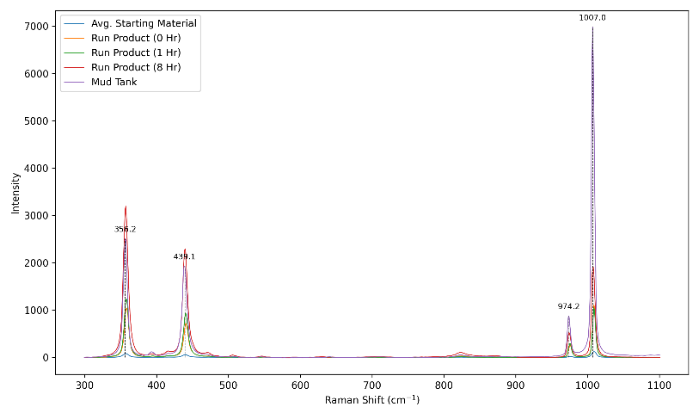
Figure 3: Average Raman spectra for AFG starting material and run products from Zir_005 (blank = 0h), Zir_006 (1 h), Zir_007 (8 h), and Mud Tank starting material. Experiments Zir_006 and Zir_007 were run at 600C and all three experiments had H₂O fluid. *What zone type were the run product spectra collected in?
Spectra from AFG-1m NaF experiments show little difference between unaltered cores and replacement rims except for the appearance of several additional peaks in the unaltered core spectrum (Figure 4). The Zir_016 run products are similar to Mud Tank except the latter has higher intensity peaks and some of the peaks are slightly shifted, especially for the ~1008 cm⁻¹ ν3(SiO4) band (−3.2 to −5.1 cm⁻¹ shift, ~80% intensity loss).
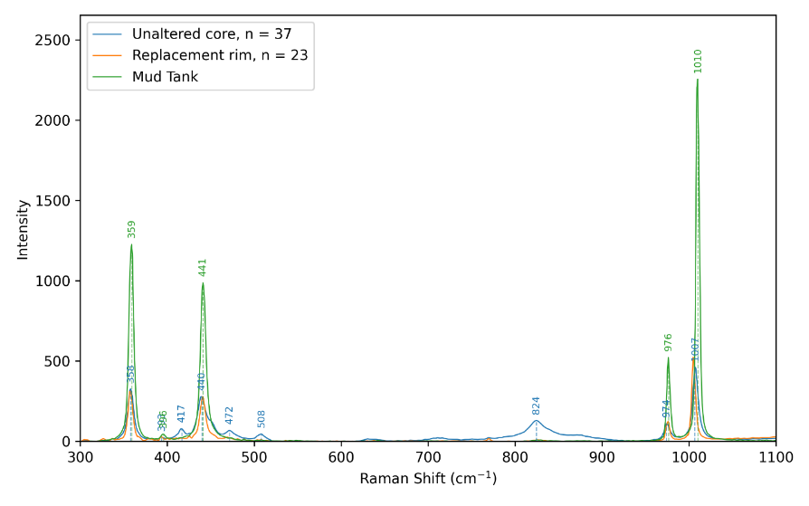
Figure 4: Raman spectra of Zir_016 run products, with Mud Tank starting material added for reference. Average intensities calculated from multiple spots. Spectrum peaks are labeled with Raman shifts (cm-1) for unaltered cores (blue) and Mud Tank starting material (green).

Isotope compositions
Kernel density estimate plots show the large shift in isotopic composition during replacement (Figure 6).
Table 2: Raman measurements for v3(SiO4) peak*
Type | Shift (cm⁻¹) | Intensity | Δ shift | Δ Intensity | FWHM meas. | FWHM corrected | Reliable (b≥2s) | α-dose (10¹⁶ α/mg)
Unaltered core | 1006.7 | 463.07 | −3.21 | −1791.80 | 7.2 | 6.62 | yes | 0.039
Replacement rim | 1004.8 | 524.05 | −5.14 | −1730.83 | 4.81 | 3.89 | no | 0.019
Mud Tank | 1009.9 | 2254.88 | 0 | 0 | 4.35 | 3.31 | no | 0.015
* FWHM calculated using method of Irmer (1985), α-dose calculated using Eq. (6) in Nasdala et al. (2001).
Table 3: O and Si isotope compositions from time series run products
Experiment/ Replaced? | Average d18O (per mille) | StdDev | Count | Average d29Si (per mille) | StdDev | Count
14 |  |  |  | 1609.3 | 4047.8 | 8
N |  |  |  | 0.3 | 1.3 | 5
P |  |  |  | 113.4 |  | 1
Y |  |  |  | 6379.9 | 7347.8 | 2
15 | -17.0 | 21.0 | 11 | 4110.4 | 7729.9 | 13
N | -2.3 | 1.9 | 7 | 2.1 | 3.5 | 7
P |  |  |  | 202.5 | 60.5 | 2
Y | -42.7 | 8.7 | 4 | 13253.8 | 8830.0 | 4
16 | -9.1 | 16.2 | 12 | 4504.5 | 10850.7 | 12
N | -0.3 | 2.5 | 9 | 30.0 | 60.8 | 8
P |  |  |  | 141.9 |  | 1
Y | -35.7 | 1.9 | 3 | 17890.9 | 17004.4 | 3

In most experiments there were not enough quenched solutes in the outer capsule to collect for analysis, despite addition of enough ²⁹SiO₂ to the outer capsule to induce quartz saturation. This may result from the metamict zircons containing baddeleyite nanocrystals that combined with the ²⁹SiO₂ to form crystalline zircon. When present they were roughly spherical with diameters of ~100 µm. EDS analysis of the solutes from Z_016 showed mostly Si (35 wt. %) and Na from the added NaF (12.5%) along with Al (2.7%(, Ti (1.3%), Ca (0.37%), and K (0.32%).
A time series at 800°C and 0.2 GPa using AFG zircon generally showed increases in measures of the extent of replacement from 3 d (Z_014) to 7 d (Z_016) to 19 d (Z_015) (Table 3). Image analysis showed the % replacement increased from 15.3% to 17.8% to 18.5%, average rim thickness increased from 9.4 to 10.4 to 15.8 microns, while the shift in δ¹⁸O_{fl} increased from 23‰ to 56‰ to 67‰ (Figure 7). In contrast, % replacement calculated assuming a homogeneous (batch equilibrium) model and using average measured δ²⁹Si of solids changed from 6% to 27% to 19% and from δ²⁹Si of solutes 15% to 10% to 20% (Figure 8). Two 24 h experiments at 0.2 GPa and 600°C using the Norway zircon and δ²⁹Si of solutes yielded 100% replacement in H₂O (Z_017) and 1m NaF (Z_018). Bulk replacement rates in moles ZrSiO₄ kg H₂O⁻¹ s⁻¹ calculated from solids were 3.0E-6, 5.4E-7 and 1.7E-7 and from solutes 4.7E-7, 2.1E-7 and 1.9E-7. Replacement rates in moles ZrSiO₄ kg H₂O⁻¹ s⁻¹ were much higher for Norway at 0.21 in H₂O and 0.017 in 1 m NaF due to higher alpha dose and higher surface area, but these are minimum rates because the metamict ZrSiO₄ was completely replaced.
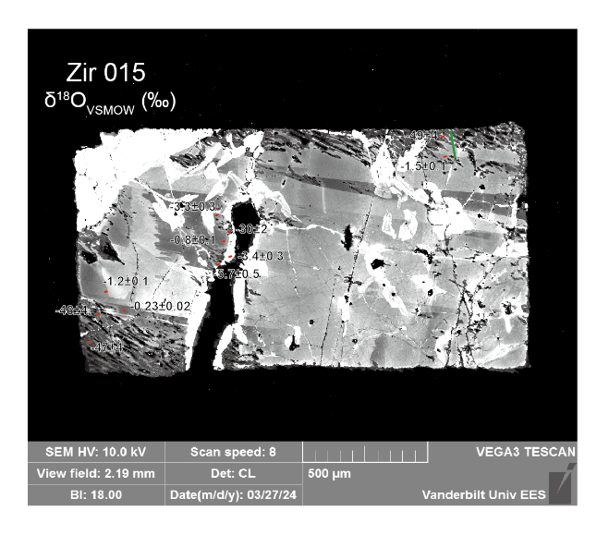 | 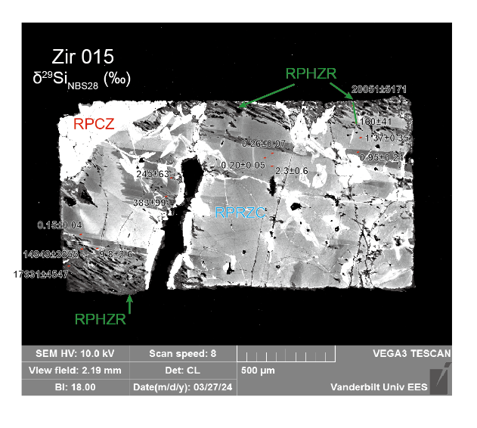
Figure 5: CL image of run product zircon grain from experiment Zir_015 with SIMS spot analysis results. δ¹⁸O values on the left, δ²⁹Si values on the right.
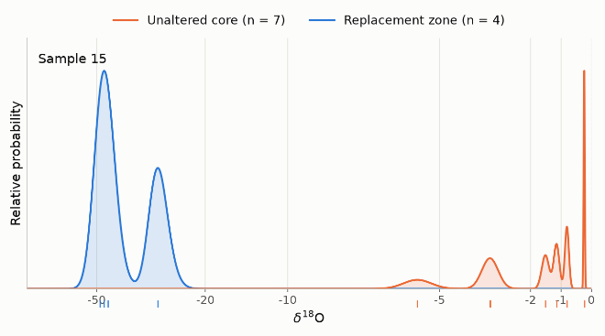 | 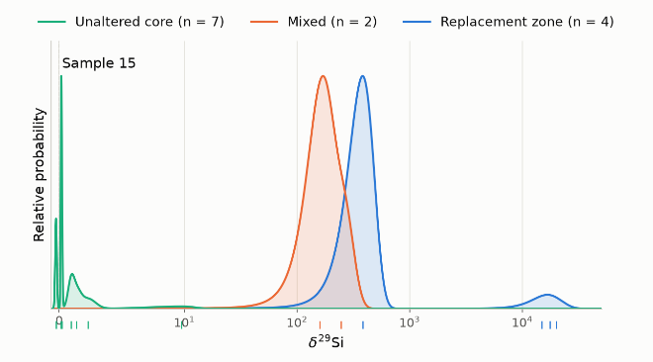
Figure 6: Uncertainity-weighted kernel density estimate plots of run products from experiment Zir_015 AFG starting material. Replacement categories inferred from texture and CL intensity are Yes, Partial, and No. Note that the z-axis in the silicon isotope plot is logarithmic. For each category relative probabilities are normalized so that the maximum value equals one. Were any of these spots located in RPCZ? *Change plots – only one experiment instead of pooling all of them
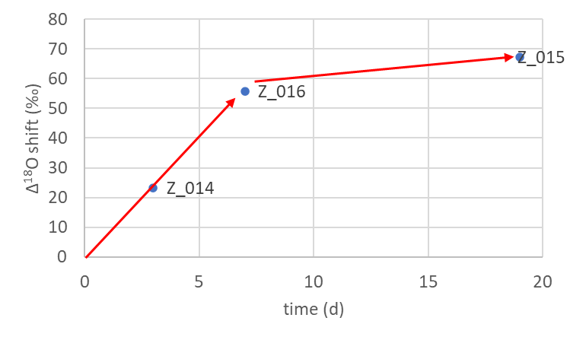
Figure 7: Shift in oxygen isotope composition of the fluid from the initial composition of USGS-49 as a function of experiment duration.

Figure 8: Estimates of % replacement of metamict ZrSiO₄ by crystalline zircon as a function of experiment duration. *Update numbers, replace plot with table
SIMS spot analyses of the Zir-015 run product cube shows that isotopic compositions cluster in two groups, with crystalline replacement zones having distinctly different isotopic compositions from metamict zones (Fig. 5). The replacement zone is relatively flat at low δ¹⁸O and high δ²⁹Si, then at ~250 µm transitions to higher δ¹⁸O and lower δ²⁹Si values.
Table 4: Bulk replacement rates of metamict ZrSiO4 by hydrothermal zircon estimated from isotope dilution of Si isotopes
Expt. | Z_014 |  | Z_015 |  |  | Z_016 |  |  | Z_017 | Z_018
Material | AFG |  |  | AFG |  |  | AFG |  | Norway | Norway
duration (s) | 259200 |  |  | 1641600 |  |  | 604800 |  | 86400 | 86400
Method | Solids | Solutes |  | Solids | Solutes |  | Solids | Solutes | Solutes | Solutes
replaced ZrSiO₄ (moles) | 9.4E-05 | 1.5E-05 |  | 3.3E-05 | 3.8E-05 |  | 3.9E-05 | 1.5E-05 | 2.2E+00 | 1.7E-01
Bulk rate (moles kg H2O⁻¹ s⁻¹) | 3.0E-06 | 4.7E-07 |  | 1.7E-07 | 1.9E-07 |  | 5.4E-07 | 2.1E-07 | 2.1E-01 | 1.7E-02
% replacement | 96.1 | 17.3 |  | 26.5 | 14.8 |  | 19.9 | 10.2 | > 100 | > 100

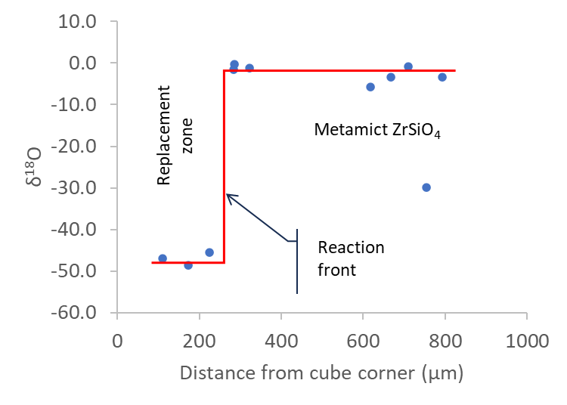 | 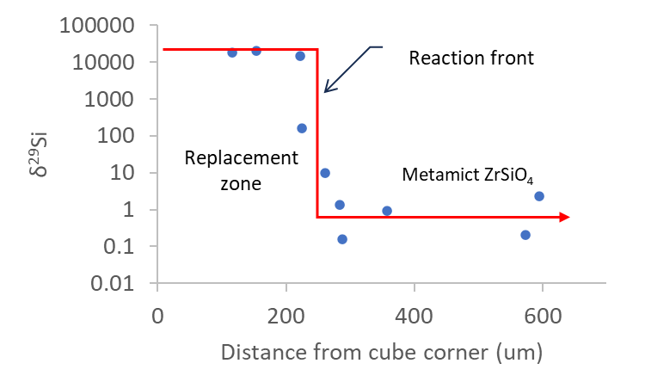
Figure 9. a) SIMS δ¹⁸O measurements as a function of distance from the corner of the run product Z_015 cube in microns. b) SIMS δ²⁹Si measurements as a function of distance from the corner of the run product Z_015 cube in microns.
Compared with the numerical mass balance models, the oxygen isotope spatial profile from experiment Z_015 (Fig. 5a) shows poor agreement with the heterogeneous model (Fig. 6a) but good agreement with the homogeneous model (Fig. 6b). The Si isotope spatial profile is also consistent with a homogeneous model (Fig. 5b), as there is very little variation in isotopic composition in the replacement zone, although as for oxygen isotopes there are only three replacement zone analyses along the linear transect.

Geochronology
Geochronology measurements were complicated because grains of the AFG starting material had crystalline and metamict zones. The crystalline zones were CL bright and BSE dark and had lower U concentrations than CL dark BSE bright metamict zones (Figure 5). ²⁰⁷Pb/²⁰⁶Pb and ²⁰⁶Pb/²³⁸U ages were higher in starting material crystalline zones than in metamict zones, and both were higher than ages in run product grains. The youngest ages were in run product replacement zones.

Discussion
Our original objective was to characterize the processes of crystalline zircon recrystallization and metamict zircon replacement. However, our experiments on crystalline Mud Tank zircon showed no visual evidence of recrystallization, and the few SIMS analyses near the rim of the Zir_011 run product cube showed no isotopic shift. Mud Tank zircon grains are relatively pure ZrSiO₄; our SIMS analyses yielded average concentrations in ppm of Pb 1.6, U 13.7, and Th 5.1. We concluded that large, pure crystalline zircon grains did not recrystallize in the presence of fluid in our experiments because there was no thermodynamic driving force. Similar results were obtained for experiments on natural zircon fragments several hundred µm in diameter at 0.2 GPa and 450-750°C (Ayers et al. 2012). In those experiments internal zoning was preserved in some grains and run product zircon grains showed no change in oxygen isotope composition despite the fluid having δ¹⁸O ~11‰ lower than the zircon starting material. Hydrothermal experiments at 850°C and 50 MPa showed enrichment of 18O to depths of only 20 nm even after four months, consistent with no hydrothermal replacement and oxygen diffusion rates comparable to anhydrous diffusion rates (Bindeman et al., 2018). In contrast, small zircon grains have been shown to recrystallize at higher pressures and temperatures, by Ostwald ripening at 1.0 GPa and 1000°C (Ayers et al., 2003) and by recrystallization of Mud Tank zircon in the presence of a trace element-enriched fluid at 1.5 GPa and 800-1000°C (Ayers and Peters, 2018). Small grains have high surface area/volume which increases interfacial energy, Gibbs Free Energy, and aqueous solubility.
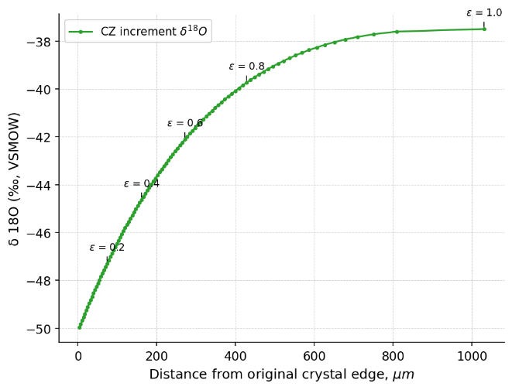 | 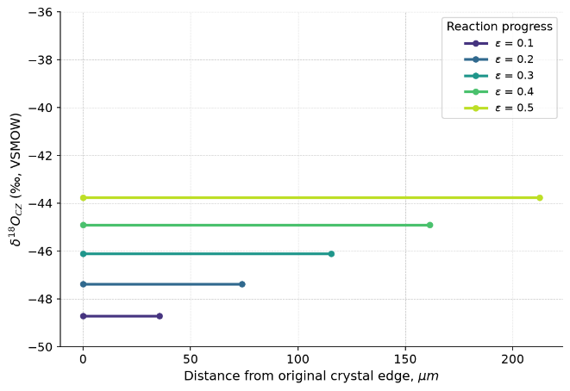
Figure 10. a) O isotope spatial profile in cube from heterogeneous mass balance numerical model. B) O isotope spatial profile in replacement zone from homogeneous model at different levels of reaction progress. The shrinking MZ zone is not plotted because it has a constant δ¹⁸O = 0.45 ‰.
Table 5: U-Pb geochronology results
Values | Mix | RPCZ | RPRZC | RPHZR | SMCZ | SMMZ
Average of ppm U | 427 | 95 | 500 | 264 | 692 | 515
StdDev of ppm U | 144 | 82 | 86 | 172 | 438 | 472
Average of ppm Th | 355 | 34 | 400 | 229 | 439 | 381
StdDev of ppm Th | 158 | 29 | 125 | 151 | 370 | 445
Average of (1) 207Pb/206Pb Age | 605 | 590 | 566 | 506 | 1455 | 1030
StdDev of (1) 207Pb/206Pb Age | 38 | 167 | 40 | 91 | 301 | 520
Average of (1) 206Pb/238U Age | 562 | 571 | 576 | 494 | 1254 | 857
StdDev of (1) 206Pb/238U Age | 19 | 8 | 10 | 64 | 272 | 380
Count of (1) 206Pb/238U Age | 7 | 6 | 19 | 11 | 6 | 4

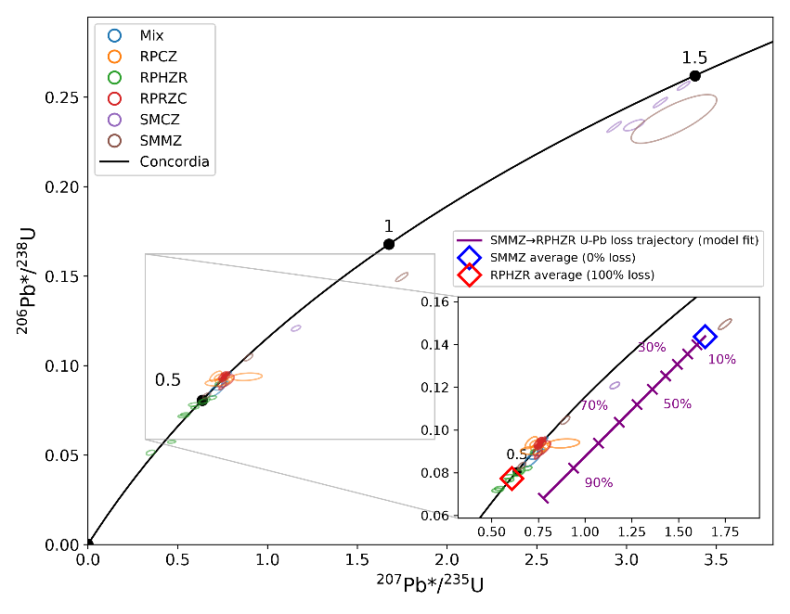
Metamict zircon is more soluble than pure crystalline zircon (Tromans, 2006), so replacement of metamict zircon by crystalline zircon decreases the Gibbs Free Energy of the system. We therefore focused on characterizing metamict ZrSiO₄ replacement.
Figure 11: Concordia diagram with 1-sigma error ellipses for AFG starting material and run products from time series experiments Zir_014, Zir_015 and Zir_016. RPMZ = Run product metamict zircon, RPRZ = run product replacement zircon, RPCZ = run product crystalline zircon (zones that were crystalline before the experiment), SMMZ = starting material metamict zircon, SMCZ = starting material crystalline zircon. The average SMMZ plotted as a blue diamond represents the initial metamict zircon that then experiences U and Pb loss to form the average RPRZ replacement zircon. The U and Pb loss trajectory is shown with 10% increments of the total loss: average SMMZ had 515 ppm U and 104.5 ppm Pb, while average RPRZ had 154 ppm U and 13.5 ppm Pb, for total % loss of 70% U and 87% lead.
Raman spectroscopy measurements show that AFG and Norway starting materials were metamict while Mud Tank zircon was crystalline (Figure 1). In Zir_016 AFG run products the unaltered core and replacement rim are both crystalline, although additional peaks in the unaltered core spectrum may result from incomplete recrystallization resulting in the presence of metastable phases (Figure 4) as observed previously (Geisler et al., 2003). Alpha doses at the ~1000 cm⁻¹ ν₃(SiO₄) band show decreasing radiation damage from unaltered core 3.9×10¹⁷ α/g > replacement rim 1.9×10¹⁷ α/g > Mud Tank 1.5×10¹⁷ α/g, with alpha doses for replacement rim and Mud Tank zircon being the same within error *check.
While the unaltered core shows partial recovery of the crystalline structure, it does not show evidence of isotopic exchange with the fluid (Figure 6), suggesting recrystallization through thermal annealing. In contrast, replacement rims show greater crystallinity (Figure 4) and large shifts in isotope composition, suggesting they formed by coupled dissolution-reprecipitation.
The crystalline zircon replacement forms a porous rim, resembling hydrothermal zircons described in the literature (Corfu et al., 2003; Tomaschek et al., 2003) . The porosity results from the volume change that occurs when less dense metamict zircon is replaced by denser crystalline zircon, and to a lesser extent to material that remains dissolved in the fluid. Metamict zircon is replaced through a coupled dissolution-precipitation process, with replaced zircon cubes maintaining their initial shape. Replacement rates and rim thicknesses are greatest at cube corners and on unpolished faces, which have higher surface areas than polished faces (Figure 5).
The finding that hydrothermal zones are compositionally homogeneous is consistent with previous observations of natural hydrothermal rims being homogeneous (citations). That our isotopic profiles are consistent with a homogeneous replacement model makes clear that the entire rim was in equilibrium with the fluid, not just the outside edge. This has implications for natural replacement rates: a thick homogeneous rim did not have to form rapidly; it could slowly grow and continuously reequilibrate with the fluid. Also, it implies that all parts of the rim remain in chemical communication with the fluid, presumably through a network of pores.
Estimates of the measured replacement rate in moles ZrSiO₄ kg H₂O⁻¹ s⁻¹ of AFG replacement at 800°C in 1 m NaF ranged from 1.7 to 5.4 x 10⁻⁷ (Table 2). Although previous experiments by Geisler et al. (2003) were conducted at lower temperatures of 554-650°C in 2M CaCl₂, replacement rates estimated using image analysis were comparable in magnitude, 2.24 to 5.8 x 10⁻⁷ mol L⁻¹ s⁻¹ (Ayers and Zhu 2025). *Convert these values to mol kg H2O-1 s-1?
The U-Pb geochronology results showed that loss of both U and lead occurred, consistent with results from previous hydrothermal experiments (Pidgeon et al., 1966; Sinha et al., 1992). Average measured ²⁰⁶Pb*/²³⁸U ages of RPHZR were 446 Ma and for RPRZC 575 Ma, younger than zones in the starting material that were in the ~0.9-1.5 Ga range (Table 4). Average U, Th, and Pb concentrations were lower in run product zones than in starting materials but still occurred in measurable amounts. The transition from SMMZ to RPHZR caused percentage losses of 70% of U and 87% of Pb. Because more lead was lost, the apparent ages decreased, but not to zero. Only if all radiogenic lead is lost will the U-Pb chronometer completely reset.
Although U, Th and Pb were released by metamict zircon dissolution, without another mineral to accept these elements, some was reincorporated into the replacement zircon, with the remainder presumably remaining dissolved in the fluid. Natural rocks are likely to behave differently from our experiments that are closed systems with a limited number of solid phases, but our results leave open the possibility that measured ages of zircon domains that formed through fluid-assisted dissolution-reprecipitation may not record the age of the fluid event.
When zircon recrystallizes it often retains its U and loses only Pb, causing it to migrate along a discordia toward the origin of the concordia diagram, and these discordia are commonly observed (refs). However, in the presence of an oxidized fluid in which U⁺⁶ is soluble (our experiments were near fO2 = NNO), U loss may be comparable in magnitude to lead loss (*references?), and recrystallized zircons may not fall along a simple discordia.

Conclusions
- Hydrothermal fluids can cause replacement of radiation-damaged zircon by crystalline hydrothermal zircon.
- A new stable isotope method was used to measure the rate of replacement.
- Replacement rate increases as degree of radiation damage increases.
- Hydrothermal zircon may form through replacement of metamict ZrSiO₄.
- The large isotopic shifts in our experiments can be explained using a homogeneous model.

References
Ayers J. C., DeLaCruz K., Miller C. and Switzer O. (2003) Experimental study of zircon coarsening in quartzite+/-H2O at 1.0 GPa and 1000C, with implications for geochronological studies of high-grade metamorphism. American Mineralogist 88, 365–376.
Ayers J. C., Dunkle S., Gao S. and Miller C. F. (2002) Constraints on timing of peak and retrograde metamorphism in the Dabie Shan Ultrahigh-Pressure Metamorphic Belt, east-central China, using U–Th–Pb dating of zircon and monazite. Chem. Geol. 186, 315–331.
Ayers J. C. and Peters T. J. (2018) Zircon/fluid trace element partition coefficients measured by recrystallization of Mud Tank zircon at 1.5 GPa and 800–1000 °C. Geochim. Cosmochim. Acta 223, 60–74.
Ayers J. C. and Watson E. B. (1991) Solubility of Apatite, Monazite, Zircon, and Rutile in Supercritical Aqueous Fluids with Implications for Subduction Zone Geochemistry. Philosophical Transactions of the Royal Society A: Mathematical, Physical and Engineering Sciences 335, 365–375.
Ayers J. C., Zhang L., Luo Y. and Peters T. J. (2012) Zircon solubility in alkaline aqueous fluids at upper crustal conditions. Geochim. Cosmochim. Acta 96, 18–28.
Ayers J. C. and Zhu C. (2025) Zircon Solubility, Metamict ZrSiO4 Replacement, and Hydrothermal Zircon Formation at Upper Crustal Pressures. Geochemistry, Geophysics, Geosystems 26, e2024GC011925.
Bernini D., Audétat A., Dolejš D. and Keppler H. (2013) Zircon solubility in aqueous fluids at high temperatures and pressures. Geochim. Cosmochim. Acta 119, 178–187.
Bindeman I. N., Schmitt A. K., Lundstrom C. C. and Hervig R. L. (2018) Stability of Zircon and Its Isotopic Ratios in High-Temperature Fluids: Long-Term (4 months) Isotope Exchange Experiment at 850°C and 50 MPa. Front. Earth Sci. (Lausanne). 6, 59.
Cherniak D. J., Watson E. B., Ribbe P. H. and Rosso J. J. (2003) Diffusion in zircon. In Zircon Mineralogical Society of America, Geochemical Society. pp. 113–143.
Corfu F., Hanchar J. M., Hoskin P. W. O., Kinny P. D., Ribbe P. H. and Rosso J. J. (2003) Atlas of zircon textures. In Zircon Mineralogical Society of America, Geochemical Society. pp. 469–500.
Ewing R. C., Meldrum A., Wang L., Weber W. J., Corrales L. R., Ribbe P. H. and Rosso J. J. (2003) Radiation effects in zircon. In Zircon Mineralogical Society of America, Geochemical Society. pp. 387–425.
Gehrels G. (2014) Detrital Zircon U-Pb Geochronology Applied to Tectonics. Annu. Rev. Earth Planet. Sci. 42, 127–149.
Geisler Thorsten, Pidgeon R. T., van Bronswijk W. and Pleysier R. (2001) Kinetics of thermal recovery and recrystallization of partially metamict zircon: a Raman spectroscopic study. European journal of mineralogy. 13, 1163–1176.
Geisler T., Pidgeon R. T., Kurtz R., Bronswijk W. Van and Schleicher H. (2003a) Experimental hydrothermal alteration of partially metamict zircon. American Mineralogist 88, 1496–1513.
Geisler T., Pidgeon R. T., Kurtz R., Bronswijk W. Van and Schleicher H. (2003b) Experimental hydrothermal alteration of partially metamict zircon. American Mineralogist 88, 1496–1513.
Geisler T, Ulonska M., Schleicher H., Pidgeon R. T. and VanBronswijk W. (2001a) Leaching and differential recrystallization of metamict zircon under experimental hydrothermal conditions. Contributions to Mineralogy and Petrology 141, 53–65.
Geisler T, Ulonska M., Schleicher H., Pidgeon R. T. and VanBronswijk W. (2001b) Leaching and differential recrystallization of metamict zircon under experimental hydrothermal conditions. Contributions to Mineralogy and Petrology 141, 53–65.
Geisler T., Zhang M. and Salje E. K. H. (2003c) Recrystallization of almost fully amorphous zircon under hydrothermal conditions: An infrared spectroscopic study. J. Nucl. Mater. 320, 280–291.
Gorski C. A. and Fantle M. S. (2017) Stable mineral recrystallization in low temperature aqueous systems: A critical review. Geochim. Cosmochim. Acta 198, 439–465.
Hoskin P. W. O. (2005) Trace-element composition of hydrothermal zircon and the alteration of Hadean zircon from the Jack Hills, Australia. Geochim. Cosmochim. Acta 69, 637–648.
Morales I., Molina J. F., Cambeses A., Montero P. and Bea F. (2022) Experimental Annealing of Zircon: Influence of Inclusions on Stability, Intracrystalline Melt Migration, Common Lead Leaching, and Permeability to Fluids. ACS Earth Space Chem. 6, 288–307.
Peters T. J., Ayers J. C., Gao S. and Liu X.-M. (2013) The origin and response of zircon in eclogite to metamorphism during the multi-stage evolution of the Huwan Shear Zone, China: Insights from Lu–Hf and U–Pb isotopic and trace element geochemistry. Gondwana Research 23, 726–747.
Pidgeon O’Neil, J.R., Silver, L.T., R. T. (1966) Uranium and lead isotopic stability in a metamict zircon under experimental hydrothermal conditions. Science (1979). 154, 1538–1540.
Pidgeon R. T. (1992) Recrystallization of oscillatory zoned zircon: some geochronological and petrological implications. Contributions to Mineralogy and Petrology 110, 463–472.
Rubatto D., Muntener O., Barnhoorn A. and Gregory C. (2008) Dissolution-reprecipitation of zircon at low-temperature, high-pressure conditions (Lanzo Massif, Italy). American Mineralogist 93, 1519–1529.
Taylor S. D., Liu J., Zhang X., Arey B. W., Kovarik L., Schreiber D. K., Perea D. E. and Rosso K. M. (2019) Visualizing the iron atom exchange front in the Fe(II)-catalyzed recrystallization of goethite by atom probe tomography. Proc. Natl. Acad. Sci. U. S. A. 116, 2866–2874.
Tole M. P. (1985) The kinetics of dissolution of zircon (ZrSiO4). Geochim. Cosmochim. Acta 49, 453–458.
Tomaschek F., Lagos M., Ballhaus C., Kennedy A. K. and Villa I. M. (2003) Zircons from Syros, Cyclades, Greece - Recrystallization and mobilization of zircon during high-pressure metamorphism. Journal of Petrology 44, 1977–2002.
Vonlanthen P., Fitz Gerald J. D., Rubatto D. and Hermann J. (2012) Recrystallization rims in zircon (Valle d’Arbedo, Switzerland): An integrated cathodoluminescence, LA-ICP-MS, SHRIMP, and TEM study. Am. Mineral. 97, 369–377.
Wilke M., Schmidt C., Dubrail J., Appel K., Borchert M., Kvashnina K. and Manning C. E. (2012) Zircon solubility and zirconium complexation in H2O+Na2O+SiO2±Al2O3 fluids at high pressure and temperature. Earth Planet. Sci. Lett. 349–350, 15–25.
Yakymchuk C., Clark C. and White R. W. (2017) Phase Relations, Reaction Sequences and Petrochronology. Rev. Mineral. Geochem. 83, 13–53.

