Intelligent Data Centre Digital Twin

Predictive cooling maintenance for a three-rack server room
Project 2 — Intelligent Ecosystem & Strategic Optimization (Advanced)
Team members
- Lourduraj John Charles (1011136)
- Syed Adeel Ahmed Mustaq Ahamed (1011010)
- Yang Xingyu (1010962)
- Kuhu Gupta (1010814)
Submission date: 16 August 2026
Repository: github.com/johncharles-dev/Data_Center_Digital_Twin, branch main
Live demonstration: https://5090-server.tail391a63.ts.net/
Every claim in this report cites a path and line in that repository. Every number is measured, and the measurement is reproducible by the command given beside it.

Executive summary
A cooling unit fails gradually. Its bearings wear, its filter loads, its motor runs hotter — and none of that appears as room temperature until the failure is nearly complete. A threshold alarm on rack temperature therefore reports a problem that is already happening. This project predicts the failure instead.
Four sub-twins and a central orchestrator consume live MQTT telemetry from three racks and one CRAC unit. A trained classifier reads eleven CRAC signals, including two ten-minute trend features, and reports the probability of failure within four hours. On the test set the model gives a median 292.5 minutes of warning against 195.2 minutes from the same room’s threshold rules — 1.5× more — and catches 31 of 31 failing runs at 0.08 false alarms per healthy run (§1). On the running system, the model crossed its action threshold 80.5 simulated minutes before the first sensor limit tripped (§1.4).
The system distinguishes a busy room from a failing one. When risk is high but compute load is high and no equipment limit has been breached, the orchestrator withholds advice and says why — 143 of 437 predictions in a measured run (§2.4). Nothing actuates: every output is advisory and every decision is recorded in a hash-chained audit trail (§3).
The cooling energy this protects is real and modelled from telemetry rather than assumed. A degrading unit draws 3.37 kW more than a healthy one, and room PUE moves 1.34 → 1.49 across a fault (§3.5).
What this is not: a validated product. The telemetry is simulated, one fault profile is modelled, and no figure here has been checked against physical hardware. The limitations are stated in each section rather than collected out of sight.

How to run this
One command, from a clean clone, on a machine with Docker and Python 3.11+:
git clone https://github.com/johncharles-dev/Data_Center_Digital_Twin.git
cd Data_Center_Digital_Twin
./run.sh
run.sh generates the broker credentials that are deliberately absent from the repository, starts Mosquitto, then launches the twins, orchestrator, telemetry simulator, occupancy publisher and audit sink. Verified from a genuine fresh clone on 11 August 2026, at run.sh --interval 0.4 (75x real time): 345 audited decisions in the first two minutes of wall clock — about 2.5 simulated hours — hash chain intact, no authentication failures in any log.
The interval is quoted because the count is a rate against the wall clock, not a property of the system: the same two minutes at the 0.05 default covers eight times the simulated span and audits roughly eight times as many decisions. The simulated figure is the one that reproduces at any playback speed.
Useful commands once it is running:
python3 watch.py datacenter/predictions/CRAC-01 # live predictions
python3 audit/audit_sink.py --show 20 # recent decisions
python3 audit/audit_sink.py --verify # check the audit chain
./serve_demo.sh # publish the dashboard
./run.sh --stop # stop the broker
The full test suite:
python3 tests/test_broker_security.py # 8 access-control attempts
python3 tests/test_audit_chain.py # 17 tamper/sequence assertions
python3 tests/test_energy_model.py # 18 energy-model assertions
python3 tests/test_slope_units.py # trend features match training units
python3 tests/test_substep_cap.py # simulated clock, playback invariance
python3 tests/test_load_driven_branch.py # load-vs-fault branch reachability
All six pass as of 11 August 2026.
A failure mode found in verification. MQTT reports a refused credential in CONNACK — after the socket has opened. A client that ignores that result code goes on to subscribe and publish into a connection the broker has already closed: it emits nothing, raises nothing, and looks healthy. We found this by starting the stack with no per-service credentials during the audit. All seven components were refused by the broker, and not one of them said so.
Both client paths now check the code and name the variable to set (twins/base_twin.py:95, orchestrator/orchestrator.py:110):
[cooling] BROKER REFUSED THE CONNECTION: rc=5 (Connection Refused: not authorised.)
[cooling] this twin will publish nothing. Check MQTT_USERNAME_TWIN_COOLING /
MQTT_PASSWORD_TWIN_COOLING, or run ./run.sh which exports them from
mosquitto/credentials.json.
Re-verified after the change: the same wrong-credential start now reports the refusal for every component, and a correct start still brings all seven to online with predictions flowing. This is the class of defect that turns a misconfigured demonstration into an unexplained blank screen, and it is the reason the start-up path is a single scripted command rather than a list of steps to follow by hand.

Continuity with Project 1
The brief asks for the initial twin to be extended. It is, and the extension is in the telemetry contract rather than in the AnyLogic file — for a reason worth stating plainly.
What Project 1 delivered. SmartDataCenterTwin.alp (Segment 1 — Asset & Schema) is an asset drawing, not a running model. Parsed, it holds 2,051 XML elements, of which 155 are positioned drawing objects: 77 labels, 33 text items, 22 lines, 15 ovals, 5 rectangles, a scale ruler and a level. It declares one ActiveObjectClass (“Main”) whose entire contents are the presentation canvas and scene properties. There are no functions, events, statecharts, transitions or flowchart blocks; <Parameters> is present and empty; of 159 CDATA blocks, none contains a statement, a return, or a control-flow keyword. The eight <Code> elements hold AnyLogic property defaults (T extends Agent, 10, 1, 1.0). It opens, and the run button does nothing, because there is no behaviour to run.
That is the correct deliverable for a segment named “Asset & Schema”: it fixes the room layout, names the assets and defines what each sensor measures. It is a specification, and a specification is extended by implementing it, not by opening it.
What therefore carries forward is the contract. Four things, all checkable:
Inherited | Where it came from | Where it lives now
Payload schema — timestamp, rack_id, location, inlet_temperature, exhaust_temperature, fan_speed, power_draw, status | Segment 1 handover | sensor_simulator.py:276, unchanged
Asset IDs SR-RACK-01/02/03, CRAC-01 | labels on the .alp canvas | sensor_simulator.py:84-86, identical strings
Topic tree datacenter/racks/<RACK_ID> | Segment 1 handover + Segment 3 dashboard | TOPIC_BASE, unchanged
Status rules — WARNING above 35 °C exhaust or 8.5 kW; CRITICAL above 40 °C, 7000 RPM or 9.0 kW | Segment 1 status rules | sensor_simulator.py:348, applied verbatim
Project 1’s telemetry engine is this simulator. sensor_simulator.py is Segment 2’s engine, carried over and extended in place — it still opens with the Segment 2 header and still states its contract as “from Segment 1 handover + dashboard.html”. The baselines are the same numbers (inlet 20.0 °C, exhaust 30.0 °C, fan 4200 RPM, power 5.8 kW), and the rack payload is byte-compatible with what the Segment 3 dashboard already consumed.
The Project 2 additions sit alongside that, deliberately: the CRAC-01 stream publishes to datacenter/racks/CRAC-01, inside the same topic family, so the Segment 3 dashboard’s datacenter/racks/# subscription picks it up with no change. Extension by addition, not by replacement — the earlier deliverable keeps working while the new assets appear next to it.
So the honest statement of lineage is: the schema, the asset identities, the topic tree and the threshold rules are Project 1’s and are unmodified; the failure physics, the CRAC asset, the four sub-twins, the model and the orchestrator are Project 2’s. The .alp is not carried forward because there is nothing executable in it to carry — a point made here rather than left for a reader to discover.

1. Predictive intelligence

1.1 Purpose
Predict CRAC-01 failure early enough to schedule maintenance rather than react to an outage, and prove the prediction beats the threshold rules it would replace.

1.2 Design decisions
Predict the cause, not the symptom. Rack temperature is the symptom of a cooling fault and lags it by hours. The model reads CRAC-internal signals — winding temperature, vibration, filter differential pressure, airflow — where the fault actually develops.
Two trend features, computed identically in training and inference. The model uses eleven features, nine instantaneous and two ten-minute slopes. The slopes are where a naive implementation breaks: the training notebook computes diff(20)/20 over 30-second samples, so a slope is change per sample, not per minute. twins/cooling_twin.py:134 divides by elapsed samples using TRAINING_SAMPLE_INTERVAL_S (line 28), and twins/cooling_twin.py:39 measures elapsed time from the payload’s own timestamp rather than wall clock — necessary because the simulated clock can run far faster than real time, and dividing simulated change by wall-clock seconds inflates every slope by the acceleration factor.
Report time-to-failure only where the regressor has support. inference/model_loader.py:26 gates the countdown at the action threshold. Below it the field is null and the dashboard renders a dash — never a zero, which would read as “failure imminent”.
Do not claim a mechanism classifier. The artefact contains a classifier and a regressor. predicted_mode is a rule over tripped sensor limits (inference/model_loader.py:29) and is published alongside predicted_mode_basis: "rule" so no consumer can mistake it for a model output.

1.3 Implementation
notebooks/train_crac_model.ipynb, committed with outputs. Grouped train/test split on run_id stratified by outcome — a random row split would leak near-identical consecutive samples across folds and produce a meaningless score. Ground-truth columns are dropped before training.
Inference runs in inference/model_loader.py, which builds its feature vector by name from the model’s own saved feature_cols rather than a second hardcoded list, making a feature-order mismatch impossible.

1.4 Evidence it works
Figure 2 — Warning before failure, per failing test run. Each point is one of the 31 failing runs; the vertical rule is the median for that detector. The model’s median lead is 292.5 minutes against 195.2 from the same room’s threshold rules, a gap of 97.3 minutes. Both detectors caught all 31 runs, so the medians are comparable. Regenerate with python3 docs/figures/make_lead_time_figure.py, which scores the committed model artefact and aborts rather than writing the figure if its numbers drift from the notebook’s.
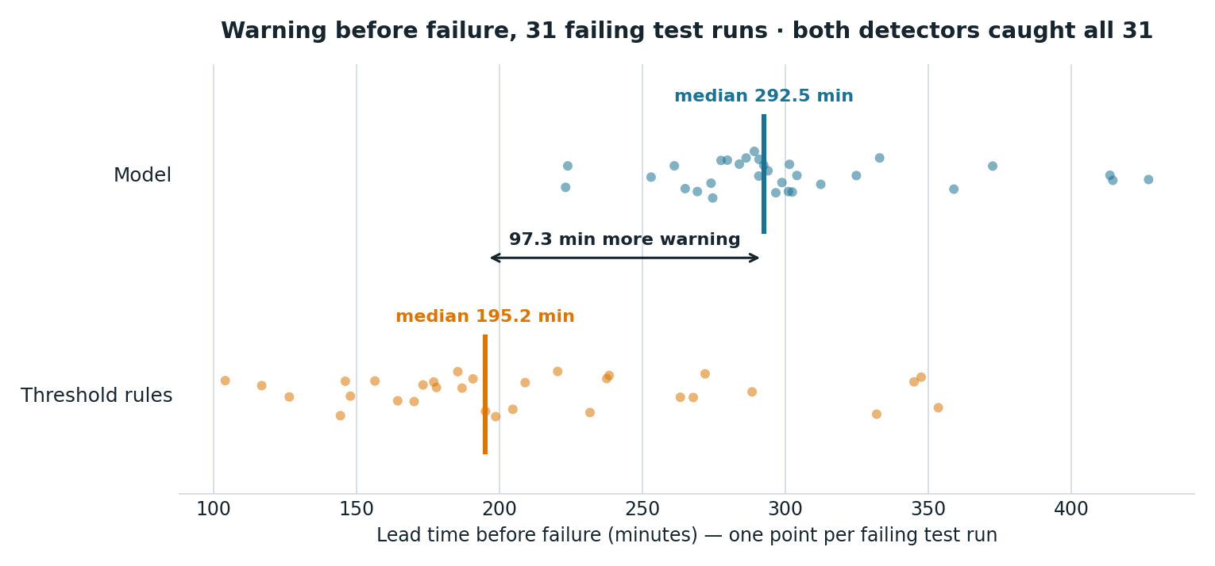
Warning before failure, 31 failing test runs
Figure 2 is the project’s central claim in one picture: the model’s distribution sits bodily to the right of the threshold rules’, not merely ahead of it on average.
Table 1 — Model quality on the held-out test set, from the committed notebook outputs:
Metric | Value | Source
AUC | 0.993 | cell 11
Precision | 0.892 | cell 11
Recall | 0.962 | cell 11
F1 | 0.925 | cell 11
False alarms per healthy run | 0.08 (1 run in 12) | cell 13
Time-to-failure MAE, gradient boosting | 17.26 min | cell 15
Time-to-failure MAE, linear regression | 31.16 min | cell 17
Linear regression is reported in Table 1 because the brief requires it, and is retained even though gradient boosting is materially better. The false-alarm rate in Table 1 is the check that the split design in §3.2 exists to protect.
The headline comparison behind Figure 2, cell 19:
Failing test runs: 31
Model median lead time: 292.5 min (caught 31/31 runs)
Threshold median lead time: 195.2 min (caught 31/31 runs)
Lead-time multiple vs. MEASURED threshold baseline: 1.5x
The baseline is measured on the same runs with the same function, not assumed. An earlier version of this notebook divided by a hardcoded ~50 minutes carried over from planning, which would have overstated the multiple several-fold. Both detectors caught all 31 runs, so the medians are comparable.
On the live system, measured 11 August 2026 over one complete degradation run:
The model crossed its action threshold 80.5 simulated minutes before the first sensor limit tripped.
Reproduce by capturing a run and passing it to tests/analyse_live_run.py. Figure 3 shows that window as an operator sees it, mid-run, with the model already warning and every sensor still inside its limit.
Figure 3 — The lead-time window, on the running system. The dashboard during a live degradation run. Failure risk reads 73.9 % with 60 simulated minutes of warning already accumulated, and all three threshold flags — bearing_overheat, filter_restriction, airflow_loss — are unlit. Every plain threshold is still below its limit at that moment: motor winding 97.8 °C against a 105 °C trip, filter ΔP 288 Pa against 350 Pa, and airflow 2515 CFM against a 2210 CFM floor. That is the argument of §1 in one frame — a threshold monitor watching these same three signals would have raised nothing at all, while the model sits at 0.739 with a 2.56 hour countdown and has been warning for an hour. The banner says it plainly: “Model has warned. Threshold rules still silent.” The risk panel is equally careful about what is not known — mechanism not yet identified · model warning only — because no sensor limit has tripped, and the mechanism label is a rule over those limits rather than a model output (§1.2).
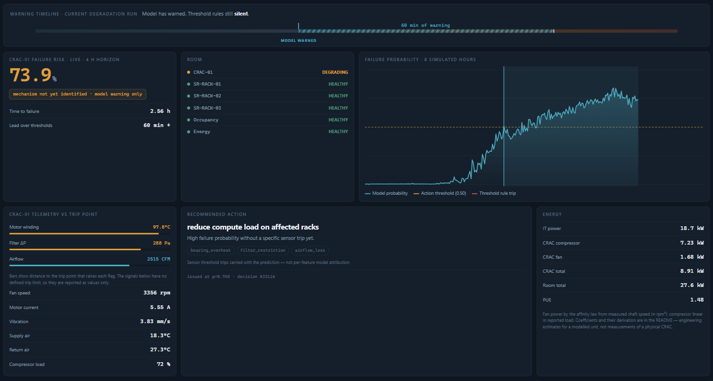
Dashboard during the lead-time window: model at 73.9 %, 60 minutes of accumulated warning, all three threshold flags unlit

1.5 Limitations
- One fault profile. Bearing wear coupled to filter loading. A different mechanism is outside the training distribution, and the model has no way to say so beyond a low probability.
- Simulated telemetry. No figure here has met a physical CRAC.
- Trend features leave the trained range briefly at each demo cycle reset. When the looping demonstrator “replaces” the unit, winding temperature drops ~120 → 65 °C in one sample, producing slopes far outside training. Measured: 40 of 600 samples (6.7%), all within 20 samples of a reset, and they produce probabilities of 0.001–0.003, so no false alarm results. In a single-fault run (--anomaly) the condition does not arise.
- tests/analyse_live_run.py assumes one run per capture and reports FAIL on a looping capture for that reason. Segment by run_id before interpreting it.

2. Ecosystem integration

2.1 Purpose
Coordinate four twin types over one shared physical environment so that a decision accounts for the whole room, not one asset.

2.2 Design decisions
Centralised coordination, chosen deliberately. The four sub-twins publish state; a single orchestrator fuses it and decides. Three reasons:
- One shared thermal zone. All six twin instances observe the same air. Any action — raising cooling, shifting workload, replacing a filter — changes conditions for every other asset. A federated design would have each twin negotiating over an environment none of them can observe alone.
- Every action affects every asset. There is no partition of this room into independently-decidable subsystems, so there is nothing for federation to decompose.
- A single auditable decision path. One decision point means every recommendation has exactly one producer and one ordered record (§3.4). The governance requirement depends on that; distributed decision-making would make “who advised this, and on what evidence” a reconstruction problem.
This is a design position, not an omission. Federation becomes correct across administrative or network boundaries, where data residency prevents pooling raw telemetry, or once central state becomes a scaling bottleneck — none of which applies to a single room. It is deferred to the multi-room phase, where room-level twins would exchange summaries rather than raw telemetry (§4).
Twins own their state and nothing else. Each twin subscribes only to the raw telemetry it needs and publishes only its own state topic. No twin subscribes to another twin’s state; occupancy reaches the decision through the orchestrator (orchestrator/orchestrator.py:148). The ACL enforces this rather than trusting it (§3.2).
Occupancy changes the decision. Load factor is what separates “the room is hot because it is busy” from “the room is hot because the CRAC is failing” (orchestrator/orchestrator.py:36).

2.3 Implementation
Component | File | Publishes
Rack Twin ×3 | twins/rack_twin.py | datacenter/twin-state/rack-SR-RACK-0{1,2,3}
Occupancy Twin | twins/occupancy_twin.py | datacenter/twin-state/occupancy
Energy Twin | twins/energy_twin.py | datacenter/twin-state/energy
Cooling Twin | twins/cooling_twin.py | datacenter/twin-state/cooling
Orchestrator | orchestrator/orchestrator.py:142 | datacenter/predictions/CRAC-01, datacenter/recommendations/room
Figure 1 — Integrated ecosystem architecture. The full path from simulated assets through telemetry, sub-twins and twin state to the central orchestrator and its two decision outputs, with the coordination-strategy rationale alongside. Vector source docs/ecosystem_diagram.svg.
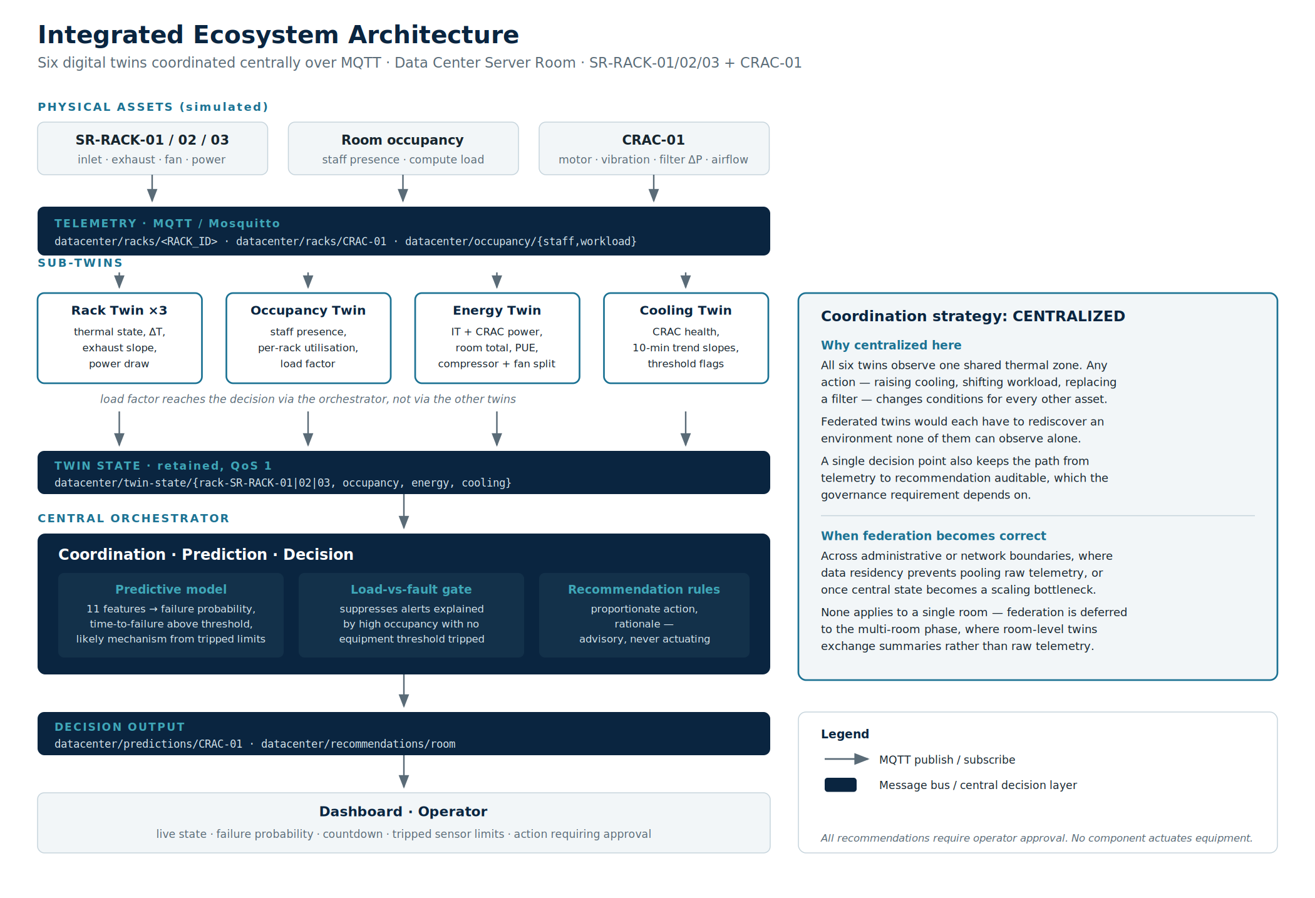
Integrated ecosystem architecture
Figure 1 is the reference for every topic name used in this report. Note what it does not show: there are no arrows between twins, because no twin subscribes to another twin’s state.
The orchestrator re-runs inference only when cooling state changes (orchestrator/orchestrator.py:142). Firing on every twin-state message meant roughly ten inferences per simulated sample; at demonstration speed the orchestrator fell behind the broker and stopped producing predictions three quarters of the way through a run.

2.4 Evidence it works
All seven components connect and publish, verified by their retained liveness topics: datacenter/status/{cooling, occupancy, energy, rack-SR-RACK-01|02|03, orchestrator} all read online.
Occupancy demonstrably changes the outcome. In a 437-prediction measured run, 143 predictions were withheld with recommendation_withheld: "load_driven" — risk above threshold, compute load above 0.8, no equipment limit breached. In an earlier longer run, 165 of 247 warning-phase samples (67%) met that condition.
The coordination is visible in Figure 3. The recommendation there reads reduce compute load on affected racks, issued at p=0.749 — an action across the rack and occupancy twins rather than a cooling action, chosen because risk is high while no equipment limit has tripped. A cooling-only twin, seeing the same CRAC telemetry, has no basis for proposing that and no rack to propose it to.
tests/test_load_driven_branch.py sweeps the reachable input space and asserts the branch behaves:
PASS prob=0.60 load=0.95 -> recommend=False (high load explains it)
PASS prob=0.60 load=0.95 -> recommend=True (equipment tripped)
PASS prob=0.60 load=0.10 -> recommend=True (load is low)
PASS prob=0.40 load=0.95 -> recommend=False (below action threshold)
That test exists because the original predicate was unreachable: load_factor > 0.8 and failure_probability < 0.3, evaluated only inside a branch already gated on probability >= 0.5. The second conjunct was always false, so occupancy could never suppress anything. It is now gated on the presence of an equipment trip instead (orchestrator/orchestrator.py:36).

2.5 Limitations
- Centralisation is a single point of failure. If the orchestrator stops, the twins keep publishing state and nothing decides. Its liveness is published on datacenter/status/orchestrator so the condition is visible, but there is no standby.
- thermal_risk is unimplemented. twins/rack_twin.py:42 notes the orchestrator would set it; nothing does. Rack thermal risk is therefore not part of any decision today.
- Recommendation cost is not computed. orchestrator/rules.py:33 returns None, so no cost accompanies advice and the dashboard renders none.

3. Governance and ethics
Full treatment in docs/Governance_Ethics_Roadmap.docx (sections A1–A5 and B1–B2). This section states the measures and the evidence for them.

3.1 Purpose
A system that advises engineers must protect the integrity of its advice, keep a record of what it advised and why, be honest about which of its outputs it can justify, and be worth running. Four requirements — security, auditability, transparency and return — and one constraint that governs all of them: a human decides, not the system.

3.2 Design decisions
Autonomy comes last, and bounded — that is the design, not an omission. The brief asks for an autonomous ecosystem. This system is autonomous in sensing, inference and coordination — it decides, unprompted and continuously, what is happening and what should be done about it — and it stops short of actuating, which the roadmap defers to its final phase rather than abandoning. Why actuation is the part that waits:
- The action space is physical and expensive. The four actions the orchestrator can recommend are replace a filter, schedule an inspection, shift workload between racks, and raise cooling. Three dispatch a technician or move live compute; the fourth raises energy draw across the room. None is reversible by publishing a correcting message, so the cost of a wrong action is not symmetric with the cost of a delayed one.
- The model’s own limits make unattended action unsafe. §1.5 records that the classifier is trained on two failure mechanisms. A third mode puts it outside its training distribution, where it degrades to a low probability rather than an error — the system cannot tell “healthy” from “a fault I have never seen”. Acting on that silence automatically converts a known blind spot into unattended physical action.
- Advice is withheld precisely where autonomy would be most tempting. When heat is explained by compute load rather than by a fault, the orchestrator declines to recommend and records why — 143 of 437 predictions in a measured run (§2.4). An autonomous loop would have no equivalent of declining; it would act, or it would need exactly this judgement encoded anyway.
- Accountability requires an actor. Every decision is hash-chained and attributable (§3.3). That record answers “why did this happen” only while a named person authorised the action. Closing the loop removes the human the audit trail exists to hold accountable, at the same time as it removes the operator’s chance to catch a bad call.
None of that is an argument for never automating. It is an argument about ordering and scope, and the roadmap states both: phase five (§4.3) introduces bounded autonomy, restricted to setpoint changes within ±1 °C and workload redistribution. The bound is chosen against the failure mode above — those are the actions whose worst outcome, if the model is wrong or silent, is a slightly warmer room. Control authority is granted in proportion to what has been measured, and only for actions that stay safe when the model is at its weakest.
The mechanism such a step needs is already built and exercised rather than hypothetical: acknowledge.py publishes an operator’s response to datacenter/acks/room under an operator identity that the ACL permits to acknowledge and explicitly forbids from publishing recommendations. Until phase five, the loop is closed by a human whose action is authenticated and recorded — a narrower claim than autonomy, and a far easier one to defend on equipment that has never been observed failing in the field.
Security — every component authenticates as itself. Twelve identities, one per service, each with a least-privilege topic ACL (mosquitto/acl). This matters because main.py runs six twins and the orchestrator in one process; a single shared credential would collapse the ACL into one account holding the union of all seven permissions. mqtt_identity.py:36 resolves per-service credentials with a fallback to a shared pair so existing deployments keep working.
Security — exactly one identity may publish a recommendation. A recommendation is the system’s actuating output, the thing a human acts on, so orchestrator alone holds topic write datacenter/recommendations/room. The audit sink can read decisions and write nothing: it cannot forge what it records. Secrets are never committed — mosquitto/make_credentials.sh creates a local CA, a server certificate and twelve passwords on first run, all gitignored, so a fresh clone cannot connect to anybody’s broker. The public dashboard credential is read-only by policy rather than convention, which is what makes it acceptable to ship inside a page anyone can view-source.
Auditability — the producer stamps the sequence number, not the recorder. A counter assigned on receipt can only count what arrived and could never reveal a gap; stamping at the source (orchestrator/orchestrator.py:171) makes a lost decision detectable. Records are hash-chained per source (audit/audit_sink.py:61) because filesystem append-only flags require root, whereas a hash chain makes tampering detectable with no privilege at all.
Auditability — a decision to withhold is a decision. The load-versus-fault rule used to suppress advice silently, so a subscriber could not distinguish low risk from risk attributed to compute load. Predictions now carry recommendation_withheld and the load factor behind it (orchestrator/orchestrator.py:162), which puts the suppression in the record rather than leaving it to be inferred.
Transparency — label the provenance of each output. Each prediction carries predicted_mode and predicted_mode_basis: "rule" (inference/model_loader.py:78), so a subscriber inherits the distinction between what the trained model produced and what a rule derived rather than having to know it. The corresponding restraint: contributing_factors is the CRAC’s own tripped sensor limits passed through (inference/model_loader.py:77), not per-feature attribution.
Bias mitigation — design the evaluation so it cannot flatter the model. Four decisions, all made before any number was quoted:
- Split on runs, not rows. Consecutive 30-second samples from one degradation are near-identical. A random row split puts almost the same sample in train and test and produces a score that measures memorisation. The split groups by run_id (notebook cell 9).
- Stratify the split by outcome. A plain group split over 140 runs can, by chance, leave zero of the 39 healthy runs in the test fold — which would silently delete the false-alarm check. Each outcome is split separately and recombined (cell 9).
- Weight the classes. Failure is the minority outcome at a 24.7% positive rate on the four-hour horizon, so an unweighted model can score well by under-predicting it. class_weight="balanced" (cell 11).
- Claim nothing the artefact cannot support. There is no mechanism classifier, so no mechanism accuracy is claimed anywhere — a figure of that kind was removed from the executive pitch during verification rather than defended.
Human oversight — nothing actuates. orchestrator/rules.py:7 produces an action string and a rationale; no component sends a control signal to any equipment. Operator acknowledgement is a separate identity (acknowledge.py, ACL operator) that may acknowledge and may not recommend: the person acting on a decision cannot author one.

3.3 Implementation
Concern | Where it lives
Identities and topic permissions | mosquitto/acl, mosquitto/make_credentials.sh
Per-service credential resolution | mqtt_identity.py:36
Decision record | audit/audit_sink.py → logs/audit.jsonl
Producer sequence + withheld reason | orchestrator/orchestrator.py:162, :171
Output provenance | inference/model_loader.py:29, :77, :78
Energy and cost basis | twins/energy_twin.py:76, :83, :86
Acknowledgement | acknowledge.py
The broker runs from docker-compose.yml with three listeners — plain MQTT on loopback, TLS on 8883, and WebSockets for the browser, the last left plaintext because Tailscale Funnel terminates TLS in front of it rather than double-terminating.

3.4 Evidence it works
Security. tests/test_broker_security.py makes eight attempts against the running broker and records the protocol response and matching broker log line. MQTT v5 is used deliberately: under 3.1.1 a denied publish receives a normal PUBACK, making “refused” indistinguishable from “delivered”.
Table 2 — Access-control transcript. Eight attempts against the running broker, each showing the protocol response and, where the broker logged one, the refusal line. Reproduce with python3 tests/test_broker_security.py.
# | Attempt | Observed
1 | Connect with no credentials | CONNACK 135 Not authorized; log: disconnected: not authorised
2 | Connect with a wrong password | CONNACK 135 Not authorized
3 | A twin forges a recommendation | PUBACK 135; not delivered; log: Denied PUBLISH from twin-cooling ... recommendations/room
4 | A twin forges another twin’s state | PUBACK 135; log: Denied PUBLISH ... twin-state/energy
5 | The dashboard credential tries to publish | PUBACK 135
6 | The dashboard credential subscribes where permitted | CONNACK 0, SUBACK 1
7 | The simulator subscribes to recommendations | messages delivered: 0, while a permitted subscriber received the same publish
8 | The orchestrator publishes a recommendation | PUBACK 0 Success, delivered
8 of 8 behave as the policy requires, on five consecutive runs. Case 7 is worth noting: Mosquitto grants the subscription and silently declines delivery rather than refusing the SUBACK, so the property asserted is no delivery, established by measurement rather than assumed from the config.
The suite runs against the live broker rather than a fixture, and that choice produced two findings of its own. The first was mechanical: a case connected using the client id the live cooling twin already held, and MQTT evicts an existing session when a second client claims its id, so the test and the running twin knocked each other off the broker. The second was substantive. That case asked “did the subscriber receive anything?” while the real orchestrator was publishing legitimate recommendations to the same topic several times a second — so a forgery the broker had correctly refused still looked delivered, and the suite failed intermittently on the case that proves the single-writer rule. The security property was never broken; the measurement of it was. Each case now tags its own payload and looks for that tag.
A fixture would have hidden both. It would also have made these results much less worth quoting: what Table 2 reports is what the broker does under the traffic the system actually generates, not what it does in isolation.
Auditability. tests/test_audit_chain.py proves the guarantee by breaking it — 17 assertions covering a clean chain, a dropped decision flagged GAP(missing=2), a producer restart distinguished from a gap, independent per-source chains, an edited payload detected, a deleted record detected, and a sink restart that continues the chain rather than forking it. All pass. On the running system, a two-minute clean-clone start produced 345 records with every chain intact.
Transparency. Removing the threshold flags from a prediction input leaves the probability unchanged at 0.662 while contributing_factors goes empty — the model contributes nothing to that field, and the system does not pretend otherwise. Reproduce with inference/model_loader.py’s predict() on any cooling state.
Bias mitigation. The split produces 97 train and 43 test runs with every outcome represented in both folds, and the false-alarm check that depends on it returns 0.08 false alarms per healthy run — one run in twelve (Table 1). Withholding advice when load explains the heat is measured on the wire: 143 of 437 predictions in one run, 165 of 247 warning-phase samples in another, and tests/test_load_driven_branch.py sweeps the reachable input space to show the branch behaves in all four quadrants.
ROI. Cooling energy is computed from telemetry, not assumed (twins/energy_twin.py:86). Fan power follows the affinity law on measured shaft speed, P = 1.459 × (rpm/3200)³, with the rated figure derived at the nominal duty point — Q·Δp/η = 1.6045 m³/s × 500 Pa / 0.55 = 1459 W (twins/energy_twin.py:76). Compressor power is linear in reported load, P = 10.0 × load%/100, from 30 kW sensible capacity at COP 3.0 (twins/energy_twin.py:83) — linear because the modelled unit is a fixed-speed scroll compressor that cycles, so mean power is proportional to run-time fraction. Measured live across a fault:
State | fan kW | comp kW | CRAC kW | IT kW | PUE
healthy | 1.46 | 5.50 | 6.96 | 18.6 | 1.37
degrading | 1.64 | 7.00 | 8.64 | 21.0 | 1.41
tripped | 1.83 | 8.50 | 10.33 | 23.4 | 1.44
Live range observed: PUE 1.337 → 1.491, CRAC draw 6.91 → 9.18 kW. The affinity law is why early detection pays — the fan runs 3200 → 3450 rpm while degrading, a 7.8% speed rise that becomes 25% more fan power. A degraded unit draws 3.37 kW more than a healthy one, SGD 14.55 per day at 0.18 SGD/kWh. tests/test_energy_model.py asserts the model obeys the laws it claims — doubling speed multiplies fan power by 8 — and that PUE stays in 1.25–1.60 and worsens monotonically as the unit degrades. 18 assertions, all pass. The business case built on this quantity is in docs/Executive_Pitch.pptx, which separates measured from assumed figures and shows the case with every benefit halved.

3.5 Limitations
- ACLs are enforced by the local broker only. A cloud deployment via render.yaml points at an external broker where these identities would have to be provisioned separately.
- The viewer password is public by construction. Read-only, but anyone with the link can watch the simulated room.
- Bias mitigation addresses evaluation, not coverage. Grouping, stratifying and weighting stop the score from flattering the model on the data it has; none of it helps with a unit that fails by a mechanism absent from training. The model has seen two coupled mechanisms and one room geometry, and its confidence outside that is not a measure of anything.
- The ROI case rests on one unmeasured quantity — how long a fault would otherwise run undetected. It is an assumption this project cannot test, and the pilot phase exists to replace it.
- Recommendation cost is not computed. orchestrator/rules.py:33 returns None, so no cost accompanies advice.

4. Strategic roadmap
Full plan in docs/Governance_Ethics_Roadmap.docx §B2; the deployment blueprint is render.yaml.

4.1 Purpose
Move from a simulated single room to monitored production hardware without asserting, at any point, more confidence than has been earned.

4.2 Design decisions
Each phase buys the answer the next one needs. The pilot exists specifically to measure the quantity the business case currently assumes — how long a fault would otherwise run undetected — which this project cannot measure because its faults are simulated.
Federation is deferred, not rejected (§2.2). It becomes correct at the multi-room boundary, where room-level twins exchange summaries rather than raw telemetry.

4.3 Implementation
Phase one is built and running; the rest are planned, and saying so plainly is part of the deliverable.
Phase | Status
Prototype — simulated room, four twin types, trained model, dashboard | complete, this repository
Pilot — one real CRAC, shadow mode, no advice acted on | not started
Production — advice acted on, ROI assumption replaced by measurement | not started
Multi-room — federated room-level twins | not started
Bounded autonomy — automatic execution limited to setpoint within ±1 °C and workload redistribution | not started

4.4 Evidence it works
The prototype phase is demonstrable end to end from a clean clone (see How to run this) and continuously at the live URL.

4.5 Limitations
- The demonstration depends on one machine remaining powered and connected. There is no offline fallback: if the stack stops, the page loads and then sits disconnected rather than replaying a recorded run.
- Every phase after the prototype is unfunded and unscheduled.
- render.yaml starts the consumer side only — it does not launch occupancy_publisher.py, so a cloud deployment would run with load_factor pinned at zero and lose the load-versus-fault distinction entirely.

5. What would change these conclusions
- A real CRAC that fails by a third mechanism would put the model outside its training distribution, and nothing in this system would announce that beyond a low probability.
- A measured undetected-fault duration from the pilot would replace the largest assumption in the ROI case, and could move it in either direction.
- A variable-speed compressor would break the linear part-load assumption in §3.5 and change every energy figure in this report.

Appendix — verification commands
Claim | Command
Model metrics, lead-time multiple | open notebooks/train_crac_model.ipynb, cells 11–19
Access control | python3 tests/test_broker_security.py
Audit integrity | python3 tests/test_audit_chain.py
Energy model | python3 tests/test_energy_model.py
Trend-feature units | python3 tests/test_slope_units.py
Simulated clock | python3 tests/test_substep_cap.py
Load-versus-fault branch | python3 tests/test_load_driven_branch.py
Live run analysis | python3 tests/analyse_live_run.py CAPTURE (run boundaries handled automatically)
Clean-clone start-up | git clone …&& ./run.sh

