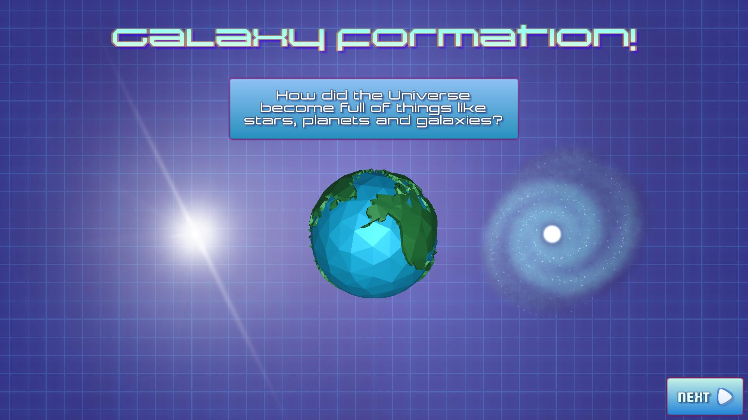
GALAXY FORMATION
Galaxy Formation is a multi-platform educational app depicting how dark matter particles in the universe clump together over billions of years to form things like stars, planets and galaxies. The app does this with a lite, real-time simulation of thousands of n-body particles that are attracted by gravitational forces that form galaxies when combined.

You can try out the live WebGL Browser version here:

- WebGL: https://johnchoi313.github.io/Galaxy-Formation-WebGL/

For better performance, you can download the native versions for each platform here:

- Android:
https://github.com/johnchoi313/Galaxy-Formation-WebGL/blob/master/Other%20Platforms/Android.zip

- Mac:
https://github.com/johnchoi313/Galaxy-Formation-WebGL/blob/master/Other%20Platforms/Mac.zip

- Windows:
https://github.com/johnchoi313/Galaxy-Formation-WebGL/blob/master/Other%20Platforms/Windows.zip

- Linux:
https://github.com/johnchoi313/Galaxy-Formation-WebGL/blob/master/Other%20Platforms/Linux.zip

- WebGL:
https://github.com/johnchoi313/Galaxy-Formation-WebGL/blob/master/Other%20Platforms/WebGL.zip
1
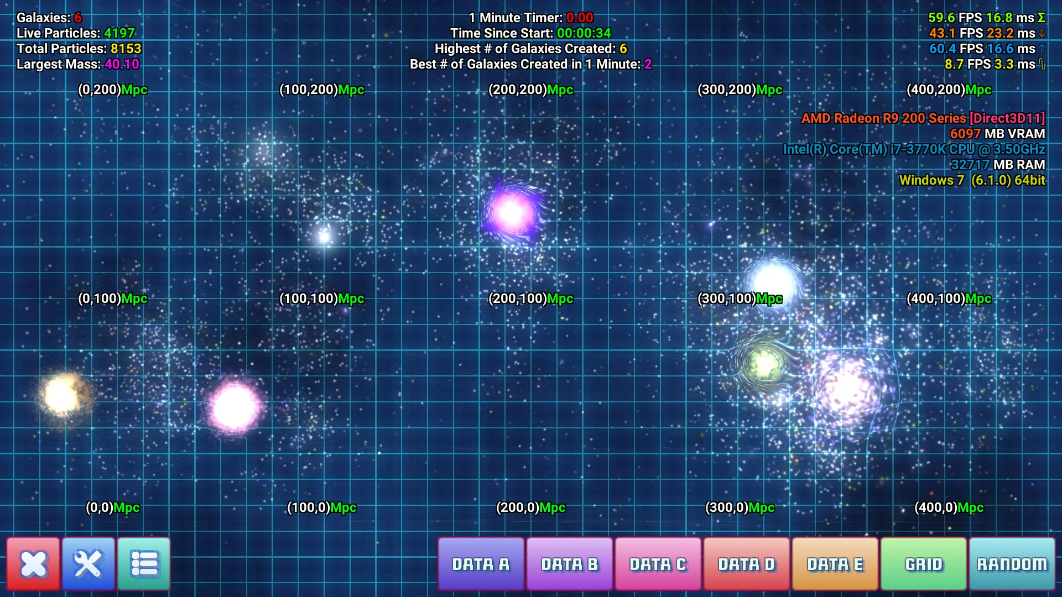
HOW TO USE
To create dark matter particles, simply click and hold on the part of the screen where you want particles to appear. If you are on a mobile device or have a touchscreen, simply touch and hold on the part of the screen where you want particles to appear. Multi-touch is supported.

To create particles faster and dispersed throughout the screen, you can press any of the colored buttons on the lower right hand corner of the screen. They do the following:
- DATA A: Creates a grid of particles according to list compiled in a.dat file.
- DATA B: Creates a grid of particles according to list compiled in b.dat file.
- DATA C: Creates a grid of particles according to list compiled in c.dat file.
- DATA D: Creates a grid of particles according to list compiled in d.dat file.
- DATA E: Creates a grid of particles according to list compiled in e.dat file.
- GRID: Creates an evenly distributed grid of particles.
- RANDOM: Creates an randomly distributed grid of particles.

On the bottom left corner of the screen, there are three buttons, from left to right:
- DELETE: This will delete all particles on the screen.
- SETTINGS: This will open up the Settings menu.
- CREDITS: This will open up the Credits slide.

On the top of the screen, there are some helpful informational overlays, from left to right:
- TOP LEFT: Displays the number of galaxies, particles, and the largest mass so far.
- TOP MIDDLE: A score showing how many galaxies were created in a minute.
- TOP RIGHT: Displays framerate and hardware information of the device.
2
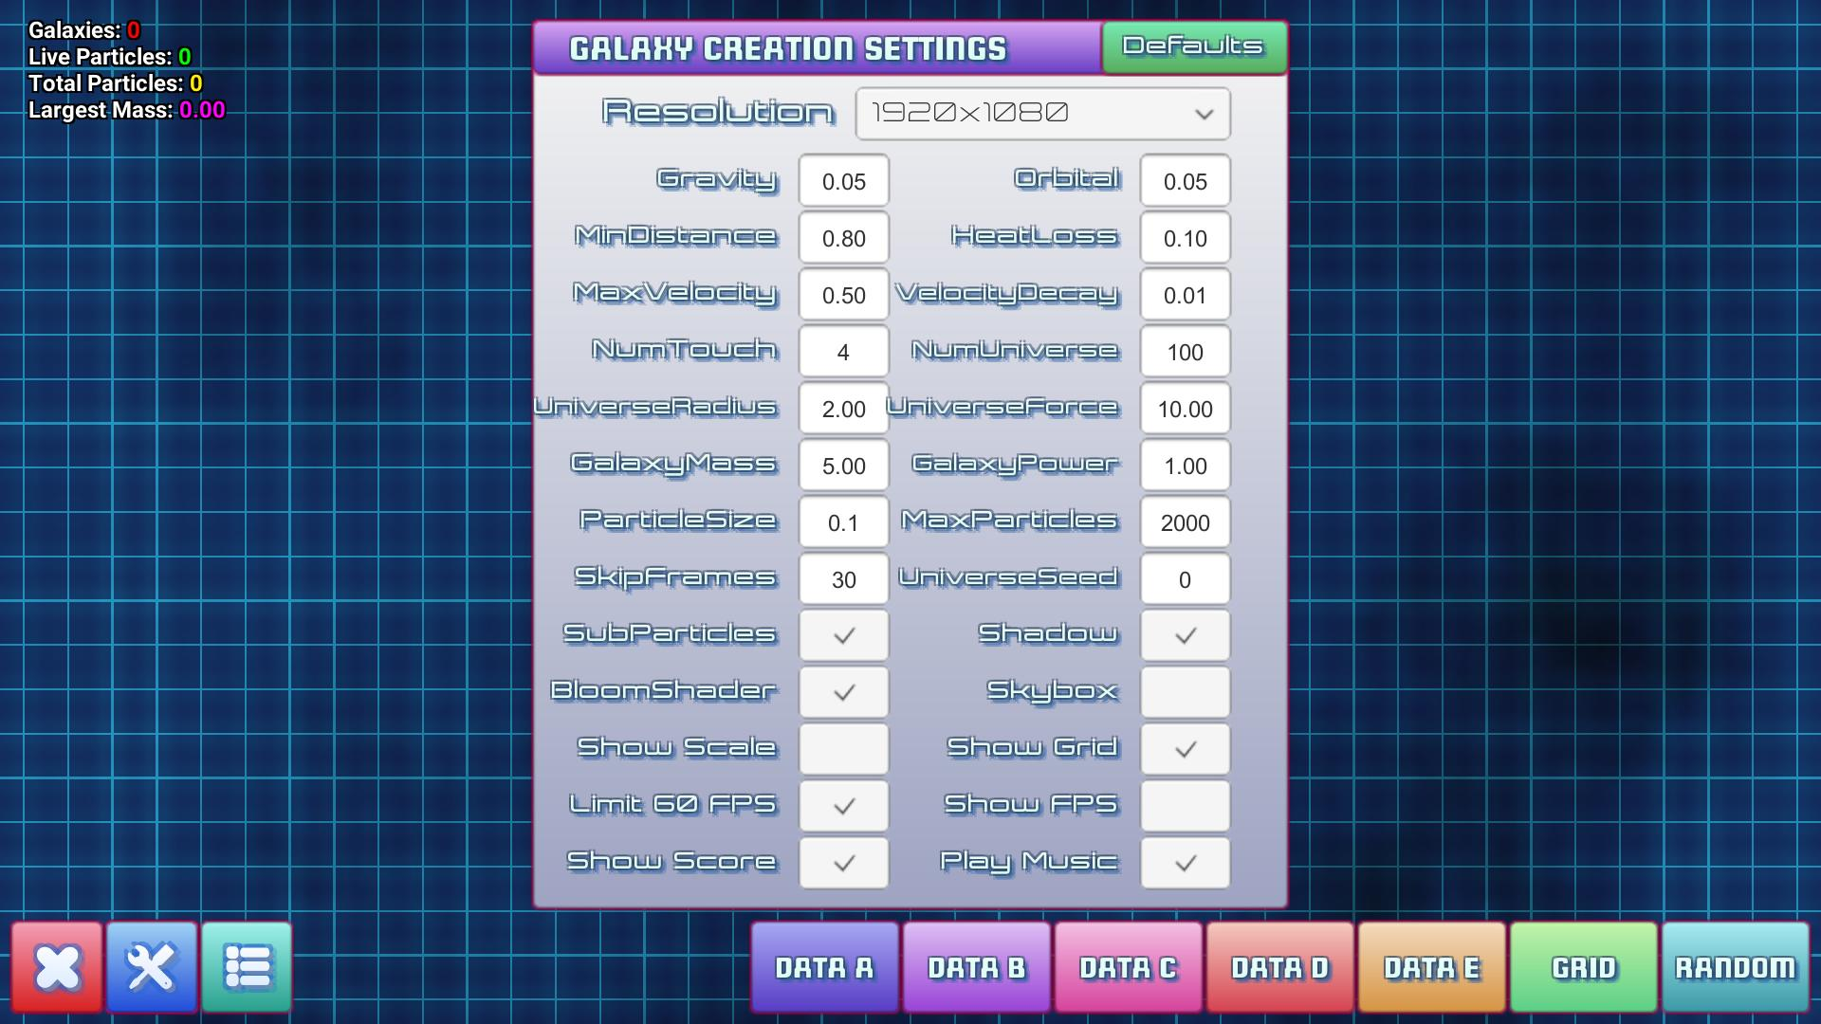
GALAXY FORMATION SETTINGS
There are a wide variety of settings that the user can tweak to change the appearance of the simulator and optimize for better real-time performance on the user's target device.

From left to right, top bottom, here are all the numeric settings the user can change:
(Note: Settings that have a high impact on performance are highlighted in orange.)

- RESOLUTION: This controls the width and height of the in-game render resolution.
- GRAVITY: This controls how strongly particles are attracted to each other.
- ORBITAL: This affects the gravitational spin of particles and galaxies.
- MIN DISTANCE: This controls how close particles have to be to collide.
- HEAT LOSS: This controls how much mass is converted to heat after a collision.
- MAX VELOCITY: This limits how fast particles and galaxies can go.
- VELOCITY DECAY: This slows down particle velocity over time (like air resistance).
- NUM TOUCH: This sets how many particles are generated after a touch/click.
- NUM UNIVERSE: This sets how many particles are generated after pressing a button.
- UNIVERSE RADIUS: This create the width of the universe when a “Spiral” is generated.
- UNIVERSE FORCE: This sets the force of the particles when a “Big Bang” is generated.
- GALAXY MASS: This sets the minimum mass required to spawn a galaxy.
- GALAXY POWER: This controls the gravitational power of galaxies.
- PARTICLE SIZE: This sets the initial particle size / mass.
- MAX PARTICLES: This sets the maximum number of particles allowed on the screen.
- SKIP FRAMES: This sets how many frames are skipped before updating particle physics.
- UNIVERSE SEED: This changes the seed value when pressing any of the DATA buttons.
3
From left to right, top bottom, here are all the toggle settings the user can change:
(Note: Settings that have a high impact on performance are highlighted in orange.)

- SUB PARTICLES: This toggles whether or not to display additional non-physics particles.
- SHADOW: This toggles whether or not to display a universe fog effect.
- BLOOM SHADER: This toggles whether or not to use the “bloom” glow effect.
- SKYBOX: This toggles whether or not to use the background “skybox” effect.
- SHOW SCALE: This toggles whether or not to show Mpc tick marks.
- SHOW GRID: This toggles whether or not to show blue grid lines.
- LIMIT 60 FPS: This toggles whether to limit render speed to 60 frames per second.
- SHOW FPS: This toggles whether or not to show frame rate and hardware information.
- SHOW SCORE: This toggles whether or not to show the one-minute timer score.
- PLAY MUSIC: This toggles whether or not to play background music.

Note: To reset the game to use default settings, press the green Defaults button on the upper right corner of the Settings menu.

4
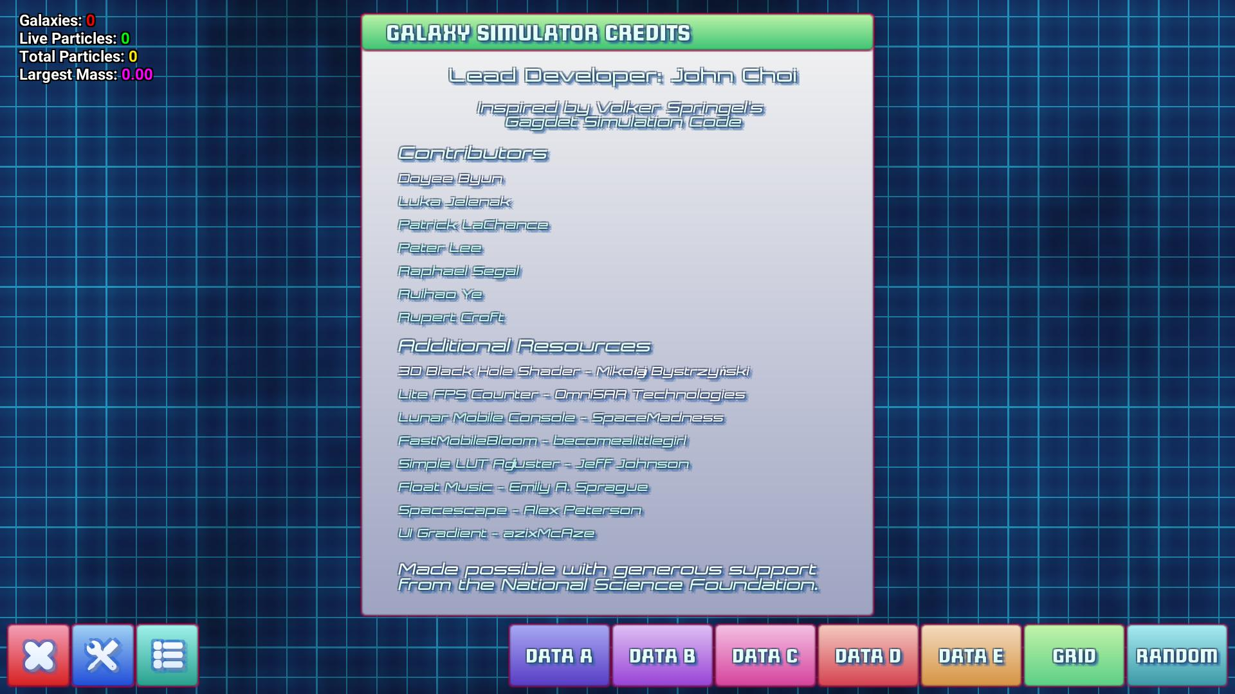
GALAXY FORMATION CREDITS
Lead Developer: John Choi.
Learn more about me here: https://www.johnchoi313.com/

Inspired by Volker Springel's Gadget Simulation Code.
Learn more about Gadget here: https://wwwmpa.mpa-garching.mpg.de/gadget/

Contributors
- Doyee Byun
- Luka Jelenak
- Patrick LaChance
- Peter Lee
- Raphael Segal
- Ruihao Ye
- Rupert Croft

Additional Resources
- 3D Black Hole Shader - Mikołaj Bystrzyński
- Lite FPS Counter - OmniSAR Technologies
- Lunar Mobile Console – SpaceMadness
- FastMobileBloom – becomealittlegirl
- Simple LUT Adjuster - Jeff Johnson
- Float Music - Emily A. Sprague
- Spacescape - Alex Peterson
- UI Gradient – azixMcAze

Made possible with generous support from the National Science Foundation.
5

