Index
First. 2
What is uCPf? 2
Demo scene setup instruction. 3
Demo scene “Demo-Index” 3
Demo scene “Demo-HowTo” 4
Demo scene “Demo-PresetSample” 4
Demo scene “Demo-Animation” 4
Demo scene “Demo-WorldUI” 4
How to use prefabs 5
How to create a color picker without prefab 6
Step 1. Create a Base 6
Step 2. Create controls 6
Step 3. Put Components 6
Step 4. Create a Hue control 7
Step 5. Color Pointer 8
Smaller structure 9
Useful scripts. 10
About ColorPicker.cs. 11
World UI 12
About Filled Type Image 13
About free version. 14
Contact 15

First.
Thank you for downlolading uGUI Color Picker – free version – uCPf.

What is uCPf?
uCPf is a color picker that works on new Unity GUI system.
It works on all rendermode of canvas, overray, screen and world.
So you can put a color picker any where.
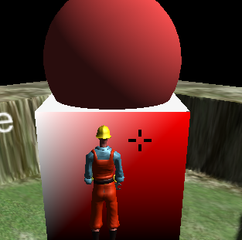
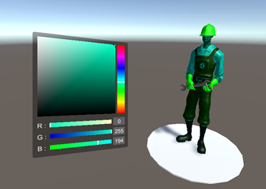

Demo scene setup instruction.
When you imported an asset, the setup menu will run automatically.
If you didn't, you can execute it in a menu [Window]->[uCP Demo Setup].

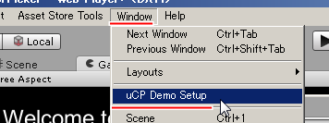

It will show you a confirm dialog.
Please be careful, if you are still editting a scene.
That won't be saved.

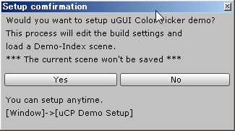
If [Yes], uCP register demo scenes on build settings and load Demo-Index scene.
Then you can play Demos.

When the dialog was shown, uCP creates "Assets/uCUIColorPicker/Demo/Resources/setupfile”.
This is for automatic setup.
If delete it, automatic setup dialog will popup again.

Demo scene “Demo-Index”
This scene is a hub scene.
You can access all demo scenes from here.

Demo scene “Demo-HowTo”
This scene tell you, how to create a color picker and others.
I recommend you to see it once.

Demo scene “Demo-PresetSample”
This scene introduce a prefab.
How is it working and picking colors.

Demo scene “Demo-Animation”
This scene tell you, how to show a color picker.
And it also tell you how to set a color to the color picker.

Demo scene “Demo-WorldUI”
This scene show you samples on world space.
There are 4 themes.

1.ColorSphere
This is for a normal object.
When touch the object, a color picker appears.

2.LightRoom
This is for light sources.
There are 3 lights and 3 controls.

3.SkyBoard
This is for a camera.

4.Ground canvas
It's a bigger color picker.
Saturation and Value with Hue vertical slider.
It paint both a character and itself.

How to use prefabs
There is a preset prefab in prefabs folder.
Path : "Assets/uCUIColorPicker/Prefabs"
When put “PresetColorPicker” prefab in a canvas, You just need to set a OnChange event.
Then it will work nicely!
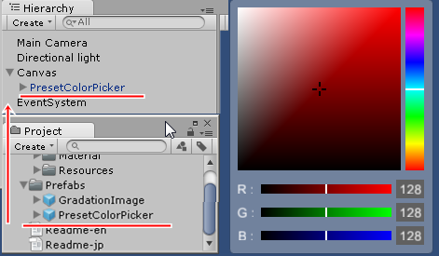
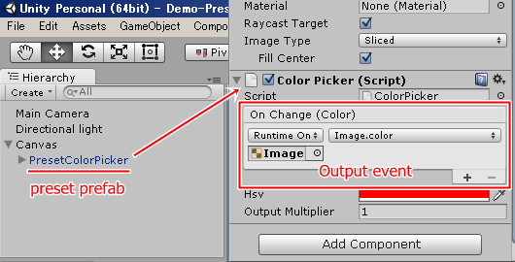
For the output event, you can make a property or a function.
example C# code.
/*-----------------------------------------------*/
// property.
public Color someProperty { get; set; }

// function.
public void someFunction ( Color c )
{
// TODO something.
}
/*-----------------------------------------------*/

If objects have this code, the event is able to setect it as a dynamic parameter.

How to create a color picker without prefab
uCPf isn't fully customizable but you can create a color picker as you like.

Step 1. Create a Base
Create a canvas and a panel.
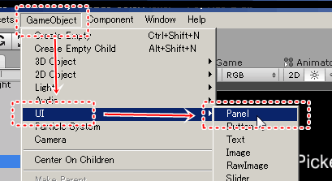
Put a ColorPicker.cs to the panel.
This is base of a color picker.

Step 2. Create controls
Create images and inputs.
These have to be a child of the panel.
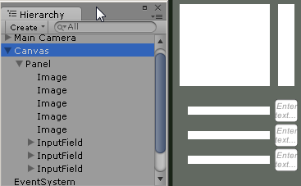

Step 3. Put Components
Put GradationRect.cs to images.
Then set Type properties in inspector window, like the screenshot below.
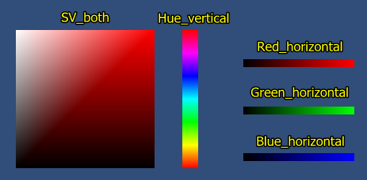
Also put ColotInputField.cs to inputs.
Then set a Property in inspector.

Step 4. Create a Hue control
For Hue control, I recommend to use a prefab.
However, you can create an object as same as that.
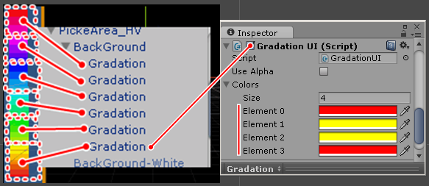
These “Gradation” objects have GradationUI.cs.
This script paints a gradation on a image.
6 images have different Colors and they are placed side by side.
These Colors are set with constant corners.
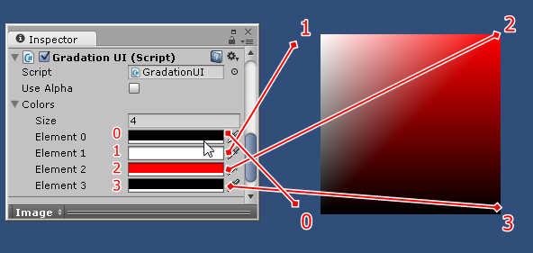

Step 5. Color Pointer
When controls are created, you can put a pointer in each control.
Create an image and Set it to a child of a control.
Choose GradationRect.cs and set a ColorPointer property.
You can add a mask component, it works nice.
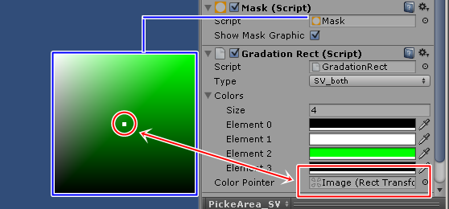

Smaller structure
uCP is able to work with just 1 object.
This's useful for specific situations.
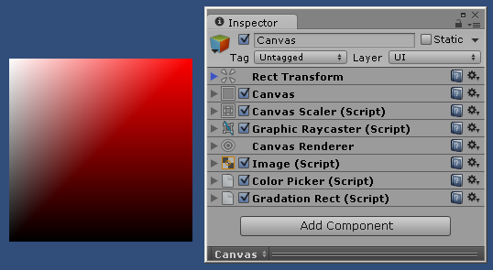

Useful scripts.
There are a few useful scripts, not only for uCP.

- GradationUI.cs
This makes a gradation on Image.
Your UI will be more rich!

- HSV.cs
This allow to use HSV type color.
It can be convert with Color implicitly.
Example C# code.
/*------------------------------------*/
Color c = new HSV ( 1,1,1,1 );
/*------------------------------------*/
And it has constant Colors.
HSV.red, HSV.green, HSV.blue,
HSV.cyan, HSV.magenta, HSV.yellow,
HSV.white, HSV.gray, HSV.grey, HSV.black,
HSV.clear

- RenderColor.cs
This is for all scene objects, they have a Renderer.
This has a function, it can receive a ColorPicker's output event.
And then this sets the renderer's color property.

When you use uCPf scripts in your script, you need to write a line, “using uCPf;”.
This is the uCPf core script's namespace.

About ColorPicker.cs.
ColorPicker.cs is a base of uCPf controls.
This manage a color and events.
When uCPf controls have run Awake(), they find a ColorPicker.cs in their parents and set events.
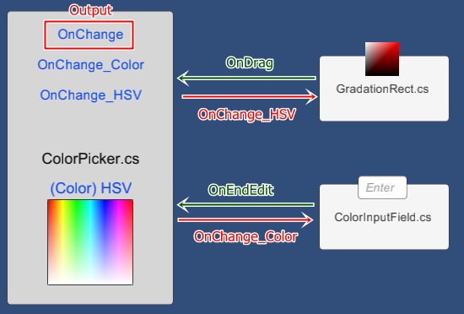
ColorPicker.cs has a OutputMultiplier propety,
It works as OutputMultiplier * Color.
If you felt the color is not enough, try it please.
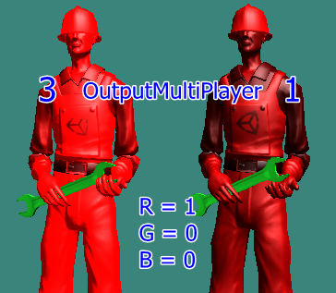

World UI
uCP works even a canvas is world space mode.
Just a bit careful about size.
When you convert Rendermode, overray to world space, the canvas is too big.
Also uCP controls and prefabs are too big.
I recommend to use a CanvasScaler.
This component converts the size very well.
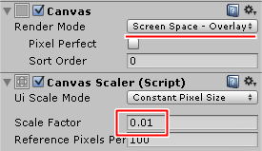
After conversion, change the Render Mode property to world space.
The size good for the world.
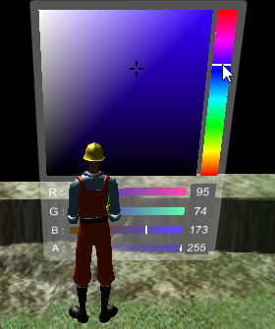

About Filled Type Image
When you use Filled type.
GradationUI.cs can not show a gradation correctly.
Please use another image with a Mask.
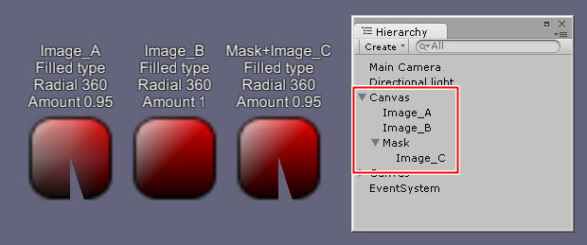

About free version.
uCPf is free version of uCP.

There are no HSV sliders, no Alpha slider and more.
Its contents are for 1 type of color picker.
See the picture below.
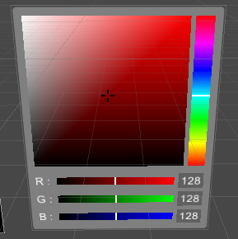
uCPf doesn't have core source code.
Those are packed in uCPf.dll file.

uCPf core scripts are not overridable.
Can not use them for super class.

And it's only for Unity 5.2.2 or higher.
Unlimited version can be used from Unity 4.6.

If you feel good with uCPf, please check unlimited version uCP.

Contact
If something happened, please contact me.

E-Mail : syu-ya_ST@hotmail.co.jp

