**IMAGE FORMAT CONVERTER**

***­­­­­FOR UNITY***

***Developed by Radiant Silver***

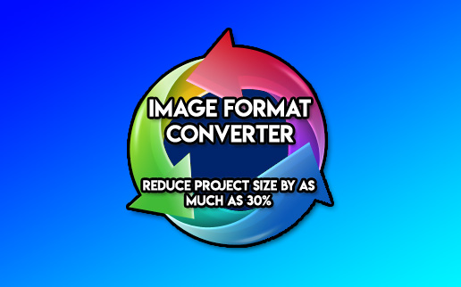

**INTRODUCTION**

**Thanks for purchasing Image Format Converter (IFC) for Unity!**

**This asset is designed to drastically reduce the size of your Unity project by changing massive image files (such as .TGA, .BMP, .TIFF) into much smaller files (like .PNG) with no loss of quality.**

**IFC was written for my own personal needs and slashed the size of my project by 25% which means it reduced my project size from 296 gigs to 222 gigs! That’s a whopping saving of 74 gigs.**

**I hope that you have similar results and that your project will be more slim-line after running it.**

**Please note, your build will remain the same size since Unity will use its own compression.**

**NOTE: This asset is in beta, there may still be bugs or features missing. Please let me know if this is the case. I would prefer to offer you support/new features than receive a bad review!**

**USAGE**

**Run the wizard by selecting from the menu:**

**Window->RadiantSilver->Image Format Converter**

**The first thing to remember is that this asset will give best results if you have a lot of huge relevant files in your project. To check potential space savings search your project for files like BMP, TIFF, TGA and then order them by size. If there are a lot of these and they’re big you should smile, because all of these files can be converted into PNG automatically, reducing your project size immensely. You don’t need to worry about renaming the converted files or the materials that use these textures, or even the .meta files, IFC does all of this for you automatically, you just run it and wait.**

**IMPORTANT**

**Please backup your project before using this asset. It is destructive in that it will convert your images into a new format and there is no undo. So you MUST backup your project before running it to avoid any damage. I will not be held responsible for any damage or loss of data.**

**Also please check the results thoroughly before assuming everything went perfectly. The asset has been tested but it is still pretty new. Keep your backup just in case something messes up.**

**Also remember, it can take a LONG time to process all of the images (24 hrs or more depending on the number of files to be processed), and uses A LOT of CPU. The best time to run this is when you aren’t using your computer. For example, run it before bed, or before you leave the house, and be safe in the knowledge your computer is working away to reduce your project size. The wait can be long, but it is worth it! The workflow has been designed to be a bit like light-baking meaning you can pause and resume the process very easily. This means you can resume it whenever you leave the computer until done.**

**BONUS SPACE SAVINGS**

**Once IFC has made all your PNGs you can further optimise them using PNG optimisers like Pngcrush, Opting (non-lossy) or Pngquant (lossy). This results in even further savings which you should definitely experiment with.**

**SUPPORT**

**You can get support on the Unity forum thread for this asset.**

**Or email me at** [gareth.murfin@gmail.com](mailto:gareth.murfin@gmail.com)

**Thanks again, let me know of any problems, or feature requests. I hope all works out well for you and good luck with your awesome game.**

**Cheers!**

**Gareth Murfin / Radiant Silver**

**Freelance app and game developer portfolio** [www.garethmurfin.co.uk](http://www.garethmurfin.co.uk)

**ALSO KEEP AN EYE OUT FOR MY NEW AI KIT “RADIAI”, COMING SOON!**