Sustained Neglect and Opportunities for Integrated Anchor-Cluster

Development in Washington, D.C.’s Southwest Neighborhoods

Chris Hays

Professor Kathryn Cooney

MGMT 536: Urban Poverty and Economic Development

Assignment 2 City Community and Economic Analysis

6 March 2018

1. **Introduction**

If Washington, D.C. is known for the stark segregation between its white and black populations, the neighborhoods Bellevue, Washington Highlands, and Congress Heights in the far southwestern corner of the city are the most extreme examples of its neighborhood-level racial homogeneity and poverty. I chose to examine thirteen census tracts in and around those three neighborhoods because of their shared proximity to what I perceived to be an economic opportunity, the anchor institutions of the large military bases near the neighborhoods, and their shared economic story: poverty and stagnation over time. Comparing census tracks between 2000 and 2010, I explore the different social and economic dimensions of poverty in the region. In the subsequent economic base analysis, I discuss the economic characteristics of the city and metropolitan region over time and across industry clusters. Finally, I analyze how anchor- and cluster-based development strategies can be integrated to bring much-needed stable, well-paying employment and growth in Southwest Washington, D.C.

1. **Geographic, Demographic and Socioeconomic Profiles**

Bordering Maryland on the east, the neighborhoods Bellevue, Washington Highlands, and Congress Heights are set apart from the rest of the city by major highways: I-295 to the west and Suitland Parkway to the north. Large anchor institutions are located on the fringes of the neighborhoods. The U.S. Coast Guard Headquarters is located to its northwest, while D.C.’s major joint Navy and Air Force military base, Anacostia-Bolling, as well as the U.S. Naval Research Laboratory are located on the other side of I-295. Along with the major military institutions, a slew of government-run shopping and lifestyle amenities are located near the bases. The neighborhoods contain about forty-thousand residents and two hospitals. There are few shops besides the gas stations and convenience stores sprinkled through the region. The Green Line of the Metro stops in Washington Heights and carries passengers into the heart of the city, and a network of buses overlays the rest of the region. Figure 1 shows the geographies of the neighborhoods and their surrounding areas.

The neighborhoods are extremely demographically homogeneous. Ninety-seven percent residents identified as black or African American in 2010, while only about one percent identify as white. Demographic changes over time have been slow, as indicated by Figure 1. Over the decade between 2000 and 2010, the area’s white population grew from 0.8 percent to 1.1 percent. Its Hispanic population grew by similar numbers, from 0.8 percent to 1.4 percent. The city as a whole is much more racially and ethnically heterogeneous, as indicated by the comparison in Figure 5. The region’s population has remained young. In 2010, about forty-two percent of its population was under twenty-five years old, a slight decrease from the forty-seven percent of 2000. Housing patterns have remained similarly consistent. Across both census data sets, more than three quarters of all residents of southwest D.C. rent their homes. High rates of renting indicate economic instability and lack of wealth in the neighborhoods, as homeownership is often a stable financial investment as well as an intergenerational wealth-building tool. The neighborhoods’ largest social gains since 2000 were in educational attainment. The percentage of college graduates in the population has increased by a factor of 1.71. However, educational attainment is still low; only about ten percent of adults twenty-five or older have a Bachelor’s degree, and twenty percent have not finished high school at all. Only five percent had college degrees in 2000, and more than thirty percent hadn’t finished high school. Over the span of ten years, the population in the neighborhoods has dropped by less than four hundred, and its race, age and ethnicity characteristics reflect an overarching demographic stability.

One of the most striking statistics emerging from census data for Bellevue, Washington Highlands and Congress Heights is family composition and the rate of single-motherhood. More than three quarters of all families with children are composed of single mothers. This number increased by a margin of five percentage points over the span between 2000 and 2010, unlike many other social metrics that decreased marginally over the decade. Only about fifteen percent of families living in the three neighborhoods were composed of married couples. The city as a whole has roughly equal levels of married-couple families and single motherhood. In his foundational 1997 book *When Work Disappears*, William Julius Wilson observed*,* “As the disappearance of work has become a characteristic feature of the inner-city ghetto, so too has the disappearance of the traditional married-couple family” (87). The statistics that Wilson cites about marriage rates and single-motherhood from the ’90s in Chicago (87-9) are almost identical to census data in Southwest Washington, D.C. fifteen years later. In these neighborhoods, marriage rates have continued to decline. Social ills accompany economic ones.

Median income in 2000 for the neighborhoods was $23,000, or about $30,000 in 2010 dollars, while in 2010, median income was about $31,000. Accounting for inflation, residents of the three neighborhoods have seen about a one-thousand dollar increase in their real wages over the ten years between 2000 and 2010 (Figure 2). The average resident works in a sales, office or service occupation, and employment type changed little between 2000 and 2010: about thirty-three percent sales and office occupations and twenty-five percent service occupations (Figure 4). The third-largest occupation sector, which includes management, professional and related occupations, comprised about twenty-four percent of the workforce across both time points. All other occupation sectors comprised less than ten percent of the workforce, including construction and manufacturing. In the city as a whole, management, professional and related occupations comprised almost sixty percent of the workforce, signaling large employment disparities between the neighborhoods and the city (Figure 5).

As residents of Bellevue, Washington Highlands and Congress Heights have been unable to get professional and managerial jobs, they have also faced rampant unemployment. Twenty percent of working-age residents in the labor force were unemployed in 2010, compared to twelve percent in 2000. This statistic may be misleading, however, since unemployment nationally hit a thirty-year low in 2000 compared to high recession-era unemployment nationwide following the 2007 housing market crash (Bureau of Labor Statistics). Even so, the percentage of people receiving public assistance decreased from seventeen to fourteen percent between the two censuses analyzed. The average amount of money in 2010 dollars has also decreased, from about $4,200 in 2000 to $3,800 in 2010. Poverty is both deep and wide in this region; in 2000, twenty seven percent of residents were living under $10,000 a year, and that number has only decreased to about nineteen percent, even as $10,000 is worth significantly less in 2010 than it was worth in 2000 (Figure 3). In both 2010 and 2000, about thirty-seven percent of individuals were living in poverty.

1. **Economic Base Analysis**

The key observations motivating my investigation into these neighborhoods was the contrast between the seeming rich sources of employment in government and related traded-sector jobs versus the stubborn poverty of the area over time. An analysis of cross-sectional composition of the economy and regional specialization will help illustrate the dynamic between these neighborhoods, the city, the metropolitan area, and the nation as a whole. The Washington, D.C. metropolitan area, which covers Northern Virginia and most of Maryland including Baltimore, is one of the wealthiest in the country. Absolute annual wages for the region are third highest in the country, while GDP per capita was seventh highest in the country in 2010 (U.S. Cluster Mapping).[[1]](#footnote-1) Growth has been strong for the region (with a GDP growth rate of 3.86 percent between 2001 and 2010 which is in the top third of growth rates for metropolitan regions). The metropolitan area’s labor specialization is the highest in the country in growth and absolute specialization with a 1.20% growth in labor specialization and almost 67 percent of traded employment in D.C.’s strong industry clusters (U.S. Cluster Mapping).[[2]](#footnote-2)

Business Services is the largest cluster in the city, with half-a-million people employed in those industries and a location quotient of 1.66 in 2010 (U.S. Cluster Mapping).[[3]](#footnote-3) Education and knowledge creation is the second largest cluster in the metropolitan area, with more than 200,000 people employed in the sector and a location quotient of 1.98. Financial services, marketing and communications each also have large shares of employment. Within its Business Services cluster, Computer Services and Consulting are by far the largest sources of growth, contributing in large part to the relatively high growth rate and wages in the region more broadly, with more than 80,000 and 50,000 new jobs created for each sub-cluster respectively between 2000 and 2010 (U.S. Cluster Mapping).[[4]](#footnote-4) Research and development is a cross-sectoral strength of the D.C. metropolitan region. Research and development expenditures have remained third highest in the country and in growth (Figure 8). Similarly, the metropolitan area is the fifth highest concentration in venture capital in the country (U.S. Cluster Mapping).

Narrowing in on the city itself, statistics on Washington, D.C. proper reveal that many of the high-performing cluster industry firms are focused primarily in the suburbs. For instance, Business Services have a location quotient of 1.24 in the city itself compared to the 1.66 of the metropolitan region (U.S. Cluster Mapping).[[5]](#footnote-5) Education and media industries in the city are the most specialized private sector industries in the market, with location quotients 2.83 for educational services, 2.69 for broadcasting services and 1.46 for publishing (Figure 6). An added nuance to the city’s economic profile is the significant influence of the Federal Government in altering the private sector landscape of the city. For instance, Washington, D.C. has a huge proportion of the total government-run printing, service providing and national security-related industries, creating a market for supporting contract-based industries like professional and technical services often employed directly by the Federal Government (Figure 6).

Another important aspect of the “supporting role” traded industries like publishing, professional and technical services is the range of high- and medium-skilled jobs incorporated into these industries. Perhaps unlike many service-sector industries, supporting role industries employ full-time, nine-to-five, clerical workers doing the copying, preparing memos, scheduling and other routine bureaucratic tasks. In publishing, these are the editor’s assistants, operations staff and secretaries, to name a few roles. This suggests that growth in supporting role industries leads to good jobs, not just jobs. As I will discuss in my recommendations, the potential for medium-skill, medium-wage jobs in publishing, professional and technical supporting industries provides the opportunity to fuse inclusive growth with cluster development.

Another key characteristic of the D.C. metropolitan region economic base (as displayed by Figure 7) is importance of the commute in the D.C. economy. Commuting patterns for jobs in the city are simple and clear; nearly two-thirds of all individuals working in Washington, D.C. live in the suburbs outside of the city. Only about a quarter of all the jobs in the city are occupied by people living there. This employment pattern reduces the city’s tax base as two-thirds of the city’s employees are paying most of their taxes outside of the city.

1. **Inclusive Development Recommendations**

The interaction between the Federal Government, supporting industries and the traded sector presents an economic opportunity for the city’s poverty-stricken neighborhoods. Washington, D.C.’s southwest neighborhood organizations and community leaders may be able to leverage federal and military employment and demand for services to create sustained traded-sector growth for lower- and middle-class workers.

In Chris Benner and Manuel Pastor’s *Just Growth*, empirical analysis shows, “The presence of a state capital city in a region has a highly significant and positive relationship with both growth and equity, perhaps because such regions benefit from stable public-sector employment” (36). Washington, D.C. benefits from similar levels of stable public-sector employment, but highly homogeneous neighborhoods like the ones in my demographic profile seem to offset these benefits. The dependency of many of Washington, D.C.’s largest industries on the Federal Government should signal stable and equitable growth, and yet the employment disparities between Southwest Washington, D.C. and the city as a whole do not reflect this correlation. This fact might also be explained by Benner and Pastor’s findings that racial and ethnic homogeneity are negatively correlated with equitable growth (21). The findings in *Just Growth* indicate that the key to the neighborhoods’ economic revitalization might be rooted in Federal Government jobs and related private sector growth.

The largest employers around the Bellevue, Washington Highlands and Congress Heights neighborhoods are the military bases and research institutions. This presents a two-pronged opportunity to grow an underdeveloped industry cluster in the city, private-sector research, while using federal military employers as anchor institutions and a tool for workforce development. Joint Base Anacostia-Bolling houses the Capitol’s major Navy and Air Force bases and a total of fifty military and federal agencies on the thousand-plus acre complex, according to the base’s website.[[6]](#footnote-6) The base itself offers paid college and graduate-level internships in fields such as Culinary Arts and Marketing. The Naval Research Laboratory employs about 2,500 full time and 2,500 part-time workers. According to employment statistics on the Naval Research Laboratory website about two-fifths of positions at the laboratory require less than a bachelor’s degree education.[[7]](#footnote-7) The NRL hosts several research internship programs, including one specifically designed for students from historically black colleges and universities, indicating a willingness to use affirmative action to effect social change in its industries. The U.S. Coast Guard Headquarters employs about 3,700 military and civilian personnel, according to a press release about the facility’s opening in 2015.

These military institutions’ existing internship programs provide an example of the anchor-based workforce development projects that would bring much-needed steady employment and middle-income wages for residents of the southwest of the city. Workforce development and geographical preference in hiring would meaningfully enact the kind of racial and geographical affirmative action that is intended by the NRL’s historically black colleges and universities internship program. In Democracy Collaborative’s Anchor Mission Playbook, Rush University Medical Center emphasizes “moving beyond simply treating the symptomatic results of place-based racial and economic inequity and towards a realignment of all institutional resources to fight the inequities at the root” (4). Globally focused agencies like the armed forces bases might seem less likely to refocus institutional resources on their particular local communities. However, the U.S. military has long attempted to be a catalyst of upward mobility, using the GI Bill to fund college and graduate education for those who serve. Providing geographic and racial affirmative action in hiring while creating workforce development opportunities would be an extension of these broader class mobility values.

Economic development is not limited to the public sector. The employment statistics of the major military institutions in Southwest Washington, D.C. do not account for the private industries that contribute to the daily operations of the institutions. Undoubtedly, many thousands more people are employed providing professional, technical, clerical and operations support primarily to these institutions. This is where traded sector cluster development has the most potential to bring already strong clusters in the metropolitan area to Southwest Washington, D.C. and to develop clusters based on existing federal research and development employment in this region of the city.

Based on the city’s high industry specialization in publishing, professional and technical services, community organizations and the neighborhood’s ward councilmember should focus on bringing “supporting role” industries into Southwest Washington, D.C. Professional, technical and publishing firms already have strong presences in the city. Locating or relocating firms in close proximity to the military institutions they are serving may provide a steady source of work coming from the agencies themselves as well as the efficiency benefits stemming from “encouraging collaborative, localized clusters of firms, with private-sector councils of competitiveness” (Goetz, Deller and Harris, 72). In the short term, these industries will serve the agglomeration of military institutions in this part of Washington, D.C. In the long term, these industries will be competitive in the national economy because of their proximity to key information sources like the military and their already-strong market share in the national economy.

Besides supporting role industries, Southwest Washington, D.C. has the opportunity to expand its private-sector research industries, building from large-scale public-sector research and development. For instance, even though Washington, D.C. receives the third most research and development funds compared to other metropolitan areas of its kind (Figure 7), its research industries are underrepresented compared to the national economy; data processing, hosting and related services industries had an annual average employment location quotient of 0.52 in 2010 (U.S. Bureau of Labor Statistics). Research and development firms focused on military and national security technology may be able to capitalize on the strong national security public sector in the city, located partially in the southwest military bases. Building from existing national security industries into new fields is what Goetz, Deller and Harris identified as “value chains for clusters” (189) whereby a region can create growth in one industry based on growth a related industry. In this case, the city has a pattern of high research and development spending per capita and a strong public sector national security industry going towards supporting private-sector research and technology.

The partnership between these underserved neighborhoods and the Federal Government is not without hurdles. For one, I-295 is a major geographical barrier between the neighborhoods in my focus area and Bolling-Anacostia base as well as the Navy Research Laboratory (although the Coast Guard headquarters is more easily accessible). Even if major anchor institutions were to offer geographic affirmative action and workforce development, transportation may still be a barrier for residents of the three neighborhoods. To get from Ballou High School, near the center of my geographical area of focus, to Joint Base Anacostia-Bolling requires a twenty-six-minute public transport trip according to Google Maps, even though the two locations are less than two miles apart. Other employment destinations may be even more distant. Similarly, the constraints of government bureaucracy may limit the collaborative and entrepreneurial dimensions of Porter’s cluster strategy. As Storper described in *The Rise and Fall of Urban Economies*, Los Angeles suffered limited growth compared to San Francisco because of “its dependence on federal government procurement: less spin-off, fewer new organizational forms, weaker internal labor mobility, weaker connections of scientists to businesspeople, and fewer robust actors” (94). If similar inflexibility were to occur in emerging D.C. data analysis and research industries, it might very well lose out to a more flexible, innovative region. The bridge between public and private sectors is of huge significance for Washington, D.C.’s competitive advantage moving forward.

Washington, D.C. has enormous potential for integrated anchor- and cluster-based inclusive economic development based on the confluence of federal jobs and high- to medium-skilled traded industries. Ultra-segregated neighborhoods like Bellevue, Washington Highlands and Congress Heights have been left out of high-performing, highly specialized industries in the city, but the neighborhoods’ economic base composition suggests that inclusive economic development is not out of reach. Targeted neighborhood workforce development programs by anchor institutions and traded-sector development in supporting role and research-based industries may uniquely improve the economic outcomes in these neighborhoods. The legacies of segregation and exclusion will present significant barriers to neighborhood-level development in the southwest of the city, but the stability of military and federal agencies and related industries serving them indicates that long-term planning and growth is possible. Beyond its immediate economic and social benefits, flipping the script on the historic poverty and segregation of D.C.’s southwest carries a larger significance; the character of the Capitol reflects on the character of the nation as a whole. To rebalance the economic map of the city might in some small way, as Ta Nehisi Coates wrote about reparations, lead to a “healing of the American psyche” (“A Case for Reparations”) based on the changing economic outcomes of the city’s most underserved population.

1. **Appendix**

**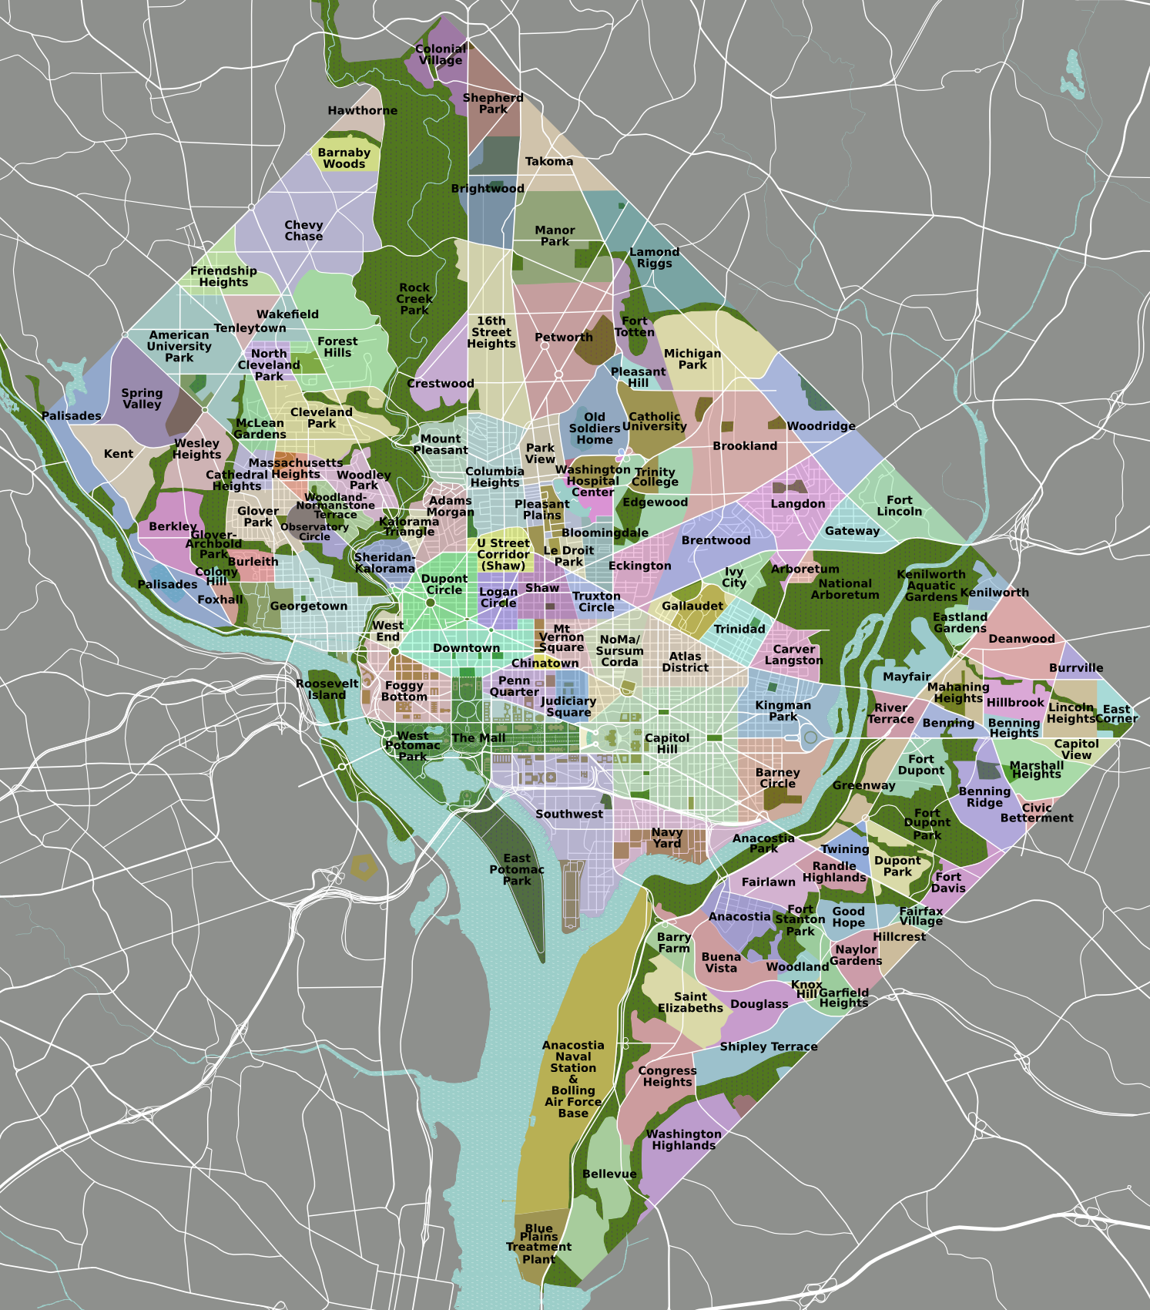**

Figure 0. Neighborhood map of Washington, D.C. (Source: Wikimedia commons. By Peter Fitzgerald - self-made, tracing done from PD satellite imagery, CC BY 3.0, https://commons.wikimedia.org/w/index.php?curid=3600981)



Figure 1. Washington, D.C.’s Bellevue, Washington Highlands and Congress Heights neighborhoods over time. Demographic, educational and housing metrics are compared between 2000 and 2010. (Data: U.S. Census Bureau, Census Tracts 104, 109, 73.04, 74.03, 74.04, 74.09, 97, 98.01, 98.02, 98.04, 98.07, 98.10, 98.11)



Figure 2. Washington, D.C.’s Bellevue, Washington Highlands and Congress Heights neighborhoods over time. Poverty, public assistance and unemployment metrics are compared between 2000 and 2010. The poverty rate statistics represent the percentage of total individuals whose income in the previous year was below the poverty line. (Data: U.S. Census Bureau)

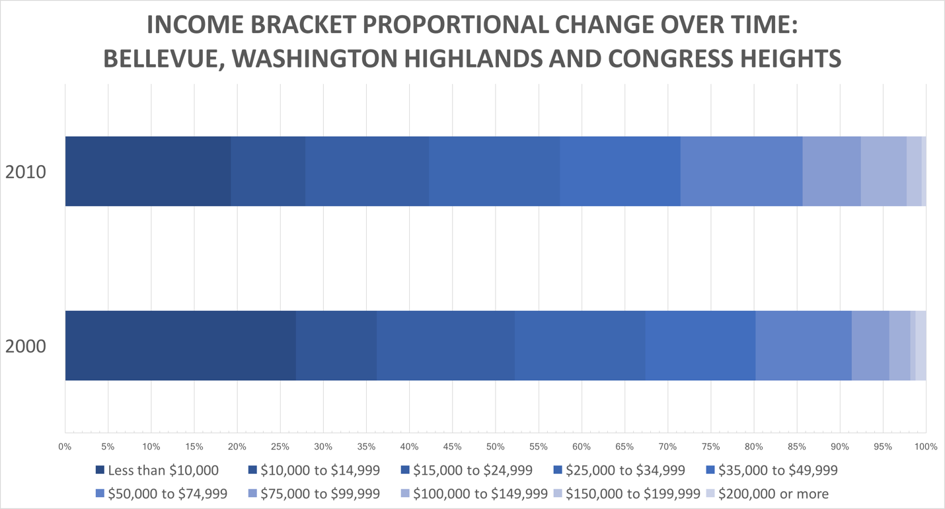

Figure 3. Comparison of income brackets in Washington, D.C.’s southwest neighborhoods between 2000 and 2010. The data from 2000 is categorized in terms of 2000-dollars and the data from 2010 is categorized in terms of 2010-dollars; the chart is not adjusted for inflation. (Data: U.S. Census Bureau)

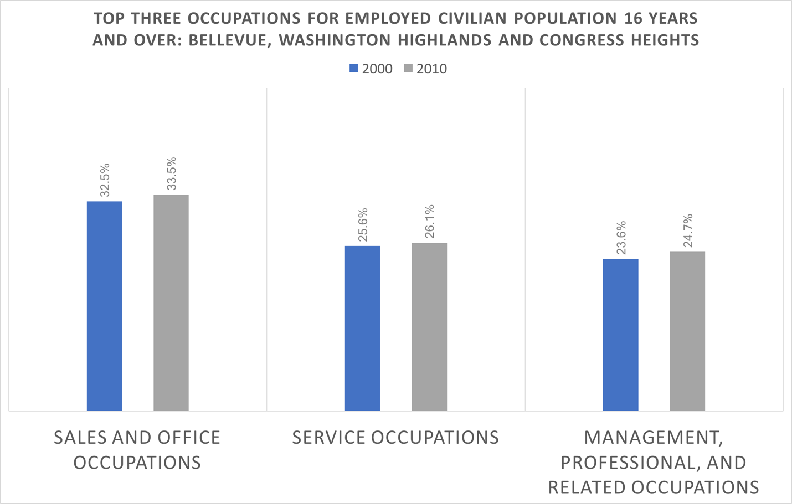

Figure 4. A comparison of the top three occupations by employment for residents of the neighborhoods between 2000 and 2010. The percentage of the workforce working in sales and office, service and management or professional occupations each increased marginally between 2000 and 2010. (Data: U.S. Census Bureau)

../Documents/WashingtonDC_EconomicBaseAnalysis/MANIPULATED_2000-2010_comparison/table_citycomp.pdf

Figure 5. Neighborhood to city comparison on selected demographic and economic metrics from 2010. The poverty and unemployment rates in the three neighborhoods are double those of the city. The city is considerably more racially and ethnically heterogeneous than the neighborhoods. (Data: U.S. Census Bureau)



Figure 6. Selected 3-digit-level industries for Washington, D.C. proper compared between 2000 and 2010 and categorized by federal or private ownership. Industries were chosen based on their consistent and high location quotient performance in the city and based on the range of high- and medium-skill jobs incorporated in the industries. Because a high percentage of administrative, service-providing and national security jobs are located in Washington, D.C., the location quotients for these industries are high. (Data: U.S. Bureau of Labor Statistics)

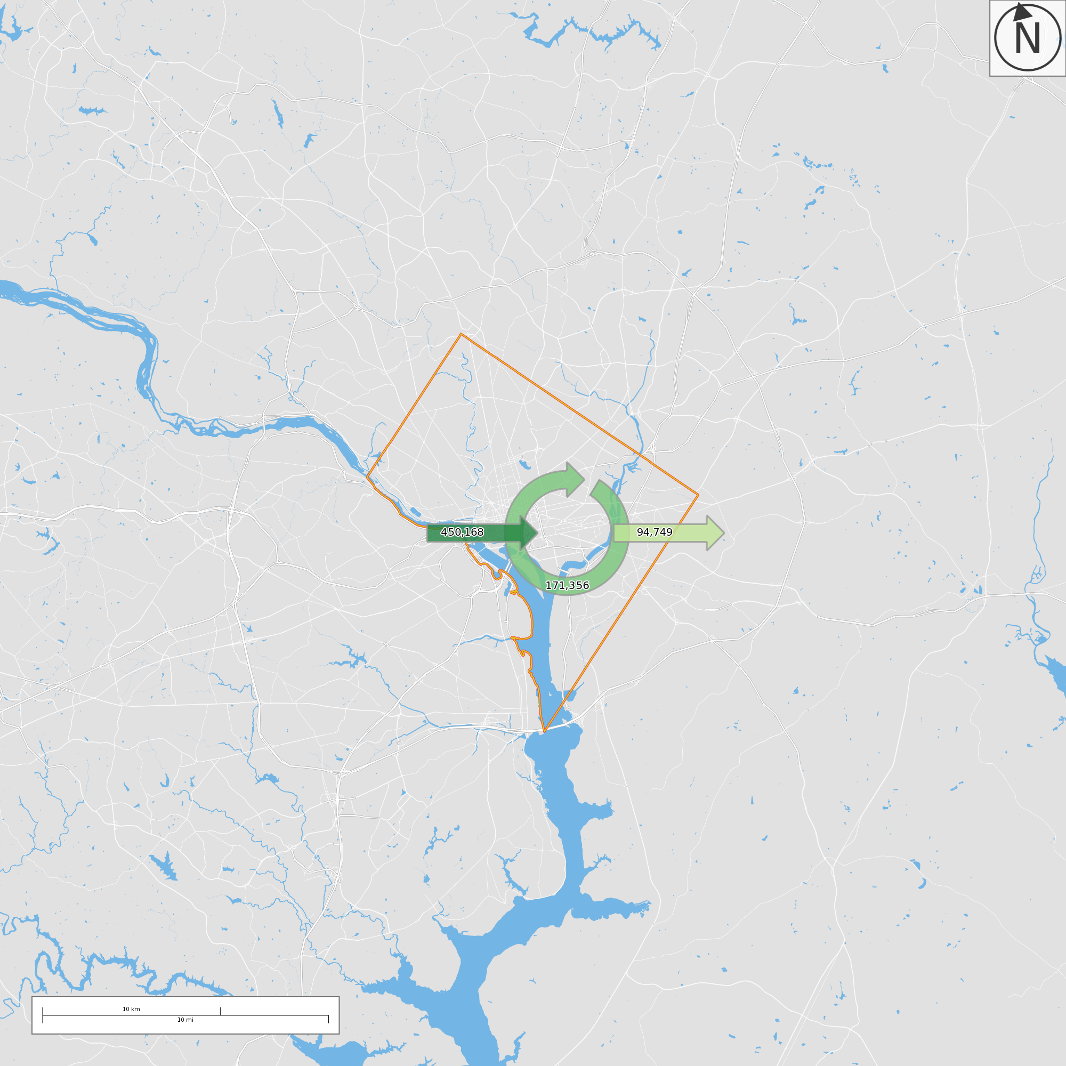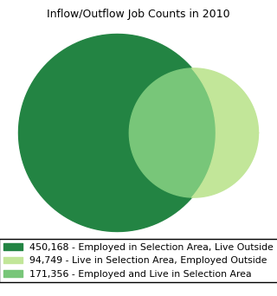

Figure 7. Commuting patterns for individuals employed in Washington, D.C. More than two-thirds of all people employed in the city commute from outside. (Source: [www.onthemap.ces.census.gov](http://www.onthemap.ces.census.gov))

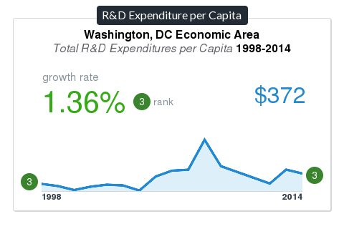

Figure 8. Research and development expenditure per capita for the Washington, D.C. economic area. The ranks indicate that Washington, D.C. spends the third largest amount of money on research and development among all U.S. economic areas. (Source: U.S. Cluster Mapping)

1. **Bibliography**

Benner, Chris & Manuel Pastor (2012). Just Growth: Inclusion and Prosperity in America’s Metropolitan Regions. Chapter 2.

Coates, Ta’Neisi. (2014). The Case for Reparations. The Atlantic.

Democracy Collaborative (2017). The Anchor Mission Playbook https://democracycollaborative.org/content/anchor-mission-playbook

Edited by Stephan J. Goetz, Steven C. Deller, and Thomas R. Harris (2009). Targeting Regional Economic Development, Chapter 5, Chapter 10. Routledge Studies in Global Competition.

Storper, M., Kemeny, T., Makarem, N., Osman, T. (2015). The rise and fall of urban economies: Lessons from San Francisco and Los Angeles. Ch. 1, 5, 6. Stanford: Stanford University Press.

William Julius Wilson (1997). When Work Disappears: The World of New Urban Poor, Chapters 1-5.

1. http://www.clustermapping.us/region/msa/washington\_arlington\_alexandria\_dc\_va\_md\_wv [↑](#footnote-ref-1)
2. Ibid. [↑](#footnote-ref-2)
3. http://www.clustermapping.us/region-cluster/business\_services/msa/washington\_arlington\_alexandria\_dc\_va\_md\_wv [↑](#footnote-ref-3)
4. Ibid. [↑](#footnote-ref-4)
5. http://www.clustermapping.us/region/county/district\_of\_columbia\_ [↑](#footnote-ref-5)
6. https://www.cnic.navy.mil/regions/ndw/installations/jbab.html [↑](#footnote-ref-6)
7. https://www.nrl.navy.mil/content\_images/2016\_FactBook.pdf [↑](#footnote-ref-7)