
Republic of the Philippines
Laguna State Polytechnic University
Province of Laguna
College of Computer Studies

Name: Coronacion, John Christian CSST-101 Section: BSCS – 3B Prof. Bernandino

“When Logic Changes: Exploring Non-Monotonic Reasoning and Argumentation”

Part I. Conceptual Understanding (20 points) Instruction:
Answer the following questions briefly but clearly. Each question is worth 4 points.
- Define non-monotonic reasoning in your own words.
- Non-monotonic reasoning is a type of reasoning where conclusions can change or be withdrawn when new information is added, unlike traditional logic where conclusions always remain true once proven..
2.How does non-monotonic reasoning differ from monotonic reasoning?
- Non-monotonic reasoning differs from monotonic reasoning in that conclusions in non-monotonic reasoning can be revised or withdrawn when new information becomes available, while in monotonic reasoning, once a conclusion is reached, it remains valid even if new information is added.
- Give a real-life situation where a conclusion must change after new information is added.
- a student is absent because they are not in the classroom, then later learning that the student is attending an approved school activity, which changes the conclusion.
- What is a default rule? Provide one example.
- Example: “Cars run on gasoline.” This is true by default, but if new information says the car is electric, the rule no longer applies.

- How do argumentation frameworks help AI systems decide between conflicting rules?

- Argumentation frameworks help AI systems decide between conflicting rules by organizing arguments and counterarguments, evaluating which arguments are stronger or better supported, and selecting the most acceptable conclusion when rules conflict.
Part II. Laboratory Application (40 points)

Task 1: Belief Revision Simulation (20 points)

Objective: Implement a simple reasoning program in Python or R that revises conclusions when new information is added.

Output:

Republic of the Philippines
Laguna State Polytechnic University
Province of Laguna
College of Computer Studies

Task 2: Argumentation Framework (20 points)

Objective: Create a simple argument diagram showing conflicting knowledge and how the stronger argument prevails.

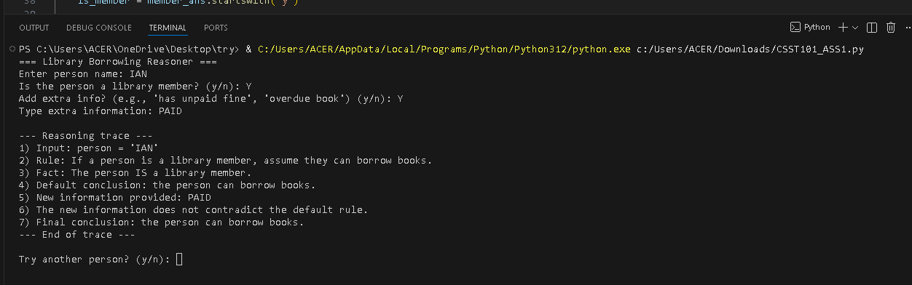

Diagram:
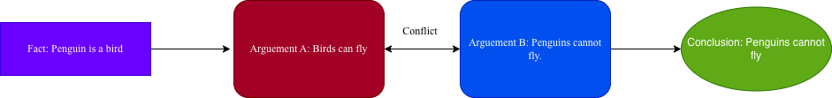

Part III. Reflection and Discussion (20 points)

Instruction: Write a short essay (150–200 words) answering the prompt below. “Think of a time when you changed your conclusion after learning new information. How is this similar to non-monotonic reasoning in AI?”

There was a time when I assumed a friend would arrive on time for our meeting because they are usually punctual. I prepared everything in advance and expected them to be on schedule. However, after waiting for several minutes, I received a message that their car had broken down, causing a delay. I immediately revised my expectation and understood that they would be late. This experience illustrates how new information can change a previously held conclusion.
This scenario is very similar to non-monotonic reasoning in AI. In AI systems, a conclusion drawn from available knowledge may later be retracted or revised when new evidence arises. For example, an AI might assume a bird can fly by default, but if it learns the bird is a penguin, the AI will revise its conclusion accordingly. Just as I adapted my expectation based on the updated situation with my friend, AI systems using non-monotonic reasoning adjust their conclusions to remain accurate when new, potentially conflicting information is introduced. This type of reasoning allows both humans and AI to make flexible decisions in dynamic environments, rather than relying on rigid assumptions that may no longer hold.

At the beginning, both humans and AI systems draw conclusions from the knowledge that is already there, but later, if new facts come up, they have to reconsider their previous assumptions in order to be accurate. In the same way in which I changed my mind after discovering that some of the reviews are fake, an AI system also changes its logic when it gets a piece of information that is against it. This is a demonstration of how the capability of being flexible is a step towards making more rational and reliable decisions.

