Course Number | CPS 8319
Course Title | Reinforcement Learning
Semester/Year
Section Number
Group Number
`  Student Name | Student ID (xxxx1234)
John Cook-Martin
Pari Qarehdaghi | 4602

Assignment No.3

Assignment Title | Question 1
Submission Date | 2026-03-17
Due Date | 2026-03-17
Answer:
From section 2.4
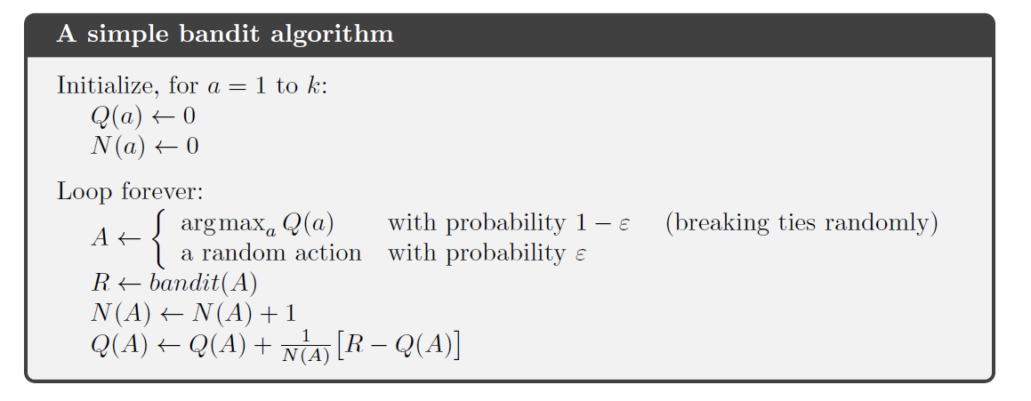
Section 5.1
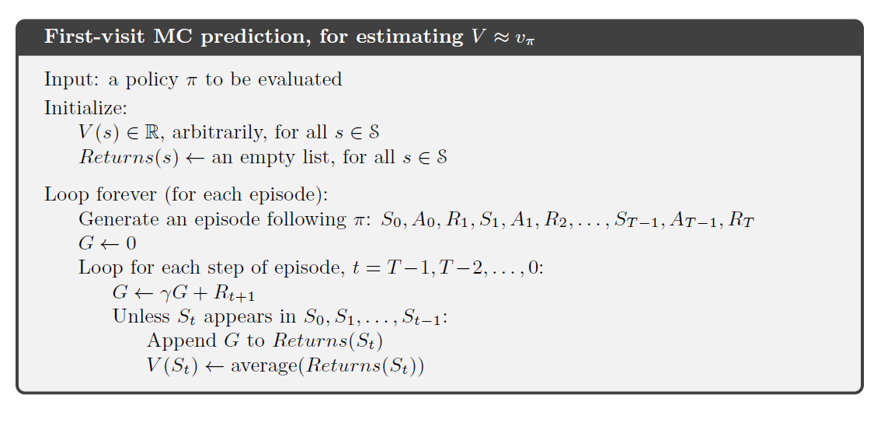
The list $Returns(s)$and averaging operation are replaced by an incremental update using a counter $N(s)$, which computes the sample average without storing past returns.

Input: a policy $π$to be evaluated
Initialize:
$$V(s)∈R,\text{ arbitrarily, for all }s∈S \\ N(s)←0,\text{ for all }s∈S$$Loop forever (for each episode):
Generate an episode following $π$:$S_{0},A_{0},R_{1},S_{1},A_{1},R_{2},…,S_{T-1},A_{T-1},R_{T}$
$$G←0$$
Loop for each step of episode, $t=T-1,T-2,…,0$:
$$G←γG+R_{t+1}$$
Unless $S_{t}$appears in $S_{0},S_{1},…,S_{t-1}$:
$$N(S_{t})←N(S_{t})+1 \\ V(S_{t})←V(S_{t})+\frac{1}{N(S_{t})}(G-V(S_{t}))$$

