Course Number | CPS 8319
Course Title | Reinforcement Learning
Semester/Year
Section Number
Group Number
`  Student Name | Student ID (xxxx1234)
John Cook-Martin
Pari Qarehdaghi | 4602

Assignment No.3

Assignment Title | Question 2
Submission Date | 2026-03-17
Due Date | 2026-03-17
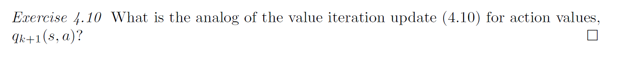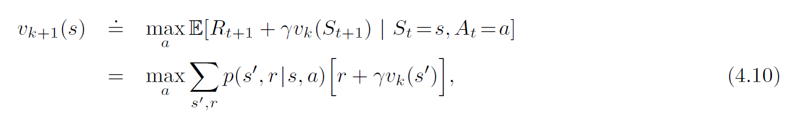
We need to use the Bellman Optimality Equation for q. The value iteration update for state values selects the best action at the current state and then uses the value of the next state. In contrast, for action values $q(s,a)$, action a is already fixed. Therefore, the maximization is applied to the next state $s^{'}$, where the agent chooses the best possible action $a^{'}$.
we can write:
$$q_{k+1}(s,a)=\sum_{s^{'},r}{p(}s^{'},r∣s,a)\left[r+γ\underset{a^{'}}{max⁡}q_{k}(s^{'},a^{'})\right]$$

