Course Number | CPS 8319
Course Title | Reinforcement Learning
Semester/Year
Section Number
Group Number
`  Student Name | Student ID (xxxx1234)
John Cook-Martin
Pari Qarehdaghi | 4602

Assignment No.3

Assignment Title | Question 3
Submission Date | 2026-03-17
Due Date | 2026-03-17

Contents
Introduction 5
Methodology 5
Experimental Setup 6
Results and Analysis 6
Baseline Comparison (Stochastic Environment) 6
Effect of Learning Rate (α) 8
Effect of Exploration Parameter (ε) 10
Epsilon Decay Strategy 13
Deterministic Environment (p₁ = 1.0, p₂ = 0) 15
Effect of Weighted Initialization 16
Conclusion 17
References 19

Figure 1: 10 × 10 grid-world divided into 4 rooms. 6
Figure 2: Q-learning learned policy (seed = 42) 7
Figure 3: SARSA learned policy (seed = 42) 7
Figure 4: Monte Carlo (seed=42) 8
Figure 5: Q- learning and SARSA learned policy (seed = 50) 8
Figure 6: Q-learning policy (α = 0.05, seed = 42) 9
Figure 7: Q-learning policy (α = 0.1, seed = 42) 9
Figure 8: Q-learning policy (α = 0.2, seed = 42) 9
Figure 9: SARSA policy (α = 0.05, seed = 42) 10
Figure 10: SARSA policy (α = 0.1, seed = 42) 10
Figure 11: SARSA policy (α = 0.2, seed = 42) 10
Figure 12: Q-learning policy (ε = 0.05, seed = 42) 11
Figure 13: Q-learning policy (ε = 0.1, seed = 42) 11
Figure 14: Q-learning policy (ε = 0.2, seed = 42) 11
Figure 15: SARSA policy (ε = 0.05, seed = 42) 12
Figure 16: SARSA policy (ε = 0.1, seed = 42) 12
Figure 17: SARSA policy (ε = 0.2, seed = 42) 12
Figure 18: Monte Carlo policy example (ε = 0.05, seed = 42) 12
Figure 19: Monte Carlo policy example (ε = 0.1, seed = 42) 13
Figure 20: Monte Carlo policy example (ε = 0.2 seed = 42) 13
Figure 21: Q-learning with ε decay (seed = 42) 14
Figure 22: SARSA with ε decay (seed = 42) 14
Figure 23: : Monte Carlo with ε decay (seed = 42) 14
Figure 24: Q-learning policy (deterministic, seed = 42) 15
Figure 25: SARSA policy (deterministic, seed = 42) 16
Figure 26: Monte Carlo (deterministic, seed=42) 16
Figure 27: Q-learning policy with weighted initialization (seed = 42) 17
Figure 28: SARSA policy with weighted initialization (seed = 42) 17

Introduction
Reinforcement learning (RL) is a framework in which an agent learns to make decisions by interacting with an environment and receiving feedback in the form of rewards. The goal is to learn an optimal policy that maximizes cumulative reward over time, even when the environment dynamics are unknown.
In this project, three well-known RL algorithms(Monte Carlo control, SARSA, and Q-learning) are implemented and evaluated in a grid-world environment. The environment consists of a 10×10 grid divided into four rooms with stochastic transitions, where the agent must learn to reach a goal state efficiently.
The objective of this study is to compare the performance of these algorithms under different conditions, including variations in learning rate (α), exploration parameter (ε), epsilon decay strategies, and deterministic versus stochastic environments. The results provide insights into how these factors influence learning efficiency and policy quality.

Methodology
Three reinforcement learning algorithms were implemented to solve the grid-world problem: Monte Carlo control, SARSA, and Q-learning.
Monte Carlo control is an episodic method that updates action-value estimates based on the total return observed after each episode. It follows an on-policy approach using ε-soft policies to ensure sufficient exploration.
SARSA is an on-policy temporal-difference method that updates Q-values using the current policy, considering the next action selected by the agent. This results in more conservative learning behavior.
Q-learning is an off-policy temporal-difference method that updates Q-values using the maximum possible future reward, regardless of the current policy. This allows it to learn more aggressively toward the optimal policy.
All methods were implemented using incremental updates, and ε-greedy strategies were used to balance exploration and exploitation.

Experimental Setup
The experiments were conducted in a 10×10 grid-world environment divided into four rooms connected by doorways. The agent can take four actions (up, down, left, right), and transitions are stochastic due to environmental noise.
Unless otherwise specified, the parameters used in the experiments were:
- Discount factor: γ = 0.9
- Learning rate: α = 0.1
- Exploration parameter: ε = 0.1
- Number of episodes: 10,000
The performance of each algorithm was evaluated using the average step ratio compared to the optimal path, as well as the learned policy visualization. Multiple experiments were conducted to analyze the effects of different parameters, including α, ε, epsilon decay, and deterministic settings (p₁ = 1.0, p₂ = 0).
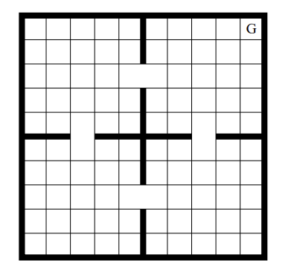
Figure 1: 10 × 10 grid-world divided into 4 rooms.

Results and Analysis

Baseline Comparison (Stochastic Environment)
In this experiment, the performance of Q-learning and SARSA was evaluated in the stochastic grid-world environment using the default parameters. Each algorithm was executed for 10,000 episodes, and the resulting policies and performance metrics were recorded.
The results indicate that both algorithms successfully learned a reasonable policy for navigating toward the goal state. However, slight differences can be observed in their efficiency. Q-learning achieved an average step ratio of approximately 1.37–1.40, while SARSA showed similar but slightly more conservative performance due to its on-policy nature.
Monte Carlo control was also evaluated under the same conditions. While it successfully learned a valid policy, its performance was generally less stable and slightly less efficient compared to SARSA and Q-learning. This is due to its reliance on full episode returns, which introduces higher variance in the updates.
To ensure the reliability of the results, each experiment was repeated using multiple random seeds (7, 42, and 50). The obtained policies and performance metrics remained consistent across runs, indicating that the algorithms are stable and not sensitive to initialization randomness.
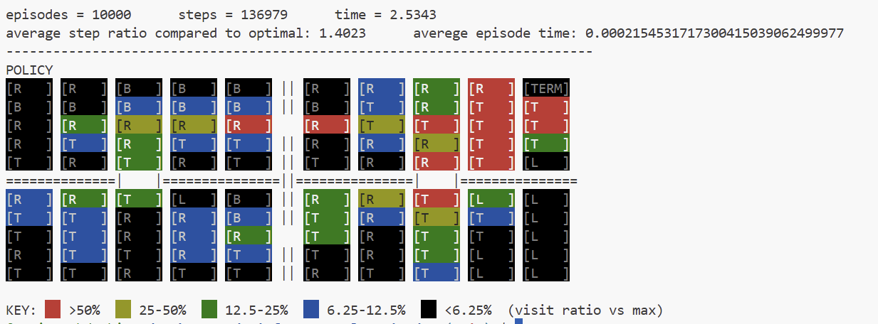
Figure 2: Q-learning learned policy (seed = 42)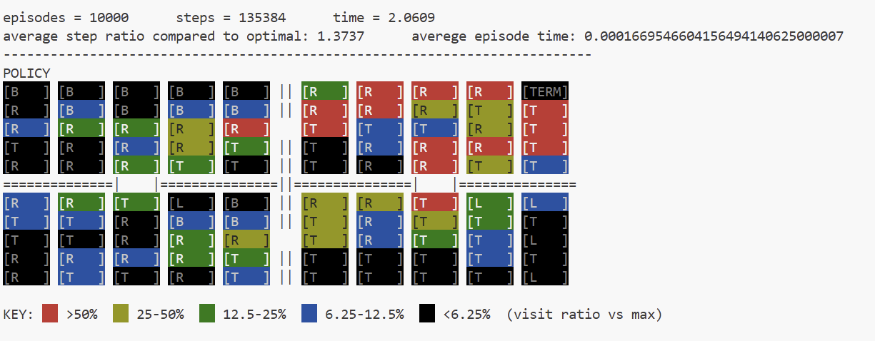
Figure 3: SARSA learned policy (seed = 42)
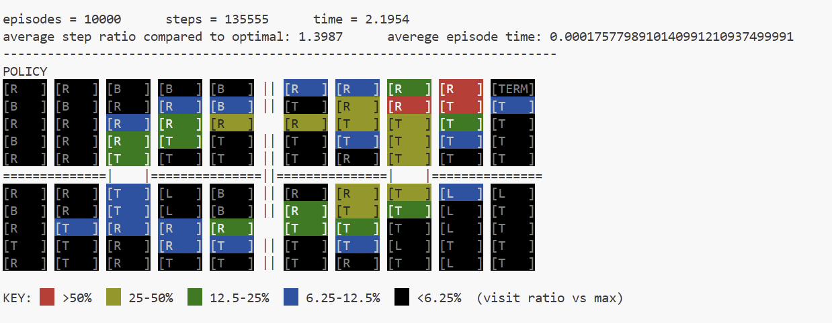
Figure 4: Monte Carlo (seed=42)
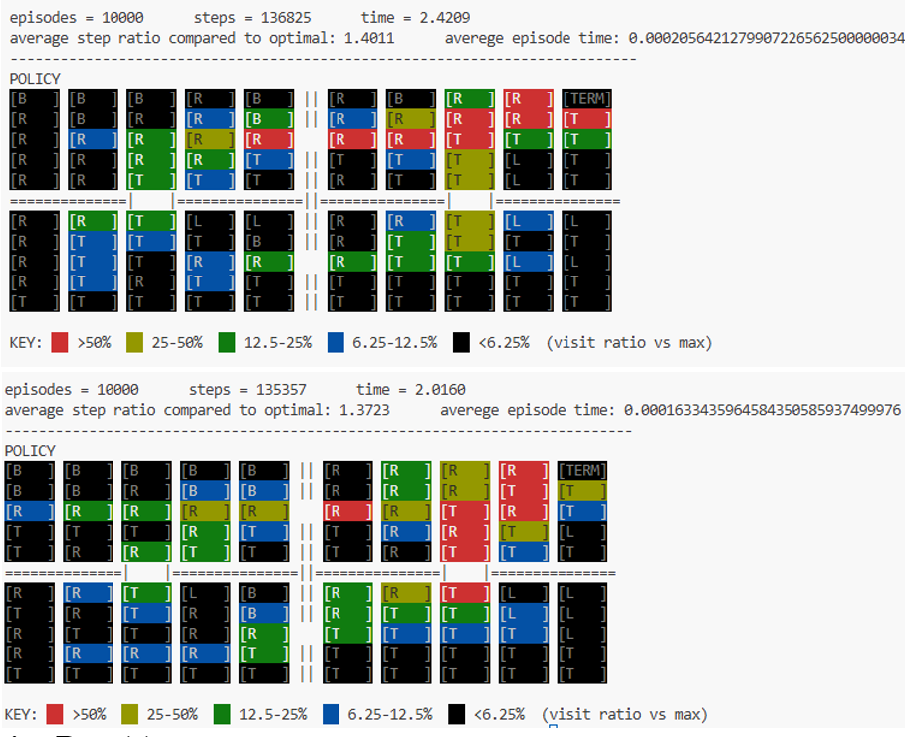
Figure 5: Q- learning and SARSA learned policy (seed = 50)

Effect of Learning Rate (α)
In this experiment, the impact of the learning rate parameter (α) on the performance of Q-learning and SARSA was analyzed. The algorithms were tested using three values of α (0.05, 0.1, and 0.2) while keeping all other parameters fixed.
The results show that the learning rate significantly influences both convergence speed and policy quality. For smaller values of α (e.g., α = 0.05), the updates to the Q-values are more gradual, resulting in more stable but slower learning. This leads to relatively smoother policies but may require more episodes to fully converge.
On the other hand, larger values of α (e.g., α = 0.2) allow the agent to learn more quickly by placing greater weight on recent experiences. However, this can introduce instability in the learning process, causing fluctuations in the learned policy and slightly worse performance in some cases.
The intermediate value (α = 0.1) provides a balance between stability and learning speed and generally produces consistent performance across both algorithms.
From the observed results, both Q-learning and SARSA demonstrate similar trends with respect to α. However, Q-learning tends to be slightly more aggressive due to its off-policy nature, while SARSA maintains more stable updates as it follows the current policy during learning.
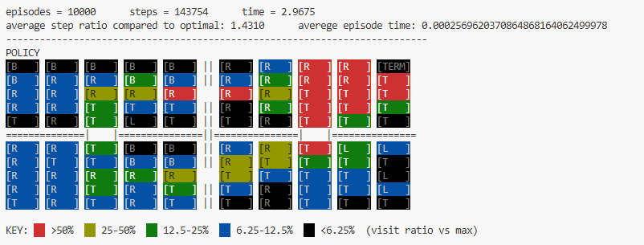
Figure 6: Q-learning policy (α = 0.05, seed = 42)
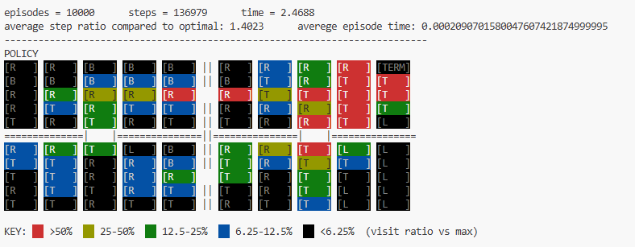
Figure 7: Q-learning policy (α = 0.1, seed = 42)
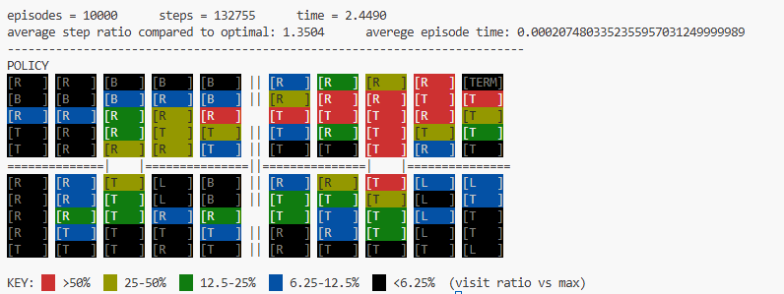
Figure 8: Q-learning policy (α = 0.2, seed = 42)

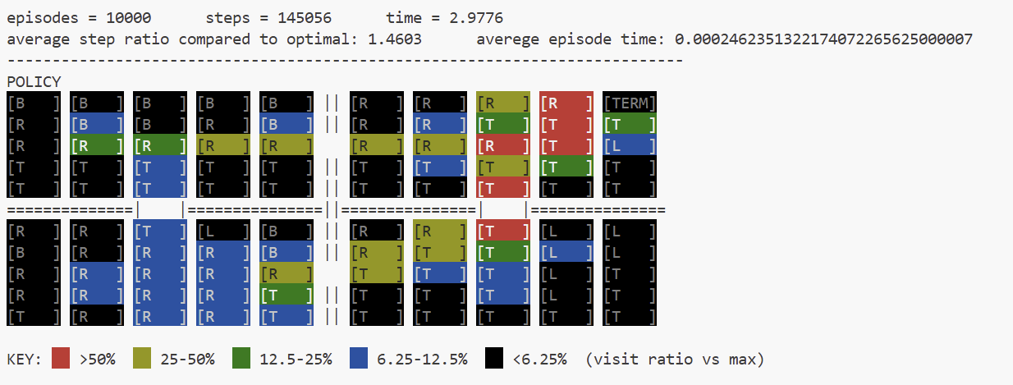
Figure 9: SARSA policy (α = 0.05, seed = 42)
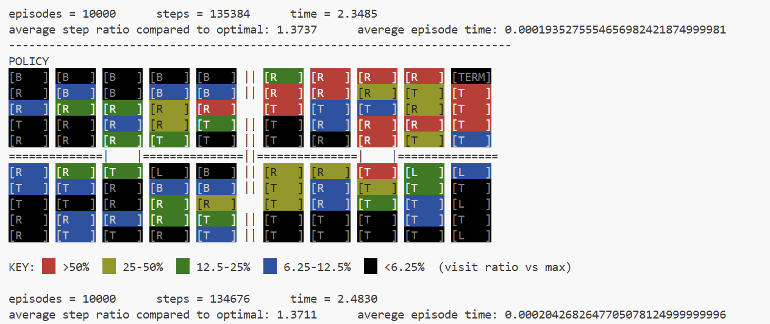
Figure 10: SARSA policy (α = 0.1, seed = 42)
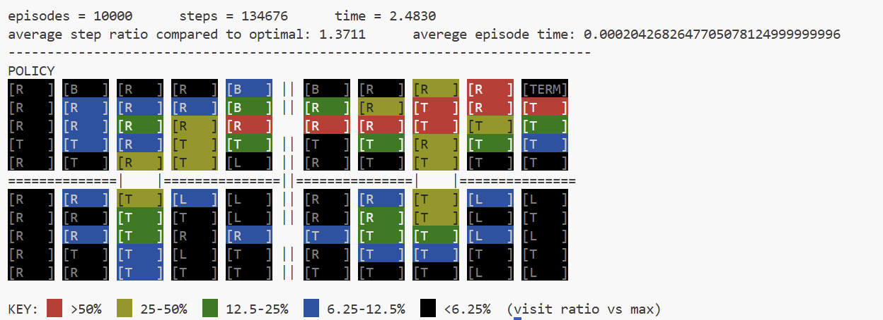
Figure 11: SARSA policy (α = 0.2, seed = 42)

Effect of Exploration Parameter (ε)
In this experiment, the effect of the exploration parameter (ε) was analyzed for Q-learning, SARSA, and Monte Carlo methods. The parameter ε controls the trade-off between exploration and exploitation by determining how often the agent selects a random action instead of following the current policy.
The results demonstrate that ε has a significant impact on learning performance. For small values of ε (e.g., ε = 0.05), the agent primarily exploits the learned policy, leading to faster convergence and more efficient paths toward the goal. This is reflected in lower average step ratios and more consistent policies.
In contrast, larger values of ε (e.g., ε = 0.2) increase the level of exploration, causing the agent to take more random actions. While this can help avoid local optima, it also leads to longer paths and higher average step ratios, indicating reduced efficiency.
Both Q-learning and SARSA exhibit similar trends with respect to ε. However, SARSA tends to be slightly more conservative due to its on-policy nature, as it accounts for exploration during updates. Q-learning, being off-policy, is less affected by exploratory actions during learning and often produces more direct policies.
Monte Carlo results further confirm this behavior, as higher ε values introduce more variability in the learned policy due to the reliance on full episode returns.
Overall, a moderate value of ε (e.g., ε = 0.1) provides a good balance between exploration and exploitation, resulting in stable and efficient learning.
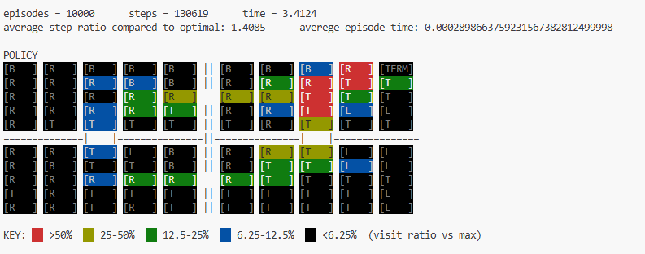
Figure 12: Q-learning policy (ε = 0.05, seed = 42)
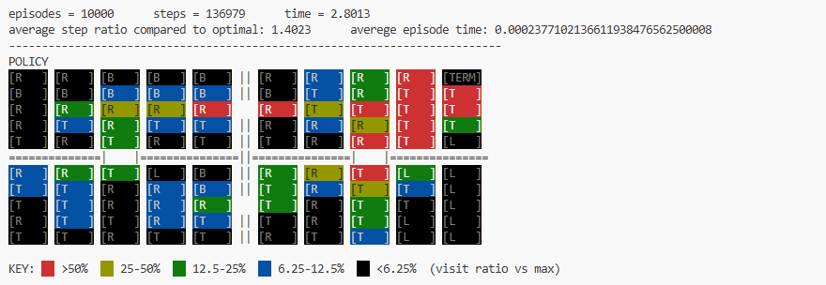
Figure 13: Q-learning policy (ε = 0.1, seed = 42)
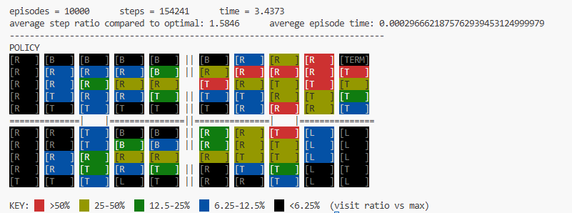
Figure 14: Q-learning policy (ε = 0.2, seed = 42)
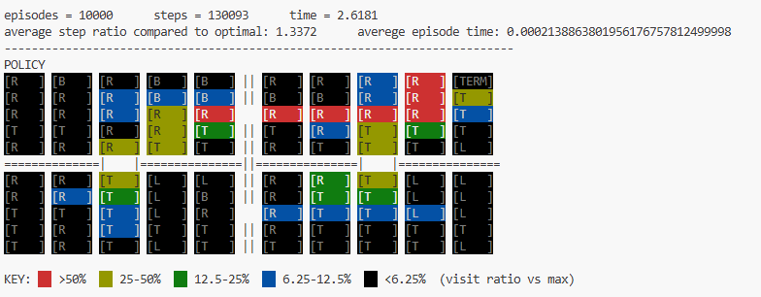
Figure 15: SARSA policy (ε = 0.05, seed = 42)
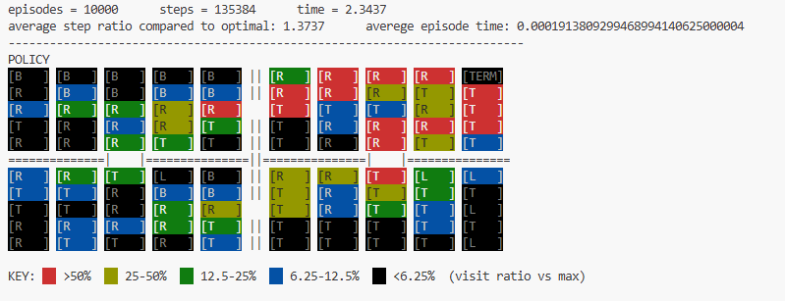
Figure 16: SARSA policy (ε = 0.1, seed = 42)
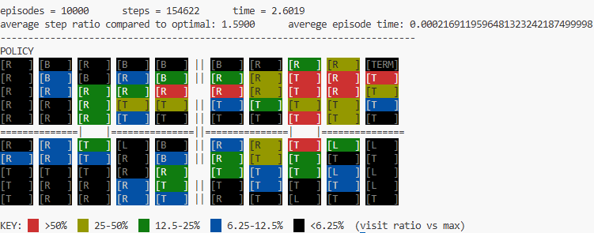
Figure 17: SARSA policy (ε = 0.2, seed = 42)
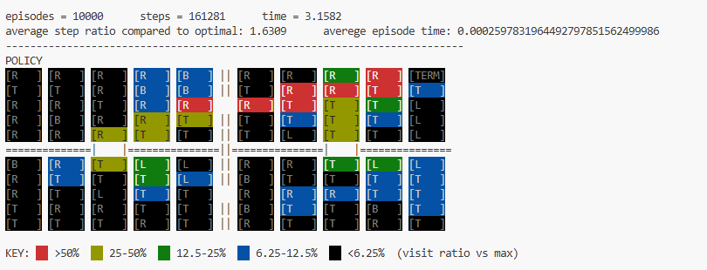
Figure 18: Monte Carlo policy example (ε = 0.05, seed = 42)

Figure 19: Monte Carlo policy example (ε = 0.1, seed = 42)

Figure 20: Monte Carlo policy example (ε = 0.2 seed = 42)

Epsilon Decay Strategy
In this experiment, the performance of Q-learning and SARSA was evaluated using a decaying ε strategy, where the exploration rate gradually decreases over time. This approach allows the agent to explore more in the early stages of learning and increasingly exploit the learned policy as training progresses.
The results show a significant improvement in performance compared to using a fixed ε. With ε decay, the agent initially explores the environment sufficiently to discover different paths, and then gradually converges to a more optimal policy as exploration is reduced.
This behavior is reflected in the lower average step ratios observed in the results. Compared to the fixed ε cases, both Q-learning and SARSA achieve more efficient navigation toward the goal, indicating better convergence properties.
Q-learning benefits particularly well from ε decay due to its off-policy nature, allowing it to learn optimal actions even while exploration is ongoing. SARSA also shows improved performance, although it remains slightly more conservative due to incorporating exploration directly into its updates.
Overall, the ε decay strategy provides a better balance between exploration and exploitation, leading to more stable learning and improved policy quality.
Monte Carlo also benefits from ε decay, although the improvement is less pronounced compared to temporal-difference methods. Since Monte Carlo updates are based on complete episode returns rather than incremental updates, the effect of gradually reducing exploration is less significant.

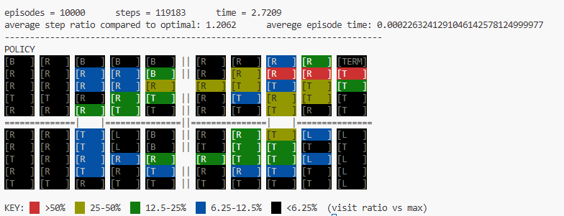
Figure 21: Q-learning with ε decay (seed = 42)
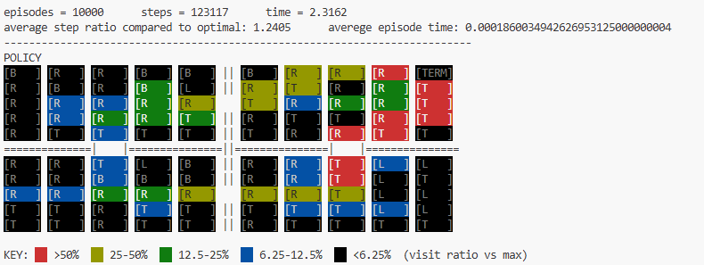
Figure 22: SARSA with ε decay (seed = 42)
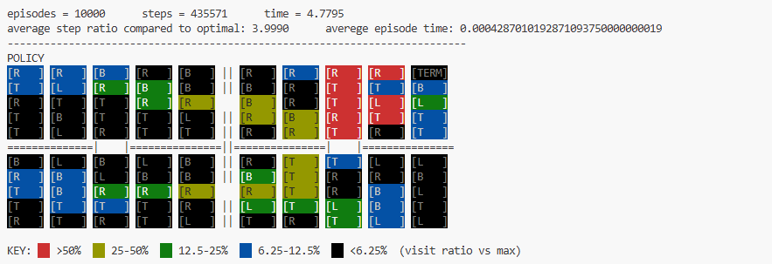
Figure 23: : Monte Carlo with ε decay (seed = 42)

Deterministic Environment (p₁ = 1.0, p₂ = 0)
In this experiment, the stochasticity of the environment was removed by setting $p_{1}=1.0$and $p_{2}=0$, resulting in a fully deterministic grid-world. In this setting, each action deterministically moves the agent in the intended direction without randomness.
The results show a clear improvement in performance compared to the stochastic environment. Both Q-learning and SARSA achieve significantly lower average step ratios, indicating that the agent can follow more optimal paths toward the goal.
This improvement is expected because the absence of randomness allows the agent to reliably execute the learned policy without deviations caused by noise. As a result, the learned policies are more consistent and efficient.
In the deterministic case, the difference between Q-learning and SARSA becomes less pronounced, as both algorithms converge to similar optimal policies. This is because the effect of exploration noise is reduced, making the learning process more stable for both methods.
Overall, the deterministic environment provides a clearer path to convergence and highlights the impact of stochasticity on reinforcement learning performance.
Monte Carlo also benefits from the deterministic environment, as the absence of randomness leads to more consistent episode returns and improved policy stability. However, like previous observations, its performance remains slightly less efficient compared to temporal-difference methods due to higher variance in updates.
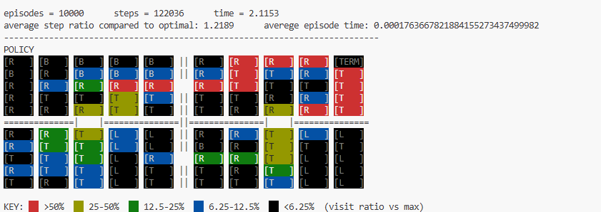
Figure 24: Q-learning policy (deterministic, seed = 42)
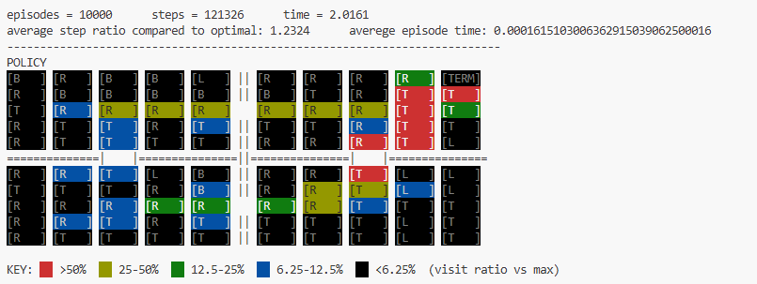
Figure 25: SARSA policy (deterministic, seed = 42)
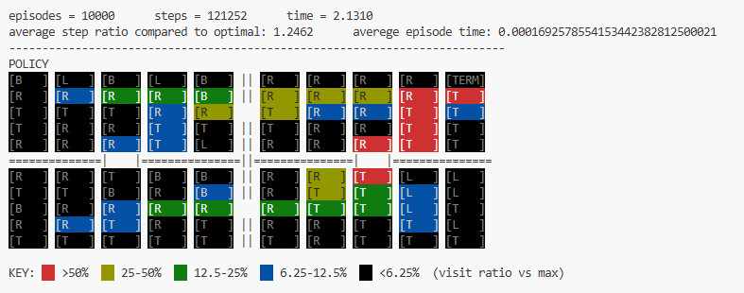
Figure 26: Monte Carlo (deterministic, seed=42)

Effect of Weighted Initialization
In this experiment, the impact of weighted initialization on the learning process was evaluated. Instead of initializing all Q-values to zero, the values were initialized using a non-zero strategy to encourage early exploration and potentially guide the learning process.
The results show that weighted initialization can influence the early stages of learning by biasing the agent toward certain actions. In some cases, this leads to faster initial exploration; however, it does not necessarily guarantee improved final performance.
For Q-learning, weighted initialization resulted in performance comparable to or slightly worse than the standard initialization. This suggests that while initialization can affect early learning behavior, its impact diminishes over time as the agent updates its Q-values based on actual experience.
Overall, the results indicate that weighted initialization has a limited effect on the final policy quality in this problem, especially when enough training episodes is used.

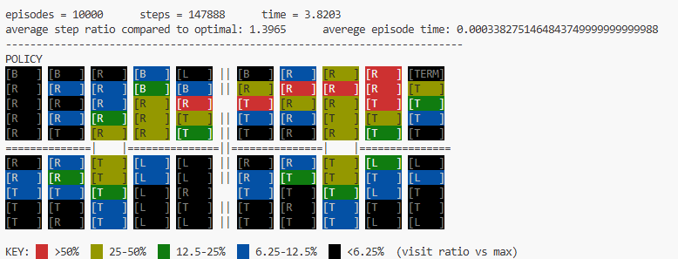
Figure 27: Q-learning policy with weighted initialization (seed = 42)
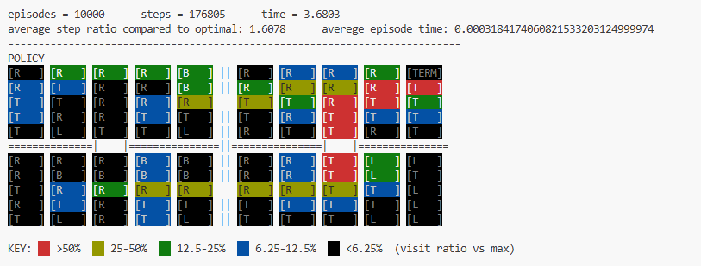
Figure 28: SARSA policy with weighted initialization (seed = 42)

Conclusion
In this project, Monte Carlo, SARSA, and Q-learning algorithms were implemented and compared in a grid-world environment. The results demonstrate that all three methods can learn effective policies; however, their performance varies depending on the choice of parameters and environmental conditions.
Q-learning generally achieved more efficient policies due to its off-policy nature, while SARSA exhibited more stable and conservative behavior. The experiments showed that the learning rate (α) and exploration parameter (ε) significantly affect performance, particularly in stochastic environments.
The use of epsilon decay provided the best overall performance by balancing exploration and exploitation over time. Additionally, removing stochasticity from the environment led to improved efficiency, highlighting the impact of uncertainty on reinforcement learning.
Overall, the study emphasizes the importance of parameter tuning and exploration strategies in achieving optimal performance in reinforcement learning tasks.

References
R. S. Sutton and A. G. Barto, Reinforcement Learning: An Introduction, 2nd ed. MIT Press, 2018.

