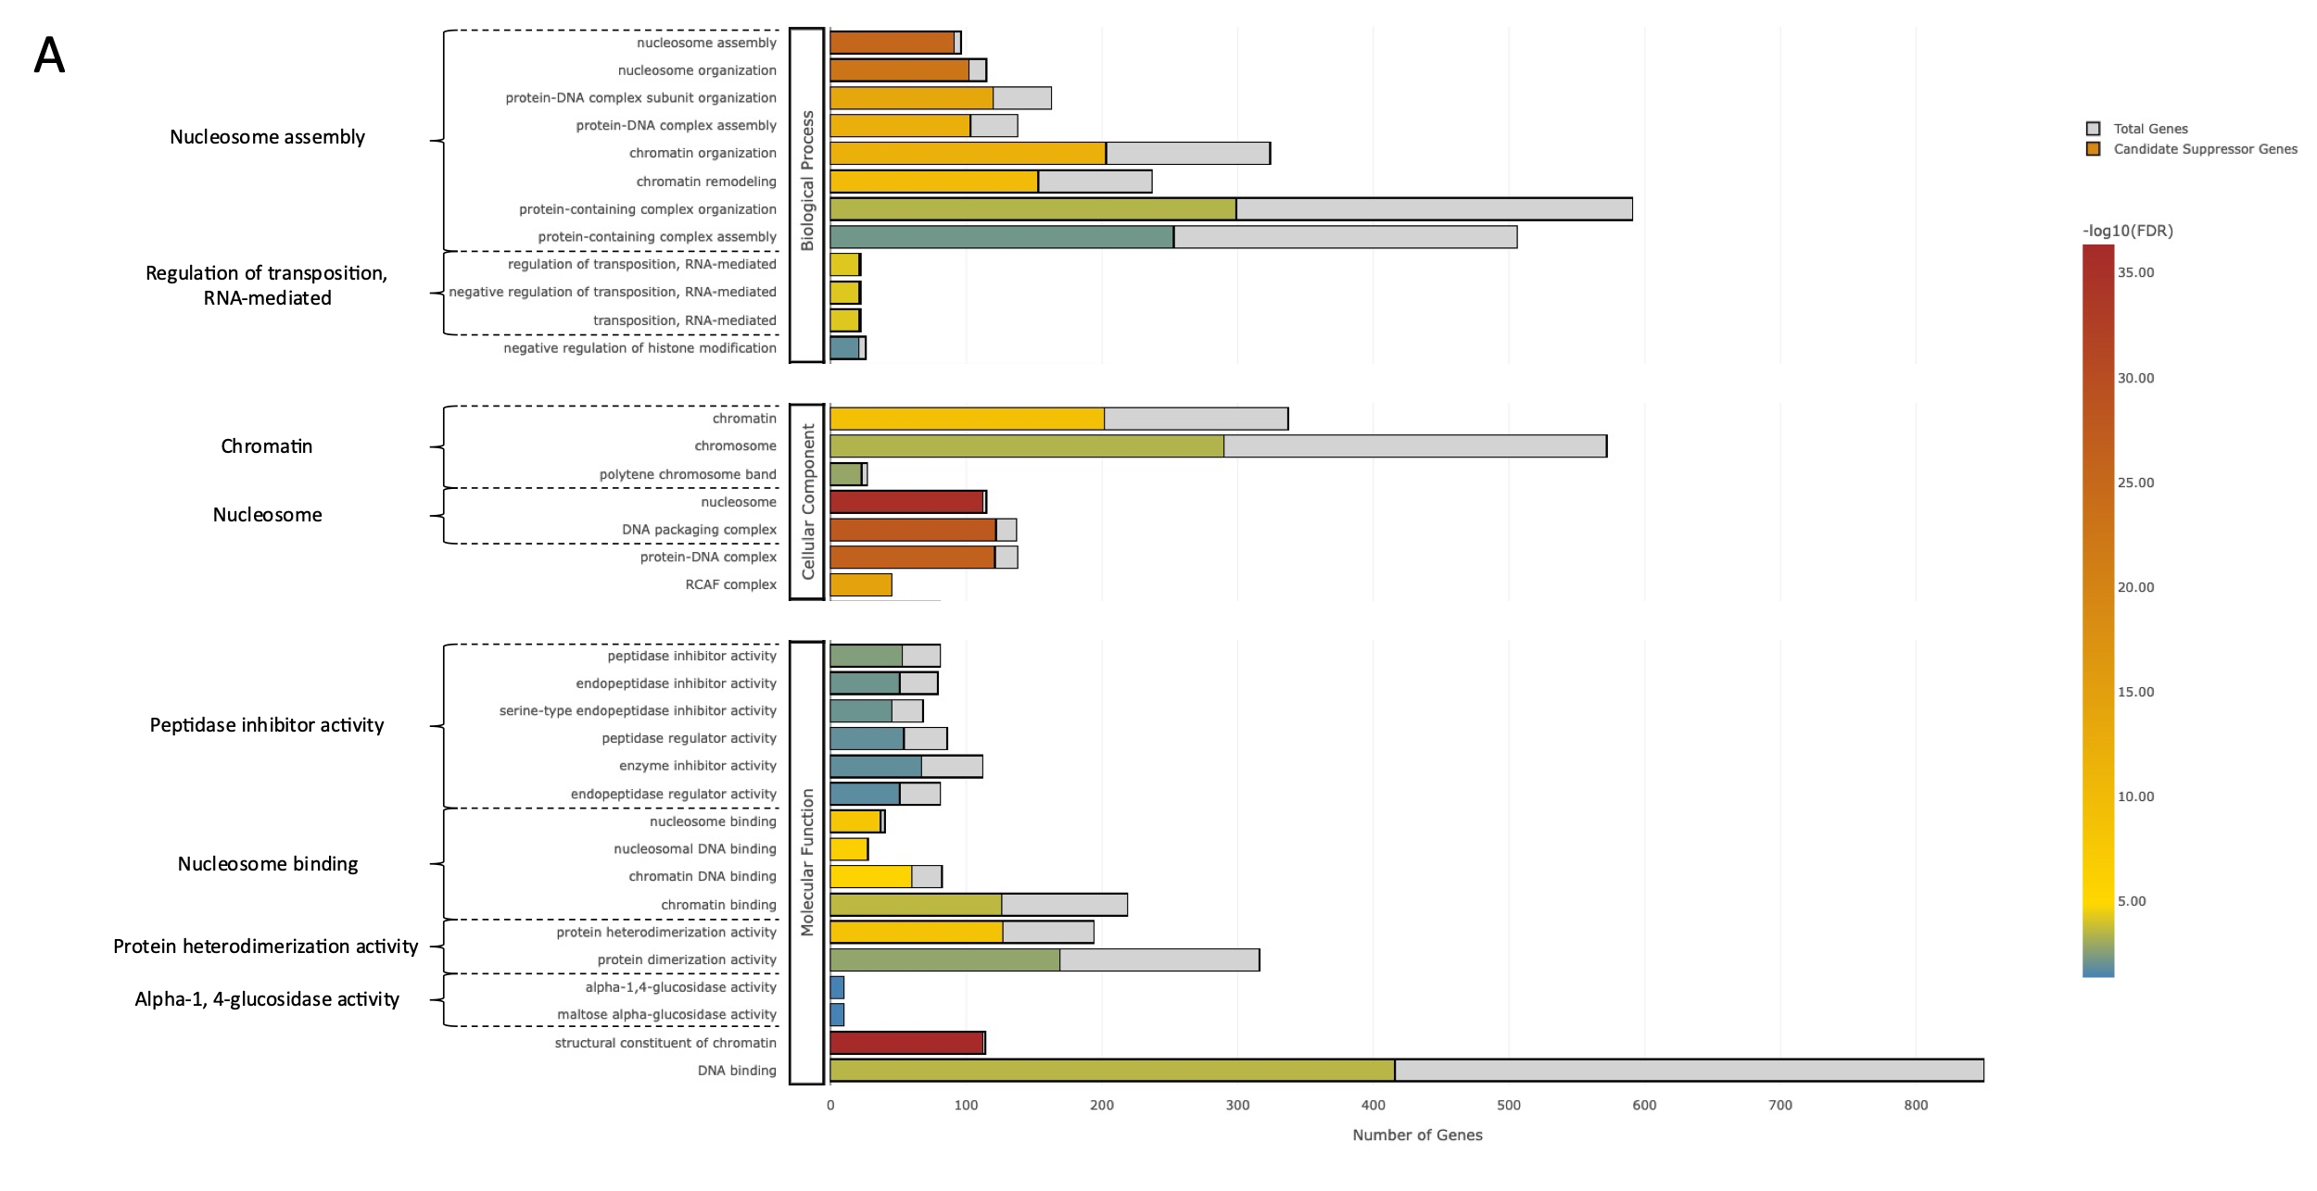

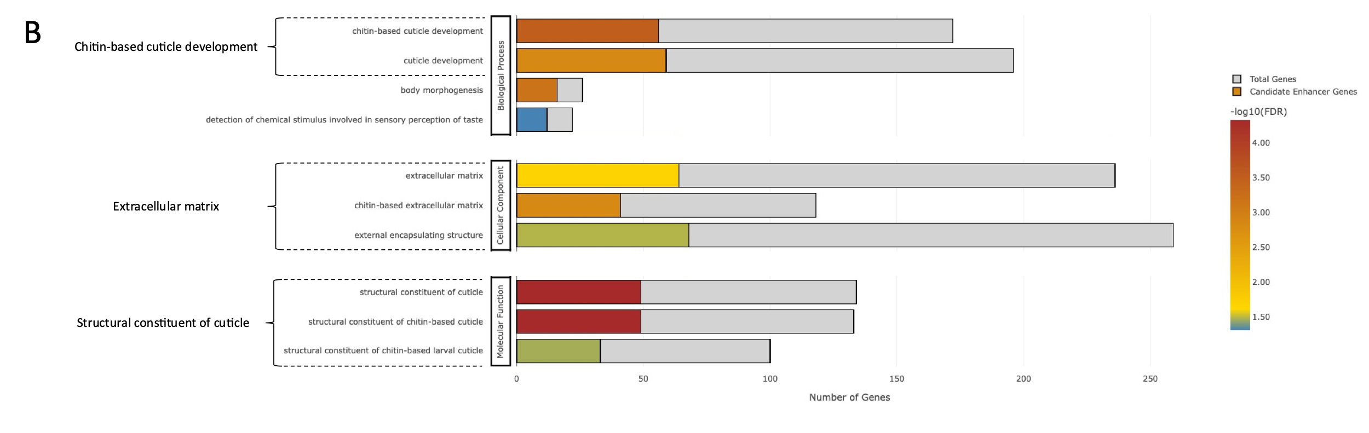

**Figure X. GO term enrichment for deficiency associated genes.** The R package GOseq [1]was used to perform a hypergeometric test for gene ontology term enrichment in candidate suppressor (A) and enhancer (B) gene sets. Significantly overrepresented terms are segregated by ontology with the total number of deficiency associated genes displayed in grey and the total number of candidate genes colored according to significance (-log10(FDR)). Within an ontology, overrepresented terms were grouped by parent terms which were determined by hierarchal clustering of semantic similarity scores between terms using the R package rrvgo [2]. A Benjamini-Hochberg FDR adjusted p-value (adj. p-value < 0.05) was used for determining significantly enriched terms.

**References**

1. Young, M.D., et al., Gene ontology analysis for 1045 RNA-seq: accounting for selection bias. Genome Biol, 2010. 11(2): p. R14.
2. Sayols, S (2023). rrvgo: a Bioconductor package for interpreting lists of Gene Ontology terms. microPublication Biology. 10.17912/micropub.biology.000811