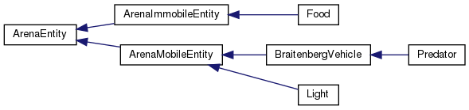
Basic Inheritance for ArenaEntities:

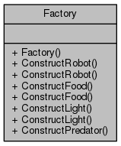

Factories can create any ArenaEntity. The reason there are two different methods for each type of construction is because one constructs an entity from a passed in JSON file and the other constructs an entity with ‘default’ values. These are mostly used as predator disguises.

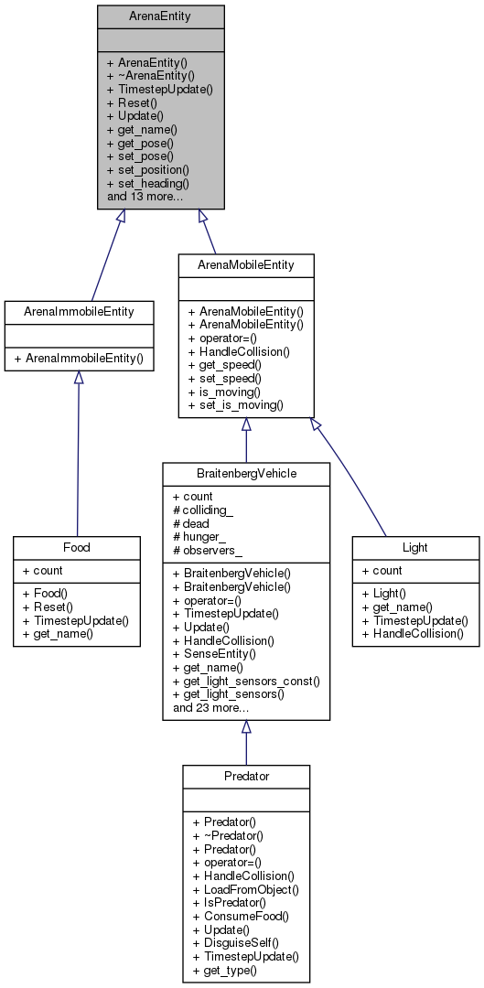
Detailed Inheritance for ArenaEntities:
Has-A relationship with Behavior class (see page 3)

ArenaEntity classes ‘Have-A’ observer (see page 4)
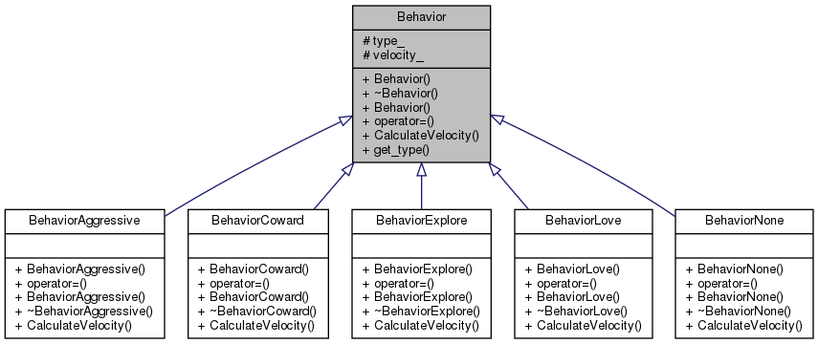
Braitenberg vehicles ‘Have-A’ Behavior
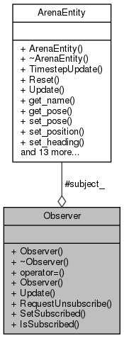
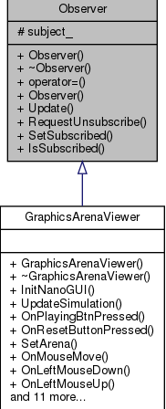
ArenaEntities “Have-A” Observer
GraphicsArenaViewer inherits from Observer

