(Logo of the Organization)
{Name_of_Organization}
GENERAL PLAN OF ACTION
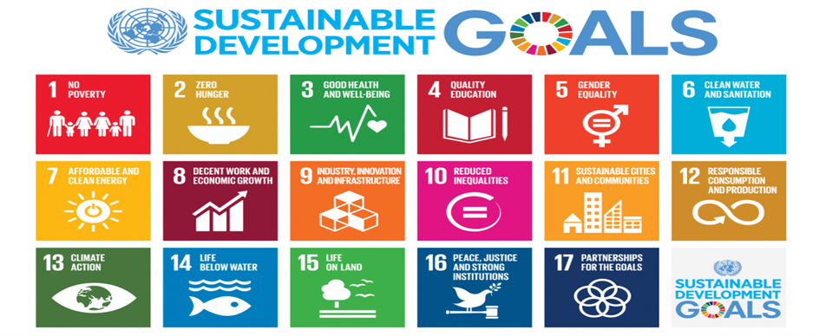
CURRICULAR ACTIVITY
SDAO APPROVED BUDGET AY 2024-2025 - (please write the amount)
# | Name of Event | Objective/Purpose | # of Sustainable Goal Development | Tentative Date (Month/Day/Year) | Proposed Budget | Person-in-charge | Remarks
{#Curricular}
{No} | {Name of Event} | {Objective/Purpose} | {No of Sustainable Goal Development} | {Tentative Date (Month/Day/Year)} | {Proposed Budget} | {Person in charge} | {Remarks}
{/Curricular}
CO-CURRICULAR ACTIVITY
# | Name of Event | Objective/Purpose | # of Sustainable Goal Development | Tentative Date (Month/Day/Year) | Proposed Budget | Person-in-charge | Location/ Remarks
{#Co-Curricular}
{No} | {Name of Event} | {Objective/Purpose} | {No of Sustainable Goal Development} | {Tentative Date (Month/Day/Year)} | {Proposed Budget} | {Person in charge} | {Location/Remarks}
{/Co-Curricular}
EXTRA-CURRICULAR ACTIVITY
# | Name of Event | Objective/Purpose | # of Sustainable Goal Development | Tentative Date (Month/Day/Year) | Proposed Budget | Person-in-charge | Location/ Remarks
{#Extra-Curricular}
{No} | {Name of Event} | {Objective/Purpose} | {No of Sustainable Goal Development} | {Tentative Date (Month/Day/Year)} | {Proposed Budget} | {Person in charge} | {Location/Remarks}
{/Extra-Curricular}

PREPARED BY: NOTED BY:
{RSO_President} {RSO_Adviser}
PRESIDENT ADVISER
APPROVED BY:
{College_Dean}
COLLEGE DEAN

