KaAyos: A WEB-BASED SERVICE PROVIDING SYSTEM WITH AI ASSISTED MATCHING AND GEOSPATIAL CLUSTERING

Aeron Marc M. Salanguit
Jan Emmanuel M. Formentos
John Dave A. Briones
Bachelor of Science in Information Technology
2026
KaAyos: A WEB-BASED SERVICE PROVIDING SYSTEM WITH AI ASSISTED MATCHING AND GEOSPATIAL CLUSTERING
A Capstone Project
presented to
The Faculty Committee of the College of Informatics and Computing Sciences
Batangas State University
The National Engineering University
ARASOF – Nasugbu Campus
In partial fulfillment
of the requirements of the degree
Bachelor of Science in Information Technology
Business Analytics Track

By
Aeron Marc M. Salanguit
Jan Emmanuel M. Formentos
John Dave A. Briones
2026
TABLE OF CONTENTS
CHAPTER I: THE PROBLEM AND ITS BACKGROUND ...…………………. 1
Introduction …………………………………………………………………… 1
Background of the Study ……………………………………..…………. 6
Statement of Objectives ………………………………………………………. 9
Significance of the Study ……………………………………………………. 11
Scope and Limitations of the Study …………………………………………. 13
CHAPTER II: RELATED LITERATURES ………...…………………………..19
Conceptual Literature ……………………………………………………….. 19
Research Literature ………………………………………………………….. 25
Technical Background ………………………………………………………. 32
Theoretical Framework ……………………………………………………… 37
Conceptual Framework ……………………………………………………… 40
Synthesis…………………………………………………………………….. 43
CHAPTER III: DESIGN AND METHODOLOGY ……………………………. 47
Research Design …………………………………………………………….. 47
Development Process ………………………………………………………... 52
Testing Phase …………………………………………………………….. 52
Debugging Phase ………………………………………………………… 53
Validation Phase ...……………………………………………………….. 55
Programming Procedure …………………………………………………….. 57
Software and Hardware Needed in the Development ……………………….. 76
Software Requirements …………………………………………………... 76
Hardware Requirements …………………………………………………. 79
Instrumentation ……………………………………………………………… 81
Preparation and Evaluation ………………………………………………….. 86
Ethical Consideration ………………………………………………………... 90
References …………………………………………………………………….. 92

LIST OF TABLES
Table Page
I Software Requirements Needed in Development ………………..………… 77
II Hardware Needed in the Development …………………………………….. 80
III System Functionality Evaluation Criteria for KaAyos …………………….. 88
IV Performance Rating Scale for KaAyos …………………………………….. 89

LIST OF FIGURES
Figure Page
1 Two-Sided Platform Theory …………………………………………………. 37
2 Conceptual Framework …………………………………………………...….. 40
3 Agile Development Method ……………………………………………...…... 49
4 System Architecture Diagram ……………………………………………...… 57
5 Requirements Analysis ……………………………………………………..... 60
6 Use Case Diagram ………………………………………………………...…. 63
7 Context Diagram …………………………………………………………….. 66
8 Diagram 0 .………………………………………………….………………... 69
9 Entity-Relationship Diagram ……………………………………………….... 73
CHAPTER I
THE PROBLEM AND ITS BACKGROUND
INTRODUCTION
The occurrence of urgent home maintenance issues, such as a burst pipe flooding a kitchen, illustrates a common challenge faced by many Filipino households. In such situations, the immediate need for assistance is often met with inefficient and time-consuming processes, where homeowners resort to browsing social media platforms or relying on delayed peer recommendations to locate reliable service providers. This delay not only exacerbates property damage but also highlights a fundamental disparity within the local digital ecosystem. While sectors such as transportation and food delivery have been transformed through integrated, on-demand digital platforms, the home services sector remains largely dependent on informal, word-of-mouth systems that are inherently inconsistent and unreliable. Consequently, this lack of a centralized and trustworthy digital marketplace creates a significant digital service gap, limiting both the efficiency of service access for homeowners and the economic opportunities available to skilled workers within the community [1].
Digital Service Gap becomes even more evident when considered alongside the Philippines’ rapidly expanding digital infrastructure. The country recorded a 73.6% internet penetration rate with approximately 86.98 million internet users as of early 2024, while 99.3% of the population has access to mobile cellular connections [2]. These figures demonstrate that the technological environment necessary to support digital service platforms already exists. However, despite this widespread connectivity, the home services market in the Philippines remains largely informal and fragmented. Industry analyses indicate that the Philippine online on-demand home services market represents only a small portion of its potential, suggesting that many opportunities remain untapped as consumers increasingly look for digital solutions to everyday household needs [3]. Globally, the home services market is projected to grow by approximately $1.02 trillion between 2024 and 2029, with a compound annual growth rate of 10.5% [4]. This projected expansion highlights the growing demand for digital platforms capable of effectively connecting service providers with customers.
The increasing demand for digital service platforms is closely related to the expansion of the gig economy. In many parts of the world, digital platforms have reshaped traditional labor markets by enabling individuals to offer services through technology-mediated systems. The Philippines has become one of the most active participants in this transformation. Approximately 9.9 million Filipinos are engaged in gig-based work, representing around 22% of the country’s employed population [5]. Many workers are attracted to this form of employment due to its flexibility and income potential. Surveys indicate that about 78% of gig workers report satisfaction with the flexibility offered by gig work, while 61% participate on a part-time basis to supplement their primary income [6]. Despite these benefits, the rapid expansion of platform-based employment has also revealed structural concerns, including limited worker protections, insufficient social safety nets, and concerns regarding fair compensation practices [7]. These challenges emphasize the importance of designing digital platforms that not only improve efficiency but also ensure fairness and sustainability for workers.
Within this broader gig economy landscape, the home services sector presents a unique set of challenges that differentiate it from other platform-based industries such as transportation or food delivery. Unlike standardized delivery tasks, home services often require specialized skills, tools, and direct interaction within private residential environments [8]. Because these services take place inside homes, issues of trust, safety, and professional credibility become particularly important. Homeowners must feel confident that the workers they invite into their homes possess the appropriate qualifications and adhere to professional standards. At the same time, service providers must be assured that the systems connecting them with clients offer fair opportunities, reliable payment arrangements, and protection from disputes or unsafe working conditions.
Despite the need for such safeguards, the current methods used to connect homeowners with service providers in the Philippines remain largely informal. Many individuals still rely on word-of-mouth recommendations, neighborhood referrals, local bulletin boards, or social media groups to locate service providers [9]. Although these methods sometimes produce satisfactory results, they often restrict service discovery to small personal networks and provide little assurance regarding worker qualifications or service reliability. Furthermore, the absence of standardized verification procedures, consistent rating systems, and effective dispute resolution mechanisms creates uncertainty for both parties involved in the transaction. Service providers also face significant challenges in marketing their services to a broader audience, building professional reputations, and securing consistent employment opportunities. As a result, the home services sector frequently experiences problems associated with information asymmetry, high transaction costs, lack of service standardization, and geographic mismatches between service providers and customers [10]. These inefficiencies ultimately prevent the market from operating in a coordinated and efficient manner.
Addressing these persistent inefficiencies requires the development of a dedicated digital platform tailored to the needs of the home services sector. In response, this study introduces KaAyos, a web-based platform designed to streamline the process of connecting homeowners with skilled service providers. The system integrates key functionalities such as worker verification, AI-assisted matching, geolocation-based recommendations, real-time communication, and user feedback mechanisms to improve both service accessibility and transaction reliability. By leveraging modern web technologies, including Laravel, MySQL, and responsive web interfaces, the platform aims to deliver a secure, scalable, and user-friendly environment. Ultimately, KaAyos seeks to enhance service coordination, reduce transaction inefficiencies, and create a more structured and trustworthy digital ecosystem for home services within the local community.
The development of the KaAyos platform is guided by established theoretical frameworks related to platform-based interactions, particularly Two-Sided Platform Theory, which explains how digital platforms facilitate value exchange between two distinct user groups in this case, homeowners and service providers. Guided by this framework, the KaAyos system incorporates key features tailored to the Philippine context, including worker verification modules, AI-assisted matching supported by geospatial clustering, transparent pricing mechanisms, and integrated communication tools. Through these features, the platform aims to create a trustworthy digital ecosystem that enhances convenience for homeowners while supporting fair opportunities and sustainable livelihoods for skilled service providers.
BACKGROUND OF THE STUDY
The global rise of digital platforms has fundamentally transformed traditional service industries, creating unprecedented opportunities for economic participation while simultaneously presenting challenges related to worker protection, quality assurance, and equitable access. The gig economy, characterized by short-term contracts and freelance work mediated through digital platforms, has grown substantially over the past decade. The World Bank estimates that the gig economy could account for up to 12% of the global labor market, with particular promise in developing countries where traditional employment opportunities may be limited [11]. This trend is equally pronounced in the Philippines, where platform-based work offers alternative employment pathways for workers seeking flexible income opportunities.
In the Philippines, the gig economy has expanded rapidly, driven by high smartphone penetration rates, increasing internet accessibility, and economic pressures that push workers toward alternative income sources. The Philippine Statistics Authority reports that approximately 1.7 million Filipinos are employed through online platforms or mobile applications, primarily in the ride-hailing, food delivery, and courier service sectors [12]. These platform-based roles have become especially prominent in urban areas, where demand for quick and efficient services remains high. Studies consistently indicate that flexibility and income potential serve as primary motivators for platform participation, while concerns regarding social protection, safety, and fair compensation represent significant challenges faced by Filipino gig workers [13].
The home services sector presents unique characteristics that differentiate it from transportation and delivery platforms. Unlike standardized delivery tasks, home services require varying levels of skill, specialized equipment, and direct interaction within private residential spaces. These factors elevate the importance of trust, verification, and quality assurance mechanisms in platform design. Homeowners must feel confident that invited workers possess the necessary qualifications, maintain professional standards, and respect property and privacy. Similarly, workers require protection against unfair treatment, payment disputes, and safety risks associated with entering unfamiliar environments.
Tuy, Batangas, represents a particularly relevant context for examining home service platform implementation. As a first-class municipality with a growing population and developing urban infrastructure, Tuy exhibits characteristics common to many Philippine provincial centers: a mix of established residential communities and new developments, a diverse population including both long-term residents and recent migrants, and an economy that supports both formal employment and informal service work. The municipality's proximity to Metro Manila and its status as a tourist destination further contribute to demand for quality home services among both permanent residents and property owners maintaining vacation homes.
The Public Employment Service Office (PESO) of Tuy serves as the cooperating agency for this study, providing valuable insights into local labor market conditions and facilitating connections with potential platform users. PESO's involvement underscores the platform's potential to contribute to local employment generation and economic development goals, aligning with national initiatives to support micro-entrepreneurs and informal sector workers.
Current methods of connecting homeowners with service providers in Tuy rely heavily on informal networks, word-of-mouth recommendations, and traditional advertising channels such as local bulletin boards and social media groups. These approaches suffer from several limitations: limited reach beyond immediate social circles, lack of standardized verification procedures, absence of reliable rating systems, and difficulties in dispute resolution when services fail to meet expectations. Workers, in turn, face challenges in marketing their services broadly, establishing professional credibility, and accessing a consistent stream of job opportunities.
The KaAyos platform addresses these gaps by providing a dedicated digital infrastructure for home service transactions. Built on the Laravel PHP framework with MySQL database support, the platform incorporates features specifically designed for the home services context: comprehensive worker verification requiring valid identification and clearances, AI-powered matching algorithms that consider proximity, skills, and reputation, transparent pricing and quotation systems, real-time booking with SMS notifications, in-app messaging for direct communication, and structured rating and review mechanisms that support accountability while protecting against unfair feedback.
STATEMENT OF THE OBJECTIVE
The main objective of the study is to develop KaAyos, a web-based home service platform that integrates modern web technologies and intelligent matching mechanisms to improve coordination between homeowners and skilled service providers in Tuy, Batangas. The system aims to provide a reliable, efficient, and localized solution for service discovery, communication, and transaction support.
Specifically, the study aims to:
- To identify and design the key features to be incorporated in the system to effectively address the challenges encountered by homeowners and service providers in terms of service discovery, worker verification, and quality assurance.
- To develop and integrate intelligent system components, specifically:
2.1. AI-assisted worker matching to recommend suitable service providers based on user needs; and
2.2. Geospatial clustering to optimize service coordination based on location and worker availability.
- To implement trust-building mechanisms within the platform, including:
3.1. Worker verification processes;
3.2. Rating and review system; and
3.3. Transparent service information and pricing.
- To evaluate the developed system in terms of:
4.1. Functionality and correctness of integrated platform features; and
4.2. Overall system performance in meeting the technical requirements for home service coordination.

SIGNIFICANCE OF THE STUDY
The development and implementation of the KaAyos platform is a technology-driven solution designed to improve the accessibility and reliability of home services in Tuy, Batangas. The system aims to address challenges in connecting homeowners with skilled service providers through a structured, secure, and efficient digital platform. This study is expected to benefit several stakeholders, including homeowners, service providers, organizations, researchers, and policymakers.
Homeowners and Households. The platform will provide homeowners with a reliable way to find verified service providers for home maintenance and improvement tasks. Through features such as worker verification, rating systems, and structured communication, users can reduce the risks associated with hiring unknown workers. It also offers convenience through easy access to skilled professionals, transparent service information, and improved decision-making when selecting providers.
Independent Home Service Providers. Service providers will benefit from increased visibility and access to job opportunities through the platform. KaAyos enables workers to build their professional reputation, manage their profiles, and communicate directly with clients. By reducing dependence on informal job sourcing methods, the system supports income stability and encourages professional growth among skilled workers.
Property Managers and Small Business Owners. The platform will serve as a reliable resource for managing property maintenance and service needs. With standardized service categories, clearer coordination, and access to verified workers, users can streamline maintenance processes and reduce the time and effort required to manage repairs and related services.
Public Employment Service Office (PESO) Tuy. The system will support PESO’s objective of promoting employment and local economic development. By facilitating connections between workers and clients, the platform contributes to job creation, skill utilization, and the formalization of service-based work within the community.
Researchers and Information Technology Practitioners. This study will provide a practical reference for the development of similar platforms that integrate modern web technologies. It demonstrates how tools such as Laravel, MySQL, geolocation services, and real-time communication can be combined to address real-world problems. The study also contributes to existing knowledge on technology adoption and digital platform design.
Policymakers and Development Organizations. The findings of this study offer insights into the implementation of digital platforms in local communities. It can support decision-making related to digitalization, gig economy regulation, worker protection, and programs that promote digital literacy and micro-enterprise development.
This study is significant as it introduces a structured and technology-based approach to improving service accessibility and employment opportunities. It contributes to both practical solutions for local communities and broader discussions on digital transformation and economic development.
SCOPE AND LIMITATION OF THE STUDY
The KaAyos platform is a web-based system developed to facilitate connections between homeowners and skilled service providers in Tuy, Batangas, Philippines. The study focuses on the design, and evaluation of the platform within the municipality’s 42 barangays, covering both urban and rural communities. This localized scope allows the system to address geographic, economic, and cultural factors that influence the demand and delivery of home services in the area.
The platform includes several core features designed to support efficient service matching and interaction. These include a worker verification module requiring valid identification and clearances, an AI-powered chatbot and worker suggestion system that recommends service providers based on proximity, reputation, and skills, and geospatial clustering to identify areas with high worker availability. Additional features include a rating and review system for service feedback, in-app chat messaging for real-time communication, and a dedicated worker portal for managing profiles, portfolios, and earnings.
The system is intended to serve multiple user groups, including homeowners seeking maintenance and repair services, independent service providers offering skilled labor, property managers and small business owners, and the Public Employment Service Office (PESO) Tuy as a cooperating agency. It supports the full service transaction lifecycle, from initial search and matching to booking, service completion, and feedback submission.
From a technical perspective, the platform is developed using the Laravel PHP framework, MySQL database, and standard web technologies such as HTML, CSS, and JavaScript. It follows the Model-View-Controller (MVC) architecture and utilizes RESTful APIs to support a responsive web interface accessible across devices.
Despite its contributions, the study is subject to certain limitations. The geographic focus on Tuy limits the generalizability of the findings to other areas with different conditions. Additionally, access to the platform depends on the availability of internet connectivity and digital devices, which may restrict usability for some users, particularly in remote barangays.
The platform’s verification process is limited to document-based validation and does not include comprehensive background checks or skills assessments, requiring users to exercise personal judgment when selecting service providers. Financial transactions are also not fully integrated within the system, as payment arrangements may occur outside the platform, limiting monitoring and control.
Furthermore, the platform primarily supports common home maintenance services such as cleaning, plumbing, electrical work, and carpentry, while highly specialized services may not be fully accommodated. The evaluation period of the study is also limited, preventing a thorough assessment of long-term user behavior, platform sustainability, and broader economic impact.
DEFINITION OF TERMS
To ensure clarity and consistency, the following terms are used in this paper:
Artificial Intelligence (AI) Chatbot. This term refers to a software application that uses natural language processing and machine learning techniques to simulate human conversation, providing automated responses to user inquiries and assistance with platform navigation and service selection.
Geolocation API. This term refers to a web browser interface that provides access to geographic location information, enabling applications to determine the user's physical location for purposes such as proximity matching and service area mapping.
Geospatial Clustering. This term refers to a computational technique that groups geographic data points based on spatial proximity, used in this platform to identify high-density areas of service provider availability and optimize matching algorithms.
Gig. This term refers to a short-term, task-based job or service performed on a temporary or on-demand basis, typically without long-term employment commitment.
Gig Economy. This term refers to a labor market characterized by short-term contracts, freelance work, and temporary positions, typically mediated through digital platforms that connect service providers with clients on a task-by-task basis.
Home Service Platform. This term refers to a digital marketplace specifically designed to facilitate transactions between homeowners seeking maintenance, repair, or improvement services and skilled workers capable of providing such services within residential settings.
Information Asymmetry. This term refers to an economic concept describing situations where one party in a transaction possesses more or better information than the other, leading to market inefficiencies and potential exploitation.
Laravel. This term refers to an open-source PHP web application framework that follows the Model-View-Controller architectural pattern, providing tools and resources for building robust, secure, and maintainable web applications.
Micro-entrepreneur. This term refers to an individual who operates a small-scale business, often as a sole proprietor, providing specialized services or products with limited capital investment and workforce.
Model-View-Controller (MVC). This term refers to a software architectural pattern that separates application logic into three interconnected components: the Model (data and business rules), the View (user interface), and the Controller (input handling and coordination).
MySQL. This term refers to an open-source relational database management system that uses Structured Query Language for data management, providing robust storage, retrieval, and manipulation capabilities for structured data.
Public Employment Service Office (PESO). This term refers to a non-fee charging multi-employment service facility established by the Department of Labor and Employment to provide employment assistance to Filipino job seekers.
Rating and Review System. This term refers to a platform feature that enables users to provide quantitative ratings and qualitative feedback on service transactions, contributing to reputation building and quality assurance within the marketplace.
Service Provider. This term refers to an individual or business entity registered on the KaAyos platform that offers skilled services to homeowners, including but not limited to cleaning, plumbing, electrical work, carpentry, and related home maintenance activities.
Transaction Costs. This term refers to the costs associated with making an economic exchange, including search and information costs, bargaining and decision costs, and policing and enforcement costs.
Two-Sided Platform. This term refers to a business model that facilitates interactions between two distinct user groups (in this case, homeowners and service providers) whose participation generates value for each other through cross-group network effects.
WebSocket. This term refers to a communication protocol that provides full-duplex communication channels over a single TCP connection, enabling real-time bidirectional data exchange between web clients and servers.
Worker Verification. This term refers to the process of confirming the identity, credentials, and background of service providers through document submission and validation procedures, designed to enhance trust and safety within the platform.
CHAPTER II
REVIEW OF RELATED LITERATURES AND STUDIES
In this chapter, the relevant concepts and related literature that support the development of the current study are discussed thoroughly. This part is composed of six sections: conceptual literature, related studies from local and foreign sources, technical background, theoretical framework, conceptual framework, and synthesis.
CONCEPTUAL LITERATURE
The rapid expansion of the gig economy has significantly reshaped the global labor landscape, transforming the way services are produced, distributed, and consumed. Kadolkar, Subramony, and Kepes [14] present a quantitative review of algorithmic management, describing it as the use of programmed algorithms and artificial intelligence to partially or fully execute workforce management functions. This form of management operates across key dimensions such as monitoring, goal setting, scheduling, performance evaluation, and compensation. A central element of this system is algorithmic matching, which connects workers to customers within digital marketplaces. This concept is directly relevant to the present study, as KaAyos employs an intelligent matching mechanism that links homeowners and service providers based on proximity, skills, and reputation.
Expanding on this perspective, van Zoonen, Sivunen, and Treem [15] examined the algorithmic management of crowdworkers, focusing on its implications for workers' identity, belonging, and the meaningfulness of their work. Their research highlights how the automation of decision-making and control processes through advanced data processing shapes the worker's experience on the platform. These insights are particularly significant for the present study’s rating and review system, which seeks to maintain accountability while ensuring a fair and meaningful representation of service providers.
The theory of two-sided platforms provides an essential theoretical foundation for understanding digital marketplaces. According to Peitz [16], platforms function as intermediaries that facilitate interactions between distinct user groups whose benefits depend on each other’s participation. In such environments, cross-group network effects emerge where increased participation from one side enhances value for the other. This framework is central to the KaAyos platform, which must effectively balance the needs of homeowners seeking reliable services and providers searching for sustainable work opportunities.
Chang and Park [17] demonstrated that AI-powered recommendation systems significantly influence consumer decision-making by narrowing options based on personal preferences and contextual information. Their findings suggest that personalized recommendations not only enhance user experience but also increase transaction success rates. This supports the integration of an AI-driven chatbot and intelligent worker suggestion feature within the KaAyos platform.
Trust-building mechanisms are equally fundamental in digital environments. Teng, Wu, and Song [18] found that the perceived quality of AI chatbot services strongly influences consumers’ purchase intentions. Trust develops when AI systems consistently deliver accurate information, operate transparently, and are designed to assist the user effectively. These findings inform the present study’s approach to strengthening trust through the integration of an AI-powered chatbot that guides homeowners in selecting verified workers.
Online reviews and ratings further shape consumer behavior in digital marketplaces. Rachmiani, Oktadinna, and Fauzan [19] evaluated the impact of online reviews and ratings on consumer purchasing decisions within e-commerce platforms. Their study revealed that positive, credible reviews significantly increase consumer trust and serve as powerful quality signals. Such findings confirm that ratings and reviews function as social proof in online transactions, reinforcing the importance of a credible and balanced feedback system in the KaAyos platform.
The growing emphasis on trust networks has also led to increased attention toward identity verification systems. Emerging trends in digital identity verification emphasize that brands reliant on online transactions must prioritize identity confidence [20]. Digital referral systems and reputation histories enhance safety and transparency, directly supporting the worker verification module proposed in this study.
Within the Philippine context, the gig economy has expanded rapidly, offering both opportunities and structural challenges. Yumang [21], involving 406 Filipino gig workers, found high levels of satisfaction due to perceived career growth and income potential compared to traditional employment. However, workers also reported occupational health concerns and operational challenges. These findings provide important local context for the service providers targeted by KaAyos.
Duggan, Sherman, Carbery, and McDonnell [22] investigated algorithmic HRM control from the app-worker perspective, finding that while gig work offers flexibility, platform algorithms often dictate job allocation and income potential, creating an omnipresent control system. This highlights the need for platforms to balance operational efficiency with genuine worker autonomy.
Palada et al. [23] examined the gig economy’s implications for small businesses in the Philippines. While platforms offer reduced operational costs, access to diverse talent, and improved productivity, they also pose legal, financial, and quality control challenges. The authors recommend strengthening digital literacy, improving worker competencies, and implementing risk management systems recommendations aligned with KaAyos’ training and verification features.
Furthermore, Yamano et al. [24] analyzed the experiences of platform drivers in the Philippines, noting that while many workers value the flexible work hours and the ability to earn supplemental income, they also face significant safety risks and lack adequate social protections. These findings underscore the importance of integrating protective measures into the KaAyos platform design.
Fairwork Philippines [25] evaluated major ride-hailing and delivery platforms and found deficiencies in fair pay and worker representation. The researchers advocated for inclusive legal frameworks, living wages after operational costs, mandated social protection benefits, and compensation coverage for work-related injuries. These recommendations strengthen the present study’s commitment to ethical and worker-centered platform practices.
At the policy and operational level, Reyes and Reyes [26] conducted a qualitative analysis of digital innovation readiness among Philippine Micro, Small, and Medium Enterprises (MSMEs). Their study highlighted that while digital tools present immense opportunities for economic competitiveness, many local enterprises face technical and financial challenges in adopting them. This provides strong institutional support for accessible, user-friendly platforms like KaAyos that lower the barrier to entry for local service providers.
However, structural vulnerabilities persist. Gonzales and Campos [27] critically analyzed the ethical implications of boundaryless careers in the gig economy. They found that many platform workers experience financial precarity, algorithmic control, and vulnerability due to the lack of traditional employment safeguards. These findings reinforce the need for fair compensation models, transparent matching, and ethical platform governance within KaAyos.
Online reviews serve as a form of digital social proof that reduces uncertainty in online transactions by providing peer-generated evaluations of products and services. In digital marketplaces, consumers often rely on reviews to assess credibility, service quality, and trustworthiness before making purchase decisions. This conceptual understanding is supported by recent Philippine-based research, which found that Filipino consumers significantly depend on online reviews when deciding to purchase products through e-commerce platforms [28]. The study demonstrated that review credibility and perceived usefulness directly influence consumer trust and purchasing intention. These findings reinforce the conceptual premise that transparent rating and review systems function as trust-building mechanisms in digital platforms, which is essential in the design of service-matching systems such as KaAyos.
RESEARCH LITERATURE
This section presents a compilation of research findings that are relevant to the present study. It includes selected studies that provide support and background for the development of the research.
Duggan et al. [22] examined algorithmic HRM control in the gig economy through the lived experiences of app-based workers. Drawing on in-depth interviews with food-delivery and rideshare workers, their study proposed the concept of “algorithmic HRM control” an omnipresent control system shaped not only by the platform organization but also by non-organizational actors such as customers and suppliers. A central finding was that customer ratings function as performance indicators that determine future work allocation and rewards, yet workers have limited capacity to contest or explain individual scores. This study is particularly relevant to the present research, as it underscores the need for fair, transparent, and balanced rating mechanisms that protect both homeowners and service providers within the KaAyos platform.
Akamatsu and Oyama [29] proposed a market-based matching mechanism for crowdsourced delivery systems that accounts for supply and demand elasticities. Their research formulated a large-scale two-sided matching problem that incorporates heterogeneous preferences of both service providers and clients. The model achieved globally efficient matching between task bundles and drivers while substantially reducing computational requirements. These methodological contributions provide valuable insights for the present study’s geospatial clustering and intelligent worker matching algorithms.
Feng, Gallego, and Lobel [30] investigated optimal match recommendations in two-sided marketplaces with endogenous prices. Their work explored how algorithmic recommender systems can effectively match user queries with available service options, highlighting how structured algorithmic ranking shapes market behavior and overall platform efficiency. This research directly informs the present study’s intelligent recommendation system, which balances proximity, reputation, and skill compatibility when suggesting service providers to homeowners.
Nowak [31] examined the transformation of informal home care through digital platforms, focusing on ethical considerations and the organization of care work. The study emphasized the tension between platform efficiency and the relational, trust-based nature of care services. It argued that platform designs must preserve worker autonomy and service quality while leveraging digital coordination tools. These insights are particularly important for home service platforms like KaAyos, where trust, safety, and personal interaction are essential.
Ruan and Mezei [32] investigated the conditions under which AI chatbots outperform human frontline employees in online service environments. Their findings indicate that AI chatbots are more effective for search-based products, where objective attributes guide decision-making, whereas human agents are preferred for experience-based services requiring subjective evaluation. The study suggests that AI effectiveness depends on the nature of the service provided. This informs the present study’s hybrid approach, integrating AI chatbot assistance while maintaining access to human customer support when necessary.
McDonald et al. [33] analyzed income generation within digital care labor platforms, focusing on how algorithmic design affects worker earnings and job stability. Their findings revealed that platform algorithms significantly determine access to job opportunities and income consistency. The authors recommended structural adjustments to ensure equitable task distribution and transparent compensation systems. These findings guide the present study’s emphasis on fair pricing structures and transparent matching logic.
Katyal and Sehgal [34] examined the influence of online consumer reviews on purchasing behavior. Their study found that review credibility, quality, and perceived helpfulness significantly shape consumer decisions, especially for services characterized by high experiential value. The research reinforces the importance of a structured, credible rating and review system within digital marketplaces, directly supporting the design considerations of the present study.
Yamano et al. [24], through the Asian Development Bank, examined gig employment conditions during the pandemic, focusing on GrabFood drivers in the Philippines. Surveying 1,200 drivers across Metro Manila, Cebu, and Davao, the study found that flexible schedules, average weekly earnings of approximately ₱5,699, and independent working conditions contributed to positive job perceptions. However, safety concerns were notable, with roughly one-third of drivers reporting accidents within a 12-month period. This study provides essential local context for understanding the needs and vulnerabilities of Filipino service providers.
Recent evaluations of platform labor conditions in the Philippines reveal persistent concerns regarding worker safety, fair compensation, and income stability. Caboverde and Flaminiano [35] explored the lived experiences of gig economy workers in the Philippines, emphasizing the urgent need to "future-proof" this sector through stronger accountability mechanisms, government regulation, and improved welfare protections. These findings highlight the importance of integrating verification systems and protective features within localized digital service platforms.
Addressing these local vulnerabilities, Yamano et al. [24] provided empirical analysis on gig worker experiences in the Philippines during economic shifts. The study demonstrated that while platform work acts as a crucial driver for local economies by providing immediate income generation, the absence of robust health and safety nets leaves workers exposed to operational risks. This reinforces the practical necessity of designing support mechanisms that enhance service provider welfare within the KaAyos ecosystem.
Cordova et al. [36] examined how digital innovation influences entrepreneurial success among Philippine MSMEs, identifying cultural resistance, lack of technical expertise, and financial constraints as the three leading obstacles to digital adoption.While MSMEs are increasingly embracing social media marketing and digital payment systems, the study found that adoption of more advanced tools such as cloud computing and enterprise resource planning systems remains limited. The authors recommend policy interventions and capacity-building programs to lower barriers to digital adoption, emphasizing the need for affordable access to tools, targeted training, and stronger awareness of digital innovation’s impact on MSME performance. These findings inform the present study’s accessibility-focused design, ensuring that service providers with limited digital experience can effectively use the platform.
Reyes and Reyes [26] further emphasized the importance of digital readiness among local enterprises, analyzing the challenges and opportunities of digital innovation for Philippine MSMEs. Their findings indicate that while digital payment systems and online marketplaces are increasingly vital, targeted capacity-building is required to ensure users can fully leverage these tools. This suggests that secure, integrated, and easy-to-use digital interfaces are essential components of modern service marketplaces to ensure high adoption rates among local workers.
Tacadao et al. [37] examined the institutional challenges within the Philippine gig economy and proposed policy recommendations, finding that existing legal frameworks do not comprehensively address the unique needs and vulnerabilities of gig workers, with dispute resolution mechanisms typically available only to those in employer-employee relationships. Platforms must remain adaptable to these evolving regulatory developments.
Gonzales [38] examined the implementation of the Philippine digital national ID system and its implications for MSMEs. The study found that digital identity verification tools, such as National ID eVerify and National ID Check through the eGovPH application, enhance operational efficiency and transactional security. These developments directly support the present study’s verification module, strengthening trust and accountability between homeowners and service providers.
Dhiman et al. [39] developed and deployed a web-based service marketplace that connects customers with multiple service providers across different categories through a unified platform. Implemented using PHP, HTML, CSS, JavaScript, and a MySQL database managed through PhpMyAdmin, the system features a customer-facing front end for browsing services, booking appointments, and receiving email confirmations, alongside an admin panel for managing service categories, provider listings, and booking statuses in real time. The platform supports both on-demand and advance service scheduling, with OTP-based email verification during registration to ensure user authenticity. The researchers demonstrated that consolidating multiple service providers into a single platform simplifies the user experience and reduces the friction of managing separate applications for each service type. These findings are directly relevant to KaAyos, which similarly consolidates home service categories under a single platform and implements booking, verification, and feedback mechanisms to improve accessibility and trust between homeowners and service providers.
Finally, Rahman et al. [40] designed and implemented a fully functional web-based e-commerce system focused on the business-to-customer (B2C) model, built using the Django framework, MySQL database, and HTML/CSS for front-end development. The deployed system supports product browsing by category, user registration and login with validation, shopping cart management, multiple payment methods including card and mobile banking, order tracking, and a customer contact interface. The system was tested across multiple devices and confirmed to meet design requirements, with high reported customer satisfaction. The study highlighted that attractive UI design, fast page load times, and seamless payment integration are critical to e-commerce adoption, particularly in emerging markets with growing internet penetration. These insights inform the present study’s emphasis on accessible, responsive interface design and integrated digital payment functionality within the KaAyos platform, ensuring usability across varying levels of digital literacy and device availability.
TECHNICAL BACKGROUND
Laravel is an open-source PHP web application framework that follows the Model-View-Controller (MVC) architectural pattern. It serves as the primary full-stack framework of the KaAyos platform, providing a structured and expressive codebase for handling routing, middleware, request lifecycle management, Blade templating, and Eloquent ORM for database abstraction. Laravel’s built-in features including CSRF protection, input validation, authentication scaffolding, and session management significantly streamline the development of secure and maintainable web applications. Its Artisan command-line interface (CLI) further accelerates development by automating repetitive tasks such as migration generation, model creation, and seeding. The framework’s middleware system enables role-based access control between homeowners, service providers, and administrators, contributing to the overall security posture of the platform
MySQL is the relational database management system (RDBMS) utilized for the storage, organization, and retrieval of all persistent data within the KaAyos platform. It manages structured data including user accounts, service records, booking transactions, and worker profiles. MySQL provides robustness, maturity, and stability essential for web applications, with key features such as ACID compliance (Atomicity, Consistency, Isolation, Durability), solid data security layers, and fast-loading utilities with memory caching capabilities.
Web hosting is the foundational service that makes the KaAyos platform accessible to users through the internet. The platform is deployed on a shared or virtual private server (VPS) hosting environment configured with either Apache or Nginx as the web server, a PHP runtime compatible with the Laravel framework, and a MySQL database server for persistent data storage. Key considerations in the web hosting configuration include SSL/TLS certificate installation for HTTPS encryption, ensuring all data transmitted between users and the server is protected. Domain name configuration links the platform’s URL to the hosting server’s IP address, while DNS management ensures reliable global accessibility. File storage for user-uploaded documents, such as worker verification IDs, is managed through the server’s file system or integrated cloud storage with appropriate access restrictions. This standard hosting setup provides a cost-effective and accessible deployment approach suitable for the platform’s initial rollout serving the Tuy community.
Geolocation API provides the foundation for location-based services within the KaAyos platform. The Geolocation API offers capabilities for local search, maps and navigation, and location tracking [41]. For KaAyos, geolocation enables real-time tracking of worker availability, calculation of proximity between homeowners and service providers, and visualization of service coverage areas. The API supports geofencing functionality that can define virtual boundaries and trigger notifications when workers enter or exit designated service zones. The platform integrates mapping services to display worker locations, calculate optimal routes, and provide navigation assistance, enhancing the user experience by enabling homeowners to track service provider arrival times and allowing workers to navigate efficiently to service locations.
WebSocket technology is leveraged for the in-app chat messaging functionality, enabling real-time bidirectional communication between homeowners and service providers. WebSocket connections establish persistent, low-latency communication channels that are ideal for chat applications and real-time coordination tools. Laravel’s broadcasting capabilities, combined with tools such as Laravel Echo and Pusher or a self-hosted WebSocket server, support event-driven real-time features. This technology ensures immediate message delivery while maintaining low latency, which is essential for effective coordination between platform users [44].
HTML5 (Hypertext Markup Language 5) serves as the foundational markup language for structuring the web pages of the KaAyos platform. It defines the layout and semantic structure of all frontend components rendered through Laravel’s Blade templating engine, including service booking interfaces, worker profiles, dashboards, and user account pages. HTML5’s semantic elements improve accessibility and document readability, while its native support for form controls and input types facilitates client-side data entry and validation across the platform’s user-facing modules. The frontend delivers a responsive and user-friendly interface accessible across desktop and mobile browsers
CSS3 (Cascading Style Sheets 3) is used to control the visual presentation of the KaAyos platform’s web pages. It defines styles, animations, transitions, color schemes, and responsive layout rules that ensure a consistent and visually appealing user interface across different screen sizes and devices. CSS3’s advanced features including flexbox, grid layout, and media queries are leveraged to create an adaptive and user-friendly design experience that complements the Blade-rendered HTML templates. The frontend delivers a responsive and user-friendly interface accessible across desktop and mobile browsers
JavaScript is employed as the client-side scripting language responsible for enhancing user interactivity within the KaAyos platform. It enables dynamic behavior such as real-time form validation, asynchronous data requests via AJAX, and UI state management without full page reloads. JavaScript works in conjunction with Laravel’s backend routes and Blade templates to deliver a responsive and seamless user experience, minimizing unnecessary server requests and improving overall system performance. The frontend delivers a responsive and user-friendly interface accessible across desktop and mobile browsers.

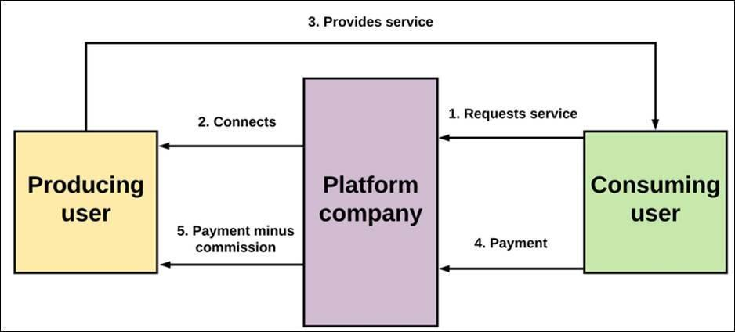
THEORETICAL FRAMEWORK
Figure 1. Two-Sided Platform Theory [45]
The researchers used Two-Sided Platform Theory as the theoretical foundation for understanding how KaAyos creates value by facilitating interactions between its two distinct user groups: homeowners and service providers. As articulated by Rochet and Tirole [42] and Armstrong [43], this theory holds that platforms create value by orchestrating interactions between distinct user groups, where the demand from one group directly influences the demand from the other through cross-group network effects. The central mechanism is the interdependence of participation: a platform’s value to homeowners increases as more service providers join, and its value to service providers increases as more homeowners join. This interdependence creates what the theory identifies as the chicken-and-egg problem facing new platforms: homeowners will not join without sufficient service providers, and service providers will not join without sufficient homeowner demand. Without deliberate intervention, the platform fails to achieve the critical mass needed for either side to derive sufficient value. This framework provides the theoretical foundation for KaAyos’s launch strategy and growth planning, grounding decisions on how to overcome initial adoption barriers through mechanisms such as sequential onboarding and asymmetric pricing.
To solve the chicken-and-egg problem, the platform operationalizes the theory’s prescriptions through a sequential “divide-and-conquer” strategy: it first enrolls service providers by leveraging its partnership with the Public Employment Service Office (PESO) of Tuy, offering zero listing fees and free onboarding assistance to build supply, and only then launches targeted homeowner acquisition campaigns with subsidized first-service offers to stimulate demand. Once both sides are present, features such as the Real-Time Booking System, Geospatial Clustering for Worker Availability, and the Analytics Dashboard for Providers reinforce cross-group network effects by making the platform increasingly valuable to each side as the other grows. The theory also guides the design of governance mechanisms like the Rating and Review System and the Service Guarantee and Dispute Resolution feature, which mitigate negative externalities that could otherwise weaken network effects. By explicitly accounting for cross-group interdependence in every feature decision, KaAyos ensures that the conditions for self-sustaining growth are established from the outset.
Two-Sided Platform Theory is thus applied within KaAyos to produce four corresponding strategic outcomes. First, the chicken-and-egg problem is solved during launch through sequential onboarding and asymmetric pricing, grounded in the theory’s analysis of cross-group interdependence. Second, sustainable growth is achieved through network effects, grounded in the theory’s mechanism of mutual demand reinforcement and operationalized through coordinated acquisition of both user groups. Third, value is created for both homeowners and service providers, grounded in the theory’s platform orchestration logic and operationalized through balanced engagement features such as the Dedicated Portal for Workers, the AI-Powered Chatbot and Worker Suggestion System, and the Transparent Pricing and Quote System. Fourth, a defensible market position is established, grounded in the theory’s treatment of multi-sided markets and operationalized through institutional integration with PESO Tuy, which creates switching costs that consolidate first-mover advantage once critical mass is achieved. Each strategic outcome addresses a distinct and documented challenge faced by new two-sided platforms entering markets with interdependent demand, and each is directly implemented in specific components of KaAyos’s feature set. The result is a theoretical framework in which every strategic decision for KaAyos has both an empirical justification from the reviewed platform economics literature and a theoretical explanation from established two-sided market theory, together contributing to the overarching goal of successfully establishing and scaling the KaAyos platform for homeowners and service providers in Tuy.
CONCEPTUAL FRAMEWORK
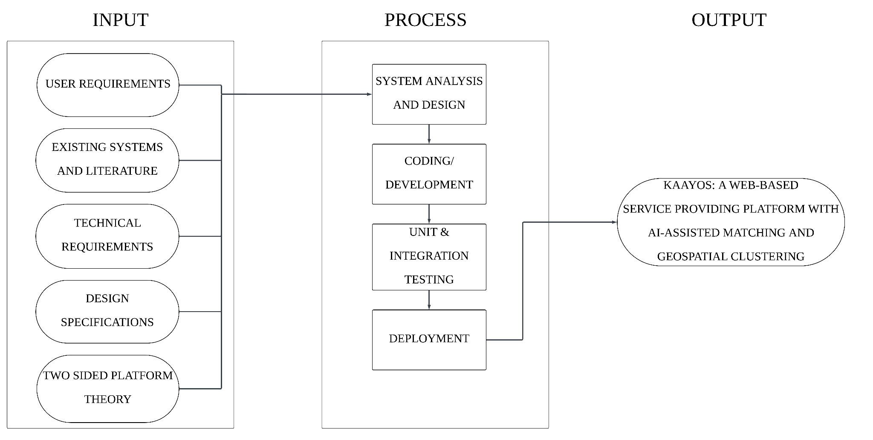
The researchers developed a conceptual framework to outline the scope, purpose, and fundamental content of the study.
Figure 2. Conceptual Framework – Input-Process-Output (IPO) Model of KaAyos
The conceptual framework of this study adopts an Input-Process-Output (IPO) model to illustrate the development process of the KaAyos web-based platform. This framework presents a structured flow of how the identified requirements and resources are transformed through systematic development activities into the final system and its deliverables.
The input component encompasses all the requirements, resources, and specifications that drive the development of the KaAyos web-based platform. These include: (1) User Requirements – the needs and expectations of the target users, specifically homeowners seeking reliable home service providers and skilled workers seeking job opportunities in Tuy, Batangas, gathered through interviews and surveys. (2) Existing Systems and Literature – insights drawn from related local and foreign studies on digital service platforms, gig economy research, and trust-building mechanisms that informed the system’s design decisions. (3) Technical Requirements – the selected technology stack consisting of the Laravel PHP framework for backend development, MySQL as the relational database management system, and standard web hosting services for deployment and accessibility. (4) Design Specifications – system architecture diagrams, use case diagrams, entity-relationship diagrams, and data flow diagrams that served as blueprints for the development team. (5) Theoretical Foundation – the core principles of Two-Sided Platform Theory, which provided the structural logic for balancing the needs of both user groups, overcoming initial adoption barriers, and driving cross-group network effects.
The process component describes the development activities undertaken to build the KaAyos platform from the gathered requirements. These include: (1) System Analysis and Design – translation of user requirements into system specifications; creation of use case diagrams, entity-relationship diagrams, and data flow diagrams to model system structure and behavior; and design of the user interface through wireframing and prototyping. (2) System Development and Implementation – coding and integration of all platform modules using the Laravel PHP framework and MySQL, including user registration and authentication, worker verification, AI-powered worker suggestion, geospatial clustering, ratings and reviews, in-app messaging, worker portal, transparent pricing and quotes, real-time booking, service guarantee and dispute resolution, service category browsing, and provider analytics. (3) System Testing – execution of unit testing and integration testing to validate that all modules function correctly and meet the defined requirements, identification and resolution of bugs and inconsistencies. (4) System Deployment – hosting of the completed platform on a standard web hosting environment to ensure accessibility through standard web browsers, followed by final refinements based on user feedback.
The output component represents the tangible deliverables produced through the development process. The primary output is the KaAyos web-based platform itself – a fully functional and secure system, accessible through standard web browsers via basic web hosting. These outputs fulfill the goal of providing a reliable digital bridge between homeowners and skilled service providers in Tuy, Batangas.
SYNTHESIS
The body of literature reviewed in this chapter converges on several consistent themes that together define the conditions necessary for the success of a digital home service platform such as KaAyos. Across conceptual literature, empirical research studies, and technical background sources, a clear pattern emerges: effective digital service platforms require the simultaneous orchestration of intelligent matching mechanisms, trust-building infrastructure, fair labor conditions, and accessible technology design. [14], [15], [29], [30], [39], and [40] collectively establish that algorithmic coordination, structured booking systems, and user-centered platform design are not merely technical conveniences but foundational design requirements that directly shape user experience, worker welfare, and platform efficiency. Complementing this, [22], [33], [25], [35], and [27] consistently highlight that poorly designed matching and compensation systems reproduce systemic inequities for gig workers, particularly in the Philippine context. The alignment across these diverse sources affirms that KaAyos must embed fairness and transparency into its matching logic from the ground up, not as a secondary consideration.
A second pattern emerging from the literature is the central role of trust as a platform asset. [17]-[20], [28], and [34] collectively demonstrate that consumer confidence in digital platforms depends heavily on transparent review systems, credible identity verification, and consistent AI-assisted service quality. This convergence underscores the necessity of robust rating and worker verification mechanisms in any platform serving homeowners who must make trust-based decisions about allowing service providers into their homes. The Philippine-specific literature from [22], [21], and the Asian Development Bank [24] reinforces that this trust deficit is especially pronounced in local markets, where informal service arrangements have historically relied on personal referrals rather than digitally mediated verification. KaAyos addresses this gap by integrating a structured worker verification module and a balanced rating system that protects both parties in each transaction.
Despite the breadth of the reviewed literature, several notable gaps persist. First, while numerous studies examine gig economy platforms from labor economics and sociological perspectives, few present fully implemented systems evaluated in community-level or semi-urban contexts comparable to Tuy, Batangas. [39] and [40] provide implemented web-based platform precedents that validate core design patterns such as role-based access, booking workflows, and integrated payment systems, yet neither addresses the specific conditions of Philippine semi-urban communities, where digital literacy constraints, limited broadband penetration, and informal labor norms shape platform adoption. Second, the existing literature on algorithmic matching represented by [29] and [30] focuses predominantly on delivery and logistics platforms rather than home-based personal services, which carry distinct trust, privacy, and relational dynamics identified [31]. Third, no reviewed study specifically examines a home service platform that combines geospatial clustering, AI-driven chatbot assistance, and a worker analytics portal within a single integrated system designed for MSME-level deployment in the Philippine context. This triple integration represents a gap in both the research and practical literature that KaAyos directly addresses.
The theoretical and conceptual frameworks reviewed further clarify how the present study fills these gaps. Two-Sided Platform Theory [42], [43] provides the structural logic for KaAyos’ launch strategy and growth model, grounding the platform’s design in established principles of cross-group network effects and sequential onboarding. The reviewed technical background covering Laravel, MySQL, WebSocket, Geolocation API, and supporting web technologies confirms that the chosen technology stack is not only appropriate for the platform’s functional requirements but is also aligned with industry-standard practices for secure, scalable, and community-accessible web applications. The IPO conceptual framework synthesizes these inputs and processes into a coherent system that directly responds to the documented needs of homeowners and service providers in Tuy.
Taken together, the reviewed literature establishes that KaAyos occupies a meaningful and underserved niche in both the academic and applied landscape of digital service platforms. The convergence of algorithmic management theory, trust and review research, Philippine gig economy studies, and implemented system precedents creates a well-supported foundation for the present study. At the same time, the identified gaps, particularly the absence of a localized, fully implemented home service platform integrating intelligent matching, AI assistance, and worker empowerment tools in a Philippine semi-urban setting confirm the original contribution that KaAyos makes to the field. By building on the strengths of prior work while specifically addressing its contextual and functional limitations, the present study advances both the theoretical understanding of two-sided platform design and the practical development of equitable, community-centered digital labor infrastructure in the Philippines.
CHAPTER III
DESIGN AND METHODOLOGY
This section will outline the structural framework and methodological approaches that will be utilized to construct KaAyos, an AI-integrated, web-based platform for service matching and geospatial clustering. Furthermore, it will detail the specific developmental tools, systematic procedures, and evaluation metrics that will be applied to guarantee the system's overall functionality and technical viability.
RESEARCH DESIGN
A descriptive-developmental research design will serve as the foundation for this study, providing a systematic pathway for building and assessing the KaAyos platform [46]. The developmental aspect will focus on the rigorous phases of designing, coding, and refining digital solutions to address tangible market problems [43]. By employing this structured framework, the researchers will ensure that the resulting technology effectively serves its intended demographic through a well-organized software engineering process.
This descriptive-developmental methodology will progress through a defined lifecycle: Planning, System Development, Testing, Deployment, and Evaluation [46]. Initially, the descriptive phase will identify the prevailing obstacles within the Philippine home services sector namely, profound coordination breakdowns, spatial misalignments, and procedural bottlenecks that hinder the connection between clients and vetted professionals [11], [30]. Guided by these initial insights, the actual construction of the system will take place. This will encompass the architectural design and coding of KaAyos, bringing to life core functionalities such as the AI-Powered Chatbot [17], [33], Geospatial Clustering algorithms [46], a robust Worker Verification Module [20], and a Real-Time Booking environment equipped with dedicated analytics for service providers [44].
Iterative testing will be embedded throughout the creation phase to verify that all modules operate correctly and satisfy end-user requirements. Following the completion of internal debugging, the research will move into a formal technical evaluation. Rather than relying on subjective user surveys, the researchers will utilize quantitative performance testing via Apache JMeter [48]. This approach will yield precise, objective metrics regarding data throughput, server response times, and system scalability under simulated traffic [49]. Particular emphasis will be placed on evaluating the computational efficiency of the AI matching logic and the geospatial mapping features, ultimately determining the platform's operational readiness for the local market.

DESIGN STAGE OF THE PROCESS
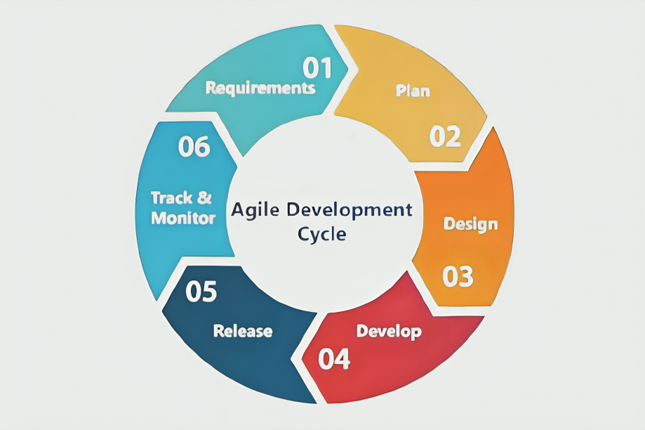
The Software Development Life Cycle (SDLC) functions as a methodical framework for overseeing the orderly creation of software systems. This structure is essential for ensuring the final product exhibits high quality, reliability, and operational efficiency. By adopting an organized strategy, the SDLC optimizes resource utilization and mitigates potential risks throughout the project. For the development and implementation of the KaAyos platform, the researchers utilized the Agile development approach.
Figure 3 Agile Development Method [1]
The researchers will adopt the Software Development Life Cycle (SDLC) framework, which is vital for delivering a reliable, high-quality digital product while minimizing technical risks. Specifically, the Agile methodology will be selected to guide the development of KaAyos [47]. Agile is highly regarded for its iterative nature, enabling continuous refinement, regular feedback integration, and the swift resolution of bugs as they emerge during coding.
By segmenting the project into smaller, manageable iterations, Agile will allow the development team to incrementally enhance the system [47]. This methodology is particularly suited for KaAyos due to the complexity of its underlying features such as artificial intelligence matching [18], real-time communication, and geolocation [46] which will require ongoing calibration. The development cycle will be organized into six distinct phases
Requirements Gathering
Instead of conducting direct user interviews, researchers will derive system prerequisites by analyzing existing literature, evaluating current market platforms, and identifying prevalent service accessibility issues [3], [6], [22]. This will establish the necessity for features like secure bookings, verification [20], and intelligent service matching [30].

Planning
The team will outline the project's trajectory by defining the scope, setting objectives, allocating resources, and establishing a strict development timeline.
System Design
In the system design phase, the researchers developed the overall structure and layout of the KaAyos platform. This included the creation of system models such as use case diagrams, Data Flow Diagrams (DFD), and Entity Relationship Diagrams (ERD) to represent system processes and data flow.
User interface designs and prototypes were also created to ensure that the platform is user-friendly and accessible. This phase provided a clear visualization of how users will interact with the system and how different components are interconnected.
System Development
This will be the functional coding phase where the database will be structured and backend logic will be written. Key integrations, such as the AI suggestion engine and geospatial mapping, will be built incrementally [33], [46].
System Release
In the system release phase, the developed platform was deployed and made accessible to selected users. The system was introduced through a web-based interface, allowing users to explore its functionalities such as browsing services, booking workers, and communicating within the platform.
This phase allow the researchers to observe user interaction with the system and gather initial feedback regarding usability and performance.
Monitoring and Improvement
A post-deployment phase will be dedicated to tracking system logs, evaluating resource consumption, and optimizing the backend response times of the AI and clustering modules [48].

DEVELOPMENT PROCESS
The construction of KaAyos will follow a highly phased technical roadmap. Every architectural and programmatic decision will be deliberately aligned with the practical needs of its primary stakeholders: Filipino households, independent laborers, and the Public Employment Service Office (PESO) of Tuy [7], [26].
Testing Process
The researchers will begin a thorough testing process before the KaAyos platform is deployed in order to identify and fix any flaws, vulnerabilities, or functional issues that might impede the system's intended results. This stage is crucial for confirming that the platform's main features including the Worker Verification Module, the AI-Powered Chatbot and Worker Suggestion System, Geospatial Clustering, and the Real-Time Booking System perform consistently in accordance with the requirements set forth for Filipino service providers and homeowners. Unit testing is the first step in the testing process. It involves testing individual components, like user authentication, booking administration, and testingprofile building, separately to make sure their core logic is solid. Before they are included into the larger system, this first stage assists in locating and fixing logic faults in crucial functions.
After the isolated tests, integration testing will be carried out to evaluate the data flow between the user interface and backend services, with a particular emphasis on the Laravel framework's interactions with external APIs such as SMS gateways for booking notifications and Geolocation for mapping service zones. System testing will be carried out to evaluate the platform as a cohesive whole, including functional, performance, and security aspects, in order to wrap up the assessment. While security testing will concentrate on safeguarding important data, such as submitted clearances and payment records, performance testing will involve load simulations to see how the system manages concurrent bookings from several users.
Debugging Process
Once the testing phase is completed, the researchers will proceed with the debugging process for the KaAyos platform, wherein all errors and inconsistencies identified during testing will be systematically examined, traced to their root causes, and resolved. This phase will involve a careful review of the system's codebase, paying particular attention to the AI-powered chatbot and worker suggestion system, as well as the geospatial clustering module. These specific components require precise logic to function correctly under varying user constraints and location data to ensure efficient and accurate matching between homeowners and local service providers.
To achieve thorough identification of faults across the platform's diverse functionalities, automated debugging tools will be utilized in conjunction with manual code inspection. Iterative re-testing will be conducted after each fix is applied to the real-time booking system, transparent pricing configurations, and the in-app chat messaging interface. This crucial step confirms that resolved issues within these transactional modules are genuinely fixed and do not inadvertently produce new errors elsewhere, ensuring that the platform's core service lifecycle and communication channels remain uninterrupted.
The debugging process will extend beyond merely correcting standard functional errors to encompass comprehensive improvements to overall system performance, data integrity, and security. Special focus will be placed on fortifying the worker verification module, ensuring the secure handling of uploaded valid IDs and clearances, and protecting sensitive user data within the dedicated worker portals and dispute resolution records. Through this exhaustive process, the researchers will ensure that KaAyos is stable, optimized, and fully prepared to deliver a secure and reliable home service experience before advancing to the validation stage.
Validation Process
To evaluate the technical viability of the KaAyos platform, the researchers will conduct a comprehensive quantitative assessment focused entirely on system performance rather than subjective user feedback. Utilizing benchmarking utilities such as Apache JMeter, the study will execute automated load testing to simulate simultaneous access by multiple homeowners and service providers. This procedure is designed to capture critical operational metrics specifically response latency, transaction throughput, and system stability under peak traffic. By observing how the web-based infrastructure handles concurrent tasks like real-time booking and in-app messaging, the developers can objectively verify the platform's capacity to maintain a seamless, crash-free experience during high-demand scenarios.
Beyond general stress testing, the validation phase will meticulously examine the computational accuracy of the platform’s core intelligent features. The AI-Powered Chatbot and Worker Suggestion System will be subjected to controlled test cases to ensure that its algorithm correctly filters and recommends workers based on predefined proximity, required skills, and reputation scores. Simultaneously, the Geospatial Clustering module will be evaluated using simulated geographic data to confirm that it accurately maps high-density worker zones and appropriately signals the AI to prioritize localized availability. These rigorous checks guarantee that the intelligent matching mechanisms function exactly as intended and efficiently solve the geographic mismatches inherent in the current market.
The empirical data extracted from both the load and functional benchmarking tests will then be analyzed to isolate any architectural inefficiencies or algorithmic bottlenecks. Subsequent modifications will be applied to the system's codebase to refine processing speeds and guarantee that all outputs meet strict software reliability standards. Ultimately, this rigorous technical validation will certify that KaAyos is a highly optimized, fully capable digital infrastructure, ready for formal deployment to its target users in collaboration with the Public Employment Service Office (PESO) of Tuy.

PROGRAMMING PROCEDURE
System Architecture
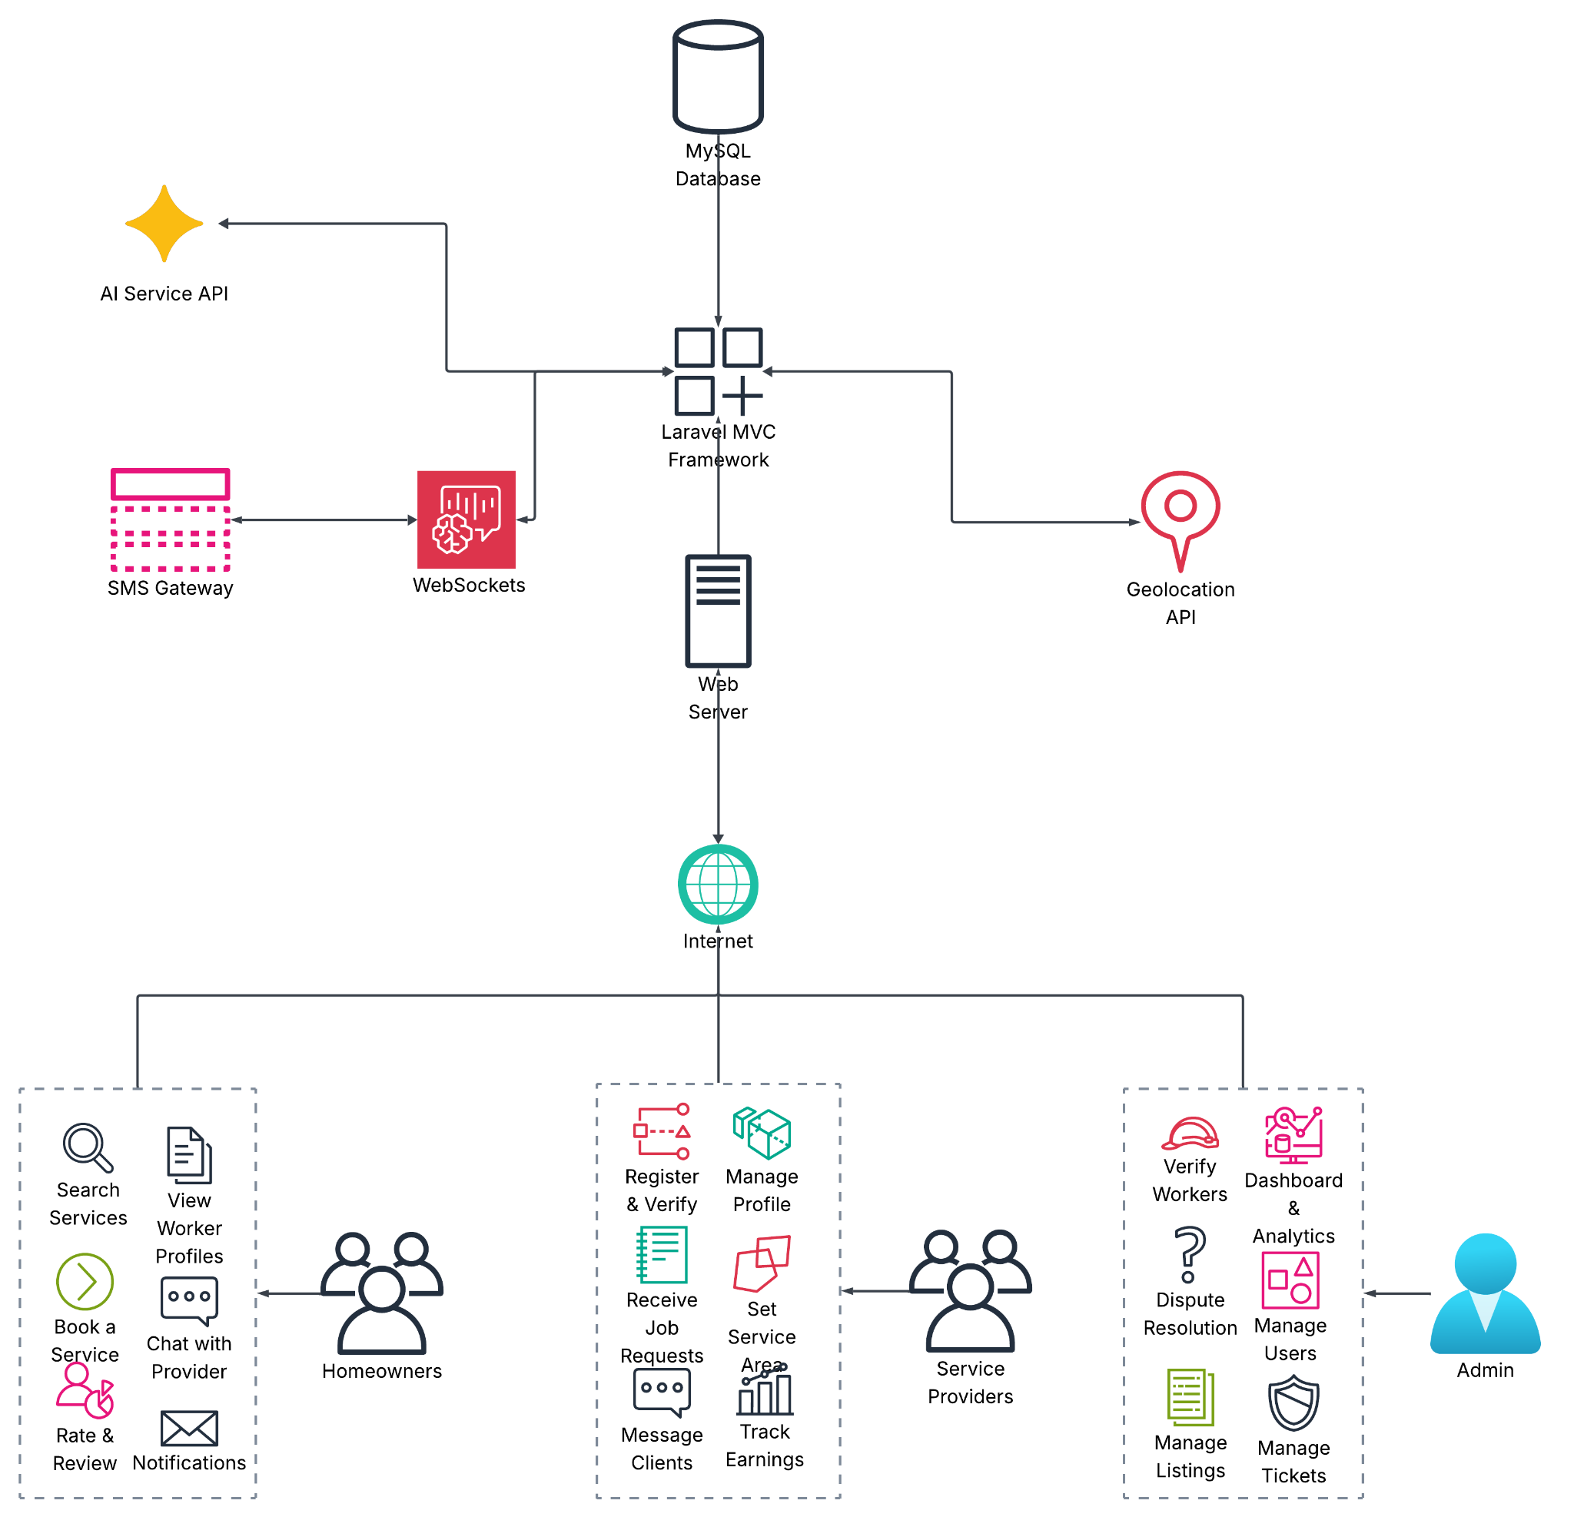
Figure 4. System Architecture Diagram of KaAyos

Figure 4 shows the system architecture of KaAyos, a Web-Based Local Service Providing Platform for Home Services with Worker Matching System. In order to address the serious coordination issues in the Philippine home services market, the program is housed on a Web server that can be accessed via the Internet, offering secure and remote communication. The Laravel MVC Framework, the system's key component, is how KaAyos combines its operations into the backend. This framework is in charge of managing user requests, processing business logic, and coordinating the platform's general operations. The MySQL database, which keeps a bidirectional connection with the Laravel core, securely stores and retrieves all processed data, including user profiles, transaction histories, and service catalogs.

Important external services and application programming interfaces (APIs) that drive the platform's sophisticated features are linked to the central framework. The AI-Powered Chatbot and Worker Suggestion System is managed by the AI Service API, which processes client requests and recommends the best service providers based on reputation, talents, and location. In parallel, locations with a high density of registered workers are mapped and clustered using the Geolocation API, which powers the Geospatial Clustering for Worker Availability. The architecture incorporates WebSockets, which power the In-App Chat Messaging between clients and employees, to enable real-time collaboration. An interconnected SMS gateway that provides automated booking updates and notifications for the Real-Time Booking System supports this.
System access and capabilities are dispersed among specialized interfaces designed to meet particular user needs beneath the basic application and server infrastructure. Homeowners can use the Rating and Review System, Book a Service, View Worker Profiles, Chat with Providers, and Search Services using simple categories through the client interface. On the other hand, independent contractors can register and verify using the Worker Verification Module, manage profiles, set service areas, receive job requests, message clients, and track earnings using the worker interface, which functions as a dedicated portal for workers. The platform is managed by a separate administration interface that offers capabilities for managing users, listings, and tickets, monitoring the Analytics Dashboard, handling Service Guarantees and Dispute Resolution, and verifying workers.
Three different user groups are supported by the architecture: Independent Home Service Providers (Workers), Filipino Homeowners (Customers), and the System Admin, which may include personnel from the Tuy Public Employment Service Office (PESO). All of these users use the web interface to access KaAyos, but the central framework's stringent role-based access controls control their views and capabilities. Homeowners navigate the service market as customers, service providers use the platform to run their microbusinesses and maximize their revenue potential, and the administrator ensures platform integrity. KaAyos provides a dependable and extremely effective home care platform that is customized to local requirements thanks to this role-based design, intelligent matching, geospatial clustering, and secure communication services.

Requirements Analysis
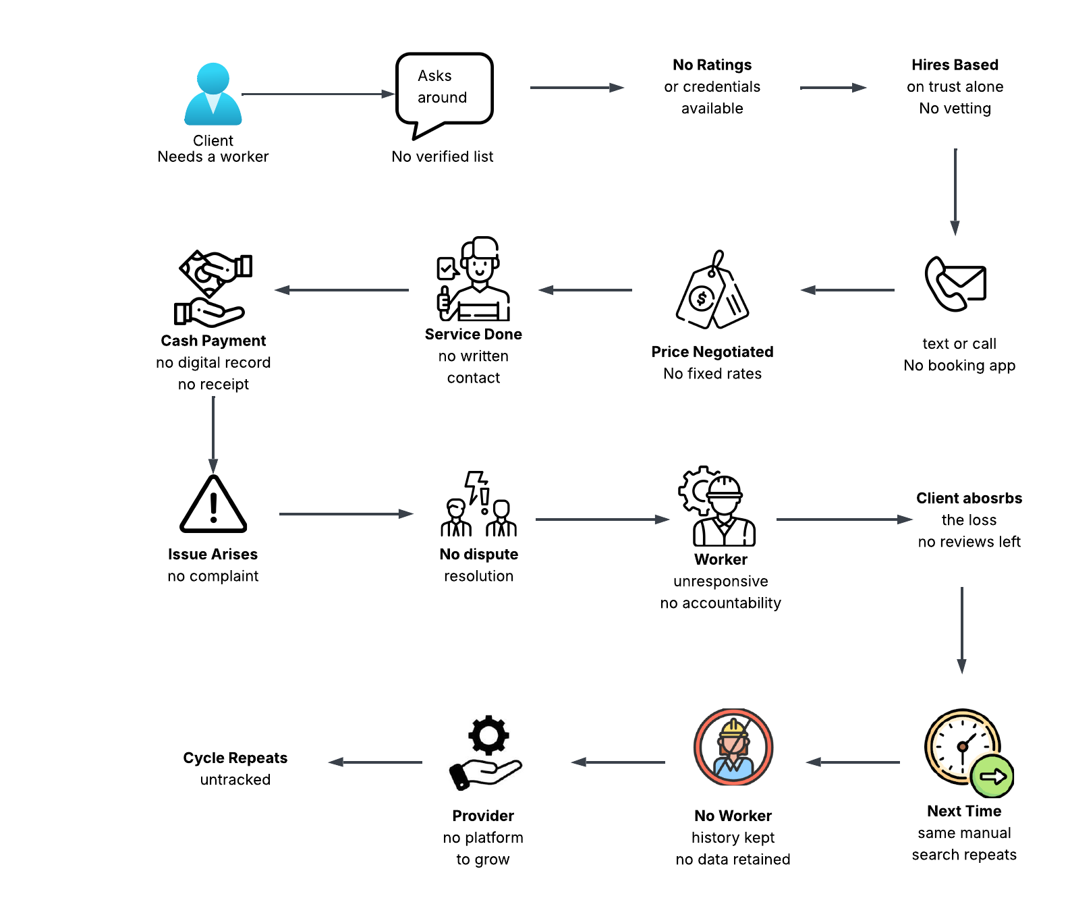

Figure 5. Requirements Analysis of KaAyos

Figure 5 depicts the current manual and informal method by which clients locate and employ home service providers without the use of any digital platform. Because there is no centralized, vetted list of service providers available in this traditional structure, a client in need of a worker starts by simply inquiring about their own network or local community. Clients do not have access to background checks, professional credentials, or previous ratings during this initial search. As a result, there is no official screening procedure; instead, hiring decisions are made solely on the basis of word-of-mouth recommendations and trust. This approach is totally reliant on the client's few personal connections, which can be very time-consuming and unreliable, particularly when specialized home services are desperately needed.
Since there isn't a specific booking software to handle schedules, the entire job coordination process is done informally through ordinary messages or phone conversations after a possible employee is located. Because there are no set rates or uniform price standards, pricing is arbitrarily negotiated between the two parties. There is no official documentation of the agreed-upon work or written contract when the service is finished. Additionally, the transaction only uses cash payments; no digital records, tracking, or official receipts are produced. The absence of official documentation, clear pricing, and consistent communication greatly raises the possibility of miscommunication and puts the client and the employee at danger.
If an issue arises after the service is rendered, clients have no established dispute resolution procedure or official complaint method to use. In many instances, the employee may stop responding, and since there is no accountability structure, the client is eventually left to bear the financial loss without any way to write a public review to alert others. The client has to start over with the same laborious, manual search procedure the next time a service is required. Clients find it difficult to rehire dependable employees because no transaction data or worker history is stored. On the other hand, competent and trustworthy suppliers lack a platform to expand their clientele or enhance their reputation. As a result, this ineffective and unmonitored loop just keeps repeating itself forever.
The urgent necessity for an organized, digital service-provisioning infrastructure is highlighted by these significant constraints in the current informal economy. It is evident that a more dependable and accountable solution is required due to issues including the lack of worker verification, the absence of secure transaction records, and the complete reliance on word-of-mouth. Clients may identify vetted employees with ease, see transparent pricing, and rely on safe booking and dispute resolution channels with a system like KaAyos. Additionally, service providers would get access to a larger market and establish a respectable professional profile with the help of a dedicated platform that keeps track of their positive past. KaAyos wants to build a more safe, effective, and responsible ecosystem for the local home services sector by filling in these gaps.

Use Case Diagram
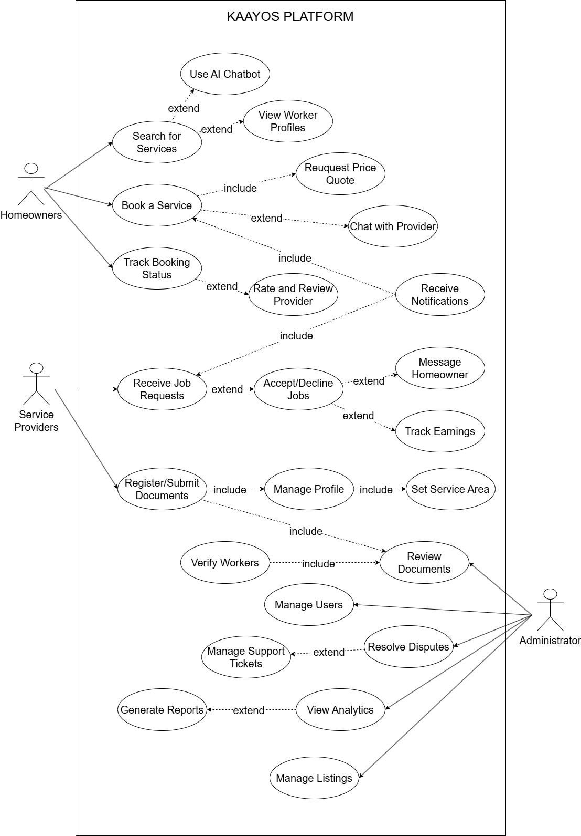
Figure 6. Use Case Diagram of KaAyos
Figure 6 presents the use case diagram for the KaAyos System. Homeowners, service providers, and the administrator are the three main actors that interact with the system, according to the diagram. Each actor is given a unique set of responsibilities that correspond to their position in the service delivery process. These responsibilities include platform administration, worker onboarding, booking management, service discovery, and dispute resolution.
The administrator is in charge of upholding the platform's general integrity, security, and quality. Through essential tasks including managing users and service listings, this actor has the power to supervise system operations. Verifying employees is a crucial part of the administrator's job, which naturally involves checking the documents providers submit at registration to make sure safety requirements are fulfilled. Additionally, the administrator can generate reports, which can be expanded to view thorough platform analytics to track overall system health, and manage support complaints, which includes actively addressing user disputes.
The homeowners are the system’s main users, who have access to features aimed at effectively locating and obtaining home services. When a homeowner starts a service search, they can choose to go further by reading particular worker profiles to evaluate credentials or using the AI chatbot for intelligent matching. They use the book as a service function to obtain a service, which automatically involves getting a quote and getting system alerts. You may extend this booking procedure by chatting with the provider directly to get more information. Homeowners can monitor their booking progress after making a reservation, which gives them the opportunity to prolong the transaction lifetime by evaluating and rating the provider after the service is finished.
The service providers use the technology the most to run their autonomous microbusinesses and address the demands of local clients. The first thing they do is register and submit documents, which entails maintaining their professional profile and checking the accuracy of the materials they have already submitted. Setting their particular service area for the geographic clustering function is an essential step that the system incorporates into profile maintenance. After completing the onboarding process, job requests are sent to providers, which immediately initiates notifications. After receiving a request, providers can choose to accept or reject assignments. They can also message the homeowner to discuss specifics or keep track of their total profits from finished projects.

Context Diagram
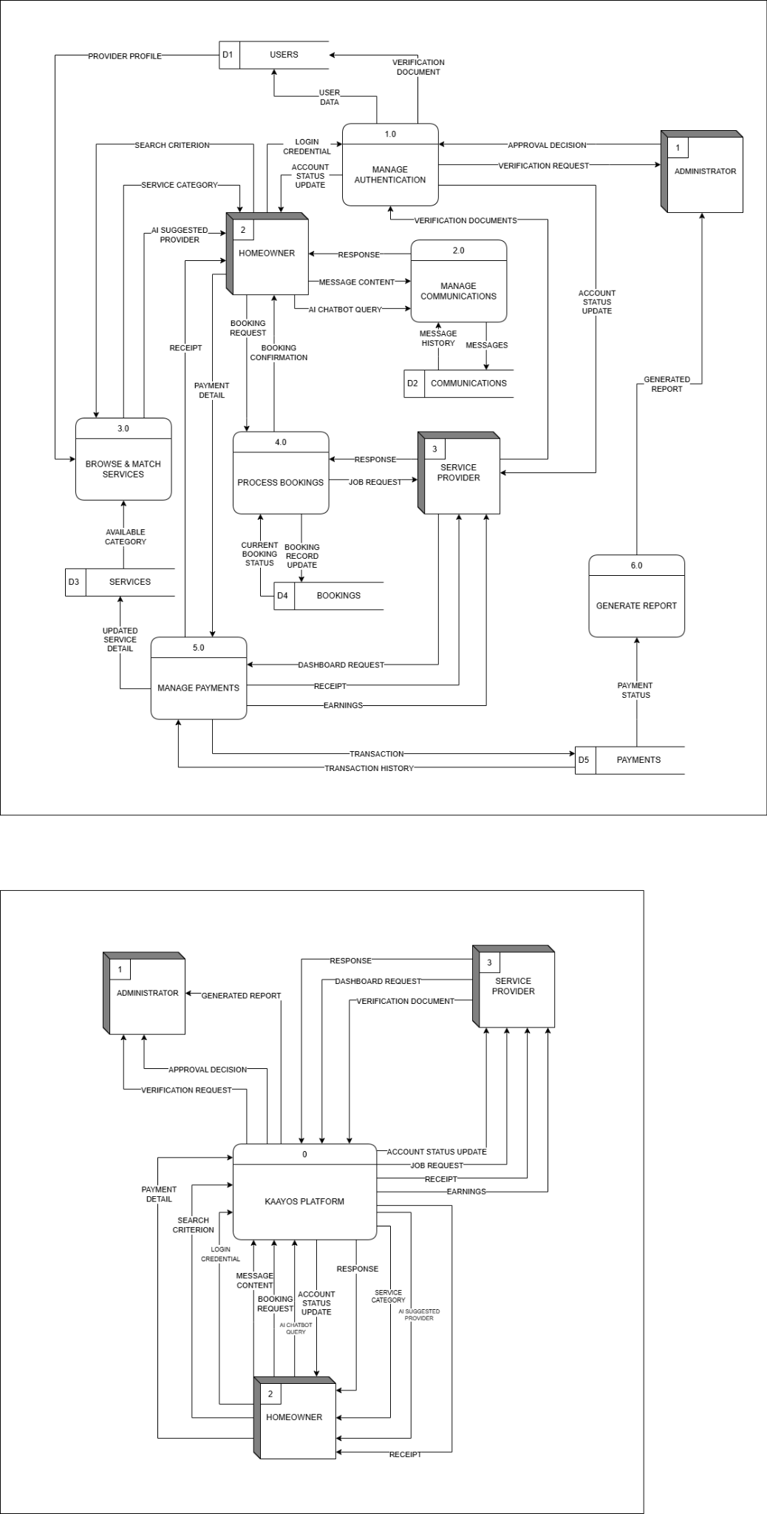
Figure 7. Context Diagram of KaAyos

Figure 7 displays the context diagram of the KaAyos Platform, which shows the basic relationships between the centralized system and its main players in the home services ecosystem. In order to handle service requests, worker verification, intelligent matching, and platform management, the KaAyos Platform serves as the primary coordinating entity. The solution is intended to provide safe, effective, and dependable relationships between local service providers and homeowners by combining digital communication, geospatial data, and AI-driven recommendations.
The primary consumer within the system is the homeowner. They interact with KaAyos by sending message content, booking requests, search parameters, login credentials, payment information, and AI chatbot inquiries. The KaAyos Platform responds by providing transaction receipts, account status updates, general system responses, classified service options, and AI-suggested provider recommendations. With the use of these outputs, homeowners can securely interact, choose dependable professionals for their particular needs, and access available services with ease.
Service providers serve as the system's vital workforce. In order to create their professional profiles, they first submit verification documents. This is followed by dashboard requests and direct message replies. These inputs are then processed by the KaAyos Platform, which then provides task requests, account status updates, transaction receipts, and ultimate earnings. Through a centralized and transparent dashboard, employees can check their collected money, obtain localized job prospects, and manage their microbusinesses efficiently as a result of this bidirectional flow.
Administrators, as the governing body, are responsible for upholding operational security and platform integrity. They mostly communicate with the system through generated reports about overall platform activity and verification requests from recently registered employees. Administrators return approval decisions to the system after examining this data. This crucial monitoring role guarantees that the platform runs efficiently and safely for every user and that all listed service providers adhere to the required security standards.
The KaAyos Platform is positioned as a key point for local home service coordination as a result of various stakeholder interactions taken together. The system ensures complete support for both customers and providers by facilitating intelligent worker matching, supporting secure information transmission, and encouraging transparent transactions. Thus, the context diagram highlights KaAyos's function in combining verification procedures, AI support, and smooth communication to foster an effective, reliable, and updated local service market.

Diagram 0

Figure 8. Diagram 0 of KaAyos

Figure 8 presents the Level 0 Data Flow Diagram (DFD) of the KaAyos Platform. It shows how the system handles bookings, secure communications, user verification, intelligent service matching, and financial transactions. A number of internal data stores, including Users, Communications, Services, Bookings, and Payments, facilitate the system's coordination of various service management and transactional operations involving Homeowners, Service Providers, and Administrators.
Homeowners and service providers first interact with the Manage Users & Authentication (1.0) process by entering their login information. This module also manages the crucial submission of verification papers for service providers, which are then processed and sent as a verification request to the administrators. The system is then able to update the Users (D1) data store with verified user data and provider profiles while providing an account status update to the corresponding users after the Administrators have reviewed these documents and returned an approval decision.
Homeowners can use the Browse & Match Services (3.0) method to investigate available home services after they have been authenticated. When homeowners enter particular search parameters, the system retrieves confirmed provider profiles from the Users (D1) data store and available categories from the Services (D3) data store. In order to expedite the homeowner's search for competent local labor, this module incorporates intelligent matching, returning suitable service categories and an AI-suggested supplier.
Users use the Manage Communications (2.0) method to enable secure communications. Homeowners can ask an AI chatbot for help or give staff direct messages with content, and the workers will respond appropriately. In order to keep a trustworthy and secure record of all platform interactions, this module manages the communication between homeowners and service providers by saving and retrieving message history from the Communications (D2) data store.
The Process Bookings (4.0) module manages the main transactional flow. Once a homeowner has made up their mind, they submit a booking request, which the system then sends to the selected service provider as a job request. After processing the provider's response, the homeowner receives a formal booking confirmation. The system regularly updates and retrieves the current booking status and booking records from the Bookings (D4) data store during this cycle.
The Process Payments (5.0) module is used to safely handle financial transactions. In order to pay their service costs, homeowners supply payment information. Both the homeowner and the service provider receive digital receipts from the system, which also logs the transaction history into the Payments (D5) data store. Service providers can also safely track and collect their cumulative revenue by submitting a dashboard request to this module.
The Generate Report (6.0) procedure pulls operational data to facilitate platform administration and supervision. In order to create a produced report that is safely sent to the administrators, this module retrieves payment status data from the Payments (D5) data store. This guarantees that the governing body of the platform can clearly see the overall health of transactions and system utilization.
To ensure operational continuity, the system depends on five core data repositories. General user information, confirmed provider profiles, and login credentials are stored in the Users (D1) data store. All direct messages and chatbot questions are stored in the Communications (D2) repository. The list of available service categories is kept up to date by the Services (D3) data store. While the Payments (D5) repository safely maintains all transaction histories and income records, the Bookings (D4) data store keeps track of all ongoing and completed task requests.
Overall, the Level 0 DFD shows how the KaAyos platform combines real-time communication, secure user verification, AI-driven service matching, and simplified booking and payment processing into a single digital infrastructure intended to enable dependable and effective home service transactions.

Entity-Relationship Diagram
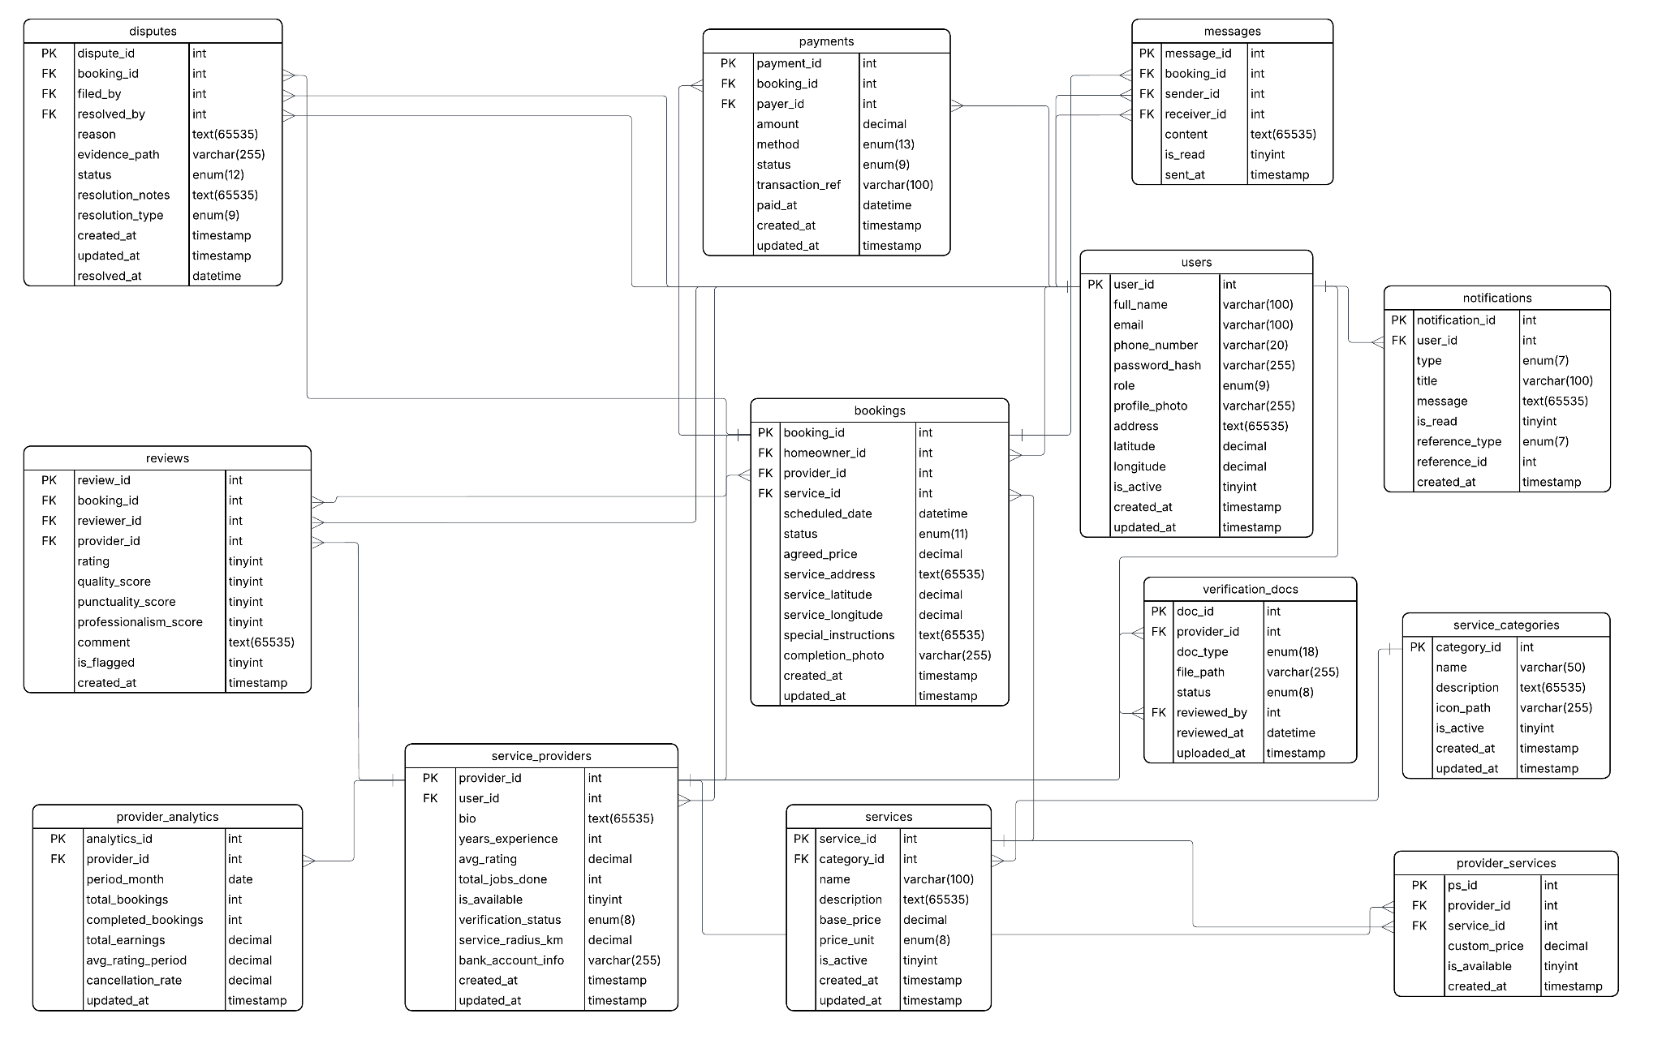
Figure 9. Entity-Relationship Diagram of KaAyos
Figure 9 illustrates the Entity Relationship Diagram of KaAyos, showing how data is structured and interconnected across the system’s major modules: User Management, Service Provision, Booking Management, Communication, and Performance Analytics.
The users entity, which represents everyone using the platform homeowners, service providers, and administrators acts as the system's core center. It is closely linked to messages, which enable the in-app chat functionality between clients and employees, and notifications, which log system alerts for users. It also maintains fundamental account information. Through the service_providers object, which relates to the main users table and maintains particular professional details like experience, availability, and service radius, the system clearly identifies service providers.
The services and service_categories entities, which specify the list of accessible home services, are the foundation of the service providing component. Custom pricing is made possible via the provider_services entity, which serves as a link between different service providers and the particular services they deliver. Importantly, the verification_docs entity is linked to service providers, safely keeping the necessary IDs and clearances uploaded during the onboarding procedure and monitoring the administrators' review status.
The bookings entity oversees the primary transactional flow. The homeowner (user), the service provider, and the requested service are all connected by this central table, which keeps track of crucial information including the agreed-upon pricing, the service location (latitude/longitude for geographical characteristics), the scheduled date, and the current status. The payments entity, which keeps track of financial transaction data, and the reviews entity, which gathers the homeowner's opinions regarding professionalism, quality, and timeliness following a job's completion, are linked to these bookings. Bookings are also connected to the disputes entity, which offers a structured record for resolving issues.
The provider_analytics entity tracks total bookings, earnings, cancellation rates, and average ratings over predetermined periods in order to facilitate ongoing improvement and business insights for the employees.
Overall, the ERD shows how the KaAyos platform supports a dependable, transparent, and effective marketplace for local home services by integrating secure user profiles, structured service catalogs, strong booking and payment monitoring, and intelligent provider analytics.

SOFTWARE AND HARDWARE NEEDED IN THE DEVELOPMENT
In this section, the software and hardware information that the researchers used in the development of the KaAyos platform are presented.

Software Requirements

Software | Description | Specification
Operating System | OS platform used for developing and testing the system | Windows 11
Web Server | Local server environment that runs the application during development | XAMPP
Database Management System | Manages and persists all system data including user accounts, verified provider profiles, service catalogs, bookings, and payment records | MySQL
Programming Language | Languages used across the front-end and back-end layers of the system | PHP, HTML, CSS, JavaScript
Framework | Structured back-end framework used for routing, authentication, and database operations | Laravel
Code Editor | Integrated development environment used throughout the coding and debugging process | Visual Studio Code
Web Browser | Browsers used for interface testing, compatibility checks, and system validation | Google Chrome, Microsoft Edge
External APIs | Handles the computation for intelligent worker suggestions, proximity matching, and geospatial clustering of service areas | AI Service API, Geolocation API
Real-time Communication | Powers the real-time in-app chat messaging and delivers automated booking alerts between users | WebSockets, SMS Gateway
Performance Testing Tool | Benchmarks system response time, throughput, and stability under simulated concurrent user loads for technical validation | Apache JMeter
Version Control System | Manages source code history and supports team collaboration during development | Git / GitHub

Table 1. Software Requirements Needed in Development
Table 1 lists the software tools chosen for the creation of KaAyos Platform. Because Windows 11 is stable and compatible with the development tools needed for the project, it was selected as the operating system. Because XAMPP is set up as the local server environment, the team can run and test the web application on separate workstations prior to any deployment activities. This controlled and repeatable configuration reduces environmental discrepancies throughout the building phase.
Because of its dependability in managing relational data at the scale needed by KaAyos, which must concurrently manage user accounts, verified provider profiles, a thorough service catalog, active transaction bookings, and secure payment records, MySQL was chosen as the database management system. With built-in features for user authentication, request routing, and database interaction through its Eloquent ORM, Laravel is chosen as the back-end framework to offer an organized and manageable codebase. These features are essential to support the role-based access model that distinguishes Homeowners, Service Providers, and Administrators within the platform.
PHP, HTML, CSS, and JavaScript are used in the construction of KaAyos' front-end interface. These elements together specify the layout, look, and interactive functionality of sites like the client service search screen, the specialized provider portal, and the real-time booking dashboard. The entire development team utilized Visual Studio Code as their code editor, mainly due to its broad plugin ecosystem that simplifies debugging and code navigation, built-in terminal access, and support for many programming languages. During testing, Google Chrome and Microsoft Edge were used simultaneously to ensure that the system's functionality and interface worked consistently in various browser contexts.
The computation for smart worker suggestions and the geospatial grouping of localized service areas are handled by external integrations, namely the AI Service API and Geolocation API, which power KaAyos's key intelligent features. WebSockets and an SMS Gateway are also used to give automated booking alerts and enable real-time in-app chat messaging, and Apache JMeter is the main testing tool used to measure system throughput and response times under simulated concurrent loads. In order to keep track of all codebase modifications, preserve a version history, and enable team members to work on different features concurrently without encountering conflicts, Git and GitHub were incorporated into the development workflow from the beginning.
Ba
Hardware Requirements
Hardware | Description | Specification
Computer System | Primary machine used by the developers for writing code, running the local server, and testing the system | 2.5 GHz processor, 8GB RAM, 512GB SSD
Mobile Device | Device used to verify the system's layout and functionality on smaller screens across different mobile platforms | Android/iOS, smartphone with internet connectivity
Monitor | Display used for coding, debugging, and testing the user interface during development | 14" Color Monitor
Keyboard | Standard input device used throughout the development and debugging process | Standard 102 Keys
Mouse | Pointing device used for navigating the development environment and interacting with system interfaces | Optical, 2 Buttons
Table 2. Hardware Needed in the Development
Table 2 identifies the hardware components that support the development and testing of the KaAyos system. The computer system functions as the core development machine for the project, and its configuration of a 2.5 GHz processor, 8GB RAM, and 512GB SSD was determined to be adequate for simultaneously running the local server environment, a code editor, a web browser, and the MySQL database without performance degradation. Tasks such as rendering the AI-assisted matching interface, processing geospatial clustering computations, and managing real-time booking operations require consistent processing availability, making sufficient RAM and storage speed essential throughout the development phase.
A 14" color monitor is included to provide adequate screen real estate for coding, debugging, and testing the system's user interface across its multiple modules. The keyboard and mouse serve as the standard input devices relied upon throughout all stages of development, supporting efficient navigation between the code editor, browser testing environments, and database management tools. A mobile device running either Android or iOS with internet connectivity is also part of the hardware setup, as KaAyos is intended to be accessed by homeowners and service providers across a range of devices, making it necessary to verify that the system's interface scales correctly and remains fully functional on the mobile screen sizes commonly used by the target end-users.

INSTRUMENTATION
In order for the researchers to gather data, industry-standard benchmarking tools and automated testing frameworks will serve as the primary instruments for data collection. These evaluation tools will be applied directly to the KaAyos platform to systematically assess the system’s functional correctness, specifically targeting the AI-Powered Chatbot and Worker Suggestion System, the Geospatial Clustering module, the Real-Time Booking System, and the core web interfaces and APIs. Quantitative performance metrics will be used to assess the overall technical reliability, capability, and operational readiness of the platform. Controlled test cases using simulated geographic data and concurrent user requests via Apache JMeter will be utilized to determine the system's response latency, transaction throughput, and matching accuracy.

All benchmarking tests will be conducted in a controlled environment with consistent hardware and network conditions to minimize the influence of external variables. Test results will be logged automatically by the respective tools and exported for analysis. The collected data will then be processed using the formulas described in the preceding section to compute the final evaluation metrics. These metrics will provide a comprehensive and objective basis for assessing the effectiveness of KaAyos as a web-based service providing platform for home services.
Evaluation Metrics and Formulas
The researchers will employ various quantitative metrics to assess the performance and functional accuracy of KaAyos. The data gathered through the benchmarking tools will be analyzed using the following formulas. Together, these metrics will offer a thorough evaluation of the system's ability to deliver dependable, precise, and efficient home service coordination.

AI Worker Matching Accuracy: Precision, Recall, and F1-Score
The effectiveness of KaAyos's AI-Powered Worker Suggestion System will be assessed using Precision, Recall, and F1-Score calculated against a benchmark dataset. Precision will assess the percentage of recommended workers that are indeed suitable matches based on established criteria such as proximity, skills, availability, and reputation. Recall will evaluate the percentage of genuinely suitable workers that the system successfully identifies and suggests. The F1-Score will represent the harmonic mean of Precision and Recall, offering a single, balanced measure of matching effectiveness.
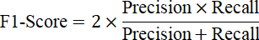
where:
- True Positives = Workers correctly recommended by the system that match the ground truth criteria
- False Positives = Workers incorrectly recommended by the system that do not meet the matching criteria
- False Negatives = Appropriate workers in the ground truth that were not recommended by the system

Geospatial Clustering Accuracy
The effectiveness of the Geospatial Clustering module will be assessed by contrasting the system's classifications of worker zones with a verified geographic dataset. The accuracy of clustering will be determined by the proportion of workers accurately allocated to their respective service zones in accordance with their registered locations and the parameters of their service radius.
Average Response Time
The Average Response Time will be calculated to measure how quickly the system processes and returns results for important user activities, including as worker search queries, booking submissions, real-time chat messaging, and dashboard data presentation. For every request made during the JMeter test execution, this statistic will be recorded in milliseconds.

Throughput
Throughput will be assessed to evaluate how many requests KaAyos can handle successfully in a specific time frame under a given load. This measurement will indicate the system's ability to accommodate multiple homeowners and service providers during peak demand times.


Scalability
Scalability will be evaluated by analyzing how KaAyos's average response time deteriorates as the count of concurrent users is progressively increased during the JMeter ramp-up test.


Reliability under Load
The reliability of KaAyos under load will be assessed by calculating the error rate during prolonged high-concurrency testing. This error rate will represent the percentage of requests that the system is unable to process successfully.

A lower error rate will signify improved system reliability. The researchers will establish an acceptable threshold for the error rate at below five percent (5%) during sustained load testing as the standard for satisfactory reliability performance of KaAyos.

PREPARATION AND EVALUATION
The researchers will prepare the evaluation environment prior to the execution of any benchmarking test to ensure consistency and fairness across all evaluation scenarios. The main tool for gathering quantitative performance and accuracy statistics will be an organized collection of test cases, benchmarking scripts, and assessment datasets. This preparation will be in line with the particular goals stated in the problem description, guaranteeing that every test will directly address a quantifiable research issue related to either the performance of KaAyos or its functional correctness.
The preparation phase will include the following key activities: creating and validating test datasets for the AI-Powered Worker Suggestion System, which consists of predefined service requests paired with expected worker recommendations based on proximity, skills, and reputation scores; creating simulated geographic data to validate the accuracy of the Geospatial Clustering module in mapping high-density worker zones; configuring Apache JMeter test plans covering response time, throughput, scalability, and reliability scenarios, including the definition of thread groups, ramp-up periods, and loop counts calibrated.

System Functionality Evaluation Criteria
System Feature | Evaluation Criterion | Test Output
AI-Powered Worker Suggestion System | Correctly recommends workers based on proximity, skills, availability, and reputation scores | Pass / Fail + Precision, Recall, F1-Score
Geospatial Clustering Module | Accurately maps and clusters workers into appropriate service zones based on location data | Pass / Fail + Clustering Accuracy (%)
Real-Time Booking System | Processes booking requests, sends notifications, and updates status within acceptable time limits | Pass / Fail + Response Time (ms)
Worker Verification Module | Validates uploaded documents and updates verification status correctly | Pass / Fail per verification workflow
In-App Chat Messaging | Delivers messages in real-time between homeowners and service providers via WebSockets | Pass / Fail + Message Delivery Latency (ms)
Rating and Review System | Records and displays accurate ratings and reviews linked to completed bookings | Pass / Fail per CRUD operation
Role-Based Access Control | Enforces correct access restrictions for Homeowner, Service Provider, and Admin roles | Pass / Fail per role-access test case
Analytics Dashboard | Displays accurate booking statistics, earnings data, and performance metrics for service providers | Pass / Fail + Data Accuracy Check
Dispute Resolution System | Correctly logs disputes, tracks resolution status, and notifies relevant parties | Pass / Fail per dispute workflow
Table 3. System Functionality Evaluation Criteria for KaAyos
Table 3 will present the functional evaluation criteria to be applied to each core feature of KaAyos. The accompanying test output column will indicate the metric or result format that will be used to document each evaluation, and each criterion will specify the expected system behavior that must be met for a feature to be deemed operational. Throughout the system validation phase, the researchers will use these criteria as the basis for both automated and manual test procedures.
Performance Rating Scale
The researchers will use the following five-point grading system to provide a consistent framework for assessing the combined outcomes of the system's benchmarking and functional evaluations. This scale will be used to assign descriptive equivalents to each computed metric score range and to summarize KaAyos' overall technical performance across all assessed system aspects.
Scale | Mean Range | Descriptive Equivalent
5 | 4.21 – 5.00 | Excellent
4 | 3.41 – 4.20 | Very Good
3 | 2.61 – 3.40 | Satisfactory
2 | 1.81 – 2.60 | Needs Improvement
1 | 1.00 – 1.80 | Unsatisfactory
Table 4. Performance Rating Scale for KaAyos
Table 4 presents the guideline intervals to be used in interpreting the aggregated performance ratings for the functional effectiveness and technical reliability of the KaAyos platform. The descriptive equivalent for each mean range, which ranges from Excellent to Unsatisfactory, is shown in the table. The accuracy of the AI-Powered Worker Suggestion System, the precision of the Geospatial Clustering Module, and the responsiveness of the Real-Time Booking System are just a few of the important system quality parameters that will be consistently and objectively evaluated thanks to these intervals. Before KaAyos is fully deployed, the guideline will help identify high-performing system components and regions that need more optimization.

ETHICAL CONSIDERATION
In conducting the proposed study, several ethical guidelines will be followed to guarantee adherence to data security, privacy, and research integrity. All user profiles, geographical locations, and transaction records obtained during the creation and assessment of KaAyos will be kept completely confidential by the researchers. The Public Employment Service Office (PESO) of Tuy will grant appropriate institutional authority for all test data utilized in the benchmarking process, which will either be manufactured artificially for evaluation purposes or taken from public service registers. Beyond what is absolutely required for system testing and technical validation, no sensitive personal information on specific homes or service providers will be gathered, processed, or disclosed.
The researchers will ensure that all operations adhere to the stringent rules of the Data Privacy Act of 2012 (Republic Act No. 10173) and local government data guidelines before using any data in the evaluation [50]. The system's role-based authentication and secure encryption procedures will safeguard all saved user profiles, submitted verification documents, and real-time location data within KaAyos, guaranteeing that only authorized users will be able to access critical personal and financial data. In order to prevent illegal tracking or data breaches, the integrity of the geographic clustering and in-app messaging modules will be strictly protected, maintaining the security and privacy of all platform interactions.
Furthermore, in compliance with academic integrity standards, any references to existing algorithms, frameworks, and literature used in the development of KaAyos will be appropriately cited and given credit to their original authors. The specific Application Programming Interfaces (APIs) utilized for AI-driven worker matching and geolocation, as well as testing tools like Apache JMeter, will be appropriately credited and implemented in KaAyos in accordance with their documented specifications and public licensing agreements. The overall goal of these ethical guidelines is to safeguard the rights, privacy, and financial stability of all homeowners, employees, and study stakeholders while ensuring that KaAyos continues to be a reliable, safe, and socially conscious platform.
References
[1] Data Reportal, "Digital 2024: The Philippines," Data Reportal, Jan. 2024. [Online]. Available: https://datareportal.com/reports/digital-2024-philippines
[2]"2024 National Information and Communications Technology Household Survey," PSA-DICT, Manila, Philippines, 2024. [Online]. Available: https://ictstatistics.dict.gov.ph/nicths2024/
[3] 6W Research, "Philippines Online On-Demand Home Services Market (2025-2031)," 6W Research, 2024. [Online]. Available: https://www.6wresearch.com/industry-report/philippines-online-on-demand-home-services-market
[4] Research and Markets, "Home Services Market Size, Competitors, Trends & Forecast," Research and Markets, 2024. [Online]. Available: https://www.researchandmarkets.com/report/home-service
[5] “The Gig Economy Boom: Opportunities and Challenges for Freelancers in 2025,” TheCompany.ph, 2025. Available: https://thecompany.ph/features/the-gig-economy-boom-opportunities-and-challenges-for-freelancers-in-2025/. Accessed: Mar. 2026.
[6] Ipsos Strategy3, "Gig Life PH: Understanding the Realities and Preferences of Filipino Gig Workers," Ipsos, 2025. [Online]. Available: https://www.ipsos.com/sites/default/files/ct/publication/documents/2025-10/Ipsos%20S3%20Gig%20Life%20PH.pdf
[7] Fairwork Philippines, "Fairwork Philippines Ratings 2025: Evaluating Labor Standards in the Philippine Platform Economy," Fairwork Foundation and De La Salle University, 2025. [Online]. Available: https://fair.work/wp-content/uploads/sites/17/2025/09/Fairwork-Philippines-Report-2025-V4.pdf
[8] A. K. Korn, “Informal Home Care in the Digital Transformation: Platform Design and Work Ethics of Care,” Soc. Sci., vol. 14, no. 4, p. 225, Apr. 2025, doi: 10.3390/socsci14040225
[9] A. A. Tandoc, S. A. M. B. Arguiñoso, S. M. F. Carungay, and K. S. Tafalla, "HandyFix: A service design for a location-based mobile application for acquiring on-demand local handyman services in Metro Manila," in Proc. 4th Asia Pacific Conf. Industrial Engineering and Operations Management (IEOM), Ho Chi Minh City, Vietnam, Sep. 2023, pp. 196–205. [Online]. Available: https://ieomsociety.org/proceedings/2023vietnam/59.pdf
[10] M. Peitz, "The economic theory of two-sided platforms," CRC TR 224 Discussion Paper Series, 2024. [Online]. Available: https://www.crctr224.de/research/discussion-papers/archive/dp584/
[11] World Bank, "Working Without Borders: The Promise and Peril of Online Gig Work," World Bank Group, Washington, DC, 2023. [Online]. Available: https://thedocs.worldbank.org/en/doc/75ec866c182238e087167ce03244c8da-0460012023/original/Reading-Deck-Working-without-borders-updated.pdf
[12] M. Esquivias, W. Guillen, S. De Costo, M. Viernes, E. Aquino, and R. Embile, "Initiatives to Measure the Size of Gig Workers and Online-related Occupations in the Philippines Using the Labor Force Survey," Philippine Statistics Authority, Manila, Philippines, 2022. [Online]. Available:https://psa.gov.ph/sites/default/files/ncs/paper-presentations-manuscripts/Initiatives%20to%20Measure%20Gig%20Workers%20and%20Online_Embile_0.pdf
[13] Asian Development Bank, "Gig Economy Employment during the Pandemic: An Analysis of GrabFood Driver Experiences in the Philippines," ADB Briefs, No. 251, Asian Development Bank, Mandaluyong City, Philippines, Jul. 2023. [Online]. Available: https://www.adb.org/publications/gig-economy-employment-pandemic-grabfood-philippine
[14] I. Kadolkar, M. V. Subramony, and S. Kepes, "Algorithmic management in the gig economy: A quantitative review and research integration," Academy of Management Proceedings, vol. 2023, no. 1, p. 14180, Jul. 2023, doi: 10.5465/AMPROC.2023.14180abstract.
[15] W. van Zoonen, A. E. Sivunen, and J. W. Treem, "Algorithmic management of crowdworkers: Implications for workers' identity, belonging, and meaningfulness of work," Computers in Human Behavior, vol. 152, Art. no. 108089, Mar. 2024, doi: 10.1016/j.chb.2023.108089.
[16] M. Peitz, “The economic theory of two-sided platforms,” CRC TR 224 Discussion Paper Series, 2024. [Online]. Available: https://www.crctr224.de/research/discussion-papers/archive/dp584/
[17] W. Chang and J. Park, “A comparative study on the effect of ChatGPT recommendation and AI recommender systems on the formation of a consideration set,” Journal of Retailing and Consumer Services, vol. 78, p. 103743, 2024, doi: 10.1016/j.jretconser.2024.103743.
[18] Z. Teng, A. Wu, and Z. Song, "Research on the influence of artificial intelligence chatbots' service quality on consumers' purchase intention," in Proc. Int. Conf. Human-Computer Interaction, Springer, 2024, pp. 119–130, doi: 10.1007/978-3-031-76806-4_9.
[19] R. Rachmiani, N. K. Oktadinna, and T. R. Fauzan, "The impact of online reviews and ratings on consumer purchasing decisions on e-commerce platforms," International Journal of Management Science and Information Technology, vol. 4, no. 2, pp. 504–515, Dec. 2024, doi: 10.35870/ijmsit.v4i2.3373.
[20] GBG, “Trust-building identity verification trends in 2024,” 2024. [Online]. Available: https://www.gbg.com/en/blog/trust-building-identity-verification-trends-in-2024/
[21] M. P. Yumang, “Impact of online gig economy and satisfaction of workers: A mixed method design,” International Journal of Thesis Projects and Dissertations, vol. 12, no. 4, pp. 1–13, 2024, doi: 10.5281/zenodo.14178305.
[22] J. Duggan, U. Sherman, R. Carbery, and A. McDonnell, "Algorithmic HRM control in the gig economy: The app-worker perspective," Human Resource Management, vol. 62, no. 4, pp. 597–612, 2023, doi: 10.1002/hrm.22168.
[23] M. Palada, P. C. B. Pamor, J. R. B. Sulit, and R. L. C. Villegas, “Uncovering the challenges and opportunities of gig economy for small businesses,” International Journal of Research and Innovation in Social Science, vol. 8, no. 8, pp. 234–247, 2024, doi: 10.47772/IJRISS.2024.8080177.
[24] T. Yamano, A. Maddawin, M. Thomas, and L. Poot, "Gig economy employment during the pandemic: An analysis of GrabFood driver experiences in the Philippines," Asian Development Bank Economics Working Paper Series, no. 251, 2023, doi: 10.22617/BRF220317-2.
[25] Fairwork Philippines, “Fairwork Philippines ratings 2023: Protecting workers’ health, safety, and security in the local platform economy,” De La Salle University, 2023. [Online]. Available: https://fair.work/wp-content/uploads/2023/08/Fairwork-Philippines-Ratings-2023.pdf
[26] R. A. C. Reyes and M. T. M. Reyes, "Digital innovation readiness: A qualitative analysis of challenges and opportunities among micro, small, and medium enterprises," in Proc. IEEE Int. Conf. Innov. Technol., 2025, pp. 1–6, doi: 10.1109/IEMCON61743.2025.11101417.
[27] M. J. Gonzales and K. P. Campos, "Boundaryless careers and ethical implications: A review and critical analysis of the gig economy," Community Development Journal, vol. 8, no. 3, pp. 437–445, 2025, doi: 10.33086/cdj.v8i3.6565.
[28] A. O. Ali, “Influence of Shopee online reviews on consumer purchasing decisions in Baguio City, Philippines,” International Journal for Multidisciplinary Research, vol. 7, no. 5, Sep.–Oct. 2025. [Online]. Available: https://www.ijfmr.com/papers/2025/5/57457.pdf
[29] T. Akamatsu and Y. Oyama, “A market-based efficient matching mechanism for crowdsourced delivery systems with demand/supply elasticities,” Transportation Research Part B: Methodological, vol. 189, pp. 102–125, 2024, doi: 10.1016/j.trb.2024.01.012.
[30] Y. Feng, G. Gallego, and A. L. Lobel, "Optimal match recommendations in two-sided marketplaces with endogenous prices," Management Science, vol. 70, no. 12, pp. 8114–8133, Dec. 2024, doi: 10.1287/mnsc.2022.02691.
[31] I. Nowak, "Informal home care in the digital transformation: Platform design and work ethics of care," Sociologia del Lavoro, vol. 159, no. 1, pp. 45–62, 2023, doi: 10.3280/SL2023-159003.
[32] Y. Ruan and J. Mezei, “When do AI chatbots lead to higher customer satisfaction than human frontline employees in online shopping assistance?” Journal of Retailing and Consumer Services, vol. 68, p. 103059, 2022, doi: 10.1016/j.jretconser.2022.103059.
[33] P. McDonald, P. Williams, R. Mayes, and M. Khan, “Income generation on care work digital labour platforms,” British Journal of Industrial Relations, vol. 62, no. 2, pp. 358–380, 2024, doi: 10.1111/bjir.12745.
[34] P. Katyal and R. Sehgal, “Unraveling the impact of online consumer reviews on consumer buying behavior,” International Journal of Systems Assurance Engineering and Management, vol. 16, no. 2, pp. 330–345, 2024, doi: 10.1007/s13198-024-02134-5.
[35] C. E. Caboverde and J. P. Flaminiano, "Future-proof work? The experiences of gig economy workers in the Philippines," The Economic and Labour Relations Review, vol. 36, no. 1, pp. 161–186, Mar. 2025, doi: 10.1017/elr.2025.10019.
[36] W. Cordova, C. T. Lim, H. T. Ong, H. S. Caraan, G. A. Dela Cruz, and E. F. Jimenez, “Digital innovation and entrepreneurial success in the Philippine MSME sector: Challenges and opportunities,” Economics, vol. 13, no. 3, pp. 69–82, 2025. [Online]. Available: https://www.researchgate.net/publication/395198618_Digital_Innovation_and_Entrepreneurial_Success_in_the_Philippine_MSME_Sector_Challenges_and_Opportunities
[37] M. S. Tacadao, D. B. Navarosa, J. D. Bondad, and M. R. Sto. Tomas, “Evolving a governance framework for workers in the gig economy,” ILS Working Papers 2023, Dept. of Labor and Employment – Institute for Labor Studies, Manila, Philippines, 2023. [Online]. Available: https://ils.dole.gov.ph/downloads/file/753-evolving-a-governance-framework-for-workers-in-the-gig-economy
[38] J. R. Gonzales, “Digital national ID system implications for MSMEs,” Philippine Statistics Authority Report, 2024. [Online]. Available: https://beta.entrepreneurship.org.ph/2024/09/26/empowering-philippine-msmes-through-digital-transformation/
[39] K. Dhiman, M. Phansikar, M. Z. Kazi, and R. Thakur, “A web-based service marketplace,” 2022. [Online]. Available: https://www.researchgate.net/publication/360300476_A_WEB-BASED_SERVICE_MARKETPLACE
[40] M. Rahman, M. Khan, and M. Islam, "Design and implementation of a web-based electronic-commerce system," European Journal of Engineering and Technology Research, vol. 7, no. 2, pp. 124–127, 2022, doi: 10.24018/ejeng.2022.7.2.2789.
[41] A. Kumar, “Unlocking the power of Geolocation API,” Medium, 2024. [Online]. Available: https://medium.com/@kamresh485/unlocking-the-power-of-geolocation-api-aa82169d96df
[42] J. C. Rochet and J. Tirole, “Platform competition in two-sided markets,” Journal of the European Economic Association, vol. 1, no. 4, pp. 990–1029, 2003, doi: 10.1162/154247603322493212.
[43] M. Armstrong, “Competition in two-sided markets,” RAND Journal of Economics, vol. 37, no. 3, pp. 668–691, 2006, doi: 10.1111/j.1756-2171.2006.tb00037.x.
[44] TopDevelopers, “Why use Node.js with React for web development?” 2024. [Online]. Available: https://www.topdevelopers.co/blog/node-js-and-react-for-web-development/
[45] J. C. Rochet and J. Tirole, “Platform competition in two-sided markets,” Journal of the European Economic Association, vol. 1, no. 4, pp. 990–1029, 2003. doi: 10.1162/154247603322493212.
[46] A. M. M. Lamis and J. S. Pisuena, "Web-based program outcomes assessment and evaluation system with data analytics," World Journal of Advanced Research and Reviews (WJARR), 2026. [Online]. Available: https://wjarr.com/sites/default/files/fulltext_pdf/WJARR-2026-0572.pdf
[47] S. Goericke, Software Quality Standards and Agile Testing. Cham, Switzerland: Springer, 2019.
[48] H. Alnuhait, W. Alzyadat, A. Althunibat, H. Kahtan, B. Zaqaibeh, and H. A. Al-Khawaja, "Web application performance assessment: A study of responsiveness, throughput, and scalability," International Journal of Advanced and Applied Sciences (IJAAS), vol. 11, no. 9, 2024. [Online]. Available: https://www.science-gate.com/IJAAS/Articles/2024/2024-11-09/1021833ijaas202409023.pdf
[49] T. Ramadhan et al., "Performance testing analysis on web application: Study case student admission web system," in Proc. 2017 Int. Conf. Sustainable Information Engineering and Technology (SIET), Malang, Indonesia, 2017, pp. 16–21, doi: 10.1109/SIET.2017.8304099.
[50] V. A. Pitogo, "National government agency's compliance on Data Privacy Act of 2012: A case study," J. Phys.: Conf. Ser., vol. 1201, no. 1, p. 012021, 2019, doi: 10.1088/1742-6596/1201/1/012021.

