**CHAPTER III**

**CONCEPTUAL FRAMEWORK**

A theoretical framework is a collection of interrelated concepts, like a theory but not necessarily. A theoretical framework guides your research, determining what things you will measure, and what statistical relationships you will look for.

1. **CONCEPT OF THE STUDY**

**OUTPUT**

Lan-Based Library System for Rizal High School

**INPUT**

* **Knowledge requirements**
* Cataloguing Of Books
* Dewey Decimal System
* **Software requirements**
* Intel (R) Core (TM) i3-2370M
* Windows 7

Home Basic

**PROCESS**

* Library user
* Logging-in
* Administrator
* Log-in
* Book
* Classification
* Cataloguing
* File maintenance
* Borrowing of books
* Returning of books

EVALUATION

A **database** is an integrated collection of logically-related records or files consolidated into a common pool that provides data for one or more multiple uses. One way of classifying databases involves the type of content. For example, bibliography picture, full text numeric, and image. Other classification methods start from examining database models or database architectures. Database consists of software-based “containers” that are structured to collect and store information so users can retrieve, add, update, or remove such information in an automatic fashion. Database programs are designed for users so that they can add, or delete any information needed. The structure of a database is tabular, consisting of rows and columns of information. Over many years general purpose of database systems have dominated the database industry. These offer a wide range of functions, applicable to many, if not most circumstances in modern data processing.

(http:// em.wikipedia.org/wiki/database/database_management_systems)

**Normalization** is the process of structuring relational database schema such that most ambiguity is removed. The stages of normalization are referred to as normal forms and progress from the least restrictive (first normal form) through the most restrictive (fifth normal form). Generally, most database designers do not attempt to implement anything higher than third normal form or boyce-codd normal form.

(<http://www.webopedia.com/term/N/normalization.html>)

**DATA FLOW DIAGRAM**

**CLIENTS**

Log-in/ Inquire Book Borrow the availability Information of book availability of books

Book donations

**DONATIONS**

Generated Reports Input new

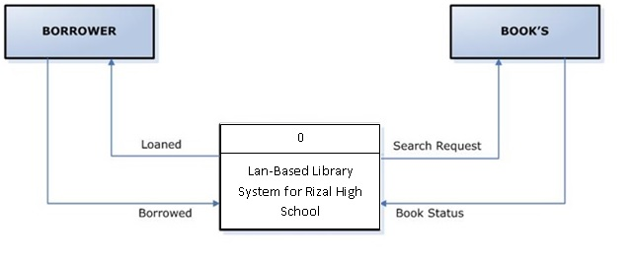

**ADMINISTRATION / STAFF**

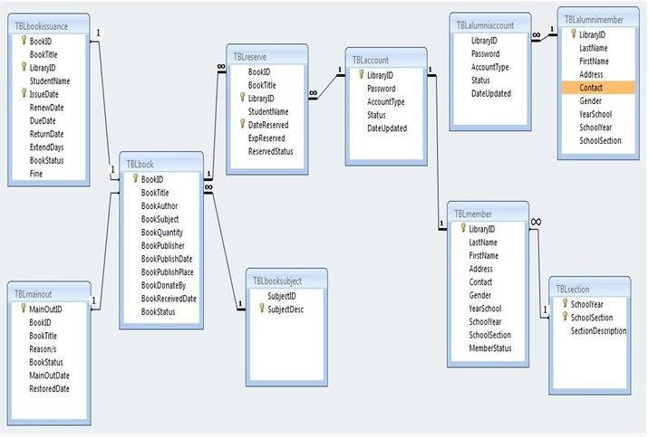**ENTITY RELATIONSHIP DIAGRAM**

1. **CONCEPTUAL OPERATION**

**The functions of the system are:**

* SPLASH SCREEN

The picture of the splash screen represents the company that we are implementing. It last up to 5 seconds.

* LOG-IN

It only allows 3 consecutive wrong attempts in the log-in. the user name accepts 10 numeric characters and the password only allow 6-8 alphanumeric characters.

* CATALOG

In this module, the students will be able to search a specific book through the Book ID, Book Title, Author, Subject and Publisher.

* MAIN FORM

It contains the overall form and functions of the system.

* CREATE ACCOUNT

In the create account form, all fields are required to be filled with information. In this form the account of the librarian is made.

* BORROWERS REGISTRATION

The student is required to register at the borrower’s registration form, for them to borrow a book; if they are not registered they can’t borrow a book. All fields are required.

* BORROWERS RECORD

List view, where you can edit and update the student records.

* BOOK MAINTENANCE

In this form, you can edit, delete, and update the book records. It is the source information and inventory of the books in the library.

* BORROWING OF BOOK

When borrowing a book, the borrower will surrender the student ID and the book to be bar-coded by the librarian. The library strictly implements the seven days policy with the penalty of fifty cents.

* RETURNING OF BOOK

In this form the book is bar-coded when returned to update the book records. Here is where the penalties are computed.

* AVAILABILITY OF BOOKS

The availability of books can also be used for the students to check their needed books, if it is available or not available in the library for their future use. Because the entire library does not have all the books that the student needed for their subjects. The librarian will ask the name of the book to check it in the book list if it is available or not, or if the library has that specific book or not. The availability form is sorted by ascending order.

**The Hierarchical Input/Process/Output (HIPO) Chart**

LAN-BASED LIBRARY SYSTEM

WITH ONLINE RESERVATION OF BOOKS

FOR RIZAL HIGHSCHOOL

1.0

INPUT

2.0

PROCESS

3.0

OUTPUT

4.0

HOURS

2.1

STUDENT DATA

2.2

BORROWERS RECORD

3.1

BORROWING OF BOOKS

3.2

BORROWERS REGISTRATION

4.1

PENALTIES

4.2

CREATE ACCOUNT

4.3

BOOK MAINTENANCE

3.1.1

RETURNING OF BOOKS

3.2.1

AVAILABILITY OF BOOKS

3.3.3

**1.0**

The HIPO chart is a tool used to analyze a problem and visualize a solution using the top down design approach. Starting at the global (macro) level, the chart is decomposed repeatedly at ever-greater levels of detail until the logical building blocks (functions) are identified. The Lan-based library system for Rizal high school process is first broken down into the first level processes. Any process may be broken down in the same way at this level. There will always be an input task, a process task, and an output task in a program.

The next step is to identify the sub-processes or functions for each of these tasks. In a typical library process, the hours worked by each employee during the library period are required as input. The process consists fundamentally of a borrower’s record, borrowing of books, book maintenance, returning of books, availability of books. The output will consist of a borrower’s registration, penalties, create account. There will also be a check register for the company's records. This is the basic process as broken down and illustrated in the example. The process can be much more complicated and detailed in

Reality.

**OPERATIONAL DEFINITION OF TERMS**

* AUTHORIZE

A person who has the right to access the system.

* CATALOUGING

A list of the holdings in a library, usually arranged according to subject, title, or author.

* INVENTORY

Making an inventory of total books and available books.

* PENALTY

A punishment for failing the agreement in the library on terms of returning of books.

* RECORD

It contains an account particularly in terms of collections.

* SEARCH ENGINE

A computer program that searches documents.

* BORROWERS REGISTRATION

It contains all the necessary information of the borrowers.

* BOOK MAINTENANCE

It maintains all the books in the library. Whether you can used it or not.

* RESERVATION OF BOOKS

An arrangement by which accommodations are secured in advance.

1. **METHODOLOGY OF THE STUDY**

Developing of a system is such a hard matter to do. It must be designed methodical, logical and step by step approach. To achieve the stated objectives, the proponents decided to use the system development life cycle. System development life cycle (SDLC) is a methodology that is constructed to ensure that the system is designed and implemented in a methodical approach. It has seven steps known as phases in the system development life cycle: preliminary investigation, data gathering, analysis, design, development, implementation, and maintenance.

**Waterfall Model**

Requirements gathering and Analysis

System Design

Testing

Implementation

Maintenance

WATER FALL MODEL

REQUIREMENTS GATHERING AND ANALYSIS

* The proponent investigates and examines the manual process of transaction inside the library. The proponents interview some of the librarian and staff of the said library and research some needed resources in doing the system. And the proponent studied the deficiency in detail. The needed data has gathered and the details about what the program should do has been identified. A requirement statement should also be done. It contains the major details of the program.

SYSTEM DESIGN

* The proponents are now choosing an interface that must be suitable for the users. In this phase, it is planned of what would be the physical appearance and software features of the system and the group considers also all the details about the system.

IMPLEMENTATION

* In this phase, the requirements of the new system must already be achieved and be tested. The proponents learned the different functions of the commands in the said language as well as the limitation of the software. The user and other beneficiaries of the system must be trained to use the program.

TESTING

* The proponents test the proposed system and analyzed if there’s a problem in the system. In this case, changing and adding of new features to the new system is the major requirement.

MAINTENANCE PHASE

* Maintenance of the system will cover updating the process according to the new requirements of the users. It features the functionality and effectiveness of the developed system. To keep the system running and useful, the proponents regularly check the system to avoid system failures and technical problem.