**Mosaic art**

**Mosaic** is the [art](http://en.wikipedia.org/wiki/Art) of creating images with an assemblage of small pieces of colored [glass](http://en.wikipedia.org/wiki/Glass), stone, or other materials. It is a technique of [decorative art](http://en.wikipedia.org/wiki/Decorative_arts)or [interior decoration](http://en.wikipedia.org/wiki/Interior_decoration).

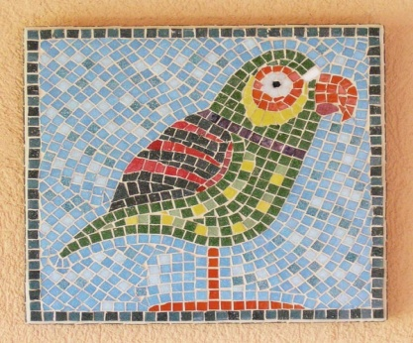 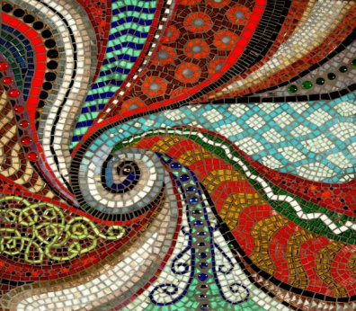 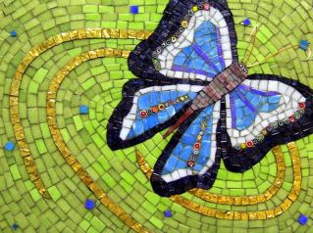

 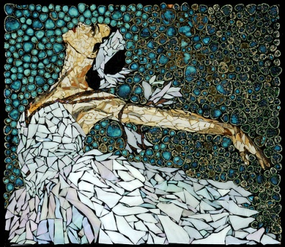 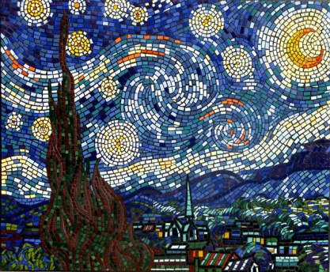

**Percussion instrument -** is a [musical instrument](http://en.wikipedia.org/wiki/Musical_instrument) that is sounded by being struck or scraped by a [beater](http://en.wikipedia.org/w/index.php?title=Beater:_Drumstick,_mallet,_metal_bar,_etc._(music)&action=edit&redlink=1) (including attached or enclosed beaters or[rattles](http://en.wikipedia.org/wiki/Rattle_(percussion_beater))); struck, scraped or rubbed by hand; or struck against another similar instrument. 

**Produse specific pitch**

A **pitched percussion instrument** is a [percussion instrument](http://en.wikipedia.org/wiki/Percussion_instrument) used to produce [musical notes](http://en.wikipedia.org/wiki/Note_(music)) of one or more [pitches](http://en.wikipedia.org/wiki/Pitch_(music)), as opposed to an [unpitched percussion instrument](http://en.wikipedia.org/wiki/Unpitched_percussion_instrument" \o "Unpitched percussion instrument) which is used to produce sounds of [indefinite pitch](http://en.wikipedia.org/wiki/Indefinite_pitch).

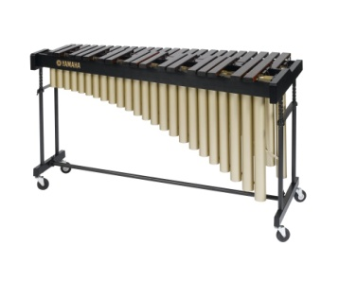**marimba-** is a [musical instrument](http://en.wikipedia.org/wiki/Musical_instrument) in the [percussion](http://en.wikipedia.org/wiki/Percussion_instrument) family. It consists of a set of wooden bars with resonators. The bars are struck with [mallets](http://en.wikipedia.org/wiki/Mallets) to produce musical tones.

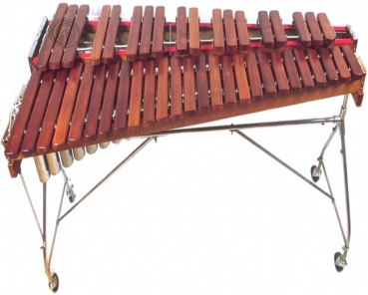 **xylophone -** The **xylophone** (from the [Greek](http://en.wikipedia.org/wiki/Greek_language) words ξύλον—*xylon*, "wood"[[1]](http://en.wikipedia.org/wiki/Xylophone#cite_note-1) + φωνή—*phonē*, "sound, voice",[[2]](http://en.wikipedia.org/wiki/Xylophone#cite_note-2) meaning "wooden sound") is a [musical instrument](http://en.wikipedia.org/wiki/Musical_instrument) in the percussion family that consists of [wooden](http://en.wikipedia.org/wiki/Wood) bars struck by [mallets](http://en.wikipedia.org/wiki/Percussion_mallet).

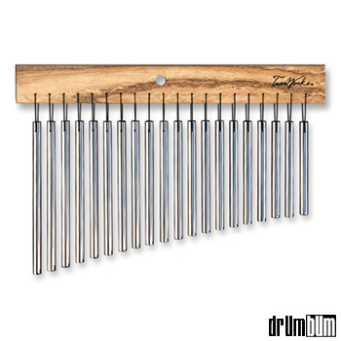 **chimes -** [Tubular bell](http://en.wikipedia.org/wiki/Tubular_bell), or chimes, a percussion instrument struck with hammers.

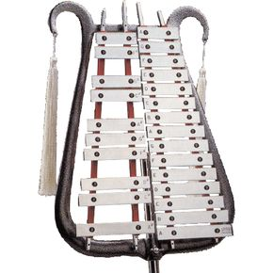 **bell lyre -** consisting of a set of tuned steel bars, arranged like a piano keyboard, which are struck with hammers.

**Non – pitched percussion**

An **unpitched percussion instrument** is a [percussion instrument](http://en.wikipedia.org/wiki/Percussion_instrument) played in such a way as to produce sounds of [indeterminate pitch](http://en.wikipedia.org/wiki/Indeterminate_pitch), or an instrument normally played in this fashion.

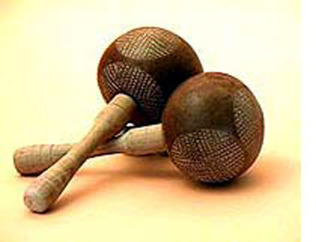 **maracas -Maracas** ([About this sound](http://en.wikipedia.org/wiki/File:Br-Maraca.ogg) [pronunciation](http://upload.wikimedia.org/wikipedia/en/2/23/Br-Maraca.ogg) ([help](http://en.wikipedia.org/wiki/Wikipedia:Media_help" \o "Wikipedia:Media help)·[info](http://en.wikipedia.org/wiki/File:Br-Maraca.ogg)), sometimes called **rumba shakers**) are a native instrument of [Latin America](http://en.wikipedia.org/wiki/Latin_America). They are percussion instruments ([idiophones](http://en.wikipedia.org/wiki/Idiophones)), usually played in pairs.

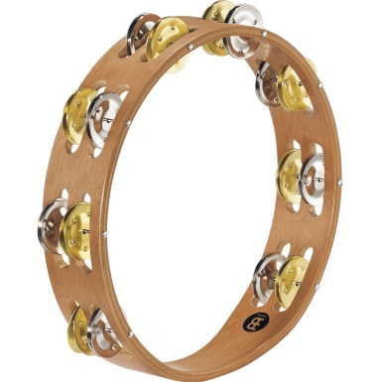 **tambourine -**  is a [musical instrument](http://en.wikipedia.org/wiki/Musical_instrument) in the [percussion family](http://en.wikipedia.org/wiki/Percussion_instrument) consisting of a frame, often of [wood](http://en.wikipedia.org/wiki/Wood) or [plastic](http://en.wikipedia.org/wiki/Plastic), with pairs of small [metal](http://en.wikipedia.org/wiki/Metal) [jingles](http://en.wikipedia.org/wiki/Jingle_(percussion)), called "[zils](http://en.wikipedia.org/wiki/Zill" \o "Zill)".

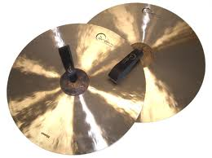 **cymbals -** are a common [percussion instrument](http://en.wikipedia.org/wiki/Percussion_instrument). Cymbals consist of thin, normally round plates of various [alloys](http://en.wikipedia.org/wiki/Alloys); see [cymbal making](http://en.wikipedia.org/wiki/Cymbal_making) for a discussion of their manufacture.

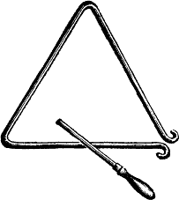 **triangle -** is an [idiophone](http://en.wikipedia.org/wiki/Idiophone) type of [musical instrument](http://en.wikipedia.org/wiki/Musical_instrument) in the [percussion](http://en.wikipedia.org/wiki/Percussion_instrument) family. It is a bar of [metal](http://en.wikipedia.org/wiki/Metal), usually [steel](http://en.wikipedia.org/wiki/Steel) but sometimes other metals like[beryllium copper](http://en.wikipedia.org/wiki/Beryllium_copper), bent into a [triangle](http://en.wikipedia.org/wiki/Triangle) shape.

Dancing terms and dance definitions

**Bailatino** - a mix of Latin dances with no need for a partner.

**Baion** - A type of slow Samba rhythm from Brazil that became popular in North America during the 50's.

**balance** - A step that rocks from one foot to the other, usually in 3/4 time.

**balance** - (ballroom) ability of the dancer to maintain an upright and controlled position of the body whether in movement or still.

**Balboa** - a form of Swing popularized during the 50's in California.

**ballerina** - female dancer. Prima ballerina, or first dancer, is usually used for one who dances leading roles.

**ballet** - classical theatrical dancing based on the danse d'ecole, the rules and vocabulary that were codified around 1700 in France.

**ballet blanc** - A ballet in which the women wear white tutus, such as the second and fourth acts of Swan Lake.

**ballet d'action** - a ballet with a plot, usually tragic.

**ballet de cour, le** (court ballet) - spectacles for entertainment, usually with allegorical or mythological themes, performed by the aristocracy in the sixteenth and seventeenth centuries, combining music, recitatives, and mime.

**ballo** - standard Italian dances and their music of the fifteenth and sixteenth centuries.

**ballon** - the ability of a dancer to remain suspended in air during a jump; elasticity in jumping.

**ballroom dances** - social dances usually performed by couples, including the fox-trot, waltz, tango, rumba, swing, mambo, samba, and cha cha.

**bambuca** - the national dance of Colombia, South America.

**barrida** -  a sweep.

**barn dances** - are the product of our colonial ancestors who recreated them from England's Country Dances. They were performed in halls and barns as get-togethers among America's first social gatherings.

**barre** - the wooden bar that runs around the wall of the ballet studio at waist height, and which the dancer holds onto during the first part of class - usually referred to as the barre. It helps the dancer find or adjust his/her balance.

**bas, en** - low, as in placement of arms.**basic movement** - a characteristic figure that remains constant.

**basse danse** - a solemn court dance usually in duple time, popular in the fifteenth and sixteenth centuries.

**battement** - a beating movement of the legs.

**beguine**  - type of Rumba, probably originated in Martinique or Cuba.

**black bottom** - black couple dance from around 1925. Probably has African American origins.

**bolero** - a dance that originated in Spain. Very slow Rumba rhythm, usually with Spanish vocals.

**boogie woogie** - African American jazz dance. The knees are held close together and the hips sway from side-to-side as the dancer travels forward. Boogie Woogie was originally a style of music, but is today also a dance that is becoming very popular in Europe. It has its roots in the Rock 'n' roll style that was danced in the fifties, like the style found in old movies with Bill Haley.

**Boston Jive** - form of Swing similar to Lindy but with kicks.

**Bossa Nova** - when Brazilian musicians heard the "cool jazz" of the U.S. in the late 1950s and adapted the it to a gentler samba rhythm the result was the music called Bossa Nova. The 1964 hit single "Girl From Ipanema") spread the Bossa Nova throughout the world.

**bourree, pas de** - a series of small, fast steps executed with the feet very close together.

**brise** - a jump off one foot that is "broken" by a beating of the legs in the air.

**bulerias** - a Spanish Gypsy dance.

**bunny hop** - dance that resembles the Conga line.

**Buck** - Buck dancing emphasizes percussive rhythms with a greater use of the heel and toe. The style uses a greater bent leg position that distinguishes it from "shuffle" clogging.