ATLAS — Pakistan Border Satellite Surveillance Report
Date: 2026-04-27 | Generated: 2026-04-28 08:57:28

Executive Summary
Total Border Crossings | 41
Unique Satellites | 21
Indian Satellites Detected | 8 crossings (4 unique)
Indian Imagery Satellites | 8 crossings
Anomalies Detected | 1
Surveillance Region | 23.5°N–37.5°N, 60.5°E–77.5°E

🇮🇳 INDIAN SATELLITE ACTIVITY (8 crossings)
Indian Space Research Organisation (ISRO) satellites detected over Pakistan:

Satellite | Type | Crossings | Primary Purpose
CARTOSAT-2 | Earth Observation | 2 | High-resolution Earth imaging for cartography, urban planning, and military reconnaissance
CARTOSAT-3 | Earth Observation | 2 | High-resolution Earth imaging for cartography, urban planning, and military reconnaissance
RESOURCESAT-2 | Earth Observation | 2 | Natural resource monitoring, agriculture, forestry, and land use mapping
RESOURCESAT-2A | Earth Observation | 2 | Natural resource monitoring, agriculture, forestry, and land use mapping

📷 INDIAN IMAGERY SATELLITES - BORDER CROSSING DETAILS
Detailed entry/exit points for Indian reconnaissance and imaging satellites:

Visual Map - All Indian Satellite Paths:
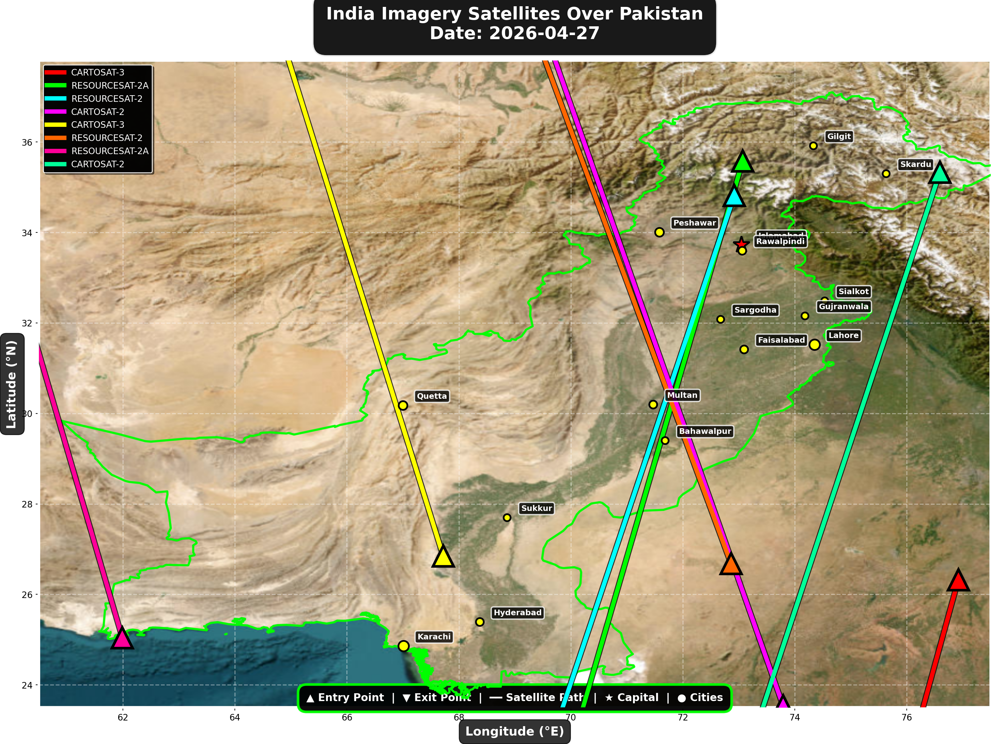

1. CARTOSAT-3 (Earth Observation)
Entry Time | 2026-04-27 04:36:00 UTC
Entry Point | 26.32°N, 76.92°E
Exit Time | 2026-04-27 04:37:00 UTC
Duration Over Pakistan | 1.0 minutes
Maximum Altitude | 514.3 km
Direction of Travel | N/A
Owner/Operator | ISRO
➤ Entered Pakistani airspace from the east (Indian border - Punjab/Rajasthan sector), traveling N/A. Satellite remained over Pakistan for 1.0 minutes at altitude 514.3 km.

2. RESOURCESAT-2A (Earth Observation)
Entry Time | 2026-04-27 04:58:00 UTC
Entry Point | 35.58°N, 73.07°E
Exit Time | 2026-04-27 05:02:00 UTC
Duration Over Pakistan | 4.0 minutes
Maximum Altitude | 514.9 km
Direction of Travel | N→S
Owner/Operator | ISRO
➤ Entered Pakistani airspace from the northeast (China/Kashmir border region), traveling north to south. Satellite remained over Pakistan for 4.0 minutes at altitude 514.9 km.

3. RESOURCESAT-2 (Earth Observation)
Entry Time | 2026-04-27 05:32:00 UTC
Entry Point | 34.82°N, 72.92°E
Exit Time | 2026-04-27 05:36:00 UTC
Duration Over Pakistan | 4.0 minutes
Maximum Altitude | 829.5 km
Direction of Travel | N→S
Owner/Operator | ISRO
➤ Entered Pakistani airspace from the border region, traveling north to south. Satellite remained over Pakistan for 4.0 minutes at altitude 829.5 km.

4. CARTOSAT-2 (Earth Observation)
Entry Time | 2026-04-27 10:42:00 UTC
Entry Point | 23.54°N, 73.79°E
Exit Time | 2026-04-27 10:47:00 UTC
Duration Over Pakistan | 5.0 minutes
Maximum Altitude | 855.3 km
Direction of Travel | S→N
Owner/Operator | ISRO
➤ Entered Pakistani airspace from the south (Arabian Sea/Indian Ocean), traveling south to north. Satellite remained over Pakistan for 5.0 minutes at altitude 855.3 km.

5. CARTOSAT-3 (Earth Observation)
Entry Time | 2026-04-27 16:41:00 UTC
Entry Point | 26.85°N, 67.72°E
Exit Time | 2026-04-27 16:44:00 UTC
Duration Over Pakistan | 3.0 minutes
Maximum Altitude | 514.6 km
Direction of Travel | S→N
Owner/Operator | ISRO
➤ Entered Pakistani airspace from the border region, traveling south to north. Satellite remained over Pakistan for 3.0 minutes at altitude 514.6 km.

6. RESOURCESAT-2 (Earth Observation)
Entry Time | 2026-04-27 16:48:00 UTC
Entry Point | 26.68°N, 72.86°E
Exit Time | 2026-04-27 16:52:00 UTC
Duration Over Pakistan | 4.0 minutes
Maximum Altitude | 819.1 km
Direction of Travel | S→N
Owner/Operator | ISRO
➤ Entered Pakistani airspace from the border region, traveling south to north. Satellite remained over Pakistan for 4.0 minutes at altitude 819.1 km.

7. RESOURCESAT-2A (Earth Observation)
Entry Time | 2026-04-27 17:05:00 UTC
Entry Point | 25.04°N, 61.99°E
Exit Time | 2026-04-27 17:07:00 UTC
Duration Over Pakistan | 2.0 minutes
Maximum Altitude | 512.5 km
Direction of Travel | S→N
Owner/Operator | ISRO
➤ Entered Pakistani airspace from the south (Arabian Sea/Indian Ocean), traveling south to north. Satellite remained over Pakistan for 2.0 minutes at altitude 512.5 km.

8. CARTOSAT-2 (Earth Observation)
Entry Time | 2026-04-27 23:08:00 UTC
Entry Point | 35.33°N, 76.59°E
Exit Time | 2026-04-27 23:12:00 UTC
Duration Over Pakistan | 4.0 minutes
Maximum Altitude | 836.9 km
Direction of Travel | N→S
Owner/Operator | ISRO
➤ Entered Pakistani airspace from the northeast (China/Kashmir border region), traveling north to south. Satellite remained over Pakistan for 4.0 minutes at altitude 836.9 km.

🇨🇳 CHINA IMAGERY SATELLITES
Visual Map - All China Satellite Paths:
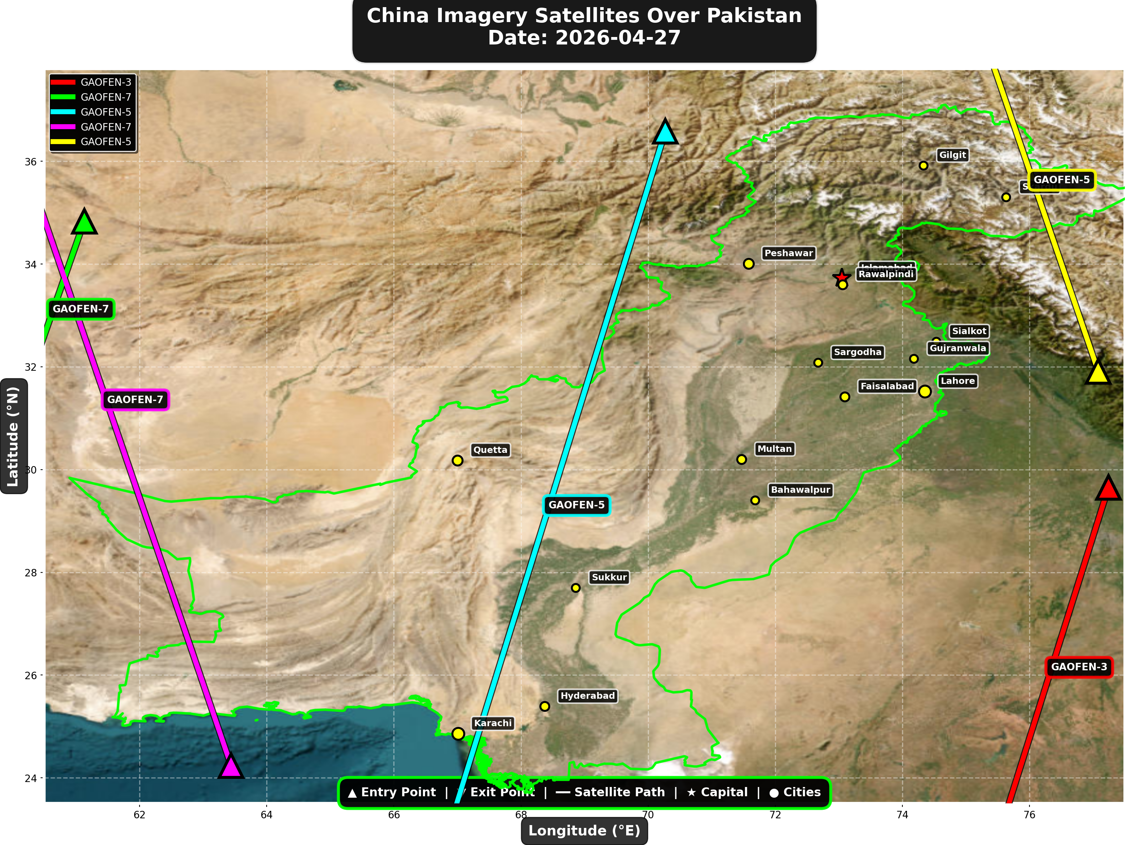

China reconnaissance and imaging satellites detected:
Satellite | Type | Entry Time | Duration (min) | Entry Point | Direction
GAOFEN-3 | Radar/SAR | 01:13:00 | 2.0 | 29.65°N, 77.24°E | N→S
GAOFEN-7 | Earth Observati | 02:35:00 | 1.0 | 34.83°N, 61.13°E | N/A
GAOFEN-5 | Earth Observati | 06:26:00 | 4.0 | 36.58°N, 70.27°E | N→S
GAOFEN-7 | Earth Observati | 13:45:00 | 4.0 | 24.24°N, 63.44°E | S→N
GAOFEN-5 | Earth Observati | 17:14:00 | 2.0 | 31.91°N, 77.08°E | S→N

🇺🇸 USA IMAGERY SATELLITES
Visual Map - All USA Satellite Paths:
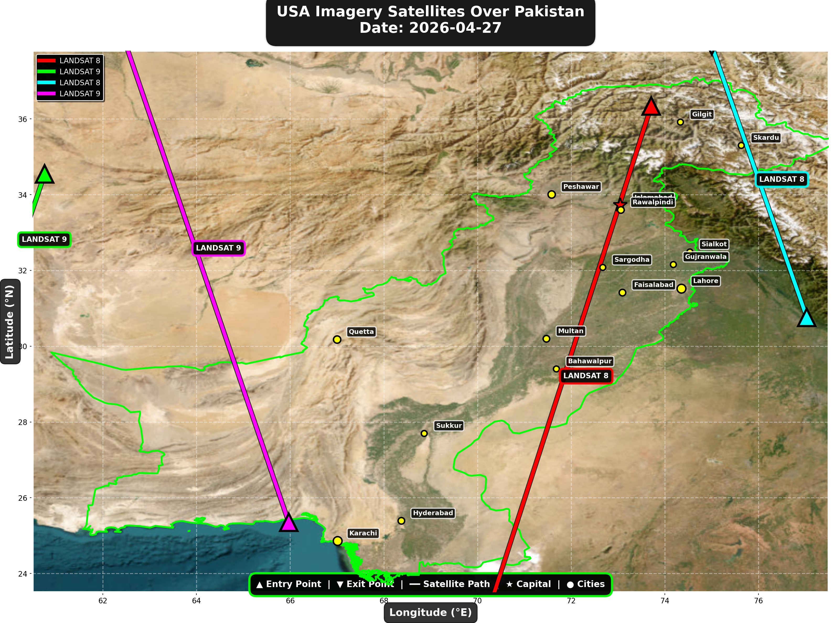

USA reconnaissance and imaging satellites detected:
Satellite | Type | Entry Time | Duration (min) | Entry Point | Direction
LANDSAT 8 | Earth Observati | 05:41:00 | 4.0 | 36.34°N, 73.71°E | N→S
LANDSAT 9 | Earth Observati | 06:31:00 | 1.0 | 34.55°N, 60.76°E | N/A
LANDSAT 8 | Earth Observati | 16:42:00 | 2.0 | 30.76°N, 77.03°E | S→N
LANDSAT 9 | Earth Observati | 17:30:00 | 4.0 | 25.35°N, 65.97°E | S→N

⚠ ANOMALIES DETECTED (1)
- [HIGH] LONG_DURATION: ISS
Owner: NASA/Roscosmos | NORAD 25544
Details: Duration 5.0min is 114% longer than avg 2.3min

Crossings by Country
Country | Crossings
China | 15
USA | 9
India | 8
Europe | 6
International | 3

Crossings by Satellite Type
Type | Crossings
Earth Observation | 16
Weather | 15
Space Station | 7
Reconnaissance | 2
Radar/SAR | 1

All Border Crossings (41 total)
# | Satellite | Owner | Country | Type | Entry Time | Duration (min) | Alt (km) | Direction
1 | FENGYUN-3C | CMA | China | Weather | 2026-04-27 00:00:00 UTC | 4.0 | 824.1 | N→S
2 | GAOFEN-3 | CNSA | China | Radar/SAR | 2026-04-27 01:13:00 UTC | 2.0 | 758.3 | N→S
3 | TIANGONG | CNSA | China | Space Station | 2026-04-27 01:31:00 UTC | 4.0 | 388.9 | W→E
4 | GAOFEN-7 | CNSA | China | Earth Observati | 2026-04-27 02:35:00 UTC | 1.0 | 793.3 | N/A
5 | ISS | NASA/Roscosmos | International | Space Station | 2026-04-27 03:02:00 UTC | 1.0 | 430.2 | N/A
6 | TIANGONG | CNSA | China | Space Station | 2026-04-27 03:09:00 UTC | 2.0 | 389.8 | W→E
7 | YAOGAN-14 | PLA | China | Reconnaissance | 2026-04-27 03:18:00 UTC | 2.0 | 160.3 | N→S
8 | METOP-B | EUMETSAT | Europe | Weather | 2026-04-27 04:25:00 UTC | 4.0 | 825.6 | N→S
9 | CARTOSAT-3 | ISRO | India | Earth Observati | 2026-04-27 04:36:00 UTC | 1.0 | 514.3 | N/A
10 | ISS | NASA/Roscosmos | International | Space Station | 2026-04-27 04:38:00 UTC | 3.0 | 431.1 | N→S
11 | METOP-C | EUMETSAT | Europe | Weather | 2026-04-27 04:56:00 UTC | 4.0 | 827.6 | N→S
12 | RESOURCESAT-2A | ISRO | India | Earth Observati | 2026-04-27 04:58:00 UTC | 4.0 | 514.9 | N→S
13 | RESOURCESAT-2 | ISRO | India | Earth Observati | 2026-04-27 05:32:00 UTC | 4.0 | 829.5 | N→S
14 | LANDSAT 8 | NASA/USGS | USA | Earth Observati | 2026-04-27 05:41:00 UTC | 4.0 | 709.1 | N→S
15 | NOAA-18 | NOAA | USA | Weather | 2026-04-27 06:04:00 UTC | 4.0 | 845.8 | N→S
16 | NOAA-19 | NOAA | USA | Weather | 2026-04-27 06:19:00 UTC | 4.0 | 862.4 | N→S
17 | GAOFEN-5 | CNSA | China | Earth Observati | 2026-04-27 06:26:00 UTC | 4.0 | 618.7 | N→S
18 | LANDSAT 9 | NASA/USGS | USA | Earth Observati | 2026-04-27 06:31:00 UTC | 1.0 | 708.9 | N/A
19 | NOAA-20 | NOAA | USA | Weather | 2026-04-27 07:54:00 UTC | 1.0 | 832.8 | N/A
20 | TIANGONG | CNSA | China | Space Station | 2026-04-27 08:00:00 UTC | 4.0 | 390.5 | W→E
21 | METOP-A | EUMETSAT | Europe | Weather | 2026-04-27 08:40:00 UTC | 3.0 | 641.1 | N→S
22 | TIANGONG | CNSA | China | Space Station | 2026-04-27 09:38:00 UTC | 1.0 | 389.6 | N/A
23 | CARTOSAT-2 | ISRO | India | Earth Observati | 2026-04-27 10:42:00 UTC | 5.0 | 855.3 | S→N
24 | FENGYUN-3C | CMA | China | Weather | 2026-04-27 11:16:00 UTC | 4.0 | 831.0 | S→N
25 | GAOFEN-7 | CNSA | China | Earth Observati | 2026-04-27 13:45:00 UTC | 4.0 | 789.3 | S→N
26 | METOP-B | EUMETSAT | Europe | Weather | 2026-04-27 15:41:00 UTC | 4.0 | 827.9 | S→N
27 | METOP-C | EUMETSAT | Europe | Weather | 2026-04-27 16:12:00 UTC | 4.0 | 826.8 | S→N
28 | CARTOSAT-3 | ISRO | India | Earth Observati | 2026-04-27 16:41:00 UTC | 3.0 | 514.6 | S→N
29 | LANDSAT 8 | NASA/USGS | USA | Earth Observati | 2026-04-27 16:42:00 UTC | 2.0 | 709.3 | S→N
30 | RESOURCESAT-2 | ISRO | India | Earth Observati | 2026-04-27 16:48:00 UTC | 4.0 | 819.1 | S→N
31 | RESOURCESAT-2A | ISRO | India | Earth Observati | 2026-04-27 17:05:00 UTC | 2.0 | 512.5 | S→N
32 | GAOFEN-5 | CNSA | China | Earth Observati | 2026-04-27 17:14:00 UTC | 2.0 | 615.3 | S→N
33 | NOAA-18 | NOAA | USA | Weather | 2026-04-27 17:24:00 UTC | 4.0 | 863.0 | S→N
34 | LANDSAT 9 | NASA/USGS | USA | Earth Observati | 2026-04-27 17:30:00 UTC | 4.0 | 709.5 | S→N
35 | NOAA-19 | NOAA | USA | Weather | 2026-04-27 17:39:00 UTC | 4.0 | 855.4 | S→N
36 | YAOGAN-26 | PLA | China | Reconnaissance | 2026-04-27 18:02:00 UTC | 3.0 | 821.9 | S→N
37 | METOP-A | EUMETSAT | Europe | Weather | 2026-04-27 19:30:00 UTC | 4.0 | 767.4 | S→N
38 | ISS | NASA/Roscosmos | International | Space Station | 2026-04-27 19:40:00 UTC | 5.0 | 424.0 | W→E
39 | CARTOSAT-2 | ISRO | India | Earth Observati | 2026-04-27 23:08:00 UTC | 4.0 | 836.9 | N→S
40 | FENGYUN-3C | CMA | China | Weather | 2026-04-27 23:38:00 UTC | 4.0 | 824.1 | N→S
41 | FENGYUN-3D | CMA | China | Weather | 2026-04-27 23:55:00 UTC | 3.0 | 832.4 | N→S

