ATLAS — Pakistan Border Satellite Surveillance Report
Date: 2026-04-28 | Generated: 2026-04-29 10:52:05

Executive Summary
Total Border Crossings | 36
Unique Satellites | 19
Indian Satellites Detected | 6 crossings (4 unique)
Indian Imagery Satellites | 6 crossings
Anomalies Detected | 3
Surveillance Region | 23.5°N–37.5°N, 60.5°E–77.5°E

🇮🇳 INDIAN SATELLITE ACTIVITY (6 crossings)
Indian Space Research Organisation (ISRO) satellites detected over Pakistan:

Satellite | Type | Crossings | Primary Purpose
CARTOSAT-2 | Earth Observation | 1 | High-resolution Earth imaging for cartography, urban planning, and military reconnaissance
CARTOSAT-3 | Earth Observation | 1 | High-resolution Earth imaging for cartography, urban planning, and military reconnaissance
RESOURCESAT-2 | Earth Observation | 2 | Natural resource monitoring, agriculture, forestry, and land use mapping
RESOURCESAT-2A | Earth Observation | 2 | Natural resource monitoring, agriculture, forestry, and land use mapping

📷 INDIAN IMAGERY SATELLITES - BORDER CROSSING DETAILS
Detailed entry/exit points for Indian reconnaissance and imaging satellites:

Visual Map - All Indian Satellite Paths:
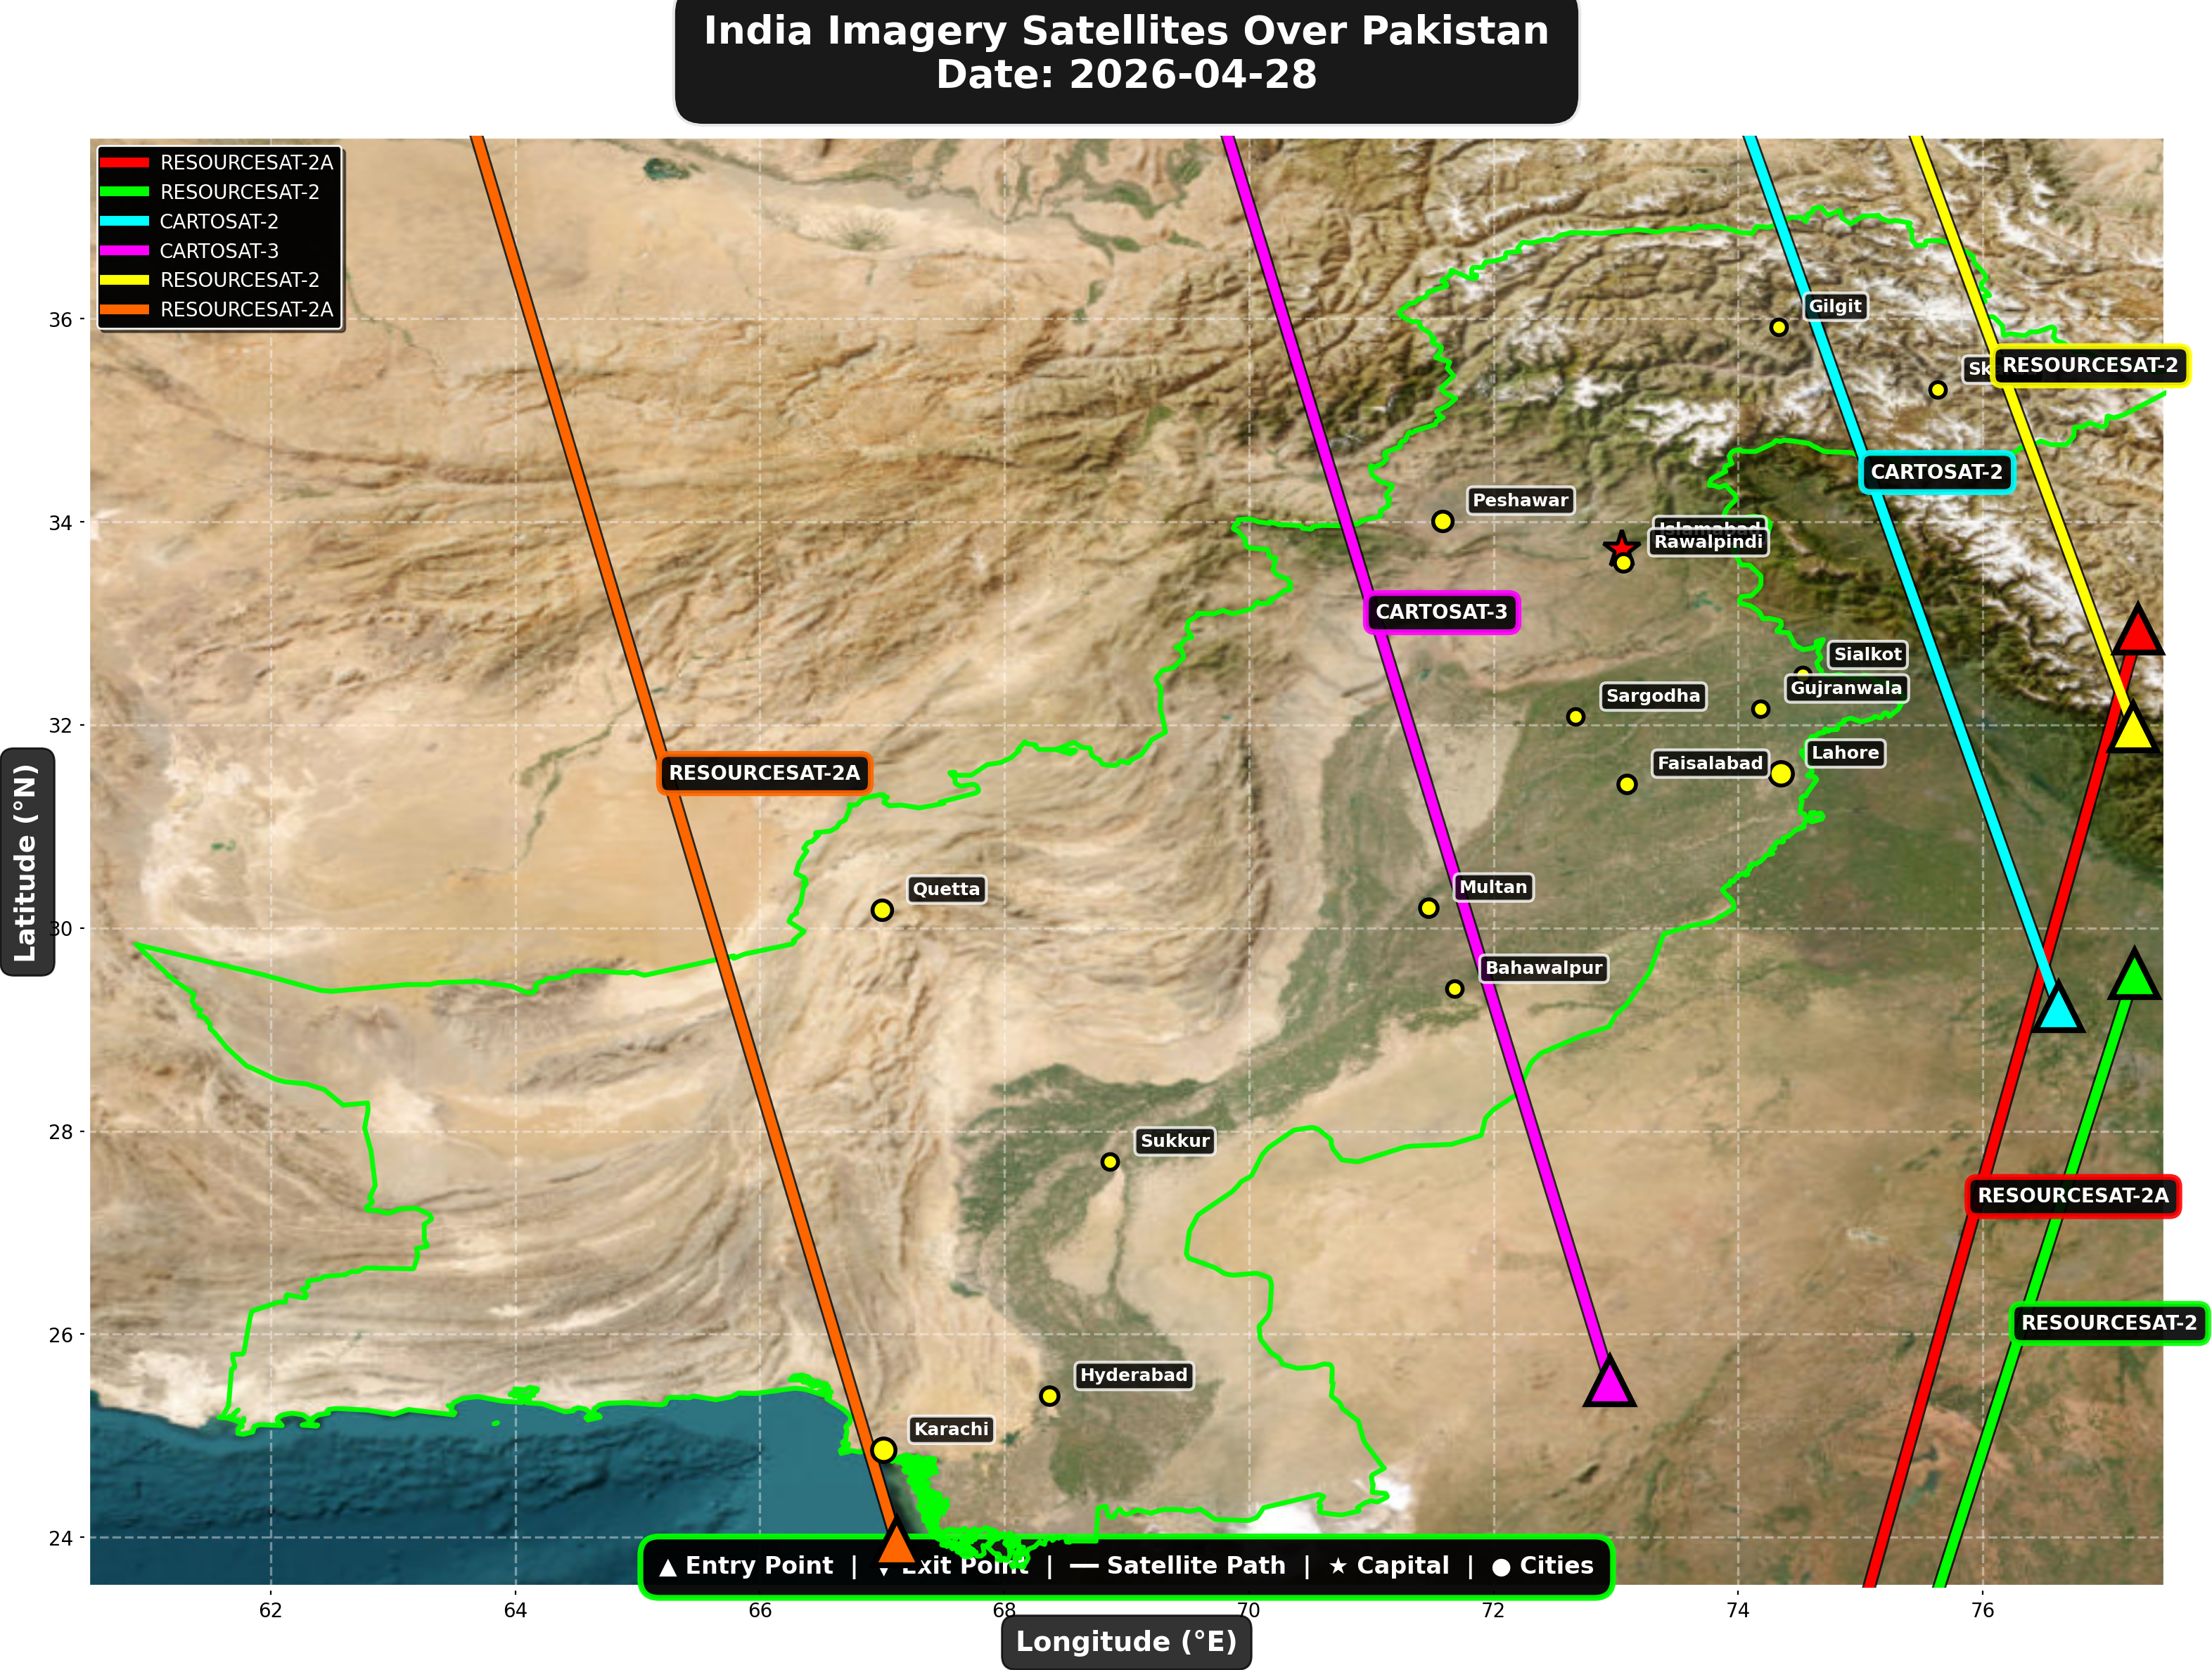

1. RESOURCESAT-2A (Earth Observation)
Entry Time | 2026-04-28 04:42:00 UTC
Entry Point | 32.94°N, 77.27°E
Exit Time | 2026-04-28 04:45:00 UTC
Duration Over Pakistan | 3.0 minutes
Maximum Altitude | 515.1 km
Direction of Travel | N→S
Owner/Operator | ISRO
➤ Entered Pakistani airspace from the east (Indian border - Punjab/Rajasthan sector), traveling north to south. Satellite remained over Pakistan for 3.0 minutes at altitude 515.1 km.

2. RESOURCESAT-2 (Earth Observation)
Entry Time | 2026-04-28 05:13:00 UTC
Entry Point | 29.55°N, 77.24°E
Exit Time | 2026-04-28 05:15:00 UTC
Duration Over Pakistan | 2.0 minutes
Maximum Altitude | 829.9 km
Direction of Travel | N→S
Owner/Operator | ISRO
➤ Entered Pakistani airspace from the east (Indian border - Punjab/Rajasthan sector), traveling north to south. Satellite remained over Pakistan for 2.0 minutes at altitude 829.9 km.

3. CARTOSAT-2 (Earth Observation)
Entry Time | 2026-04-28 10:29:00 UTC
Entry Point | 29.22°N, 76.62°E
Exit Time | 2026-04-28 10:32:00 UTC
Duration Over Pakistan | 3.0 minutes
Maximum Altitude | 854.0 km
Direction of Travel | S→N
Owner/Operator | ISRO
➤ Entered Pakistani airspace from the east (Indian border - Punjab/Rajasthan sector), traveling south to north. Satellite remained over Pakistan for 3.0 minutes at altitude 854.0 km.

4. CARTOSAT-3 (Earth Observation)
Entry Time | 2026-04-28 16:24:00 UTC
Entry Point | 25.54°N, 72.95°E
Exit Time | 2026-04-28 16:28:00 UTC
Duration Over Pakistan | 4.0 minutes
Maximum Altitude | 514.4 km
Direction of Travel | S→N
Owner/Operator | ISRO
➤ Entered Pakistani airspace from the south (Arabian Sea/Indian Ocean), traveling south to north. Satellite remained over Pakistan for 4.0 minutes at altitude 514.4 km.

5. RESOURCESAT-2 (Earth Observation)
Entry Time | 2026-04-28 16:29:00 UTC
Entry Point | 31.98°N, 77.23°E
Exit Time | 2026-04-28 16:31:00 UTC
Duration Over Pakistan | 2.0 minutes
Maximum Altitude | 818.7 km
Direction of Travel | S→N
Owner/Operator | ISRO
➤ Entered Pakistani airspace from the east (Indian border - Punjab/Rajasthan sector), traveling south to north. Satellite remained over Pakistan for 2.0 minutes at altitude 818.7 km.

6. RESOURCESAT-2A (Earth Observation)
Entry Time | 2026-04-28 16:48:00 UTC
Entry Point | 23.95°N, 67.12°E
Exit Time | 2026-04-28 16:52:00 UTC
Duration Over Pakistan | 4.0 minutes
Maximum Altitude | 512.2 km
Direction of Travel | S→N
Owner/Operator | ISRO
➤ Entered Pakistani airspace from the south (Arabian Sea/Indian Ocean), traveling south to north. Satellite remained over Pakistan for 4.0 minutes at altitude 512.2 km.

🇨🇳 CHINA IMAGERY SATELLITES
Visual Map - All China Satellite Paths:
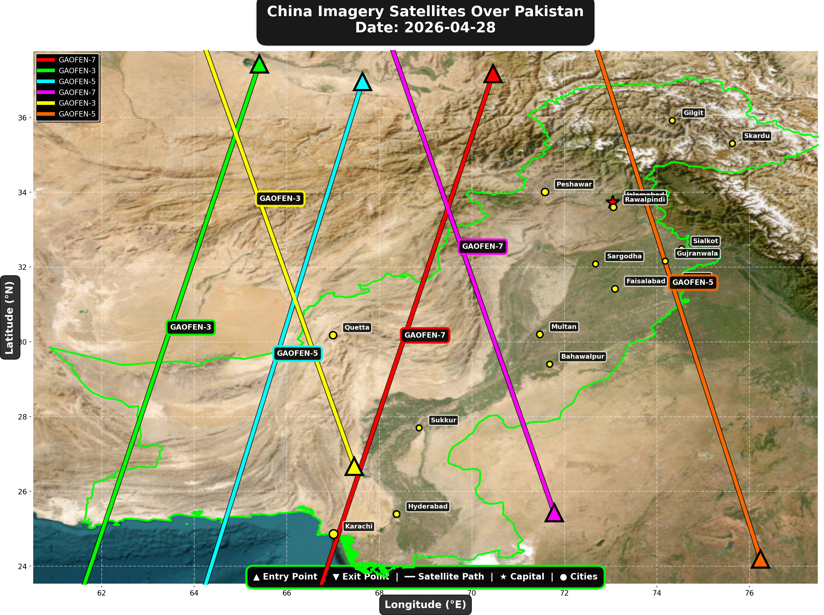

China reconnaissance and imaging satellites detected:
Satellite | Type | Entry Time | Duration (min) | Entry Point | Direction
GAOFEN-7 | Earth Observati | 02:03:00 | 4.0 | 37.17°N, 70.46°E | N→S
GAOFEN-3 | Radar/SAR | 02:10:00 | 4.0 | 37.43°N, 65.41°E | N→S
GAOFEN-5 | Earth Observati | 06:40:00 | 4.0 | 36.96°N, 67.64°E | N→S
GAOFEN-7 | Earth Observati | 13:14:00 | 4.0 | 25.43°N, 71.78°E | S→N
GAOFEN-3 | Radar/SAR | 13:17:00 | 4.0 | 26.67°N, 67.46°E | S→N
GAOFEN-5 | Earth Observati | 17:26:00 | 4.0 | 24.19°N, 76.24°E | S→N

🇺🇸 USA IMAGERY SATELLITES
Visual Map - All USA Satellite Paths:
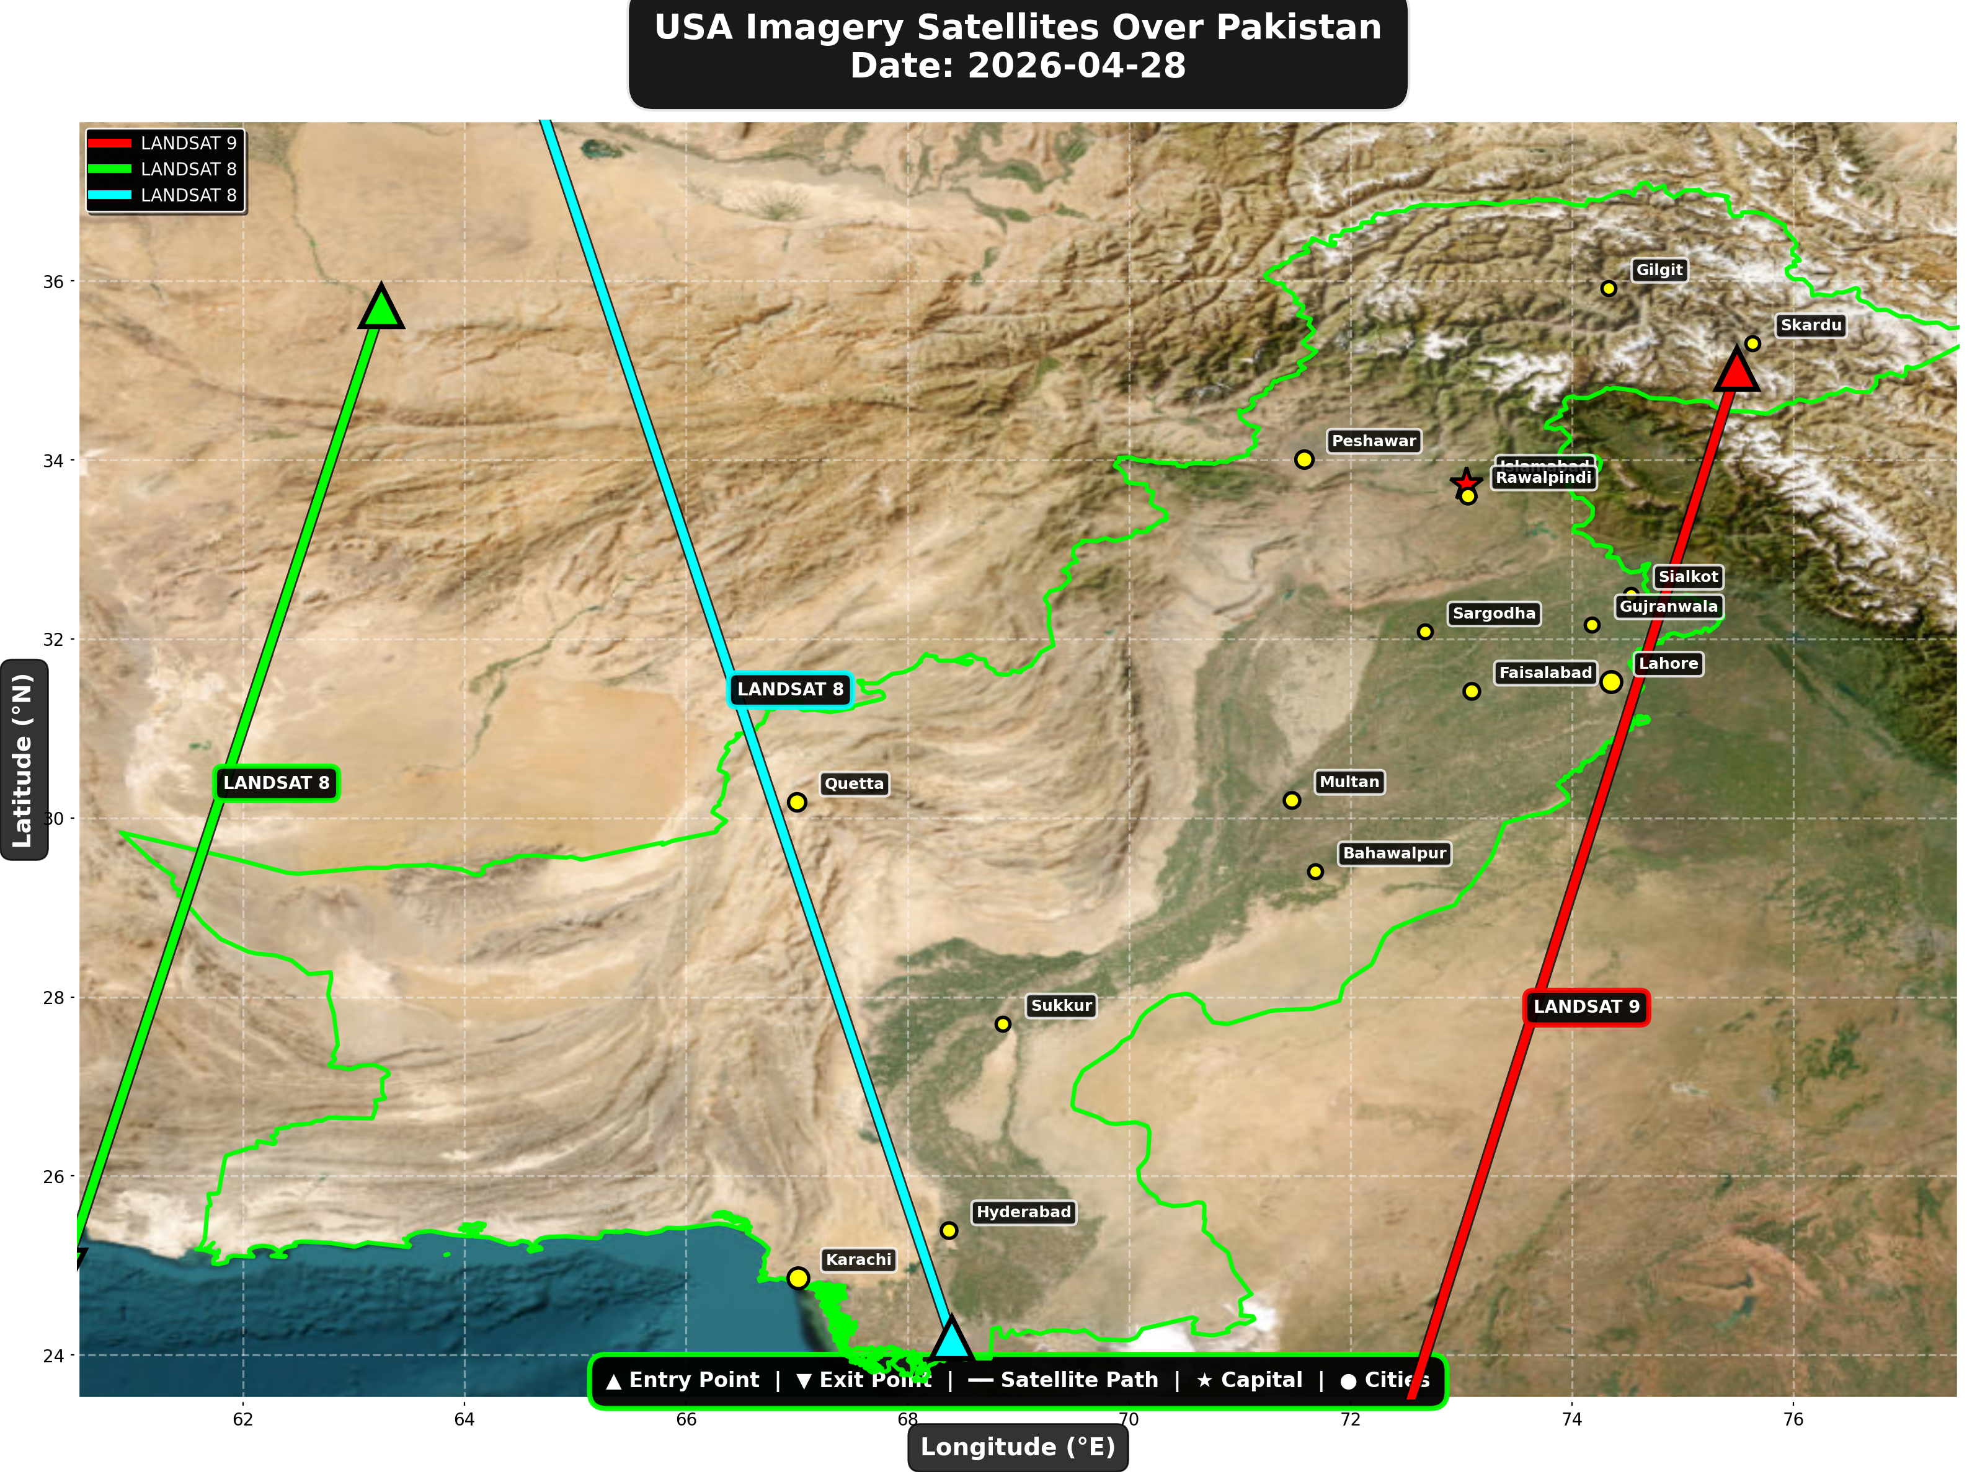

USA reconnaissance and imaging satellites detected:
Satellite | Type | Entry Time | Duration (min) | Entry Point | Direction
LANDSAT 9 | Earth Observati | 05:36:00 | 4.0 | 35.02°N, 75.49°E | N→S
LANDSAT 8 | Earth Observati | 06:25:00 | 3.0 | 35.72°N, 63.25°E | N→S
LANDSAT 8 | Earth Observati | 17:24:00 | 4.0 | 24.19°N, 68.4°E | S→N

⚠ ANOMALIES DETECTED (3)
- [HIGH] LONG_DURATION: GAOFEN-7
Owner: CNSA | NORAD 44547
Details: Duration 4.0min is 71% longer than avg 2.3min
- [HIGH] LONG_DURATION: NOAA-20
Owner: NOAA | NORAD 43013
Details: Duration 4.0min is 100% longer than avg 2.0min
- [MEDIUM] INCREASED_FREQUENCY: FENGYUN-3D
Owner: CMA | NORAD 43010
Details: 3 crossings today vs avg 1.0 per day

Crossings by Country
Country | Crossings
China | 19
USA | 8
India | 6
International | 2
Europe | 1

Crossings by Satellite Type
Type | Crossings
Earth Observation | 13
Weather | 11
Space Station | 6
Reconnaissance | 4
Radar/SAR | 2

All Border Crossings (36 total)
# | Satellite | Owner | Country | Type | Entry Time | Duration (min) | Alt (km) | Direction
1 | FENGYUN-3D | CMA | China | Weather | 2026-04-28 00:00:00 UTC | 1.0 | 832.3 | N/A
2 | TIANGONG | CNSA | China | Space Station | 2026-04-28 00:30:00 UTC | 3.0 | 387.7 | W→E
3 | GAOFEN-7 | CNSA | China | Earth Observati | 2026-04-28 02:03:00 UTC | 4.0 | 793.2 | N→S
4 | TIANGONG | CNSA | China | Space Station | 2026-04-28 02:06:00 UTC | 4.0 | 388.9 | W→E
5 | GAOFEN-3 | CNSA | China | Radar/SAR | 2026-04-28 02:10:00 UTC | 4.0 | 758.3 | N→S
6 | ISS | NASA/Roscosmos | International | Space Station | 2026-04-28 03:50:00 UTC | 4.0 | 430.8 | W→E
7 | YAOGAN-14 | PLA | China | Reconnaissance | 2026-04-28 04:04:00 UTC | 4.0 | 161.1 | N→S
8 | RESOURCESAT-2A | ISRO | India | Earth Observati | 2026-04-28 04:42:00 UTC | 3.0 | 515.1 | N→S
9 | RESOURCESAT-2 | ISRO | India | Earth Observati | 2026-04-28 05:13:00 UTC | 2.0 | 829.9 | N→S
10 | LANDSAT 9 | NASA/USGS | USA | Earth Observati | 2026-04-28 05:36:00 UTC | 4.0 | 709.0 | N→S
11 | NOAA-18 | NOAA | USA | Weather | 2026-04-28 05:52:00 UTC | 4.0 | 845.2 | N→S
12 | NOAA-19 | NOAA | USA | Weather | 2026-04-28 06:07:00 UTC | 4.0 | 861.8 | N→S
13 | YAOGAN-26 | PLA | China | Reconnaissance | 2026-04-28 06:16:00 UTC | 4.0 | 915.1 | N→S
14 | LANDSAT 8 | NASA/USGS | USA | Earth Observati | 2026-04-28 06:25:00 UTC | 3.0 | 709.0 | N→S
15 | GAOFEN-5 | CNSA | China | Earth Observati | 2026-04-28 06:40:00 UTC | 4.0 | 618.4 | N→S
16 | TIANGONG | CNSA | China | Space Station | 2026-04-28 06:58:00 UTC | 4.0 | 390.3 | W→E
17 | TIANGONG | CNSA | China | Space Station | 2026-04-28 08:36:00 UTC | 2.0 | 389.9 | W→E
18 | CARTOSAT-2 | ISRO | India | Earth Observati | 2026-04-28 10:29:00 UTC | 3.0 | 854.0 | S→N
19 | FENGYUN-3C | CMA | China | Weather | 2026-04-28 10:56:00 UTC | 4.0 | 830.8 | S→N
20 | FENGYUN-3D | CMA | China | Weather | 2026-04-28 11:13:00 UTC | 4.0 | 834.0 | S→N
21 | GAOFEN-7 | CNSA | China | Earth Observati | 2026-04-28 13:14:00 UTC | 4.0 | 789.8 | S→N
22 | GAOFEN-3 | CNSA | China | Radar/SAR | 2026-04-28 13:17:00 UTC | 4.0 | 757.7 | S→N
23 | YAOGAN-14 | PLA | China | Reconnaissance | 2026-04-28 15:16:00 UTC | 3.0 | 163.6 | S→N
24 | CARTOSAT-3 | ISRO | India | Earth Observati | 2026-04-28 16:24:00 UTC | 4.0 | 514.4 | S→N
25 | RESOURCESAT-2 | ISRO | India | Earth Observati | 2026-04-28 16:29:00 UTC | 2.0 | 818.7 | S→N
26 | RESOURCESAT-2A | ISRO | India | Earth Observati | 2026-04-28 16:48:00 UTC | 4.0 | 512.2 | S→N
27 | NOAA-18 | NOAA | USA | Weather | 2026-04-28 17:12:00 UTC | 4.0 | 862.4 | S→N
28 | YAOGAN-26 | PLA | China | Reconnaissance | 2026-04-28 17:19:00 UTC | 4.0 | 856.1 | S→N
29 | LANDSAT 8 | NASA/USGS | USA | Earth Observati | 2026-04-28 17:24:00 UTC | 4.0 | 709.4 | S→N
30 | GAOFEN-5 | CNSA | China | Earth Observati | 2026-04-28 17:26:00 UTC | 4.0 | 615.8 | S→N
31 | NOAA-19 | NOAA | USA | Weather | 2026-04-28 17:26:00 UTC | 4.0 | 856.0 | S→N
32 | ISS | NASA/Roscosmos | International | Space Station | 2026-04-28 18:53:00 UTC | 4.0 | 423.3 | W→E
33 | METOP-A | EUMETSAT | Europe | Weather | 2026-04-28 19:55:00 UTC | 4.0 | 769.8 | S→N
34 | NOAA-20 | NOAA | USA | Weather | 2026-04-28 21:37:00 UTC | 4.0 | 833.9 | N→S
35 | FENGYUN-3C | CMA | China | Weather | 2026-04-28 23:18:00 UTC | 4.0 | 823.8 | N→S
36 | FENGYUN-3D | CMA | China | Weather | 2026-04-28 23:37:00 UTC | 4.0 | 832.3 | N→S

