ATLAS — Pakistan Border Satellite Surveillance Report
Date: 2026-04-29 | Generated: 2026-04-30 09:13:29

Executive Summary
Total Border Crossings | 30
Unique Satellites | 17
Indian Satellites Detected | 3 crossings (2 unique)
Indian Imagery Satellites | 3 crossings
Anomalies Detected | 3
Surveillance Region | 23.5°N–37.5°N, 60.5°E–77.5°E

🇮🇳 INDIAN SATELLITE ACTIVITY (3 crossings)
Indian Space Research Organisation (ISRO) satellites detected over Pakistan:

Satellite | Type | Crossings | Primary Purpose
CARTOSAT-3 | Earth Observation | 2 | High-resolution Earth imaging for cartography, urban planning, and military reconnaissance
RESOURCESAT-2A | Earth Observation | 1 | Natural resource monitoring, agriculture, forestry, and land use mapping

📷 INDIAN IMAGERY SATELLITES - BORDER CROSSING DETAILS
Detailed entry/exit points for Indian reconnaissance and imaging satellites:

Visual Map - All Indian Satellite Paths:
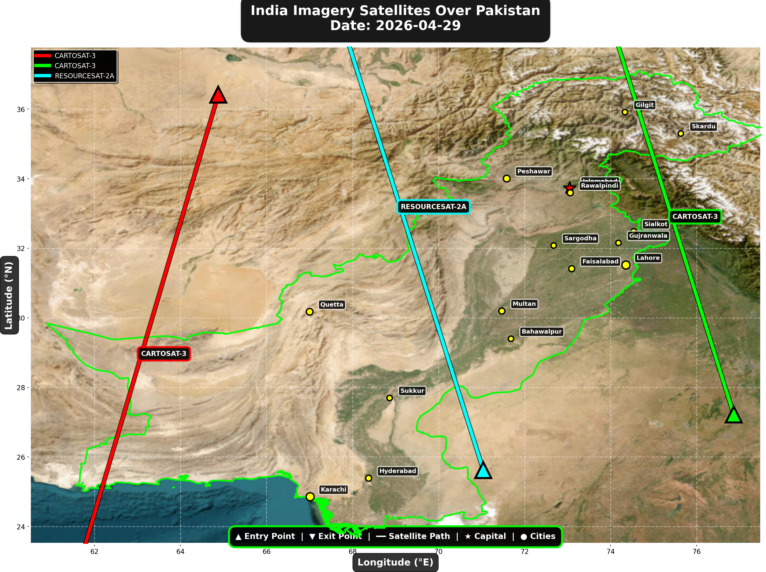

1. CARTOSAT-3 (Earth Observation)
Entry Time | 2026-04-29 05:34:00 UTC
Entry Point | 36.42°N, 64.88°E
Exit Time | 2026-04-29 05:38:00 UTC
Duration Over Pakistan | 4.0 minutes
Maximum Altitude | 514.4 km
Direction of Travel | N→S
Owner/Operator | ISRO
➤ Entered Pakistani airspace from the northwest (Afghanistan/China border region), traveling north to south. Satellite remained over Pakistan for 4.0 minutes at altitude 514.4 km.

2. CARTOSAT-3 (Earth Observation)
Entry Time | 2026-04-29 16:07:00 UTC
Entry Point | 27.22°N, 76.86°E
Exit Time | 2026-04-29 16:10:00 UTC
Duration Over Pakistan | 3.0 minutes
Maximum Altitude | 514.3 km
Direction of Travel | S→N
Owner/Operator | ISRO
➤ Entered Pakistani airspace from the east (Indian border - Punjab/Rajasthan sector), traveling south to north. Satellite remained over Pakistan for 3.0 minutes at altitude 514.3 km.

3. RESOURCESAT-2A (Earth Observation)
Entry Time | 2026-04-29 16:31:00 UTC
Entry Point | 25.62°N, 71.04°E
Exit Time | 2026-04-29 16:35:00 UTC
Duration Over Pakistan | 4.0 minutes
Maximum Altitude | 512.0 km
Direction of Travel | S→N
Owner/Operator | ISRO
➤ Entered Pakistani airspace from the south (Arabian Sea/Indian Ocean), traveling south to north. Satellite remained over Pakistan for 4.0 minutes at altitude 512.0 km.

🇨🇳 CHINA IMAGERY SATELLITES
Visual Map - All China Satellite Paths:
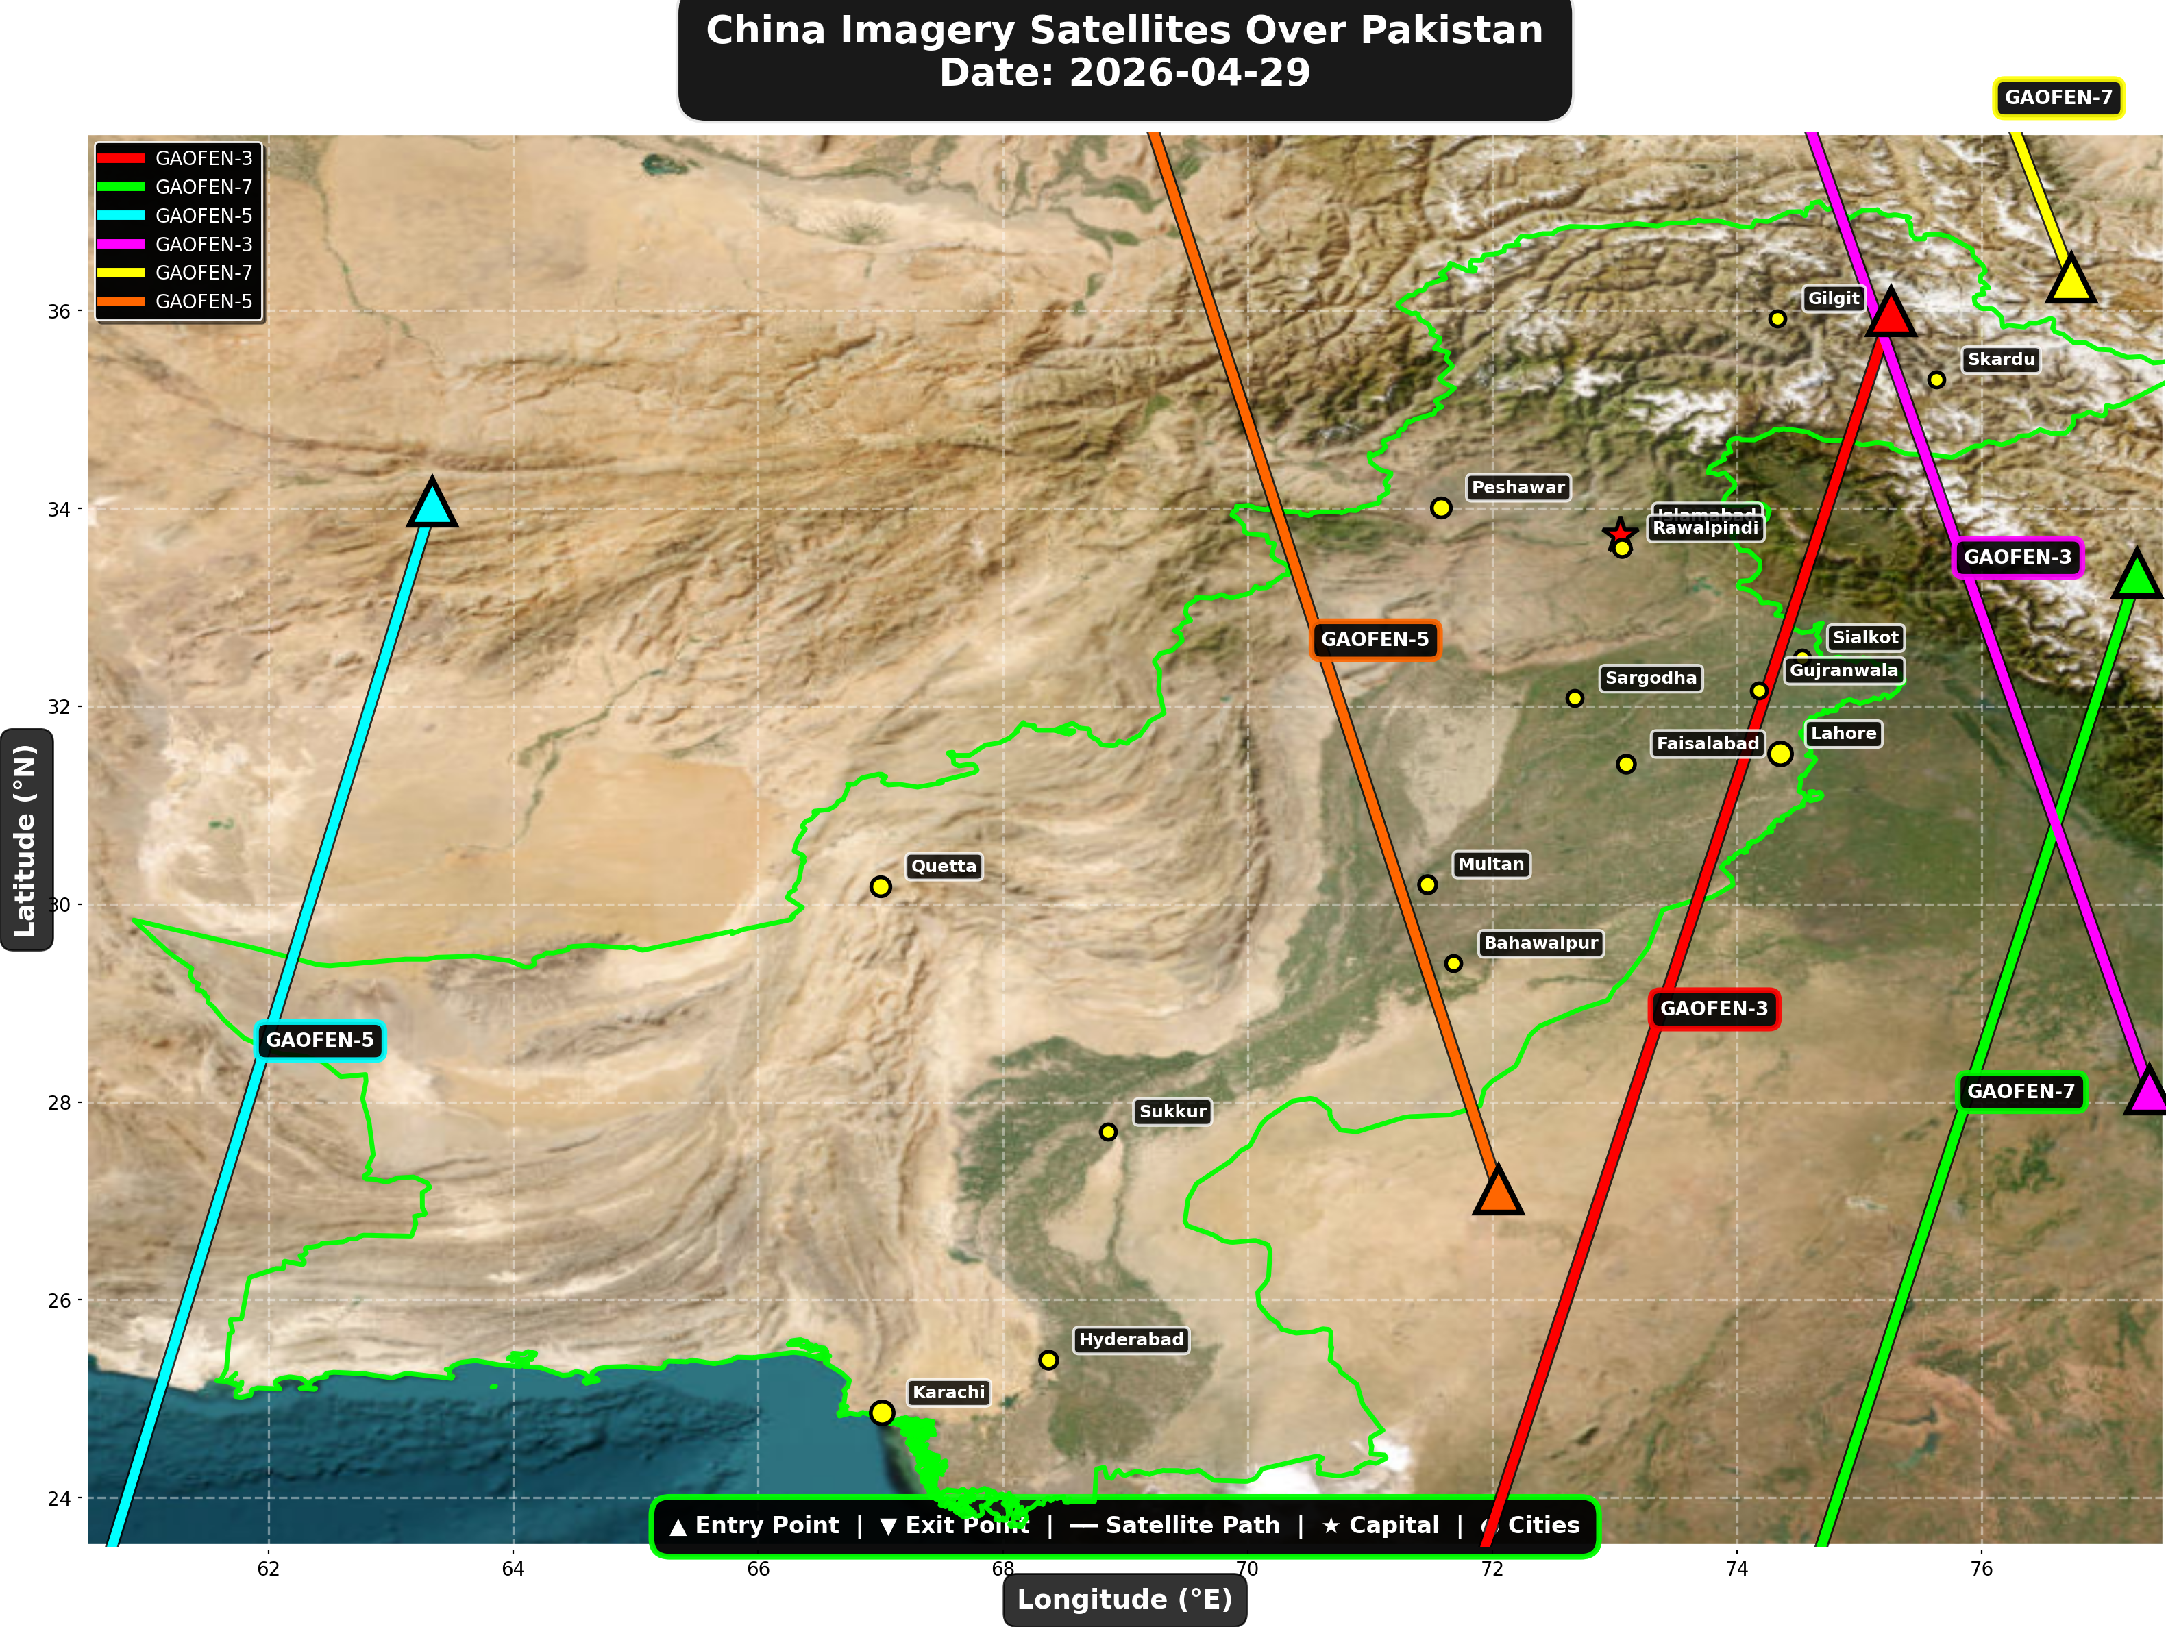

China reconnaissance and imaging satellites detected:
Satellite | Type | Entry Time | Duration (min) | Entry Point | Direction
GAOFEN-3 | Radar/SAR | 01:29:00 | 4.0 | 35.99°N, 75.26°E | N→S
GAOFEN-7 | Earth Observati | 01:32:00 | 3.0 | 33.34°N, 77.27°E | N→S
GAOFEN-5 | Earth Observati | 06:54:00 | 3.0 | 34.06°N, 63.34°E | N→S
GAOFEN-3 | Radar/SAR | 12:36:00 | 3.0 | 28.12°N, 77.37°E | S→N
GAOFEN-7 | Earth Observati | 12:45:00 | 1.0 | 36.33°N, 76.73°E | N/A
GAOFEN-5 | Earth Observati | 17:40:00 | 3.0 | 27.11°N, 72.05°E | S→N

🇺🇸 USA IMAGERY SATELLITES
Visual Map - All USA Satellite Paths:
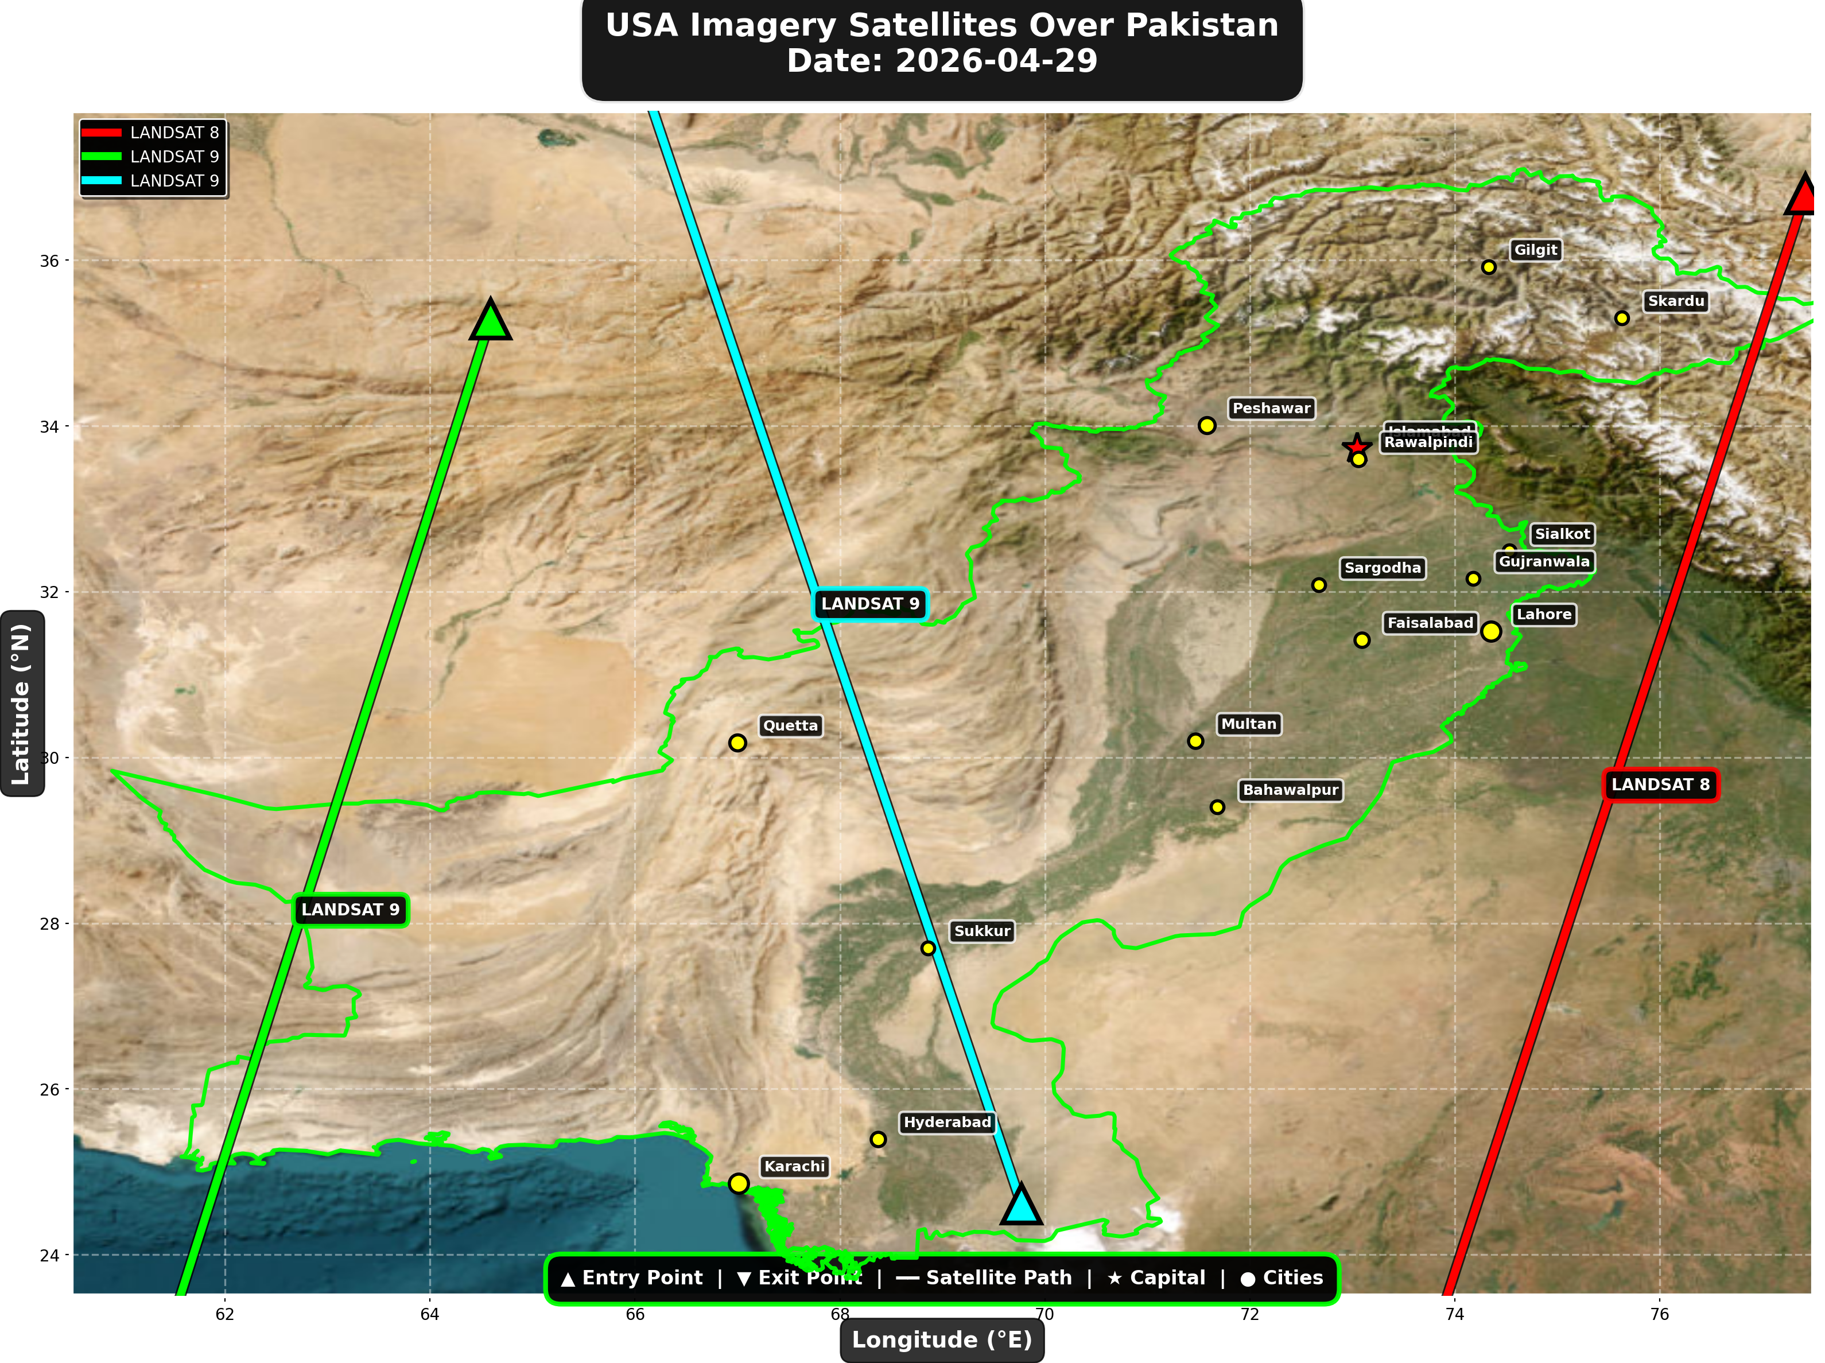

USA reconnaissance and imaging satellites detected:
Satellite | Type | Entry Time | Duration (min) | Entry Point | Direction
LANDSAT 8 | Earth Observati | 05:29:00 | 4.0 | 36.8°N, 77.42°E | N→S
LANDSAT 9 | Earth Observati | 06:19:00 | 4.0 | 35.29°N, 64.59°E | N→S
LANDSAT 9 | Earth Observati | 17:18:00 | 4.0 | 24.61°N, 69.77°E | S→N

⚠ ANOMALIES DETECTED (3)
- [HIGH] LONG_DURATION: TIANGONG
Owner: CNSA | NORAD 48274
Details: Duration 5.0min is 67% longer than avg 3.0min
- [HIGH] LONG_DURATION: ISS
Owner: NASA/Roscosmos | NORAD 25544
Details: Duration 5.0min is 67% longer than avg 3.0min
- [HIGH] LONG_DURATION: NOAA-20
Owner: NOAA | NORAD 43013
Details: Duration 4.0min is 60% longer than avg 2.5min

Crossings by Country
Country | Crossings
China | 15
USA | 8
International | 3
India | 3
Europe | 1

Crossings by Satellite Type
Type | Crossings
Earth Observation | 10
Weather | 9
Space Station | 6
Reconnaissance | 3
Radar/SAR | 2

All Border Crossings (30 total)
# | Satellite | Owner | Country | Type | Entry Time | Duration (min) | Alt (km) | Direction
1 | TIANGONG | CNSA | China | Space Station | 2026-04-29 01:04:00 UTC | 5.0 | 388.1 | W→E
2 | GAOFEN-3 | CNSA | China | Radar/SAR | 2026-04-29 01:29:00 UTC | 4.0 | 758.3 | N→S
3 | GAOFEN-7 | CNSA | China | Earth Observati | 2026-04-29 01:32:00 UTC | 3.0 | 793.1 | N→S
4 | ISS | NASA/Roscosmos | International | Space Station | 2026-04-29 03:02:00 UTC | 5.0 | 430.5 | W→E
5 | YAOGAN-14 | PLA | China | Reconnaissance | 2026-04-29 03:24:00 UTC | 4.0 | 161.1 | N→S
6 | LANDSAT 8 | NASA/USGS | USA | Earth Observati | 2026-04-29 05:29:00 UTC | 4.0 | 709.0 | N→S
7 | CARTOSAT-3 | ISRO | India | Earth Observati | 2026-04-29 05:34:00 UTC | 4.0 | 514.4 | N→S
8 | NOAA-18 | NOAA | USA | Weather | 2026-04-29 05:39:00 UTC | 4.0 | 845.1 | N→S
9 | TIANGONG | CNSA | China | Space Station | 2026-04-29 05:58:00 UTC | 2.0 | 390.1 | W→E
10 | LANDSAT 9 | NASA/USGS | USA | Earth Observati | 2026-04-29 06:19:00 UTC | 4.0 | 709.0 | N→S
11 | GAOFEN-5 | CNSA | China | Earth Observati | 2026-04-29 06:54:00 UTC | 3.0 | 618.1 | N→S
12 | TIANGONG | CNSA | China | Space Station | 2026-04-29 07:33:00 UTC | 5.0 | 390.1 | W→E
13 | METOP-A | EUMETSAT | Europe | Weather | 2026-04-29 07:52:00 UTC | 4.0 | 623.7 | N→S
14 | NOAA-20 | NOAA | USA | Weather | 2026-04-29 08:55:00 UTC | 4.0 | 832.9 | S→N
15 | FENGYUN-3C | CMA | China | Weather | 2026-04-29 10:35:00 UTC | 4.0 | 830.7 | S→N
16 | FENGYUN-3D | CMA | China | Weather | 2026-04-29 10:54:00 UTC | 4.0 | 834.0 | S→N
17 | GAOFEN-3 | CNSA | China | Radar/SAR | 2026-04-29 12:36:00 UTC | 3.0 | 757.7 | S→N
18 | GAOFEN-7 | CNSA | China | Earth Observati | 2026-04-29 12:45:00 UTC | 1.0 | 790.0 | N/A
19 | YAOGAN-14 | PLA | China | Reconnaissance | 2026-04-29 14:36:00 UTC | 3.0 | 163.6 | S→N
20 | CARTOSAT-3 | ISRO | India | Earth Observati | 2026-04-29 16:07:00 UTC | 3.0 | 514.3 | S→N
21 | RESOURCESAT-2A | ISRO | India | Earth Observati | 2026-04-29 16:31:00 UTC | 4.0 | 512.0 | S→N
22 | NOAA-18 | NOAA | USA | Weather | 2026-04-29 16:59:00 UTC | 4.0 | 862.2 | S→N
23 | NOAA-19 | NOAA | USA | Weather | 2026-04-29 17:16:00 UTC | 1.0 | 856.6 | N/A
24 | LANDSAT 9 | NASA/USGS | USA | Earth Observati | 2026-04-29 17:18:00 UTC | 4.0 | 709.5 | S→N
25 | GAOFEN-5 | CNSA | China | Earth Observati | 2026-04-29 17:40:00 UTC | 3.0 | 616.0 | S→N
26 | ISS | NASA/Roscosmos | International | Space Station | 2026-04-29 18:06:00 UTC | 2.0 | 422.6 | S→N
27 | YAOGAN-26 | PLA | China | Reconnaissance | 2026-04-29 18:15:00 UTC | 1.0 | 824.5 | N/A
28 | ISS | NASA/Roscosmos | International | Space Station | 2026-04-29 19:43:00 UTC | 1.0 | 423.2 | N/A
29 | NOAA-20 | NOAA | USA | Weather | 2026-04-29 21:18:00 UTC | 4.0 | 833.9 | N→S
30 | FENGYUN-3D | CMA | China | Weather | 2026-04-29 23:17:00 UTC | 4.0 | 832.3 | N→S

