ATLAS — Pakistan Border Satellite Surveillance Report
Date: 2026-04-30 | Generated: 2026-05-04 09:57:25

Executive Summary
Total Border Crossings | 40
Unique Satellites | 20
Indian Satellites Detected | 7 crossings (4 unique)
Indian Imagery Satellites | 7 crossings
Anomalies Detected | 2
Surveillance Region | 23.5°N–37.5°N, 60.5°E–77.5°E

🇮🇳 INDIAN SATELLITE ACTIVITY (7 crossings)
Indian Space Research Organisation (ISRO) satellites detected over Pakistan:

Satellite | Type | Crossings | Primary Purpose
CARTOSAT-2 | Earth Observation | 2 | High-resolution Earth imaging for cartography, urban planning, and military reconnaissance
CARTOSAT-3 | Earth Observation | 1 | High-resolution Earth imaging for cartography, urban planning, and military reconnaissance
RESOURCESAT-2 | Earth Observation | 2 | Natural resource monitoring, agriculture, forestry, and land use mapping
RESOURCESAT-2A | Earth Observation | 2 | Natural resource monitoring, agriculture, forestry, and land use mapping

📷 INDIAN IMAGERY SATELLITES - BORDER CROSSING DETAILS
Detailed entry/exit points for Indian reconnaissance and imaging satellites:

Visual Map - All Indian Satellite Paths:
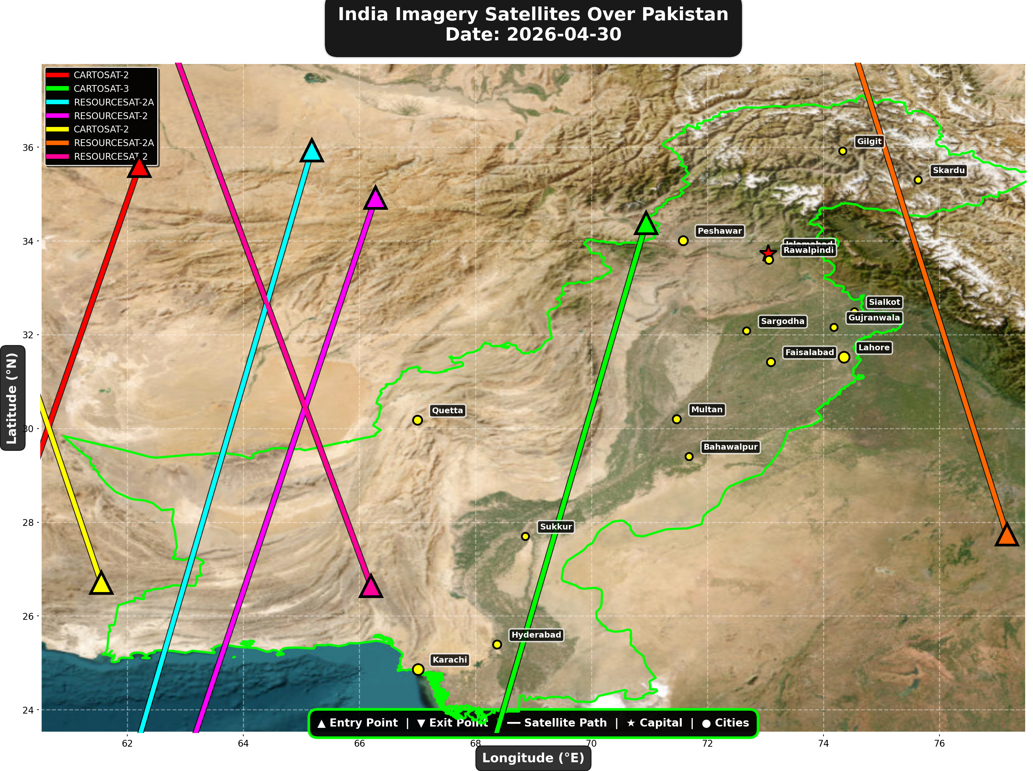

1. CARTOSAT-2 (Earth Observation)
Entry Time | 2026-04-30 00:23:00 UTC
Entry Point | 35.6°N, 62.21°E
Exit Time | 2026-04-30 00:25:00 UTC
Duration Over Pakistan | 2.0 minutes
Maximum Altitude | 835.9 km
Direction of Travel | N→S
Owner/Operator | ISRO
➤ Entered Pakistani airspace from the northwest (Afghanistan/China border region), traveling north to south. Satellite remained over Pakistan for 2.0 minutes at altitude 835.9 km.

2. CARTOSAT-3 (Earth Observation)
Entry Time | 2026-04-30 05:20:00 UTC
Entry Point | 34.38°N, 70.94°E
Exit Time | 2026-04-30 05:23:00 UTC
Duration Over Pakistan | 3.0 minutes
Maximum Altitude | 514.2 km
Direction of Travel | N→S
Owner/Operator | ISRO
➤ Entered Pakistani airspace from the border region, traveling north to south. Satellite remained over Pakistan for 3.0 minutes at altitude 514.2 km.

3. RESOURCESAT-2A (Earth Observation)
Entry Time | 2026-04-30 05:44:00 UTC
Entry Point | 35.93°N, 65.18°E
Exit Time | 2026-04-30 05:48:00 UTC
Duration Over Pakistan | 4.0 minutes
Maximum Altitude | 515.8 km
Direction of Travel | N→S
Owner/Operator | ISRO
➤ Entered Pakistani airspace from the northwest (Afghanistan/China border region), traveling north to south. Satellite remained over Pakistan for 4.0 minutes at altitude 515.8 km.

4. RESOURCESAT-2 (Earth Observation)
Entry Time | 2026-04-30 06:13:00 UTC
Entry Point | 34.92°N, 66.28°E
Exit Time | 2026-04-30 06:17:00 UTC
Duration Over Pakistan | 4.0 minutes
Maximum Altitude | 831.8 km
Direction of Travel | N→S
Owner/Operator | ISRO
➤ Entered Pakistani airspace from the border region, traveling north to south. Satellite remained over Pakistan for 4.0 minutes at altitude 831.8 km.

5. CARTOSAT-2 (Earth Observation)
Entry Time | 2026-04-30 11:42:00 UTC
Entry Point | 26.71°N, 61.55°E
Exit Time | 2026-04-30 11:44:00 UTC
Duration Over Pakistan | 2.0 minutes
Maximum Altitude | 852.4 km
Direction of Travel | S→N
Owner/Operator | ISRO
➤ Entered Pakistani airspace from the west (Iran/Afghanistan border), traveling south to north. Satellite remained over Pakistan for 2.0 minutes at altitude 852.4 km.

6. RESOURCESAT-2A (Earth Observation)
Entry Time | 2026-04-30 16:17:00 UTC
Entry Point | 27.74°N, 77.16°E
Exit Time | 2026-04-30 16:20:00 UTC
Duration Over Pakistan | 3.0 minutes
Maximum Altitude | 511.7 km
Direction of Travel | S→N
Owner/Operator | ISRO
➤ Entered Pakistani airspace from the east (Indian border - Punjab/Rajasthan sector), traveling south to north. Satellite remained over Pakistan for 3.0 minutes at altitude 511.7 km.

7. RESOURCESAT-2 (Earth Observation)
Entry Time | 2026-04-30 17:29:00 UTC
Entry Point | 26.64°N, 66.2°E
Exit Time | 2026-04-30 17:33:00 UTC
Duration Over Pakistan | 4.0 minutes
Maximum Altitude | 818.7 km
Direction of Travel | S→N
Owner/Operator | ISRO
➤ Entered Pakistani airspace from the border region, traveling south to north. Satellite remained over Pakistan for 4.0 minutes at altitude 818.7 km.

🇨🇳 CHINA IMAGERY SATELLITES
Visual Map - All China Satellite Paths:
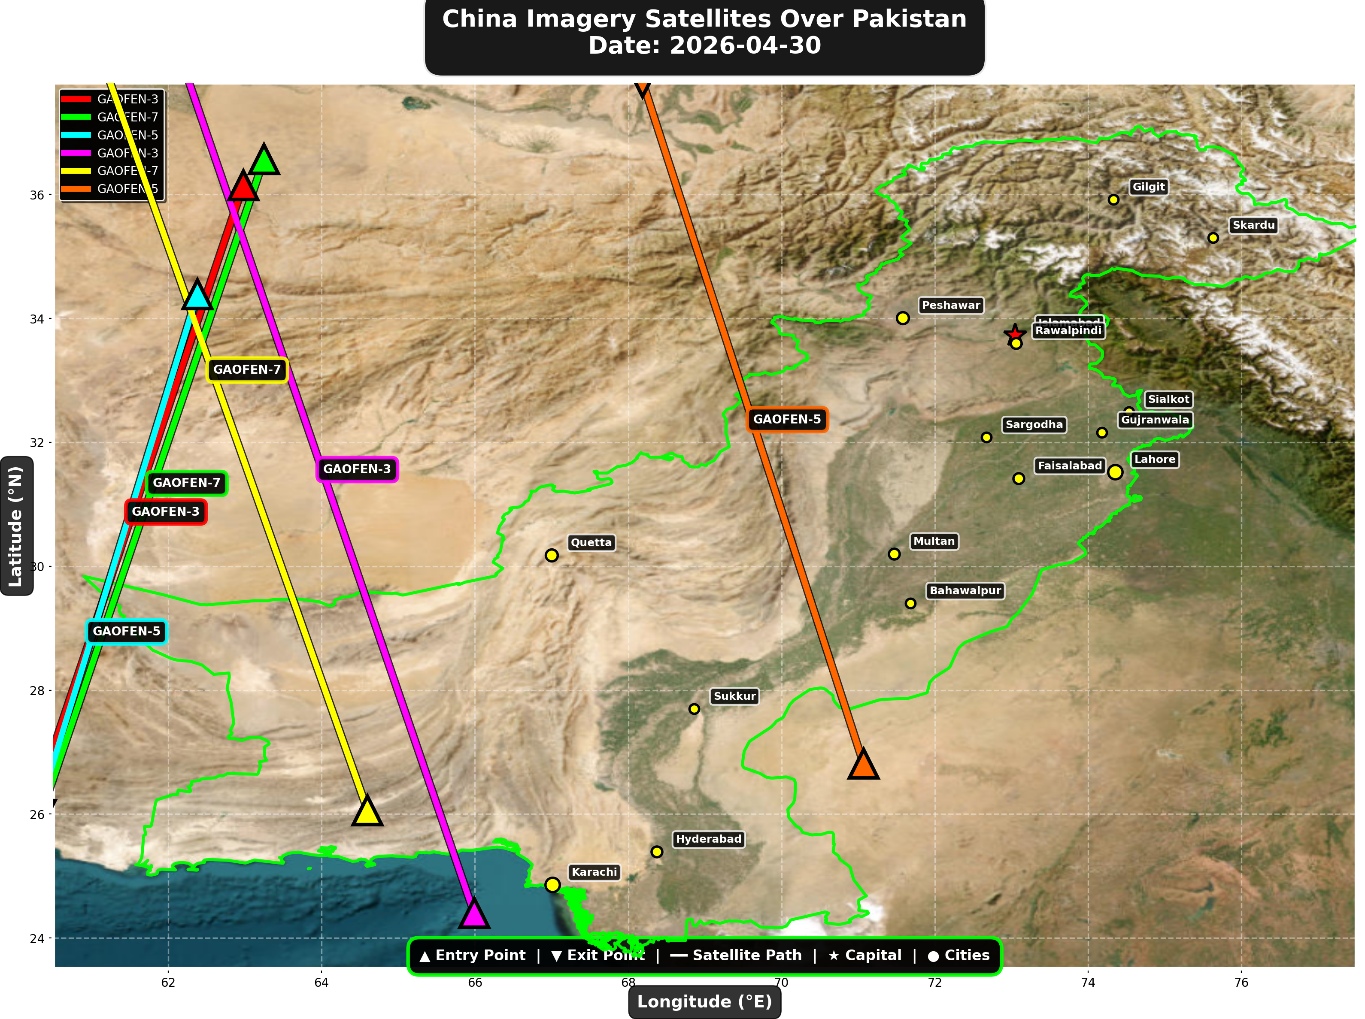

China reconnaissance and imaging satellites detected:
Satellite | Type | Entry Time | Duration (min) | Entry Point | Direction
GAOFEN-3 | Radar/SAR | 02:30:00 | 3.0 | 36.15°N, 62.98°E | N→S
GAOFEN-7 | Earth Observati | 02:42:00 | 3.0 | 36.57°N, 63.25°E | N→S
GAOFEN-5 | Earth Observati | 07:10:00 | 3.0 | 34.39°N, 62.38°E | N→S
GAOFEN-3 | Radar/SAR | 13:36:00 | 4.0 | 24.4°N, 65.99°E | S→N
GAOFEN-7 | Earth Observati | 13:53:00 | 4.0 | 26.06°N, 64.6°E | S→N
GAOFEN-5 | Earth Observati | 17:56:00 | 3.0 | 26.81°N, 71.07°E | S→N

🇺🇸 USA IMAGERY SATELLITES
Visual Map - All USA Satellite Paths:
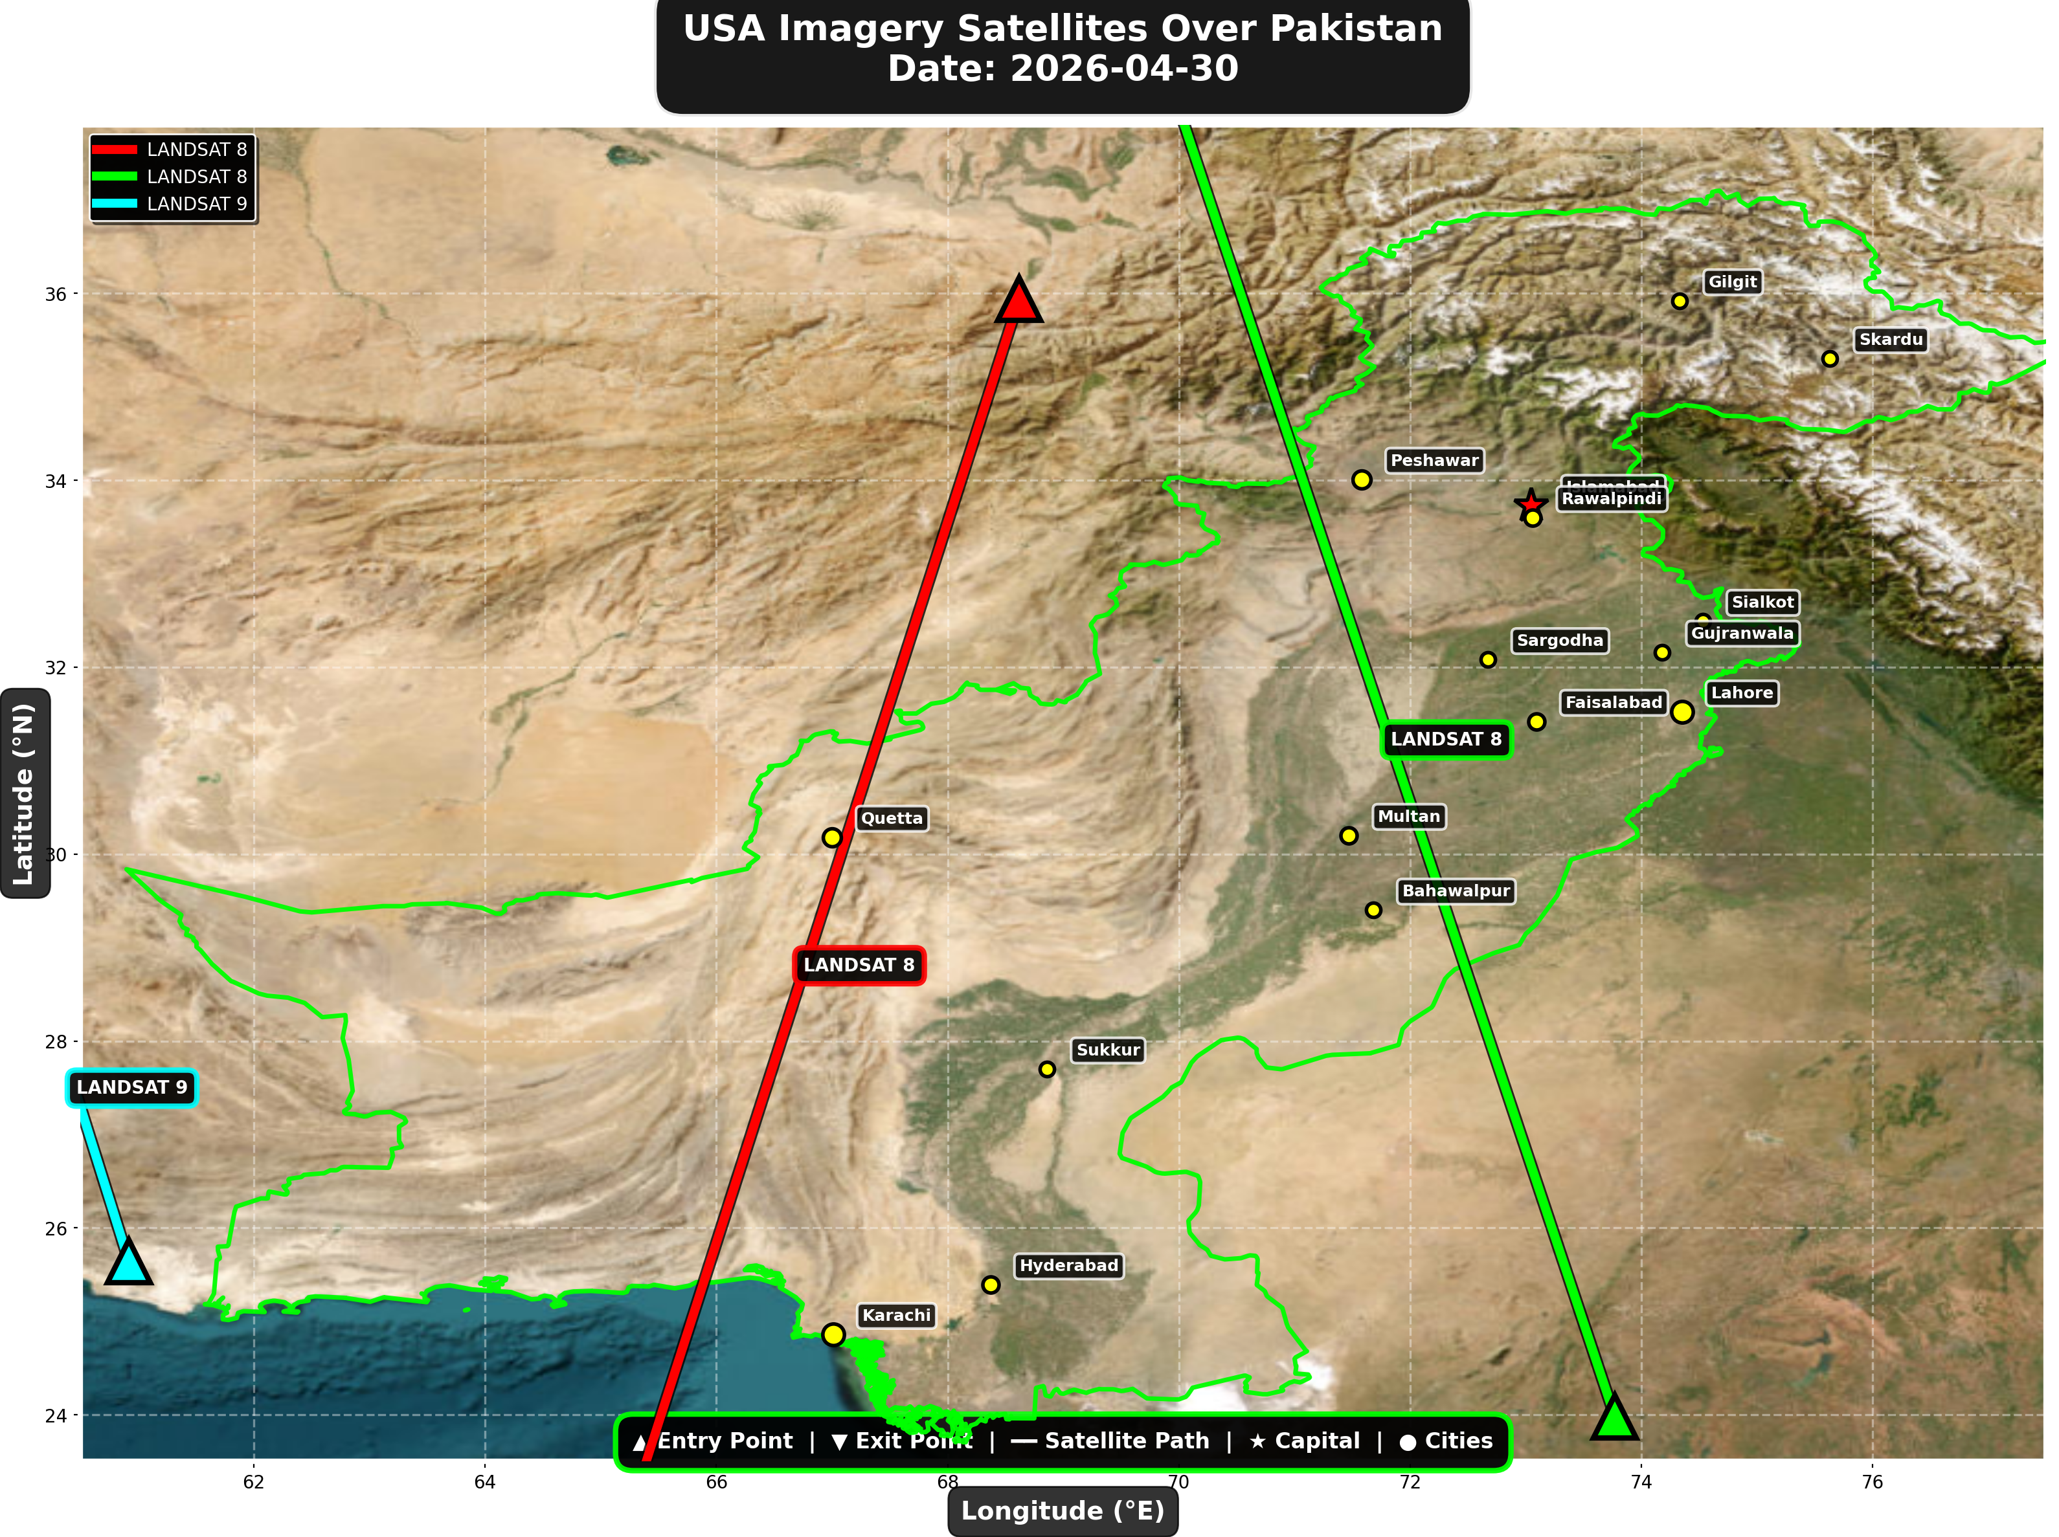

USA reconnaissance and imaging satellites detected:
Satellite | Type | Entry Time | Duration (min) | Entry Point | Direction
LANDSAT 8 | Earth Observati | 06:15:00 | 4.0 | 35.94°N, 68.62°E | N→S
LANDSAT 8 | Earth Observati | 17:14:00 | 4.0 | 23.98°N, 73.77°E | S→N
LANDSAT 9 | Earth Observati | 18:04:00 | 1.0 | 25.64°N, 60.92°E | N/A

⚠ ANOMALIES DETECTED (2)
- [HIGH] LONG_DURATION: TIANGONG
Owner: CNSA | NORAD 48274
Details: Duration 5.0min is 56% longer than avg 3.2min
- [HIGH] LONG_DURATION: ISS
Owner: NASA/Roscosmos | NORAD 25544
Details: Duration 5.0min is 72% longer than avg 2.9min

Crossings by Country
Country | Crossings
China | 16
USA | 8
India | 7
Europe | 6
International | 3

Crossings by Satellite Type
Type | Crossings
Earth Observation | 14
Weather | 13
Space Station | 7
Reconnaissance | 4
Radar/SAR | 2

All Border Crossings (40 total)
# | Satellite | Owner | Country | Type | Entry Time | Duration (min) | Alt (km) | Direction
1 | TIANGONG | CNSA | China | Space Station | 2026-04-30 00:01:00 UTC | 3.0 | 385.9 | W→E
2 | CARTOSAT-2 | ISRO | India | Earth Observati | 2026-04-30 00:23:00 UTC | 2.0 | 835.9 | N→S
3 | ISS | NASA/Roscosmos | International | Space Station | 2026-04-30 00:39:00 UTC | 1.0 | 428.2 | N/A
4 | ISS | NASA/Roscosmos | International | Space Station | 2026-04-30 02:15:00 UTC | 3.0 | 429.7 | N→S
5 | GAOFEN-3 | CNSA | China | Radar/SAR | 2026-04-30 02:30:00 UTC | 3.0 | 758.2 | N→S
6 | GAOFEN-7 | CNSA | China | Earth Observati | 2026-04-30 02:42:00 UTC | 3.0 | 792.7 | N→S
7 | YAOGAN-14 | PLA | China | Reconnaissance | 2026-04-30 04:12:00 UTC | 1.0 | 160.9 | N/A
8 | TIANGONG | CNSA | China | Space Station | 2026-04-30 04:53:00 UTC | 4.0 | 389.0 | W→E
9 | METOP-B | EUMETSAT | Europe | Weather | 2026-04-30 05:06:00 UTC | 4.0 | 825.8 | N→S
10 | CARTOSAT-3 | ISRO | India | Earth Observati | 2026-04-30 05:20:00 UTC | 3.0 | 514.2 | N→S
11 | NOAA-18 | NOAA | USA | Weather | 2026-04-30 05:32:00 UTC | 1.0 | 844.3 | N/A
12 | METOP-C | EUMETSAT | Europe | Weather | 2026-04-30 05:34:00 UTC | 4.0 | 827.6 | N→S
13 | RESOURCESAT-2A | ISRO | India | Earth Observati | 2026-04-30 05:44:00 UTC | 4.0 | 515.8 | N→S
14 | RESOURCESAT-2 | ISRO | India | Earth Observati | 2026-04-30 06:13:00 UTC | 4.0 | 831.8 | N→S
15 | LANDSAT 8 | NASA/USGS | USA | Earth Observati | 2026-04-30 06:15:00 UTC | 4.0 | 709.0 | N→S
16 | YAOGAN-26 | PLA | China | Reconnaissance | 2026-04-30 06:31:00 UTC | 4.0 | 863.9 | N→S
17 | TIANGONG | CNSA | China | Space Station | 2026-04-30 06:31:00 UTC | 1.0 | 389.2 | N/A
18 | GAOFEN-5 | CNSA | China | Earth Observati | 2026-04-30 07:10:00 UTC | 3.0 | 616.8 | N→S
19 | NOAA-19 | NOAA | USA | Weather | 2026-04-30 07:24:00 UTC | 2.0 | 860.5 | N→S
20 | METOP-A | EUMETSAT | Europe | Weather | 2026-04-30 08:19:00 UTC | 4.0 | 598.8 | N→S
21 | NOAA-20 | NOAA | USA | Weather | 2026-04-30 08:38:00 UTC | 4.0 | 832.9 | S→N
22 | FENGYUN-3D | CMA | China | Weather | 2026-04-30 10:37:00 UTC | 4.0 | 833.9 | S→N
23 | CARTOSAT-2 | ISRO | India | Earth Observati | 2026-04-30 11:42:00 UTC | 2.0 | 852.4 | S→N
24 | GAOFEN-3 | CNSA | China | Radar/SAR | 2026-04-30 13:36:00 UTC | 4.0 | 757.8 | S→N
25 | GAOFEN-7 | CNSA | China | Earth Observati | 2026-04-30 13:53:00 UTC | 4.0 | 790.8 | S→N
26 | YAOGAN-14 | PLA | China | Reconnaissance | 2026-04-30 15:23:00 UTC | 4.0 | 163.7 | S→N
27 | RESOURCESAT-2A | ISRO | India | Earth Observati | 2026-04-30 16:17:00 UTC | 3.0 | 511.7 | S→N
28 | METOP-B | EUMETSAT | Europe | Weather | 2026-04-30 16:22:00 UTC | 4.0 | 827.4 | S→N
29 | METOP-C | EUMETSAT | Europe | Weather | 2026-04-30 16:50:00 UTC | 4.0 | 826.9 | S→N
30 | NOAA-18 | NOAA | USA | Weather | 2026-04-30 16:51:00 UTC | 1.0 | 859.4 | N/A
31 | LANDSAT 8 | NASA/USGS | USA | Earth Observati | 2026-04-30 17:14:00 UTC | 4.0 | 709.4 | S→N
32 | ISS | NASA/Roscosmos | International | Space Station | 2026-04-30 17:17:00 UTC | 5.0 | 422.2 | W→E
33 | RESOURCESAT-2 | ISRO | India | Earth Observati | 2026-04-30 17:29:00 UTC | 4.0 | 818.7 | S→N
34 | YAOGAN-26 | PLA | China | Reconnaissance | 2026-04-30 17:34:00 UTC | 4.0 | 908.5 | S→N
35 | GAOFEN-5 | CNSA | China | Earth Observati | 2026-04-30 17:56:00 UTC | 3.0 | 617.3 | S→N
36 | LANDSAT 9 | NASA/USGS | USA | Earth Observati | 2026-04-30 18:04:00 UTC | 1.0 | 709.4 | N/A
37 | METOP-A | EUMETSAT | Europe | Weather | 2026-04-30 19:12:00 UTC | 1.0 | 771.5 | N/A
38 | NOAA-20 | NOAA | USA | Weather | 2026-04-30 21:01:00 UTC | 4.0 | 834.0 | N→S
39 | TIANGONG | CNSA | China | Space Station | 2026-04-30 22:59:00 UTC | 5.0 | 385.5 | W→E
40 | FENGYUN-3D | CMA | China | Weather | 2026-04-30 23:04:00 UTC | 1.0 | 832.2 | N/A

