ATLAS — Pakistan Border Satellite Surveillance Report
Date: 2026-05-01 | Generated: 2026-05-04 09:57:38

Executive Summary
Total Border Crossings | 39
Unique Satellites | 19
Indian Satellites Detected | 8 crossings (4 unique)
Indian Imagery Satellites | 8 crossings
Anomalies Detected | 2
Surveillance Region | 23.5°N–37.5°N, 60.5°E–77.5°E

🇮🇳 INDIAN SATELLITE ACTIVITY (8 crossings)
Indian Space Research Organisation (ISRO) satellites detected over Pakistan:

Satellite | Type | Crossings | Primary Purpose
CARTOSAT-2 | Earth Observation | 3 | High-resolution Earth imaging for cartography, urban planning, and military reconnaissance
CARTOSAT-3 | Earth Observation | 2 | High-resolution Earth imaging for cartography, urban planning, and military reconnaissance
RESOURCESAT-2 | Earth Observation | 2 | Natural resource monitoring, agriculture, forestry, and land use mapping
RESOURCESAT-2A | Earth Observation | 1 | Natural resource monitoring, agriculture, forestry, and land use mapping

📷 INDIAN IMAGERY SATELLITES - BORDER CROSSING DETAILS
Detailed entry/exit points for Indian reconnaissance and imaging satellites:

Visual Map - All Indian Satellite Paths:
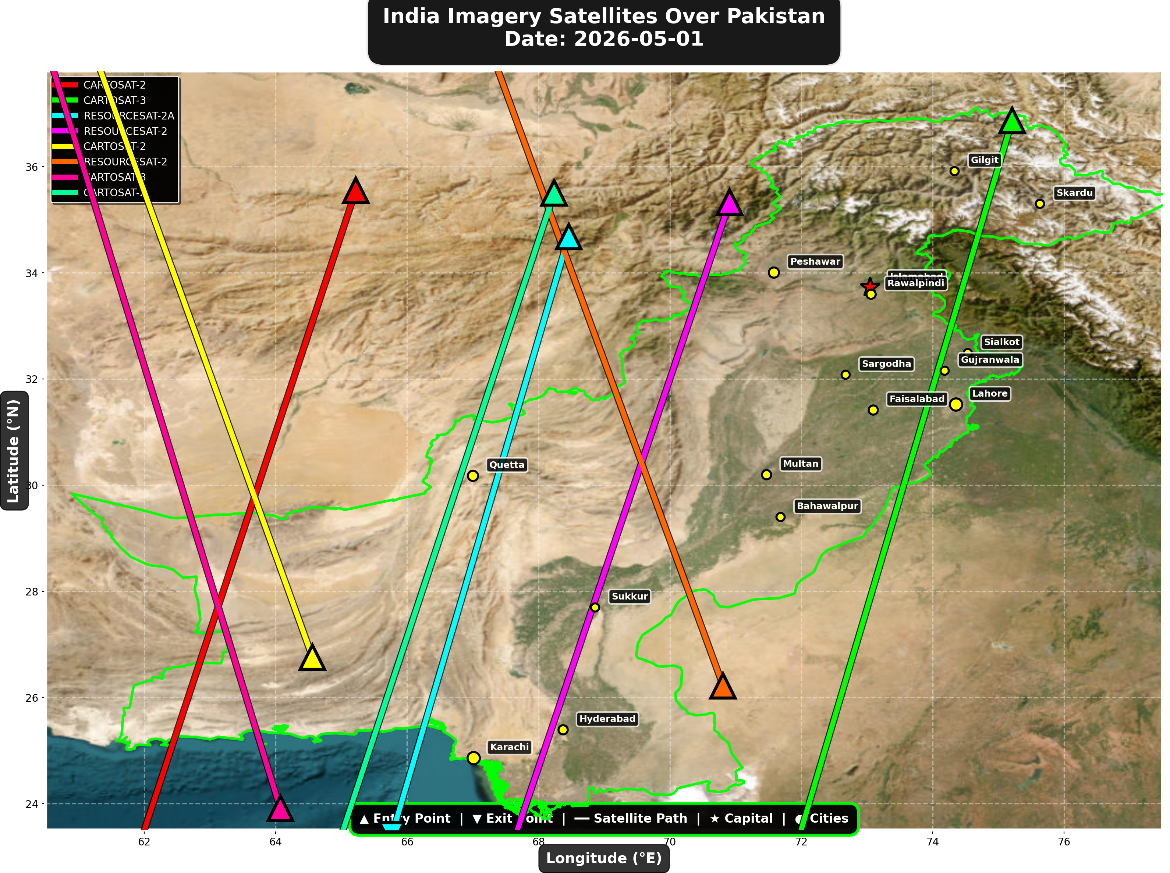

1. CARTOSAT-2 (Earth Observation)
Entry Time | 2026-05-01 00:07:00 UTC
Entry Point | 35.55°N, 65.22°E
Exit Time | 2026-05-01 00:11:00 UTC
Duration Over Pakistan | 4.0 minutes
Maximum Altitude | 836.0 km
Direction of Travel | N→S
Owner/Operator | ISRO
➤ Entered Pakistani airspace from the northwest (Afghanistan/China border region), traveling north to south. Satellite remained over Pakistan for 4.0 minutes at altitude 836.0 km.

2. CARTOSAT-3 (Earth Observation)
Entry Time | 2026-05-01 05:01:00 UTC
Entry Point | 36.87°N, 75.21°E
Exit Time | 2026-05-01 05:05:00 UTC
Duration Over Pakistan | 4.0 minutes
Maximum Altitude | 514.3 km
Direction of Travel | N→S
Owner/Operator | ISRO
➤ Entered Pakistani airspace from the northeast (China/Kashmir border region), traveling north to south. Satellite remained over Pakistan for 4.0 minutes at altitude 514.3 km.

3. RESOURCESAT-2A (Earth Observation)
Entry Time | 2026-05-01 05:26:00 UTC
Entry Point | 34.68°N, 68.46°E
Exit Time | 2026-05-01 05:29:00 UTC
Duration Over Pakistan | 3.0 minutes
Maximum Altitude | 515.7 km
Direction of Travel | N→S
Owner/Operator | ISRO
➤ Entered Pakistani airspace from the border region, traveling north to south. Satellite remained over Pakistan for 3.0 minutes at altitude 515.7 km.

4. RESOURCESAT-2 (Earth Observation)
Entry Time | 2026-05-01 05:51:00 UTC
Entry Point | 35.33°N, 70.91°E
Exit Time | 2026-05-01 05:55:00 UTC
Duration Over Pakistan | 4.0 minutes
Maximum Altitude | 831.7 km
Direction of Travel | N→S
Owner/Operator | ISRO
➤ Entered Pakistani airspace from the northwest (Afghanistan/China border region), traveling north to south. Satellite remained over Pakistan for 4.0 minutes at altitude 831.7 km.

5. CARTOSAT-2 (Earth Observation)
Entry Time | 2026-05-01 11:26:00 UTC
Entry Point | 26.76°N, 64.56°E
Exit Time | 2026-05-01 11:30:00 UTC
Duration Over Pakistan | 4.0 minutes
Maximum Altitude | 852.4 km
Direction of Travel | S→N
Owner/Operator | ISRO
➤ Entered Pakistani airspace from the border region, traveling south to north. Satellite remained over Pakistan for 4.0 minutes at altitude 852.4 km.

6. RESOURCESAT-2 (Earth Observation)
Entry Time | 2026-05-01 17:07:00 UTC
Entry Point | 26.22°N, 70.81°E
Exit Time | 2026-05-01 17:11:00 UTC
Duration Over Pakistan | 4.0 minutes
Maximum Altitude | 818.7 km
Direction of Travel | S→N
Owner/Operator | ISRO
➤ Entered Pakistani airspace from the border region, traveling south to north. Satellite remained over Pakistan for 4.0 minutes at altitude 818.7 km.

7. CARTOSAT-3 (Earth Observation)
Entry Time | 2026-05-01 17:08:00 UTC
Entry Point | 23.91°N, 64.07°E
Exit Time | 2026-05-01 17:12:00 UTC
Duration Over Pakistan | 4.0 minutes
Maximum Altitude | 514.2 km
Direction of Travel | S→N
Owner/Operator | ISRO
➤ Entered Pakistani airspace from the south (Arabian Sea/Indian Ocean), traveling south to north. Satellite remained over Pakistan for 4.0 minutes at altitude 514.2 km.

8. CARTOSAT-2 (Earth Observation)
Entry Time | 2026-05-01 23:51:00 UTC
Entry Point | 35.5°N, 68.24°E
Exit Time | 2026-05-01 23:55:00 UTC
Duration Over Pakistan | 4.0 minutes
Maximum Altitude | 836.0 km
Direction of Travel | N→S
Owner/Operator | ISRO
➤ Entered Pakistani airspace from the northwest (Afghanistan/China border region), traveling north to south. Satellite remained over Pakistan for 4.0 minutes at altitude 836.0 km.

🇨🇳 CHINA IMAGERY SATELLITES
Visual Map - All China Satellite Paths:
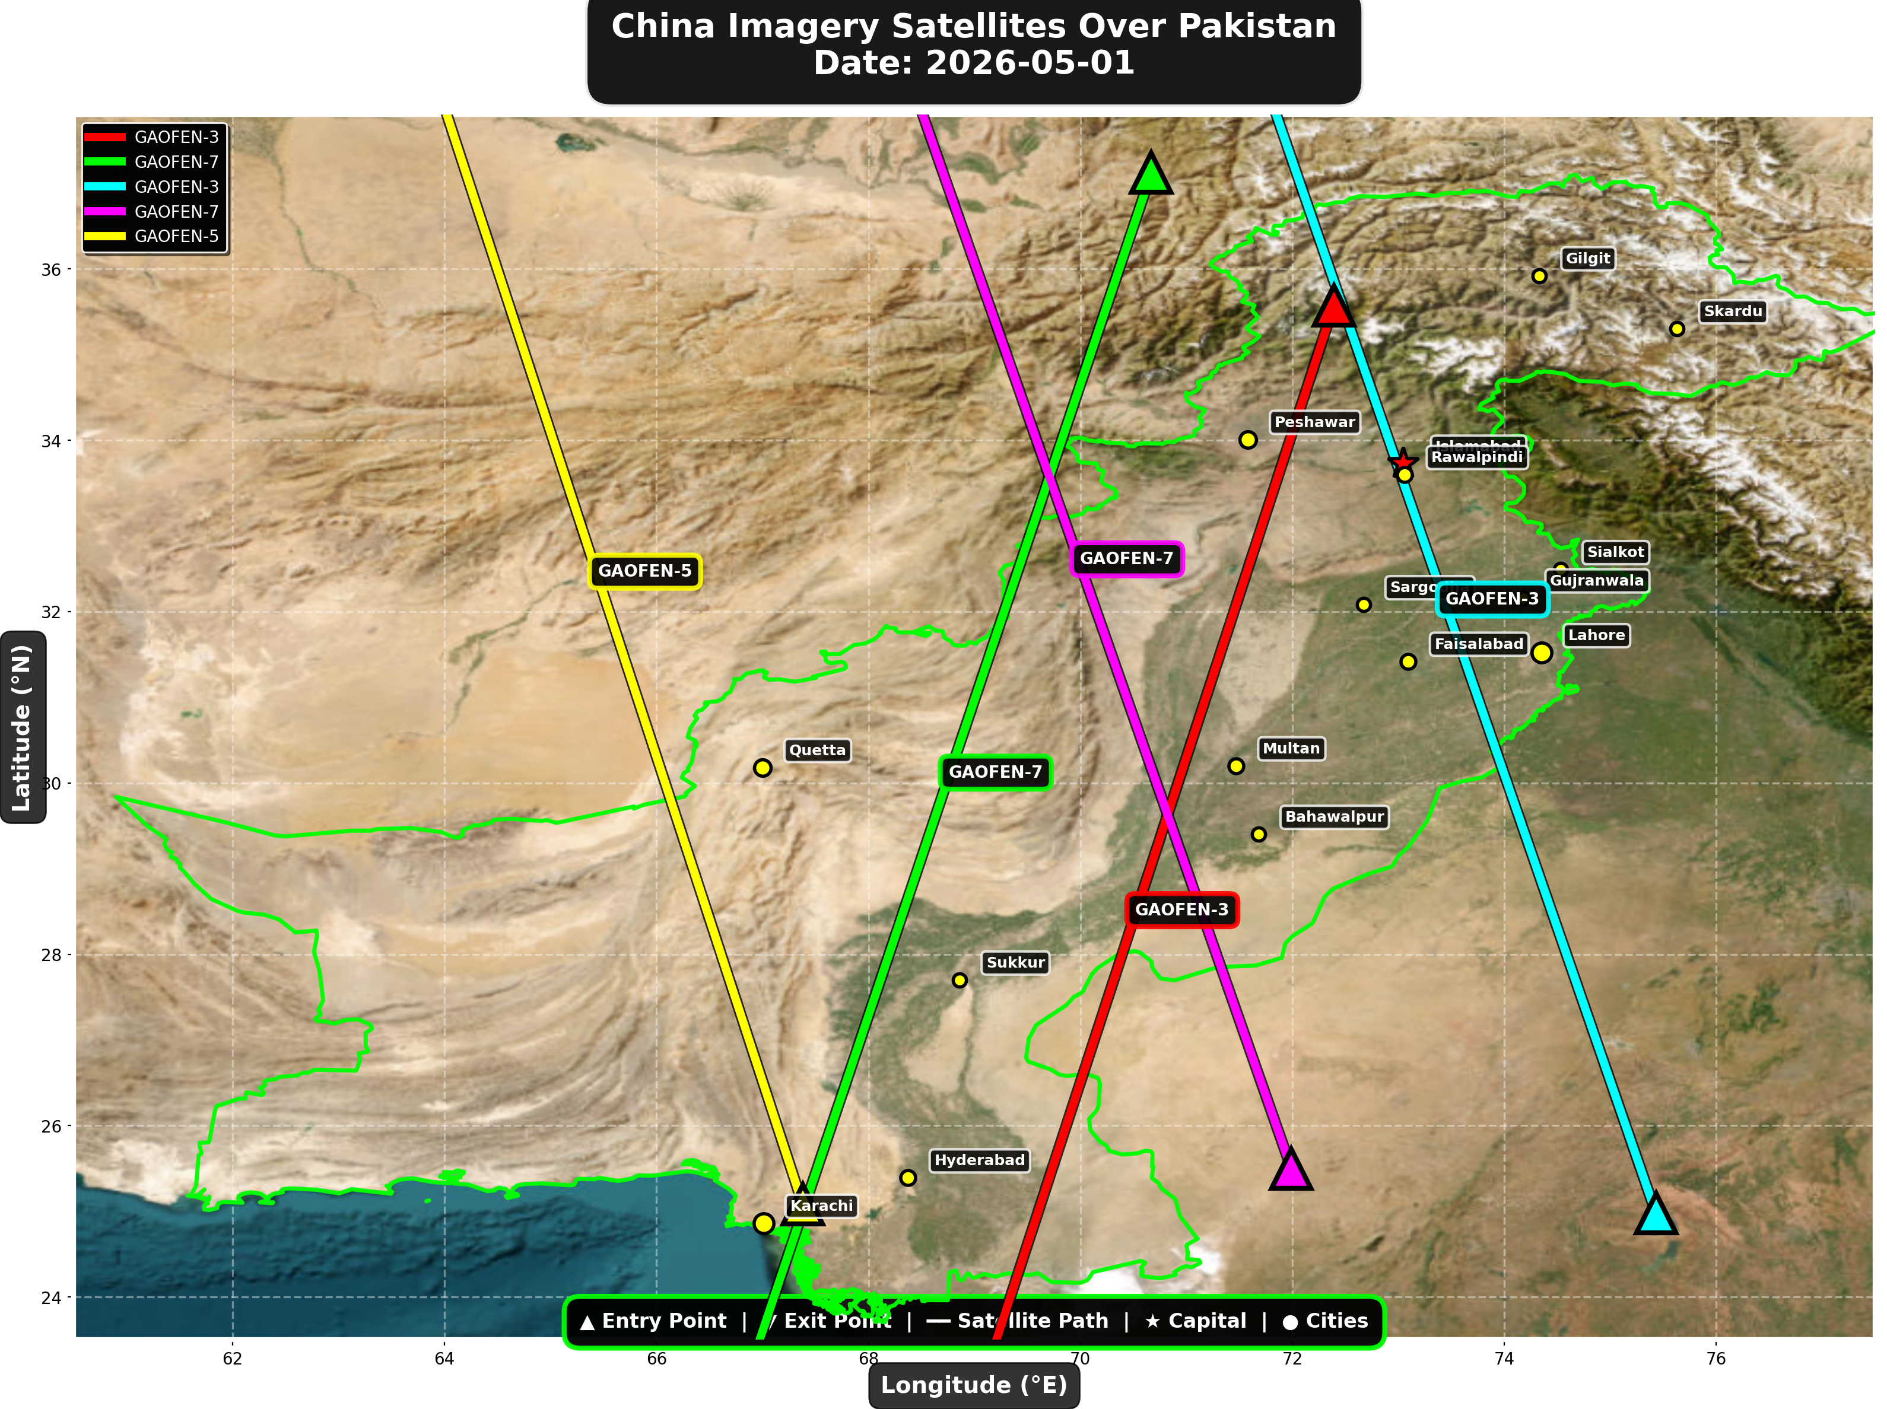

China reconnaissance and imaging satellites detected:
Satellite | Type | Entry Time | Duration (min) | Entry Point | Direction
GAOFEN-3 | Radar/SAR | 01:48:00 | 4.0 | 35.57°N, 72.39°E | N→S
GAOFEN-7 | Earth Observati | 02:09:00 | 4.0 | 37.12°N, 70.67°E | N→S
GAOFEN-3 | Radar/SAR | 12:54:00 | 4.0 | 24.98°N, 75.43°E | S→N
GAOFEN-7 | Earth Observati | 13:20:00 | 4.0 | 25.5°N, 71.99°E | S→N
GAOFEN-5 | Earth Observati | 18:08:00 | 4.0 | 25.08°N, 67.38°E | S→N

🇺🇸 USA IMAGERY SATELLITES
Visual Map - All USA Satellite Paths:
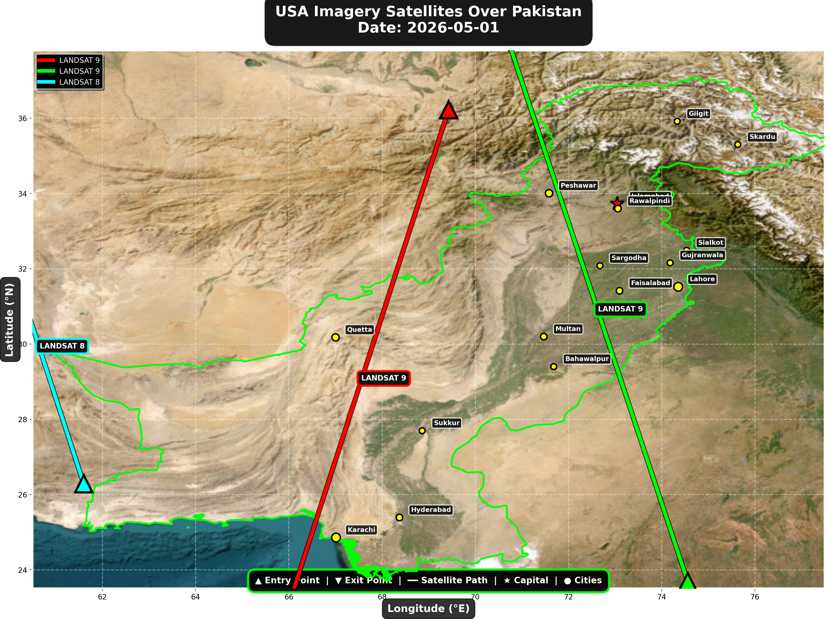

USA reconnaissance and imaging satellites detected:
Satellite | Type | Entry Time | Duration (min) | Entry Point | Direction
LANDSAT 9 | Earth Observati | 06:08:00 | 4.0 | 36.22°N, 69.43°E | N→S
LANDSAT 9 | Earth Observati | 17:07:00 | 4.0 | 23.68°N, 74.56°E | S→N
LANDSAT 8 | Earth Observati | 17:57:00 | 2.0 | 26.29°N, 61.6°E | S→N

⚠ ANOMALIES DETECTED (2)
- [HIGH] LONG_DURATION: ISS
Owner: NASA/Roscosmos | NORAD 25544
Details: Duration 5.0min is 71% longer than avg 2.9min
- [MEDIUM] INCREASED_FREQUENCY: CARTOSAT-2
Owner: ISRO | NORAD 39260
Details: 3 crossings today vs avg 1.4 per day

Crossings by Country
Country | Crossings
China | 15
India | 8
USA | 7
Europe | 6
International | 3

Crossings by Satellite Type
Type | Crossings
Earth Observation | 14
Weather | 13
Space Station | 8
Radar/SAR | 2
Reconnaissance | 2

All Border Crossings (39 total)
# | Satellite | Owner | Country | Type | Entry Time | Duration (min) | Alt (km) | Direction
1 | CARTOSAT-2 | ISRO | India | Earth Observati | 2026-05-01 00:07:00 UTC | 4.0 | 836.0 | N→S
2 | FENGYUN-3C | CMA | China | Weather | 2026-05-01 00:20:00 UTC | 3.0 | 823.3 | N→S
3 | TIANGONG | CNSA | China | Space Station | 2026-05-01 00:37:00 UTC | 1.0 | 386.0 | N/A
4 | ISS | NASA/Roscosmos | International | Space Station | 2026-05-01 01:27:00 UTC | 5.0 | 429.6 | W→E
5 | GAOFEN-3 | CNSA | China | Radar/SAR | 2026-05-01 01:48:00 UTC | 4.0 | 758.2 | N→S
6 | GAOFEN-7 | CNSA | China | Earth Observati | 2026-05-01 02:09:00 UTC | 4.0 | 792.7 | N→S
7 | YAOGAN-14 | PLA | China | Reconnaissance | 2026-05-01 03:32:00 UTC | 4.0 | 161.0 | N→S
8 | TIANGONG | CNSA | China | Space Station | 2026-05-01 03:54:00 UTC | 1.0 | 388.6 | N/A
9 | METOP-B | EUMETSAT | Europe | Weather | 2026-05-01 04:45:00 UTC | 4.0 | 825.9 | N→S
10 | CARTOSAT-3 | ISRO | India | Earth Observati | 2026-05-01 05:01:00 UTC | 4.0 | 514.3 | N→S
11 | METOP-C | EUMETSAT | Europe | Weather | 2026-05-01 05:12:00 UTC | 4.0 | 827.6 | N→S
12 | RESOURCESAT-2A | ISRO | India | Earth Observati | 2026-05-01 05:26:00 UTC | 3.0 | 515.7 | N→S
13 | TIANGONG | CNSA | China | Space Station | 2026-05-01 05:29:00 UTC | 4.0 | 389.2 | W→E
14 | RESOURCESAT-2 | ISRO | India | Earth Observati | 2026-05-01 05:51:00 UTC | 4.0 | 831.7 | N→S
15 | LANDSAT 9 | NASA/USGS | USA | Earth Observati | 2026-05-01 06:08:00 UTC | 4.0 | 709.0 | N→S
16 | NOAA-19 | NOAA | USA | Weather | 2026-05-01 07:10:00 UTC | 4.0 | 860.5 | N→S
17 | NOAA-20 | NOAA | USA | Weather | 2026-05-01 08:18:00 UTC | 4.0 | 832.9 | S→N
18 | METOP-A | EUMETSAT | Europe | Weather | 2026-05-01 08:43:00 UTC | 3.0 | 596.3 | N→S
19 | FENGYUN-3D | CMA | China | Weather | 2026-05-01 10:20:00 UTC | 1.0 | 833.7 | N/A
20 | CARTOSAT-2 | ISRO | India | Earth Observati | 2026-05-01 11:26:00 UTC | 4.0 | 852.4 | S→N
21 | FENGYUN-3C | CMA | China | Weather | 2026-05-01 11:36:00 UTC | 4.0 | 830.2 | S→N
22 | GAOFEN-3 | CNSA | China | Radar/SAR | 2026-05-01 12:54:00 UTC | 4.0 | 757.8 | S→N
23 | GAOFEN-7 | CNSA | China | Earth Observati | 2026-05-01 13:20:00 UTC | 4.0 | 790.8 | S→N
24 | YAOGAN-14 | PLA | China | Reconnaissance | 2026-05-01 14:43:00 UTC | 4.0 | 163.7 | S→N
25 | METOP-B | EUMETSAT | Europe | Weather | 2026-05-01 16:00:00 UTC | 4.0 | 827.5 | S→N
26 | METOP-C | EUMETSAT | Europe | Weather | 2026-05-01 16:28:00 UTC | 4.0 | 826.9 | S→N
27 | ISS | NASA/Roscosmos | International | Space Station | 2026-05-01 16:31:00 UTC | 2.0 | 421.8 | S→N
28 | LANDSAT 9 | NASA/USGS | USA | Earth Observati | 2026-05-01 17:07:00 UTC | 4.0 | 709.5 | S→N
29 | RESOURCESAT-2 | ISRO | India | Earth Observati | 2026-05-01 17:07:00 UTC | 4.0 | 818.7 | S→N
30 | CARTOSAT-3 | ISRO | India | Earth Observati | 2026-05-01 17:08:00 UTC | 4.0 | 514.2 | S→N
31 | LANDSAT 8 | NASA/USGS | USA | Earth Observati | 2026-05-01 17:57:00 UTC | 2.0 | 709.4 | S→N
32 | GAOFEN-5 | CNSA | China | Earth Observati | 2026-05-01 18:08:00 UTC | 4.0 | 617.4 | S→N
33 | ISS | NASA/Roscosmos | International | Space Station | 2026-05-01 18:08:00 UTC | 1.0 | 422.2 | N/A
34 | NOAA-19 | NOAA | USA | Weather | 2026-05-01 18:30:00 UTC | 3.0 | 857.9 | S→N
35 | METOP-A | EUMETSAT | Europe | Weather | 2026-05-01 19:33:00 UTC | 4.0 | 771.9 | S→N
36 | NOAA-20 | NOAA | USA | Weather | 2026-05-01 20:44:00 UTC | 2.0 | 834.1 | N→S
37 | TIANGONG | CNSA | China | Space Station | 2026-05-01 22:00:00 UTC | 2.0 | 384.5 | W→E
38 | TIANGONG | CNSA | China | Space Station | 2026-05-01 23:36:00 UTC | 4.0 | 386.1 | W→E
39 | CARTOSAT-2 | ISRO | India | Earth Observati | 2026-05-01 23:51:00 UTC | 4.0 | 836.0 | N→S

