ATLAS — Pakistan Border Satellite Surveillance Report
Date: 2026-05-02 | Generated: 2026-05-04 09:57:42

Executive Summary
Total Border Crossings | 35
Unique Satellites | 18
Indian Satellites Detected | 8 crossings (4 unique)
Indian Imagery Satellites | 8 crossings
Anomalies Detected | 2
Surveillance Region | 23.5°N–37.5°N, 60.5°E–77.5°E

🇮🇳 INDIAN SATELLITE ACTIVITY (8 crossings)
Indian Space Research Organisation (ISRO) satellites detected over Pakistan:

Satellite | Type | Crossings | Primary Purpose
CARTOSAT-2 | Earth Observation | 2 | High-resolution Earth imaging for cartography, urban planning, and military reconnaissance
CARTOSAT-3 | Earth Observation | 2 | High-resolution Earth imaging for cartography, urban planning, and military reconnaissance
RESOURCESAT-2 | Earth Observation | 2 | Natural resource monitoring, agriculture, forestry, and land use mapping
RESOURCESAT-2A | Earth Observation | 2 | Natural resource monitoring, agriculture, forestry, and land use mapping

📷 INDIAN IMAGERY SATELLITES - BORDER CROSSING DETAILS
Detailed entry/exit points for Indian reconnaissance and imaging satellites:

Visual Map - All Indian Satellite Paths:
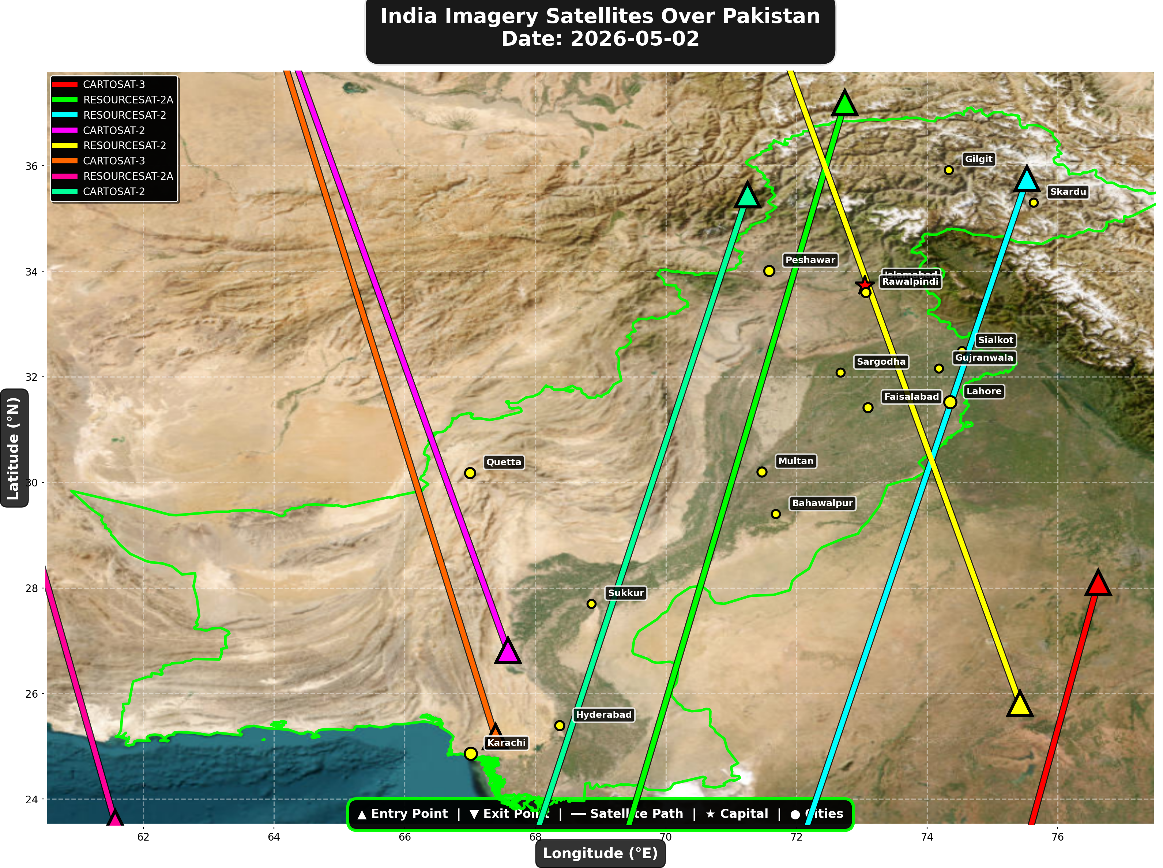

1. CARTOSAT-3 (Earth Observation)
Entry Time | 2026-05-02 04:45:00 UTC
Entry Point | 28.1°N, 76.62°E
Exit Time | 2026-05-02 04:47:00 UTC
Duration Over Pakistan | 2.0 minutes
Maximum Altitude | 514.3 km
Direction of Travel | N→S
Owner/Operator | ISRO
➤ Entered Pakistani airspace from the east (Indian border - Punjab/Rajasthan sector), traveling north to south. Satellite remained over Pakistan for 2.0 minutes at altitude 514.3 km.

2. RESOURCESAT-2A (Earth Observation)
Entry Time | 2026-05-02 05:07:00 UTC
Entry Point | 37.19°N, 72.74°E
Exit Time | 2026-05-02 05:11:00 UTC
Duration Over Pakistan | 4.0 minutes
Maximum Altitude | 515.7 km
Direction of Travel | N→S
Owner/Operator | ISRO
➤ Entered Pakistani airspace from the northeast (China/Kashmir border region), traveling north to south. Satellite remained over Pakistan for 4.0 minutes at altitude 515.7 km.

3. RESOURCESAT-2 (Earth Observation)
Entry Time | 2026-05-02 05:29:00 UTC
Entry Point | 35.75°N, 75.53°E
Exit Time | 2026-05-02 05:33:00 UTC
Duration Over Pakistan | 4.0 minutes
Maximum Altitude | 831.7 km
Direction of Travel | N→S
Owner/Operator | ISRO
➤ Entered Pakistani airspace from the northeast (China/Kashmir border region), traveling north to south. Satellite remained over Pakistan for 4.0 minutes at altitude 831.7 km.

4. CARTOSAT-2 (Earth Observation)
Entry Time | 2026-05-02 11:10:00 UTC
Entry Point | 26.81°N, 67.58°E
Exit Time | 2026-05-02 11:14:00 UTC
Duration Over Pakistan | 4.0 minutes
Maximum Altitude | 852.4 km
Direction of Travel | S→N
Owner/Operator | ISRO
➤ Entered Pakistani airspace from the border region, traveling south to north. Satellite remained over Pakistan for 4.0 minutes at altitude 852.4 km.

5. RESOURCESAT-2 (Earth Observation)
Entry Time | 2026-05-02 16:45:00 UTC
Entry Point | 25.81°N, 75.42°E
Exit Time | 2026-05-02 16:49:00 UTC
Duration Over Pakistan | 4.0 minutes
Maximum Altitude | 818.7 km
Direction of Travel | S→N
Owner/Operator | ISRO
➤ Entered Pakistani airspace from the south (Arabian Sea/Indian Ocean), traveling south to north. Satellite remained over Pakistan for 4.0 minutes at altitude 818.7 km.

6. CARTOSAT-3 (Earth Observation)
Entry Time | 2026-05-02 16:50:00 UTC
Entry Point | 25.18°N, 67.39°E
Exit Time | 2026-05-02 16:54:00 UTC
Duration Over Pakistan | 4.0 minutes
Maximum Altitude | 514.2 km
Direction of Travel | S→N
Owner/Operator | ISRO
➤ Entered Pakistani airspace from the south (Arabian Sea/Indian Ocean), traveling south to north. Satellite remained over Pakistan for 4.0 minutes at altitude 514.2 km.

7. RESOURCESAT-2A (Earth Observation)
Entry Time | 2026-05-02 17:14:00 UTC
Entry Point | 23.55°N, 61.57°E
Exit Time | 2026-05-02 17:16:00 UTC
Duration Over Pakistan | 2.0 minutes
Maximum Altitude | 511.8 km
Direction of Travel | S→N
Owner/Operator | ISRO
➤ Entered Pakistani airspace from the south (Arabian Sea/Indian Ocean), traveling south to north. Satellite remained over Pakistan for 2.0 minutes at altitude 511.8 km.

8. CARTOSAT-2 (Earth Observation)
Entry Time | 2026-05-02 23:35:00 UTC
Entry Point | 35.45°N, 71.25°E
Exit Time | 2026-05-02 23:39:00 UTC
Duration Over Pakistan | 4.0 minutes
Maximum Altitude | 836.0 km
Direction of Travel | N→S
Owner/Operator | ISRO
➤ Entered Pakistani airspace from the northwest (Afghanistan/China border region), traveling north to south. Satellite remained over Pakistan for 4.0 minutes at altitude 836.0 km.

🇨🇳 CHINA IMAGERY SATELLITES
Visual Map - All China Satellite Paths:
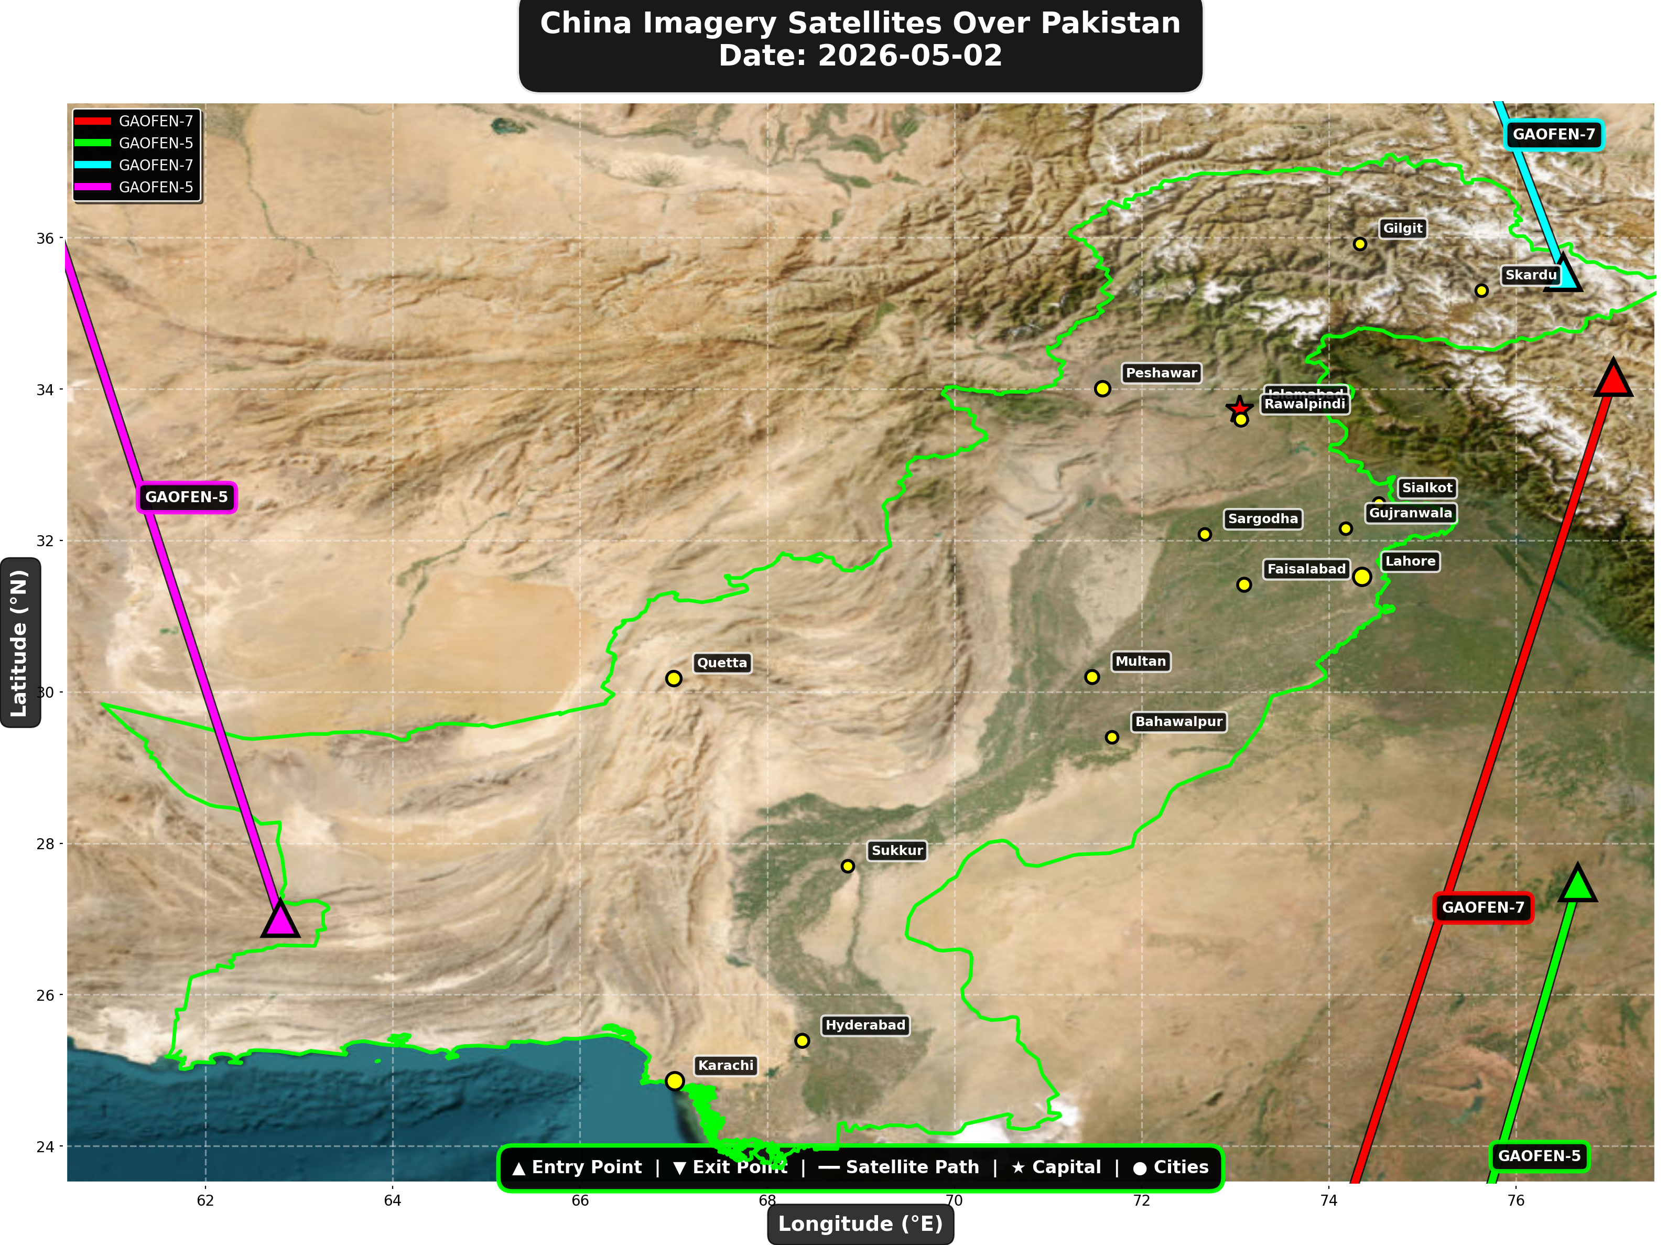

China reconnaissance and imaging satellites detected:
Satellite | Type | Entry Time | Duration (min) | Entry Point | Direction
GAOFEN-7 | Earth Observati | 01:37:00 | 4.0 | 34.15°N, 77.04°E | N→S
GAOFEN-5 | Earth Observati | 06:00:00 | 2.0 | 27.48°N, 76.66°E | N→S
GAOFEN-7 | Earth Observati | 12:50:00 | 1.0 | 35.54°N, 76.5°E | N/A
GAOFEN-5 | Earth Observati | 18:21:00 | 3.0 | 27.01°N, 62.8°E | S→N

🇺🇸 USA IMAGERY SATELLITES
Visual Map - All USA Satellite Paths:
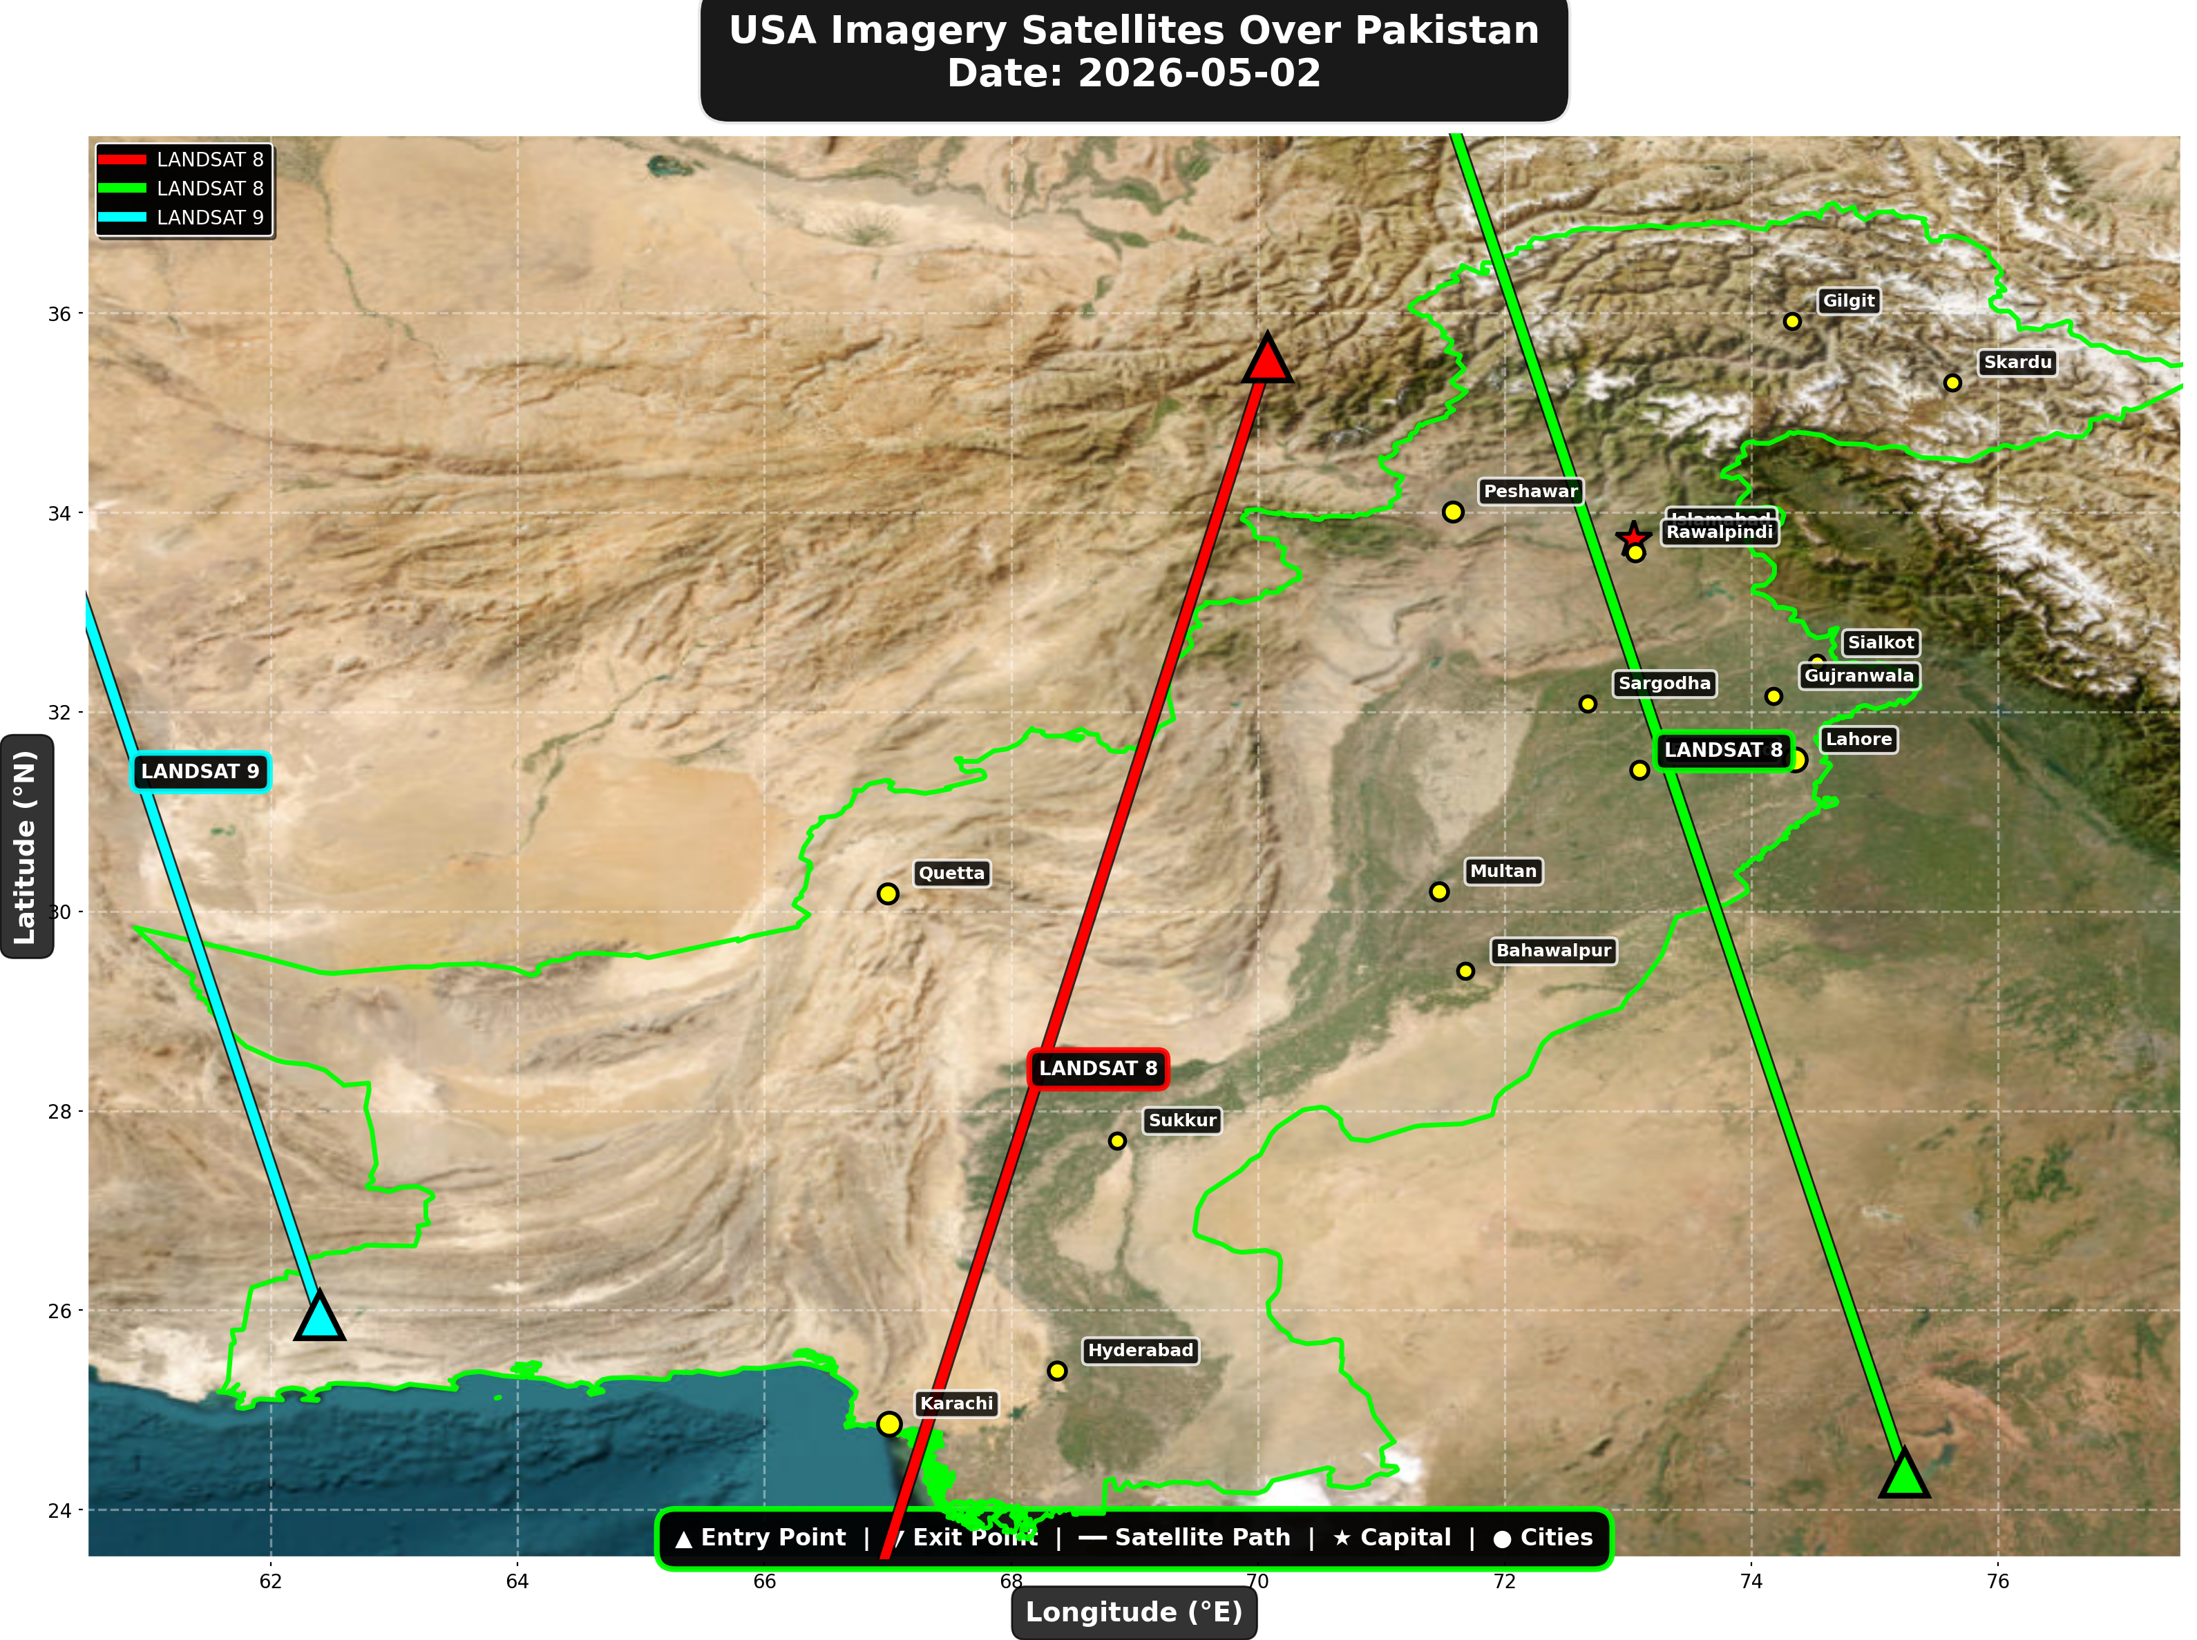

USA reconnaissance and imaging satellites detected:
Satellite | Type | Entry Time | Duration (min) | Entry Point | Direction
LANDSAT 8 | Earth Observati | 06:01:00 | 4.0 | 35.55°N, 70.08°E | N→S
LANDSAT 8 | Earth Observati | 17:00:00 | 4.0 | 24.37°N, 75.24°E | S→N
LANDSAT 9 | Earth Observati | 17:50:00 | 3.0 | 25.95°N, 62.4°E | S→N

⚠ ANOMALIES DETECTED (2)
- [HIGH] LONG_DURATION: ISS
Owner: NASA/Roscosmos | NORAD 25544
Details: Duration 5.0min is 73% longer than avg 2.9min
- [MEDIUM] INCREASED_FREQUENCY: FENGYUN-3C
Owner: CMA | NORAD 40069
Details: 3 crossings today vs avg 1.7 per day

Crossings by Country
Country | Crossings
China | 13
India | 8
USA | 6
Europe | 5
International | 3

Crossings by Satellite Type
Type | Crossings
Earth Observation | 15
Weather | 11
Space Station | 6
Reconnaissance | 3

All Border Crossings (35 total)
# | Satellite | Owner | Country | Type | Entry Time | Duration (min) | Alt (km) | Direction
1 | FENGYUN-3C | CMA | China | Weather | 2026-05-02 00:00:00 UTC | 2.0 | 823.3 | N→S
2 | ISS | NASA/Roscosmos | International | Space Station | 2026-05-02 00:41:00 UTC | 2.0 | 428.6 | W→E
3 | GAOFEN-7 | CNSA | China | Earth Observati | 2026-05-02 01:37:00 UTC | 4.0 | 792.6 | N→S
4 | ISS | NASA/Roscosmos | International | Space Station | 2026-05-02 02:18:00 UTC | 1.0 | 429.5 | N/A
5 | YAOGAN-14 | PLA | China | Reconnaissance | 2026-05-02 02:55:00 UTC | 1.0 | 159.6 | N/A
6 | METOP-B | EUMETSAT | Europe | Weather | 2026-05-02 04:23:00 UTC | 4.0 | 825.8 | N→S
7 | TIANGONG | CNSA | China | Space Station | 2026-05-02 04:28:00 UTC | 3.0 | 388.9 | W→E
8 | CARTOSAT-3 | ISRO | India | Earth Observati | 2026-05-02 04:45:00 UTC | 2.0 | 514.3 | N→S
9 | METOP-C | EUMETSAT | Europe | Weather | 2026-05-02 04:51:00 UTC | 4.0 | 827.6 | N→S
10 | RESOURCESAT-2A | ISRO | India | Earth Observati | 2026-05-02 05:07:00 UTC | 4.0 | 515.7 | N→S
11 | RESOURCESAT-2 | ISRO | India | Earth Observati | 2026-05-02 05:29:00 UTC | 4.0 | 831.7 | N→S
12 | GAOFEN-5 | CNSA | China | Earth Observati | 2026-05-02 06:00:00 UTC | 2.0 | 616.2 | N→S
13 | LANDSAT 8 | NASA/USGS | USA | Earth Observati | 2026-05-02 06:01:00 UTC | 4.0 | 709.0 | N→S
14 | TIANGONG | CNSA | China | Space Station | 2026-05-02 06:05:00 UTC | 3.0 | 389.2 | W→E
15 | YAOGAN-26 | PLA | China | Reconnaissance | 2026-05-02 06:42:00 UTC | 4.0 | 861.4 | N→S
16 | NOAA-19 | NOAA | USA | Weather | 2026-05-02 06:56:00 UTC | 4.0 | 860.5 | N→S
17 | NOAA-20 | NOAA | USA | Weather | 2026-05-02 08:01:00 UTC | 1.0 | 832.7 | N/A
18 | CARTOSAT-2 | ISRO | India | Earth Observati | 2026-05-02 11:10:00 UTC | 4.0 | 852.4 | S→N
19 | FENGYUN-3C | CMA | China | Weather | 2026-05-02 11:14:00 UTC | 4.0 | 830.3 | S→N
20 | GAOFEN-7 | CNSA | China | Earth Observati | 2026-05-02 12:50:00 UTC | 1.0 | 790.7 | N/A
21 | METOP-B | EUMETSAT | Europe | Weather | 2026-05-02 15:39:00 UTC | 4.0 | 827.3 | S→N
22 | METOP-C | EUMETSAT | Europe | Weather | 2026-05-02 16:06:00 UTC | 4.0 | 826.9 | S→N
23 | RESOURCESAT-2 | ISRO | India | Earth Observati | 2026-05-02 16:45:00 UTC | 4.0 | 818.7 | S→N
24 | CARTOSAT-3 | ISRO | India | Earth Observati | 2026-05-02 16:50:00 UTC | 4.0 | 514.2 | S→N
25 | LANDSAT 8 | NASA/USGS | USA | Earth Observati | 2026-05-02 17:00:00 UTC | 4.0 | 709.4 | S→N
26 | RESOURCESAT-2A | ISRO | India | Earth Observati | 2026-05-02 17:14:00 UTC | 2.0 | 511.8 | S→N
27 | ISS | NASA/Roscosmos | International | Space Station | 2026-05-02 17:19:00 UTC | 5.0 | 422.3 | W→E
28 | YAOGAN-26 | PLA | China | Reconnaissance | 2026-05-02 17:45:00 UTC | 4.0 | 910.7 | S→N
29 | LANDSAT 9 | NASA/USGS | USA | Earth Observati | 2026-05-02 17:50:00 UTC | 3.0 | 709.4 | S→N
30 | NOAA-19 | NOAA | USA | Weather | 2026-05-02 18:16:00 UTC | 4.0 | 858.4 | S→N
31 | GAOFEN-5 | CNSA | China | Earth Observati | 2026-05-02 18:21:00 UTC | 3.0 | 617.3 | S→N
32 | METOP-A | EUMETSAT | Europe | Weather | 2026-05-02 19:57:00 UTC | 4.0 | 771.9 | S→N
33 | TIANGONG | CNSA | China | Space Station | 2026-05-02 22:34:00 UTC | 4.0 | 385.1 | W→E
34 | CARTOSAT-2 | ISRO | India | Earth Observati | 2026-05-02 23:35:00 UTC | 4.0 | 836.0 | N→S
35 | FENGYUN-3C | CMA | China | Weather | 2026-05-02 23:36:00 UTC | 4.0 | 823.4 | N→S

