ATLAS — Pakistan Border Satellite Surveillance Report
Date: 2026-05-03 | Generated: 2026-05-04 09:57:46

Executive Summary
Total Border Crossings | 37
Unique Satellites | 20
Indian Satellites Detected | 7 crossings (4 unique)
Indian Imagery Satellites | 7 crossings
Anomalies Detected | 3
Surveillance Region | 23.5°N–37.5°N, 60.5°E–77.5°E

🇮🇳 INDIAN SATELLITE ACTIVITY (7 crossings)
Indian Space Research Organisation (ISRO) satellites detected over Pakistan:

Satellite | Type | Crossings | Primary Purpose
CARTOSAT-2 | Earth Observation | 2 | High-resolution Earth imaging for cartography, urban planning, and military reconnaissance
CARTOSAT-3 | Earth Observation | 1 | High-resolution Earth imaging for cartography, urban planning, and military reconnaissance
RESOURCESAT-2 | Earth Observation | 2 | Natural resource monitoring, agriculture, forestry, and land use mapping
RESOURCESAT-2A | Earth Observation | 2 | Natural resource monitoring, agriculture, forestry, and land use mapping

📷 INDIAN IMAGERY SATELLITES - BORDER CROSSING DETAILS
Detailed entry/exit points for Indian reconnaissance and imaging satellites:

Visual Map - All Indian Satellite Paths:
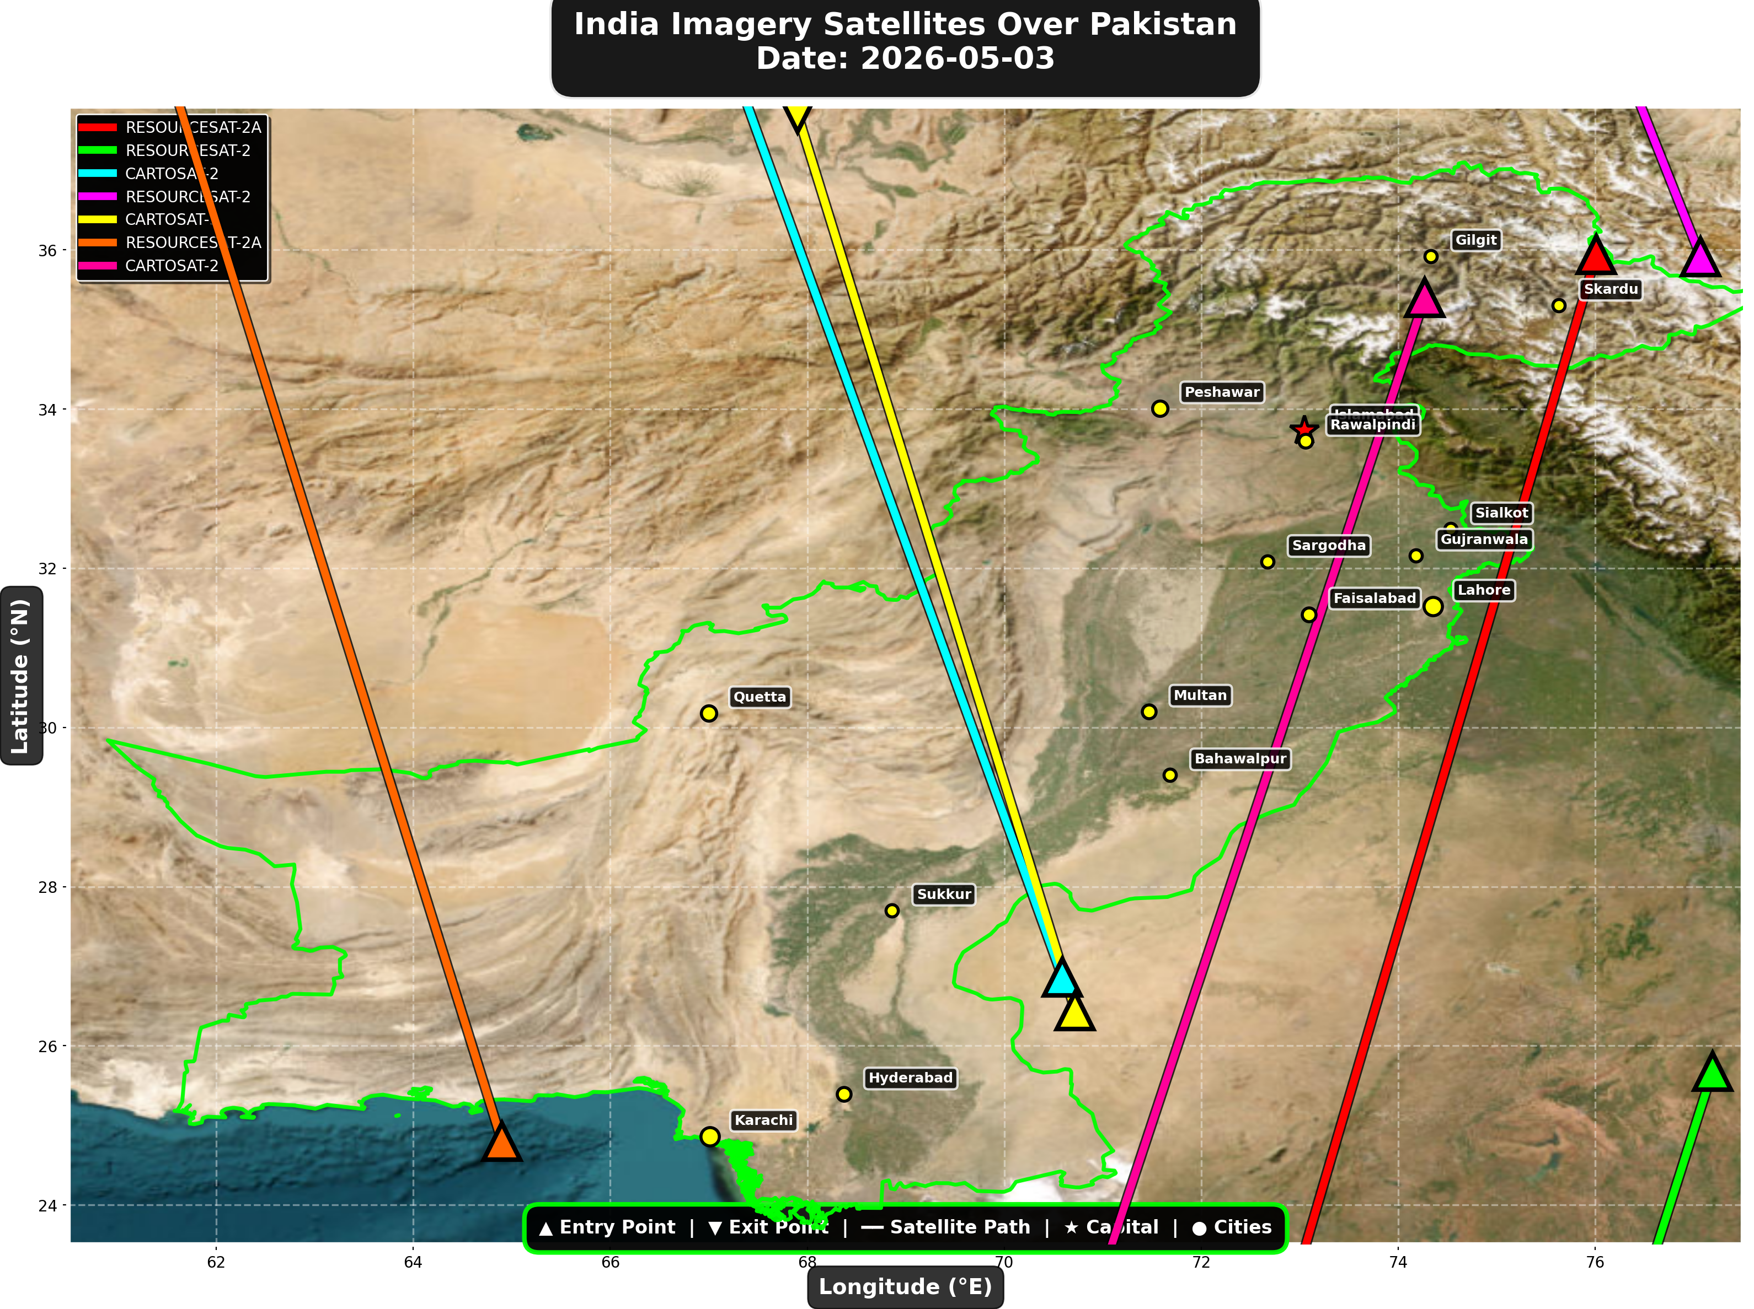

1. RESOURCESAT-2A (Earth Observation)
Entry Time | 2026-05-03 04:49:00 UTC
Entry Point | 35.94°N, 76.01°E
Exit Time | 2026-05-03 04:53:00 UTC
Duration Over Pakistan | 4.0 minutes
Maximum Altitude | 515.8 km
Direction of Travel | N→S
Owner/Operator | ISRO
➤ Entered Pakistani airspace from the northeast (China/Kashmir border region), traveling north to south. Satellite remained over Pakistan for 4.0 minutes at altitude 515.8 km.

2. RESOURCESAT-2 (Earth Observation)
Entry Time | 2026-05-03 05:10:00 UTC
Entry Point | 25.68°N, 77.19°E
Exit Time | 2026-05-03 05:11:00 UTC
Duration Over Pakistan | 1.0 minutes
Maximum Altitude | 831.6 km
Direction of Travel | N/A
Owner/Operator | ISRO
➤ Entered Pakistani airspace from the south (Arabian Sea/Indian Ocean), traveling N/A. Satellite remained over Pakistan for 1.0 minutes at altitude 831.6 km.

3. CARTOSAT-2 (Earth Observation)
Entry Time | 2026-05-03 10:54:00 UTC
Entry Point | 26.86°N, 70.59°E
Exit Time | 2026-05-03 10:58:00 UTC
Duration Over Pakistan | 4.0 minutes
Maximum Altitude | 852.4 km
Direction of Travel | S→N
Owner/Operator | ISRO
➤ Entered Pakistani airspace from the border region, traveling south to north. Satellite remained over Pakistan for 4.0 minutes at altitude 852.4 km.

4. RESOURCESAT-2 (Earth Observation)
Entry Time | 2026-05-03 16:26:00 UTC
Entry Point | 35.91°N, 77.07°E
Exit Time | 2026-05-03 16:27:00 UTC
Duration Over Pakistan | 1.0 minutes
Maximum Altitude | 818.7 km
Direction of Travel | N/A
Owner/Operator | ISRO
➤ Entered Pakistani airspace from the northeast (China/Kashmir border region), traveling N/A. Satellite remained over Pakistan for 1.0 minutes at altitude 818.7 km.

5. CARTOSAT-3 (Earth Observation)
Entry Time | 2026-05-03 16:32:00 UTC
Entry Point | 26.44°N, 70.72°E
Exit Time | 2026-05-03 16:35:00 UTC
Duration Over Pakistan | 3.0 minutes
Maximum Altitude | 514.1 km
Direction of Travel | S→N
Owner/Operator | ISRO
➤ Entered Pakistani airspace from the border region, traveling south to north. Satellite remained over Pakistan for 3.0 minutes at altitude 514.1 km.

6. RESOURCESAT-2A (Earth Observation)
Entry Time | 2026-05-03 16:56:00 UTC
Entry Point | 24.8°N, 64.9°E
Exit Time | 2026-05-03 17:00:00 UTC
Duration Over Pakistan | 4.0 minutes
Maximum Altitude | 511.7 km
Direction of Travel | S→N
Owner/Operator | ISRO
➤ Entered Pakistani airspace from the south (Arabian Sea/Indian Ocean), traveling south to north. Satellite remained over Pakistan for 4.0 minutes at altitude 511.7 km.

7. CARTOSAT-2 (Earth Observation)
Entry Time | 2026-05-03 23:19:00 UTC
Entry Point | 35.4°N, 74.27°E
Exit Time | 2026-05-03 23:23:00 UTC
Duration Over Pakistan | 4.0 minutes
Maximum Altitude | 836.0 km
Direction of Travel | N→S
Owner/Operator | ISRO
➤ Entered Pakistani airspace from the northeast (China/Kashmir border region), traveling north to south. Satellite remained over Pakistan for 4.0 minutes at altitude 836.0 km.

🇨🇳 CHINA IMAGERY SATELLITES
Visual Map - All China Satellite Paths:
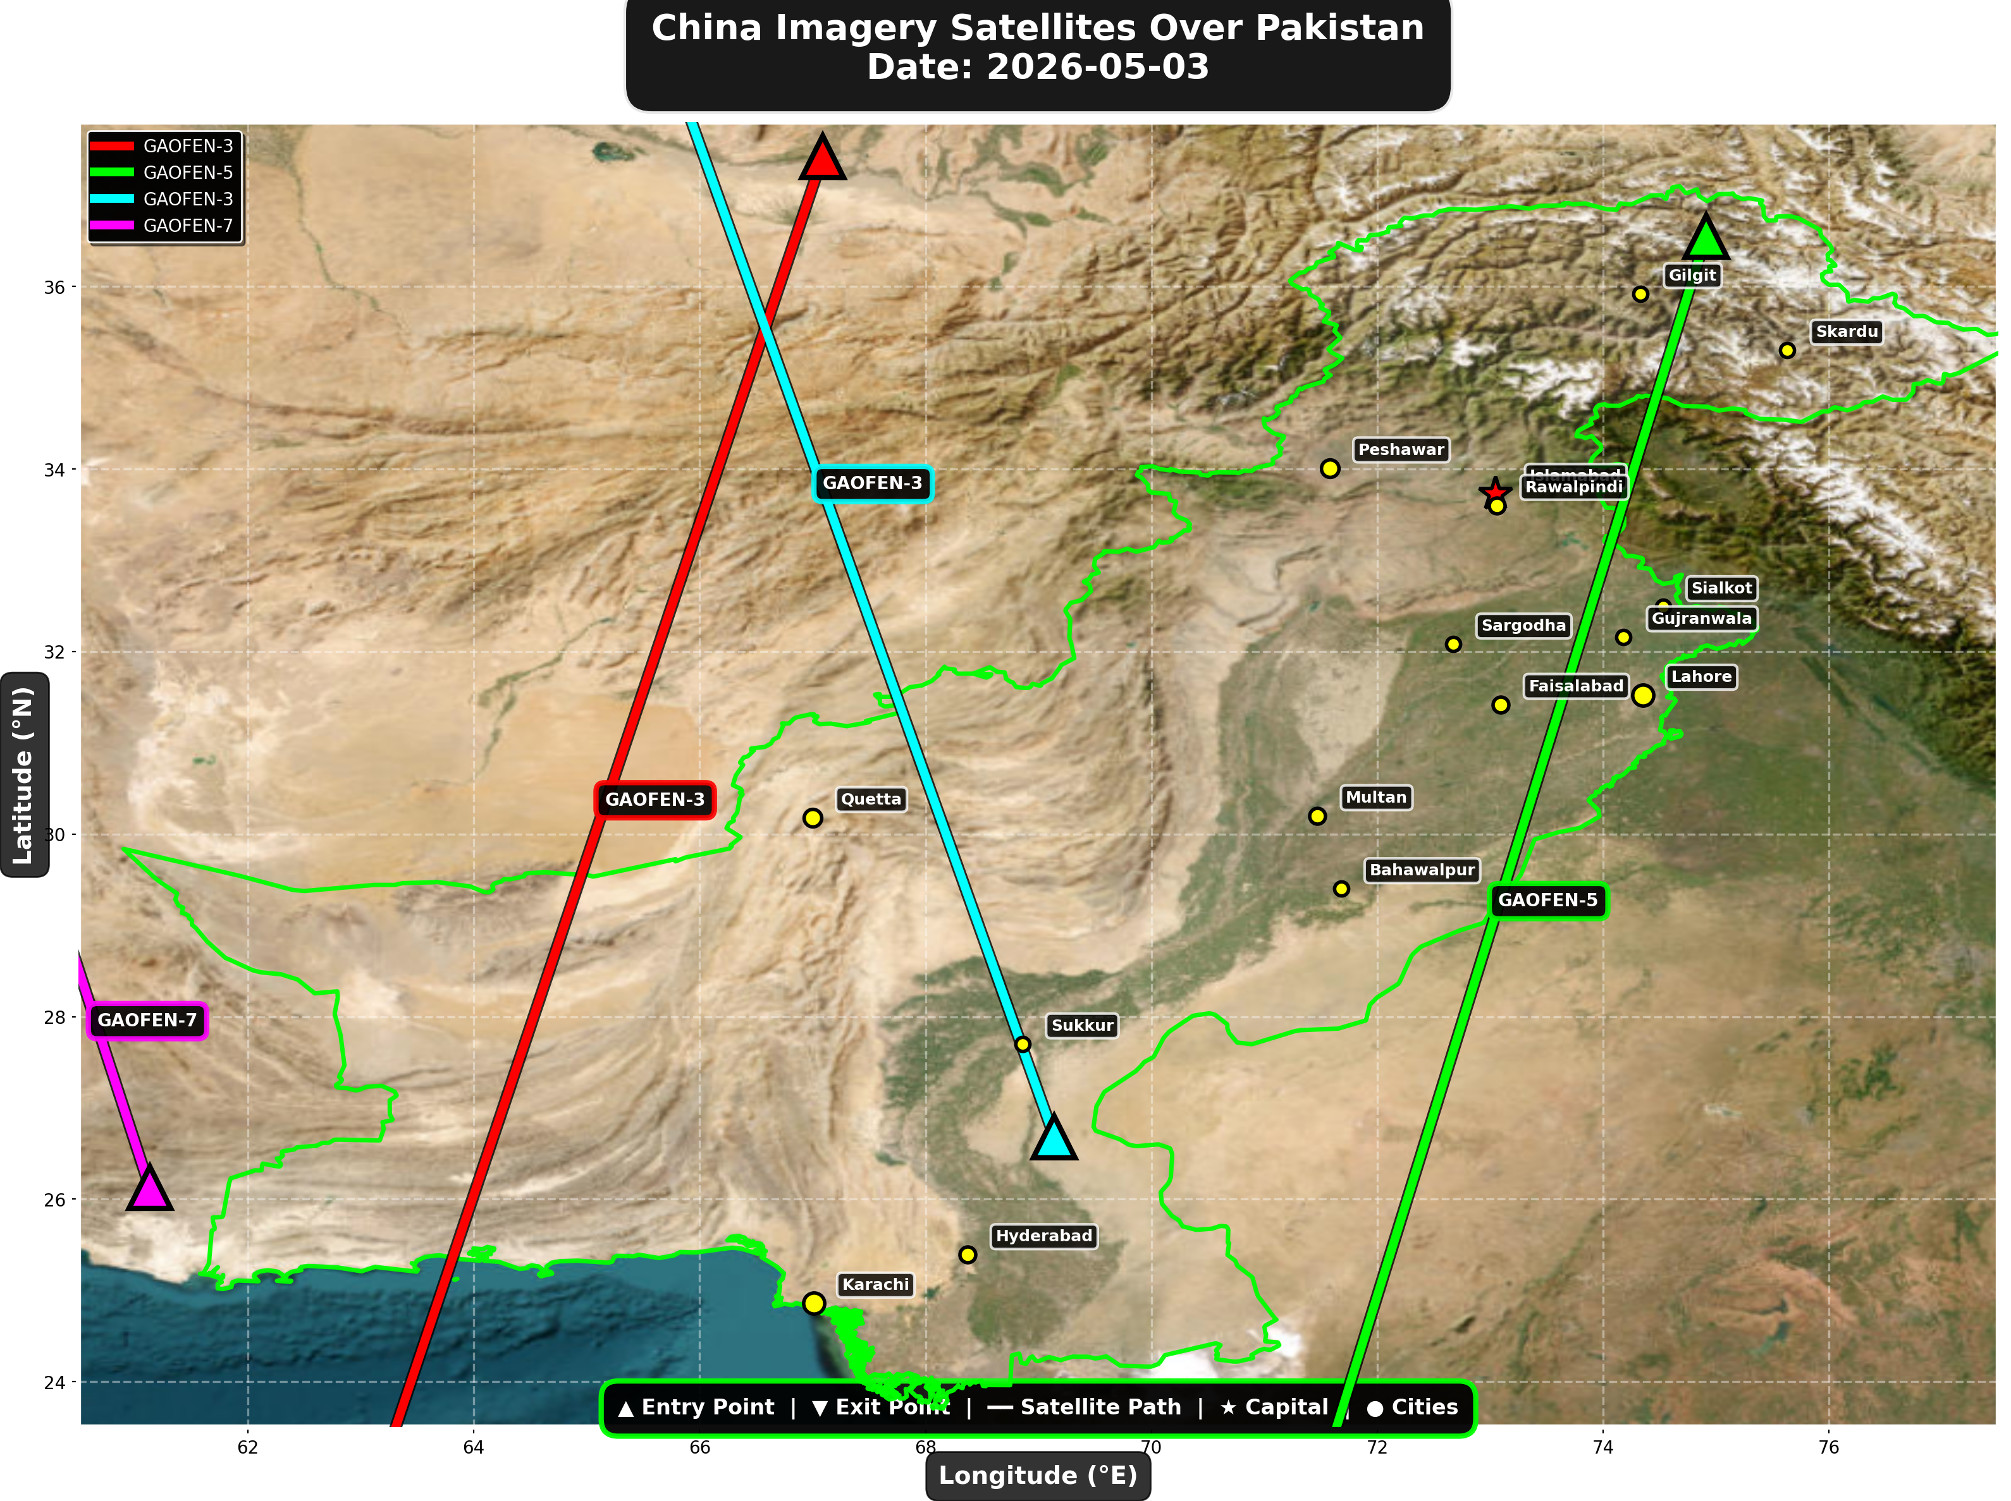

China reconnaissance and imaging satellites detected:
Satellite | Type | Entry Time | Duration (min) | Entry Point | Direction
GAOFEN-3 | Radar/SAR | 02:03:00 | 4.0 | 37.42°N, 67.09°E | N→S
GAOFEN-5 | Earth Observati | 06:10:00 | 4.0 | 36.55°N, 74.91°E | N→S
GAOFEN-3 | Radar/SAR | 13:10:00 | 4.0 | 26.68°N, 69.14°E | S→N
GAOFEN-7 | Earth Observati | 13:55:00 | 1.0 | 26.13°N, 61.13°E | N/A

🇺🇸 USA IMAGERY SATELLITES
Visual Map - All USA Satellite Paths:
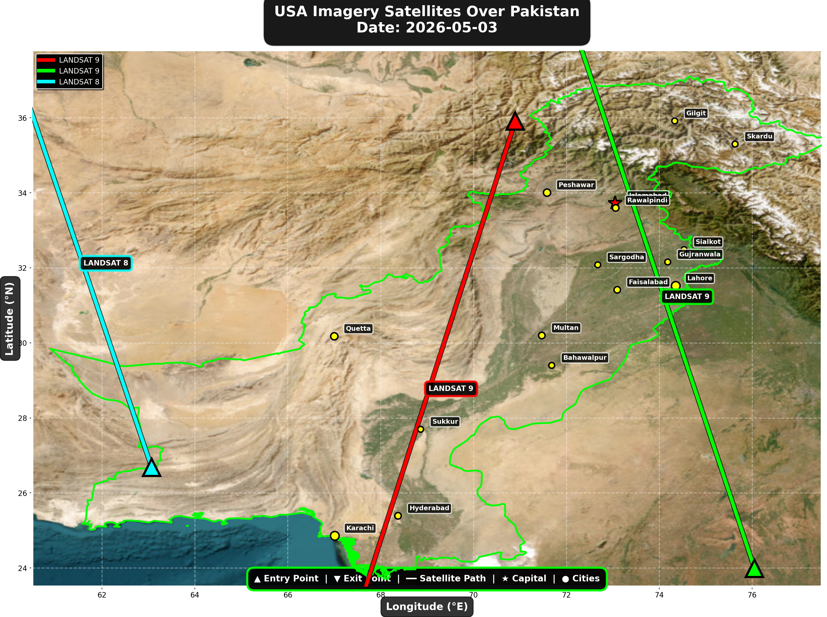

USA reconnaissance and imaging satellites detected:
Satellite | Type | Entry Time | Duration (min) | Entry Point | Direction
LANDSAT 9 | Earth Observati | 05:54:00 | 4.0 | 35.91°N, 70.9°E | N→S
LANDSAT 9 | Earth Observati | 16:53:00 | 4.0 | 23.99°N, 76.05°E | S→N
LANDSAT 8 | Earth Observati | 17:43:00 | 3.0 | 26.68°N, 63.07°E | S→N

⚠ ANOMALIES DETECTED (3)
- [HIGH] LONG_DURATION: TIANGONG
Owner: CNSA | NORAD 48274
Details: Duration 5.0min is 63% longer than avg 3.1min
- [HIGH] LONG_DURATION: ISS
Owner: NASA/Roscosmos | NORAD 25544
Details: Duration 5.0min is 75% longer than avg 2.9min
- [MEDIUM] INCREASED_FREQUENCY: FENGYUN-3D
Owner: CMA | NORAD 43010
Details: 3 crossings today vs avg 1.4 per day

Crossings by Country
Country | Crossings
China | 16
USA | 8
India | 7
International | 3
Europe | 3

Crossings by Satellite Type
Type | Crossings
Weather | 13
Earth Observation | 12
Space Station | 6
Reconnaissance | 4
Radar/SAR | 2

All Border Crossings (37 total)
# | Satellite | Owner | Country | Type | Entry Time | Duration (min) | Alt (km) | Direction
1 | FENGYUN-3D | CMA | China | Weather | 2026-05-03 00:02:00 UTC | 3.0 | 832.2 | N→S
2 | TIANGONG | CNSA | China | Space Station | 2026-05-03 00:12:00 UTC | 2.0 | 386.1 | W→E
3 | ISS | NASA/Roscosmos | International | Space Station | 2026-05-03 01:29:00 UTC | 5.0 | 429.6 | W→E
4 | GAOFEN-3 | CNSA | China | Radar/SAR | 2026-05-03 02:03:00 UTC | 4.0 | 758.2 | N→S
5 | YAOGAN-14 | PLA | China | Reconnaissance | 2026-05-03 03:40:00 UTC | 3.0 | 160.9 | N→S
6 | METOP-C | EUMETSAT | Europe | Weather | 2026-05-03 04:30:00 UTC | 3.0 | 827.6 | N→S
7 | RESOURCESAT-2A | ISRO | India | Earth Observati | 2026-05-03 04:49:00 UTC | 4.0 | 515.8 | N→S
8 | TIANGONG | CNSA | China | Space Station | 2026-05-03 05:03:00 UTC | 5.0 | 389.1 | W→E
9 | RESOURCESAT-2 | ISRO | India | Earth Observati | 2026-05-03 05:10:00 UTC | 1.0 | 831.6 | N/A
10 | LANDSAT 9 | NASA/USGS | USA | Earth Observati | 2026-05-03 05:54:00 UTC | 4.0 | 709.0 | N→S
11 | YAOGAN-26 | PLA | China | Reconnaissance | 2026-05-03 05:57:00 UTC | 4.0 | 868.8 | N→S
12 | GAOFEN-5 | CNSA | China | Earth Observati | 2026-05-03 06:10:00 UTC | 4.0 | 617.0 | N→S
13 | NOAA-18 | NOAA | USA | Weather | 2026-05-03 06:29:00 UTC | 3.0 | 844.5 | N→S
14 | NOAA-19 | NOAA | USA | Weather | 2026-05-03 06:42:00 UTC | 4.0 | 860.5 | N→S
15 | METOP-A | EUMETSAT | Europe | Weather | 2026-05-03 07:52:00 UTC | 4.0 | 601.5 | N→S
16 | FENGYUN-3C | CMA | China | Weather | 2026-05-03 10:52:00 UTC | 4.0 | 830.3 | S→N
17 | CARTOSAT-2 | ISRO | India | Earth Observati | 2026-05-03 10:54:00 UTC | 4.0 | 852.4 | S→N
18 | FENGYUN-3D | CMA | China | Weather | 2026-05-03 11:19:00 UTC | 2.0 | 833.9 | S→N
19 | GAOFEN-3 | CNSA | China | Radar/SAR | 2026-05-03 13:10:00 UTC | 4.0 | 757.7 | S→N
20 | GAOFEN-7 | CNSA | China | Earth Observati | 2026-05-03 13:55:00 UTC | 1.0 | 790.2 | N/A
21 | YAOGAN-14 | PLA | China | Reconnaissance | 2026-05-03 14:51:00 UTC | 4.0 | 163.8 | S→N
22 | METOP-C | EUMETSAT | Europe | Weather | 2026-05-03 15:46:00 UTC | 3.0 | 826.9 | S→N
23 | RESOURCESAT-2 | ISRO | India | Earth Observati | 2026-05-03 16:26:00 UTC | 1.0 | 818.7 | N/A
24 | CARTOSAT-3 | ISRO | India | Earth Observati | 2026-05-03 16:32:00 UTC | 3.0 | 514.1 | S→N
25 | ISS | NASA/Roscosmos | International | Space Station | 2026-05-03 16:33:00 UTC | 2.0 | 421.8 | W→E
26 | LANDSAT 9 | NASA/USGS | USA | Earth Observati | 2026-05-03 16:53:00 UTC | 4.0 | 709.5 | S→N
27 | RESOURCESAT-2A | ISRO | India | Earth Observati | 2026-05-03 16:56:00 UTC | 4.0 | 511.7 | S→N
28 | YAOGAN-26 | PLA | China | Reconnaissance | 2026-05-03 17:03:00 UTC | 1.0 | 904.3 | N/A
29 | LANDSAT 8 | NASA/USGS | USA | Earth Observati | 2026-05-03 17:43:00 UTC | 3.0 | 709.4 | S→N
30 | NOAA-18 | NOAA | USA | Weather | 2026-05-03 17:49:00 UTC | 2.0 | 860.9 | S→N
31 | NOAA-19 | NOAA | USA | Weather | 2026-05-03 18:02:00 UTC | 4.0 | 858.4 | S→N
32 | ISS | NASA/Roscosmos | International | Space Station | 2026-05-03 18:10:00 UTC | 1.0 | 422.2 | N/A
33 | NOAA-20 | NOAA | USA | Weather | 2026-05-03 21:43:00 UTC | 3.0 | 833.9 | N→S
34 | TIANGONG | CNSA | China | Space Station | 2026-05-03 23:10:00 UTC | 5.0 | 385.9 | W→E
35 | FENGYUN-3C | CMA | China | Weather | 2026-05-03 23:15:00 UTC | 4.0 | 823.3 | N→S
36 | CARTOSAT-2 | ISRO | India | Earth Observati | 2026-05-03 23:19:00 UTC | 4.0 | 836.0 | N→S
37 | FENGYUN-3D | CMA | China | Weather | 2026-05-03 23:42:00 UTC | 4.0 | 832.2 | N→S

