ATLAS — Pakistan Border Satellite Surveillance Report
Date: 2026-05-04 | Generated: 2026-05-05 10:27:24

Executive Summary
Total Border Crossings | 39
Unique Satellites | 20
Indian Satellites Detected | 5 crossings (3 unique)
Indian Imagery Satellites | 5 crossings
Anomalies Detected | 0
Surveillance Region | 23.5°N–37.5°N, 60.5°E–77.5°E

🇮🇳 INDIAN SATELLITE ACTIVITY (5 crossings)
Indian Space Research Organisation (ISRO) satellites detected over Pakistan:

Satellite | Type | Crossings | Primary Purpose
CARTOSAT-2 | Earth Observation | 2 | High-resolution Earth imaging for cartography, urban planning, and military reconnaissance
CARTOSAT-3 | Earth Observation | 2 | High-resolution Earth imaging for cartography, urban planning, and military reconnaissance
RESOURCESAT-2A | Earth Observation | 1 | Natural resource monitoring, agriculture, forestry, and land use mapping

📷 INDIAN IMAGERY SATELLITES - BORDER CROSSING DETAILS
Detailed entry/exit points for Indian reconnaissance and imaging satellites:

Visual Map - All Indian Satellite Paths:
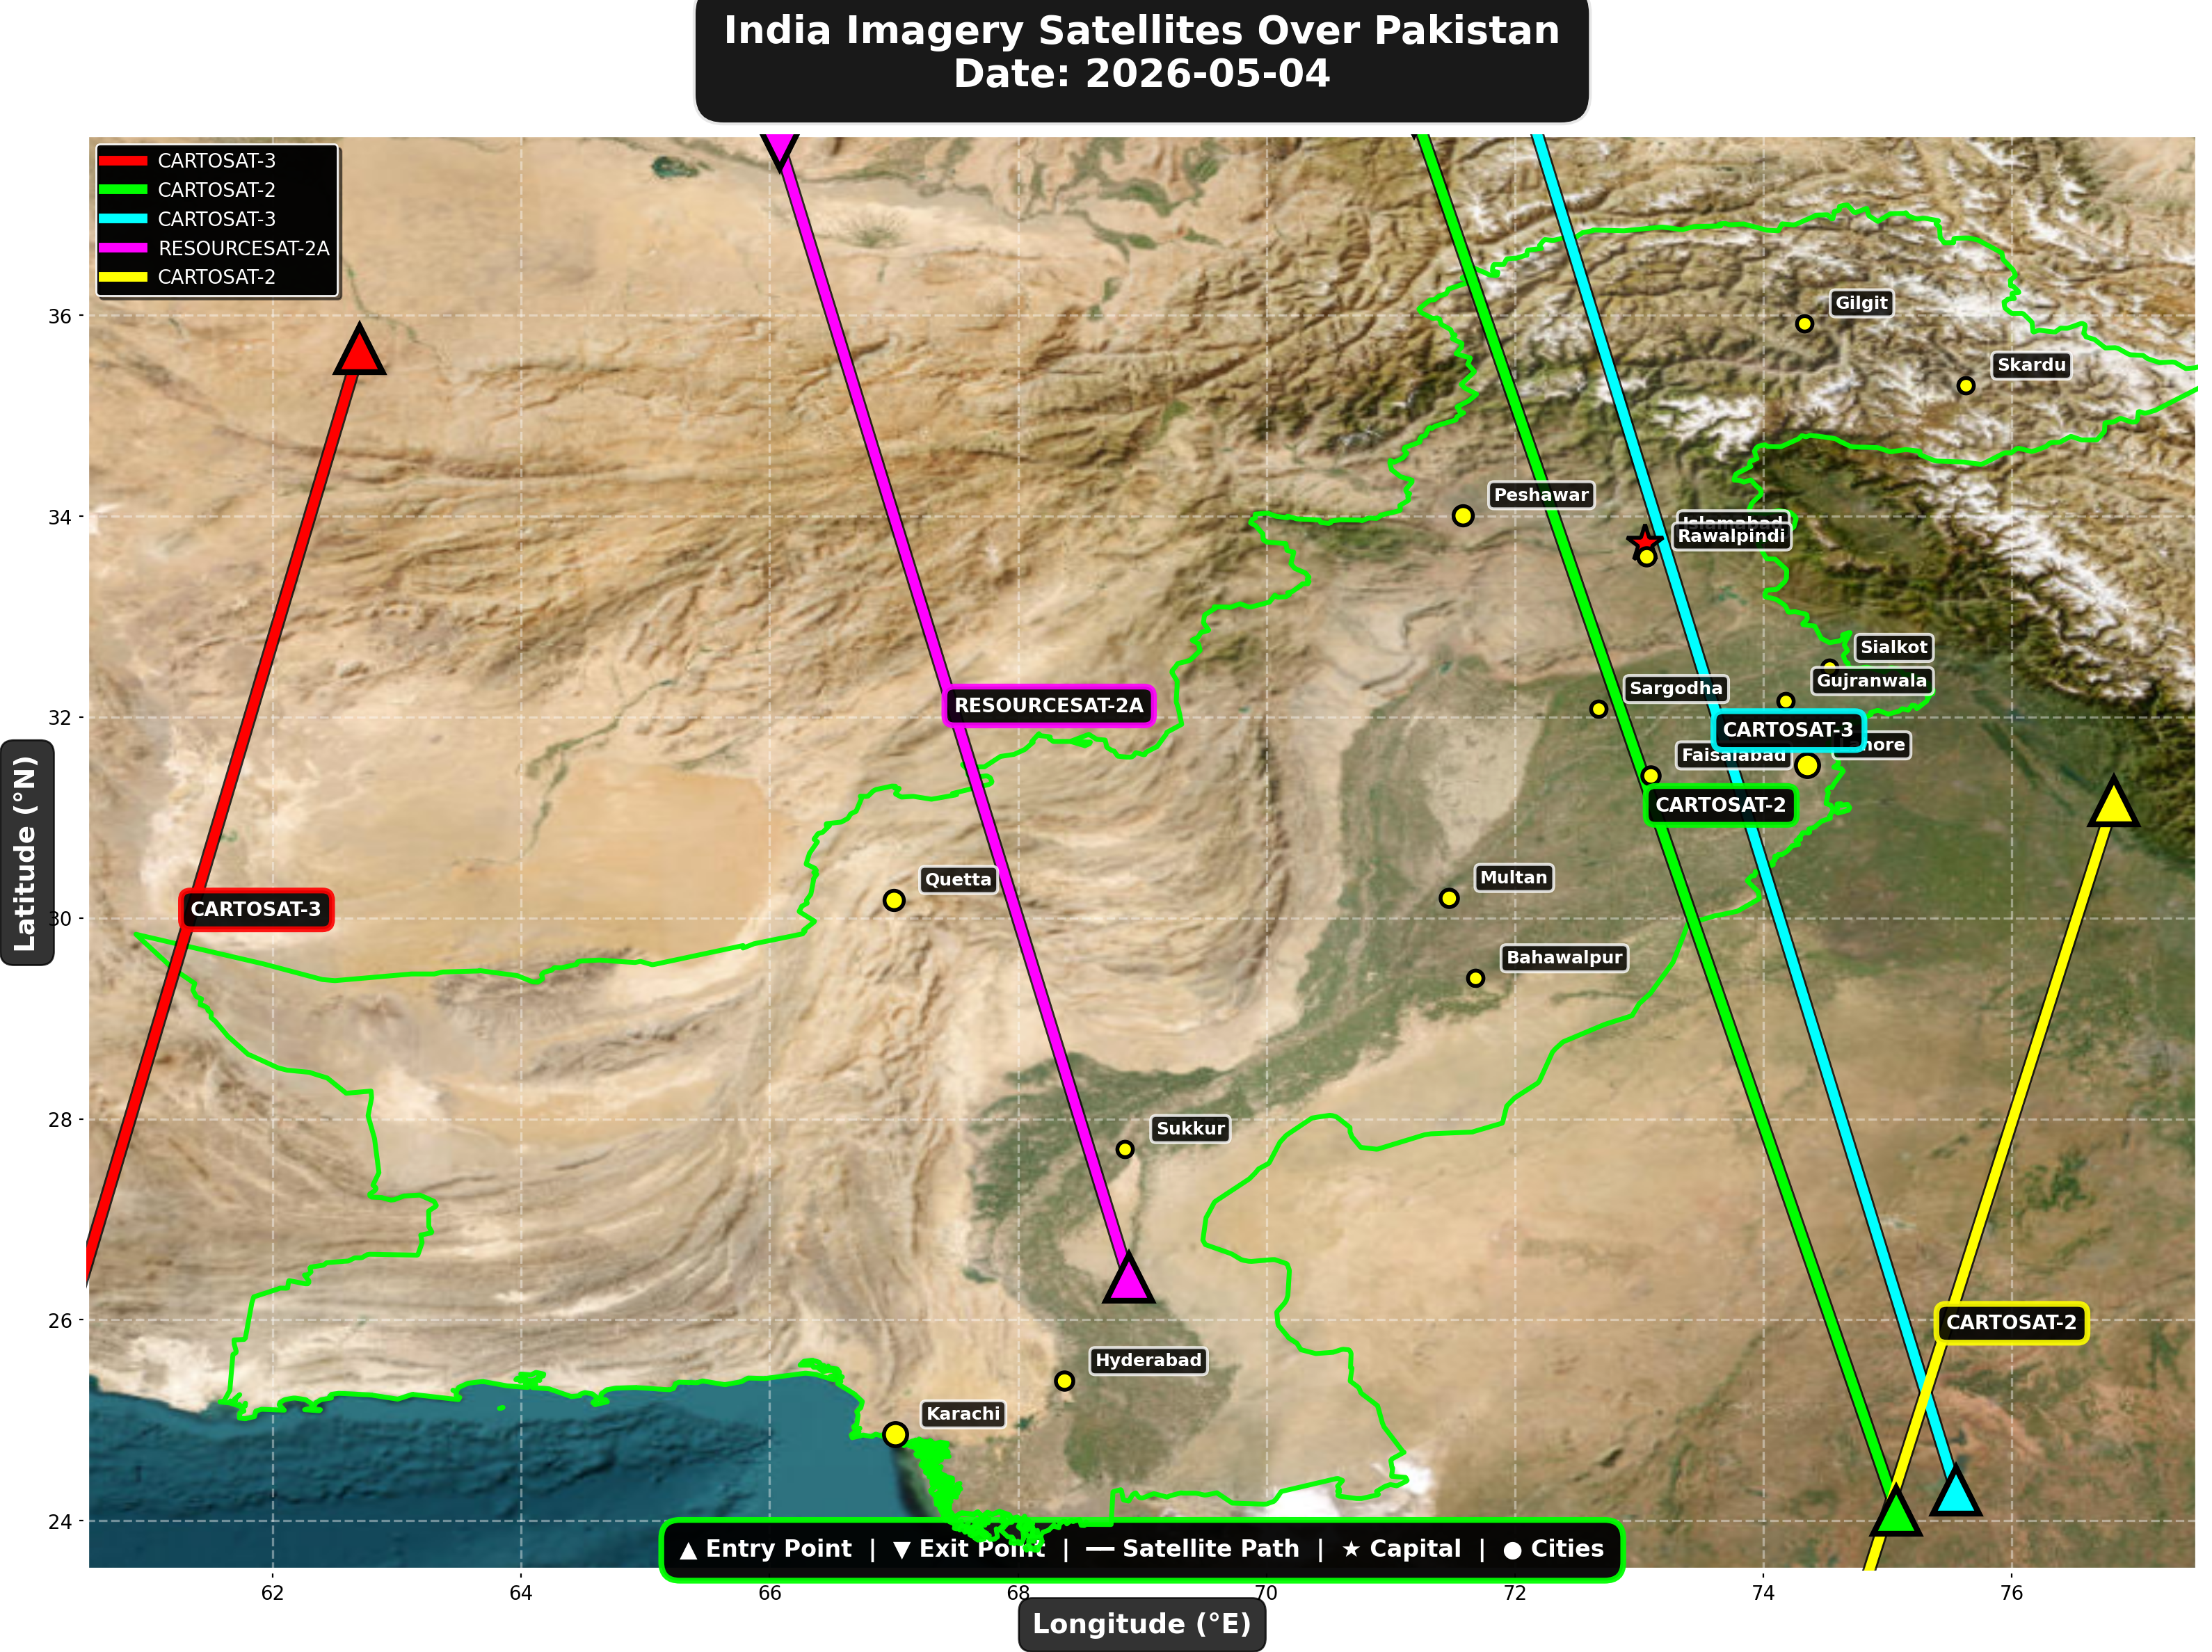

1. CARTOSAT-3 (Earth Observation)
Entry Time | 2026-05-04 05:42:00 UTC
Entry Point | 35.66°N, 62.7°E
Exit Time | 2026-05-04 05:45:00 UTC
Duration Over Pakistan | 3.0 minutes
Maximum Altitude | 514.2 km
Direction of Travel | N→S
Owner/Operator | ISRO
➤ Entered Pakistani airspace from the northwest (Afghanistan/China border region), traveling north to south. Satellite remained over Pakistan for 3.0 minutes at altitude 514.2 km.

2. CARTOSAT-2 (Earth Observation)
Entry Time | 2026-05-04 10:38:00 UTC
Entry Point | 24.1°N, 75.07°E
Exit Time | 2026-05-04 10:42:00 UTC
Duration Over Pakistan | 4.0 minutes
Maximum Altitude | 852.4 km
Direction of Travel | S→N
Owner/Operator | ISRO
➤ Entered Pakistani airspace from the south (Arabian Sea/Indian Ocean), traveling south to north. Satellite remained over Pakistan for 4.0 minutes at altitude 852.4 km.

3. CARTOSAT-3 (Earth Observation)
Entry Time | 2026-05-04 16:14:00 UTC
Entry Point | 24.3°N, 75.55°E
Exit Time | 2026-05-04 16:18:00 UTC
Duration Over Pakistan | 4.0 minutes
Maximum Altitude | 514.1 km
Direction of Travel | S→N
Owner/Operator | ISRO
➤ Entered Pakistani airspace from the south (Arabian Sea/Indian Ocean), traveling south to north. Satellite remained over Pakistan for 4.0 minutes at altitude 514.1 km.

4. RESOURCESAT-2A (Earth Observation)
Entry Time | 2026-05-04 16:39:00 UTC
Entry Point | 26.42°N, 68.89°E
Exit Time | 2026-05-04 16:42:00 UTC
Duration Over Pakistan | 3.0 minutes
Maximum Altitude | 511.6 km
Direction of Travel | S→N
Owner/Operator | ISRO
➤ Entered Pakistani airspace from the border region, traveling south to north. Satellite remained over Pakistan for 3.0 minutes at altitude 511.6 km.

5. CARTOSAT-2 (Earth Observation)
Entry Time | 2026-05-04 23:05:00 UTC
Entry Point | 31.16°N, 76.82°E
Exit Time | 2026-05-04 23:08:00 UTC
Duration Over Pakistan | 3.0 minutes
Maximum Altitude | 836.1 km
Direction of Travel | N→S
Owner/Operator | ISRO
➤ Entered Pakistani airspace from the east (Indian border - Punjab/Rajasthan sector), traveling north to south. Satellite remained over Pakistan for 3.0 minutes at altitude 836.1 km.

🇨🇳 CHINA IMAGERY SATELLITES
Visual Map - All China Satellite Paths:
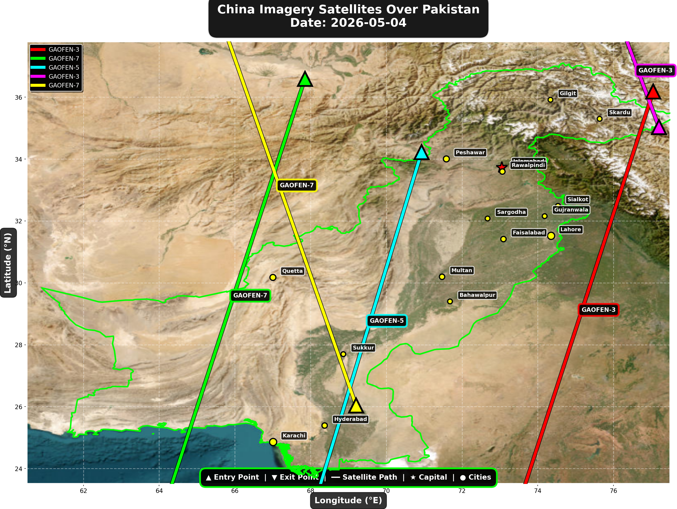

China reconnaissance and imaging satellites detected:
Satellite | Type | Entry Time | Duration (min) | Entry Point | Direction
GAOFEN-3 | Radar/SAR | 01:22:00 | 4.0 | 36.18°N, 77.05°E | N→S
GAOFEN-7 | Earth Observati | 02:12:00 | 4.0 | 36.59°N, 67.85°E | N→S
GAOFEN-5 | Earth Observati | 06:24:00 | 3.0 | 34.22°N, 70.93°E | N→S
GAOFEN-3 | Radar/SAR | 12:31:00 | 1.0 | 35.03°N, 77.2°E | N/A
GAOFEN-7 | Earth Observati | 13:23:00 | 4.0 | 26.04°N, 69.2°E | S→N

🇺🇸 USA IMAGERY SATELLITES
Visual Map - All USA Satellite Paths:
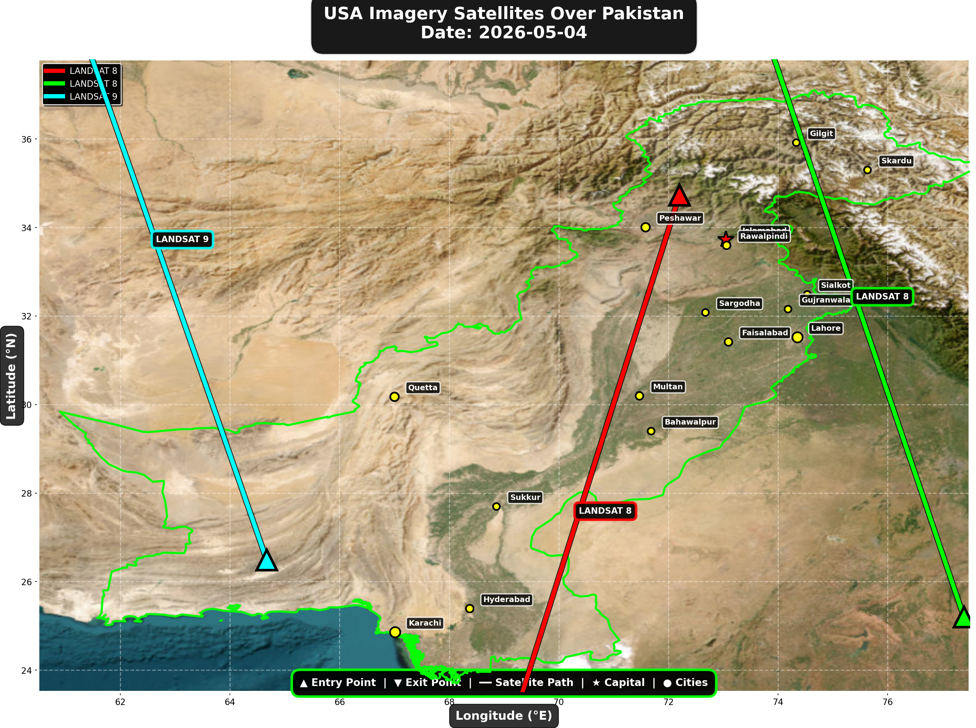

USA reconnaissance and imaging satellites detected:
Satellite | Type | Entry Time | Duration (min) | Entry Point | Direction
LANDSAT 8 | Earth Observati | 05:48:00 | 4.0 | 34.73°N, 72.2°E | N→S
LANDSAT 8 | Earth Observati | 16:47:00 | 4.0 | 25.2°N, 77.39°E | S→N
LANDSAT 9 | Earth Observati | 17:37:00 | 4.0 | 26.49°N, 64.67°E | S→N

Crossings by Country
Country | Crossings
China | 16
USA | 9
India | 5
Europe | 5
International | 4

Crossings by Satellite Type
Type | Crossings
Weather | 14
Earth Observation | 11
Space Station | 8
Reconnaissance | 4
Radar/SAR | 2

All Border Crossings (39 total)
# | Satellite | Owner | Country | Type | Entry Time | Duration (min) | Alt (km) | Direction
1 | ISS | NASA/Roscosmos | International | Space Station | 2026-05-04 00:42:00 UTC | 4.0 | 429.0 | W→E
2 | GAOFEN-3 | CNSA | China | Radar/SAR | 2026-05-04 01:22:00 UTC | 4.0 | 758.2 | N→S
3 | GAOFEN-7 | CNSA | China | Earth Observati | 2026-05-04 02:12:00 UTC | 4.0 | 792.5 | N→S
4 | YAOGAN-14 | PLA | China | Reconnaissance | 2026-05-04 03:00:00 UTC | 4.0 | 160.9 | N→S
5 | TIANGONG | CNSA | China | Space Station | 2026-05-04 04:02:00 UTC | 3.0 | 388.5 | W→E
6 | TIANGONG | CNSA | China | Space Station | 2026-05-04 05:39:00 UTC | 3.0 | 388.9 | W→E
7 | CARTOSAT-3 | ISRO | India | Earth Observati | 2026-05-04 05:42:00 UTC | 3.0 | 514.2 | N→S
8 | LANDSAT 8 | NASA/USGS | USA | Earth Observati | 2026-05-04 05:48:00 UTC | 4.0 | 709.0 | N→S
9 | METOP-C | EUMETSAT | Europe | Weather | 2026-05-04 05:53:00 UTC | 1.0 | 827.5 | N/A
10 | NOAA-18 | NOAA | USA | Weather | 2026-05-04 06:16:00 UTC | 4.0 | 844.4 | N→S
11 | GAOFEN-5 | CNSA | China | Earth Observati | 2026-05-04 06:24:00 UTC | 3.0 | 616.4 | N→S
12 | NOAA-19 | NOAA | USA | Weather | 2026-05-04 06:29:00 UTC | 4.0 | 860.1 | N→S
13 | YAOGAN-26 | PLA | China | Reconnaissance | 2026-05-04 06:53:00 UTC | 2.0 | 858.7 | N→S
14 | METOP-A | EUMETSAT | Europe | Weather | 2026-05-04 08:17:00 UTC | 4.0 | 591.8 | N→S
15 | NOAA-20 | NOAA | USA | Weather | 2026-05-04 09:01:00 UTC | 3.0 | 832.9 | S→N
16 | FENGYUN-3C | CMA | China | Weather | 2026-05-04 10:32:00 UTC | 3.0 | 830.0 | S→N
17 | CARTOSAT-2 | ISRO | India | Earth Observati | 2026-05-04 10:38:00 UTC | 4.0 | 852.4 | S→N
18 | FENGYUN-3D | CMA | China | Weather | 2026-05-04 11:00:00 UTC | 4.0 | 833.8 | S→N
19 | GAOFEN-3 | CNSA | China | Radar/SAR | 2026-05-04 12:31:00 UTC | 1.0 | 757.7 | N/A
20 | GAOFEN-7 | CNSA | China | Earth Observati | 2026-05-04 13:23:00 UTC | 4.0 | 791.0 | S→N
21 | YAOGAN-14 | PLA | China | Reconnaissance | 2026-05-04 14:13:00 UTC | 2.0 | 163.7 | S→N
22 | ISS | NASA/Roscosmos | International | Space Station | 2026-05-04 15:46:00 UTC | 1.0 | 421.6 | N/A
23 | CARTOSAT-3 | ISRO | India | Earth Observati | 2026-05-04 16:14:00 UTC | 4.0 | 514.1 | S→N
24 | METOP-B | EUMETSAT | Europe | Weather | 2026-05-04 16:37:00 UTC | 2.0 | 827.4 | S→N
25 | RESOURCESAT-2A | ISRO | India | Earth Observati | 2026-05-04 16:39:00 UTC | 3.0 | 511.6 | S→N
26 | LANDSAT 8 | NASA/USGS | USA | Earth Observati | 2026-05-04 16:47:00 UTC | 4.0 | 709.4 | S→N
27 | METOP-C | EUMETSAT | Europe | Weather | 2026-05-04 17:08:00 UTC | 2.0 | 827.1 | S→N
28 | ISS | NASA/Roscosmos | International | Space Station | 2026-05-04 17:22:00 UTC | 2.0 | 422.0 | W→E
29 | NOAA-18 | NOAA | USA | Weather | 2026-05-04 17:36:00 UTC | 4.0 | 860.6 | S→N
30 | LANDSAT 9 | NASA/USGS | USA | Earth Observati | 2026-05-04 17:37:00 UTC | 4.0 | 709.4 | S→N
31 | NOAA-19 | NOAA | USA | Weather | 2026-05-04 17:49:00 UTC | 4.0 | 858.9 | S→N
32 | YAOGAN-26 | PLA | China | Reconnaissance | 2026-05-04 17:56:00 UTC | 4.0 | 912.9 | S→N
33 | METOP-A | EUMETSAT | Europe | Weather | 2026-05-04 19:07:00 UTC | 4.0 | 771.9 | S→N
34 | NOAA-20 | NOAA | USA | Weather | 2026-05-04 21:24:00 UTC | 4.0 | 834.1 | N→S
35 | TIANGONG | CNSA | China | Space Station | 2026-05-04 22:08:00 UTC | 4.0 | 384.6 | W→E
36 | CARTOSAT-2 | ISRO | India | Earth Observati | 2026-05-04 23:05:00 UTC | 3.0 | 836.1 | N→S
37 | FENGYUN-3D | CMA | China | Weather | 2026-05-04 23:23:00 UTC | 4.0 | 832.2 | N→S
38 | TIANGONG | CNSA | China | Space Station | 2026-05-04 23:46:00 UTC | 2.0 | 385.6 | W→E
39 | ISS | NASA/Roscosmos | International | Space Station | 2026-05-04 23:56:00 UTC | 1.0 | 427.9 | N/A

